

TPM Profile Recertification and Update Guide
Table of Contents
Overview 2
Step 1. Login to MAG 3
Step 2. Access Organization Account in TPM 4
General TPM System Information – Helpful Tips 5
Step 3. Perform Organization Recertification or General Organization Maintenance Updates 6
Step 4. Organization Summary - Review Data Only (not editable) 6
Step 5. Business Description 8
Step 6. Company Profile 9
Step 7. Socio-economic 11
Step 8. Self-Certification 11
Socio-Economic Section 12
Executive Compensation Report Section 13
National Defense Authorization Act (NDAA) Section 889 Section 14
Cyber Security Section 15
Submit Certifications and Representations 17
Step 9. History – Review Data Only (not editable) 19
Step 10. D&B Other Information – Review Data Only (not editable) 20
Step 11. Foreign (Non-U.S.)/Domestic (U.S.) Owned 21
Step 12. Payments/Remittance 22
Step 13. Contacts 23
Step 14. Perform Final Certify Step 25
Step 15. Complete Recertification 25
Recertification Success Confirmation 25

Overview
The purpose of this user guide is to describe the processes and procedures for performing an official Organization/Vendor Profile recertification and performing general maintenance updates to your Organization/Vendor Profile, both being performed in Exostar’s Trading Partner Manager (TPM) system. Lockheed Martin uses TPM as their vendor management solution to support the Lockheed Martin Procure-to-Pay (LMP2P) system processes.

It covers the following TPM Organization/Vendor profile maintenance processes:
- Performing general organization profile maintenance activity, such as updating your contact person’s information or your banking information. This can be performed at any time updates are needed and when status is either active or expired.
- Performing an official organization recertification action, which is required at least once every three years to remain in active status. This can be performed at any time and when status is either active or expired. When status is expired this process must be performed to get to active status to allow procurement activity to occur.

A pre-requisite to performing these processes and procedures is that you previously completed the initial TPM vendor registration process (Invitation Acceptance) and have at least one Managed Access Gateway (MAG) Organization Administrator with an active user account and two-factor authentication (2FA) credential associated to it.

IMPORTANT: Only a designated MAG Organization Administrator, logged in with 2FA will have access to TPM to make any changes to their company’s TPM organization profile information.

For more information on 2FA credentials and the associated authentication processes please visit the Lockheed Martin landing page on MyExostar.com, Exostar’s self-help website.

NOTE: To recertify an organization, there needs to be at least one Active status LMP2P user with a valid 2FA credential (this can be the Organization Administrator) associated with the organization, which makes it 2FA compliant.

If you have any questions or need assistance with access to MAG or on how to add a new Organization Administrator, please contact Exostar Customer Service at: https://www.myexostar.com/knowledge-base/contact-support/.

Step 1. Login to MAG
To login to your existing MAG account:
- Navigate to https://ui.portal.exostar.com/iamui/mfa/userReference.
- Enter your Email or User ID. Click Next.
NOTE: Additional login options display: Login Using Company Credential (EAG) or Login Using Badge or Certificate.
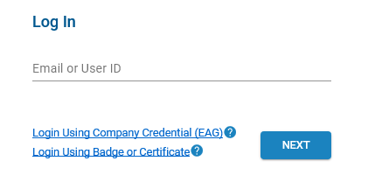

- Enter your Password. Click Next to open the MAG dashboard.
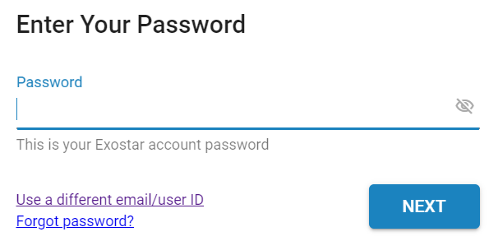

Step 2. Access Organization Account in TPM
To access TPM from MAG:
- Click the My Account tab and the View Organization Details sub-tab.
NOTE: This page displays general organization information, such as Exostar ID (a unique ID assigned to your organization), organization name, address, and DUNS Number, along with a list of the current Organization and Application Administrators.
- Select the View in Trading Partner Manager (TPM) link, located next to your organization’s name.
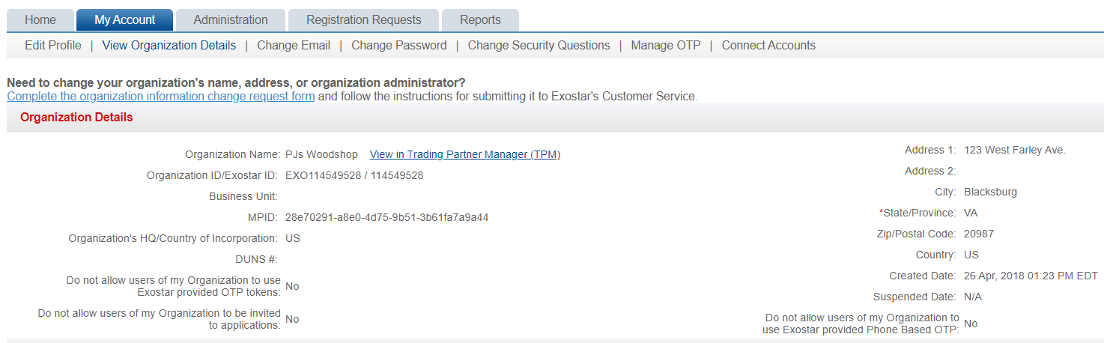

- The following message displays. Review and click Continue to access your Organization’s TPM Profile.
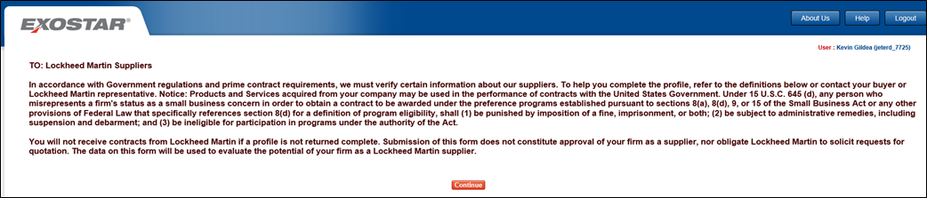

NOTE: The Organization Summary page displays initially.
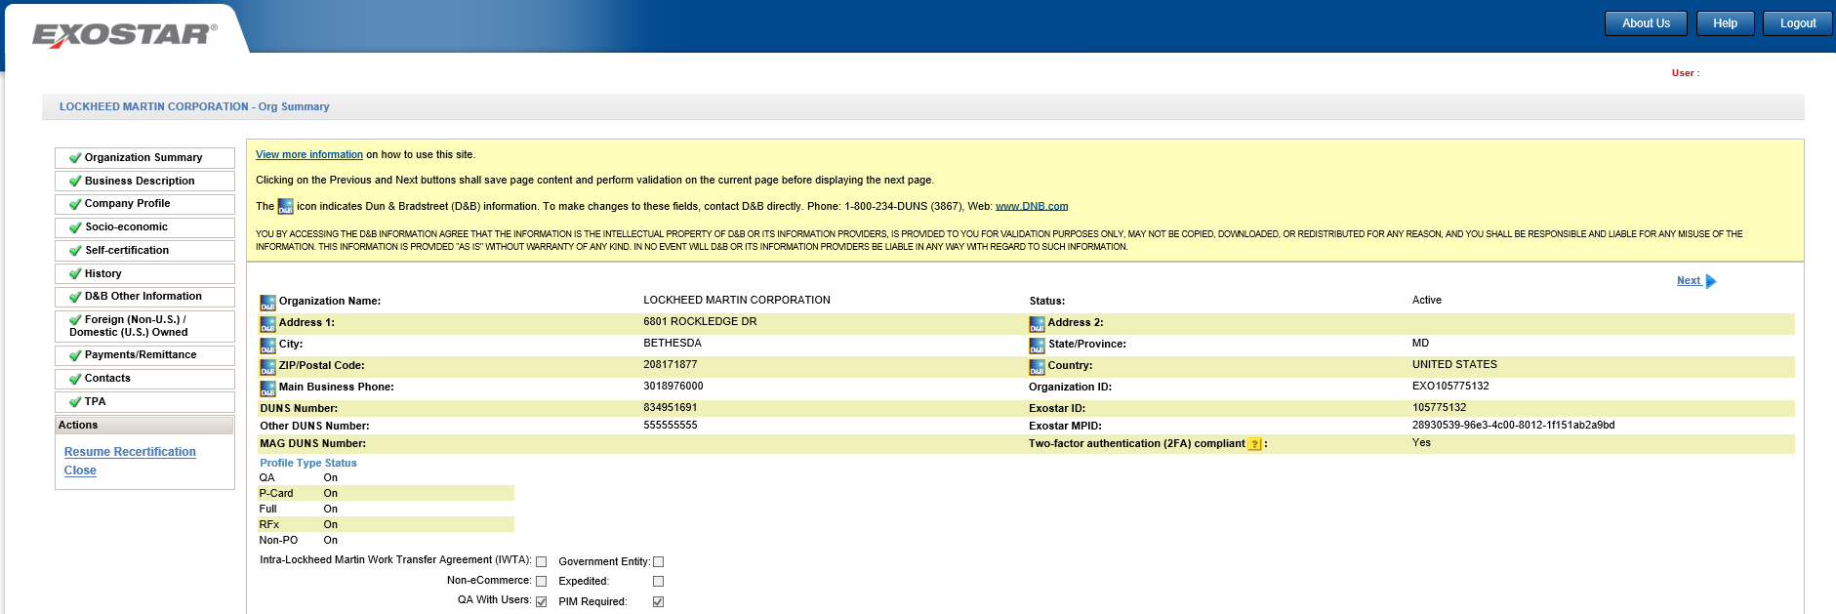

General TPM System Information – Helpful Tips
The following helpful tips are applicable to all TPM pages/screens:
- At any time during the online supplier recertification process, you can click Save, which saves any data already entered/selected. To resume, repeat the login process and click Resume Recertification from the left-side menu.
- All data fields preceded by a red asterisk (*) are required. All other data fields are optional.
- Click the vertical scrollbar to navigate through a page.
- The words Screen and Page are used synonymously throughout the document.
- The words Organization, Vendor, and Supplier are used synonymously throughout the document.
- When a page is complete, a green check mark displays next to the application page title, on the left-side menu.
- If a data field is protected from input/selection, it is not applicable for this specific vendor registration, so can be skipped over.
- All data field values manually entered will be validated for accuracy and completeness, where possible. If an error occurs, a detailed error message (in color red), displays adjacent to the data field itself or in very close proximity.
- All pages contain Save, Next, and Previous action buttons that save the page content to the database when clicked. Clicking on any page title item, on the left-side menu also saves content to the database and takes you directly to that page.
- At this point in the process, the Status value on the Organization Summary page is set to Vendor in Process. The end goal is to get it to Active status.
- At this point in the process, the Status value on the Organization Summary page is set to either Active or Expired. The end goal is to get it to or remain in Active status.

Step 3. Perform Organization Recertification or General Organization Maintenance Updates
To begin the organization profile recertification process:
- Click the Perform Recertification link under Actions, on the left-side navigation menu.
NOTE: If you only want to update specific data fields for your organization, without officially recertifying the entire profile, click NEXT to navigate to the pages requiring updates, or select the applicable page title on the left-side navigation to go directly to a page.
- If you are performing general maintenance, once specific data fields have been updated, click Save.
NOTE: Clicking the Previous or Next links or selecting a page title from left-side navigation, any data updates are automatically saved to the database.

The remainder of this guide assumes you are performing the official organization recertification process.

Step 4. Organization Summary - Review Data Only (not editable)
Your company’s general information, such as organization name, address, and D&B DUNS Number are displayed on the Organization Summary page. Most of this information populates from Dun & Bradstreet (D&B) directly, and those fields are marked with the D&B icon.
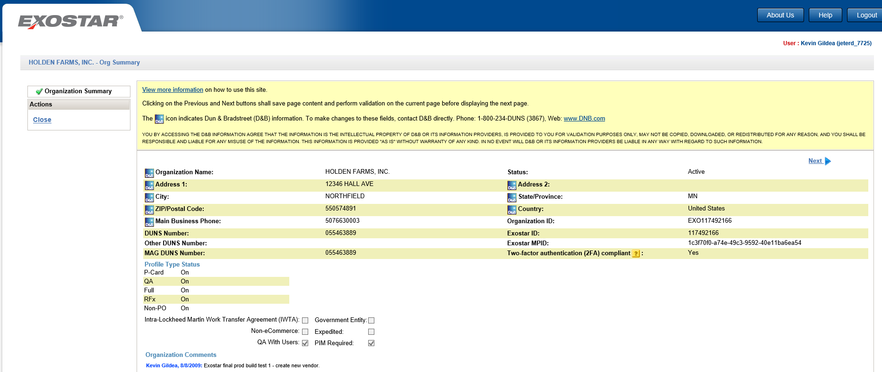

No user input is required. The Status field displays the following primary possible values:
- Active
- Expired
- Suspended
- Deactivated

NOTE: If the D&B data is not correct, you must contact D&B directly to have corrections made. Corrections made at D&B eventually automatically populate in this profile. You may access D&B here: https://www.dnb.com/. See other D&B helpful contact information displayed on the page itself. When an organization requests updates on the D&B website, it may take up to 30 days for the changes to display in TPM.

Click Next to continue.

Step 5. Business Description
On the Business Description page, all data fields preceded by a red asterisk (*) are required. All other data fields are optional.
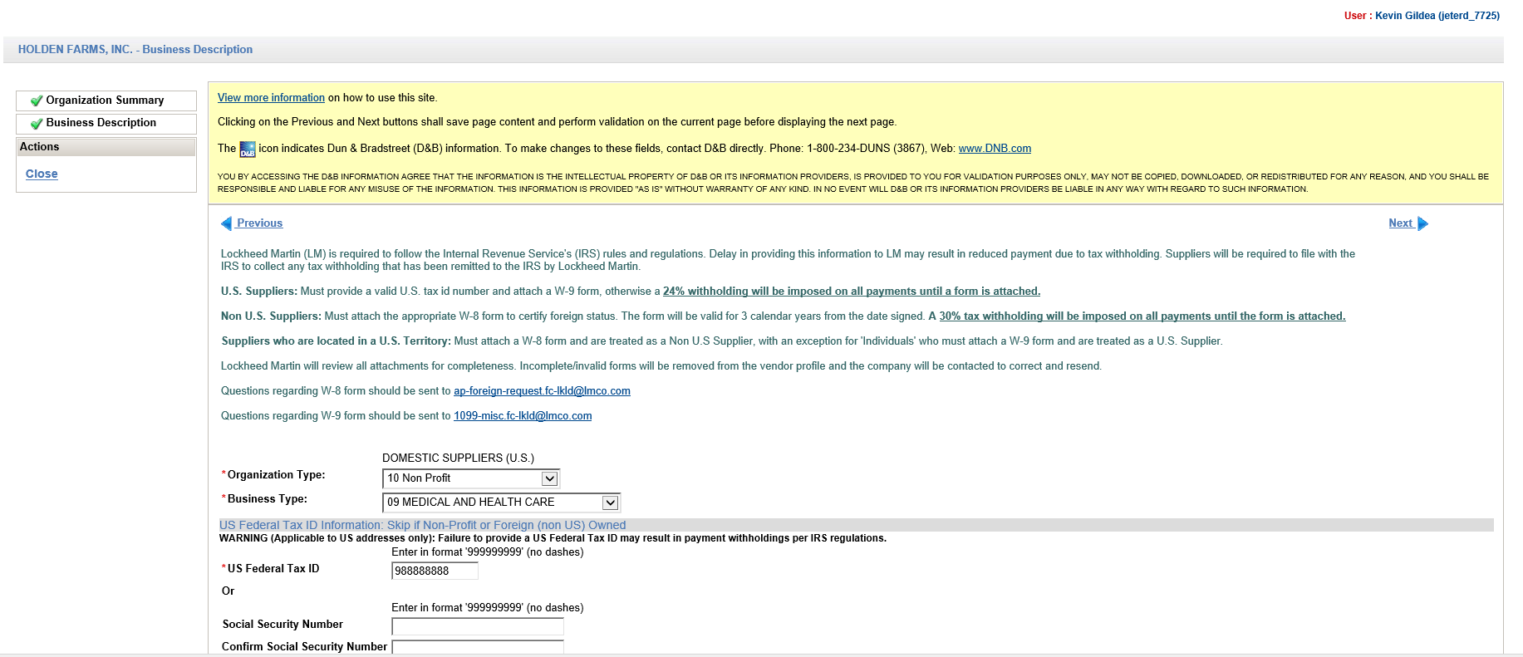

Update your company’s Federal Tax ID or a person’s Social Security Number (for individuals), if necessary. One or the other is required. This information is only required for Domestic/US-based business entities.

Per IRS rules and regulations, U.S. suppliers are required to submit a W-9 tax form and NON- U.S. suppliers a W-8 tax form. If a tax form is not submitted, a 24% (U.S.) or 30% (Non-U.S.) withholding is imposed on all invoice payments.

To upload a completed IRS W-8 or W-9 tax form:
- Click the Upload Tax Form button.
- Select your tax form file from your computing device or other storage area.
- Click Open or double-click on the file.
- Select the IRS Tax Form Type from selection list.
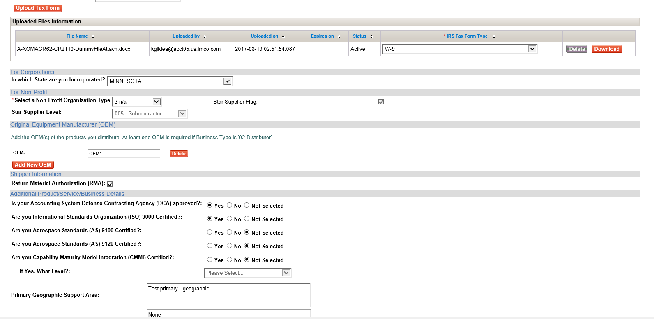

NOTE: If you do not attach a completed tax form now, you can attach it at a later time, but it must be attached prior to payments being successfully processed.

Click Next to continue.

Step 6. Company Profile
On the Company Profile page, review, and update, as necessary, Parent Company information and Nexus Location data fields.

Nexus Location Field:
- Read the instructions provided on page to determine your required selections.
- Click the dropdown selection arrow and select the appropriate items from the list.
- For Non-U.S./Foreign suppliers, leave selection as Please Select or select Not Applicable.
- Use standard Windows control-click keystroke combination to select all values that apply.
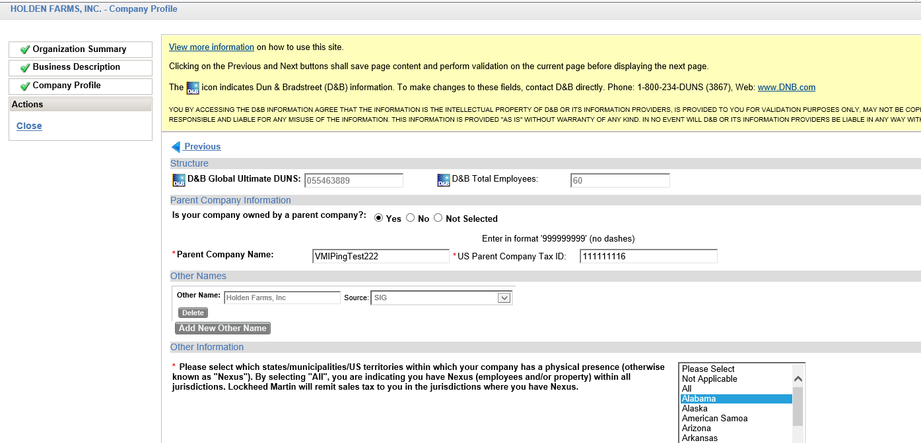

Click Next to continue.

Step 7. Socio-economic
All data fields preceded by a red asterisk (*) are required. Review all data fields and update as necessary.
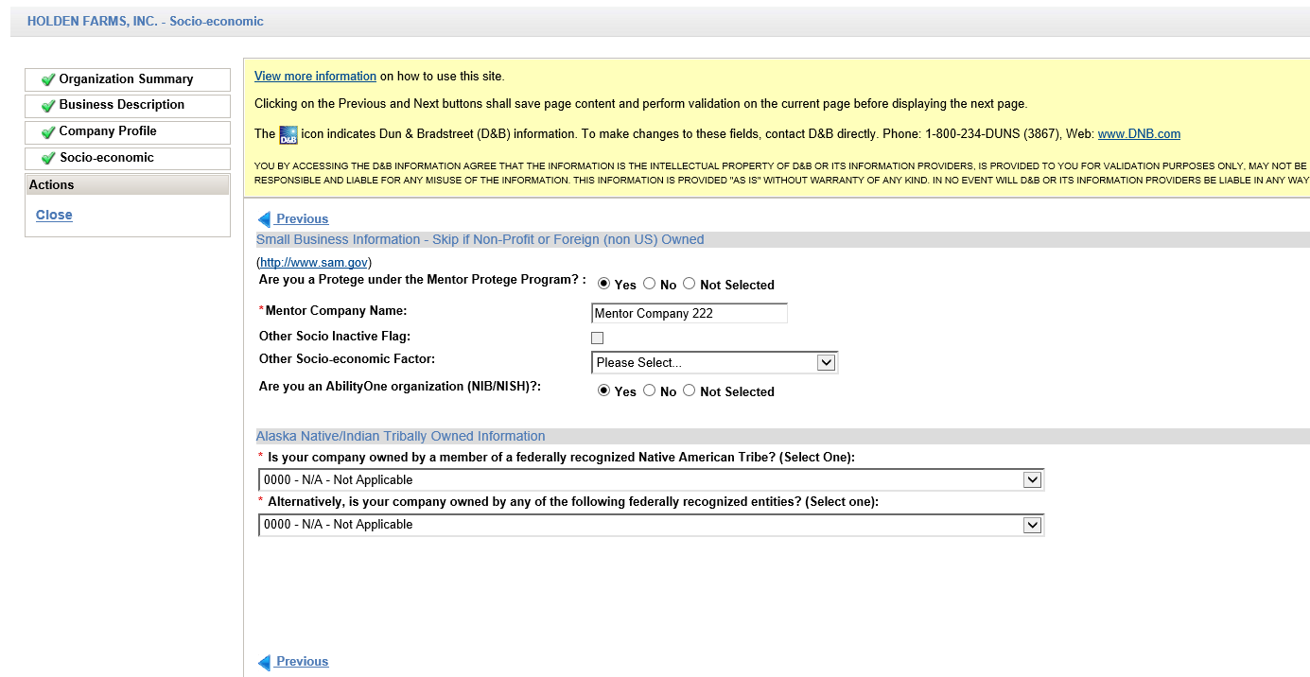

Click Next to continue.

Step 8. Self-Certification
The Self-Certification page contains up to four sections each requiring an annual response, dependent on the organization’s main Country.

Socio-economic: Required when organization address country is U.S. (including U.S. Territories).

Executive Compensation Report: Required for all vendors regardless of organization address country.

National Defense Authorization Act (NDAA) Section 889: Required for all vendors regardless of organization address country.

Cyber Security: Required for all vendors regardless of organization address country.
To complete each section, follow the step-by-step instructions provided directly on the application page, and are also described in general in the steps below. Several links to external web sites are also provided on the application page to assist in completing the task.

NOTE: If no changes are needed, click the Submit Certifications and Representations button to complete the annual certification requirement. A confirmation message displays and self-certification dates and user information display below the message.

All data fields preceded by a red asterisk (*) are required. Review all data fields and update as necessary.

Socio-Economic Section
NAICS: North American Industry Classification System. For assistance with NAICS Codes please refer to this U.S. Census Bureau web site at https://www.census.gov/naics.

NOTE: This section is entirely suppressed for non-U.S. (and not a U.S. Territory) vendors.

To begin:
- Click the Browse and Add button to select your NAICS codes from the NAICS Browser application window.
- Once you have finished your selections scroll to the bottom of the window and click OK.
- For each NAICS Code selected and now displayed:
  - Select its company size (Small or Other) from the dropdown selection list.
  - Click the NAICS Primary Code checkbox for your company’s primary NAICS code.
NOTE: Only one NAICS Code can be checked as the primary.
- To add more NAICS codes at any time, click the Browse and Add button again.
- Proceed to the Executive Compensation Report section of page.
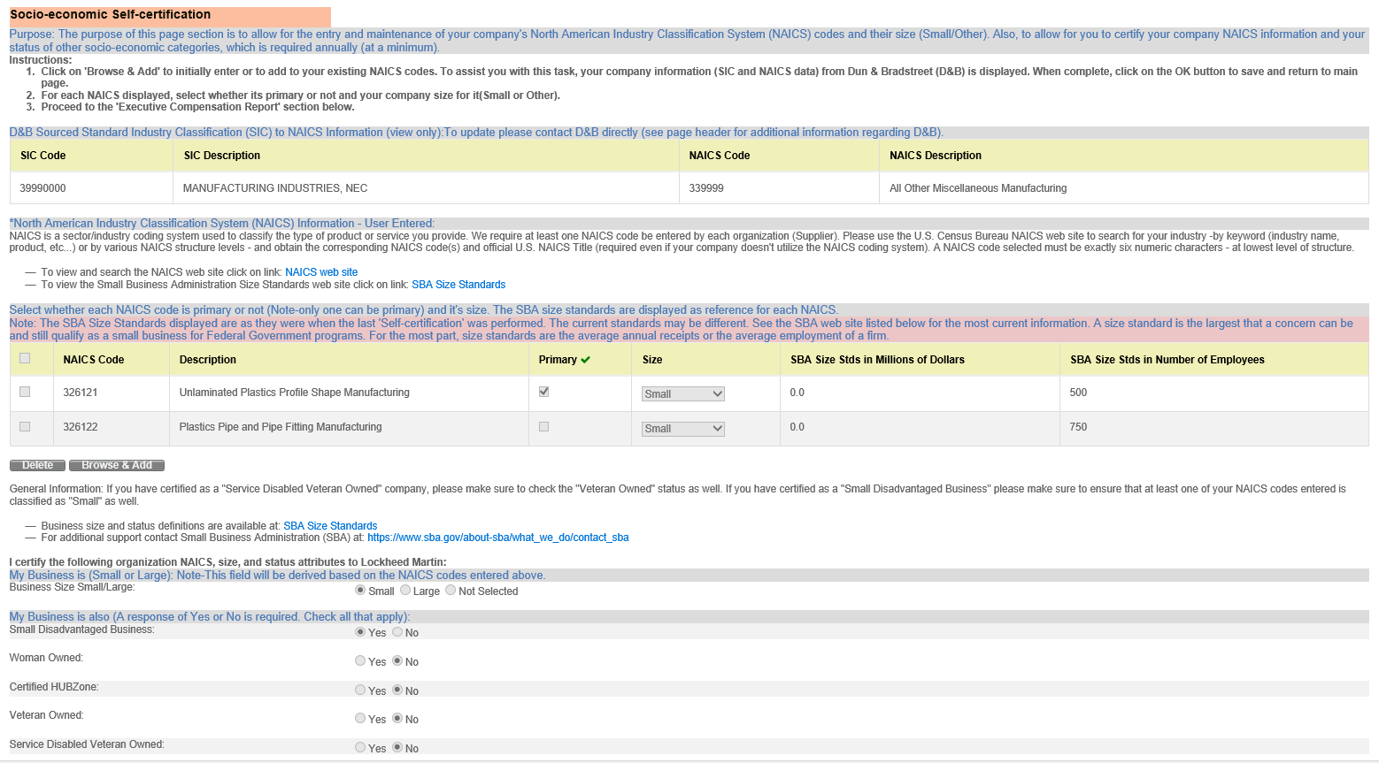

Executive Compensation Report Section
The application page displays detailed step-by-step instructions on how to complete this section:
- The following first two questions must be answered Yes or No:
- In the preceding completed fiscal year, did this business or organization (the legal entity to which the DUNS number it provided belongs) receive 1) 80 percent or more of its annual gross revenues in U.S. federal contracts, subcontracts, loans, grants, subgrants, and/or cooperative agreements; AND 2) $25,000,000 or more in annual gross revenues from U.S. federal contracts, subcontracts, loans, grants, subgrants, and/or cooperative agreements?
- Does the public have access to information about the compensation of the executives in this business or organization (the legal entity to which this specific SAM record, represented by a DUNS number, belongs) through periodic reports filed under section 13(a) or 15(d) of the Securities Exchange Act of 1934 (15 U.S.C. 78m(a), 78o(d)) or section 6104 of the Internal Revenue Code of 1986?
- If Yes to #1 and No to #2, provide the total compensation of each of the five most highly compensated executives as defined in FAR 52.204-10 for the preceding completed fiscal year.
NOTES:
- The table/grid to enter the executive names and total compensation amount data only displays when the answers to the two questions are ‘Yes’ and ‘No’ respectively. When required, at least one and a maximum of five rows must be completed.
- The total compensation dollar amount is considered sensitive data and will be protected as such. It is only displayed in TPM to Organization Administrators.
- For additional information regarding the requirements driving Lockheed Martin to capture this information from our suppliers, refer to U.S. Government FAR clause 52.204-10.
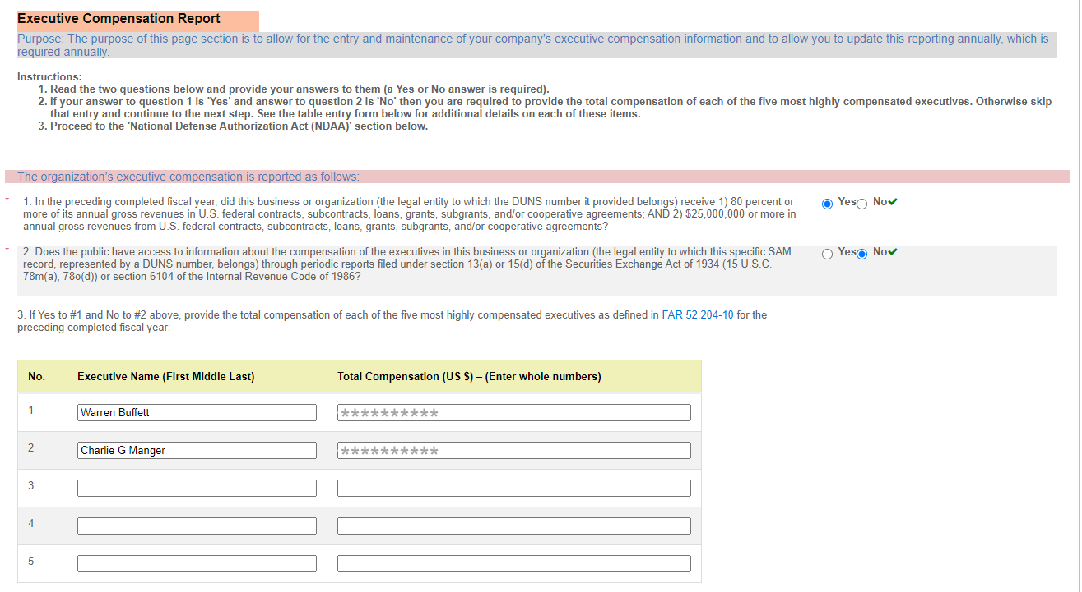

National Defense Authorization Act (NDAA) Section 889 Section
The application page displays detailed step-by-step instructions on how to complete this section:
The following representation must be provided whereas the Company represents that it:
provide covered defense telecommunications equipment or services as a part of its offered products or services to Lockheed Martin in the performance of any contract, subcontract, or other contractual instrument.
or
(c)
Company is unable to make an assertion to provide a representation on all products, but the company agrees to promptly provide the required representation signed by an authorized representative upon the request of LOCKHEED MARTIN prior to each contract award.
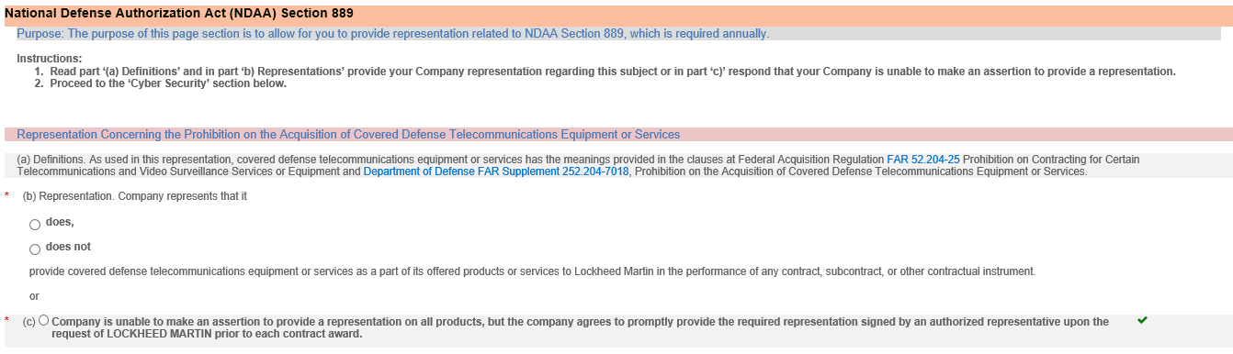

Cyber Security Section
Cyber Security is important to Lockheed Martin and these requirements have been implemented to mitigate risks to suppliers as it relates to sensitive data sharing. Additional information about completing this section can be found by clicking the links provided on the application page.
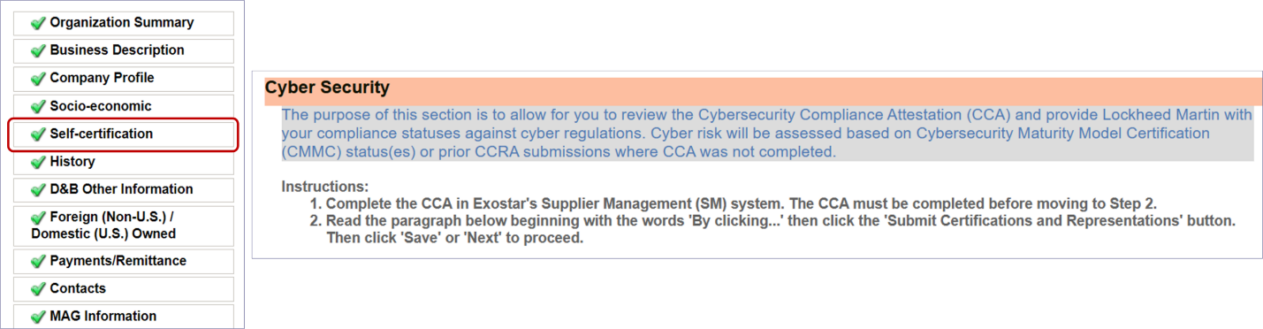
Cybersecurity Compliance: Review the information in this section and click the yellow highlighted messaging to access the Cybersecurity Compliance Attestation (CCA) Form in Supplier Management (SM).
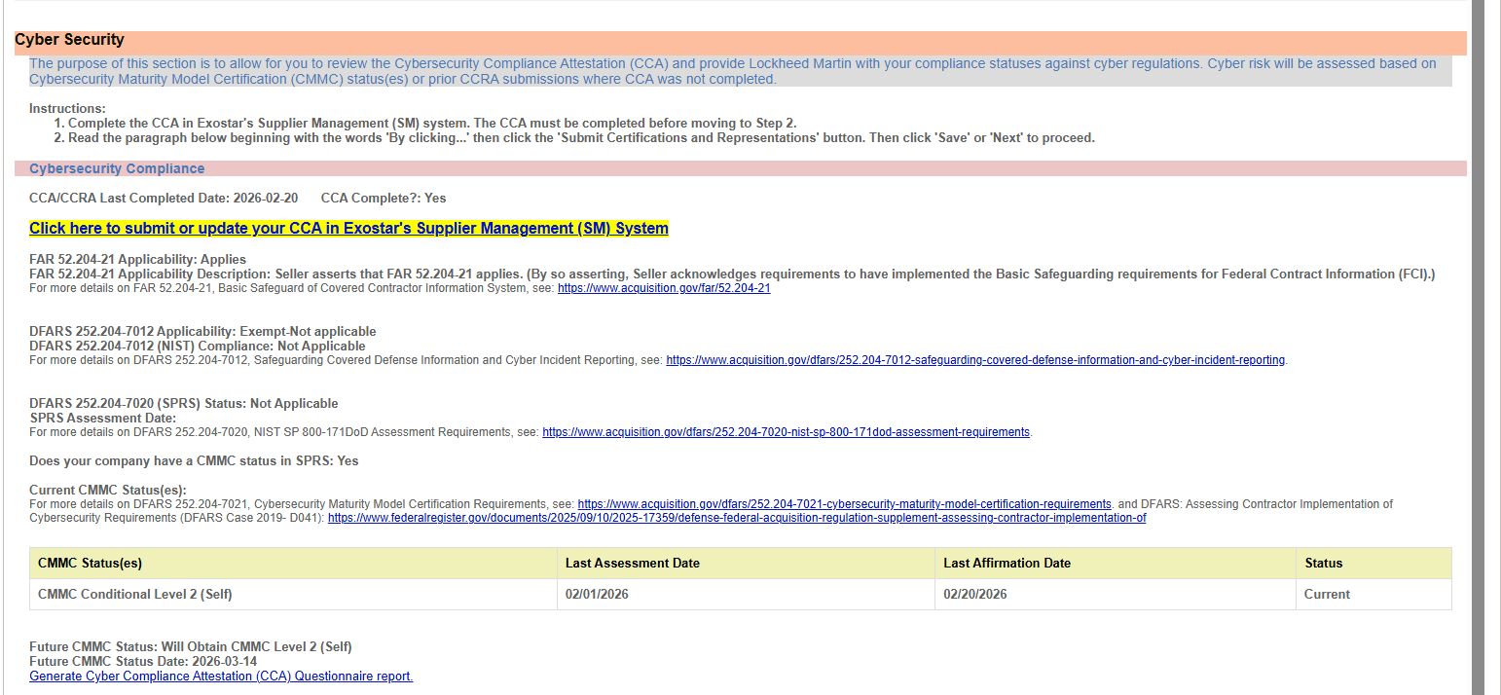

Cybersecurity Risk: Review the information in this section. Please see the next section for more information on submitting certification and representation.
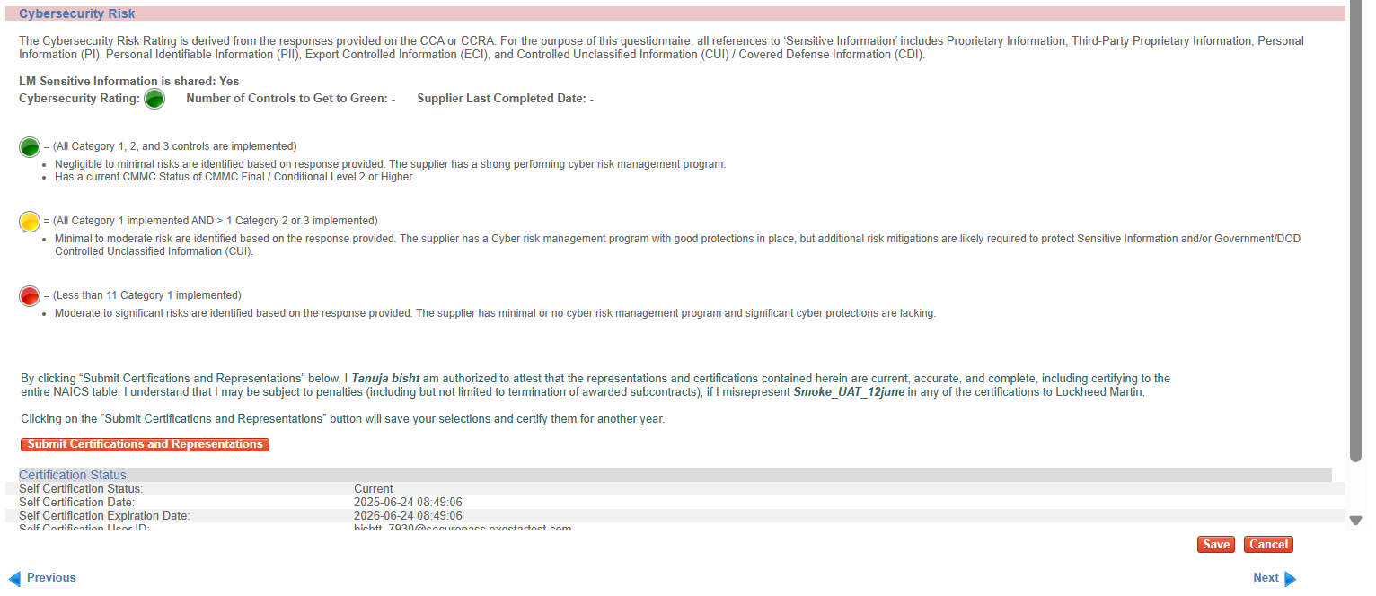

Submit Certifications and Representations
IMPORTANT! If your Submit Certifications and Representations button is disabled, a warning message is displayed on the TPM Self-Certification screen. You are required to complete or update the CCA Form in Exostar’s Supplier Management application. To complete or update the form, please visit the TPM Cyber Security article for step-by-step instructions.
If your vendor profile is expired, you are attempting to recertify, AND your organization does NOT have access to Supplier Management, please contact Exostar’s Customer Support for additional guidance.
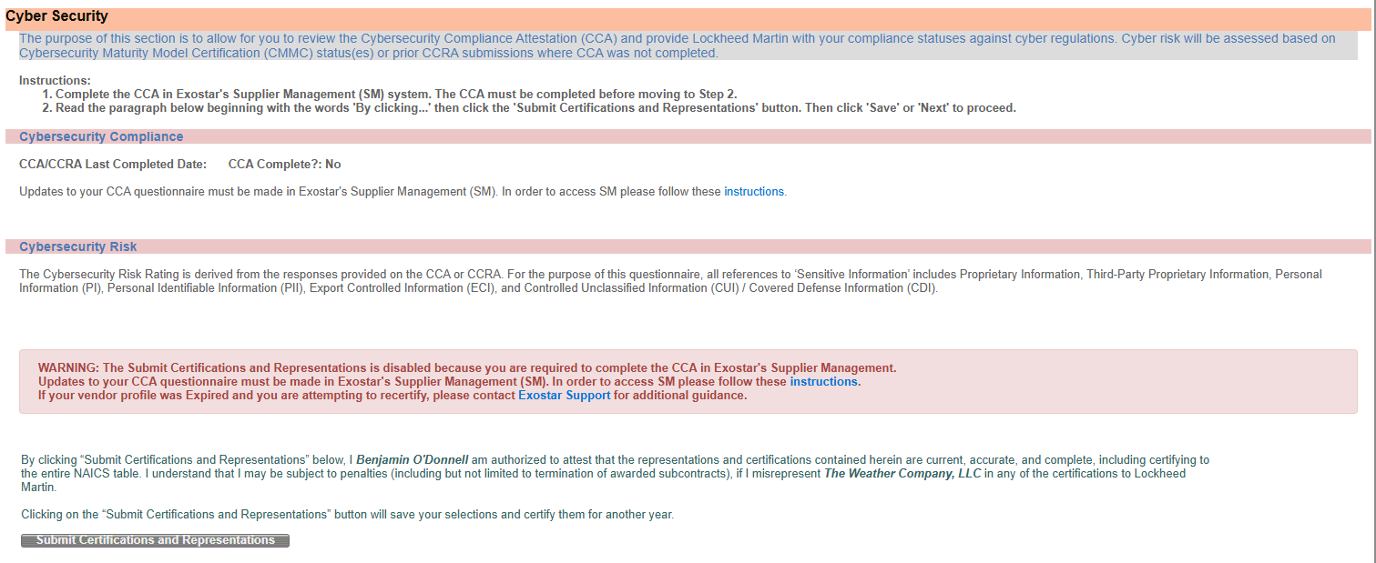

You can verify Supplier Management access status via the My Account tab and View Organization Details sub-tab or the Dashboard on MAG.
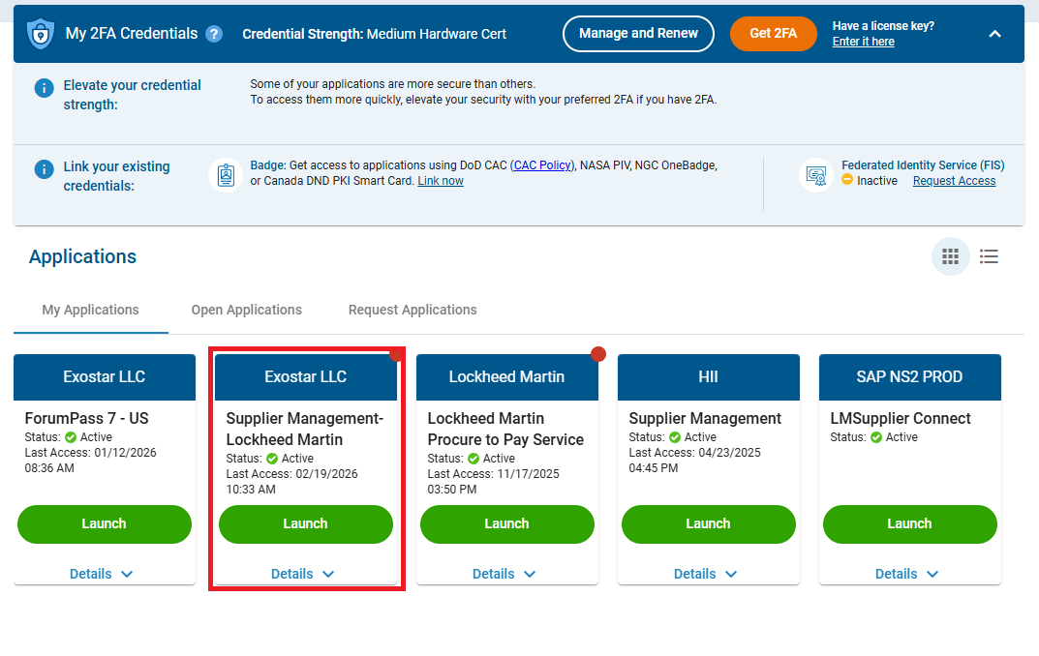

Once all required sections are complete, click Submit Certifications and Representations. A confirmation message displays, self-certification dates and user information displays below the message.

The completed certification and representation are valid for one year from submission. The system sends your Organization Administrators annual expiration warning emails, 60 days in advance of the calculated expiration date. You can perform the certification and representation process at any time during the year.

Click Next to continue.

Step 9. History – Review Data Only (not editable)
On the History page, information is pre-populated with data already stored in the database. No user input is required. All the data displayed is for informational purposes only.

NOTE: The Profile Recertification Expiration field is the date your organization profile certification expires, per the three-year expiration rule. If a recertification is not completed by this date, the organization status systemically is set to Expired, which prevents procurement activity with Lockheed Martin.

Click Next to continue.
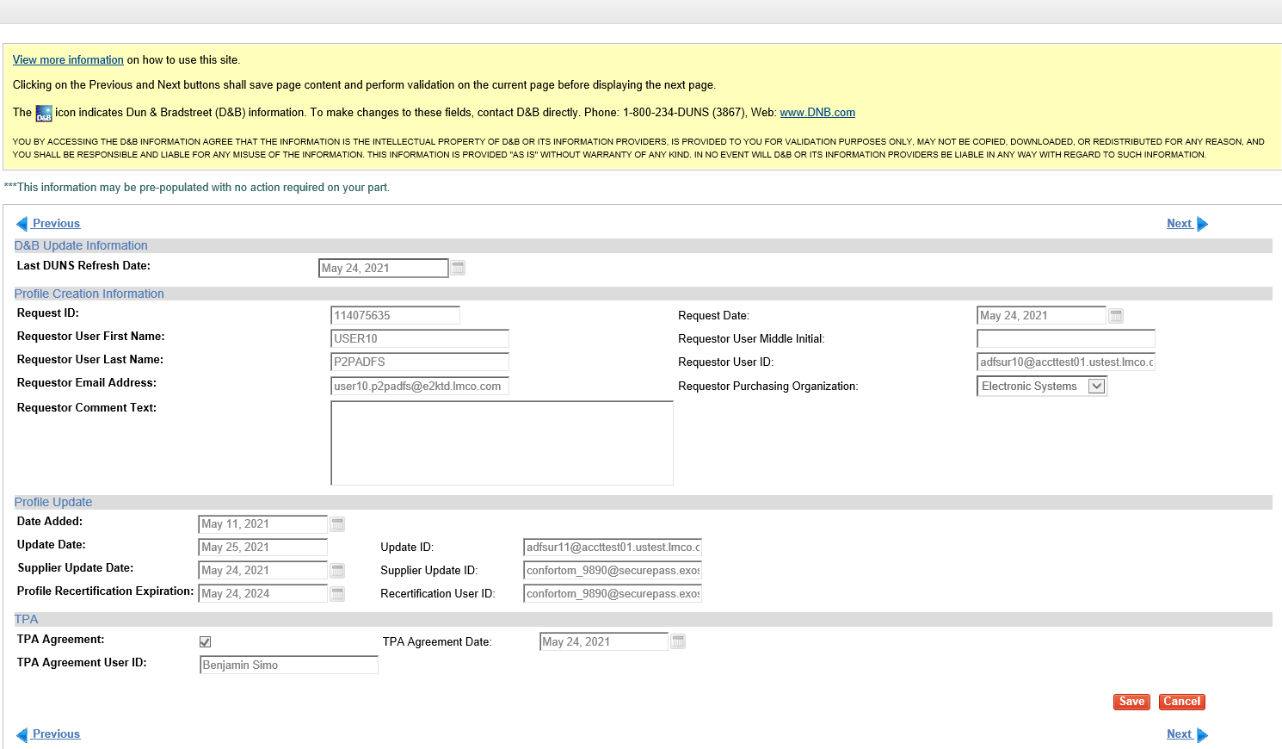

Step 10. D&B Other Information – Review Data Only (not editable)
On the D&B Other Information page, fields with the D&B icon are populated by D&B. No user input is required.

Click Next to continue.

Step 11. Foreign (Non-U.S.)/Domestic (U.S.) Owned
For assistance with the Value Added Tax (VAT) field, click View the VAT Instructions. Questions requiring completion will vary, depending on the answer provided to the initial status question (U.S. Entity/Person or Non-U.S. Entity/Person).

If identified as a U.S. Entity/Person, complete the If Domestic (U.S.) section. If identified as a Non-U.S. Entity/Person, complete the If Foreign (Non-U.S.) section.

The Anti-Corruption survey is required for all suppliers that select Non-U.S. Entity/Person. For all other suppliers, only complete this section when requested by Lockheed Martin. After completing this section, please click the CERTIFY button.

The certification status and date displays. The expiration date is system-calculated as three years from the date certify action was performed.

Click Next to continue.
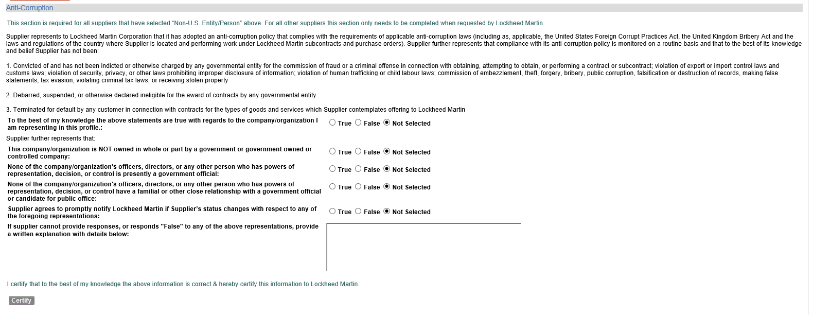

Step 12. Payments/Remittance
For assistance with the Payments/Remittance page, click View the Payments/Remittance Page Instructions displayed under the Previous link.

All data fields preceded by a red asterisk (*) are required. All other data fields are optional.

If the A/T - ACH Domestic (US)/International (Bank Transfers) or W/M – Wire-Manual/World-link Wire option is selected, completion of all data fields in the Bank Information section with a red asterisk (*) is required.

NOTE: Your bank account number does NOT display in this field, because it is protected as sensitive data. Only masking characters (#) display.

Depending on the bank country, additional information such as SWIFT Code and IBAN may be required. The Payments/Remittance page help document, referenced above, provides additional information regarding these requirements.
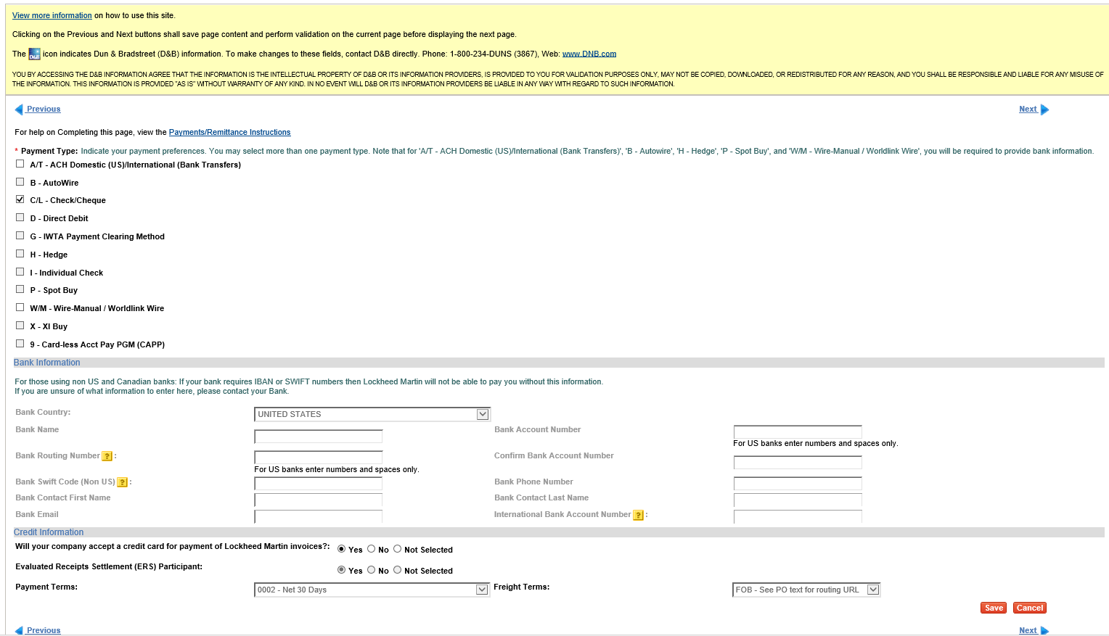

Payment Terms are automatically defaulted to Net 30 Days and cannot be changed by an Organization Administrator. To request different payment terms, contact your Lockheed Martin Buyer/Procurement representative.

Click Next to continue.
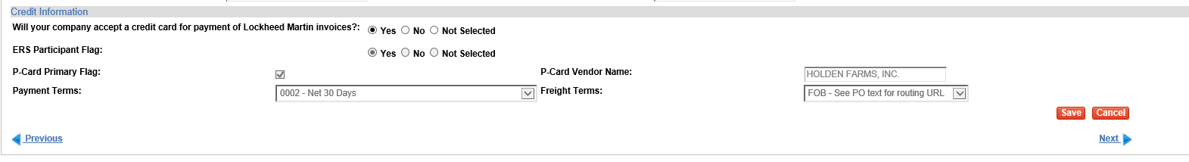

Step 13. Contacts
On the Contacts page, all data fields preceded by a red asterisk (*) are required to add a contact record. All other data fields are optional.

The bullets listed under, View the Contacts Page instructions for help with completing the page, are helpful instructions/guidance only, not error messages.
For assistance with completing this page, click View the Contacts Page Instructions, under the Previous link.

A contact record should be added for each unique contact person. Multiple contact types may be assigned to one individual person.
NOTE: If you are not performing the complete profile recertification process, click Save at this time, to save any updates made to the database.

Click Next to continue.
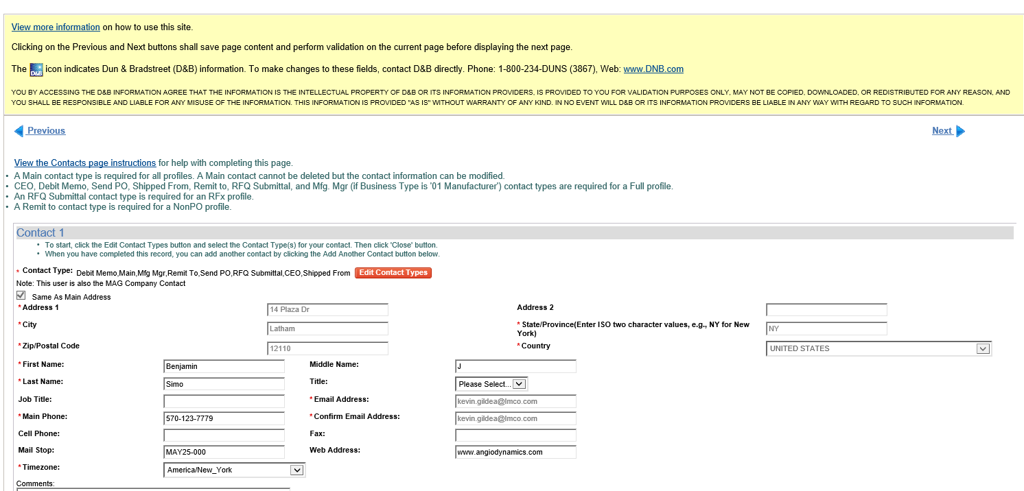

IMPORTANT: Steps 15 and 16 are only applicable when performing the complete recertification process.

Step 14. Perform Final Certify Step
The MAG Information page displays. When all updates are complete, click Certify under Actions on the left-side menu or the *** Complete Profile Certification Now *** link. It is very important to complete this step, or the recertification process remains open.
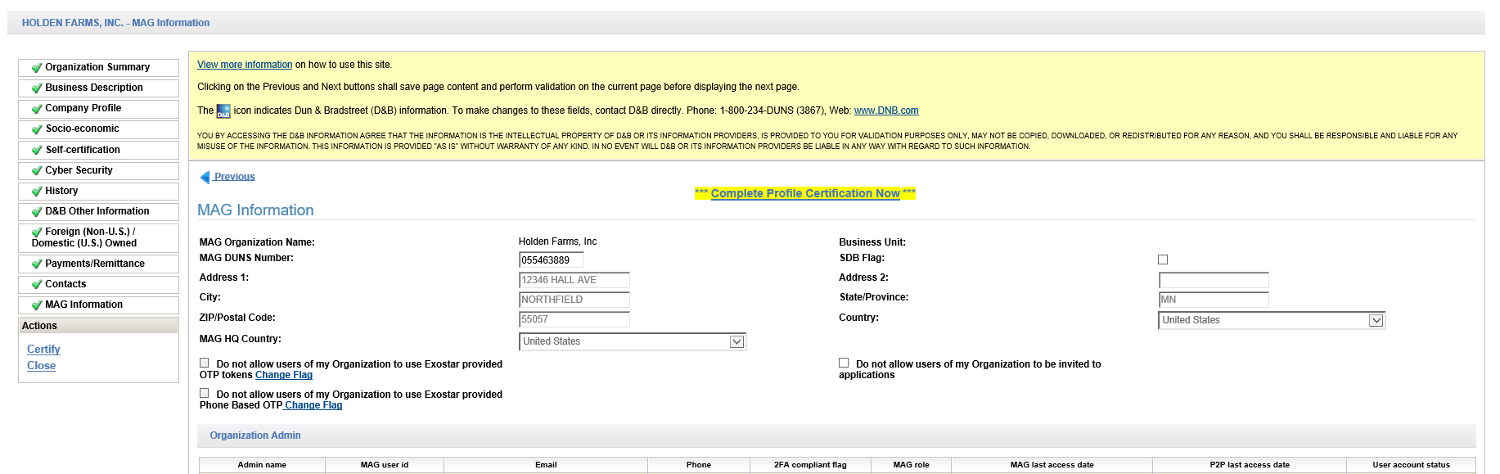

Step 15. Complete Recertification
Review the message and click Yes to successfully complete the organization profile recertification process.
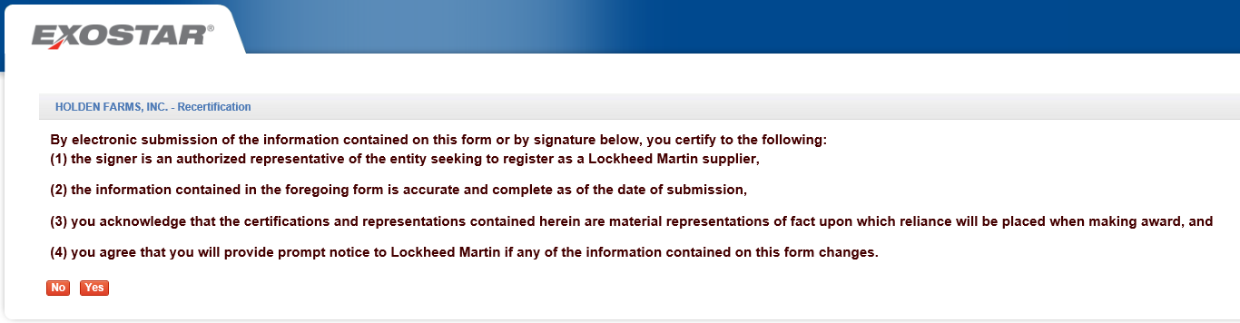

Recertification Success Confirmation
A recertification process confirmation message displays.
