Version 1.4, Date: 02/23/2026

Exostar Trading Partner Manager (TPM) Vendor Profile Recertification Process Instructions

Purpose:
The purpose of this document is to describe the procedural steps required to perform the Exostar Trading Partner Manager (TPM) vendor profile recertification process. The information provided in TPM is used by the Lockheed Martin Procure-to-Pay (LMP2P) system for all purchasing and payment business processes.

Intended Audience:
Exostar Managed Access Gateway (MAG) users with the Organization Administrator role assigned to their user account for their organization.

General Information:
The vendor recertification process must be performed in TPM by a vendor Organization Administrator when their vendor profile has been changed to a status of ‘Expired’ for any of these reasons: ‘3-year expiration’, ‘No recent PO activity’, or ‘Supplier reduction activity’.
A vendor organization administrator can also perform this process at any time even when the profile status is active, by clicking on the TPM action titled ‘Perform Recertification’. Every time it’s performed the profile status is changed to active and the recertification expiration date is re-calculated to be three years out.
It is highly recommended that your vendor information be reviewed and updated as necessary on a regular basis and the socio-economic self-certifications – on the TPM ‘Self-certification’ page - must be certified annually.

Pre-requisites:
The vendor Organization Administrator user must have an active MAG user account and have a two-factor authentication (2FA) credential. The TPM vendor profile level 2FA Compliant field displayed on the Org Summary page must also = ‘Yes’.
If you don’t have an active user account or a valid 2FA credential, or a new Organization Administrator is required to be setup due to none existing (or current one is no longer with your Organization), please call Exostar customer service for assistance: U.S.A 703-793-7800 or United Kingdom 0203 3007093.
You can also contact Exostar customer service by creating an Exostar NetSuite case online via the Contact Support page.

Any current Organization Administrator can add a user as an Organization Administrator. It is recommended that at least two users are granted this role so there is always a backup available.
For additional information regarding the Exostar MAG system and 2FA requirements please refer to the following self-help pages:
- MAG Credentials
- LMP2P Get Started

Procedure Steps (Details) - Recertification:
This assumes all pre-requisites stated above have been satisfied.
- Logon to MAG - The vendor Organization Administrator user must logon to the Exostar MAG system using their assigned Email Address/User ID and Password, along with a Lockheed Martin accepted 2FA credential.
The direct web site URL to get to the Exostar MAG portal system is; https://portal.exostar.com/. This will take you to the MAG login page.
As an alternate path, Exostar also has a customer support web site where help can be obtained in the form of user guides, training material, FAQs, or to submit a request for service (case). The web site URL is: https://myexostar.com. To access the MAG portal system; On upper right side of page click on Managed Access Gateway (MAG) Login.
Once you are logged on successfully, perform the following steps:
- Select My Account tab.
- Select View Organization Details tab.
- Click View in Trading Partner Manager (TPM) link to open the application. If you’re prompted to select an identity provider (IDP), select Suppliers (MAG IDP) from the list and then click Log on.
- Read the “To: Lockheed Martin Suppliers” notice and then click Continue. Once the Organization Summary page is displayed please validate that you are logged on the correct profile by validating the following key information displayed; Org Name, Address, Exostar ID and DUNS#.
- Click on action titled ‘Perform Recertification’ that’s available on the left sidebar menu under Actions then click Continue.
  - Review and update as necessary your vendor profile information on each page.
  - To scroll through all screens/pages use the Next link. Note – clicking Next will save the current page information. You can also click Prev link at any time to go back a page.
- When you reach the last TPM page an action titled ‘Certify’ will display in the left sidebar menu under Actions. In addition, a link titled ‘*** Complete Profile Certification Now ***’ will be displayed. The title of the last page will normally be ‘MAG Information’.
- Click either the action ‘Certify’ link or the ‘*** Complete Profile Certification Now ***’ link to complete the recertification process. Important Note: If this step isn’t completed the status field will not be updated to active.

- A page will display with your organization name, followed by the words ‘- Re-certification’. Read the certification terms and reply accordingly. You must reply ‘Yes’ for the recertification process to be successfully completed. Upon replying ‘Yes’ the following confirmation page will display:

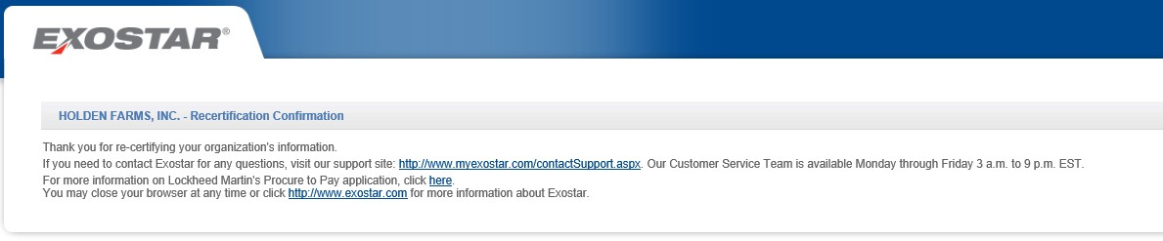

- You can now logout of TPM and return to MAG.

Additional Information:
To obtain the TPM user guide that describes the vendor profile recertification and general maintenance processes in more details, including screen shots, please visit the TPM Training Resources article on myexostar.com, Exostar’s self-help website, and select the TPM Profile Recertification and Update Guide.
Once the vendor/organization recertification process has been completed the TPM vendor profile status will be set to Active and all changes made are passed over to the LMP2P Vendor Master database within approximately 10 minutes.
If you start the vendor recertification process and for any reason you must leave it while in process, follow these instructions:
- Click Save (on bottom of current page) to ensure all changes made are applied
- Click action Close -> a Popup titled ‘Save and Resume Later’ is displayed
- Reply Yes -> Click on Yes to close tab to exit TPM and return to MAG
- To return later to complete the recertification process:
  - Follow same instructions above to get to TPM from MAG
  - Click on the action ‘Resume Recertification’ -> click Continue
  - You will be taken to the first page titled ‘Org Summary’ -> continue per the standard recertification process instructions

