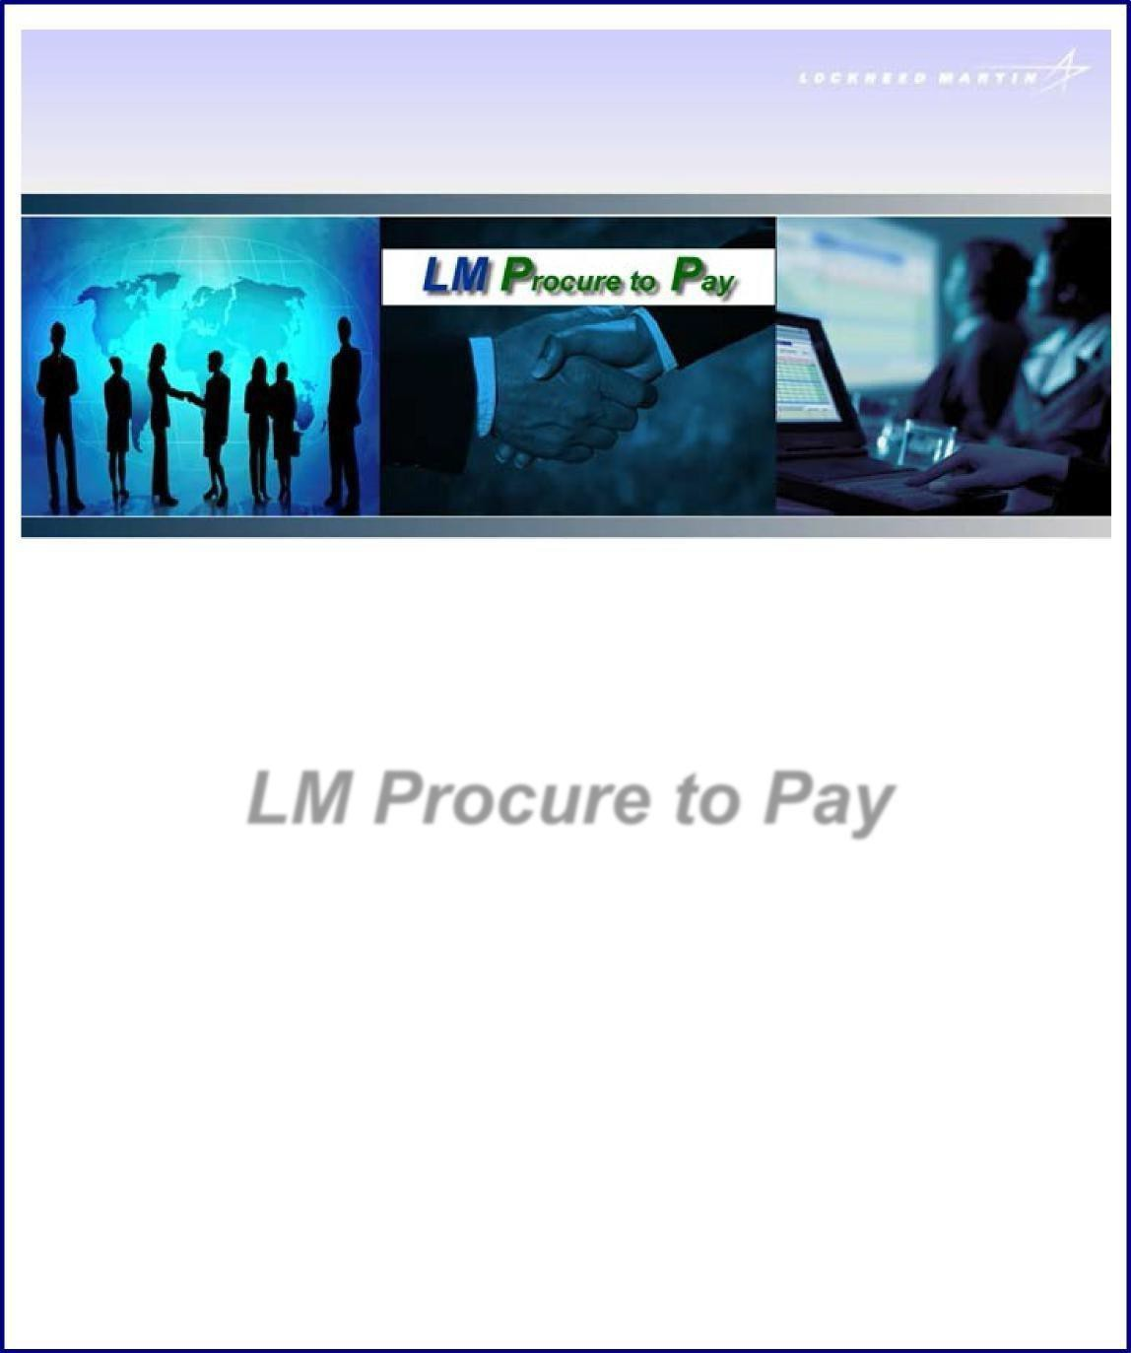
Updated 7/01/2025, V.7

LM Procure to Pay
Quick Reference Guide for Suppliers
Completing a TPM Registration Request

Purpose:
The purpose of this quick reference guide is to describe the process and procedure for completing the Exostar Trading Partner Manager (TPM) profile registration process to register as a Lockheed Martin (LM) supplier. The process is initiated by a LM Buyer/SCA creating and submitting a TPM invitation request, which generates an email being sent to a supplier invitee (the main point of contact person).

TPM Sample Invitation Request email: (contains non-production system information)

You have been invited by an Exostar Trading Partner Manager (TPM) Customer to join their supply network. You were nominated by the following Customer Buyer:

Name: USER11 P2PADFS Phone: 301-897-6000
Email: user11.p2padfs@e2ktd.lmco.com

ORGANIZATION DETAILS:
Organization Name: Happy Valley Farm Exostar ID: 112331860

To transact with an Exostar Trading Partner Manager (TPM) Customer you must complete the actions (2) indicated below. All potential/pending purchase orders will be held pending completion of the vendor profile and two-factor authentication registration.

- Register with Exostar, which provides supplier profile and user identity management services for Lockheed Martin Procure to Pay (P2P) transaction system via the Exostar Managed Access Gateway (MAG). Click the following link to initiate the registration process: https://portal.exostartest.com/tprmgr/pages/Invitee/pocHome.seam?rqstRef=tpr-poi- 116752010&rqstNonce=p2plm-718241474

If you have trouble with the above URL, please paste the following URL and form fields. URL: https://portal.exostartest.com/tprmgr/pages/Invitee/pocHome.seam
Invitation Reference Code: tpr-poi-116752010 Invitation Confirmation Code: p2plm-718241474

To assist you with the Exostar Trading Partner Manager (TPM) vendor registration process, the following help documents are available from https://www.myexostar.com/?ht_kb=tpm-training-resources:
- TPM Vendor Registration Checklist
- TPM Vendor Registration User Guide

- In order to securely access this Customer's Procure to Pay(P2P) and Exostar Trading Partner Manager (TPM) Systems, it is required to either purchase or be in possession of an approved 2-Factor Authentication credential. For more information on the process and recommended/approved credentials, please see https://www.myexostar.com/?ht_kb=lockheed-martin#lockheed-martin-accepted-credentials.

Additional Instructions (if any):

Please complete the Lockheed Martin vendor registration process.

If you have any questions regarding this request or need assistance with completing these actions, please contact Exostar Customer Service.

Registration Process and Procedure (Step-by-Step):
Step | Action(s)
1. | This sample TPM invitation request email states that you have been sent an invitation request by Lockheed Martin to join their supplier network.  The email always has these key characteristics:  From: Prod Exostar Administrators [CustomerService@exostar.com]  Subject: Invitation to join the Exostar Trading Partner Manager (TPM) and Lockheed Martin's Procure to Pay system  An invitation request is only valid for 90 days including 2FA compliance and activation steps. Please contact your Lockheed Martin purchasing representative (included in body of email) to determine the necessary completion date.  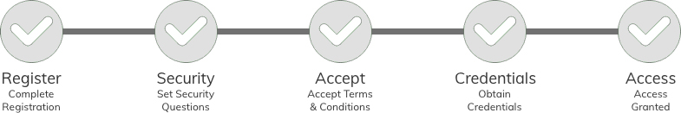  Each email will contain a unique link to continue your request. Click the link provided – in item number 1 - to begin the registration process.  The email contains links to several helpful user guides to assist you with the process.  Note: If you need additional assistance completing the request, access the Exostar Customer Service Self-Help site link provided in the email.

Vendor Invitation

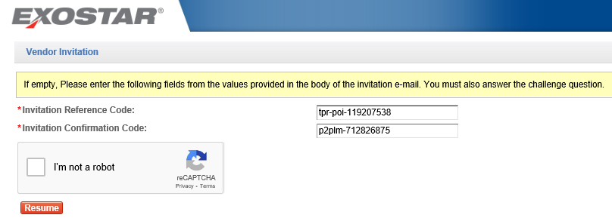
Step | Action(s)
2. | The Vendor Invitation screen is the initial one displayed upon user clicking the link in the invitation request email.  All data fields with an asterisk (*) are required entry.  - Register with Exostar, which provides supplier profile and user identity management services for Lockheed Martin Procure to Pay (P2P) transaction system via the Exostar Managed Access Gateway (MAG).  In this example, the Invitation Reference Code and Confirmation Code have been automatically populated. Check the ’I’m not a robot’ box displayed directly below it.  Click the Resume button to continue.

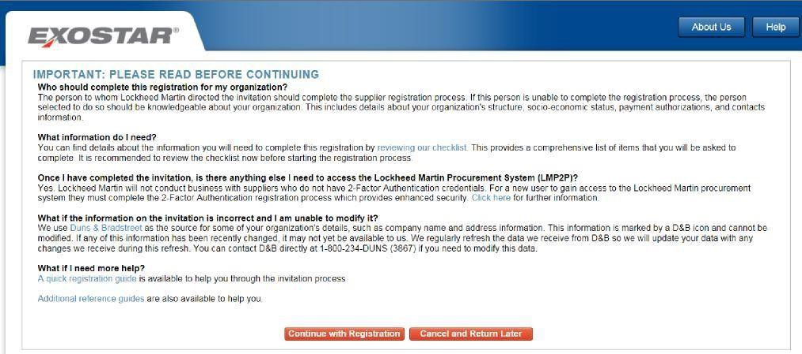

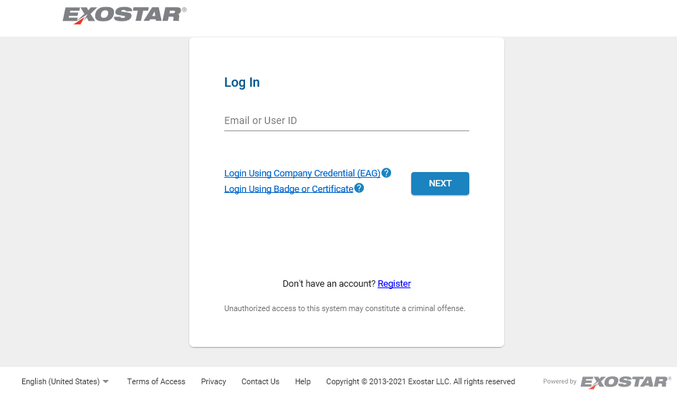

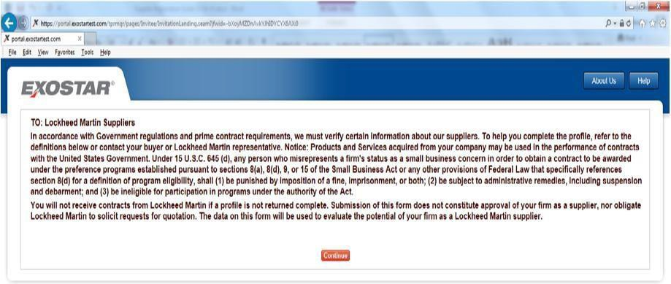

Step | Action(s)
3. | Note for Existing Exostar Managed Access Gateway (MAG) Users: In lieu of the above screen, existing MAG users will be taken to the Exostar MAG Sign-In screen where they will enter their User ID and password. The user will also need to have a valid two-factor authentication (2FA) to complete the profile registration process. See the invitation request email example – item number 2 - for additional information on this topic.
3. | Click the Continue with Registration button.

Step | Action(s)
4. | Prior to proceeding, please read the regulations and requirements text presented to become familiar with Lockheed Martin policies.  Click the Continue button.

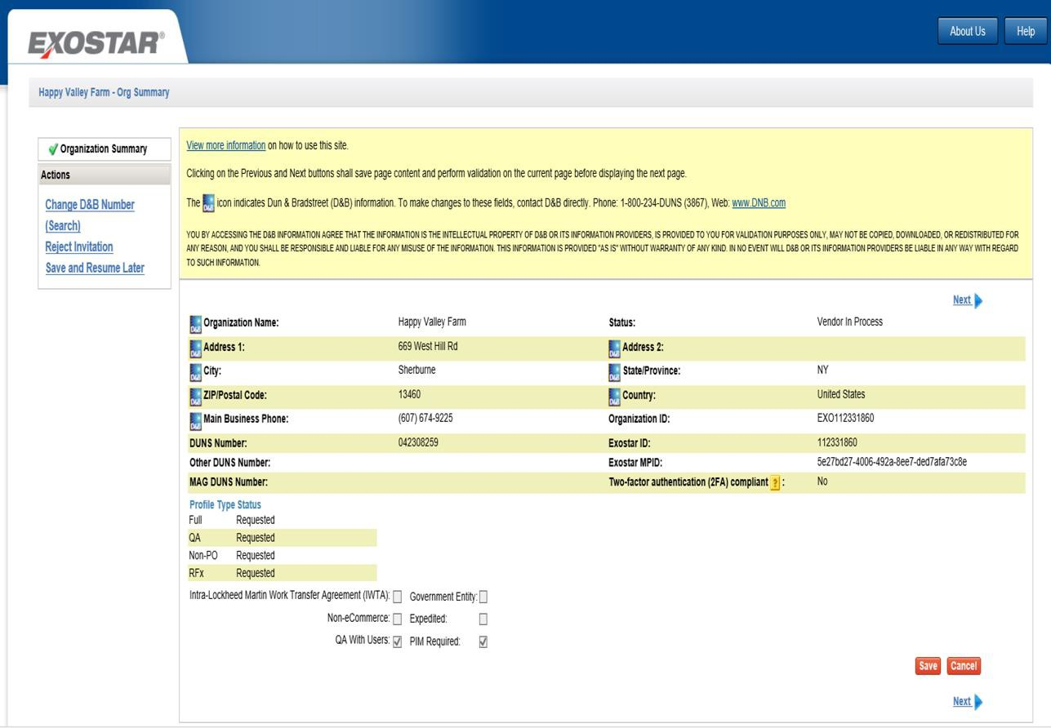
Organization Summary

Step | Action(s)
n/a | General Registration Information – Helpful Tips:  - At any time during the online supplier registration process you can click the action titled ‘Save and Resume Later’ (on left side menu), which will save any data already entered / selected. To resume, return to the invitation email previously received and click the link provided.  - All data fields on the various pages that are preceded by a red asterisk (*) are required to be completed. All other data fields are optional and may be entered as appropriate.  - Click the vertical scrollbar to navigate through a page.  - The words ‘Page’ and ‘Screen’ are used synonymously throughout the document.  - The words ‘Vendor’, ‘Supplier’, and ‘Organization’ are used synonymously throughout the document.  - When a page has been successfully completed a green check mark will appear next to the application page title displayed on the left side menu.  - If a data field is protected from input/selection, then it’s been determined that it’s not applicable for this specific vendor registration so can be skipped over.

Step | Action(s)
- All data field values manually entered/changed will be validated for accuracy and completeness where possible. If an error occurs a detailed error message (in color red) will be displayed adjacent to the data field itself or in very close proximity to it.
- All pages contain ‘Save’, ‘Next’, and ‘Previous’ action buttons that when pressed will save the page content to the database. Clicking on any page title item on left side menu will also save content to the database and take you directly to that page.
- At this point in the process the Status value on the Organization Summary page is set to ‘Vendor in Process’. The end goal is to get it to ‘Active’ status.
5. | Your company’s general information such as organization name, address, D&B DUNS Number, and Exostar ID (a unique ID assigned to your organization) will be displayed on the initial Organization Summary page. Most of this information will be populated from Dun & Bradstreet (D&B) sourced data.  No user input is required on this page.  Note: If the D&B data reflected is not correct, you will need to contact D&B directly to have corrections made. Corrections made at D&B will eventually automatically populate this profile. You may access D&B by clicking the following link: https://www.dnb.com/duns-number.html. See other D&B helpful contact information displayed on the page itself.  IMPORTANT: When an organization requests updates on the D&B website, it may take up to 30 days for the changes to be reflected in TPM.  Click the vertical scrollbar to navigate through this page. Click Next to continue.

Business Description

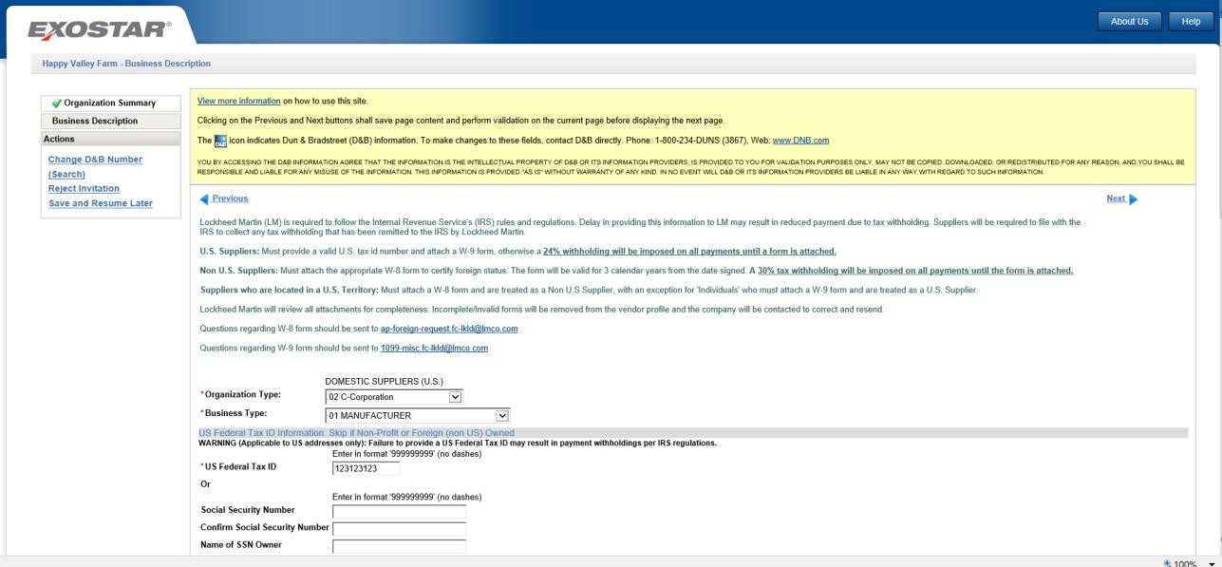

Step | Action(s)
6. | All data fields on this page preceded by a red asterisk (*) are required to be completed. All other data fields are optional and may be entered as appropriate.
7. | On the Organization Type and Business Type fields – For each one click the dropdown selection to select the appropriate item for your business from the list.
8. | Enter your company’s Federal Tax ID or a person’s Social Security Number without dashes (for individuals and must enter twice along with the person’s name) – one or the other is required.  This information is only required for Domestic/U.S. organizations/ business entities.  NOTE: The social security number entered will NOT be displayed in this field as it is considered sensitive data and will be protected as such.
9. | Click the vertical scrollbar to navigate through the page.

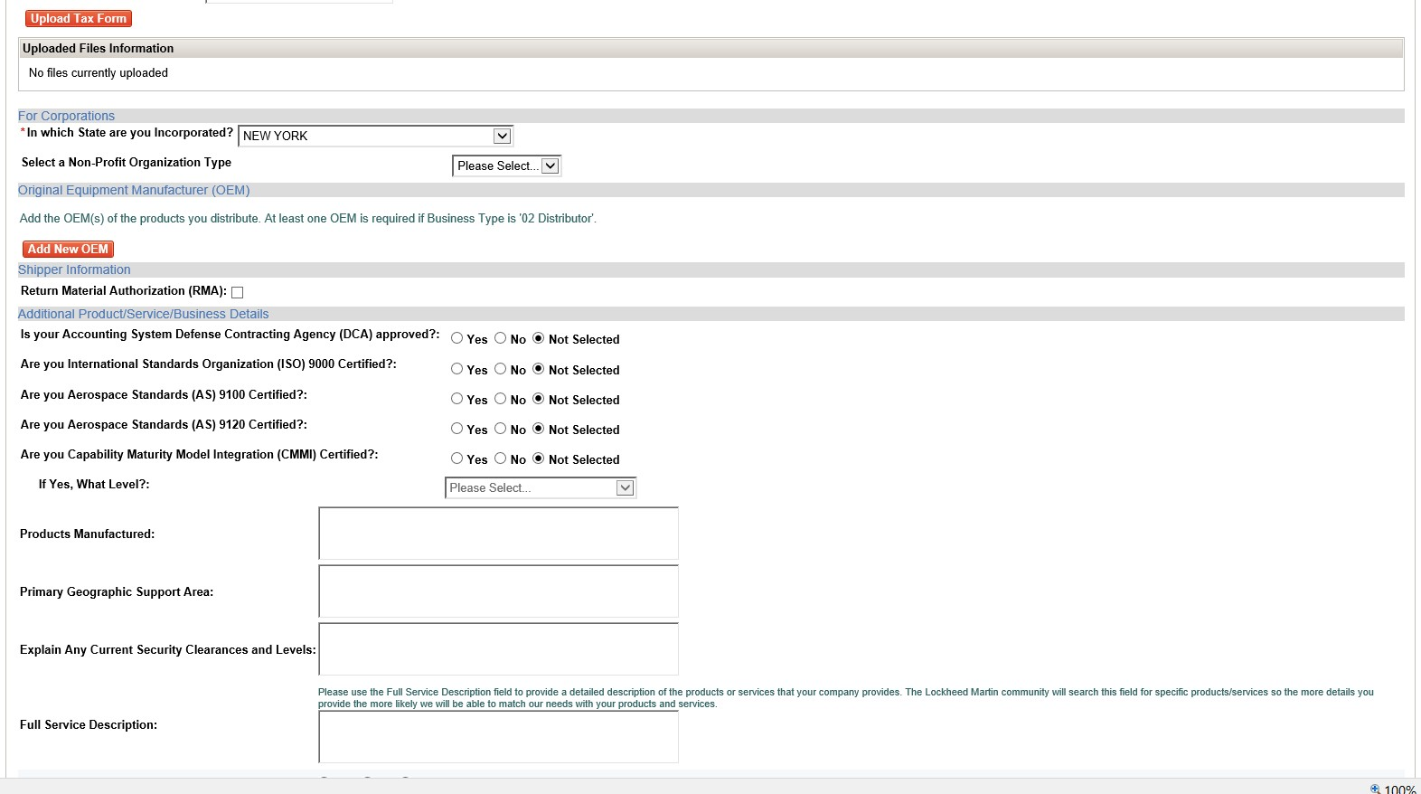

Step | Action(s)
10. | Per IRS rules and regulations, U.S. suppliers are required to submit a W-9 tax form and Non-U.S. suppliers a W-8 tax form. If no tax form is submitted a 24% (U.S.) or 30% (Non-U.S.) withholding will be imposed on all invoice payments.  Additional instructions for U.S. Territories: Suppliers who are located in a U.S. Territory: Must attach a W-8 form and are treated as a Non-U.S. Supplier, with an exception for 'Individuals' who must attach a W-9 form and are treated as a U.S. Supplier.  The application web page itself provides several Lockheed Martin Accounts Payable email addresses if you need further assistance with tax form requirements.  To upload a completed IRS W-8 or W-9 tax form:  - Click on the Upload Tax Form button  - Select your tax form file from your computing device or other storage area  - Click ‘Open’ (or double-click on the file)  - Select the IRS Tax Form Type from selection list  If you do not attach a completed tax form during the initial profile registration process you will be able to attach it at any time later, but it must be attached prior to payments being successfully processed.
11. | If a U.S. organization - Click the dropdown selection arrow in the In Which State are you Incorporated field and select the appropriate item from the list.
12. | If your organization is a Non-Profit Organization, click the dropdown selection arrow in the Select a Non-Profit Organization Type field and select the appropriate item from list. (n/a is not required).

Step | Action(s)
12.b | Original Equipment Manufacturer (OEM) – If you selected Business Type ’02  Distributor’ then at least one OEM is required to be added. See screen for instructions on how to add one.
12.c | Shipper Information Section – Return Material Authorization (RMA) Question: What does it mean to check the ‘Return Material Authorization (RMA) flag?  Answer: By checking the RMA flag, you allow the recipient of your product(s) to return goods for repair, replacement or to receive credit.

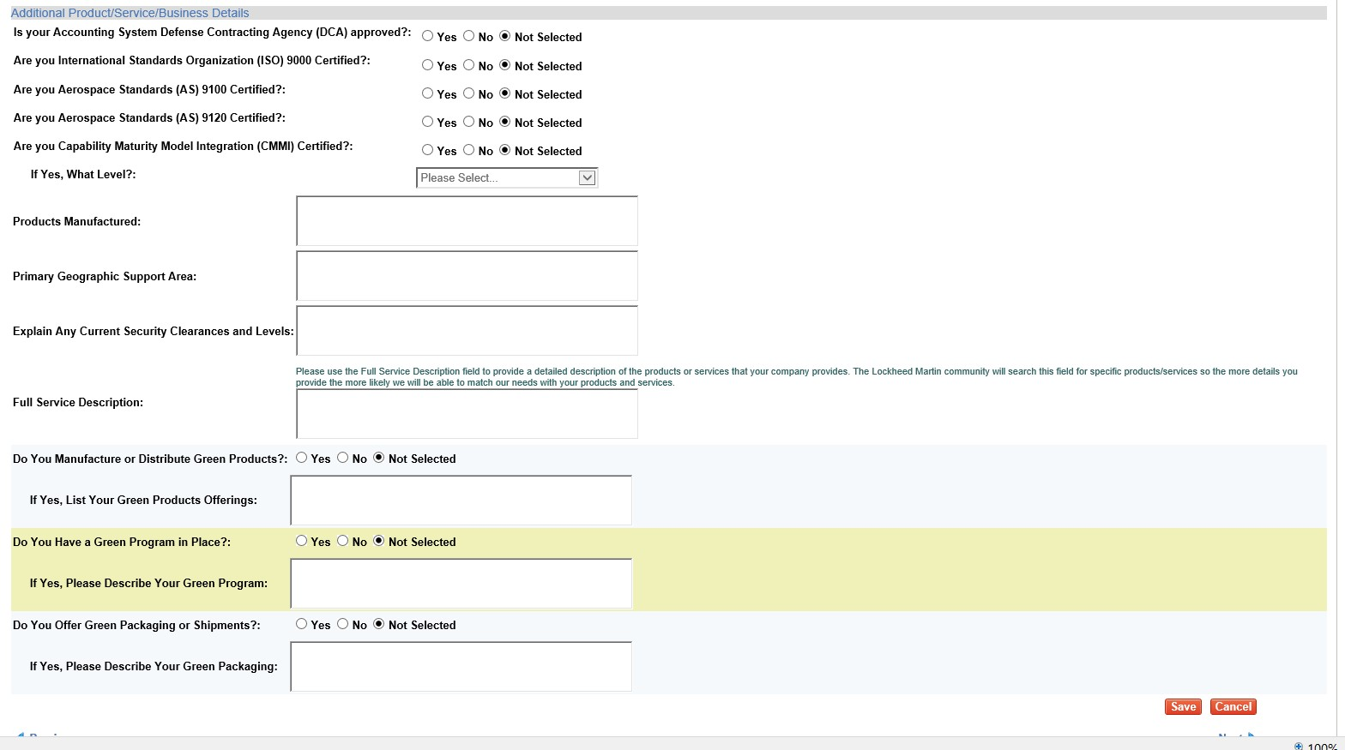

13. | All the questions listed under section titled Additional Product/Service Business Details are optional; however, they are used by Lockheed Martin to evaluate potential suppliers for purchasing activity.
13.b | Click NEXT to continue.

Company Profile
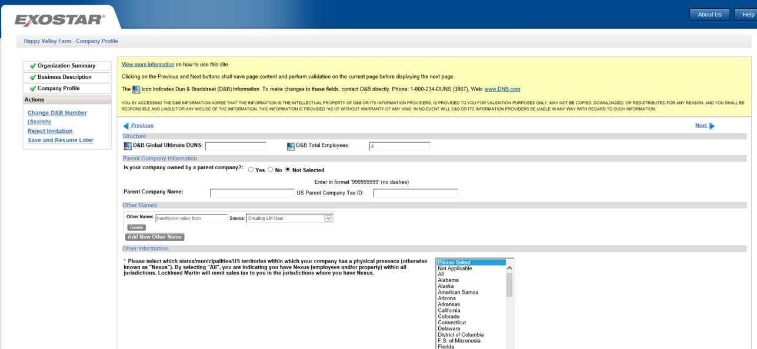

Step | Action
14. | On the Company Profile screen, D&B populate the fields with the D&B icon present.
15. | All data fields on this page preceded by a red asterisk (*) are required to be completed. All other data fields are optional and may be entered as appropriate.  Click the vertical scrollbar to navigate through the page.
16. | In the Parent Company Information section, select the best option that suits your company. If you select ‘Yes’ to the question, then the other related data is required.  NEXUS Locations – Read the instructions provided on page to determine your required selection(s). Click the dropdown selection arrow and select the appropriate item(s) from the list. For non-US/Foreign suppliers leave selection as ‘Please Select’ or select ‘Not Applicable’.  Use standard Windows control-click keystroke combination to select all values that apply.
17. | Click Next to continue.

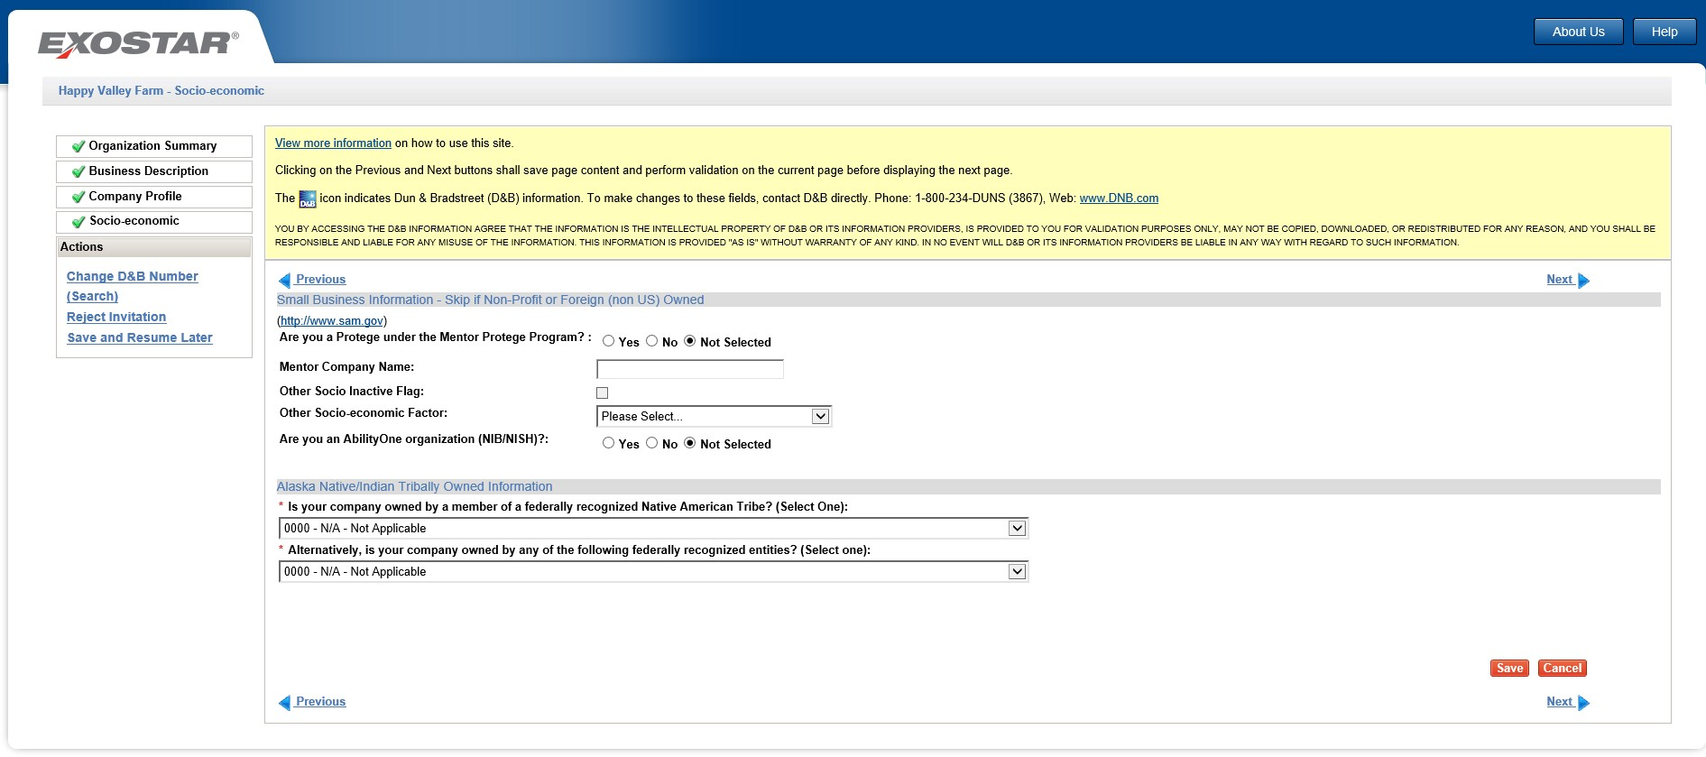
Socio-economic

Step | Action
18. | On the Socio-Economic screen, D&B will populate data fields with the D&B icon displayed.  All data fields on this page preceded by a red asterisk (*) are required to be completed. All other data fields are optional and may be entered as appropriate.  Click the vertical scrollbar to navigate through this page.
19. | Not Selected or N/A Not Applicable is the default selection for each field.  In the Small Business and Alaska Native/Indian Tribally Owned sections, if/when applicable, select the responses appropriate to your company.
19.b | Click Next to continue.

Self-certification
The self-certification page contains up to four sections to be completed depending on the country of the organization’s main address.
- Socio-economic: Required when organization address country is U.S. (including U.S. Territories).
- Executive Compensation Report: Required for all vendors regardless of organization address country.
- National Defense Authorization Act (NDAA) Section 889: Required for all vendors regardless of organization address country.
- Cyber Security: Required for all vendors regardless of organization address country.

To complete each section, follow the step-by-step instructions provided directly on the application web page itself and described in general in the below steps. Several links to external web sites are also provided on the page to assist you.

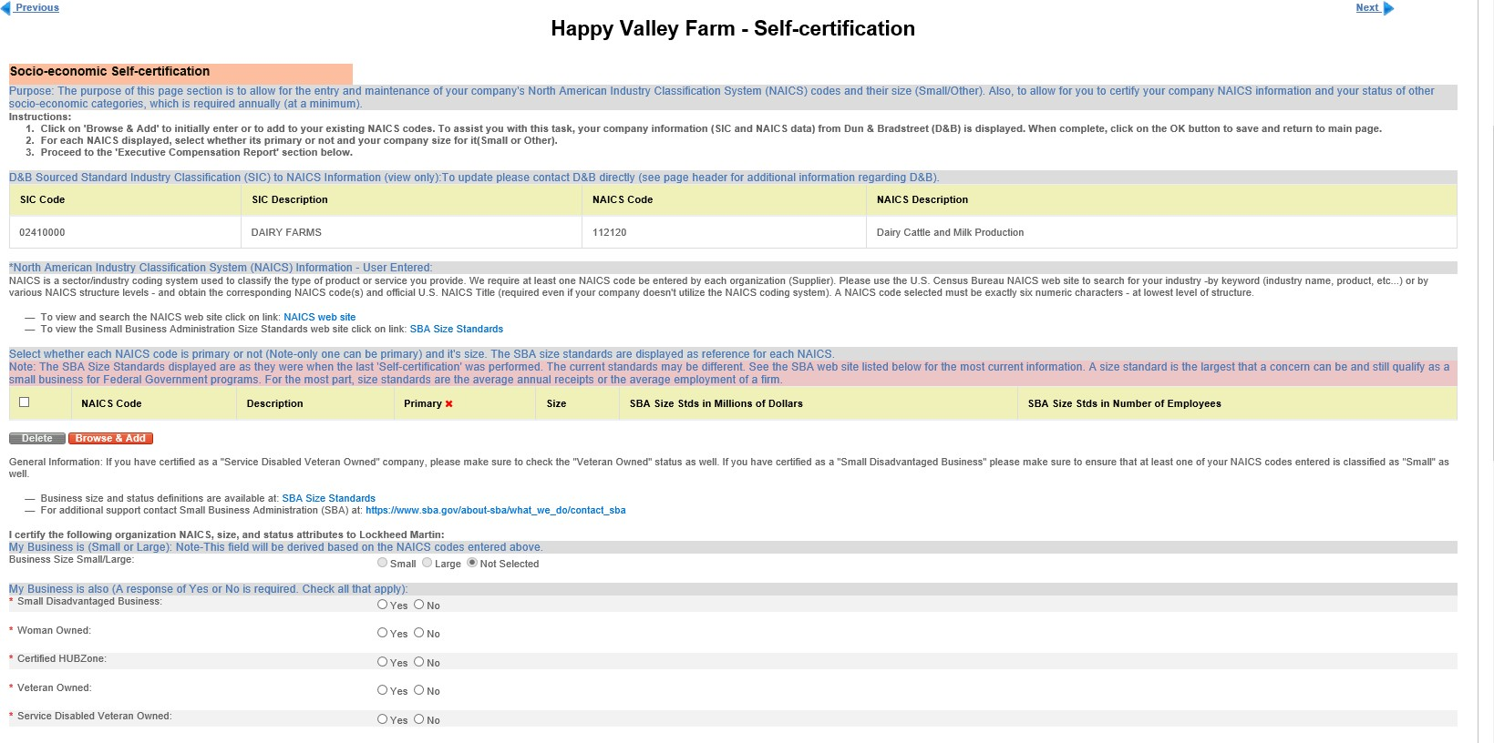
Socio-economic Section

Executive Compensation Report Section
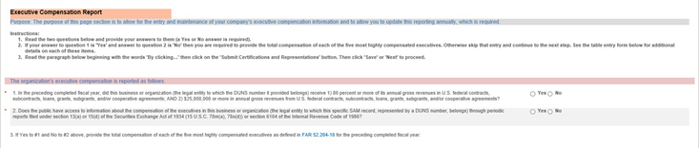

National Defense Authorization Act (NDAA) Section
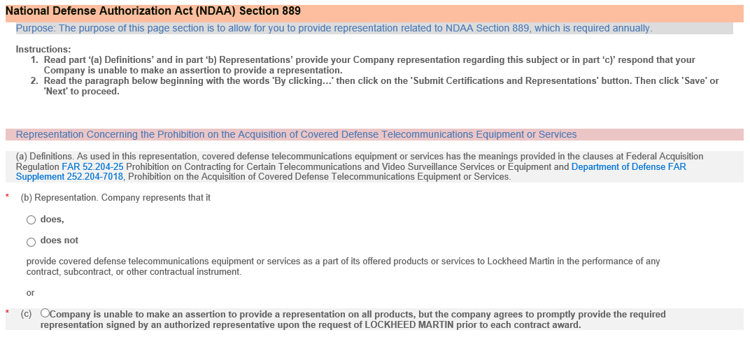

Cyber Security Section:

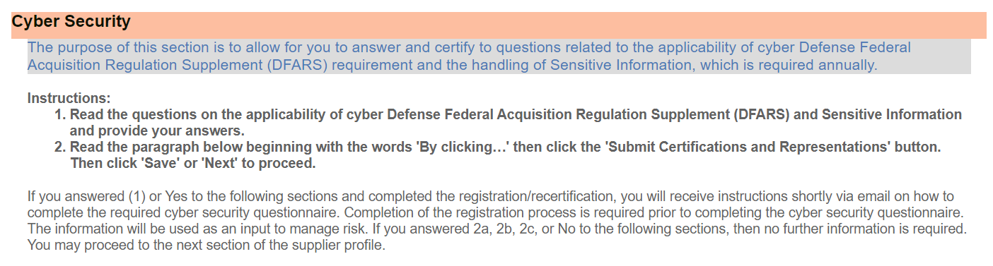
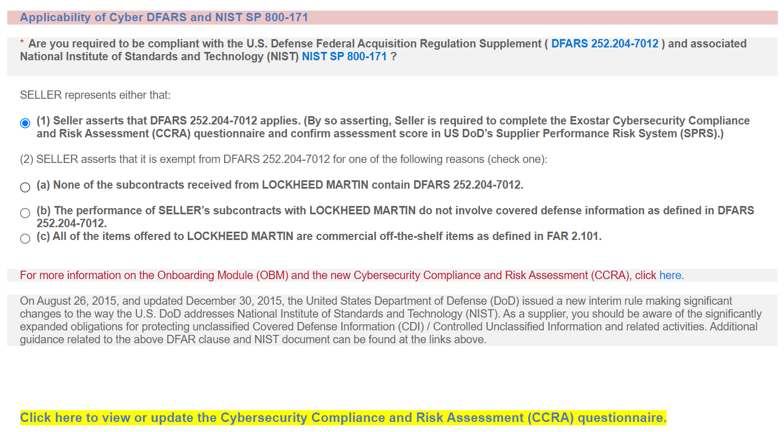
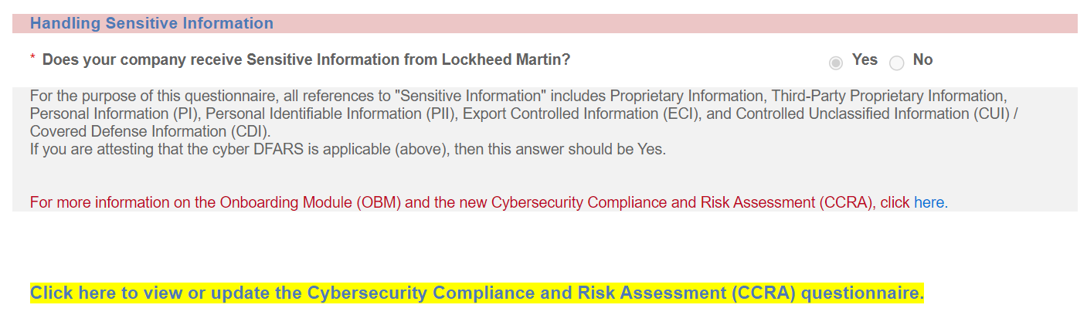

 | Step |  | Action
20. |  |  | All data fields on this page preceded by a red asterisk (*) are required to be completed. All other data fields are optional and may be entered as appropriate.  Click the vertical scrollbar to navigate through this page.
21. |  |  | Socio-economic section:  NAICS=North American Industry Classification System.  For assistance with NAICS Codes please refer to this U.S. Census Bureau web site: https://www.census.gov/naics/  Note – This section will be entirely suppressed for vendors that are non-U.S. (and not a U.S. Territory).  To begin, click the ‘Browse and Add’ button to select your NAICS code(s) from the ‘NAICS Browser’ application window. Once you have finished your selections scroll to the bottom of the window and click OK.  For each NAICS Code selected and now displayed:  - Select its company size (Small or Other) from the dropdown selection list. Note: Small may be selected if a NAICS code has an exception (certain NAICS codes have multiple criteria for which to determine size status) and the predominant work being performed meets the exception criteria and threshold requirements.  - Click the NAICS Primary Code checkbox for your company’s primary NAICS code. One and only one NAICS Code can be checked as the primary one.  - To add more NAICS codes at any time, click the ‘Browse and Add’ button again.

22. | Executive Compensation Report section:  The web page displayed itself provides detailed step-by-step instructions on how to complete this section.  The following first two questions must be answered (Yes or No):  1. In the preceding completed fiscal year, did this business or organization (the legal entity to which the DUNS number it provided belongs) receive  1) 80 percent or more of its annual gross revenues in U.S. federal contracts, subcontracts, loans, grants, subgrants, and/or cooperative agreements; AND 2) $25,000,000 or more in annual gross revenues from  U.S. federal contracts, subcontracts, loans, grants, subgrants, and/or cooperative agreements?  Yes No  - Does the public have access to information about the compensation of the executives in this business or organization (the legal entity to which this specific SAM record, represented by a DUNS number, belongs) through periodic reports filed under section 13(a) or 15(d) of the Securities Exchange Act of 1934 (15 U.S.C. 78m(a), 78o(d)) or section 6104 of the Internal Revenue Code of 1986?  Yes No  - If Yes to #1 and No to #2 above, provide the total compensation of each of the five most highly compensated executives as defined in FAR 52.204- 10 for the preceding completed fiscal year:  The table/grid to enter the executive names and total compensation amount data will be presented only when the answers to the two questions are ‘Yes’ and ‘No’ respectively. When required, at least one and a maximum of five rows must be completed.  The total compensation dollar amount is considered sensitive data and will be protected as such. It will only be displayed in TPM to organization administrators.  For additional information regarding the requirements driving Lockheed Martin to capture this information from our suppliers, refer to U.S. Government FAR clause 52.204-10 available at the link above (step 22, item #3).

23. | National Defense Authorization Act (NDAA) Section 889:  Representation Concerning the Prohibition on the Acquisition of Covered Defense Telecommunications Equipment or Services  Company represents that it  does,  does not  provide covered defense telecommunications equipment or services as a part of its offered products or services to Lockheed Martin in the performance of any contract, subcontract, or other contractual instrument.  or  (c)  Company is unable to make an assertion to provide a representation on all products, but the company agrees to promptly provide the required representation signed by an authorized representative upon the request of LOCKHEED MARTIN prior to each contract award.
24. | Cyber Security: Cyber Security is important to Lockheed Martin and these requirements have been implemented to mitigate risks as it relates to sensitive data sharing. Additional information on completing this section can be found by clicking on the links provided on the application pages.  Applicability of Cyber DRAS and NIST SP 800-171: Are you required to be compliant with the U.S. Defense Federal Acquisition Regulation Supplement ( DFARS 252.204-7012 ) and associated National Institute of Standards and Technology (NIST) NIST SP 800-171?.  SELLER represents either that:  (1) Seller asserts that DFARS 252.204-7012 applies. (By so asserting, Seller is required to complete the Exostar Cybersecurity Compliance and Risk Assessment (CCRA) questionnaire and confirm assessment score in US DoD’s Supplier Performance Risk System (SPRS).)  (2) SELLER asserts that it is exempt from DFARS 252.204-7012 for one of the following reasons (check one):  (a) None of the subcontracts received from LOCKHEED MARTIN contain DFARS 252.204-7012.  (b) The performance of SELLER’s subcontracts with LOCKHEED MARTIN do not involve covered defense information as defined in DFARS 252.204-7012.  (c) All of the items offered to LOCKHEED MARTIN are commercial off-the-shelf items as defined in FAR 2.101.  Handling Sensitive Information:  Does your company receive sensitive information from Lockheed Martin?  For the purposes of this questionnaire, all references to “Sensitive Information” includes Proprietary Information, Personal Information (PI), Personal Identifiable Information (PII), Export Controlled Information (ECI), and Controlled Unclassified Information (CUI)/Covered Defense Information (CDI).  If you are attesting that the cyber DFARS is applicable (above), then the answer should be Yes.  YesNo
25. | Dependent on responses provided to either of the two questions above in steps 23 and 24, then after your organization has been registered and approved, you (and other defined users) will receive an email notification that you have been granted access to the Exostar Supplier Management (SM) system where the questionnaire will be completed. It is suggested that these questions be answered in consult with your Information Technology (IT) representatives.  The answers you provide to the questions serve as an indicator of supplier cyber  maturity or to highlight the need to mitigate risks of sharing Lockheed Martin sensitive information.
26. | Submit Certifications and Representations section:  Once all required sections have been completed, click on button titled ‘Submit Certifications and Representations’. A confirmation message ‘Certification Success’ will be displayed and self-certification dates and user information will be displayed below the message.  The completed certification and representation will be valid for one year from time the action is performed. The system will send your organization administrator(s) annual expiration warning emails starting at 60 days in advance of the calculated expiration date. You can perform the certification and representation process at  any time during the year.
27. | Click Next to continue.

Foreign (Non-U.S) / Domestic (U.S.) Owned
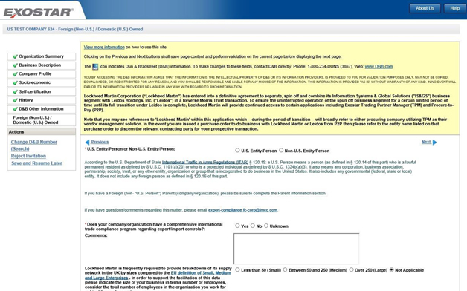

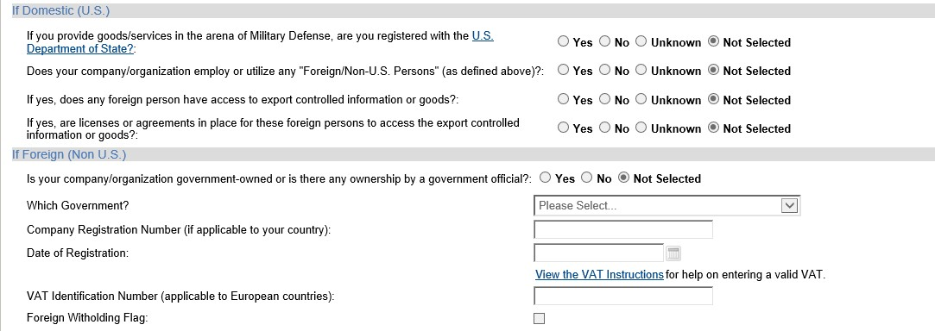

Step | Action
28. | General Information:  All data fields on this page preceded by a red asterisk (*) are required to be completed. All other data fields are optional and may be entered as appropriate.  Click the vertical scrollbar to navigate through this page.  Questions requiring completion will vary, depending on answer provided to initial status question (U.S.  Entity/Person or Non-U.S. Entity/Person).  Additional information for completing this section can be obtained by sending an email to this Lockheed Martin email address:  export-compliance.fc-corp@lmco.com
29. | Read the text displayed directly below the first question that defines what a  U.S. Entity/Person is.  If identified as a U.S. Entity/Person, complete the If Domestic (U.S)  section.  If identified as a Non-U.S. Entity/Person, complete the If Foreign (Non- U.S.) section.  The section that is not applicable, based on how you answered the Entity/Person question, will be disabled/protected.  See link titled ‘View the VAT Instructions‘, for assistance with entering your Value Added Tax (VAT) identifier.
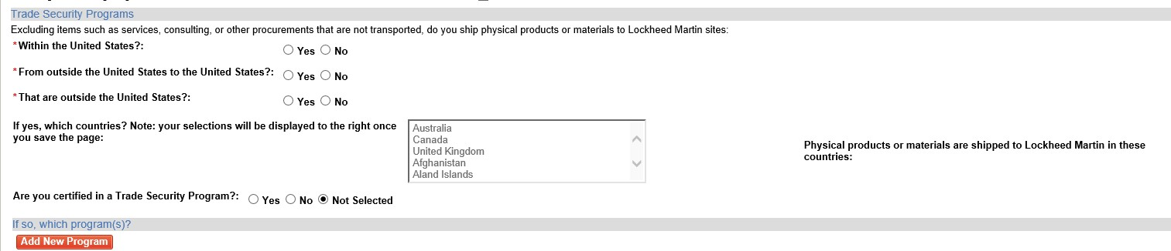

Step | Action
30. | Completion of Trade Security Programs section is required for shipping physical products to all Lockheed Martin locations.

31. | Select all countries where physical materials are sent to Lockheed Martin sites. Use standard Windows control-click keystroke combination  to select all locations that apply.
32. | If you are certified in a Trade Security Program, please select any and all that apply. Click ‘Add New Program button’, select the appropriate program and complete additional requested fields.  NOTE: You can add multiple programs.
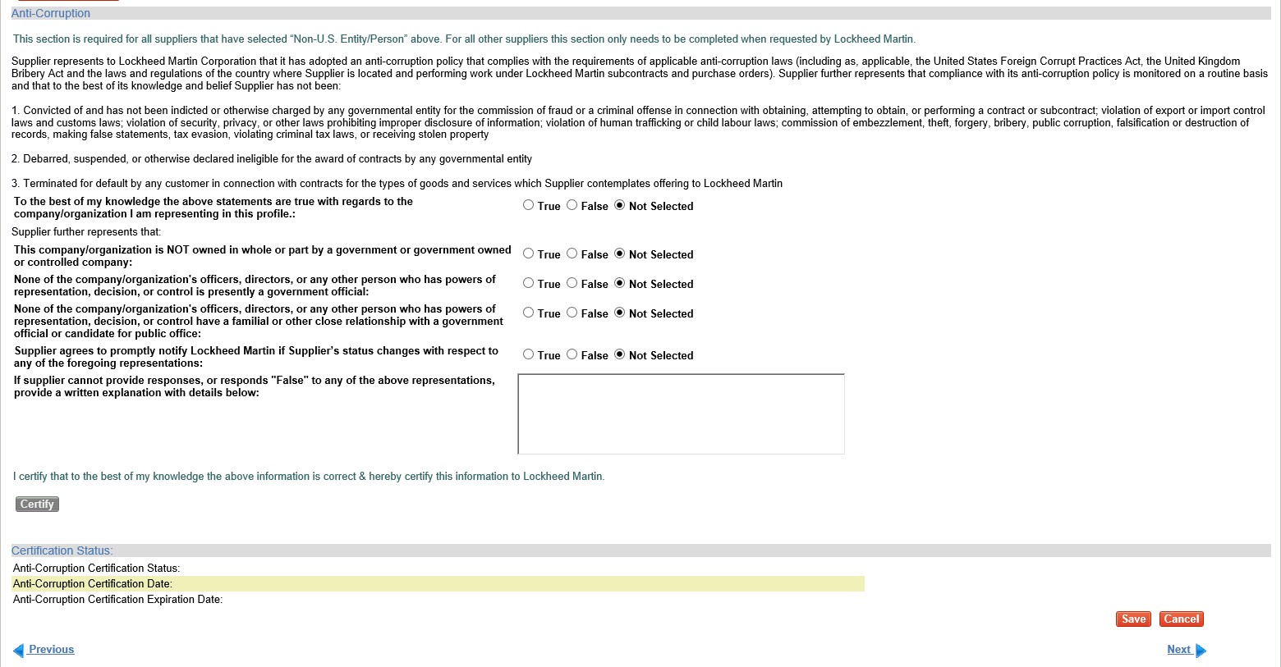

Step | Action
33. | Completion of the Anti-Corruption Survey is required for all suppliers that have selected “Non-U.S. Entity/Person” above. For all other suppliers, this section only needs to be completed when requested by Lockheed Martin. After completing this section, please click the CERTIFY button.  The certification status and date will be set and displayed. The expiration date is system calculated as three years from the date certify action was performed.
34. | Click ‘Next’ to continue.

Payments/Remittance
For additional help with completing this page click on the link located near top of page titled ‘View the Payments/Remittance Page Instructions’. This document describes each data field on the page and provides some examples, some being Country specific.
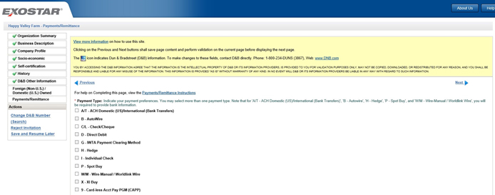

Step | Action
35. | All data fields on this page preceded by a by asterisk (*) are required to be completed. All other data fields are optional and may be entered as appropriate.  Click the vertical scrollbar to navigate through this screen.
36. | On the Payment/Remittance screen, select the payment type(s) you can receive.  Based on what payment types are selected, additional banking data may be required.  Note: The preferred payment type is an electronic banking one such as ‘A/T – ACH Domestic (US)/International (Bank Transfers).  Note – As a vendor organization administrator user not all payment types are available for selection. The Payments/Remittance page help document referenced  above provides a list of those that are available.
37. | If the A/T - ACH Domestic (US)/International (Bank Transfers) or W/M – Wire-Manual / World-link Wire option is selected, completion of all data fields in the Bank Information section with an asterisk (*) is required.

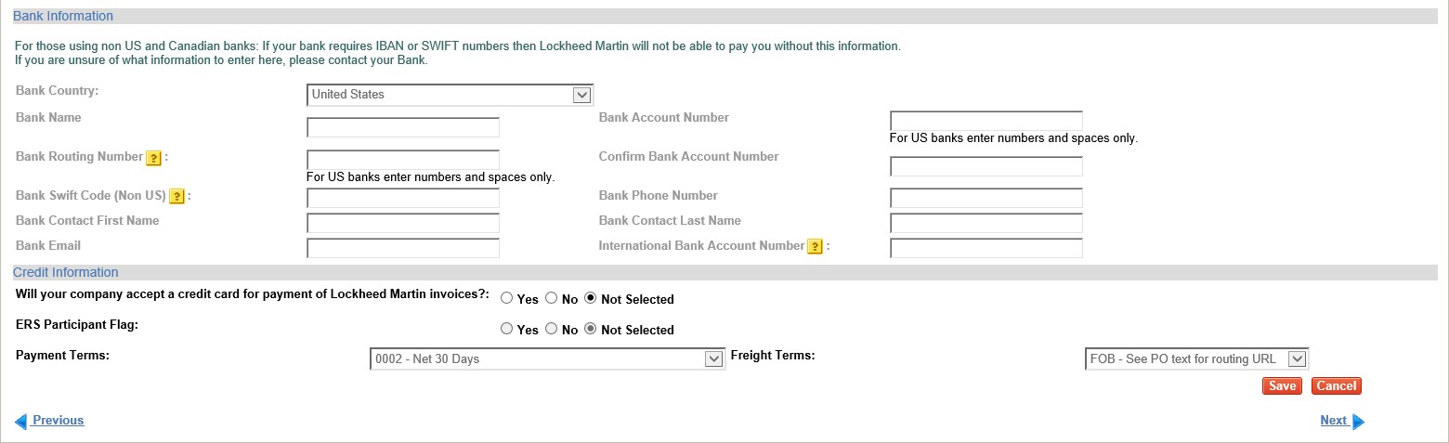

Step | Action
37.a | All data fields on this page preceded by a red asterisk (*) are required to be completed. All other data fields are optional and may be entered as appropriate.  Click the vertical scrollbar to navigate through this screen.  On some data fields a ‘?’ help icon is available – click on it to see additional information.
37.b | Click the Bank Country dropdown selection arrow and select the appropriate country from the list.
38. | Enter the name of your bank in the Bank Name field and your bank's routing number in the Bank Routing Number field.  Depending on the bank country additional information such as SWIFT Code and IBAN may be required to be provided. The Payments/Remittance page help document referenced above provides additional information regarding these requirements.
39. | Enter your company's bank account number in the Bank Account  Number field. Repeat entry in the Confirm Bank Account Number field. The same value must be entered in both fields or an error message will be returned.
39. | NOTE: Your bank account number will NOT be displayed in this field as it is considered sensitive data and will be protected as such. Only masking characters (#) will be displayed.
40. | In the Credit Information section select the information that best suits your company.  Note – some of the data fields, e.g., ERS Participant and Payment Terms, will be disabled for organization administrators.

Step | Action
41. | Payment Terms are automatically defaulted to ‘Net 30 Days’ and cannot be changed by an organization administrator. To request different payment terms, contact your Lockheed Martin Buyer/Procurement representative.
41.b | Click Next to continue.

Contacts
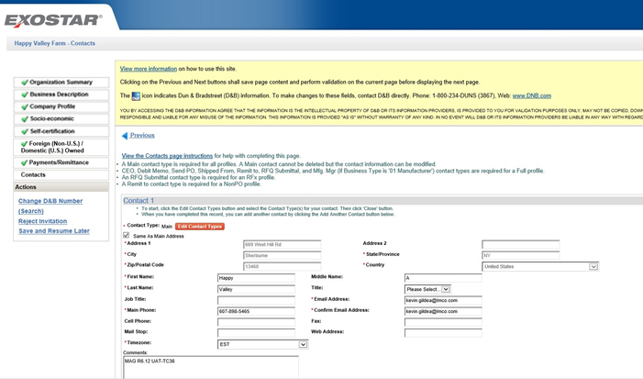

Step | Action
42. | On the Contacts screen, all data fields preceded by a red asterisk (*) are required to be completed in order to add a contact record. All other data fields are optional and may be entered as appropriate.  Click the vertical scrollbar to navigate through this screen.
43. | Click on View the Contacts page instructions link for detailed instructions and help in completing this page.

Step | Action
 | A contact record should be added for each unique contact person name.
44. | On an existing contact record, click the Edit Contact Types button and select the Contact type(s) for each contact record. Multiple contact types may be assigned to one person on the same contact record.  Click ‘Close’ to apply the selected contact types.  Enter all the contact information, required and as desired optional data.  To add another Contact record, click on ‘Add Another Contact’ button.  To auto-fill the address with the main address check the ‘same as main address’ box.
45. | When all required contacts have been added and updated, click the Accept  and Continue the Invitation link at the top of the screen (highlighted) or found in the left-side ACTIONS menu.

Contacts page after completion – ready to click ‘Accept and Continue’;

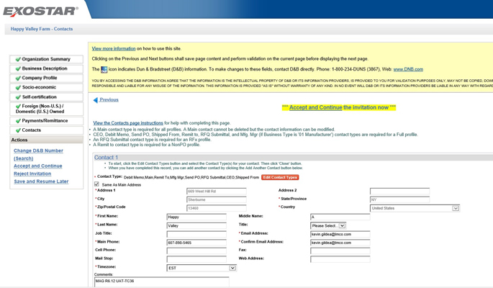
Certification
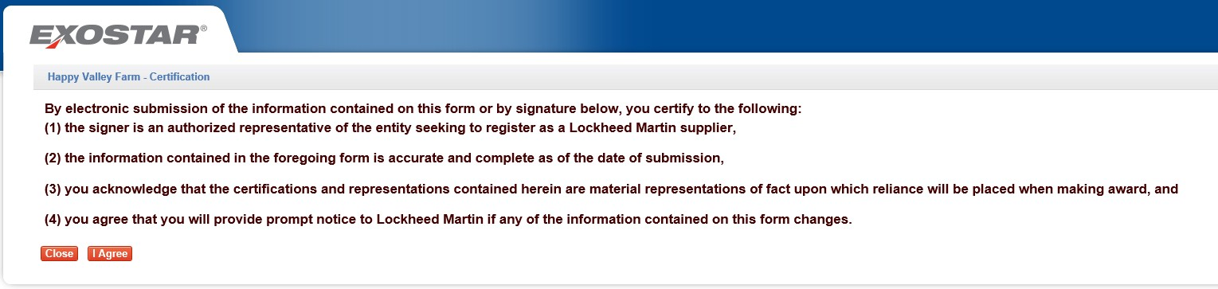

Step | Action
46. | The Certification screen provides certification that the person completing this invitation is an authorized representative of the company. Please review prior to proceeding.
47. | Click the I Agree button to continue.

Select Administrator
The purpose of this page if to define your users who will perform the various roles required to conduct e- commerce procurement activity with Lockheed Martin. See text message on top of page that provides definitions of each role.
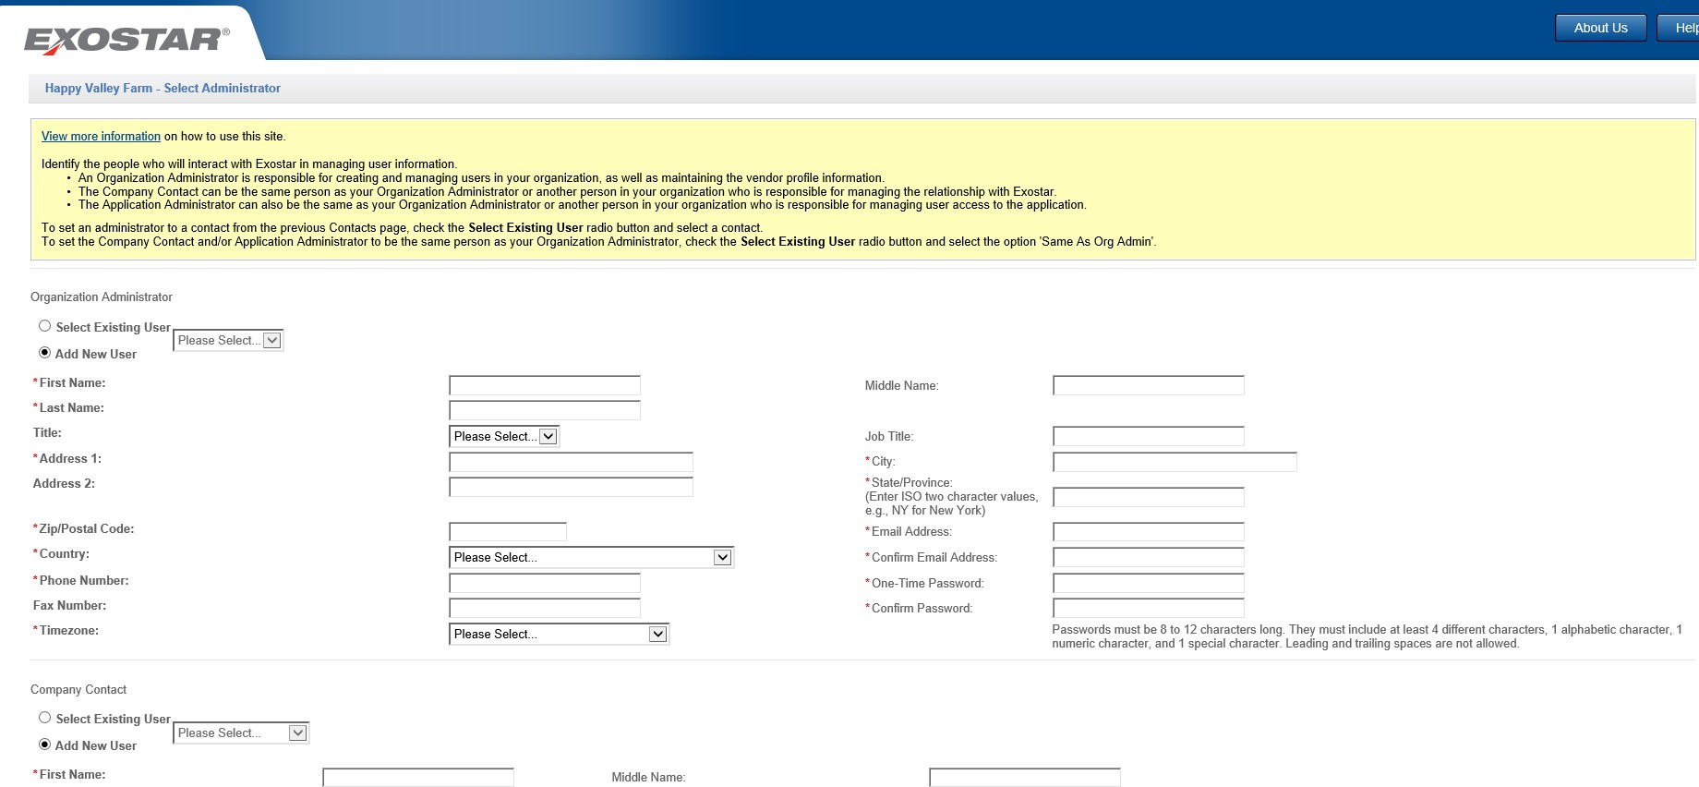

Step | Action
48. | Click the vertical scrollbar to navigate through this page.  Each company must have an Organization Administrator setup at this time. This may or may not be the person who received the invitation request email, but in most cases it is.  It is highly recommended that more than one person be assigned this user role, so a backup person is always available. This can be done at a later time, post initial registration being completed.
49. | Add New User is the default in the Organization Administrator and other sections. If the person completing the invitation or another contact person already defined (on Contacts page) is to be the Organization Administrator, click the Select Existing User radio button and select an existing user from the list.
50. | If the Organization Administrator is an existing user (as selected from list ‘Same as org admin’), then person name, address and other required information will be auto-populated.
51. | You are required to assign a One-Time Password to the Organization Administrator defined and confirm it in the field directly below. The two values entered must be equal or else an error message will be returned.

52. | A Company Contact, P2P Application Administrator, Partner Information Manager (PIM) Application Administrator (conditionally), and LM eInvoicing Application Administrator must also be selected.  These contacts may be the same as the Organization Administrator or new users may be defined. Select either ‘Select Existing User’ or ‘Add New User’ option and proceed as described above.  Note: Suppliers that handle sensitive information will also be required to select a PIM administrator in order to complete their Cyber Security Questionnaire.
53. | Click Next to continue.

Exostar Subscriber Agreement

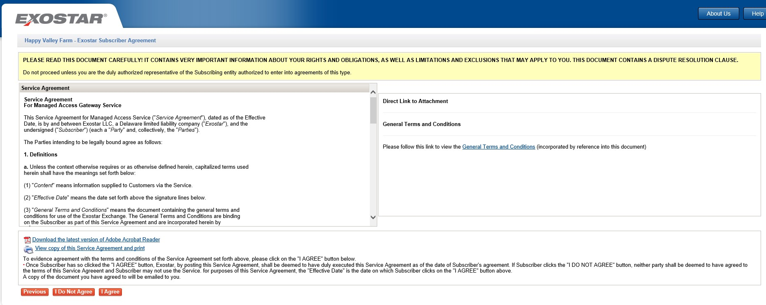

Step | Action(s)
54. | The Exostar Subscriber Agreement is displayed for your review and approval. You may also view and print a copy of this document by clicking the appropriate link provided.
55. | After review, click the I Agree button to continue.

Trading Partner Agreement (TPA)
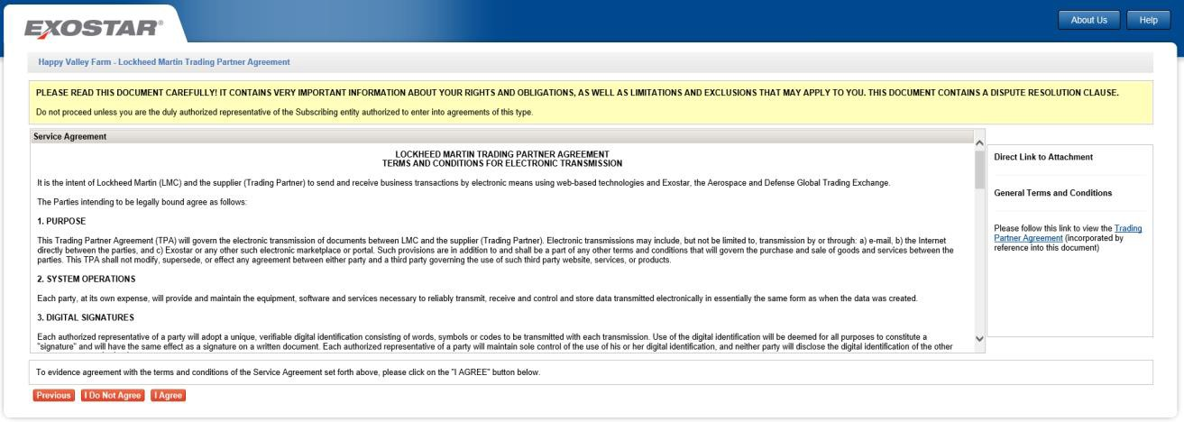

Step | Action
56. | Review the Lockheed Martin Trading Partner Agreement. This agreement can also be displayed by clicking on the Trading Partner Agreement link in the upper right section of this screen (Under General Terms and Conditions).  You may also view and print a copy of the Trading Partner Agreement  by clicking the appropriate links.
57. | If you agree to the terms in the Trading Partner Agreement, click the I Agree button.

Step | Action
58. | Your registration request has now been submitted. The status of the invitation request is now set to ‘Pending Exostar Approval”. Once Exostar reviews the vendor profile and approves it, status will be set to ’Pending 2FA Compliance’. See next steps for additional information regarding two-  factor authentication (2FA) requirements.
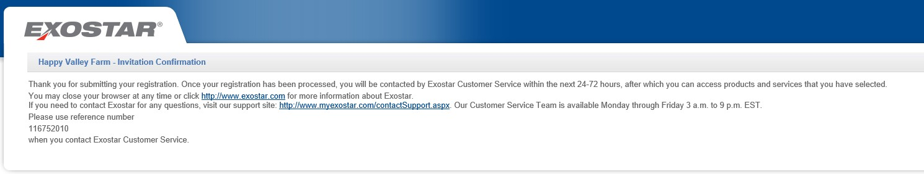

Step | Action
59. | This is a sample of the email you will receive noting that your invitation has been accepted. The email subject is: Organization Notice: Exostar Registration Request Submitted.  Your Organization will now be registered in MAG upon approval. Note – the next step in the process is for Exostar to review and approve the registration. This will normally be completed within less than 24 hours.

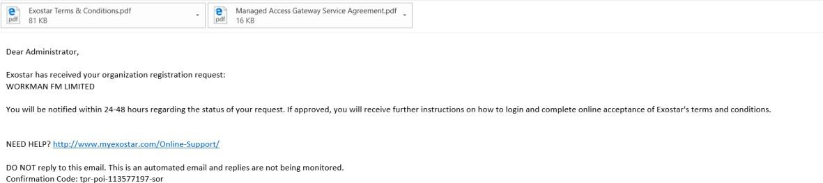

60. | Once the supplier profile registration process has been completed and Exostar has completed their review and approval, users who will be accessing the LMP2P portal must complete the 2-Factor Authentication (2FA) registration process. As cyber-attacks against the Aerospace and Defense industry continue to increase in frequency and sophistication, Lockheed Martin is focused on mitigating risks associated with its supply chain.  Each user defined during the registration process will receive system emails from TPM with instructions on how to proceed, e.g., performing first- time login, etc.  Additional information on Lockheed Martin 2-Factor Authentication can be found at the following link: https://my.exostar.com/display/TE/Credentialing+-+Lockheed+Martin. It is recommended that this information be reviewed, in its entirety, prior to initiating this process.  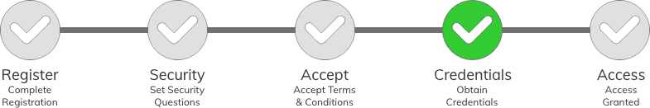  Please proceed with completion of the 2FA purchase and activation process in order to achieve ‘Active’ status on your TPM Supplier Profile and enable PO placement. If you do not already have a credential, Lockheed Martin requires purchasing a Phone OTP with Identity Proofing credential type for Level 3 assurance. This will allow you to access the LM Procure-to-Pay (LMP2P) system.

The END.

