

Supplier Management Supplier Guide
Table of Contents
Supplier Management (SM) Overview 2
Roles, Permissions, Responsibilities 2
Access 3
SM Supplier Dashboard 5
Top Header 5
Pending Forms Tab 6
Pending Approval Forms Tab 7
Completed Forms Tab 9
Cancelled Forms Tab 10
Communication 10
My Organization 13
User Management 13
Form Details 14
Assignment History 15
Downloads Section 16
Offline Forms 17
Print Forms 17
Form Renewal 18
Form Grouping 18
Business Issue 18
Solution 19
Group Setup 19
View Form Groups 20

Supplier Management (SM) Overview
Supplier Management (SM) focuses on providing the ability to manage vetting and certification of prospective and existing suppliers. It contains built-in data collection processes and workflows, automated features, and services that allow users to continuously review and make future decisions on supplier relationships.

This role-based user guide outlines functionalities and actions for users in SM:
- Roles, Permissions, and Responsibilities
- Access
- Navigation
- Viewing Details of Form Assignment for a Supplier Organization
- Viewing and Printing Submitted Forms
- Running and Viewing Reports
- Form Grouping

IMPORTANT! You MUST use Google Chrome to access the Supplier Management application.

Roles, Permissions, Responsibilities
SM provides Supplier Administrator, Supplier Approver, and Supplier User roles. It is important to note that MAG Organization Administrators and MAG Supplier Management Application Administrators are given the Supplier Administrator role within the Supplier Management application.

The Supplier User role allows users to execute the following actions:
- View form requests assigned to self in Pending Forms, Pending Approval Forms, Completed Forms, and Cancelled Forms
- Edit, Re-assign and Submit the form
- View the Form Details page
- Download, upload, View PDF for completed forms in the Form Details Page
- Initiates communication to the Supplier Administrators

The Supplier Administrator role allows users to execute everything a Supplier User can, in addition to the following:
- Assign roles to users
- Assign Supplier Users and Supplier Approvers to forms
- Respond to communication initiated by Supplier Users

The Supplier Approver role can execute the following actions:
- Access the Pending Approval forms tab and Accept or Deny only forms assigned to self, with a comment

Access
To access SM, you must have an Exostar’s Managed Access Gateway (MAG) account, as well as an acceptable security credential. Please note, your Buyer Organization determines the credential requirement, so please reach out to your Buyer for more information. For help resetting your MAG password or any other MAG-related questions, refer to https://www.myexostar.com/?ht_kb=mag.

NOTE: If you are the first user in your organization to access SM, you must accept the standard MAG Usage Service Agreement. If you see Agree to Terms on the Supplier Management tile in your MAG account, click the button and accept the service agreement.

Once you successfully activate your MAG account, all subsequent logins proceed as follows:
- Navigate to https://portal.exostar.com. Input your Email Address or User ID. Click Next.
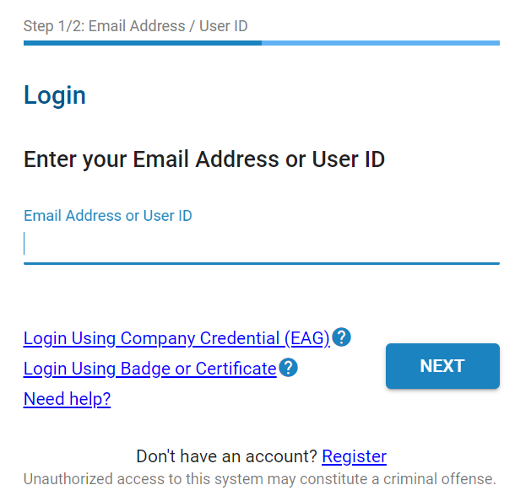

- Input your Password. Click Next to access the MAG Dashboard.
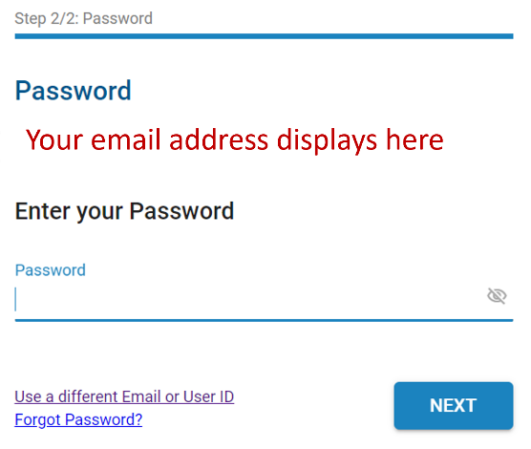

- From the My Applications section, click the Launch button from the Supplier Management tile.
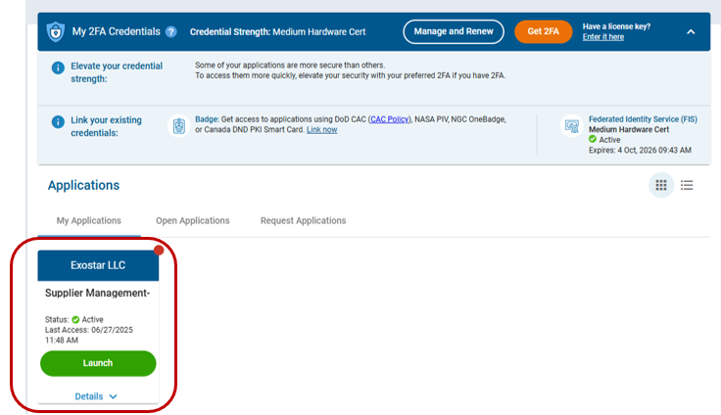

IMPORTANT: At this point in the process, the system may prompt for your security credential. The Buyer Organization determines the credential type required to access the SM application and 2FA enabled forms. Please reach out to the Buyer for more information on the credential type. A 2FA enabled form will be represented with a lock, shown below.
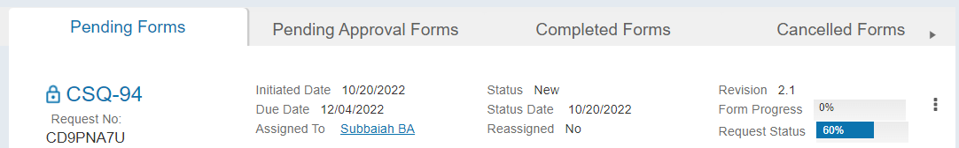

- Once you successfully login with your security credential, the system displays the Export Control Acknowledgement. Place a checkmark next to I understand that this application is accessible by both U.S. and Non-U.S. Persons. I agree not to post Export Controlled Technical Information to this application. Click Accept.
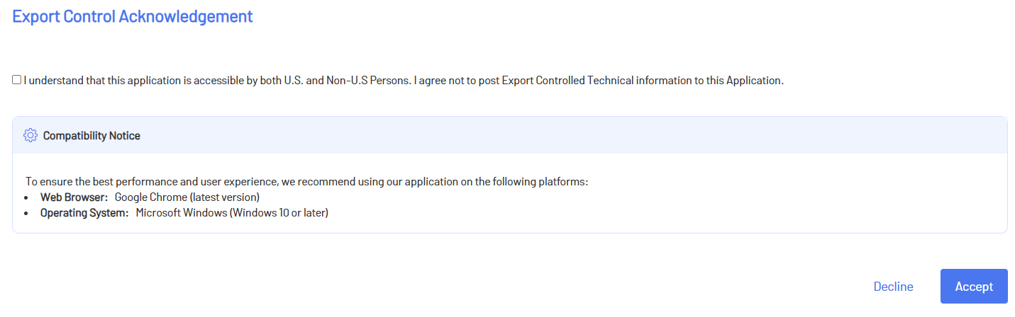

Once you acknowledge the notice, the SM dashboard displays.

SM Supplier Dashboard
The SM Dashboard displays upon successful login. Users can conduct various tasks from the Dashboard.

Top Header
The top header provides the following options, and is static regardless of where you are in the SM application:
- Exostar Logo: Click this to redirect to Exostar’s corporate website.
- Supplier Management: Click this to navigate to the SM Dashboard.
- Home: Click this to navigate to the SM Dashboard.
- myExostar: Click this to navigate to Exostar’s self-help site, which provides on-screen help content, downloadable guides, FAQs, etc.
- Contact Us: This option is configurable to point to the desired contact.
- Help: Click this to open Exostar’s Support page. This page provides dial-in numbers, a Chat feature, as well as an online case form.
- User Drop-down: This section displays your role, and provides options to navigate to your profile, as well as to logout of the system.
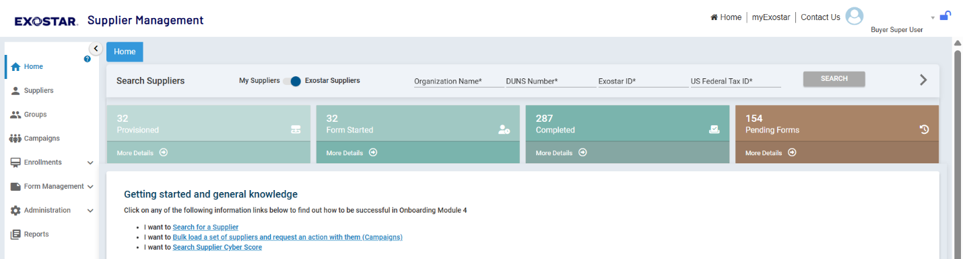

Pending Forms Tab
This tab displays a comprehensive list of all pending forms assigned to you, and additional details like Revision, Form Progress, and the Request Status. Click the hyperlinked form name to open the Form Details page. The action menu, located to the right of each form provides options to reassign and assign approvers. Please see the Form Details section below for more information.
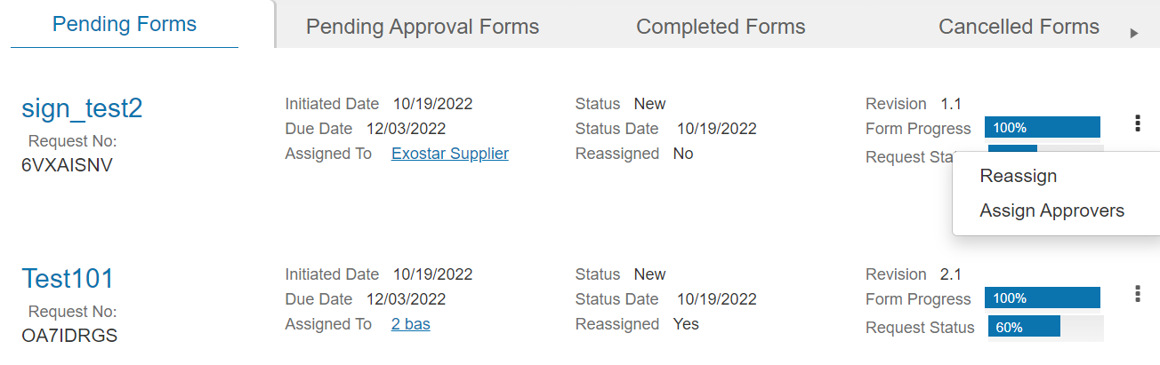

To Assign Approvers:
- Select the action link (three dots), located to the right the desired form. Select Assign Approvers.

- Make desired user selection.
- If desired, select to Enable Approval Workflow. Select Approvers.
- Click Save.
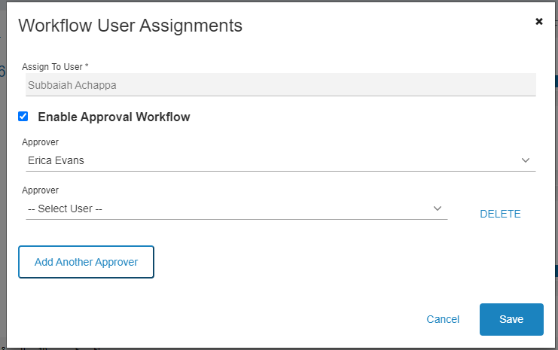

Pending Approval Forms Tab
This tab displays a comprehensive list of all forms pending approval, and other additional details including approver names for each form. Please note the form moves to this tab only if Approver workflow is enabled and the user has submitted the form. Each form displays the list of approvers assigned to the form. The name of the approver currently logged into the system will have their name represented as a link. It will also indicate whether the decision is Pending or Completed for a form. The link will be enabled if the user has not submitted their decision.
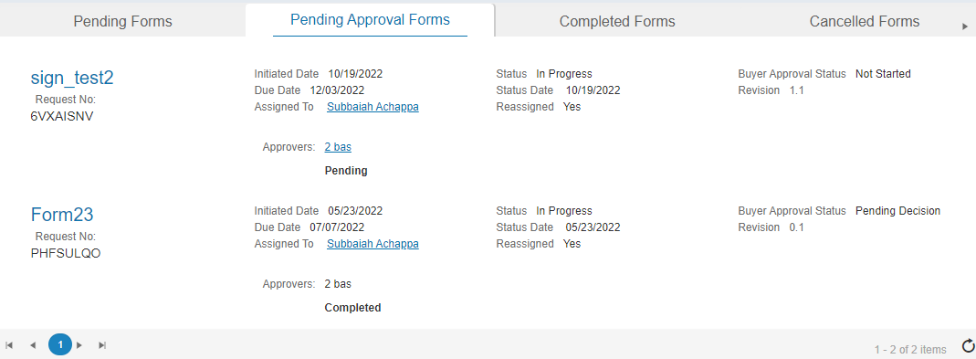

When the user clicks on their name, the system displays a modal allowing them to enter their Decision, state the Reason, and Submit.
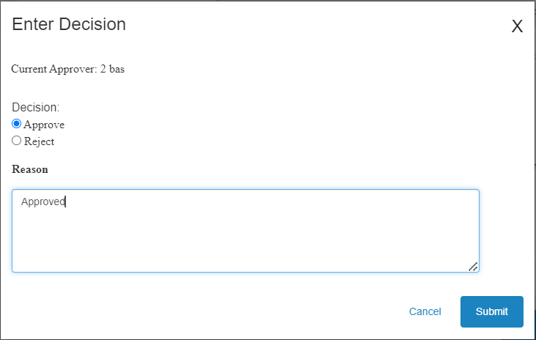

The link will be disabled if the decision has already been submitted.
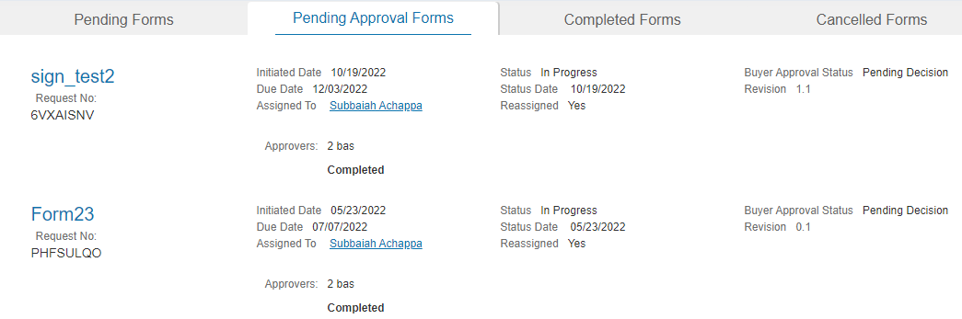

Completed Forms Tab
This tab displays a comprehensive list of all completed forms, additional details like expiration date for each form. Note the form moves to this tab only once the form is submitted and all the approvers have approved the forms. Click the hyperlinked form name to open the Form Details page. This page also has a link to the Approval Summary, and once clicked, you can view the Approval Decision.
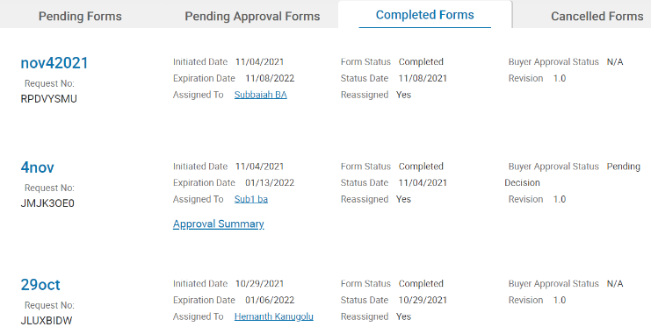

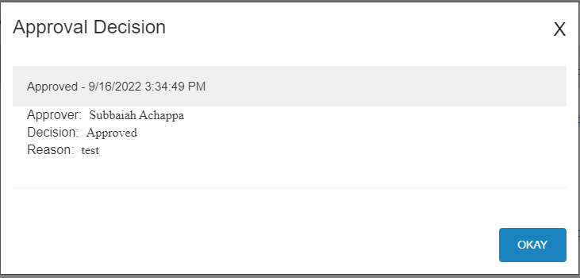

Cancelled Forms Tab
This tab displays a comprehensive list of all cancelled forms, and additional details for each form. Click the hyperlinked form name to open the Form Details page.
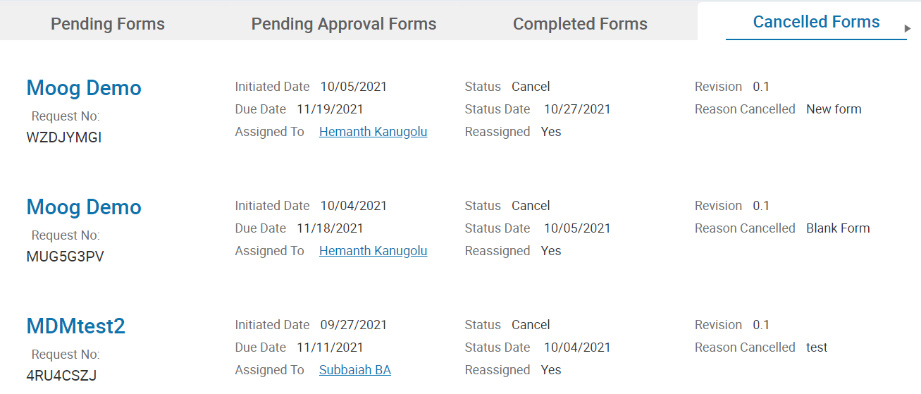

Communication
The Communication section of the dashboard provides messaging capabilities. The table displays the latest messaging thread, along with additional details, and a reply option. Select View All below the most recent messages to view a comprehensive list of all messaging threads. Only a Supplier User can initiate a communication with an Administrator by clicking Add New Question.
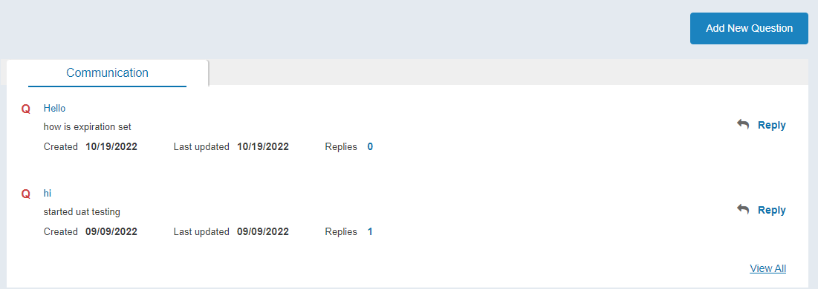

To view the entire messaging thread and reply:
- Click the hyperlinked Subject.
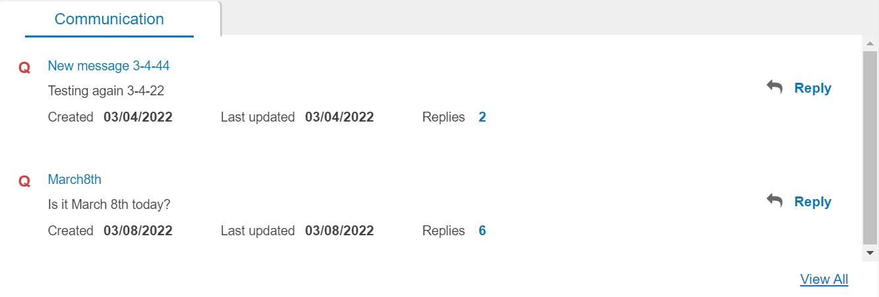

- The thread displays. View each message via the Replies tab. Input a reply in the field provided. Click Add.
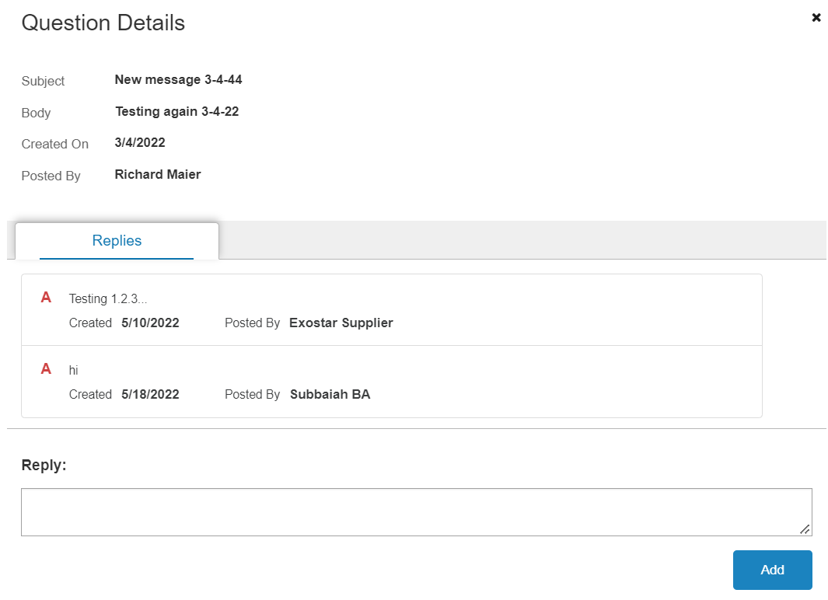

My Organization
The section displays details specific to your organization, including a hyperlinked number of users associated with your organization and your hyperlinked organization name.
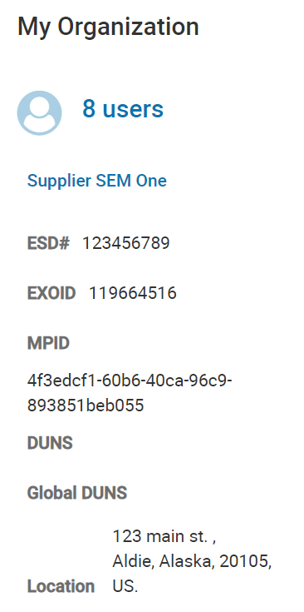

User Management
As an administrator, you can manage users associated with your organization within the SM application. To manage users:
- Select the number of users or organization name via the My Organization widget.

- Select the Manage option next to the desired user.
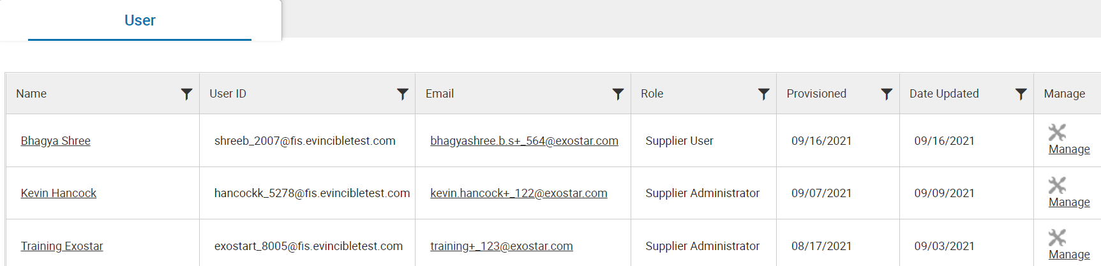

- In the Role Management window, select the desired roles and update the User’s Active status, if desired. Click Update.
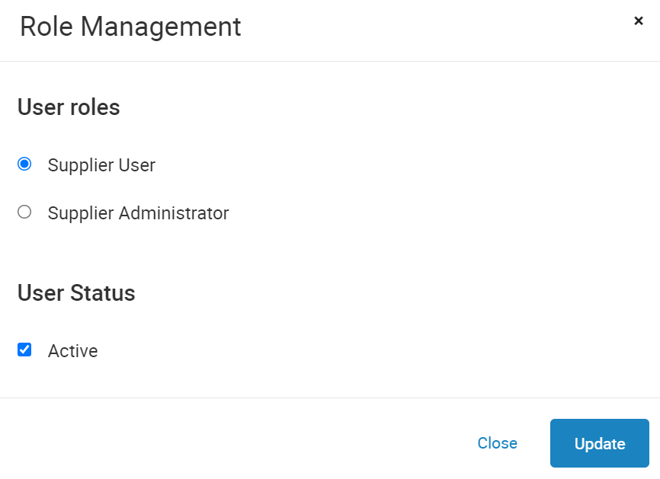

Form Details
Access the Form Details page by selecting the desired Form Name anywhere in the SM system. The Form Details page displays the following supplier attributes:
- Recent Request
- Revision History
- Assignment History
- Summary
- Section Progress

The Form Details page also provides the ability to download, upload, and view the form, as well as allows users to print the latest submission and all previously completed submissions of the form.
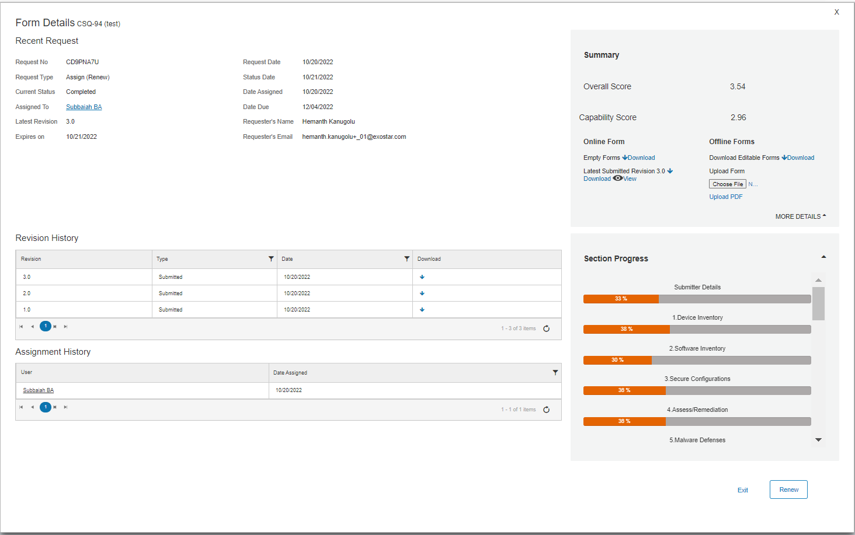

Assignment History
The Assignment History table displays the user and date assignment in a table format.

Downloads Section
This section is located along the right side of the screen, in the Summary section of the Form Details page for custom forms. Select the MORE DETAILS option to view. From here, users can download empty forms, the Latest Submitted Revision, as well as offline Editable Forms. You can also upload supported forms.
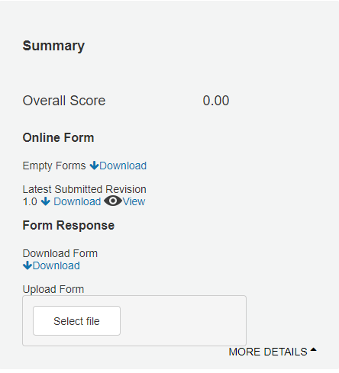

Offline Forms
This Section is located on the right side of the Form Details page for standard forms like NIST and Common Questionnaire. You can download Editable PDFs using the Download button, edit it offline, and upload the form using the Choose File link. Exostar recommends using Chrome for this option, for now.
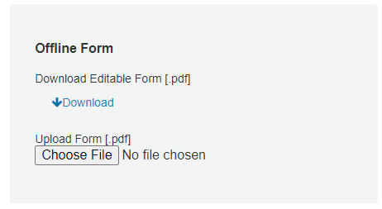

Print Forms
Users can only see and download completed/submitted forms. To print the last submitted form:
- Navigate to the desired Form Details page and locate the Downloads section.
- Click the PDF icon next to Latest Submitted Revision.
- Select the Print option.

To view and print any other forms:
- Go to the Download column of the Revision History table and click arrow icon for the desired revision number.
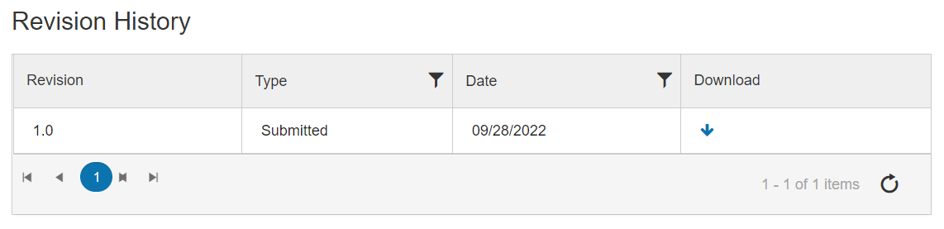

- Select the Print option.

Form Renewal
To renew a form:
- On all Completed Form Details pages, select the Renew button at the bottom of the screen or from the action menu.
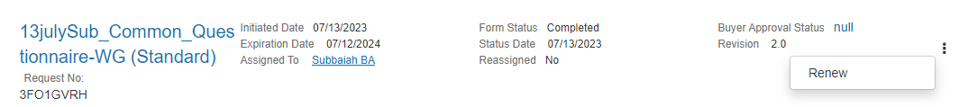

- The system prompts for confirmation. Click Proceed.
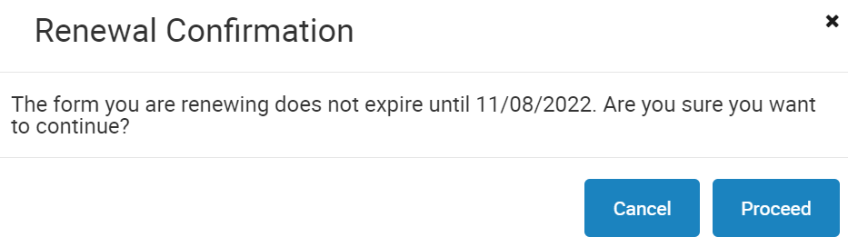

NOTE: Once you confirm, the form is moved to Pending Forms tab.

Form Grouping
Form Grouping is used to share a completed form your organization filled out with your compatriot business units. The sections below provide step-by-step instructions on how to share your group form.

Business Issue
Company XYZ is composed of several subsidiary companies and/or business units (BU), each one of which is a Supplier to one or several Exostar Buyer organizations. Each of the subsidiaries is being asked to complete forms from one or more Buyer organizations. This results in requesting many of the subsidiaries to complete the same form. The security policies and infrastructure of the subsidiaries of Supplier XYZ are managed and controlled by a single shared service, an organizational unit located within one of the registered XYZ companies/subsidiaries. That unit can answer the form on behalf of many of the XYZ subsidiaries. This unit would like to answer the form once for all subsidiaries covered by its security program.

Solution
Exostar has the capability to create a Form Group of companies/businesses where one of the businesses can represent the group when completing forms. The XYZ business needs to nominate one of the business units as the source to represent the group. That business completes the form on behalf of the group (Destinations), and the results are provided to Buyers XYZ subsidiaries chose to share the results. In this way, the form is under the control of a single subsidiary or business unit within the group, but shared by any of the others with whatever Buyers they wish.

Destination organizations can share the group form with individual Buyers just like any other normal assigned form with two major exceptions:
- The form is locked and only the Source Organization can edit it. All further edits are reflected in the destination form in real-time.
- When a form is submitted, the scoring of the shared form applies to the one associated with Destination Organization as well.

Group Setup
Company XYZ needs to do the following to setup the group within Exostar:
- Create a support case via the Support page and describe the case as Create a Form Group in SM.
- Provide the Form Grouping Submission Form that identifies:
  - The source business unit by its Exostar ID, DUNS ID, full address, and email address of the responsible person who will handle the security form.
  - The destinations or business units within the group by Exostar ID, DUNS ID, and address for each.
  - Which form is to be shared with the Destinations.

- Exostar contacts each destination business unit to confirm they will be added to the new group.
- Exostar creates the group within the organization data and the form from the source will be available for the destinations.
NOTES:
- The source organization must submit the form for the responses to be duplicated onto their respective destination organization forms.
- If a new supplier is added to the existing Form group, the Source organization must resubmit (renew) the form for the responses to be duplicated onto their respective destination organization forms.

View Form Groups
Suppliers can determine if their form groups have been migrated to the Buyer’s SM application by going to the specific form in the Buyer’s SM and reviewing the Form Details page to determine if they are a destination of a form group. The message will read: This form is being shared by the following organization ORGNAME. You do not have permissions to edit this form.

The screenshot below shows the form is provided by another organization, which is the Source of the completed form.
