

Supplier Management Reporting Guide
Table of Contents
Supplier Management (SM) Reporting Overview 2
Access Reporting Tool 3
Reporting Tool Dashboard 5
Create New Report 6
Manage Existing Reports 11
Edit Existing Report 12
Delete Existing Report 13
Dashboard Reports 13
Create Dashboard Report 14
Remove Dashboard Report 15
Update Dashboard Report 16
Hide Dashboard Reports 17

Supplier Management (SM) Reporting Overview
SM focuses on vetting and certification management of prospective and existing Suppliers. It contains built-in data collection processes and workflows, automated features, and services that allow users to continuously review and make future decisions on Supplier relationships.

IMPORTANT! You MUST use Google Chrome to access the Supplier Management application.

The Reporting Tool is one of the main SM features and provides Buyer Technical and Functional Administrators the ability to pull aggregate Supplier reports. SM provides several pre-existing reports, as well as the capability for users to create custom reports. Users can save up to ten most viewed reports on the dashboard, in tabular or chart format. These reports display at the bottom of the dashboard via the My Reports drop-down.
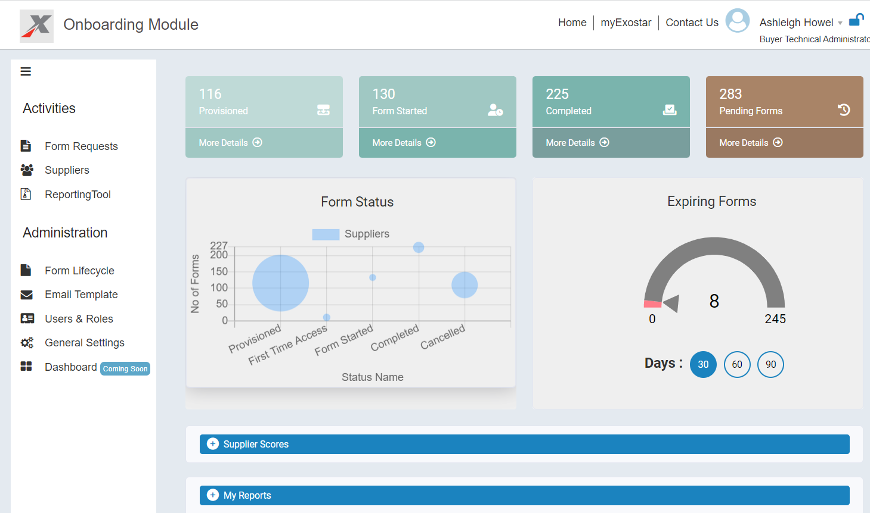

There are two main types of available reports:
- Standard Report: These reports pull content based on built-in parameters and are not customizable.
- User Report: These reports are built by users and are customizable.

Access Reporting Tool
You must be designated as a Technical Administrator or Functional Administrator in the SM application to access the Reporting Tool, which displays in the left-hand navigation. To access the reporting feature:
- Navigate to the MAG Login screen. Input your Email Address OR User ID. Click Next.
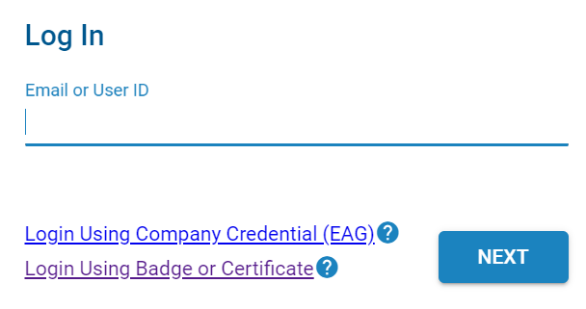

- Input your Password. Click Next to display the MAG Dashboard.
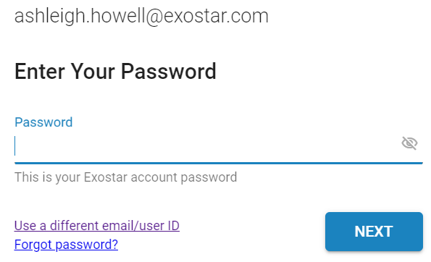

- From the My Applications section, click the Launch button from the Supplier Management tile.
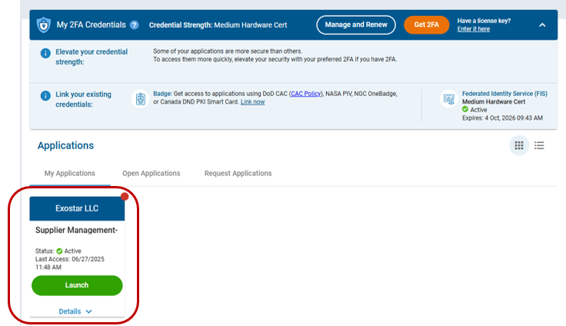

IMPORTANT: At this point in the process, the system prompts for your security credential. The Buyer Organization determines the credential type required to access the SM application, so please reach out to them for more information.

- Once you successfully login with your security credential, the system displays the Export Control Acknowledgement. Place a checkmark next to I understand that this application is accessible by both U.S. and Non-U.S. Persons. I agree not to post Export Controlled Technical Information to this application. Click Accept to display the SM dashboard.
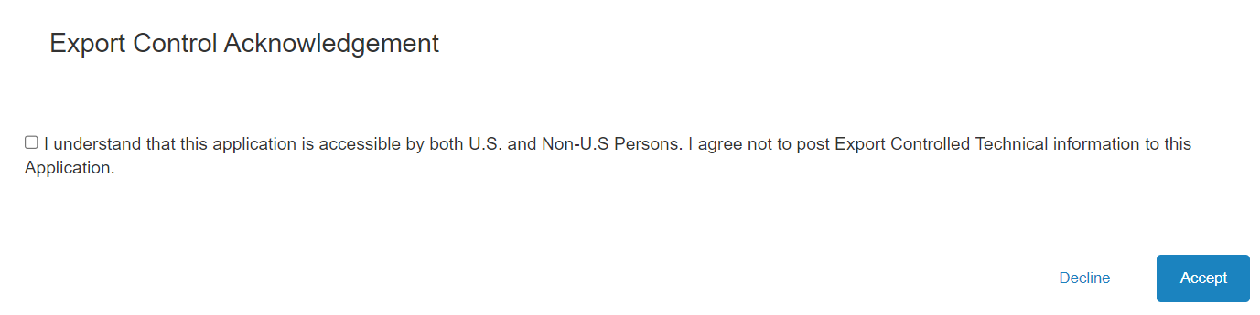

- From the SM Dashboard, select Reporting Tool from the Activities menu.
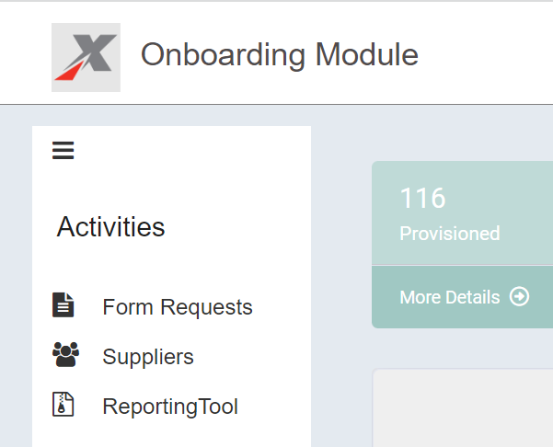

Reporting Tool Dashboard
The Reporting Tool dashboard displays a comprehensive list of reports in their respective formats (bar chart, graph), as well as additional navigational features:
- View All Reports (Home button): This displays a library of all existing Standard Reports and custom-created User Reports. Select this option to return to the Reporting Tool Dashboard.
- Create New Report x2 (+ buttons): Select either of these buttons to start a new report.
- View Dashboard Reports (graph button): Select this option to view and manage existing dashboard reports.

Use the left-hand navigation to open existing reports based on type.
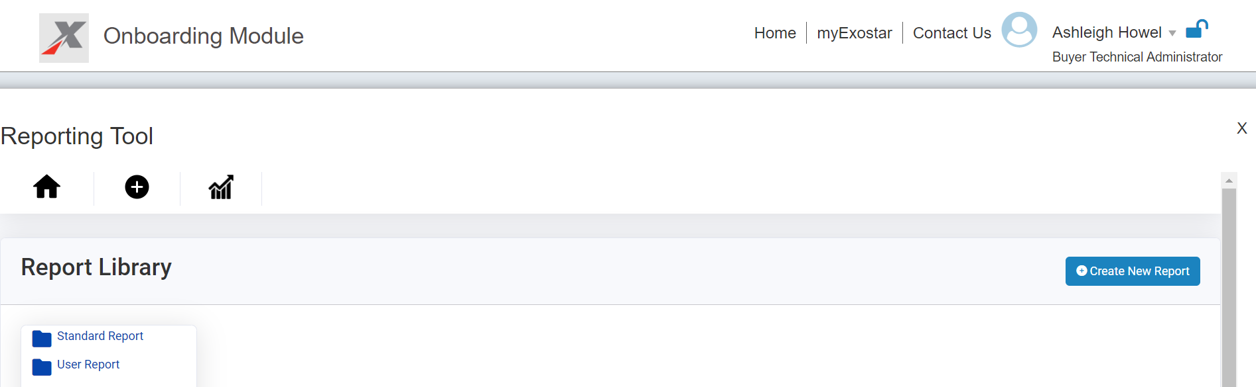

Create New Report
The Create New Report interface allows Technical and Functional Administrators to drag and drop attributes from the left-hand View section into the Column Header section. Users can further enhance the report utilizing the following features:
- Filter: This section allows you to filter the report using specific attributes.
- Sorting: This section allows you to sort desired attributes in ascending or descending order.
- Group By: This field is used with aggregate functions, such as COUNT, MAX, MIN, SUM to group the result set by one or more columns.
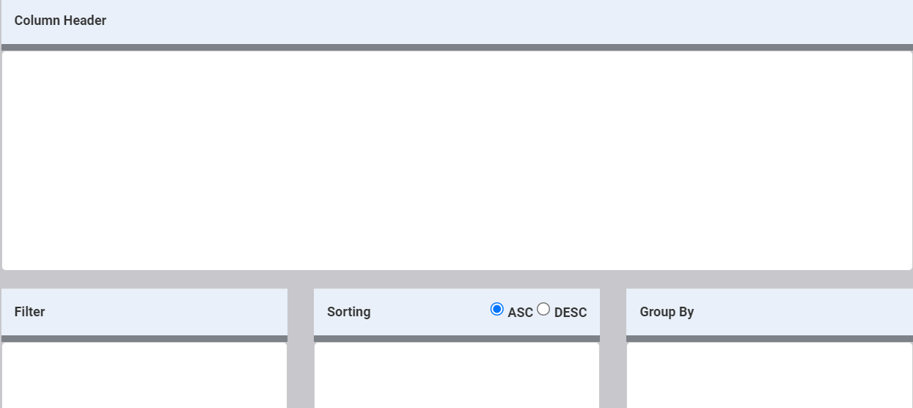

To create a new report:
- Navigate to the Reporting Tool. Click the +Create New Report button.

- Locate desired attributes in the left-hand View column.
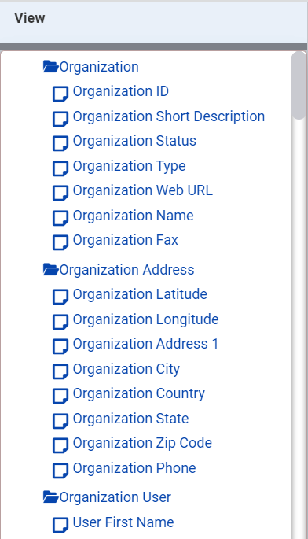

NOTE: Please see Appendix A for a comprehensive list of all available attributes and descriptions for each.

- Drag and drop attributes into the Column Header section.
NOTE: Rearrange the order by selecting and moving the attributes. To remove, select the red X.
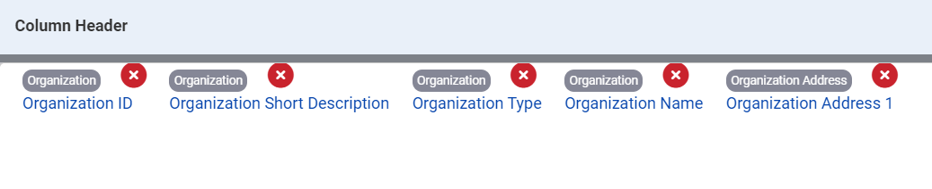

- Drag and drop attributes into the Filter section. The Filter dialogue box displays for you to make further selections.
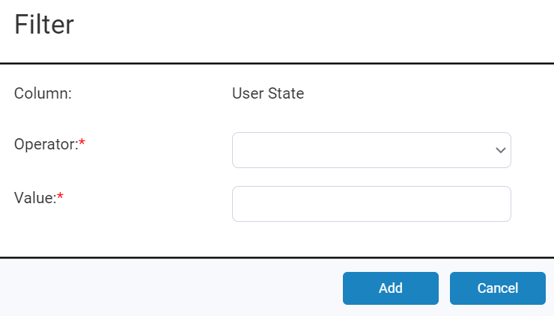

- Select the desired option from the Operator drop-down menu:
  - EQUAL: This selection yields results equal to the value you input.
  - GREATER: This selection yields results greater than the value you input.
  - GREATEREQUAL: This selection yields results greater than or equal to the value you input.
  - LESS: This selection yields results less than the value you input.
  - LESSEQUAL: This selection yields results less than or equal to the value you input.
  - NOTEQUAL: This selection yields other values than specified.
  - BETWEEN: This selection yields results in between two different values.
  - ISNULL: This selection yields values that are empty.
  - ISNOTNULL: This selection yields values that are NOT empty.
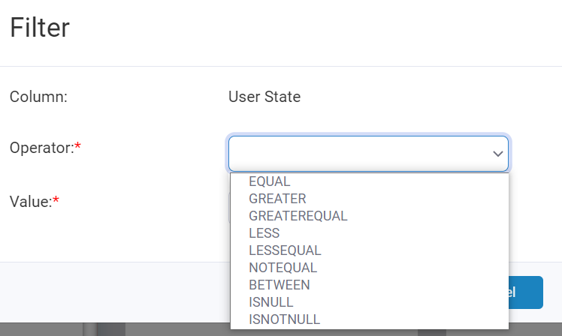

- Input the corresponding numeric Value, depending on the Operator you selected. Click Add.
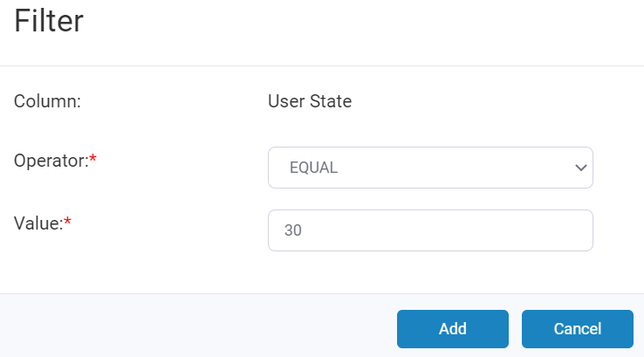

- Repeat steps 4-6, as necessary, to complete the Filter section.
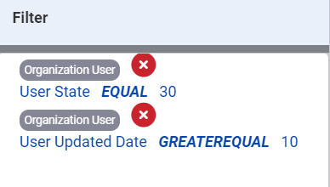

- Drag and drop attributes in the Sorting section.
NOTE: Select the radio button for ASC (ascending) or DSC (descending) at any point.
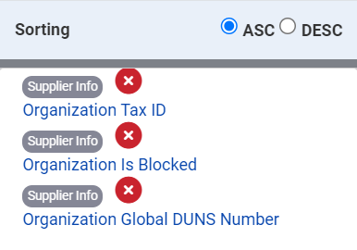

- Optionally, drag and drop attributes in the Group By section. The Function dialogue box displays each time you drop an attribute. Place checkmarks next to the desired Column Headers. From the center drop-down menu, select from the following:
  - Count:
  - Maximum:
  - Minimum:
  - Sum:
- Input an Alias in the field provided. Click Update to add the Group By attribute.
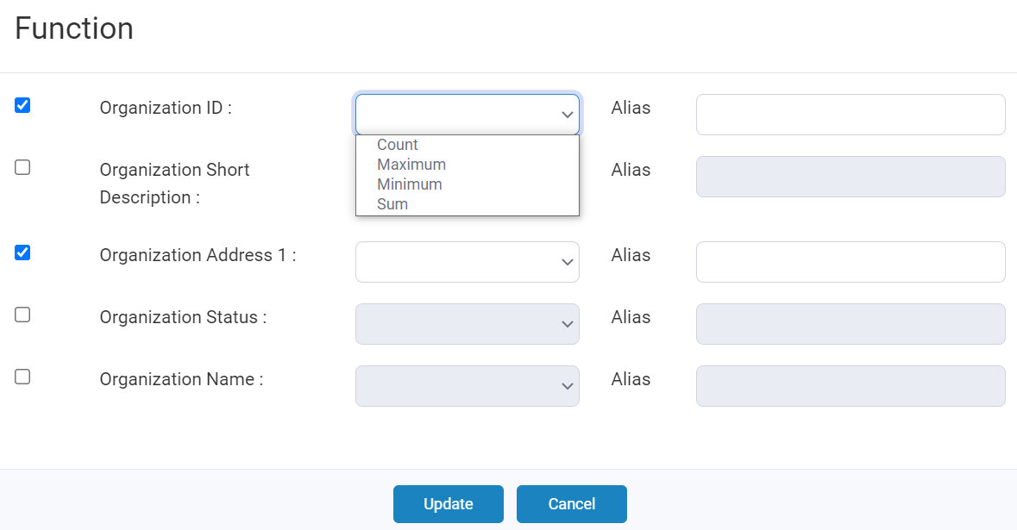

- Once you drag and drop all desired attributes, select the Save Report button.
NOTE: Click the Preview Report button to view the report. Click the Clear button to remove selected attributes.
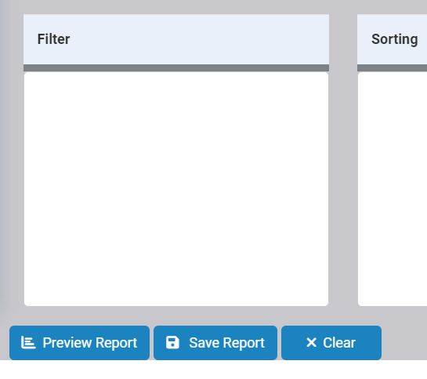

- In the Save Report dialog box, input Report Name (required) and Report Description (optional). Click Save.
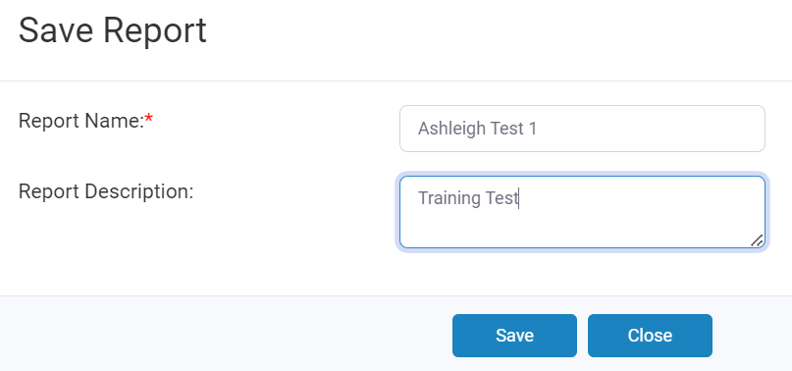

Manage Existing Reports
Select the User Report option from the left-hand navigation to view a list of existing reports. This Reports Dashboard provides a comprehensive list of all existing reports, as well as additional columns of details. Report management options display in the Actions column.
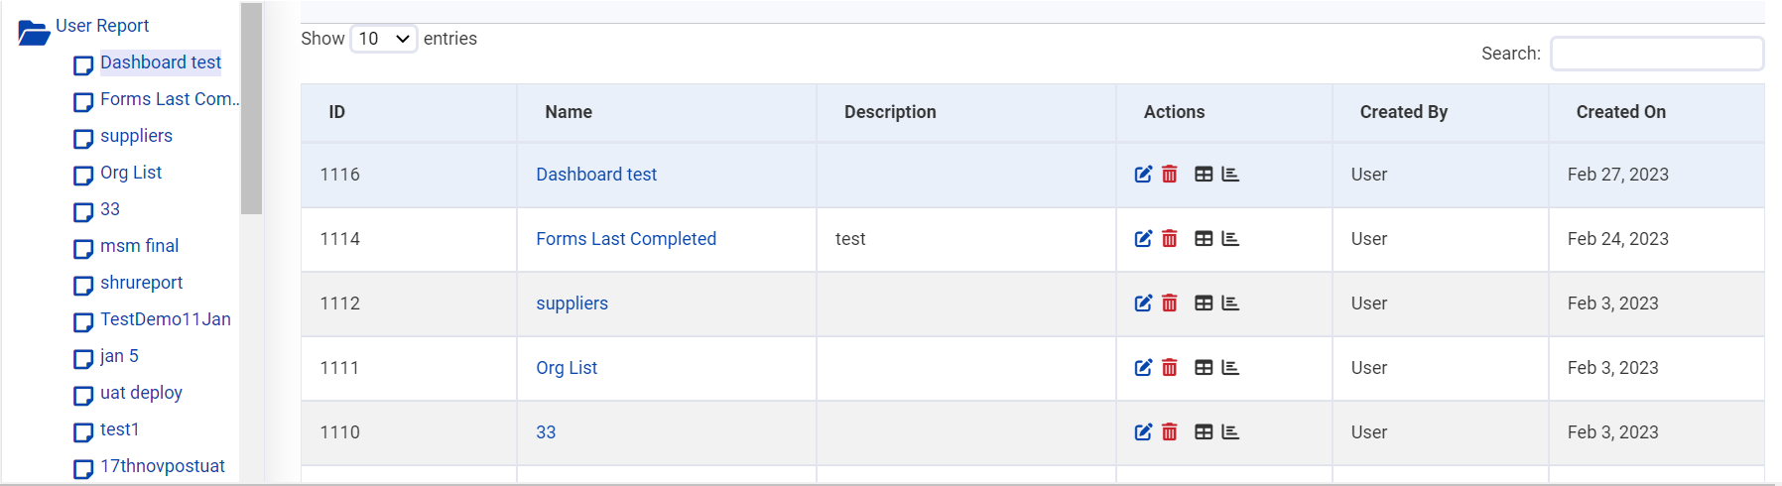

The following actions are available:
- Edit: The blue, edit icon allows you to make changes to an existing report.
- Delete: The red trashcan icon allows you to delete an existing report.
- Create Dashboard Report: The table icon allows you to create a dashboard report out of an existing report.
- Create Dashboard Chart: The chart icon allows you to create a dashboard chart out of an existing report.

IMPORTANT: SM only allows for 10 dashboard reports. If this maximum is met, an error displays when you try to add another.

Edit Existing Report
To edit an existing report:
- Locate the desired report. Click the Edit icon.

- Make desired changes. Click the Save Report button.

- In the Save Report dialog box, input Report Name (required) and Report Description (optional). Click Save.

Delete Existing Report
To delete an existing report:
- Locate the desired report. Click the Delete icon.

- Click OK to confirm deletion.
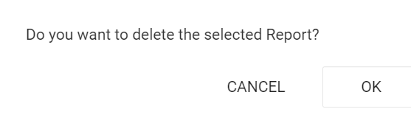

Dashboard Reports
Once you successfully create a report, SM provides the ability to add that report to the main dashboard. Please note, SM limits the number of dashboard reports to ten. Reports allow only three columns. Charts only allow one horizontal column that can be a name, but the vertical axis must be a numbered value.

Create Dashboard Report
To create a dashboard report:
- Locate the desired User Report. Click the Create Dashboard Report or Create Dashboard Chart icon.

NOTE: If there are already ten reports displayed on the main dashboard, an error message displays. Click OK to navigate to the main dashboard to review existing reports and determine if you can remove any. Please see the Remove Dashboard Report section below for instructions.
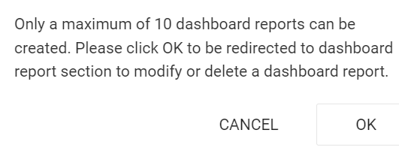

- Input a Display Name in the field provided.
- Select the desired Chart Type: Line Chart, Pie Chart, or Bar Chart.
- Add desired columns by selecting the column name and using the left/right arrow buttons.
- Click the Save Dashboard Report button to complete the process.
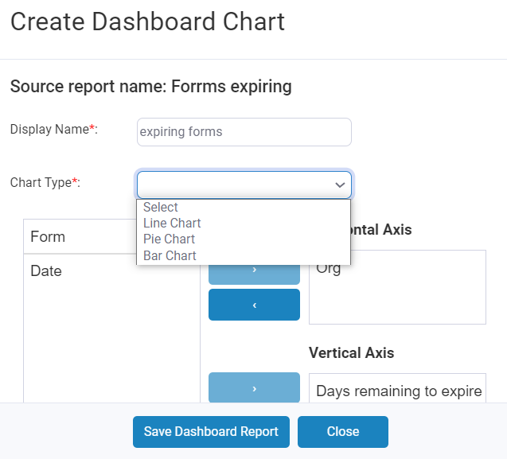

Remove Dashboard Report
To remove an existing dashboard report:
- Navigate to the Reporting Tool. Select the View Dashboard Reports icon.

- Select the desired report from the left-hand menu. In the Edit Dashboard Report dialogue box, select the Delete Report button.
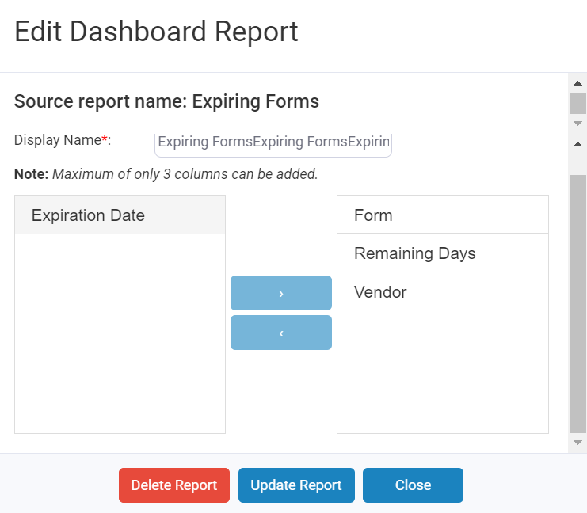

Update Dashboard Report
To update or manage an existing dashboard report:
- Navigate to the Reporting Tool. Select the View Dashboard Reports icon.

- Select the desired report from the left-hand menu. In the Edit Dashboard Report dialogue box, made desired changes. Select the Update Report button.

Hide Dashboard Reports
SM provides the option to hide an existing dashboard report from view. It is important to note, this only hides the report, it does not remove it from the limit of ten. To hide a report:
- Navigate to the Reporting Tool. Select the View Dashboard Reports icon.

- Locate the desired report and right click. Select the Hide from dashboard option.
