

Supplier Management Campaigns Guide
Table of Contents
Supplier Management (SM) Overview 2
Step 1. Access Supplier Management (SM) 2
Step 2. Prepare and Upload Spreadsheet 4
Step 3. Curate (Validate) Suppliers 7
Step 4. Choose Subscription Action 9
Expedited Subscription 10
Qualified Subscription 11
Assign Form 12
External Source Name 13
Step 5. Check Enrollment 14
Appendix A: Country Codes 15
Appendix B: Common Input Errors 19

Supplier Management (SM) Overview
Supplier Management (SM) focuses on providing the ability to manage vetting and certification of prospective and existing suppliers. It contains built-in data collection processes and workflows, automated features, and services that allow users to continuously review and make future decisions on supplier relationships.

This guide focuses on the SM Campaigns process. A campaign allows you to load a set of Supplier organizations into the system and initiate an action on the set of suppliers, such as providing application access and assigning forms. The supplier list can contain existing and new suppliers and requires you to complete an Excel template saved as a CSV file. The template should not exceed more than 200 suppliers.

You must have the Adoption Administrator role, and this role must be assigned by Exostar. You can only load suppliers for applications to which you have permission as the Adoption Administrator.

Step 1. Access Supplier Management (SM)
To access SM, you must have an Exostar’s Managed Access Gateway (MAG) account, as well as an acceptable security credential. For help resetting your MAG password or any other MAG-related questions, refer to https://www.myexostar.com/?ht_kb=mag.

NOTE: If you are the first user in your organization to access SM, you must accept the standard MAG Usage Service Agreement. If you see Agree to Terms on the Supplier Management tile in your MAG account, click the button and accept the service agreement.

Once you successfully activate your MAG account, all subsequent logins proceed as follows:
- Navigate to https://portal.exostar.com. Input your Email Address or User ID. Click Next.
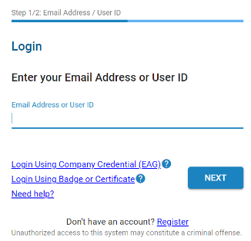
- Input your Password. Click Next to access the MAG Dashboard.
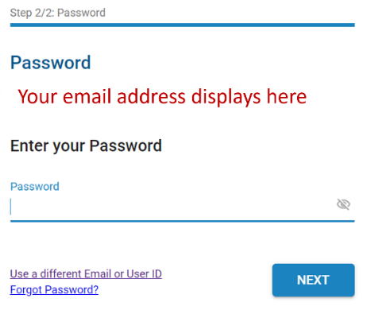

- From the My Applications section, click the Launch button from the Supplier Management tile.
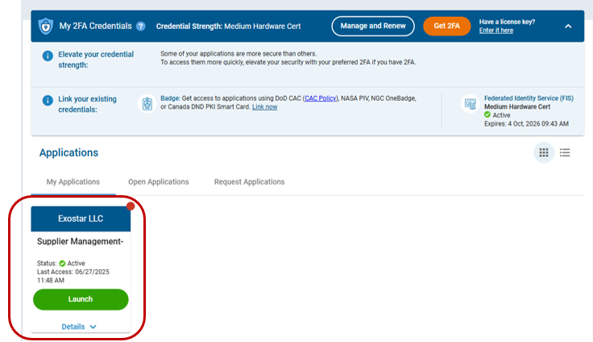

IMPORTANT: At this point in the process, the system may prompt for your security credential. The Buyer Organization determines the credential type required to access the SM application and 2FA enabled forms. Please reach out to the Buyer for more information on the credential type. A 2FA enabled form will be represented with a lock, shown below.
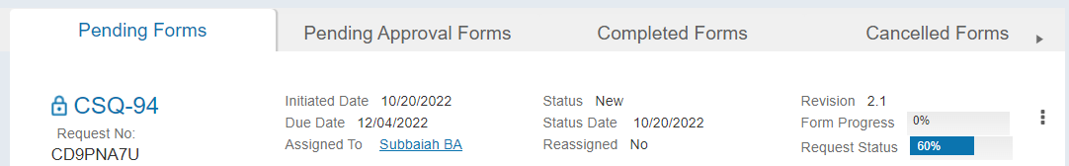

- Once you successfully login with your security credential, the system displays the Export Control Acknowledgement. Place a checkmark next to I understand that this application is accessible by both U.S. and Non-U.S. Persons. I agree not to post Export Controlled Technical Information to this application. Click Accept.
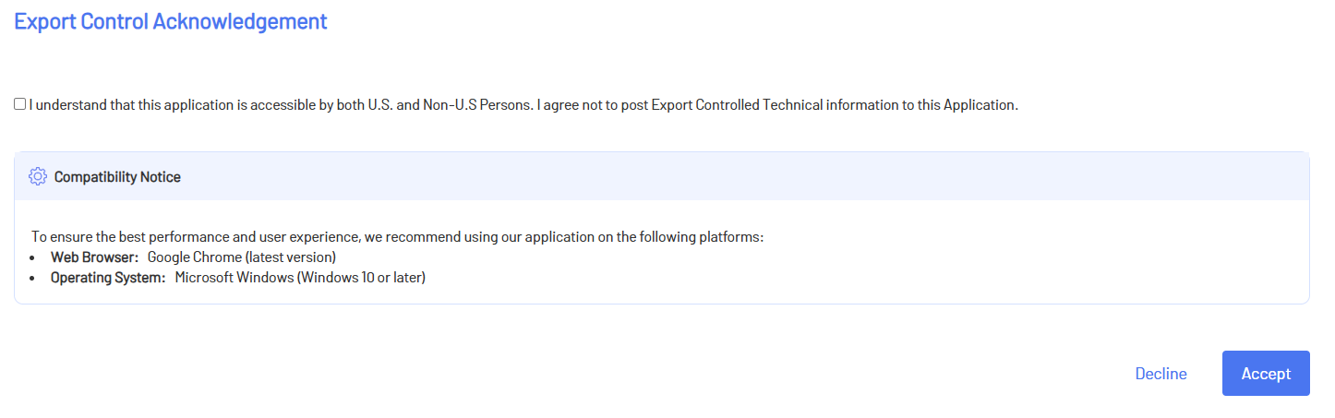

Once you acknowledge the notice, the SM dashboard displays.

Step 2. Prepare and Upload Spreadsheet
You must first download a copy of the template directly from the application. The data provided in the required spreadsheet will be matched with the Exostar database. The more accurate the data, the more accurate the results. You will be provided with a list of options to choose from if the system cannot identify a supplier with high accuracy.

IMPORTANT! Do NOT change the format of the supplier data tab as this is a fixed template and the data will be loaded in error if it is changed.

To prepare the spreadsheet:
- Select the Campaigns tab.
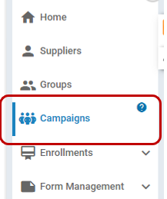
- Click the New Campaign button.
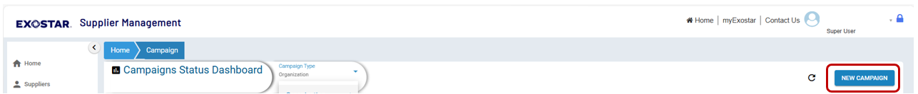

- Click the Download template link to download the file.
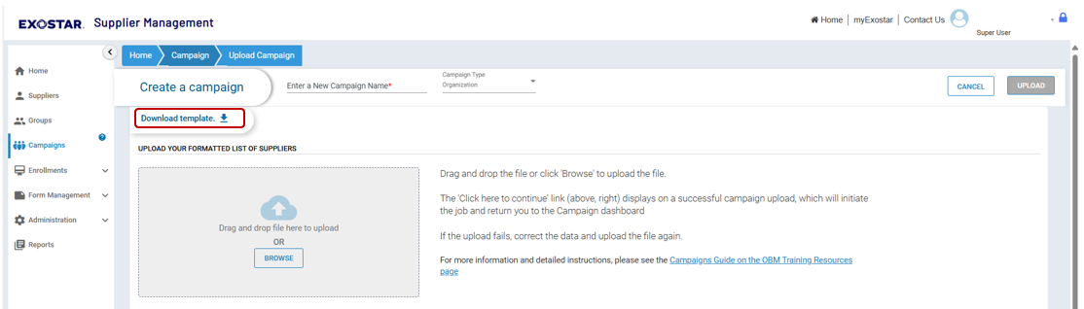

- Complete the following information:
  - *Supplier Name: This field is required and should provide the full business name.
  - Exostar Id: This field is optional and is the designated Exostar ID in the system for existing suppliers.
  - Business Unit: This field is optional and when available, the business unit name is in addition to the full organization name and avoids duplicates within the supplier directory.
  - DUNS #: This field is optional and Dun & Bradstreet (DUNS) Number, a unique nine-digit identification number, for the physical location of the business.
  - External Id: This field is optional and is the tax identifier of the organization.
  - *Physical Address: This field is required and is street/site address of the supplier.
  - *City: This field is required is the full city or town name.
  - *State/Province (Postal Abbrev.): This field is required and is the postal abbreviation for the state or province (Ex: VA, MA, NY, etc.).
  - *Postal Zip Code: This field is required.
  - *HQ Country (ISO 3): This field is required. Please see the Country Codes section below for more information.
  - *Telephone number: This field is required and ONLY numbers, plus +, and dash - but no brackets [ () ].
  - *Contact name: This field is required and should be the full name of the contact.
  - *Contact email address: This field is required and must be in the correct email format (abcd@example.com).
  - *Supplier user first name: This field is required, and the user will become the first user in the new organization. If adding to an existing organization, this user will become the Application Administrator.
  - Supplier user middle name: This field is optional.
  - *Supplier user last name: This field is required.
  - *Supplier user email address: This field is required.
  - Supplier user telephone #: This field is optional.
  - Supplier user honorific: This field is optional.
  - Supplier user time zone: This field is optional.
  - *Supplier User Street Address 1: This field is required.
  - Supplier User Street Address 2: This field is optional.
  - *Supplier User City: This field is required.
  - *Supplier User State/Province (Postal Abbrev.): This field is required.
  - *Supplier User Postal Zip Code: This field is required.
  - *Supplier User HQ Country (ISO 3): This field is required. Please see the Country Codes section for acceptable abbreviations.

- Save the completed template to your local drive as CSV (comma delimited). Navigate to the Campaigns tab. Click the New Campaign button.

- Provide a name for this new campaign in the field provided. Select the Campaign Type.
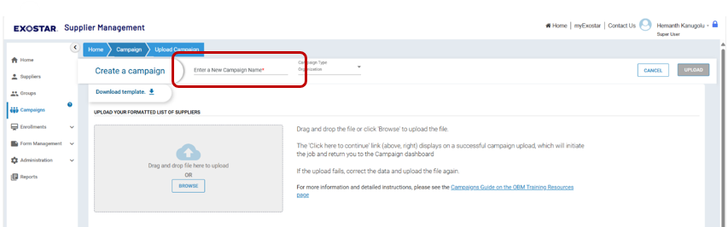
- Drag and drop the supplier file or click the Browse button to add the file.
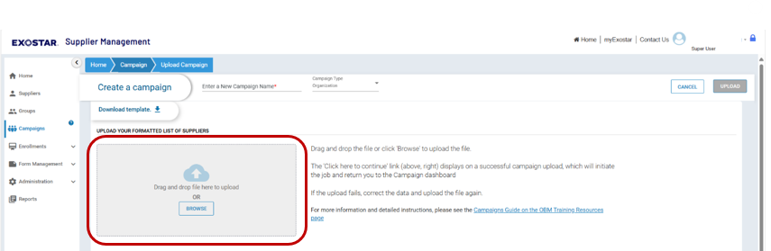

- Once you add the CSV (comma delimited) file, select the Click here to continue link (above, right).
NOTE: This link displays on a successful campaign upload, which will initiate the job and return you to the Campaigns dashboard.
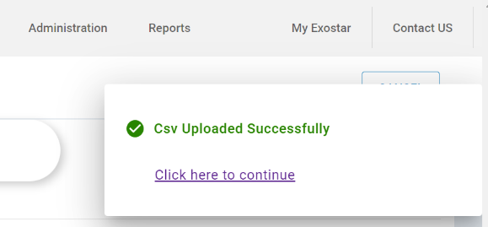

- If the upload fails, correct the data and upload the file again.
NOTE: Please see the Common Input Errors and Important Input Notes section below for more information.

Step 3. Curate (Validate) Suppliers
Once the campaign status changes to Pending Data Review, you must validate each supplier against the data pulled from the Exostar system. The system provides a percentage match for your review, based on the data you input in the CSV file.

To validate suppliers:
- On the Campaigns dashboard, click the Resolve button.
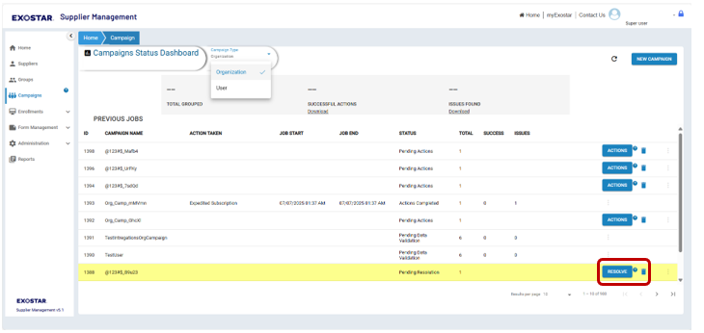

NOTE: Clicking the Resolve button navigates to the Data Review tab. Errored records display in the Data Review tab.
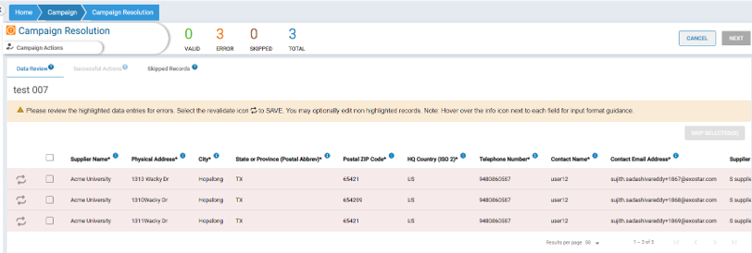

- The fields with issues are highlighted in red. Click on the affected field to enter edit mode. Fix the issue. Click the check mark once the field is corrected.
NOTE: The info icons on the headers give an overview of the validation criteria. There are tooltips as well to guide on the validation rules.
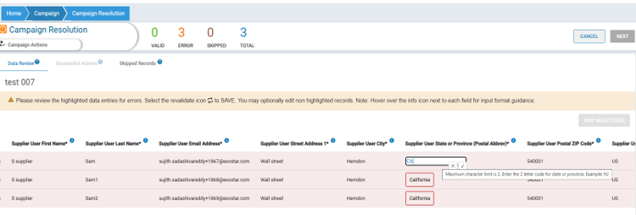
- Once the corrected data is entered, click the Revalidate to Save icon.
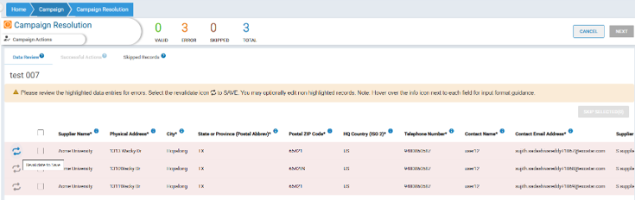

- To skip records, place a checkmark next to each desired row. Click Skip Selected.
NOTE: These rows will be added to the Skipped Records tab.
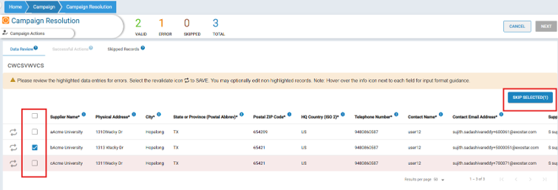

- Once all records are revalidated or skipped, the Next button becomes enabled. Click Next.
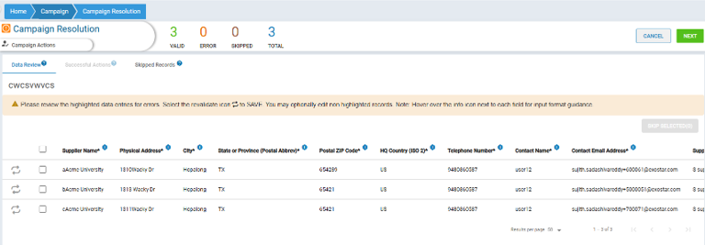

- The system navigates to the Successful Actions to for you to review and select matching records.
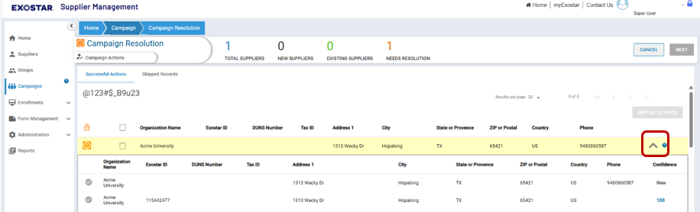

- Review the list of suppliers.
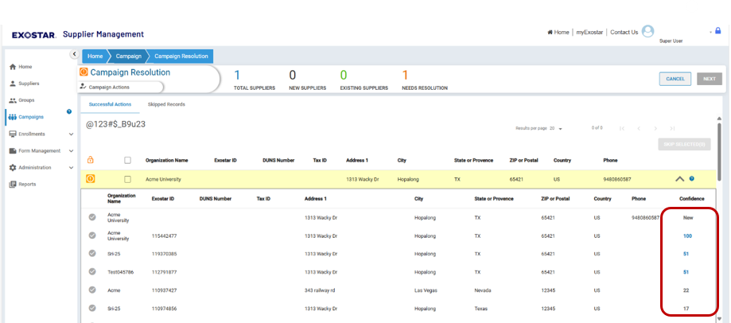

- Select the desired row. Click Next.
NOTE: If the organization you wish to invite does not get a desired match, select the first row to create an entirely new organization. A new organization does not have an Exostar ID.
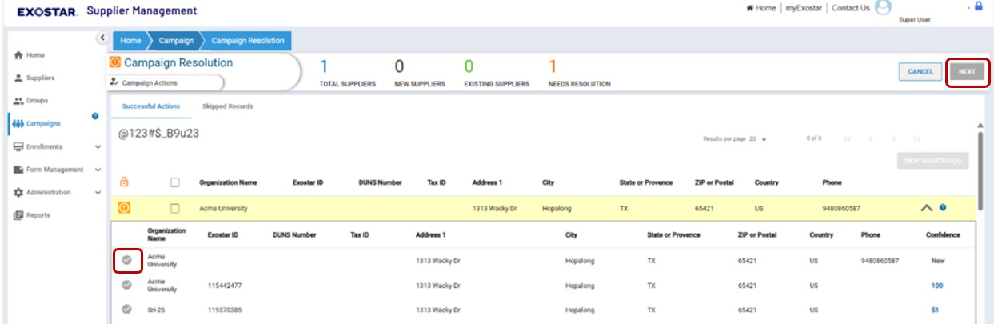

Step 4. Choose Subscription Action
Now that you selected to subscribe an existing organization or create an entirely new one, you must select the desired action. The following options are available, and each process is outlined below:
- Expedited Subscription: This option invites the supplier to access other applications.
- Qualified Subscription: This option invites the supplier to access SM and assigns a form, as well as provide access to other applications post approval.
- Assign Form: This option invites the supplier to access SM and assigns a form.
- External Source Name: To provision users to an application, you must first select their external source name from the MAG application.

Expedited Subscription
To complete the Expedited Subscription process:
- On the Expedited Subscription screen, place checkmarks next to the desired applications. Click Start.
NOTE: Only applications for which you are designated as the Adoption Administrator display.
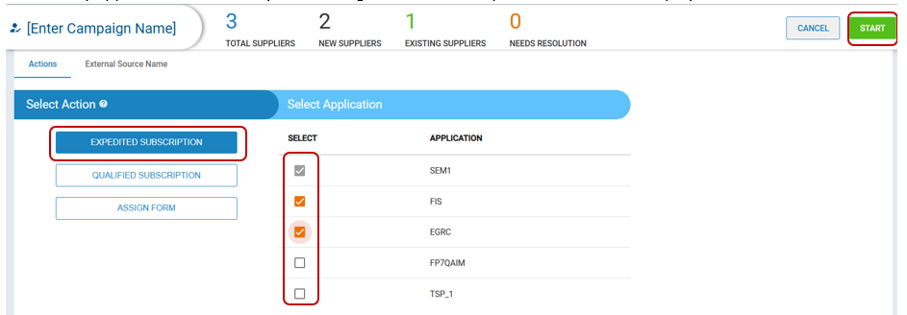

- The system will navigate to the Campaigns board and show the status as Actions in Progress. Refresh the page until Actions Completed displays.
- Select the menu at the end of the row to display a graph of how many records were successful or had issues.
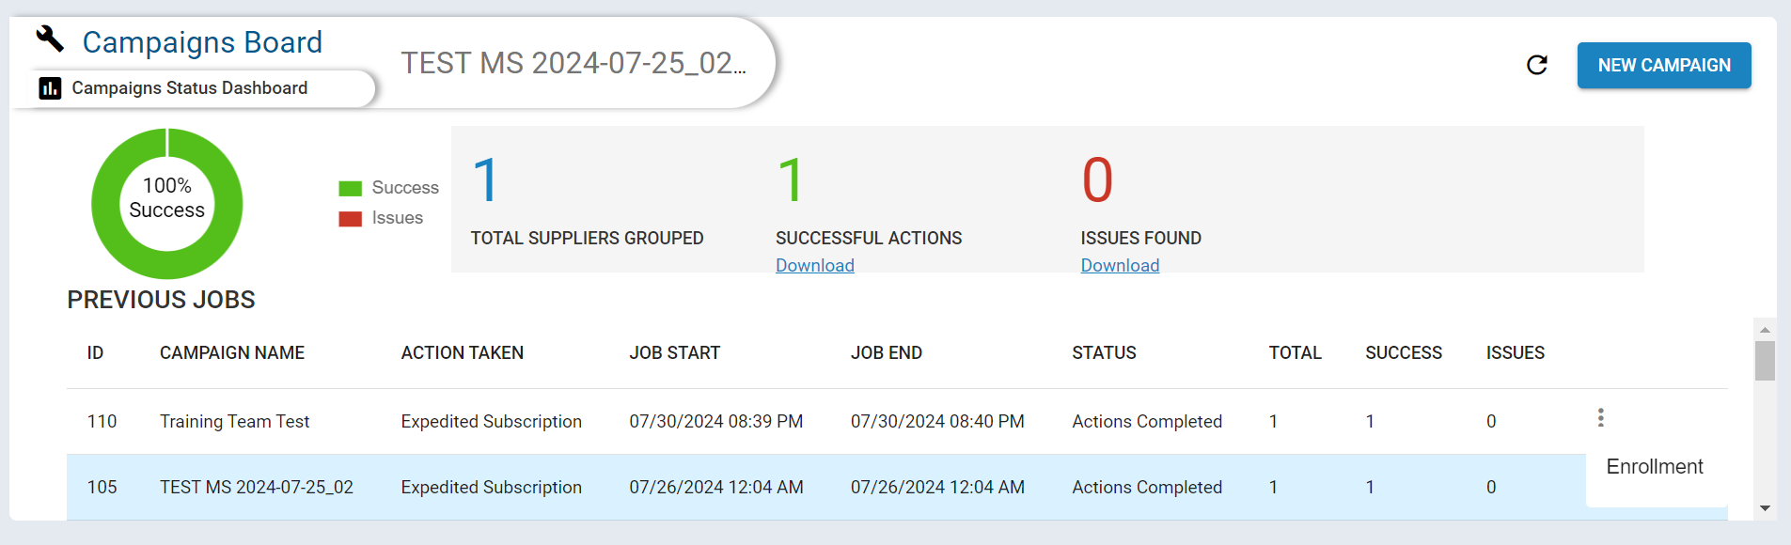
NOTE: There is an option to download successful enrollments, as well as an errors download. The issues file displays errors in the AB column.
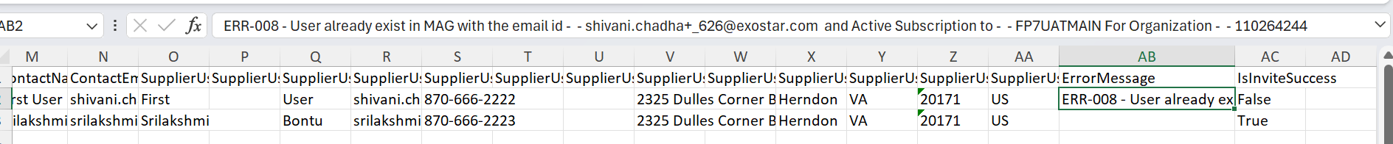

Qualified Subscription
To complete a Qualified Subscription:
- From the Select Action section, click Qualified Subscription.
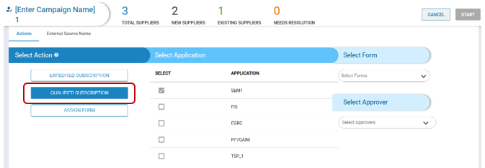

- Place checkmarks next to the desired applications.
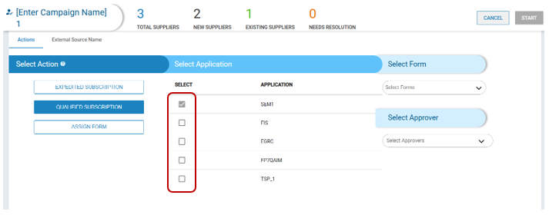

- Select the desired forms.
- Select the desired approvers.
- Once you have completed all selections, click Start.
NOTE: The button remains greyed out until all selections are made.
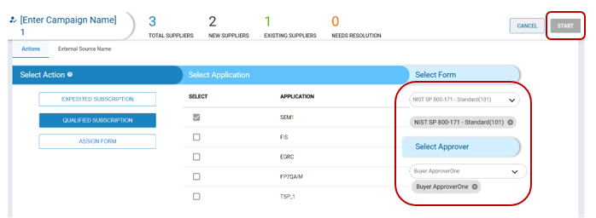

- The system will navigate to the Campaigns board and show the status as Actions in Progress. Refresh the page until Actions Completed displays.

- Select the menu at the end of the row to display a graph of how many records were successful or had issues.

NOTE: There is an option to download successful enrollments, as well as an errors download. The issues file displays errors in the AB column.

Assign Form
To assign a form:
- From the Select Action section, click Assign Form.
- Select the desired form. Click Start.
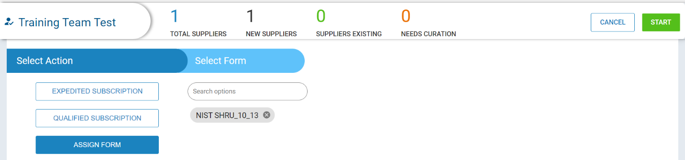

- The system will navigate to the Campaigns board and show the status as Actions in Progress. Refresh the page until Actions Completed displays.

- Select the menu at the end of the row to display a graph of how many records were successful or had issues.

NOTE: There is an option to download successful enrollments, as well as an errors download. The issues file displays errors in the AB column.

External Source Name
To select external source name:
- From the Select External Source Name section.
- Select from dropdown.
- Navigate back to actions.
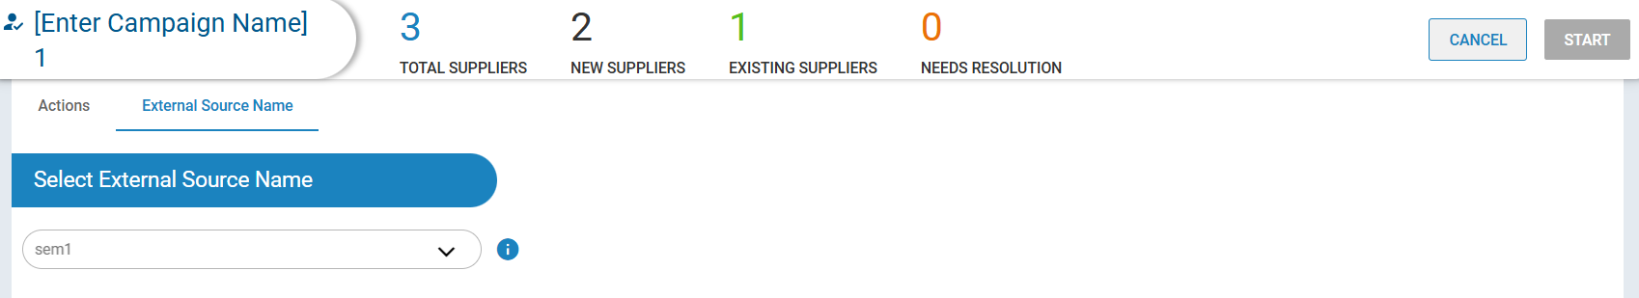

Step 5. Check Enrollment
The Enrollments tab provides invitation progress information. To check the status of an invitation:

- Click the action menu from the desired row. Click Enrollment.

- Review the progress of the campaign.
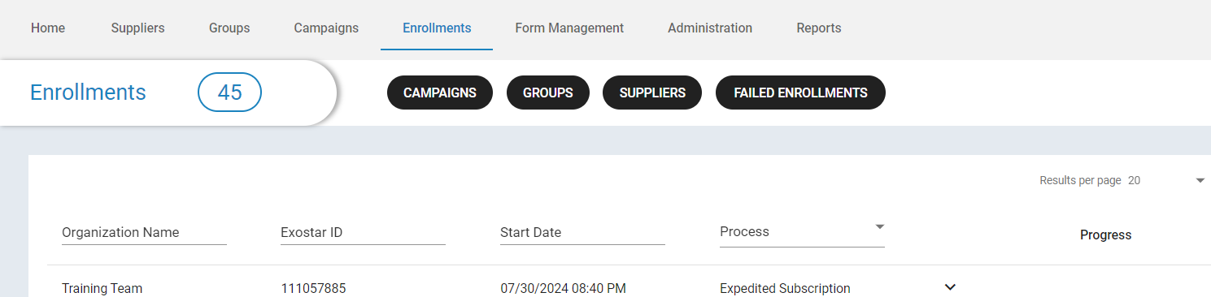

NOTE: Select Failed Enrollments to view failed invitations. Hover over the information icon to see the failed reason. The same error will be inserted in the campaign column AB as well when you download the issues file.
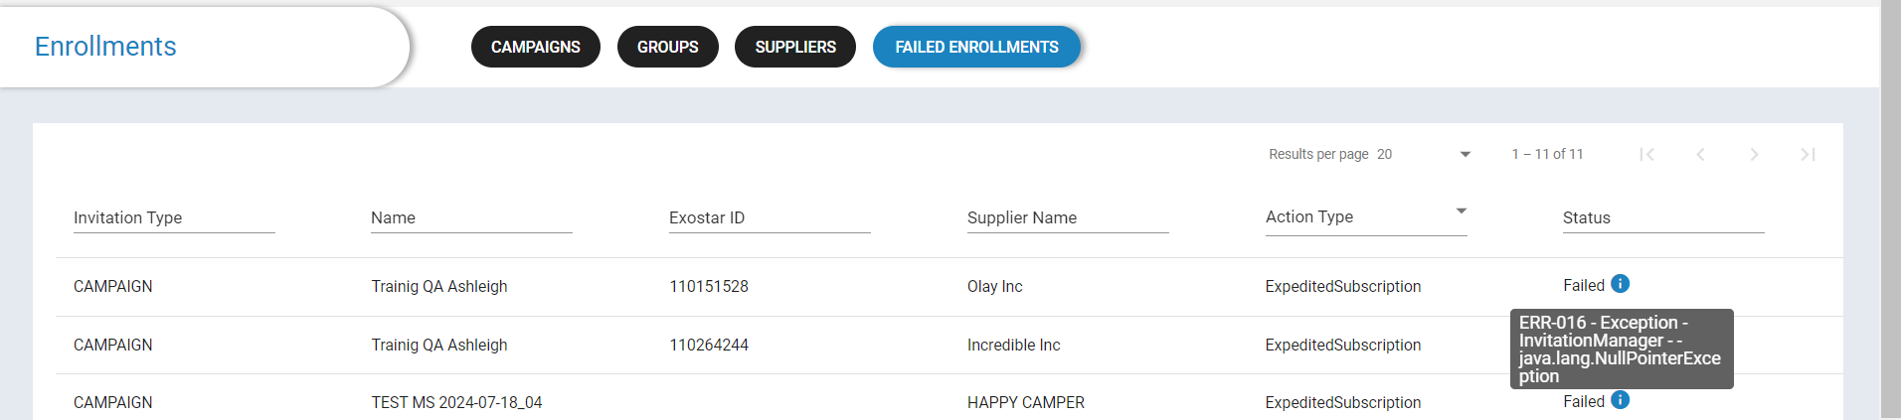

Appendix A: Country Codes
Country | Abbreviation | Country | Abbreviation
Afghanistan | AF | Lesotho | LS
Aland Islands | AX | Liberia | LR
Albania | AL | Libyan Arab Jamahiriya | LY
Algeria | DZ | Liechtenstein | LI
American Samoa | AS | Lithuania | LT
Andorra | AD | Luxembourg | LU
Angola | AO | Macao | MO
Anguilla | AI | Macedonia, The Former Yugoslav Republic Of | MK
Antarctica | AQ | Madagascar | MG
Antigua And Barbuda | AG | Malawi | MW
Argentina | AR | Malaysia | MY
Armenia | AM | Maldives | MV
Aruba | AW | Mali | ML
Australia | AU | Malta | MT
Austria | AT | Marshall Islands | MH
Azerbaijan | AZ | Martinique | MQ
Bahamas | BS | Mauritania | MR
Bahrain | BH | Mauritius | MU
Bangladesh | BD | Mayotte | YT
Barbados | BB | Mexico | MX
Belarus | BY | Micronesia, Federated States Of | FM
Belgium | BE | Moldova | MD
Belize | BZ | Monaco | MC
Benin | BJ | Mongolia | MN
Bermuda | BM | Montenegro | ME
Bhutan | BT | Montserrat | MS
Bolivia | BO | Morocco | MA
Bosnia and Herzegovina | BA | Mozambique | MZ
Botswana | BW | Myanmar | MM
Bouvet Island | BV | Namibia | NA
Brazil | BR | Nauru | NR
British Indian Ocean Territory | IO | Nepal | NP
Brunei Darussalam | BN | Netherlands | NL
Bulgaria | BG | New Caledonia | NC
Burkina Faso | BF | New Zealand | NZ
Burundi | BI | Nicaragua | NI
Cambodia | KH | Niger | NE
Cameroon | CM | Nigeria | NG
Canada | CA | Niue | NU
Cape Verde | CV | Norfolk Island | NF
Cayman Islands | KY | Northern Mariana Islands | MP
Central African Republic | CF | Norway | NO
Chad | TD | Oman | OM
Chile | CL | Pakistan | PK
China | CN | Palau | PW
Christmas Island | CX | Palestinian Territory, Occupied | PS
Cocos (Keeling) Islands | CC | Panama | PA
Colombia | CO | Papua New Guinea | PG
Comoros | CM | Paraguay | PY
Congo | CG | Peru | PE
Congo, The Democratic Republic of | CD | Philippines | PH
Cook Islands | CK | Pitcairn | PN
Cook Islands | CR | Poland | PL
Cote D'Ivoire | CI | Portugal | PT
Croatia | HR | Puerto Rico | PR
Cuba | CU | Qatar | QA
Cyprus | CY | Reunion | RE
Czech Republic | CZ | Romania | RO
Denmark | DK | Russian Federation | RU
Djibouti | DJ | Rwanda | RW
Dominica | DM | Saint Barthelemy | BL
Dominican Republic | DO | Saint Helena | SH
Ecuador | EC | Saint Kitts And Nevis | KN
Egypt | EG | Saint Lucia | LC
El Salvador | SV | Saint Martin | MF
Equatorial Guinea | GQ | Saint Pierre And Miquelon | PM
Eritrea | ER | Saint Vincent And The Grenadines | VC
Estonia | EE | Samoa | WS
Ethiopia | ET | San Marino | SM
Falkland Islands (Malvinas) | FK | Sao Tome And Principe | ST
Faroe Islands | FO | Saudi Arabia | SA
Fiji | FJ | Senegal | SN
Finland | FI | Serbia | RS
France | FR | Seychelles | SC
French Guiana | GF | Sierra Leone | SL
French Polynesia | PF | Singapore | SG
French Southern Territories | TF | Slovakia | SK
Gabon | GA | Slovenia | SI
Gambia | GM | Solomon Islands | SB
Georgia | GE | Somalia | SO
Germany | DE | South Africa | ZA
Ghana | GH | South Georgia And The South Sandwich Islands | GX
Gibraltar | GI | Spain | ES
Greece | GR | Sri Lanka | LK
Greenland | GL | Sudan | SD
Grenada | GD | Suriname | SR
Guadeloupe | GP | Svalbard And Jan Mayen | SJ
Guam | GU | Swaziland | SZ
Guatemala | GT | Sweden | SE
Guernsey | GG | Switzerland | CH
Guinea | GN | Syrian Arab Republic | SY
Guinea-Bissau | GW | Taiwan | TW
Guyana | GY | Tajikistan | TJ
Haiti | HT | Tanzania, United Republic Of | TZ
Heard Island and McDonald Islands | HM | Thailand | TH
Holy See (Vatican City State) | VA | Timor-Leste | TL
Honduras | HN | Togo | TG
Hong Kong | HK | Tokelau | TK
Hungary | HU | Tonga | TO
Iceland | IS | Trinidad And Tobago | TT
India | IN | Tunisia | TN
Indonesia | ID | Turkey | TR
Iran, Islamic Republic of | IR | Turkmenistan | TM
Iraq | IQ | Turks And Caicos Islands | TC
Ireland | IE | Tuvalu | TV
Isle Of Man | IM | Uganda | UG
Israel | IL | Ukraine | UA
Italy | IT | United Arab Emirates | AE
Jamaica | JM | United Kingdom | GB
Japan | JP | United States | US
Jersey | JE | United States Minor Outlying Islands | UM
Jordan | JO | Uruguay | UY
Kazakhstan | KZ | Uzbekistan | UZ
Kenya | KE | Vanuatu | VU
Kiribati | KI | Venezuela | VE
Korea, Democratic People's Republic Of | KP | Viet Nam | VN
Korea, Republic Of | KR | Virgin Islands, British | VG
Kuwait | KW | Virgin Islands, U.S. | VI
Kyrgyzstan | KG | Wallis And Futuna | WF
Lao People's Democratic Republic | LA | Western Sahara | EH
Latvia | LV | Yemen | YE
Lebanon | LB | Zambia | ZM
 |  | Zimbabwe | ZW

Appendix B: Common Input Errors
Please see common input errors:
- Do NOT change the format of the supplier data tab as this a fixed template and the data will be loaded in error if it is changed
- The system will only load 201 rows of data which includes the first row
- Avoid leading and trailing white spaces. This commonly occurs when copying and pasting data. Leading and trailing whitespaces surrounding all fields shall be trimmed (ignored).
- Ensure you complete ALL required fields, denoted with an asterisk. An error will occur if required fields are missing.
- Phone Numbers should ONLY include numbers, plus +, and dash - but no brackets [ () ]
- Empty and all blank rows shall be ignored.
- Lines starting with -- (2 hyphens) shall be ignored and can be used for comments.
- The supported character encodings are: utf-8, utf-16, utf-16be, utf-16le.
- The supported character set is ASCII-7.
- Characters outside the specified character set shall be flagged as errors and not read.

