
Last Updated 09/17/25

LM Procure to Pay
Quick Reference Guide
For Suppliers

Locating the status of an
Invoice in
LM eInvoicing

Procedure

This quick reference guide navigates through the process of locating the status of an invoice within the LM eInvoicing Application.

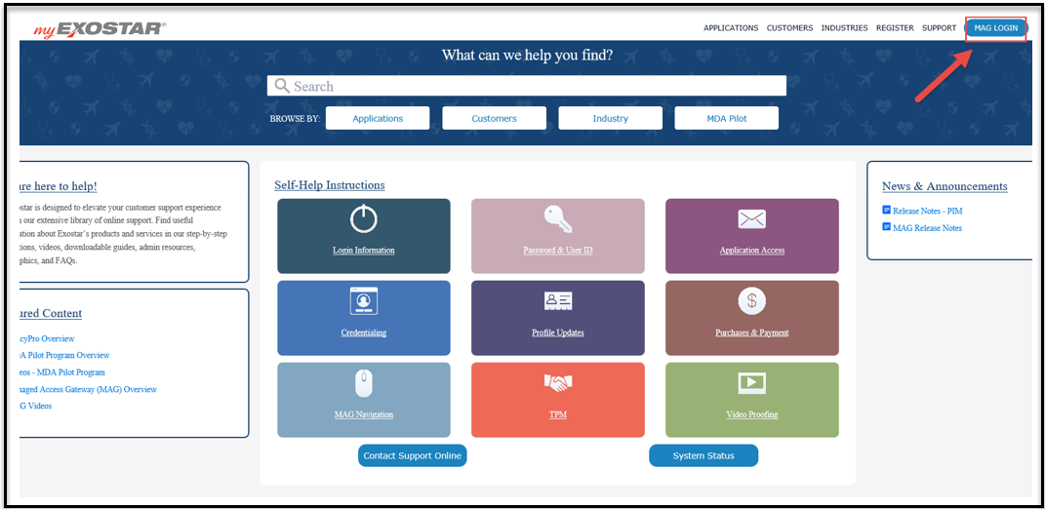

Step | Action
Log into Exostar using Internet Explorer at https://my.exostar.com/
When the screen above appears, click on the MAG LOGIN link at the top right of the page

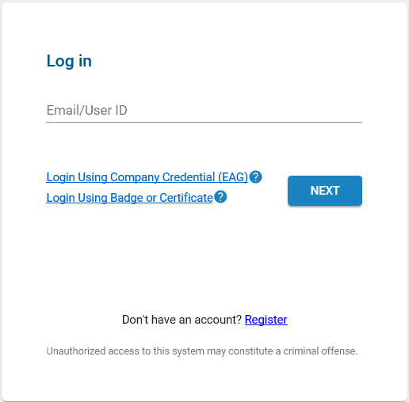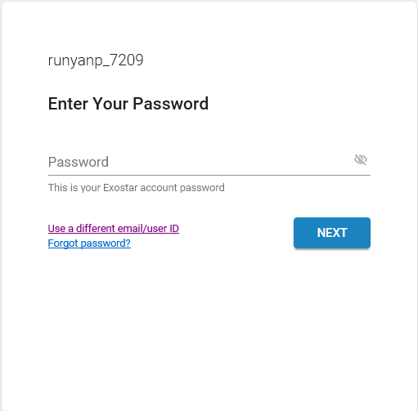

Step | Action
Enter your User ID and click Next
Enter your Password and click Next

*For issues logging in or help with user ID/Password, contact Exostar support at: https://my.exostar.com/display/TE/Support

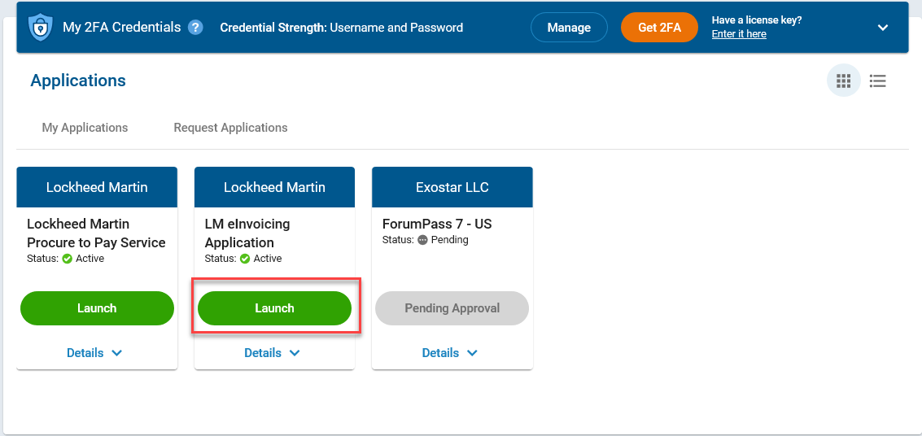

Step | Action
3. | Click the Launch button under LM eInvoicing Application

Step | Action
4. | Authenticate using an approved credential (e.g. Hardware token, Mobile ID, etc.) Complete 2FA login and click on Next.

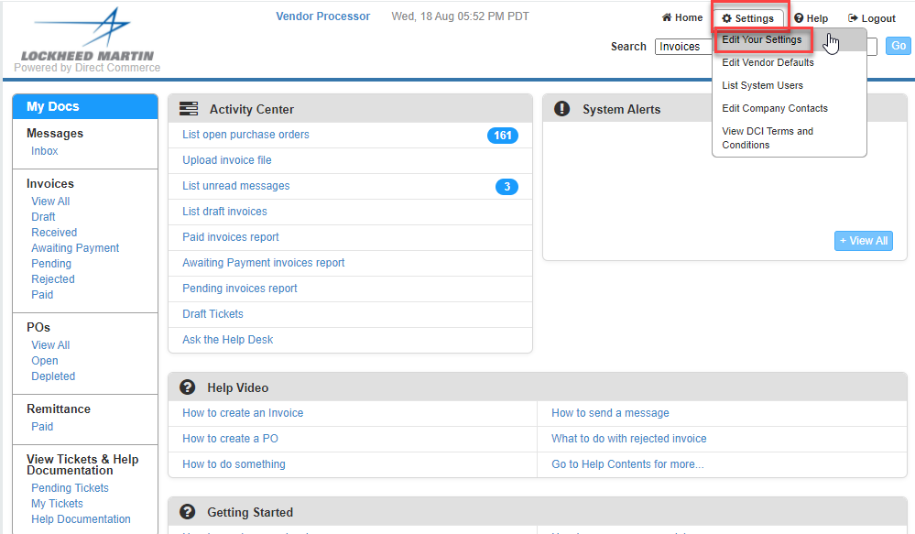

Step | Action
5. | First time users will be asked to update User Information
6. | Click Settings>Edit Your Settings. Update name, email address and phone number.

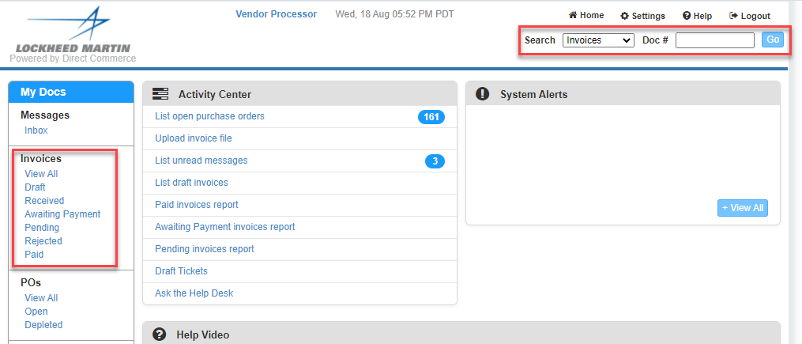

Step | Action
7. | To locate the status of an invoice:  - You can search using the various statuses under Invoices located on the left-hand side of the screen.  - If you know the Invoice number, you can also use the Search at the top of the page. Type the Invoice number in the Doc# field, change the drop down to “Invoice” and click Go.  - You can also search for invoices under a Purchase Order by changing the drop-down search to PO and entering the PO number. This will display all invoices under that Purchase Order.

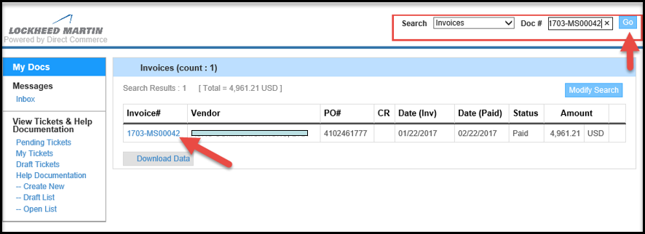

Step | Action
8. | Once you locate the invoice, click on the Invoice Number to get to the invoice details

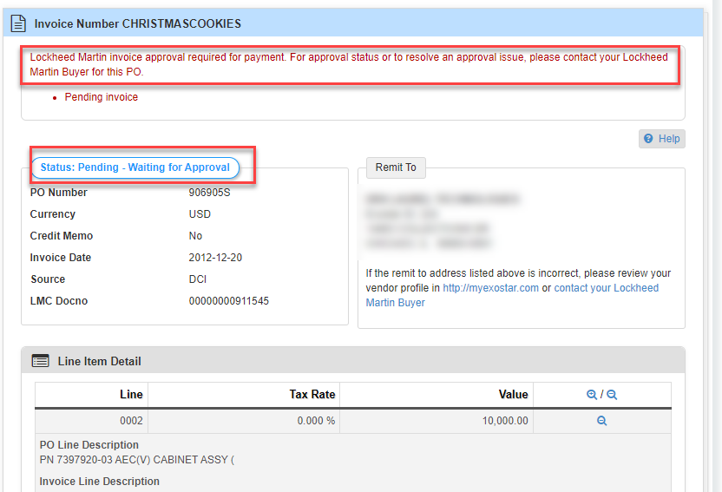

Step | Action
9. | The invoice status displays at the top of the invoice  - Pending Invoices will give a pending reason and corrective action required to clear the issue.

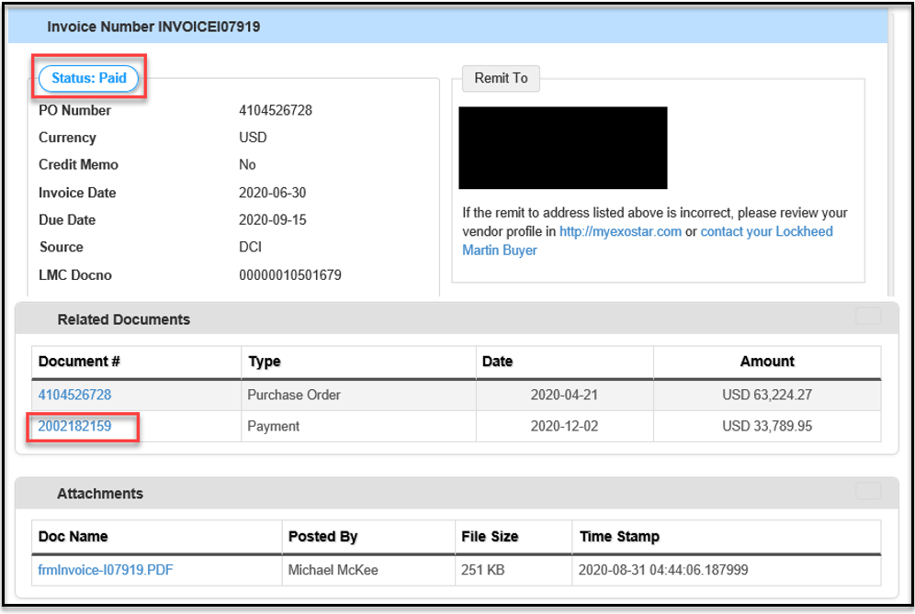

Step | Action
9a. | The invoice status displays at the top of the invoice  - Paid Invoices will show payment details by clicking into the Payment Document number located under Related Documents.

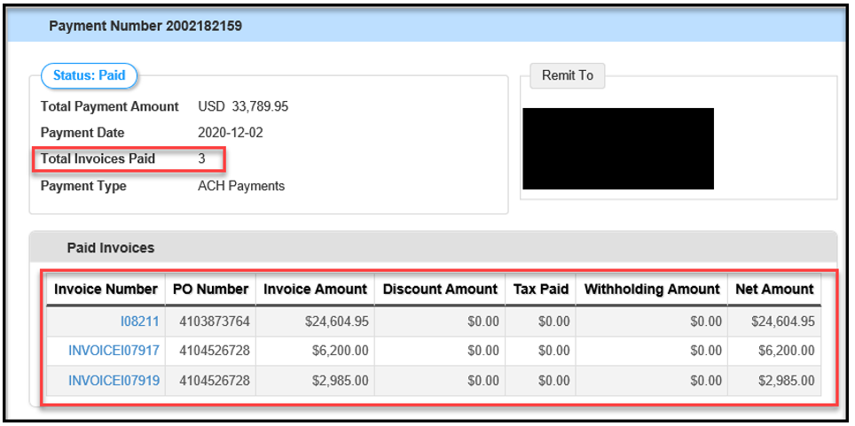

Step | Action
10. | Inside the Payment document, information on the specifics of the payment are provided.

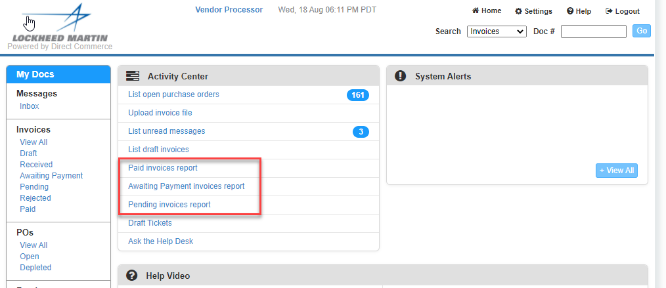

Step | Action
11. | Invoice Status can also be seen by using the Paid, Awaiting Payment and Pending Invoices Reports located from the home page:  - The Paid Invoices report will contain invoices with status “Paid” and will provide paid invoice data for the past 30 days, based on the Paid date  - The Pending Invoices report will contain invoices with status “Pending” and “Received”  - The Awaiting Payment Invoices report will contain invoices with statuses of “Awaiting Payment”  *Note: these reports can be downloaded into Excel by clicking the Download Data button

Helpful Tips and Frequently Asked Questions

Why hasn’t my invoice status changed?
Current invoice status is updated overnight. For example, if you submit an invoice in the morning, the status will not change from “received” until the next business day.

I submitted an invoice on Friday at 6pm EST; why is the received date reflecting the following Monday?
Invoices submitted after 3 pm EST will not be picked up until the following business day. If submitted on Friday after 3pm the invoice will not show as received until the following Monday.
What if my invoice gets rejected via the LM eInvoicing Application?
If you have questions about why an invoice was rejected, create a ticket via the ticketing tool to the LMP2P Help Desk asking for the reason. The help desk will get back to you within 24 business hours of your request. Some typical reasons why your invoice might be rejected include:
- Supplier submitted the wrong invoice amount.
- Lockheed Martin considers the invoice a duplicate of an invoice previously submitted

If you can’t locate your Purchase Order within the LM eInvoicing Application:
Check to make sure that your user id is associated to the same vendor number that your Purchase Order has been issued to
You can see what vendor number you are logged into by clicking on the Home Tab in LMP2P. Your vendor number and vendor name will be listed in the center of the page (LMxxxxxxx)

Help Documentation can be located under View Tickets and Help Documentation or under the “Ask the Help Desk” link.
Narrow your Help Search by category
Create a ticket that will route to the LMP2P Help Desk and be answered within 24 business hours

What is the ticketing tool (Ask the Help Desk) and why do I want to use it?
- The ticketing tool is an easy way to get quick answers to your questions. There are multiple FAQ’s and Help Documents posted in the eInvoicing Application. If the help documents do not answer your question, you can create a ticket that is routed to the LMP2P Help Desk. It is the fastest way for you to get a response from Lockheed Martin. However, you need to make sure you have completed your contact information under Settings.

An Invoice in a “Draft” Status has not been submitted to LMCO for payment and is not visible to Accounts Payable.
To submit: click on “Draft” under Invoices and then click on submit from within the invoice.
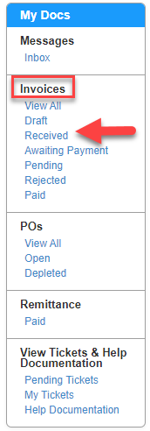

What is the process for generating Evaluated Receipt Settlement (ERS) Invoice numbers?

- ERS Invoice numbers are systematically generated upon receipt of goods/materials and will not match your company’s invoice number. ERS Invoice numbers are typically 10 digits and start with a 52 (i.e.: 52xxxxxxxx). Payment details are available within the LM eInvoicing Application. You can search for payment details by entering the Lockheed Martin generated invoice number (52xxxxxxxx) in the quick search or by searching by the Purchase Order (PO) number.
Note: when searching by PO, if no invoices appear and material has been shipped, please contact your LM buyer and provide them with Proof of Delivery (POD).

More FAQ’s:
LM eInvoicing Supplier Frequently Asked Questions
LM eInvoicing FAQs

LM Accounts Payable Frequently Asked Questions
LM Accounts Payable FAQs

