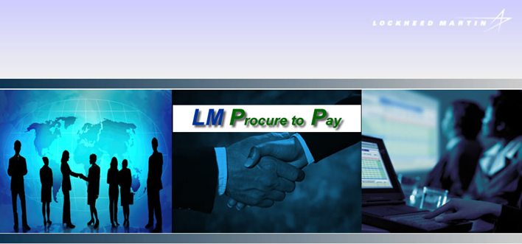
Last Updated 09/17/25

LM Procure to Pay
Quick Reference Guide
For Suppliers

Locating payment details in
LM eInvoicing

Procedure

This quick reference guide navigates through the process of locating payment details within the LM eInvoicing Application.

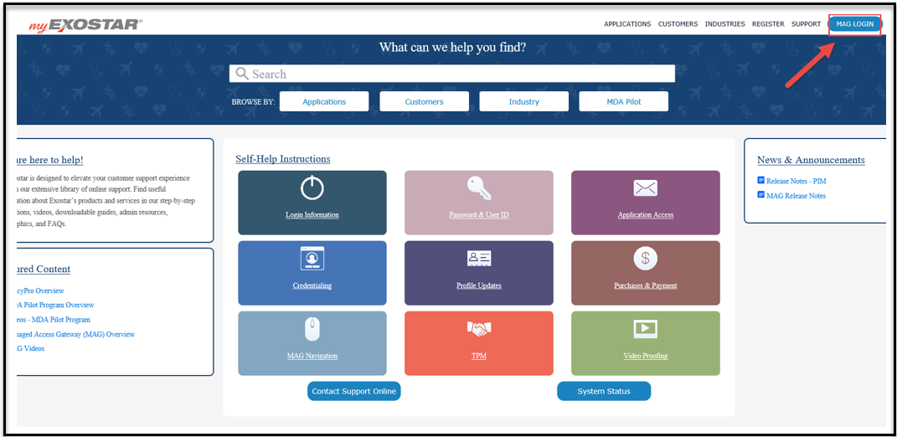

Step | Action
Log into Exostar at https://my.exostar.com/
When the screen above appears, click on the MAG LOGIN link at the top right of the page

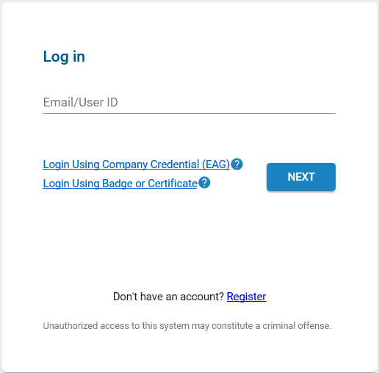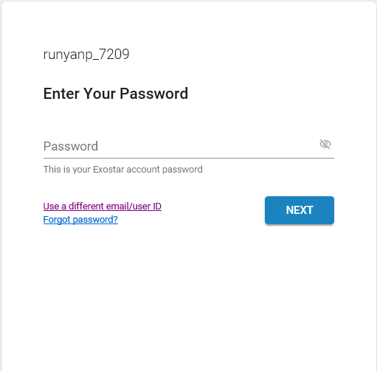

Step | Action
Enter your User ID and click Next
Enter your Password and click Next
*For issues logging in or help with user ID/Password, contact Exostar support at: https://my.exostar.com/display/TE/Support

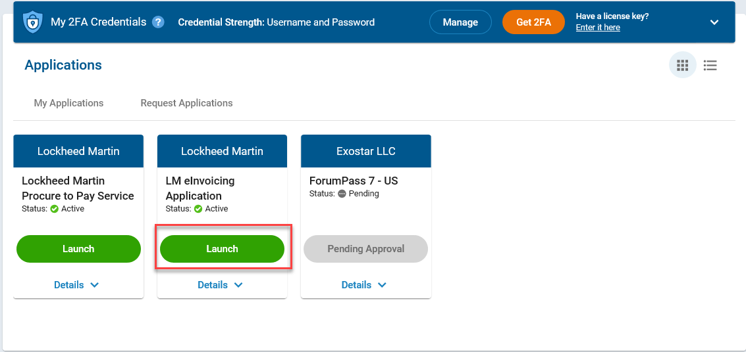

Step | Action
3. | Click the Launch button under LM eInvoicing Application

Step | Action
4. | Authenticate using an approved credential (e.g. Hardware token, Mobile ID, etc.) Complete 2FA login and click on Next.

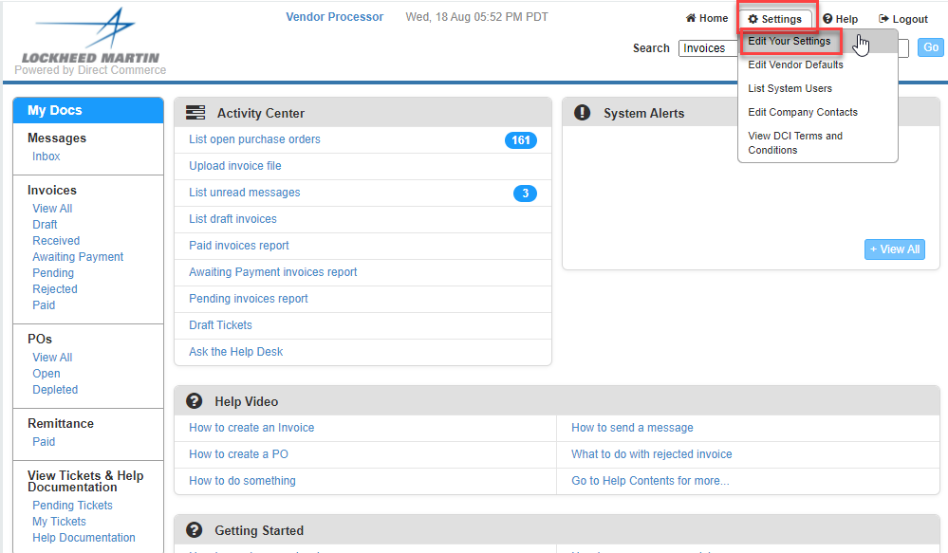

Step | Action
5. | First time users will be asked to update User Information
6. | Click Settings>Edit Your Settings. Update name, email address and phone number.

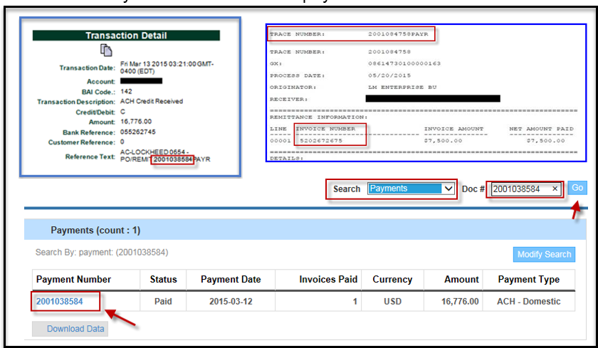

Step | Action
7. | You can locate payment details by utilizing the Transaction Details received from your bank remittance advice. The PO/Remit Number, Trace Number or PAYR # are payment identification details that can be used to locate details of a payment within the LM eInvoicing Application.  - From the Search menu (top right of screen) choose Payments and then enter the PO/Remit Number, Trace Number or PAYR # in the Doc # field and click “GO”. If the details also contain an invoice number, you can search by the invoice number using the Search menu and choose Invoices.  - Click on the Payment number to view the details of the payment.

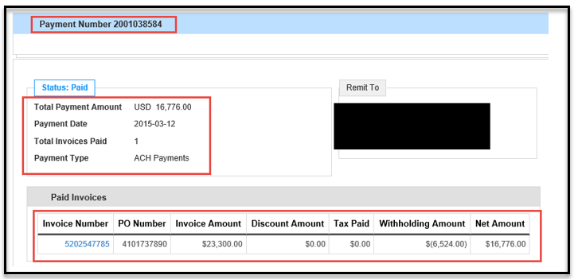

Step | Action
8. | Once inside the Payment document, information on the specifics of the payment are provided in the middle of the screen

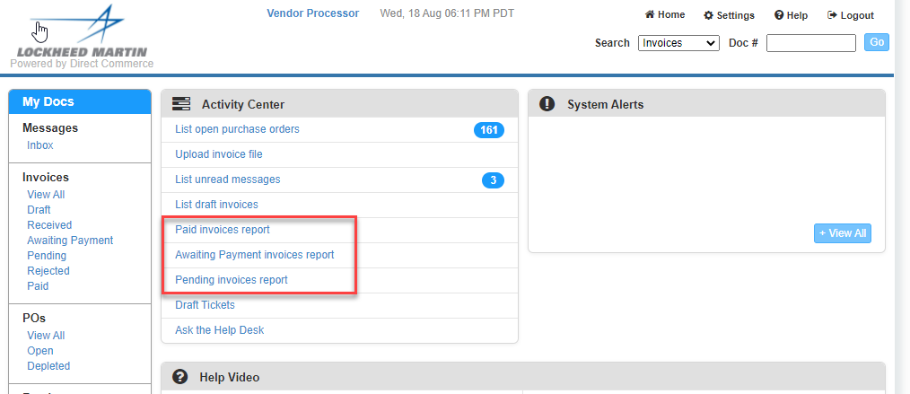

Step | Action
9. | Payment details can also be seen by using the Paid Invoices Reports located from the home page. The Paid Invoices report will contain invoices with status “Paid” and will show paid invoice data for the past 30 days, based on the Paid date  *Note: this report can be downloaded into Excel by clicking the Download Data button

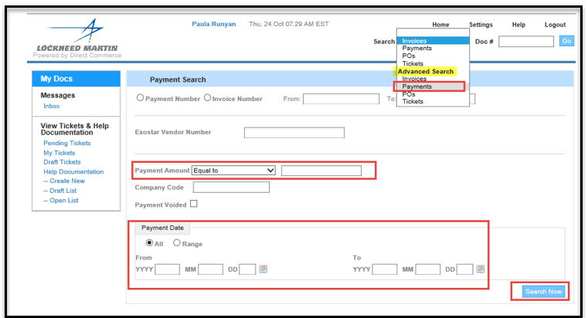

Step | Action
10. | You may also use the “Payments” option under the Advanced Search located in the Search Field to filter your search or run a custom report. Under the Payment Amount, choose the “Equal to” in the drop down and then enter the exact payment amount received.  You can also run a custom report under Payment Date to see all payments received in a specific range. Click the radial button next to Range and use the calendar icons to enter the From and To dates and click on Search Now  You can also choose ALL to see all payments issued to your company.  *Note: these reports can be downloaded into Excel by clicking the Download Data button

Frequently Asked Questions

What is the process for generating Evaluated Receipt Settlement (ERS) Invoice numbers?
- ERS Invoice numbers are systematically generated upon receipt of goods/materials and will not match your company’s invoice number. ERS Invoice numbers are typically 10 digits and start with a 52 (i.e.: 52xxxxxxxx). Payment details are available within the LM eInvoicing Application. You can search for payment details by entering the Lockheed Martin generated invoice number (52xxxxxxxx) in the quick search or by searching by the Purchase Order (PO) number.

Help Documentation can be located under View Tickets and Help Documentation or under the “Ask the Help Desk” link.
- Narrow your Help Search by category
- Create a ticket that will route to the LMP2P Help Desk and be answered within 24 business hours

What is the ticketing tool (Ask the Help Desk) and why do I want to use it?
- The ticketing tool is an easy way to get quick answers to your questions. There are multiple FAQ’s and Help Documents posted in the eInvoicing Application. If the help documents do not answer your question, you can create a ticket that is routed to the LMP2P Help Desk. It is the fastest way for you to get a response from Lockheed Martin. However, you need to make sure you have completed your contact information under Settings.

More FAQ’s:
LM eInvoicing Supplier Frequently Asked Questions
LM eInvoicing FAQs

LM Accounts Payable Frequently Asked Questions
LM Accounts Payable FAQs

