
Last Updated 9/17/25

LM Procure to Pay
Quick Reference Guide
For Suppliers

Creating an invoice in
LM eInvoicing

Procedure

This quick reference guide navigates through the process of creating an invoice within the LM eInvoicing Application.

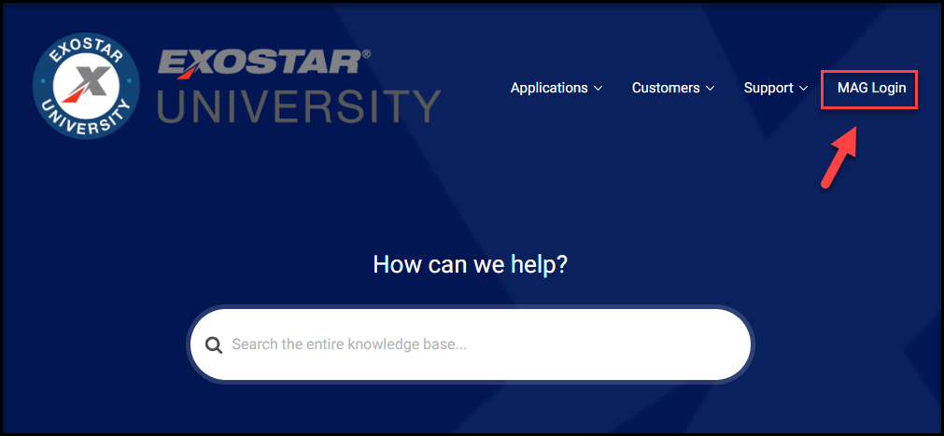

Step | Action
Log into Exostar at https://my.exostar.com/
When the screen above appears, click on the MAG LOGIN link at the top right of the page

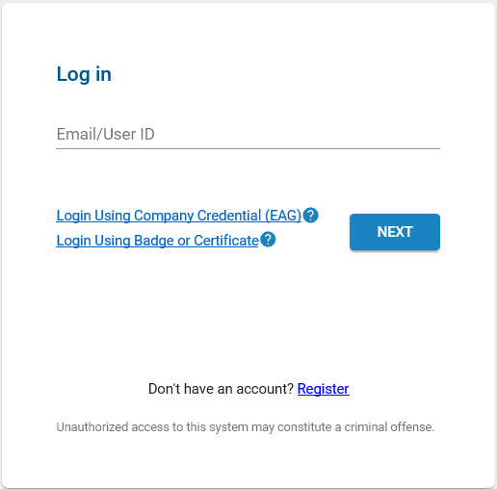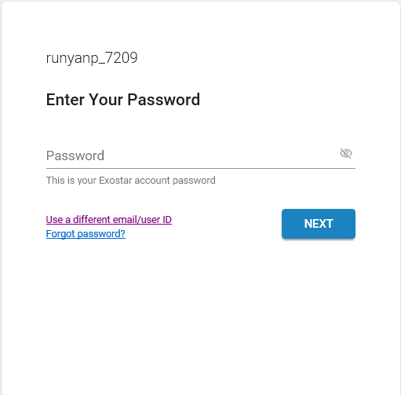

Step | Action
Enter your User ID and click Next
Enter your Password and click Next

*For issues logging in or help with user ID/Password, contact Exostar support at: https://my.exostar.com/display/TE/Support

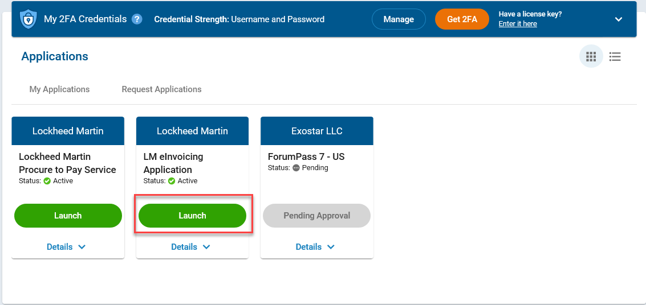

Step | Action
3. | Click the Launch button under LM eInvoicing Application

Step | Action
4. | Authenticate using an approved credential (e.g. Hardware token, Mobile ID, etc.) Complete 2FA login and click on Next.

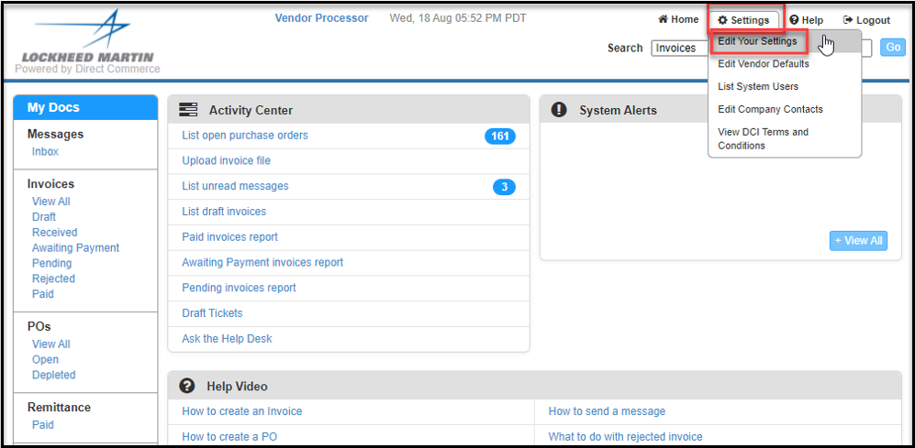

Step | Action
5. | First time users will be asked to update User Information
6. | Click Settings>Edit Your Settings. Update name, email address and phone number.

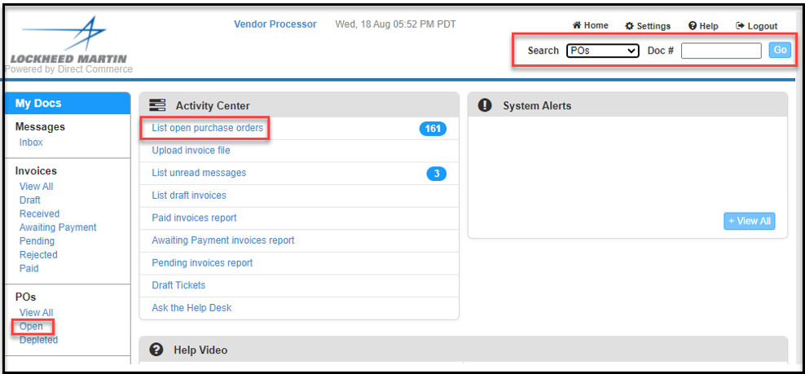

Step | Action
7. | To locate a PO to bill as an invoice, you can either click on the link in the Activity Center List Open Purchase Orders or you can click the Open link under the POs List.  In addition, if you know the PO number, you can also use the Search at the top of the page. Type in the PO number in the Doc# filed, change the drop down to “POs” and click Go.

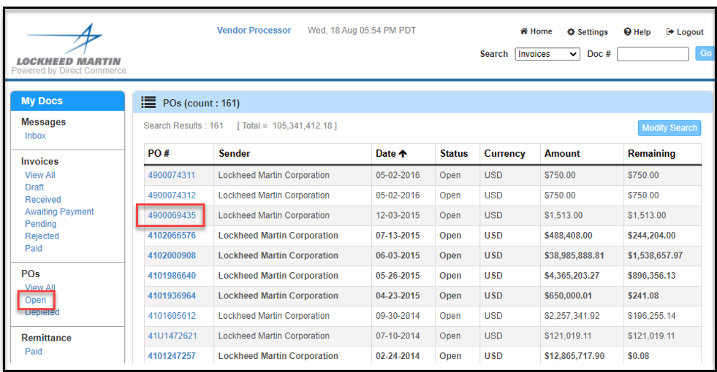

Step | Action
8. | Here you will see the purchase orders from Lockheed Martin which are open and ready for invoice submittal. To select a PO, click on the link in the PO # column.

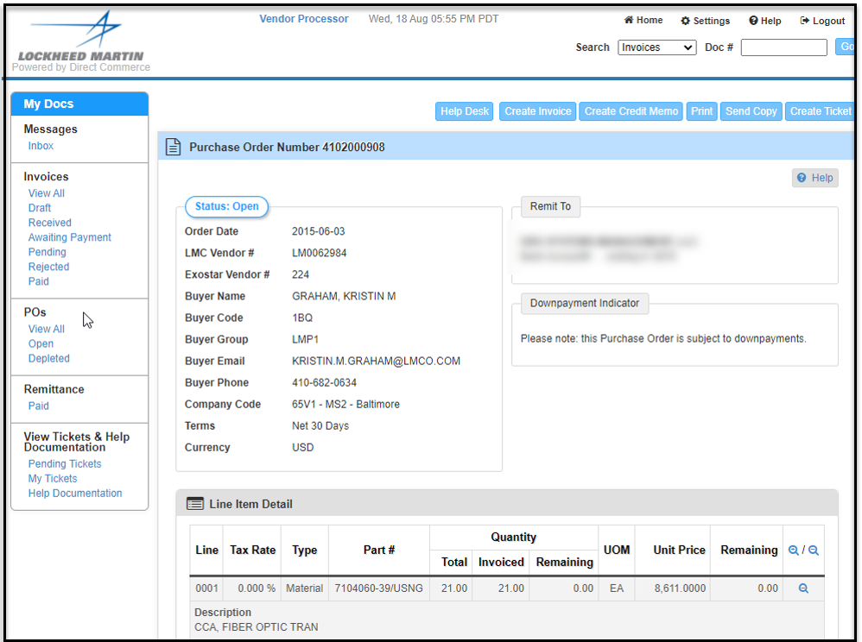

Step | Action
9. | The top of the screen displays the PO header information.
10. | The lower half of the screen displays the PO line information.

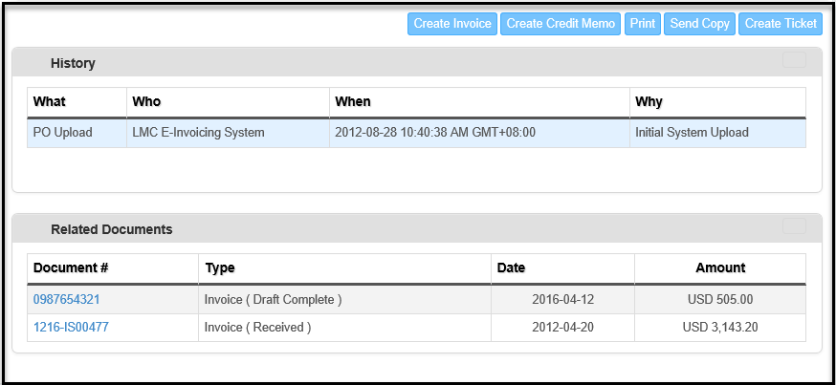

Step | Action
11. | The History section shows the history of the PO, which are all the changes that have been made to this PO by the Buyer.
12. | The Related Documents section shows all invoices that have been submitted against this PO.

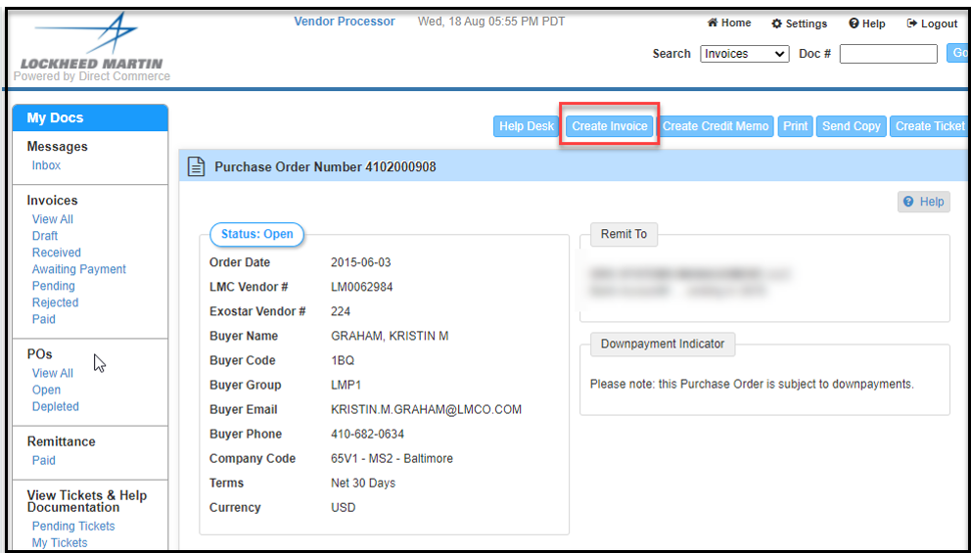

Step | Action
13. | When you are ready to submit an invoice, click on the Create Invoice button

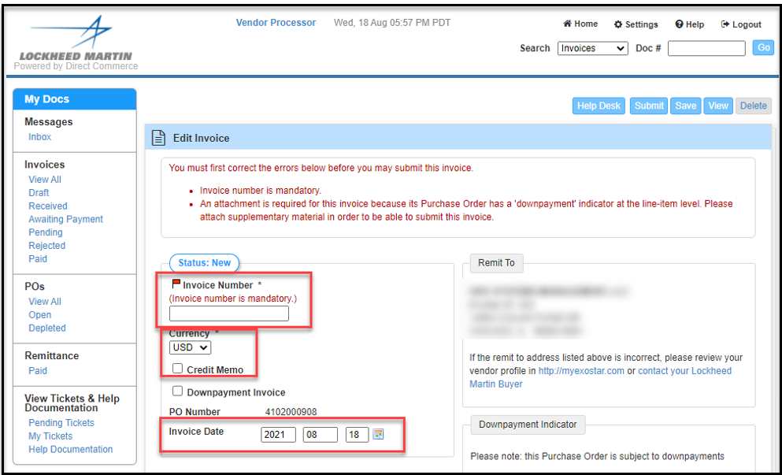

Step | Action
14. | Follow these steps to submit an invoice:  - Input the invoice number in the Invoice Number field  - Currency will default to US Dollars, but can be changed using the drop down if needed  - If the invoice is a credit, check the Credit Memo box  - Enter the invoice date. This field defaults to the current date but can be modified using the calendar icon.

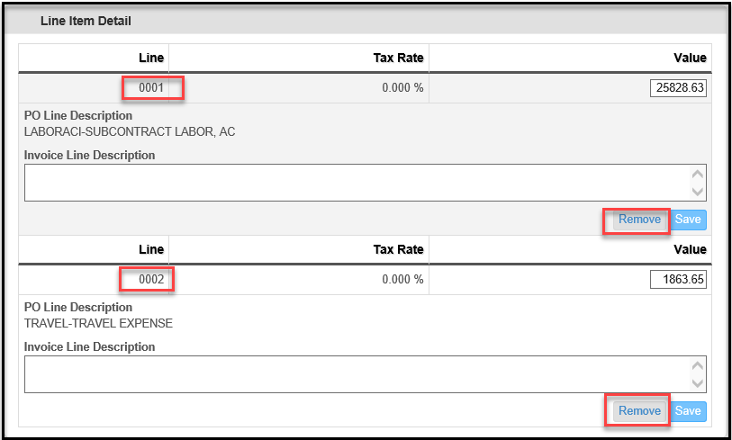

Step | Action
15. | Remove the line items that you do not want to appear on your invoice.  - Click the “Remove” button to remove any line(s) from your invoice

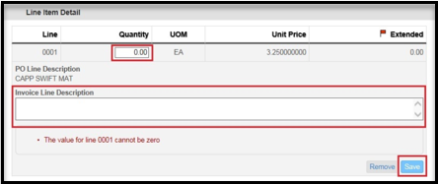

Step | Action
16. | Enter Quantity or Value on each line item you are invoicing for  For Material (deliverable) Line Items  - Enter the Quantity  - Click Save

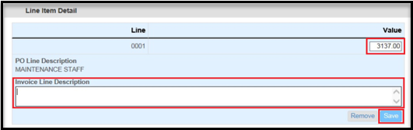

Step | Action
16a. | For Service Line Items  - Verify the total in the Value box  - Update if necessary  - Click Save  *Note: Value will default to the full value of the line and will need to be updated if necessary.

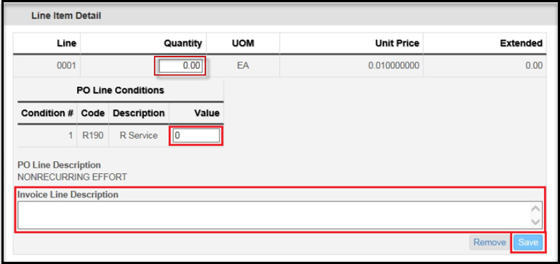

Step | Action
16b. | For Line Items with Conditions  - Input the Quantity  - Input the condition Value  - Click Save  *If invoicing for the Condition Only, enter the Quantity as 0.00

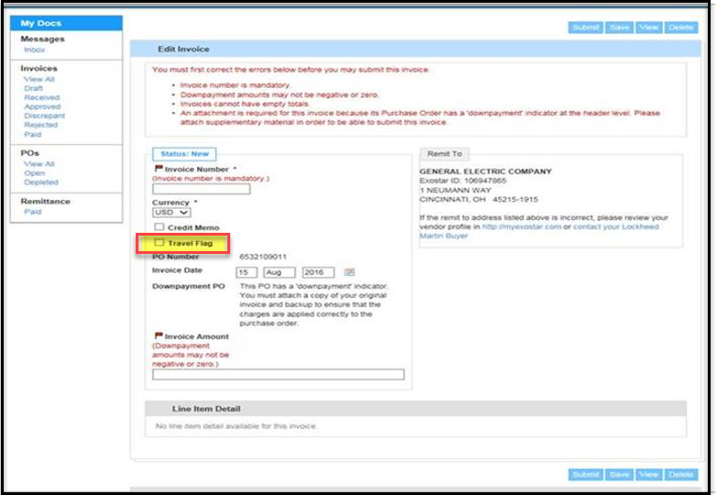

Step | Action
16c. | For LM Aero PO’s with Travel Expenses  - Check the Travel Flag button  - Upload all backup receipts

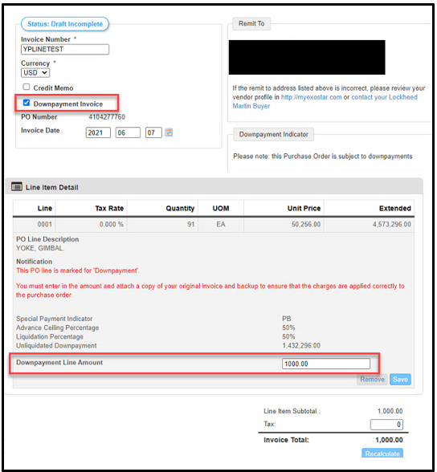

Step | Action
16d. | Invoicing for a Down payment Line Item (LMP2P)  - Click the “Down payment Invoice” box  - Click the “Remove” button to remove any line(s) from your invoice that you are not invoicing for currently  - Enter the Down payment amount  - Click the Save button  - Add attachment (attachment must match what you are invoicing for)  *Down payment invoices must be invoiced separately from invoices with materials or services.

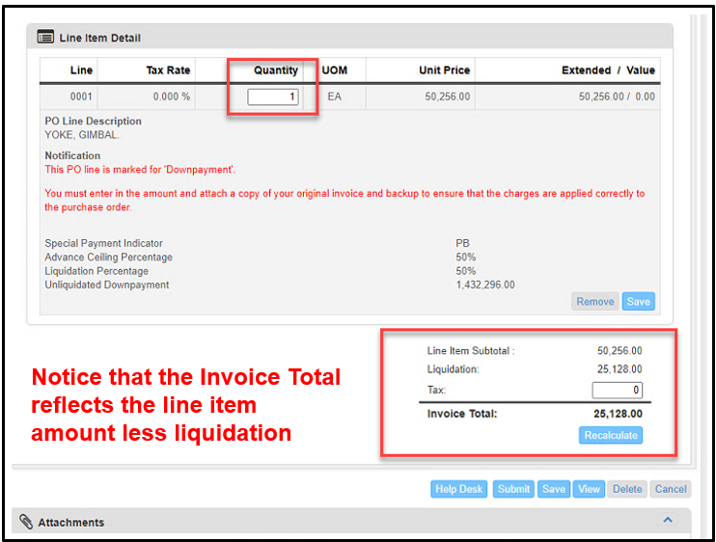

Step | Action
16e. | Invoicing for a Down payment Line Item – Material Invoice (deliverable) Line Items (LMP2P)  - Remove any line items that you are not invoicing for currently  - Update the Quantity  - Click Save  - Add attachment (attachment must match what you are invoicing for)
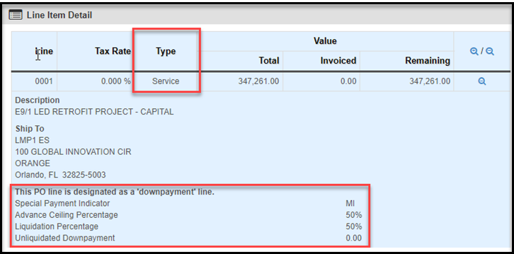

Step | Action
16f. | Invoicing for a Service Line Item on a Down Payment PO (LMP2P)  - Remove any line items that you are not invoicing for currently  - Update the dollar amount  - Click Save  - Add attachment (attachment must match what you are invoicing for)  * Do not click the Down Payment Invoice box for Service Items *

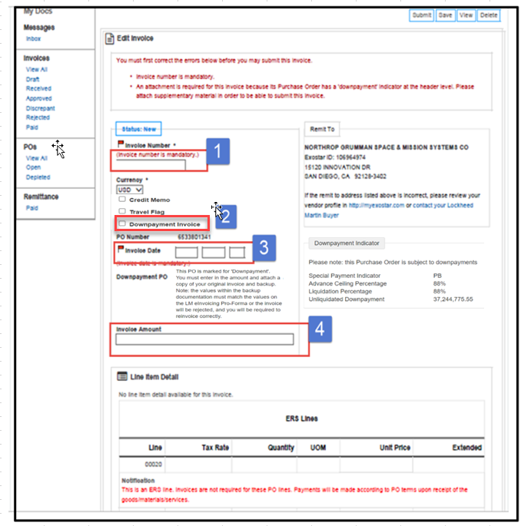

Step | Action
16g. | Invoicing for a Down payment - One Aero Purchase Order  - Enter Invoice Number  - Click the “Down Payment Invoice” box  - Enter Invoice Date  - Enter Down Payment Amount  - Click Save  - Add attachment (attachment must match what you are invoicing for)  *Note: One Aero Down payment Invoices – there is no need to remove the lines on PO, invoicing is done at the header level.

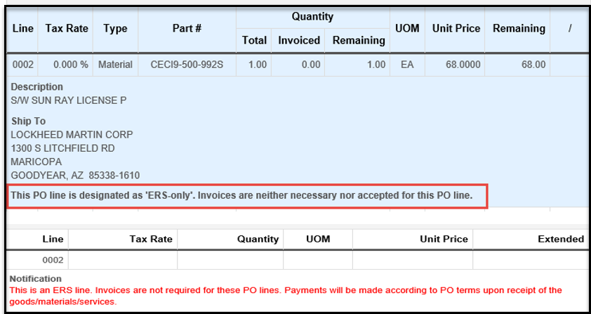

Step | Action
16h. | For Evaluated Receipt Settlement (ERS) line items  - Invoices are not required nor accepted  - The system will generate an invoice upon receipt of goods/materials

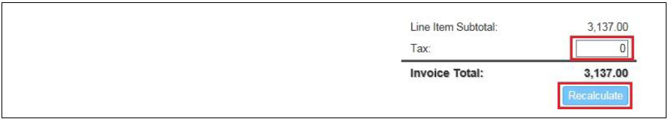

Step | Action
17. | Enter the tax on the invoice, if necessary  Click on Recalculate  *Note: If tax amount billed differs from the PO calculated tax amount, you will receive a soft warning. You may continue to submit your invoice or save the invoice and contact your buyer.

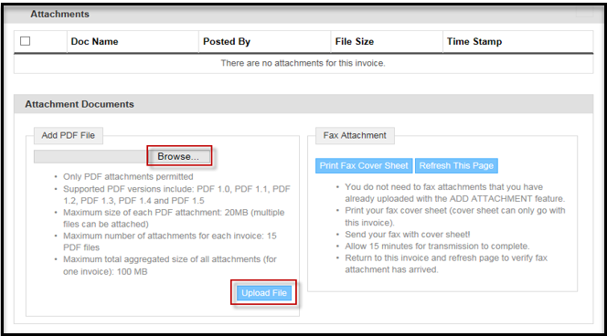

Step | Action
18. | To add an attachment,  - Click on the Browse button to find the file on your computer  - Click on document to Add  - Click on Upload File

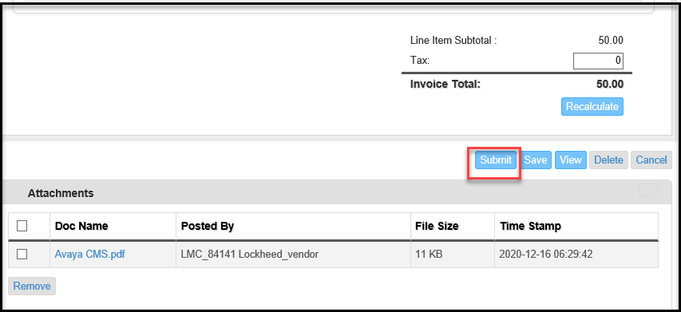

Step | Action
19. | Click Submit to submit invoice to Lockheed Martin

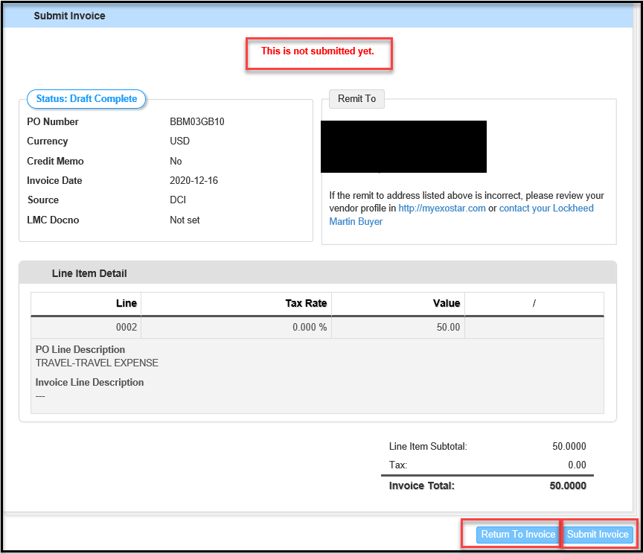

Step | Action
20. | Review invoice for accuracy, click Submit Invoice  - Return to Invoice if you need to make any changes

Frequently Asked Questions

What if I submit an incorrect invoice amount?
If you have submitted an incorrect invoice create a ticket via the ticketing tool to the LMP2P Help Desk and ask for the invoice to be rejected. Funds will be added back to the PO once the invoice status is changed to rejected (typically the next business day).

Can I submit more than one invoice against a PO?
You can submit invoices until the PO is depleted. (A depleted PO means that there are no remaining funds on the PO, or it has been closed by Lockheed Martin.) Once the PO line items are depleted, the PO becomes closed and you will no longer be able to create invoices from the PO; however, you will be able to apply credits to the PO.

How do I know if my invoice was successfully submitted?
You can tell if the invoice status changes from “draft” to “received” on the eInvoicing application. There is no notification that is emailed to you after an invoice is submitted. In addition, you can check the history section at the bottom of the invoice to see when the invoice was submitted to Lockheed Martin.

Why hasn’t my invoice status changed?
Current invoice status is updated overnight. For example, if you submit an invoice in the morning, the status will not change from “received” until the next business day.

I submitted an invoice on Friday at 6pm EST; why is the received date reflecting the following Monday?
Invoices submitted after 3 pm EST will not be picked up until the following business day.
If submitted on Friday after 3pm the invoice will not show as received until the following Monday.

Help Documentation can be located under View Tickets and Help Documentation or under the “Ask the Help Desk” link.
Narrow your Help Search by category
Create a ticket that will route to the LMP2P Help Desk and be answered within 24 business hours

What is the ticketing tool (Ask the Help Desk) and why do I want to use it?
- The ticketing tool is an easy way to get quick answers to your questions. There are multiple FAQ’s and Help Documents posted in the eInvoicing Application. If the help documents do not answer your question, you can create a ticket that is routed to the LMP2P Help Desk. It is the fastest way for you to get a response from Lockheed Martin. However, you need to make sure you have completed your contact information under Settings.

More FAQ’s:
LM eInvoicing FAQs
LM Accounts Payable FAQs

