

Supplier Management Buyer Guide
Table of Contents
Supplier Management (SM) Overview 4
Access 4
SM Buyer Dashboard 6
Form Status 7
Expiring Forms 7
Supplier Scores 7
NIST Supplier Score View 8
Cybersecurity Compliance and Risk Assessment (CCRA) Questionnaire View 9
My Reports 9
Top Header 10
Lefthand Navigation Menu 10
Campaigns 11
Form Creation 15
Step 1. Add New System Form 15
Step 2. Properties Tab 16
Step 3. Data Mapping 20
Step 4. Add Conditional Rules 21
Step 5. Review Summary Tab 21
Manage System Forms 22
Enable/Disable Form 23
Clone Form 23
Upgrade Form 24
Form Assignments 27
Assign Single Form to Single Supplier 27
Assign Single Form to Multiple Suppliers 32
Assign Multiple Forms to Single Supplier 36
Reassign Form 40
Form Details Page 40
Request History 41
Workflow Timeline 41
Assignment History 41
Print Forms 42
Print Last Submitted Forms 42
Print Older Form Version 42
Approval Workflow 43
Bulk Download Completed Forms 44
Bulk Cancel Forms 45
Approval Decision 45
Approve Form 46
Reject Form 47
Manage System Emails 49
User Management 51
Modify User Role and Status 52
Set Role Definitions 53
Modify Existing Role Definitions 53
Create New Role Definitions 55
General Settings 56
General Settings 56
Banner 57
Modify Existing Banner 57
Add New Banner 59
Notification 60
Appearance 63
Upload Logo 63
Customize Links 64
Two-Factor Configuration 68
Attribute Configuration 68
Suppliers 73
Supplier Search 73
Invite 74
Add New Supplier 80
Adoption Module Invitation 85
Scenario 1: Existing Org, Subscribed to SM, Add New User 85
Scenario 2: Existing Org Subscribed to SM, Invite Existing User 88
Scenario 3: Shell Orgs with NO Organization Administrator 90
Track Invitations 94

Supplier Management (SM) Overview
Supplier Management (SM) focuses on providing the ability to manage vetting and certification of prospective and existing suppliers. It contains built-in data collection processes and workflows, automated features, and services that allow users to continuously review and make future decisions on supplier relationships.

IMPORTANT! You MUST use Google Chrome to access the Supplier Management application.

Access
To access SM, you must have an Exostar’s Managed Access Gateway (MAG) account, as well as an acceptable security credential. For help resetting your MAG password or any other MAG-related questions, refer to https://www.myexostar.com/?ht_kb=mag.

NOTE: If you are the first user in your organization to access SM, you must accept the standard MAG Usage Service Agreement. If you see Agree to Terms on the Supplier Management tile in your MAG account, click the button and accept the service agreement.

Once you successfully activate your MAG account, all subsequent logins proceed as follows:
- Navigate to https://portal.exostar.com. Input your Email Address or User ID. Click Next.
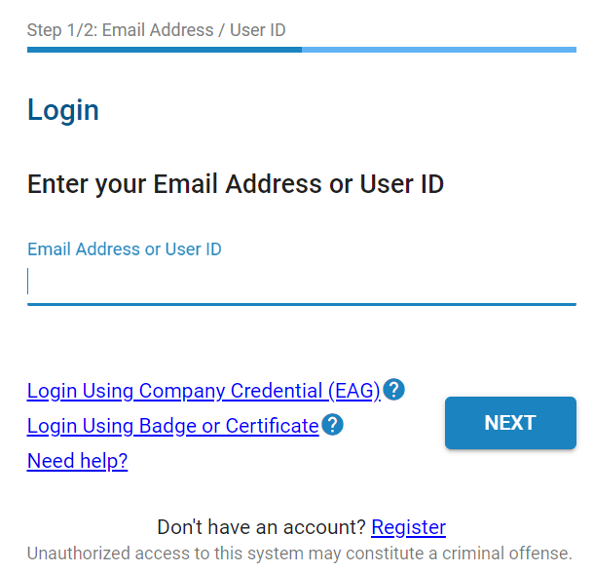

- Input your Password. Click Next to access the MAG Dashboard.
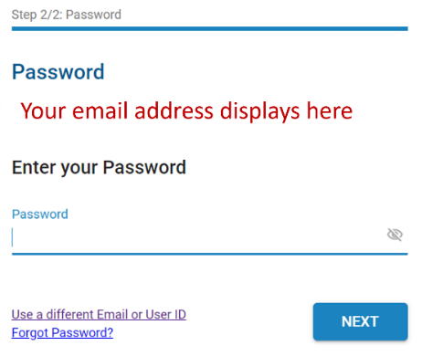

- From the My Applications section, click the Launch button from the Supplier Management tile.
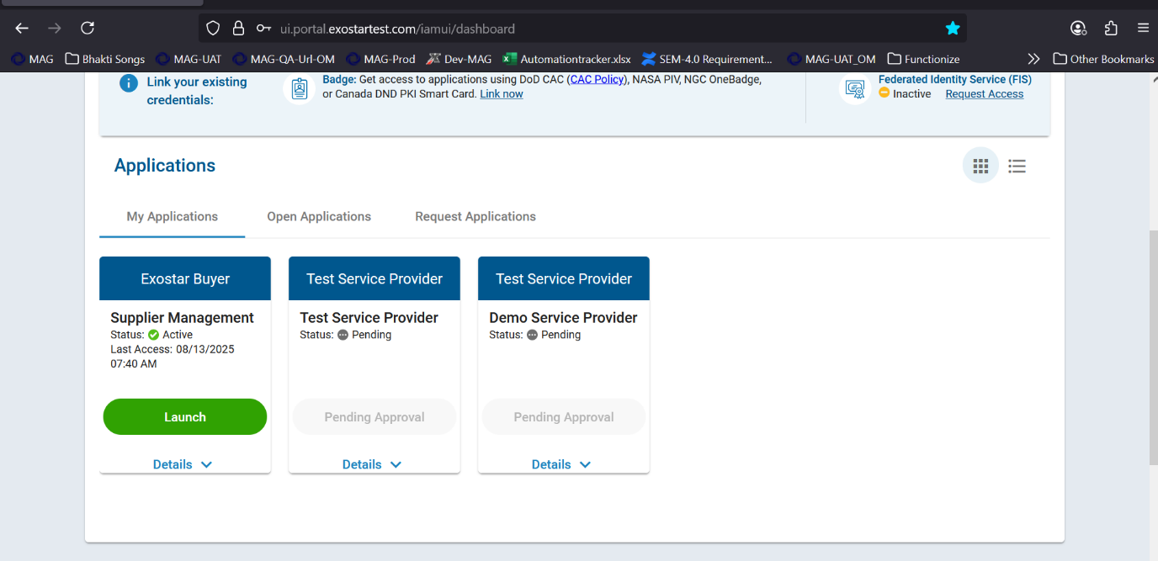

IMPORTANT: At this point in the process, the system may prompt for your security credential. The Buyer Organization determines the credential type required to access the SM application and 2FA enabled forms. Please reach out to the Buyer for more information on the credential type. A 2FA enabled form will be represented with a lock, shown below.
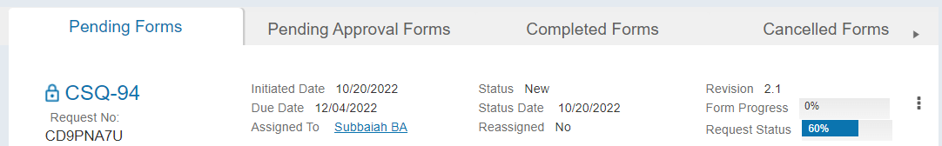
- Once you successfully login with your security credential, the system displays the Export Control Acknowledgement. Place a checkmark next to I understand that this application is accessible by both U.S. and Non-U.S. Persons. I agree not to post Export Controlled Technical Information to this application. Click Accept.
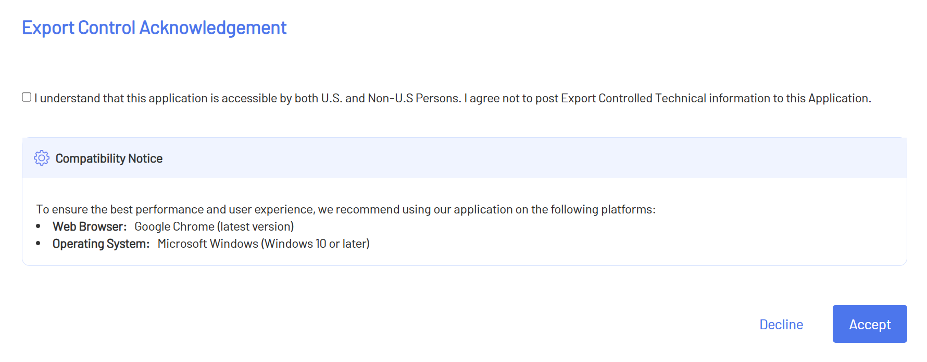

Once you acknowledge the notice, the SM dashboard displays.

SM Buyer Dashboard
Depending on your role, the dashboard displays different management options. The four tiles, located under the top header, provide a Form Status snapshot with an option to view additional details.
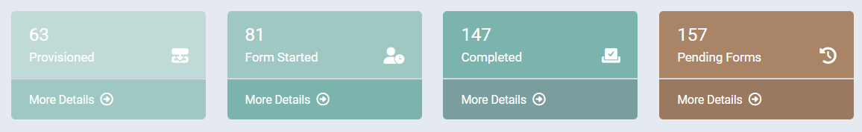

Form Status
This section provides a graph depicting the number of forms/suppliers per status. Hover over each circle to view the exact number.
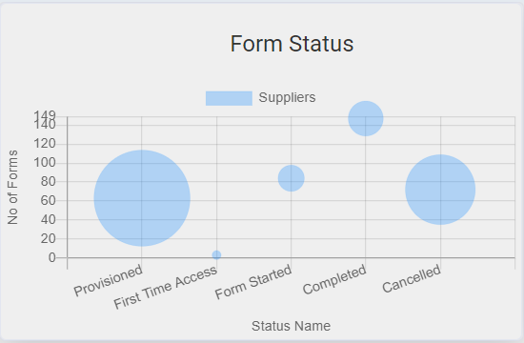

Expiring Forms
This section provides a number of expiring forms, as well as radio buttons for 30 days, 60 days and 90 days.
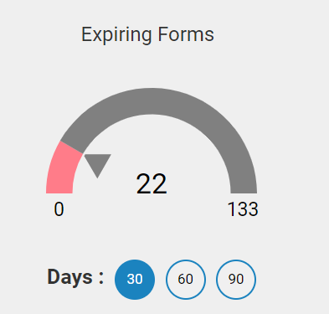

Supplier Scores
A Buyer Admin can view detailed Supplier Scores for NIST 171 and Cybersecurity Compliance and Risk Assessment (CCRA) Questionnaires. To complete a Supplier search and view scores:
- Select “I want to Search Supplier Cyber Score” from the Getting started and general knowledge section.
- Input the Exostar ID or Supplier Name in the Supplier Name field. The corresponding forms will populate in the Form list dropdown.
NOTE: The Form List is grayed out until you input a valid Supplier.
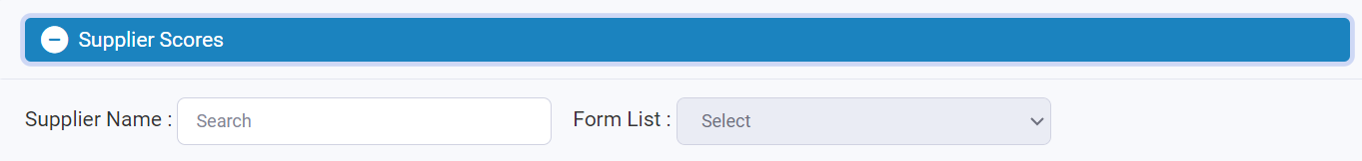

- Select the desired form from the Form List drop-down to display the Supplier Scores.
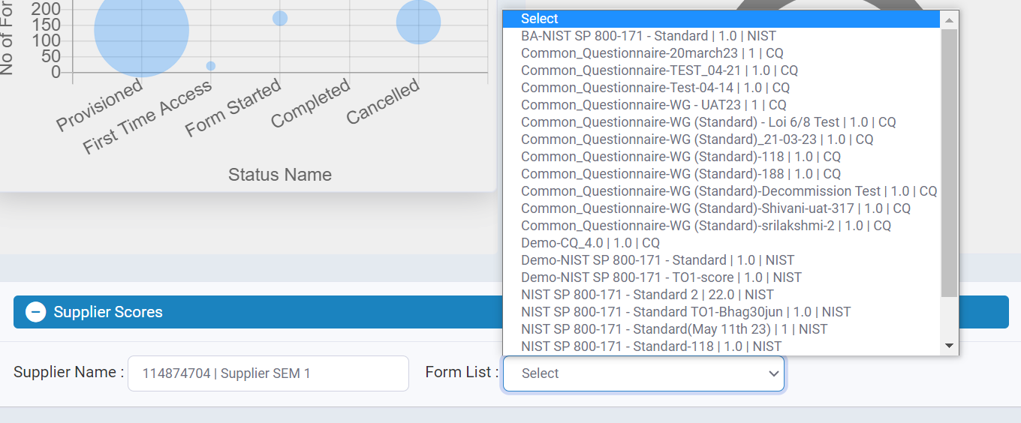

NIST Supplier Score View
The following displays when you select to view a Supplier’s NIST Score:
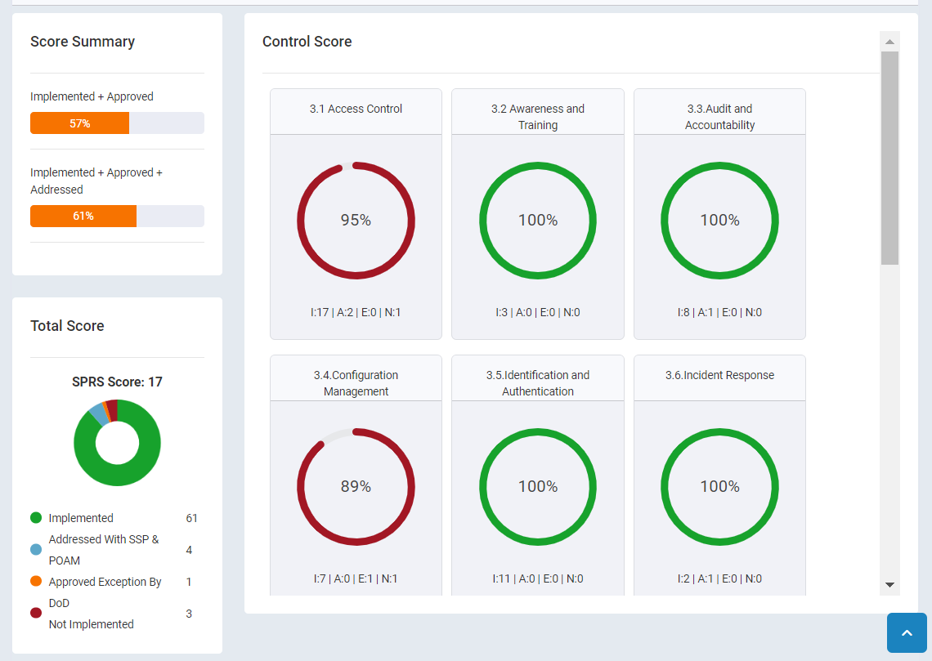

Cybersecurity Compliance and Risk Assessment (CCRA) Questionnaire View
The following displays when you select to view a Cybersecurity Compliance and Risk Assessment (CCRA) Questionnaire Score:
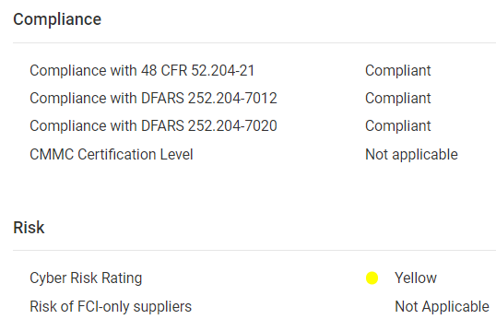

My Reports
This section is automatically collapsed. Select the plus sign (+) to open a view of all the reports you created and added to your dashboard. It is important to note, only ten reports can display on the dashboard at a time. For more information on the My Reports feature, please see the SM Reporting Guide on the Supplier Management Training Resources page on myexostar.com.
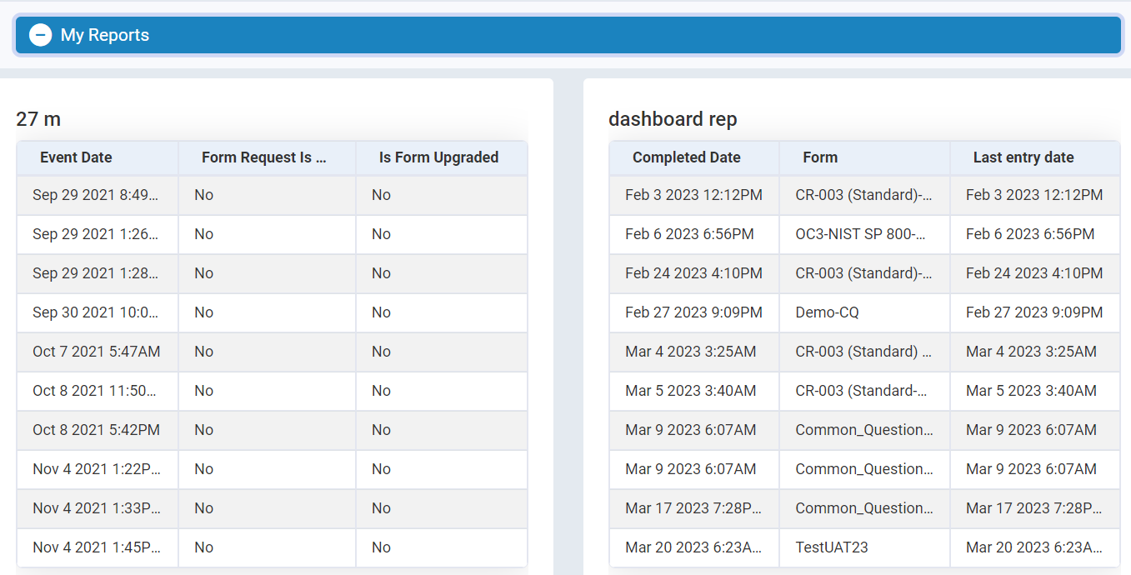

Top Header
The top header provides the following options, and is static regardless of where you are in the SM application:
- Exostar Logo: Click this to redirect to Exostar’s corporate website. This feature is editable from the General Settings page.
- Supplier Management: Click this to navigate to the SM Dashboard. This feature is editable from the General Settings page.
- Home: Click this to navigate to the SM Dashboard.
- myExostar: Click this to navigate to Exostar’s self-help site, which provides on-screen help content, downloadable guides, FAQs, and more. This feature is editable from the General Settings page.
- Contact Us: This section is configurable to point to the desired contact. This feature is editable from the General Settings page.
- User Drop-down: This section displays your role, and provides options to navigate to your profile, as well as to log out of the system. The Lock icon reflects 2-Factor Authentication enablement. Unlocked reflects no 2FA enablement, and locked reflects 2FA enablement.

Lefthand Navigation Menu
The following options are available from the left-hand navigation menu, and are dependent on your role and permissions:
- Activities:
  - Suppliers: This page provides the ability to search existing suppliers associated with your organization via MAG and Supplier Management Database (SMD), as well as the ability to add new suppliers and send forms to those suppliers.
  - Groups: This page allows you to categorize existing suppliers into groups for easy form assignment or application provisioning.
  - Campaigns:
    - Bulk Load Organization - Bulk invite organizations in groups of 200 to your supplier management application, vet the suppliers against Exostar’s Master Database, and assign them a standard or custom form
    - Bulk Load Users - Bulk Invite users to suppliers’ organization. Provision them to other applications.
  - Form Requests: This page provides a list of all Pending Forms, Pending Approval Forms, Completed Forms, and Cancelled Forms, as well as search capabilities using various filters. Functional Administrators can send forms to Suppliers from this page as well.
  - Reporting Tool: This page allows you to run Standard Reports and create User Reports based on various entities like supplier organization, user details, form details, etc.
  - Approval Decision: This page is available to Functional Admins when a buyer approval workflow is enabled for any form and provides a list of those forms in the sub tabs Pending Decision, Assigned to me (Forms assigned to you to enter decision), Decision Complete (Forms for which decision is complete).
- Administration:
  - Form Lifecycle: The Manage System Forms page allows you to create new forms, as well as manage existing forms.
  - Email Template: This page allows you to manage system-generated emails by target audience; Buyer Administrator, Supplier Administrator, or Supplier User.
  - Users & Roles: This page allows you to manage users access and roles within your organization with SM access.
  - General Settings: This page allows you to manage General Settings, Banners, Notifications, Appearance, and Attribute Configuration.

Campaigns
Please see the campaigns guide on the supplier management training resources page.

Groups

Step 1. Create a New Group
To create a group:
- On the dashboard, in the left-hand navigation, click Groups
- In the groups dashboard, select New Group
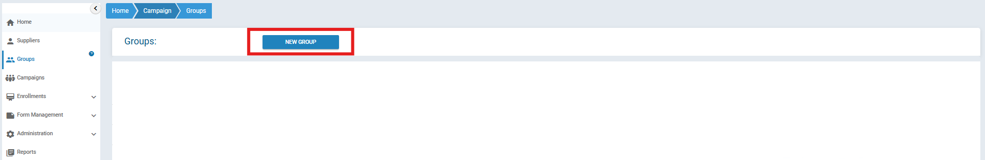
- Insert the group Name and optional Description
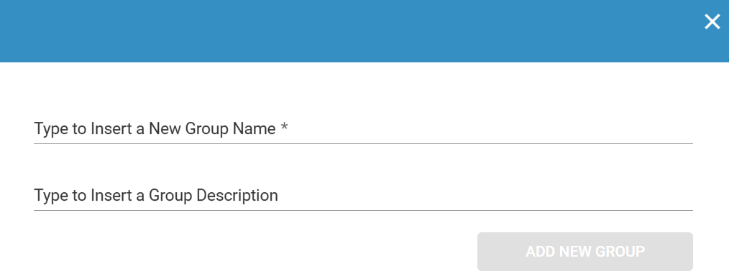
- Select Add New Group

Step 2. Inviting Suppliers to the Group
To Invite Suppliers:
- Select the Suppliers tab from the global navigation menu
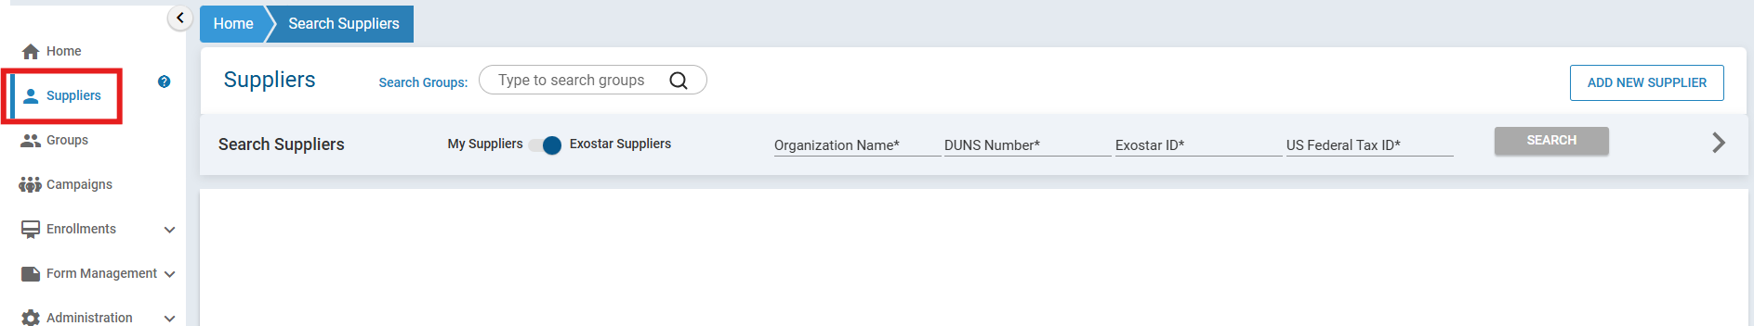
- Make sure that my suppliers is selected
- Search for the supplier you wish to add to the group
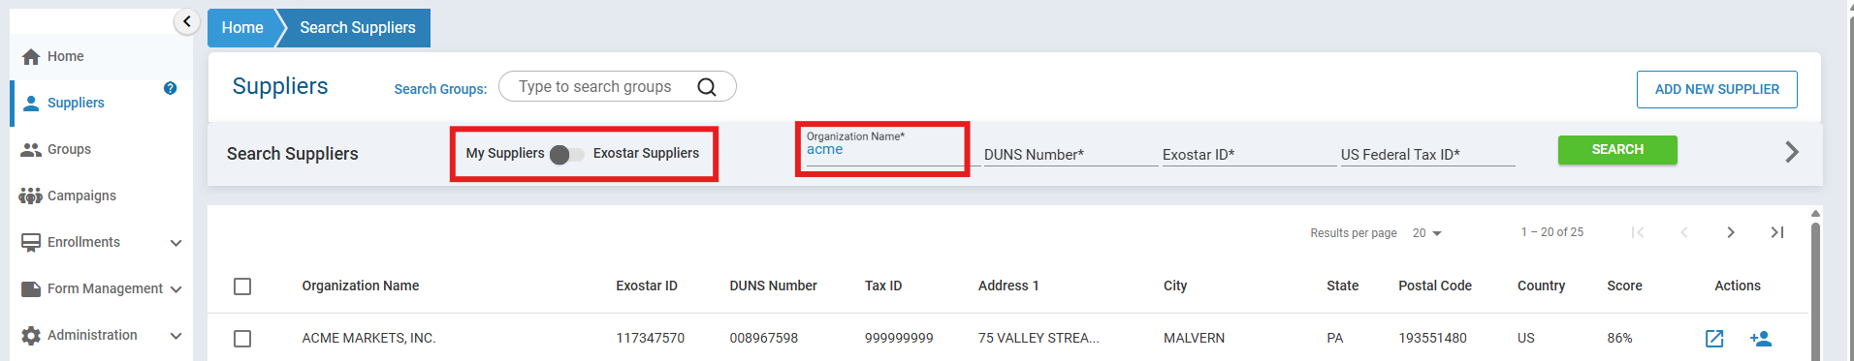
- Select the checkbox next to the organization you wish to add
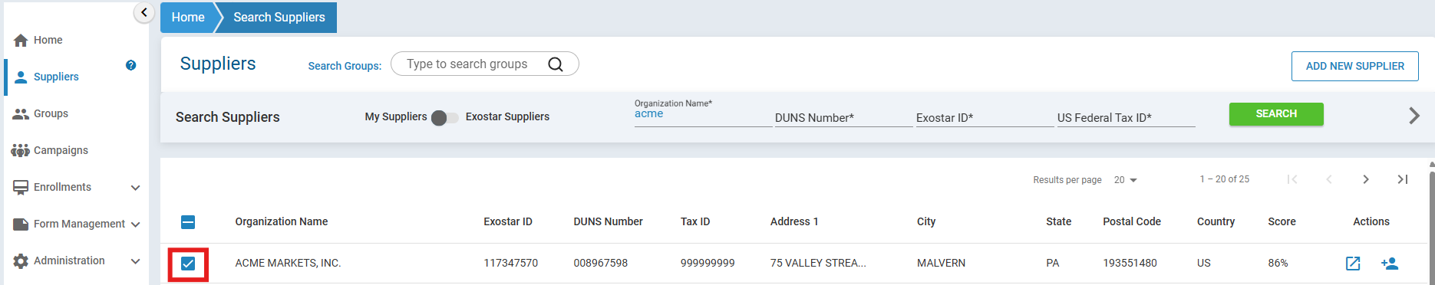
- In Search groups search for the group you have just created and hit enter
- Repeat this process to add multiple suppliers to your groups

Step 3. Group Actions
- From the Group’s dashboard, select the invite icon on the group you wish to action on
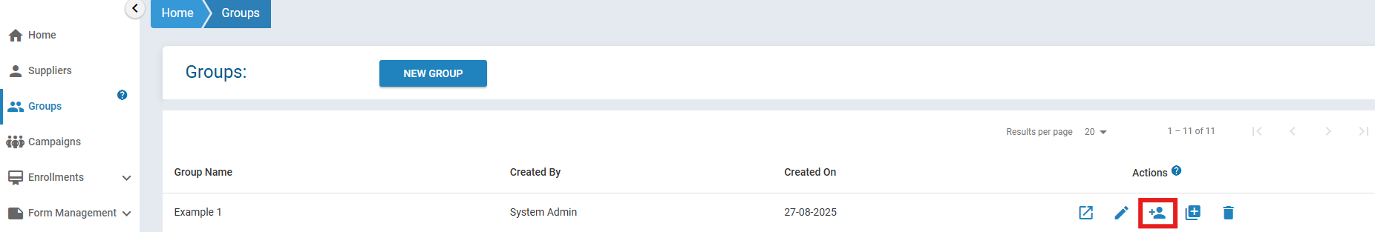
- Select the appropriate action: Expedited Subscription, Qualified Subscription or Assign form.
- Select External Source name
- For Assign form: Select the form which you would like to assign to the group:
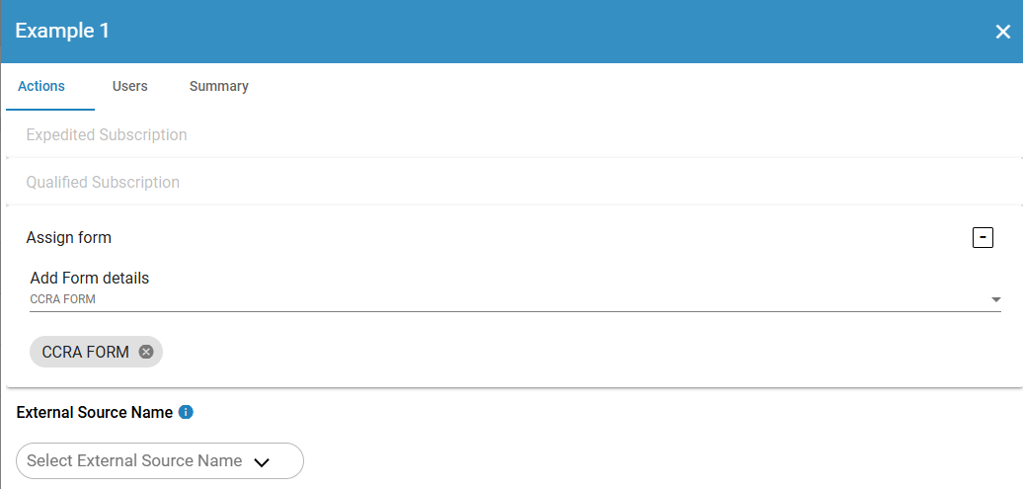
- Navigate to the user tab
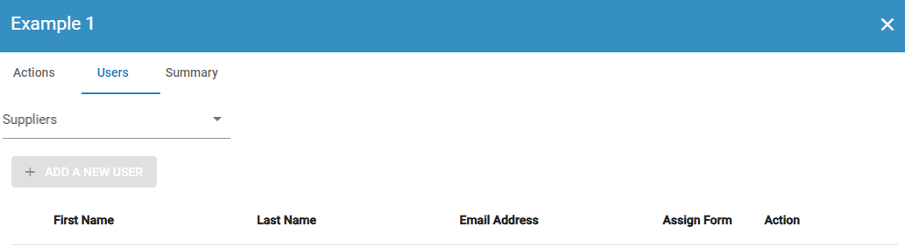
- Select a supplier from the dropdown list
- Select a user from the presented list OR select Add new user
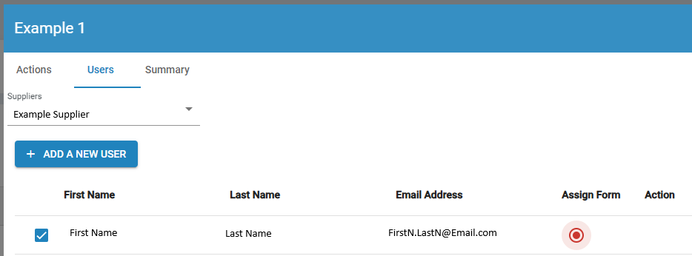
- Select the Summary tab
- Confirm the information is correct and select invite

Form Creation
Forms are used to gather supplier information. Buyer Organization Technical Administrators can create multiple forms using the SM Form Creation functionality. The five-step form creation process is outlined in the sections below.

Step 1. Add New System Form
To create a form:
- On the dashboard, in the left-hand navigation, click Form Lifecycle.
- When the Manage System Forms page displays, click the Create New System Form button.
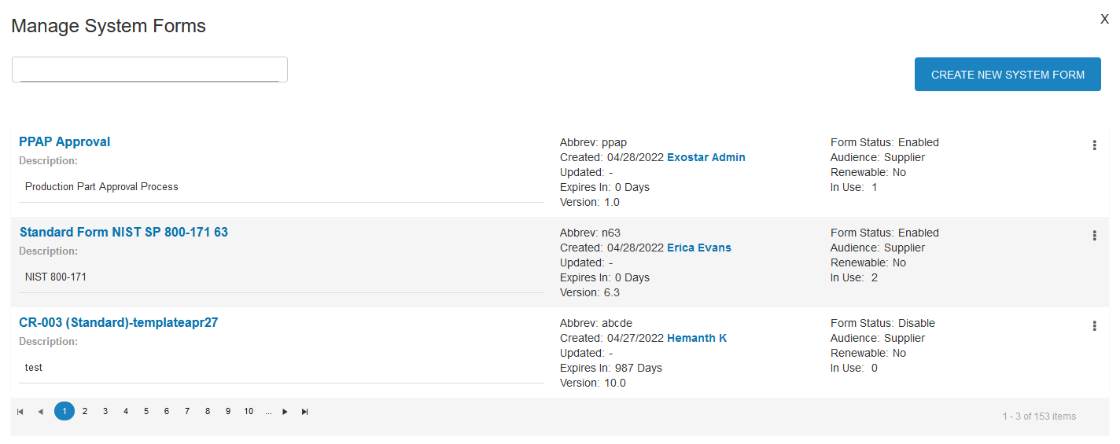

- In the Add New System Form prompt, enter a Title, Description, Abbreviation, and Version number for the form. Click the Create button.
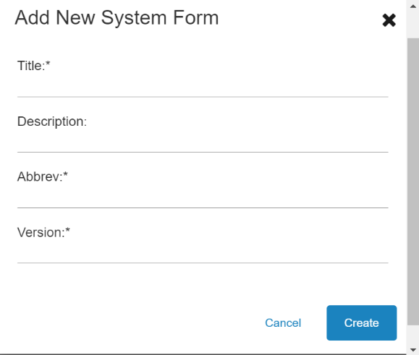

Step 2. Properties Tab
To edit the Properties tab:
- Place checkmarks next to the desired options:
  - Enable Expiration: This allows you to set the number of days the form will be set to expire using the Expire in (in days) field.
  - Renewable: This allows a Supplier to renew the form on their own.
  - Blocked Override: This feature is client-specific, please ignore.
  - Enable 2FA: This form will require 2FA enabled on a logged in user to access view/edit the form.
- Click Next.
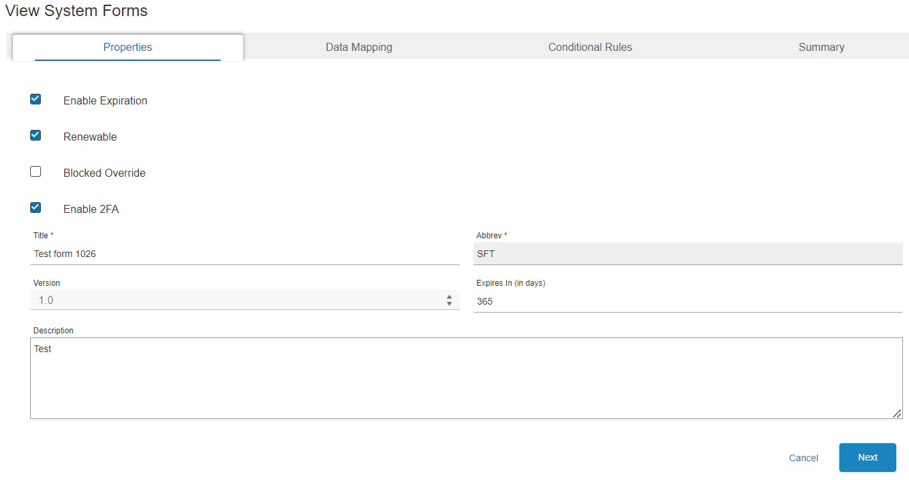
- Click the Next button on the following tabs:
  - Data Mapping: Used for another client to map data fields to an external database. Please ignore for now.
  - Conditional Rules: This tab allows you to enable or disable required fields based on the values of other fields. For example, if X, then Y.
  - Summary: A quick review of your title, description, and version, as well as a place to save the configuration.
- Click Save.
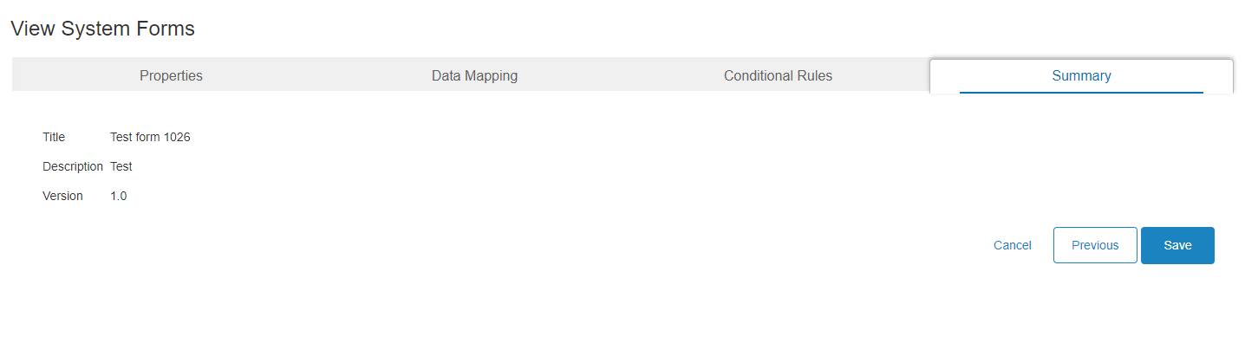

- To start building the form, click on Form Editor when the Manage System Forms page displays.
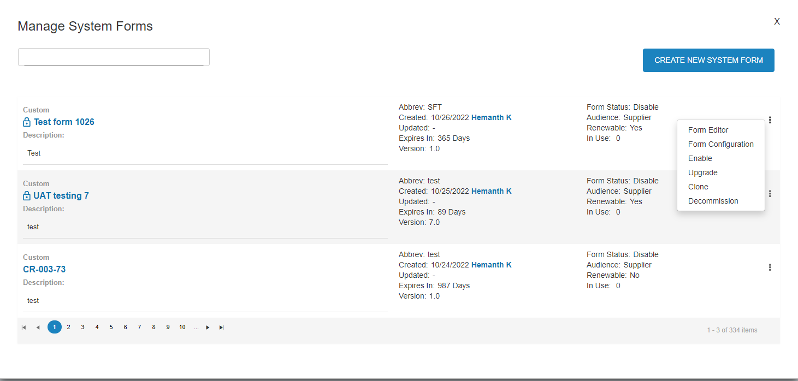

- In the Form Editor, add sections and questions using the +Add Section button, Master Data Fields or Custom controls along the left-hand side of the screen.
NOTE: Master Data Fields pulls data from a master database for Supplier information and is auto populated so the Supplier does not have to enter the information. Custom data fields allows you to create your own custom questions and fields.
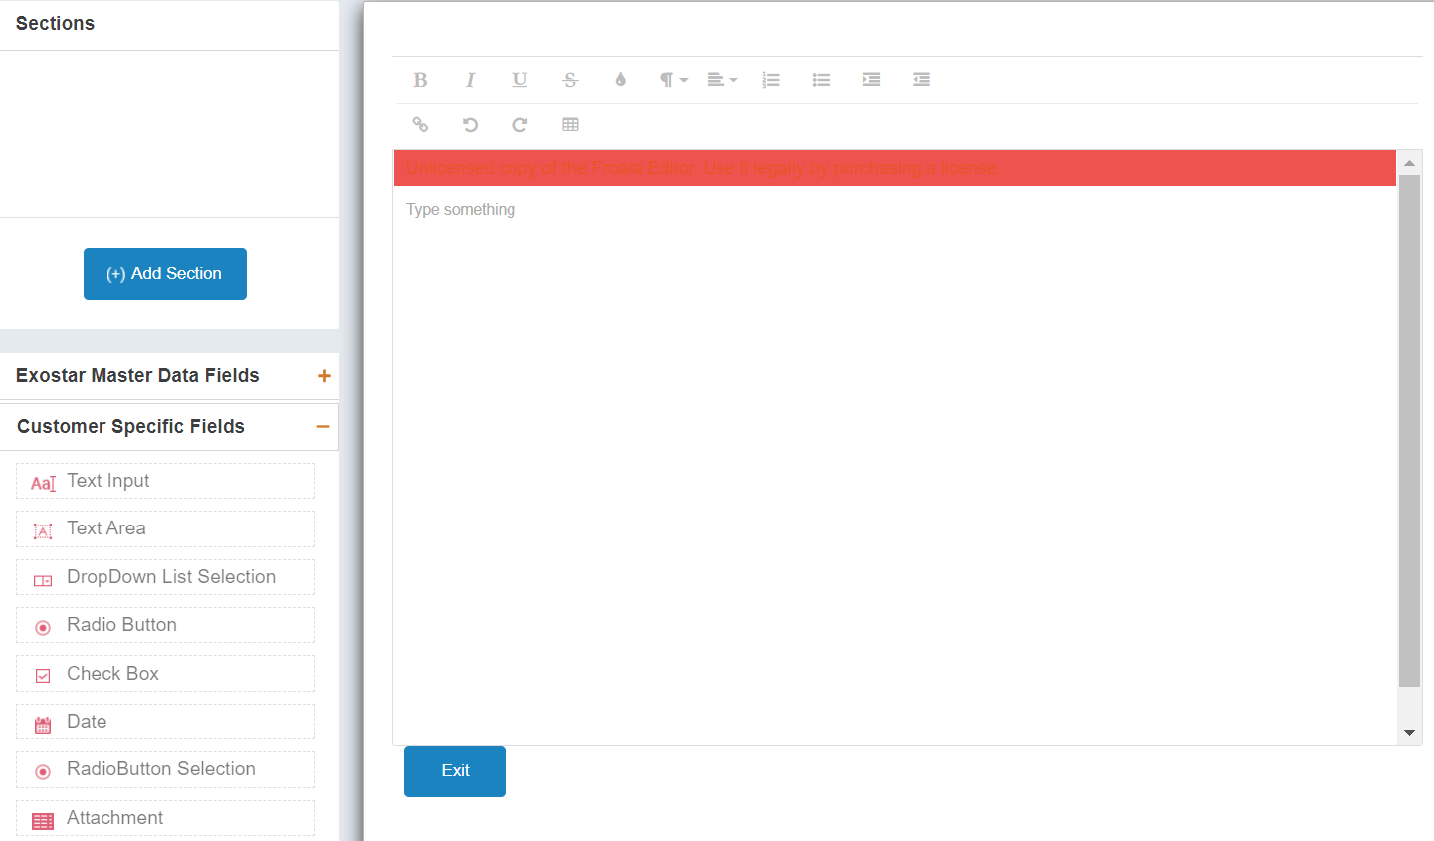

NOTE: Once you start adding sections, Master Data Fields or Customer Specific Fields, Save & Configure, Save and Preview buttons display in the bottom right corner of the form. Sections are like pages and sub-sections are like tabs on a page. We highly recommend creating sections and sub-sections, instead of the entire form being on a single page.

- Once you add all desired sections, sub-sections, and fields, click Save & Configure to return to the Properties tab.
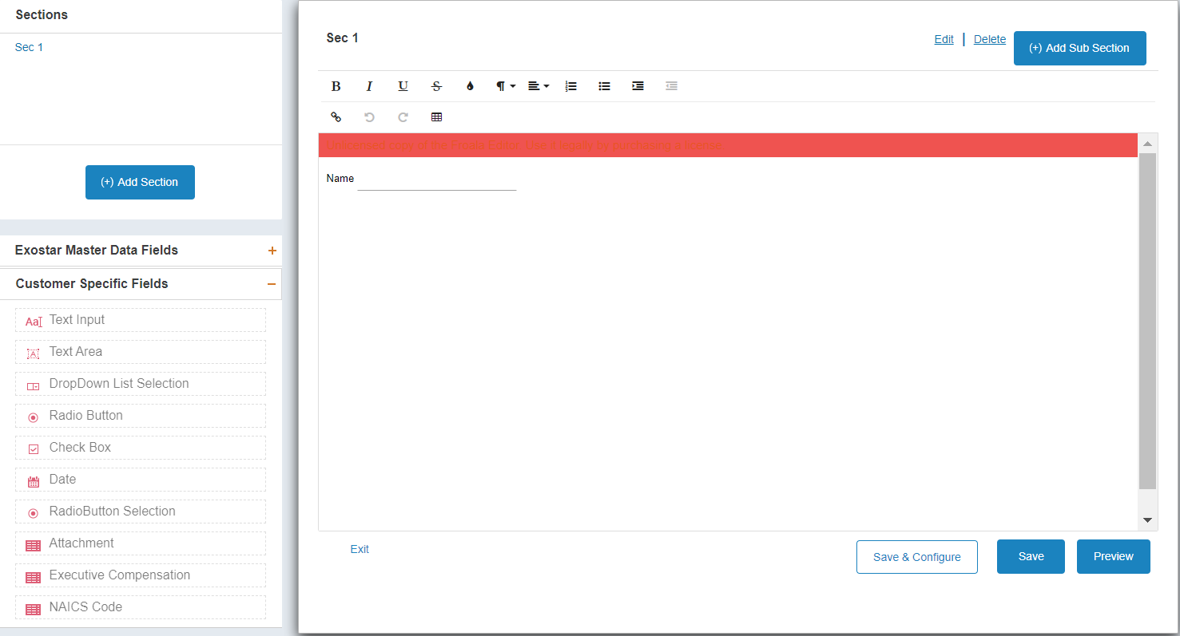

- On the Properties tab, click Next to open the Data Mapping tab.
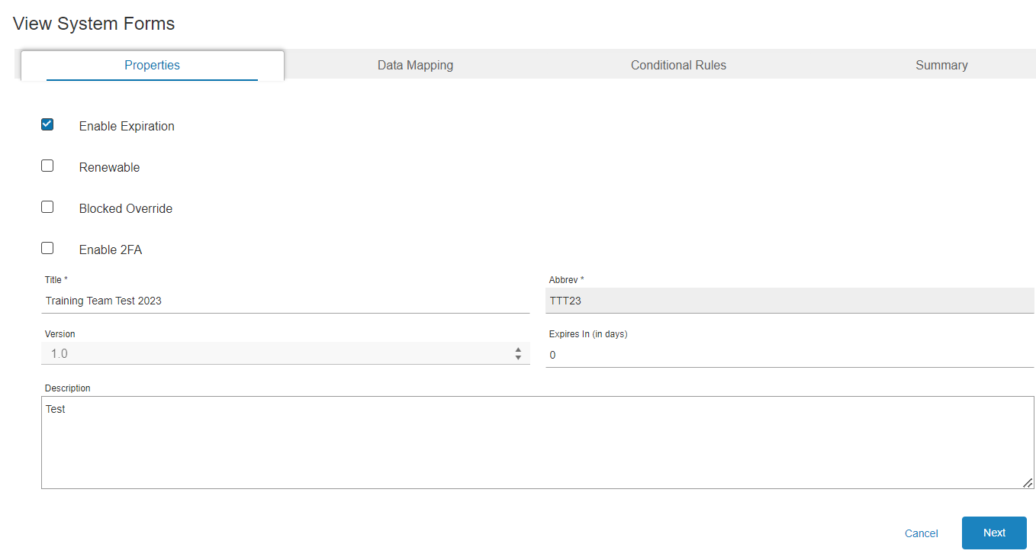

Step 3. Data Mapping
This is a client-specific tab, so click Next to continue to the Conditional Rules tab.
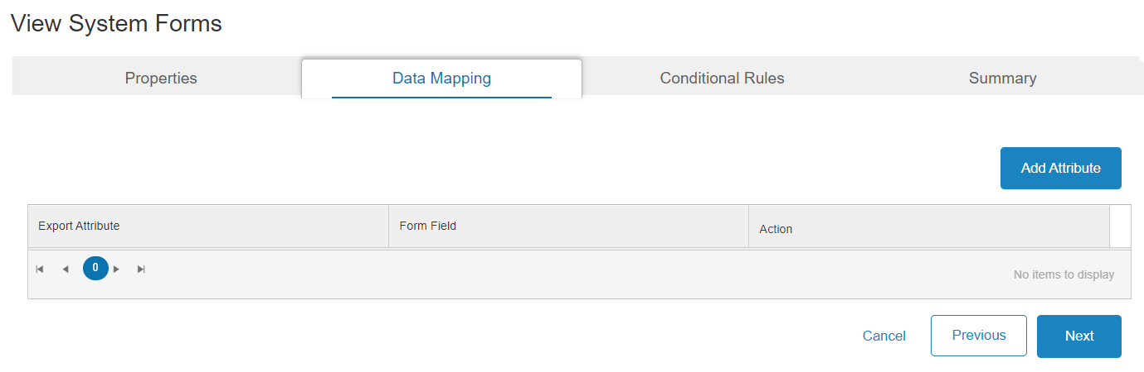

Step 4. Add Conditional Rules
The options that display in the drop-down menus on this tab, are pulled from the sections and questions you created in the Form Editor. To create a conditional rule:
- Place a checkmark next to Is Required if you want the Target Control to be required if the Source Evaluation is True.
- Select from the Source Section and Source Control drop-down menus.
- Select from the Target Section and Target Control drop-down menus.
- Choose what to compare Target Value to by first choosing the Evaluation method and then type in the value in Compare To Value field.
- Click Add to create the rule. Click Next when all rules are added.
NOTE: To manage an existing rule, click Edit to update selections or click Delete to remove.
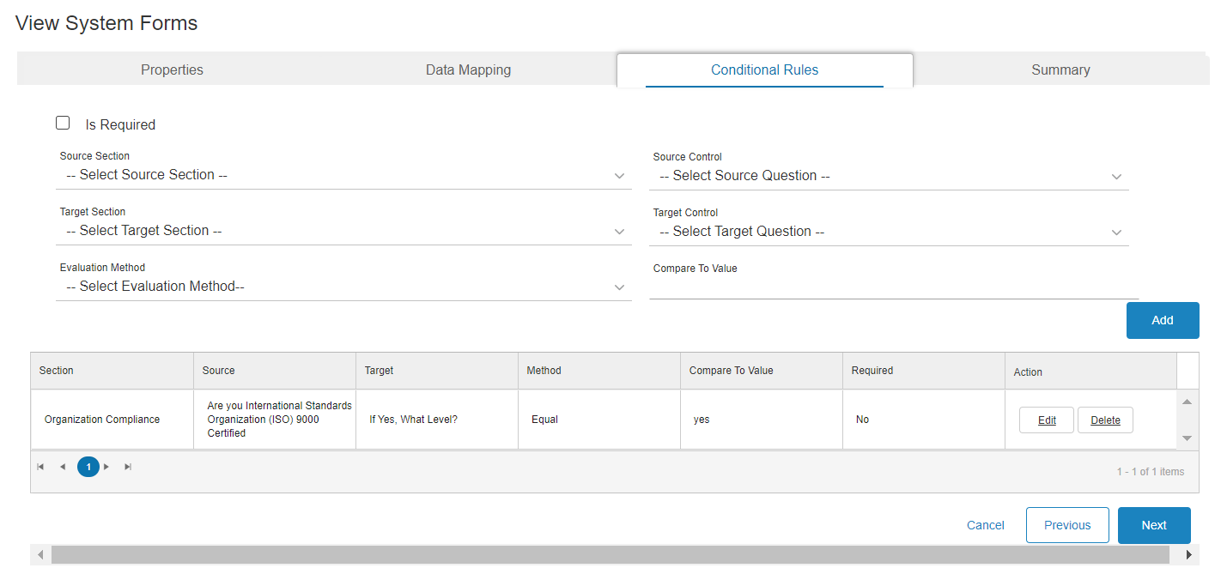

Step 5. Review Summary Tab
To complete the form creation process:
- On the Summary tab, review all data input. Go back and make edits, if necessary.
- Click Save to complete editing your form. The system takes you back to the Manage System Forms page.
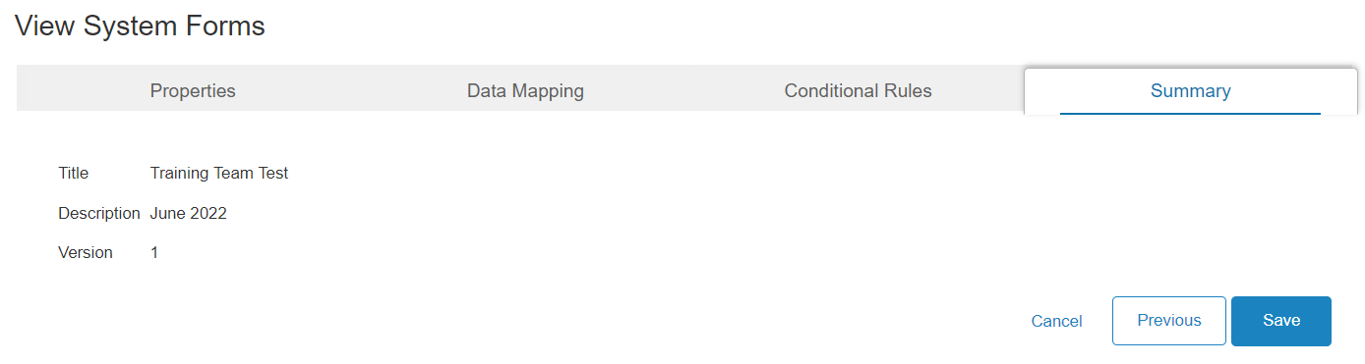

NOTE: You can preview the form by clicking the arrow next to the Form Name. Once the form has been sent to the Supplier, you can no longer edit the form.
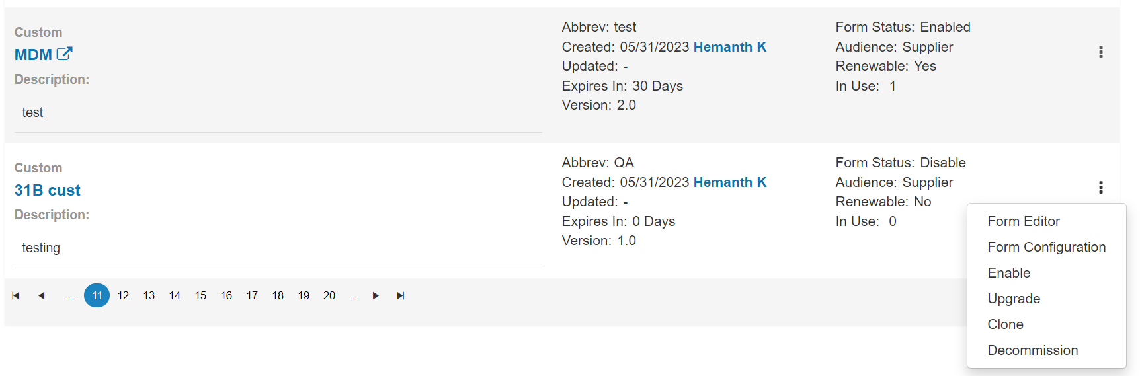

Manage System Forms
The Manage System Forms page provides a comprehensive list of forms, as well as the option to create a new form. Each row provides a snapshot of the specific form’s details, as well as form management options via the ellipses, located to the far right of each form row. This drop-down menu’s options depend on the current Form Status. Please see the possible options and their descriptions:
- Form Editor: This allows you to edit form sections, sub-sections, and fields.
- Form Configuration: This allows you to manage Form Properties and Conditional Rules.
- Enable: Only displays when the Form Status is Disable. Select this option to enable the form for use and to send out to Suppliers.
- Disable: Only displays when the Form Status is Enabled. Select this option to disable the form from use. Once disabled, the form can no longer be sent out to Suppliers.
- Upgrade: Only displays when the Form Status is Disable. You must create a new version of a form prior to taking this action. This option also allows you to make changes to an existing form while auto updating the Supplier’s form to view new changes while retaining existing information.
- Clone: This option allows you to create a copy of an existing form as a template for a new form, or to be used to update or upgrade an existing form with new fields.
- Decommission: This option allows you to remove it from the Manage System Forms screen and from being used again. Once this action is completed, the form can no longer be assigned. If the form is still in Supplier View, you may need to cancel the form in Form Requests.
NOTE: Once a form is sent to a Supplier, the only options that display are: Disable, Clone, and Decommission.

Enable/Disable Form
Enable: Only displays when the Form Status is Disable. Select this option to enable the form for use and to send out to Suppliers.

Disable: Only displays when the Form Status is Enabled. Select this option to disable the form from use. Once disabled, the form can no longer be sent out to Suppliers.

To enable or disable a form:
- From the left-hand navigation, select Form Life Cycle.
- Locate the desired form. Select Enable or Disable from the ellipses at the end of the row.
NOTE: The Form Status reflects the change.

Clone Form
To clone an existing form:
- From the left-hand navigation, select Form Life Cycle. Locate the desired form. Select Clone from the ellipses at the end of the row.
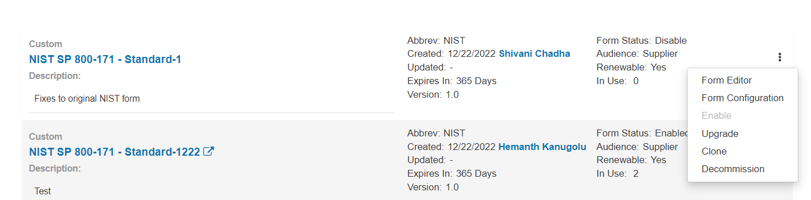

- Update the Form Name. Add an Abbreviation, Version Number and Description. Click Clone.
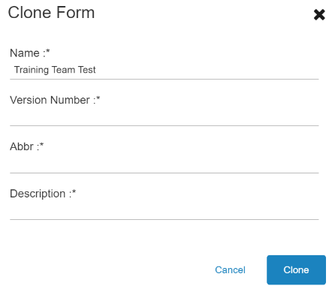

Upgrade Form
SM provides the ability to upgrade a form from its current version to a newer version. Prior to upgrading the form, you must first create the new version. To upgrade a form:
- Navigate to the Form Life Cycle page. Locate the desired form. Select Clone from the ellipses.

- Ensure you leave the Form Name the same. Give a higher Version Number from the original form. Click Clone.
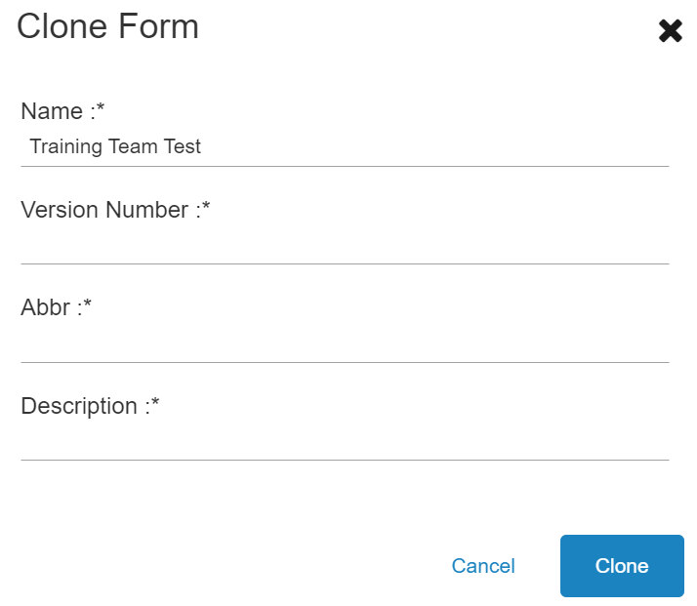

- Make desired edits to cloned form. Ensure the Form Status for the form you want to upgrade is set to Disable and the newer version’s status is set to Enabled. Select Upgrade from the ellipses.

- On the Upgrade Forms page, select the Source Form (original/old version number). Select the Destination Form (new or upgraded form/new version number. Click Next.
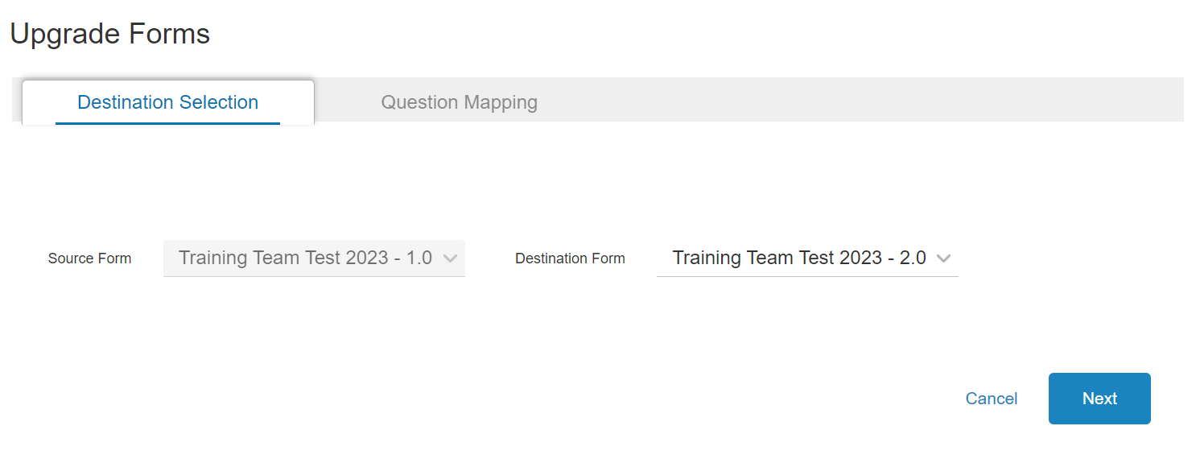

- The Question Mapping tab allows you to map original form questions to the upgraded version. To map questions, select the Source Question and the Destination Questions. Click Add. Once you map all fields, click Save.
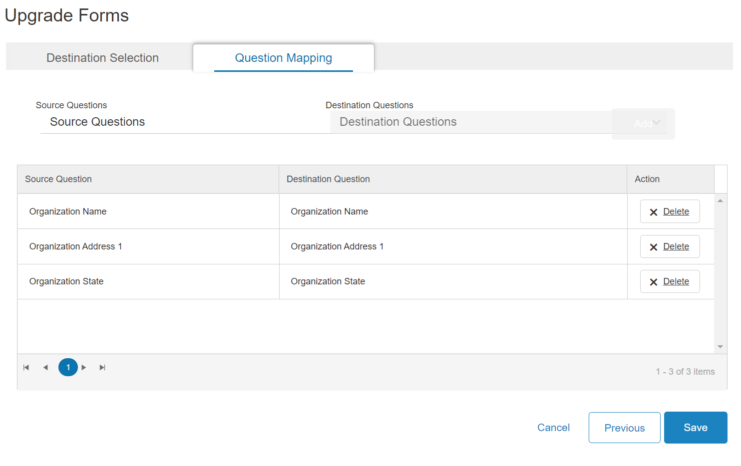
NOTE: If a Supplier has an older version of the form, the system prompts them to upgrade when they try to edit it form.

Form Assignments
Functional Administrators can assign a single form to a single Supplier, multiple forms to a single Supplier, as well as a single form to multiple Suppliers. Functional Administrators can also reassign forms.

Assign Single Form to Single Supplier
To assign a single form to a single Supplier:
- On the dashboard, click Form Requests. Click the Add New Form Request button.
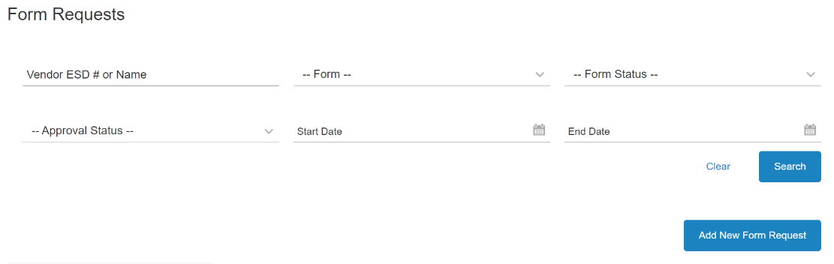

- Select A single form to a single supplier.
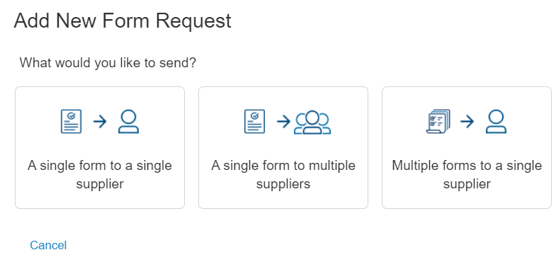

- Type the desired form name. Click Add. Once you finish adding desired form, click Next.
NOTE: Place a checkmark next to Match Case for the field to be case-sensitive. The added form displays in a blue bubble. Click the X to remove. An error displays if you try to add multiple forms.
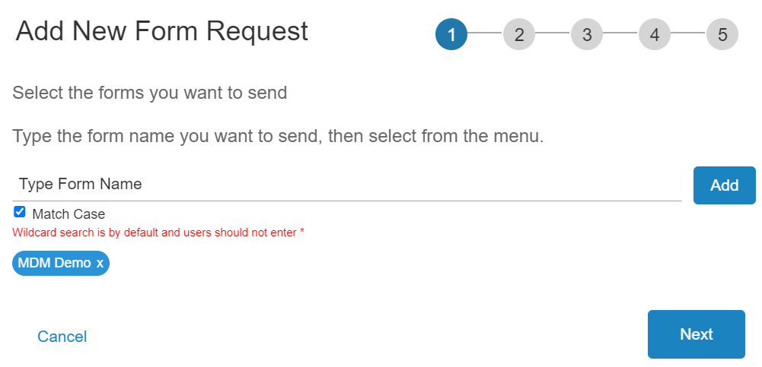

- Enter the Supplier Name. Click the name when located in the search results box. Click Next.
NOTE: The added Supplier displays in a blue bubble. Select the X to remove any unwanted Suppliers. An error displays if you try to add multiple Suppliers.
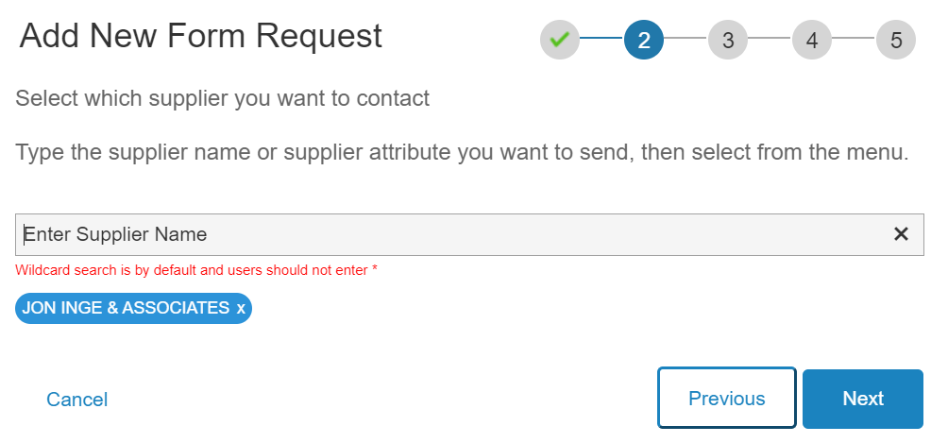

- The Existing User checkbox is already selected and provides a drop-down of existing users for the Supplier. Select from the drop-down menu. Click Next.
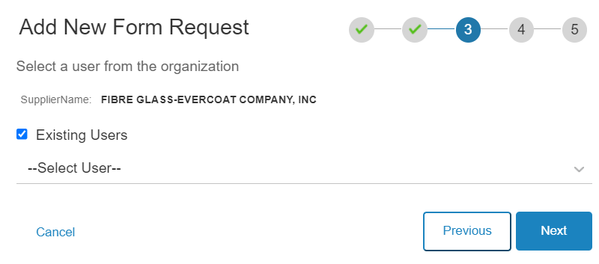
NOTE: Deselect the box to display new user fields. Input information. Click Next.
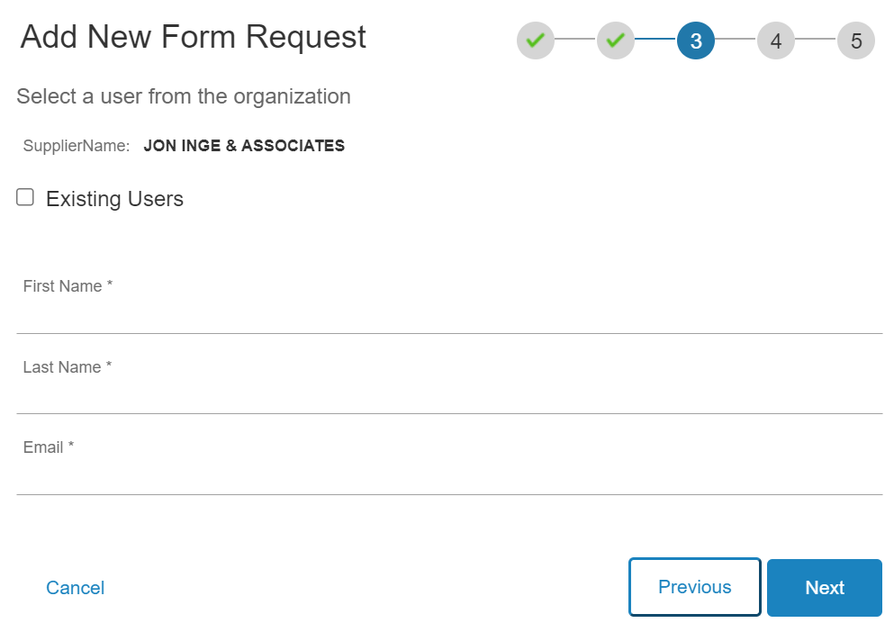

- Select to enable or disable Buyer Workflow Approvals and assign Buyer Users as the approvers to the form. If Yes is selected, the admin has the option to assign the same approvers to all the forms. Select the approver name from the drop down. Click Next.
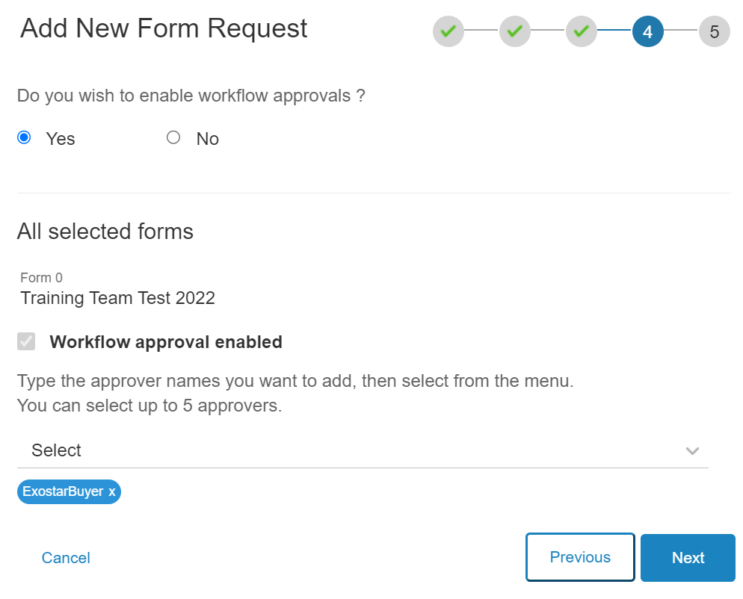

- The system prompts you to review the summary. If you do not wish to make any changes, click Done.
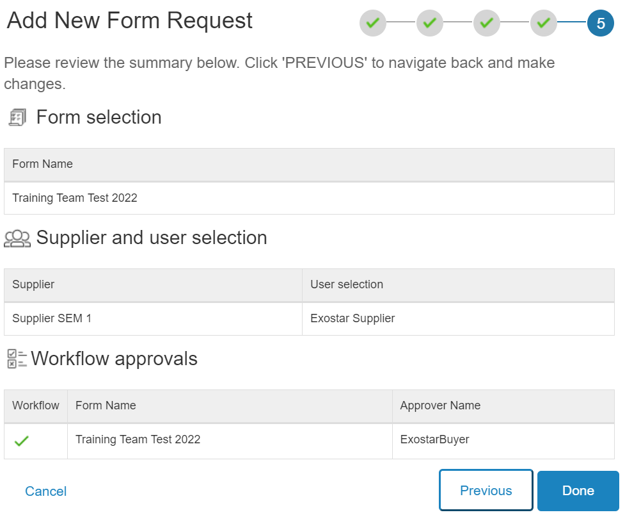

NOTE: A processing screen displays.
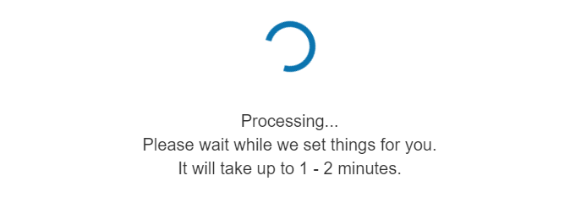

- On the Success dialogue box, click Okay. At this point your form has been successfully assigned to a Supplier Administrator.
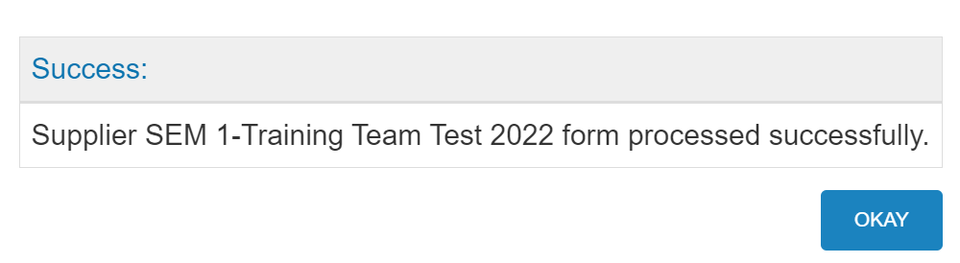

Assign Single Form to Multiple Suppliers
To assign a single form to multiple Suppliers:
- On the dashboard, click Form Requests. Click the Add New Form Request button.

- Select A single form to multiple suppliers.

- Type the desired form name. Click Add. Once you finish adding the desired form, click Next.
NOTE: Place a checkmark next to Match Case for the field to be case-sensitive. The added form displays in a blue bubble. Click the X to remove. An error displays if you try to add multiple forms.

- Select to Search By Name or Search By Attribute, which are like groups of suppliers that can be configured in General Settings. Enter the Name. Click the name when located in the search results box. Complete this process as many times as necessary. Once all Suppliers are added, click Next.
NOTE: The added Suppliers displays in a blue bubble. Select the X to remove any unwanted Suppliers.
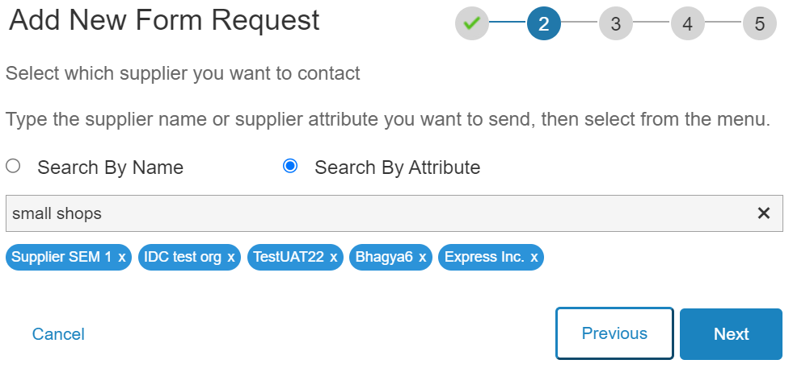

- Select a Supplier and an assigned User for each Supplier. Click Next.
NOTE: Existing Users is automatically checked. Remove the checkmark to add a new user for that specific Supplier.
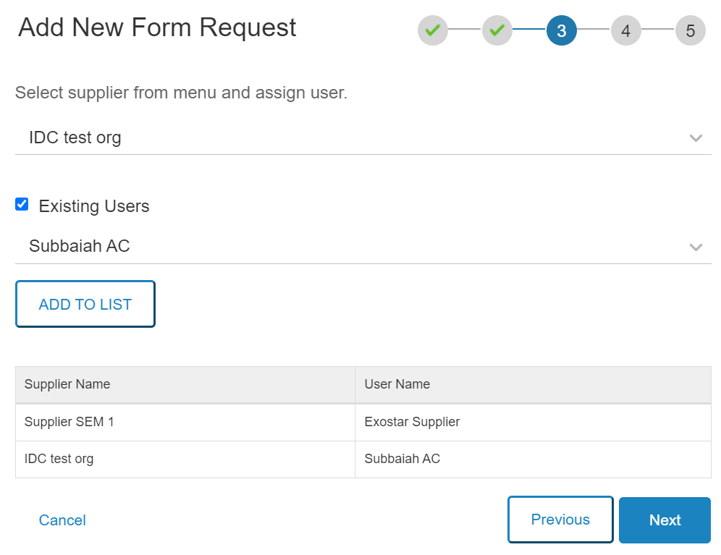

- Select to enable or disable Buyer Workflow Approvals and assign Buyer Users as the approvers to the form. If Yes is selected, the admin has the option to assign the same approvers to all the forms. If No, the admin has the option to assign different users in each Supplier tab. Select the approver name from the drop down. Click Next.
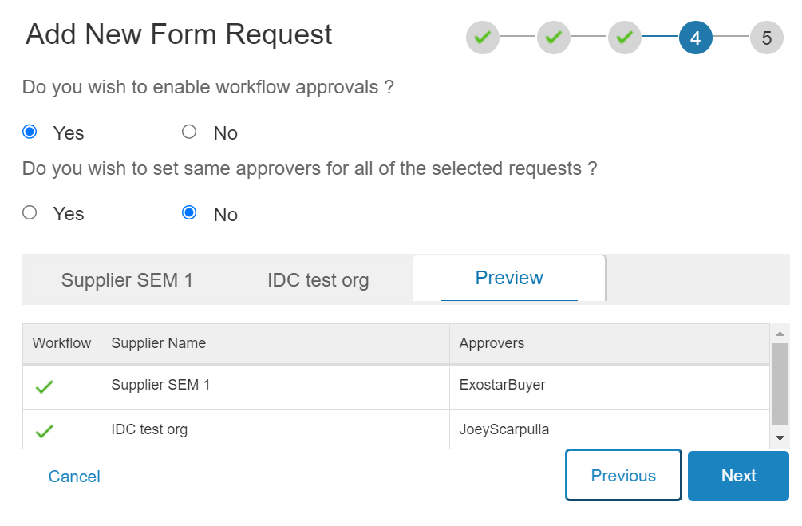

- The system will prompt you to review the summary. If you do not wish to make any changes, click Done.
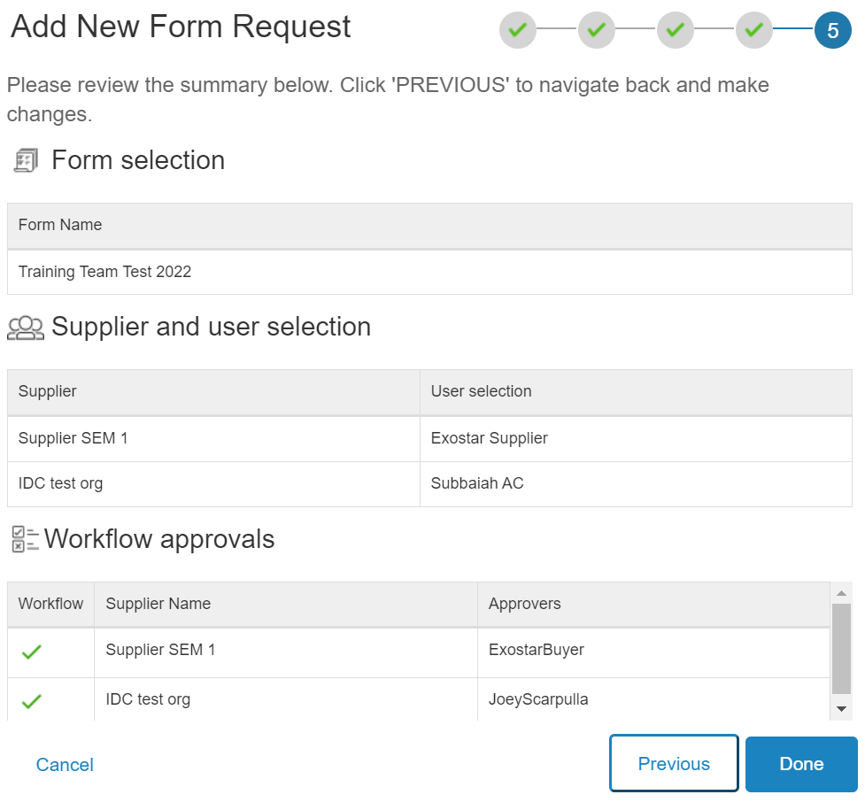

NOTE: A processing screen displays.

- On the Success dialogue box, click Okay. At this point your form has been successfully assigned to a Supplier Administrator.
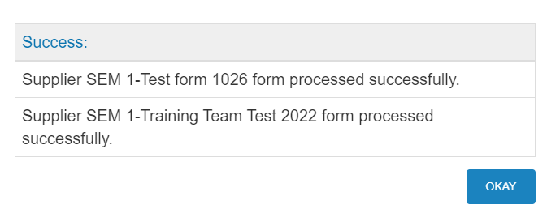

Assign Multiple Forms to Single Supplier
To assign multiple forms to a single Supplier:
- On the dashboard, click Form Requests. Click the Add New Form Request button.

- Select Multiple forms to a single supplier.
- Type the desired form name. Click Add. Once you finish adding the desired form, click Next.
NOTE: Place a checkmark next to Match Case for the field to be case-sensitive. The added forms are displayed in blue bubbles. Click the X to remove any unwanted forms.
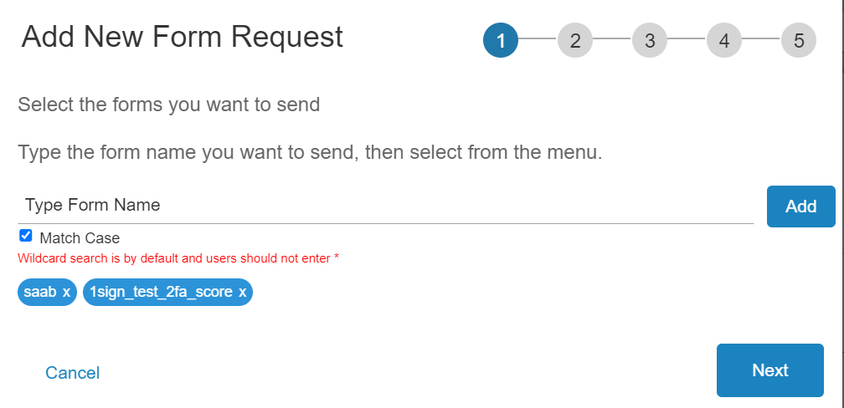

- Enter the Supplier Name. Click the name when located in the search results box. Click Next.
NOTE: The added Supplier displays in a blue bubble. Select the X to remove any unwanted Suppliers. An error displays if you try to add multiple Suppliers.

- The Existing User checkbox is already selected and provides a drop-down of existing users for the Supplier. Select from the drop-down menu. Click Next.

NOTE: Deselect the box to display new user fields. Input information. Click Next.
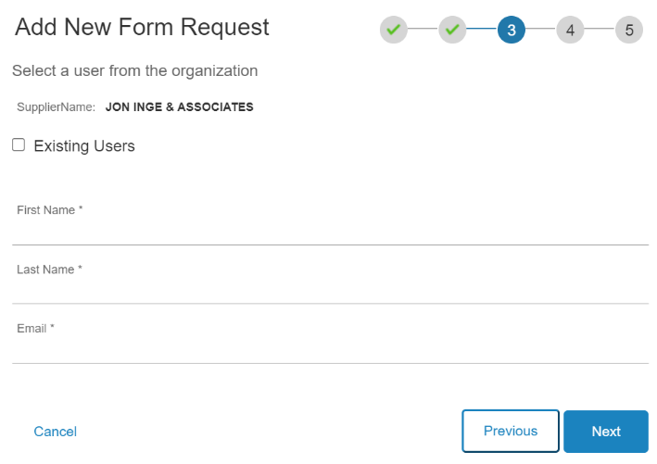
- Select to enable or disable Buyer Workflow Approvals and assign Buyer Users as the approvers to the form. If Yes is selected, the admin has the option to assign the same approvers to all the forms. Select the approver name from the drop down. Click Next.
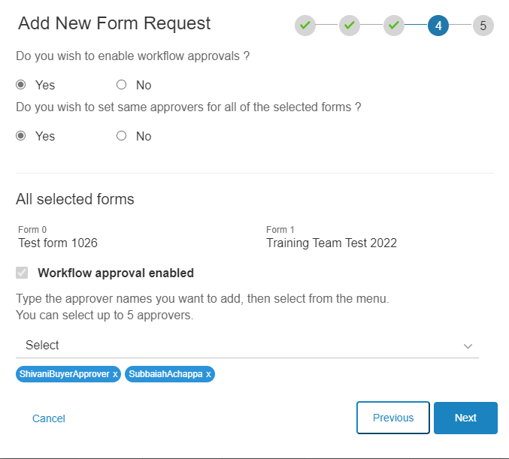

NOTE: A processing screen displays.

- On the Success dialogue box, click Okay. At this point your form has been successfully assigned to a Supplier Administrator.

Reassign Form
Please note, only Functional Administrators can reassign a Supplier User from the Buyer role. To reassign a pending form:
- On the dashboard, click Form Requests. On the Pending Forms tab, locate the desired form and select the ellipses in the Action column. Click Reassign.
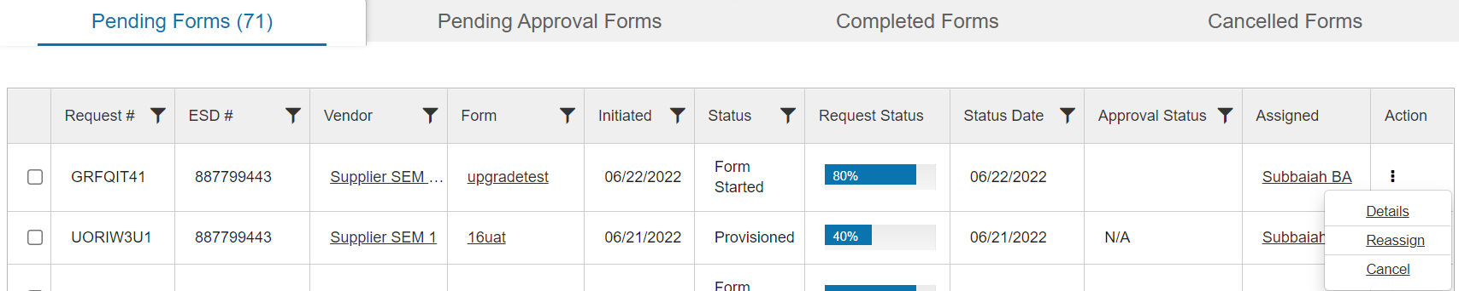

- Select the desired Supplier User from the dropdown. Click Save.
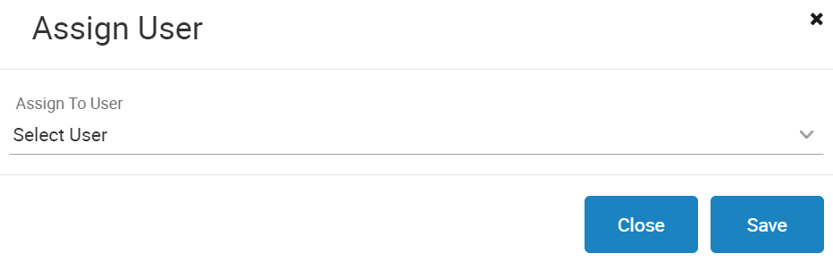

Form Details Page
Select any Form Name in the system to open the individual Form Details page. This page provides form management options, outlined below.

Request History
The request history outlines details for each form request of the form previously sent to the supplier organization. Please note, all underlined information is clickable, and clicking the Request ID will update the Workflow Timeline.
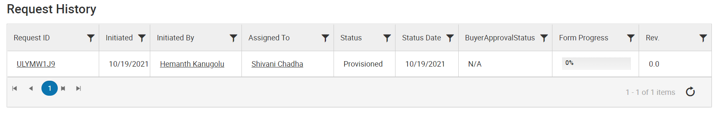

Workflow Timeline
This section outlines the workflow details for the specific form.
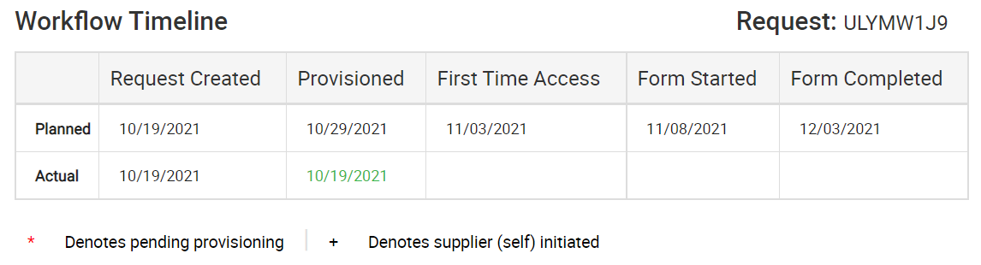

Assignment History
The assignment history table outlines user information and dates for each instance the form was assigned or reassigned to a specific supplier user.
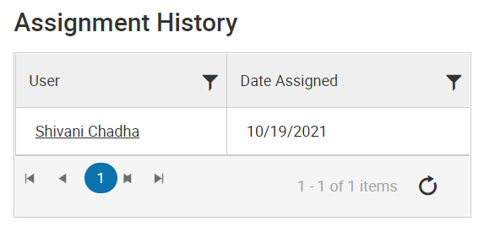

Print Forms
Functional/Technical Administrators can only see and download forms, whether completed or in progress.

Print Last Submitted Forms
To print the last submitted form:
- Navigate to the desired Form Details page and locate the Downloads section.
- Click the PDF icon next to Latest Submitted Revision.
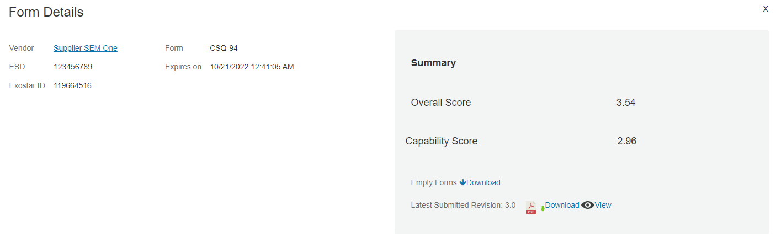

- Select the Print option and follow your system’s print process.

Print Older Form Version
To view and print older revisions of the form:
- Go to the Rev. column of the Revision History table and click the revision number link of any form to download.
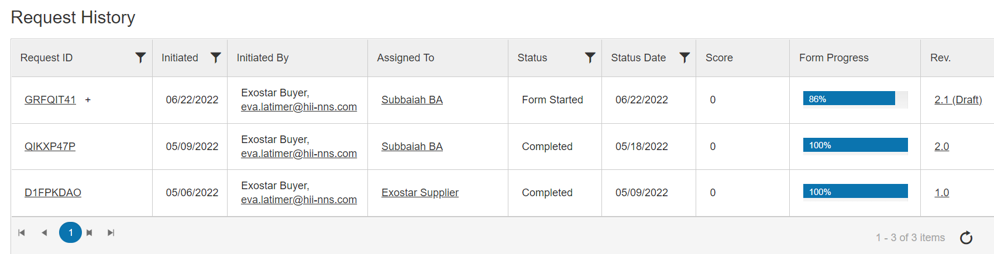

- Select the Print option.

Approval Workflow
If a form is still Pending, Approval Workflow can be enabled or disabled, and users can be added, removed, or changed from the workflow via the Form Details page. To update the Approval Workflow settings:
- Navigate to the Form Details page of the desired pending form. Select the Approval Workflow button.
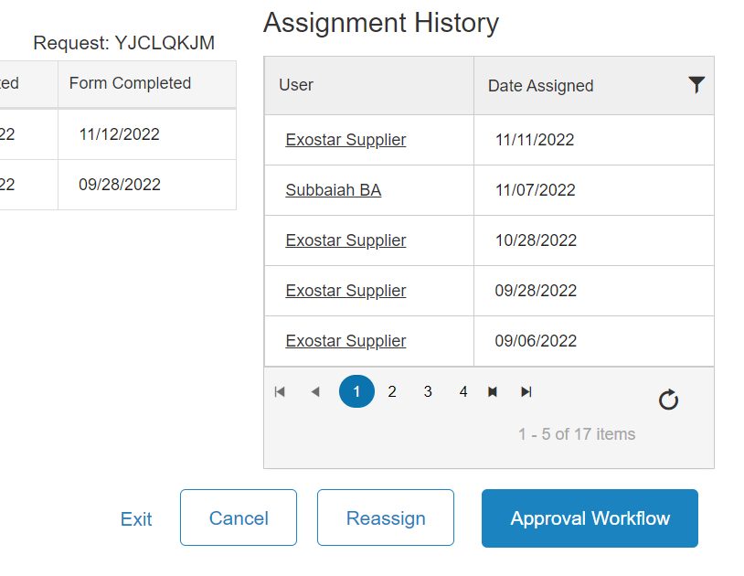

- Place a checkmark to enable or remove the checkmark to disable. If desired, update the Approver selections. Click the Save button to complete.
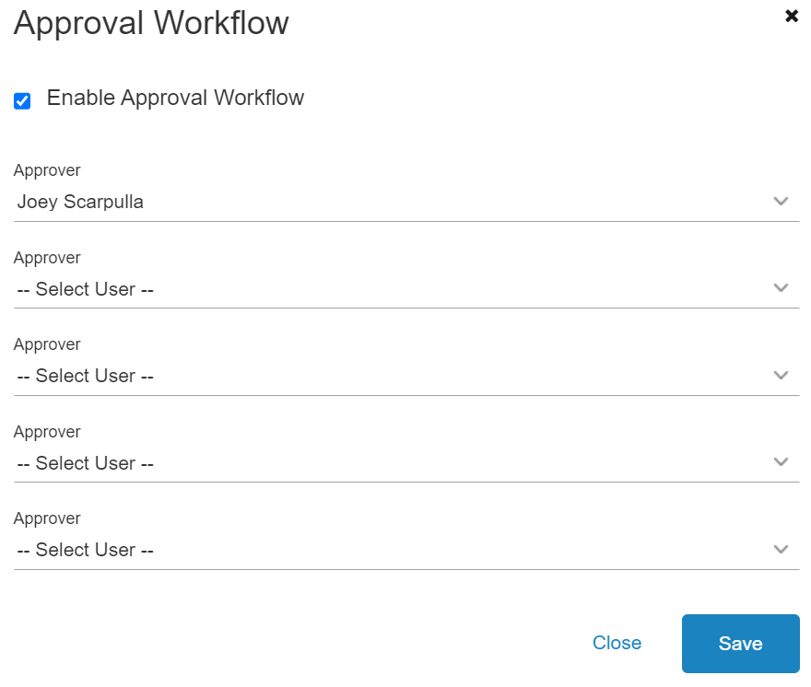

Bulk Download Completed Forms
Functional/Technical Administrators can also bulk download Completed Forms. To bulk download forms:
- From the Dashboard, click Form Requests.
- Go to the Completed Forms tab. Place checkmarks next to all desired forms.
- Select Bulk Download on the bottom left of the screen.
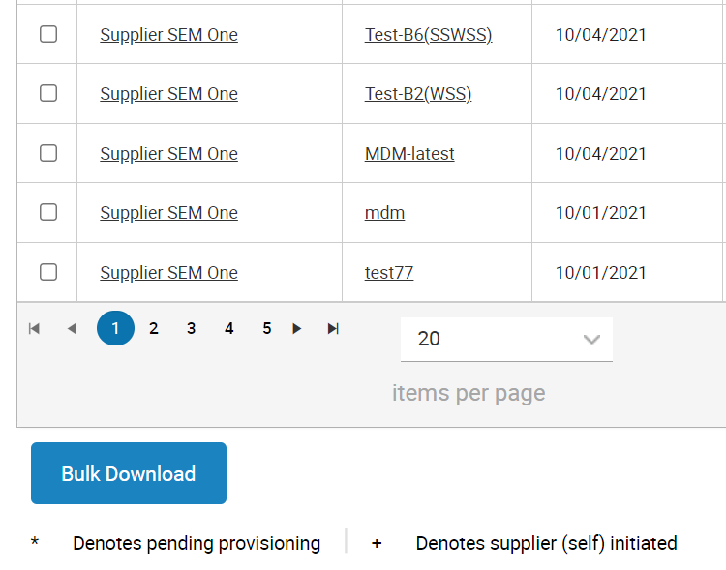

Bulk Cancel Forms
Functional/Technical Administrators can also bulk download Completed Forms. To bulk download forms:
- From the Dashboard, click Form Requests.
- Go to the Pending Forms tab. Place checkmarks next to all desired forms.
- Select Bulk Cancel on the bottom left of the screen.
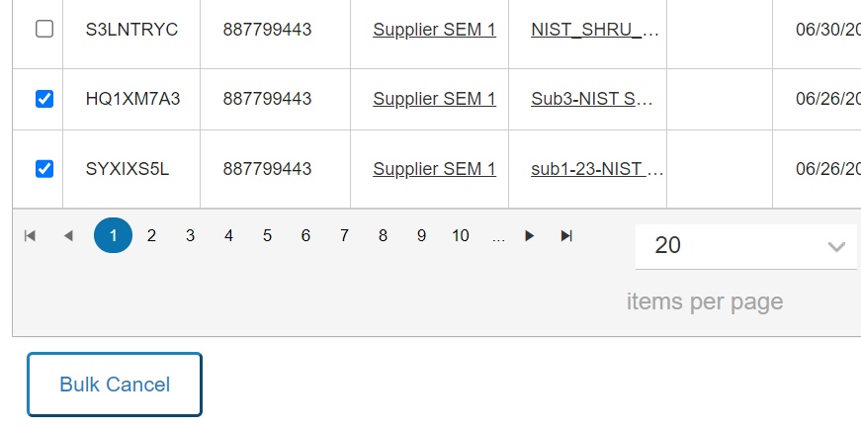

Approval Decision
This page is available to Functional Administrators. It displays forms with the approval workflow enabled, which is selected during the form creation process. There is a search feature at the top of the screen and below that, the following tabs are provided:
- Pending Decision: Provides a comprehensive list of all forms which are Pending Decision for the Buyer Approval Workflow, which is enabled during the form submission process.
- Assigned to Me: Provides a list of forms assigned to you to enter decision.
- Decision Complete: Provides a list of forms for which decision is complete (approved or rejected.
IMPORTANT! Unless a form is assigned to you for an approval decision and has a Pending Decision status, the action links are grayed out and not clickable.
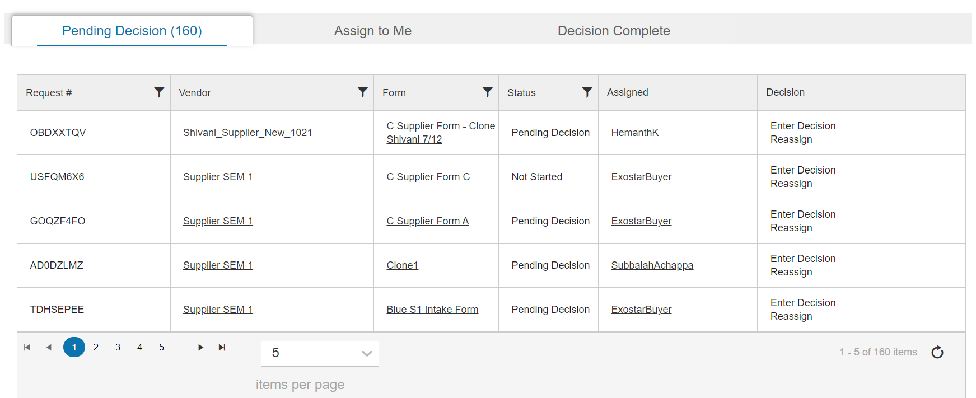

Approve Form
To approve a form:
- Select Approval Decision from the left-hand menu.
- Locate the desired form. Click the Enter Decision link.
NOTE: If Approval Decision has been assigned to you, the form displays in both the Pending Decision tab and the Assign to Me tab.
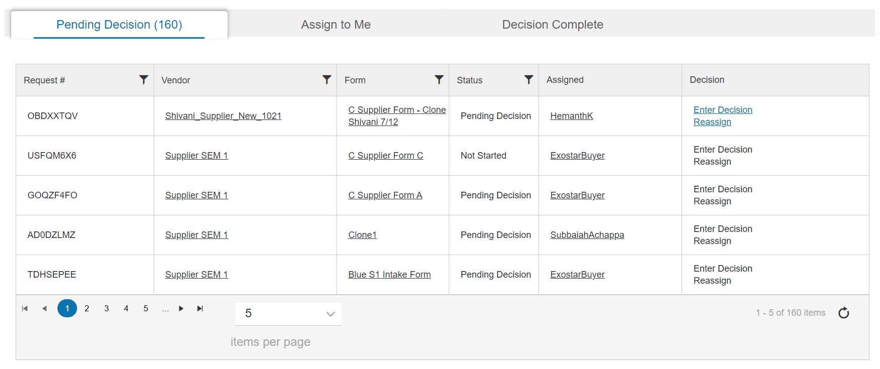

NOTE: You can select the Reassign link to reassign Buyer Approvers.

- Select the Approve radio button. Enter Approval Reason. Click Submit to move the form to the Decision Complete tab.
NOTE: Once approved, no further action is required at this time.
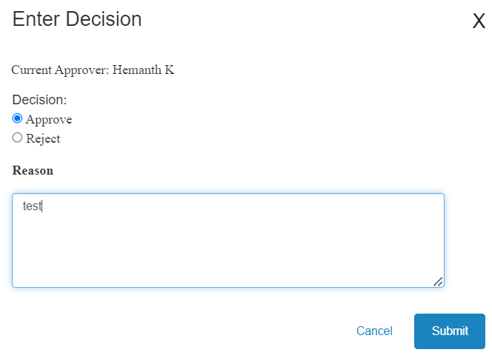

Reject Form
To reject a form:
- Select Approval Decision from the left-hand menu.
- Locate the desired form. Click the Enter Decision link.
NOTE: If Approval Decision has been assigned to you, the form displays in both the Pending Decision tab and the Assign to Me tab.
NOTE: You can select the Reassign link to reassign the Approval Decision.

- Select the Reject radio button. Enter Reject Reason. Click Submit to send the form to the Decision Complete tab.
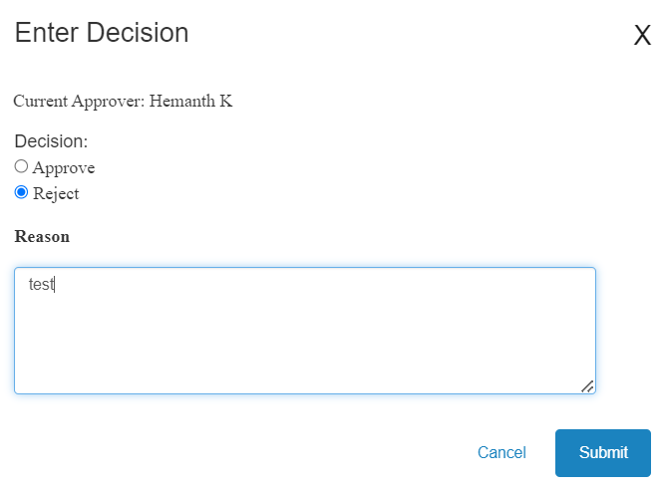

- Navigate to the Decision Complete tab and locate the form. Click the Resubmit link.
NOTE: If no further action is needed, click Mark Complete.
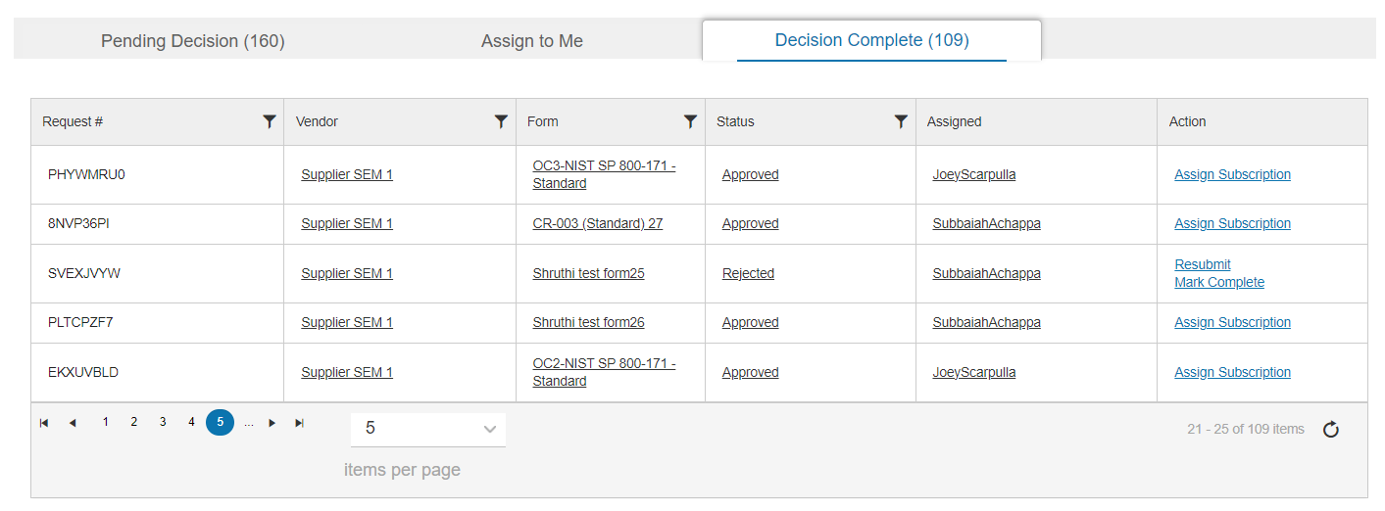

- Assign the desired user from the drop-down menu. Click Resubmit to send the form back to the Supplier for updates.
NOTE: Selecting Resubmit will move the form back to the Supplier’s Pending Forms tab and it will go through the same cycle again.
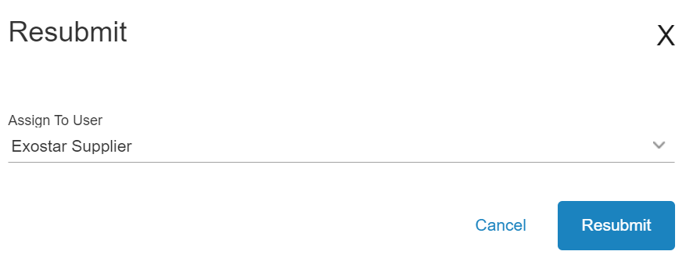

Reporting tool
To generate a report:
- Select Reports from the left hand navigation menu
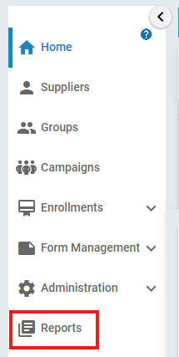
- Select standard reports folder to open the standard reports available
- Select the standard report that accomplishes your goal
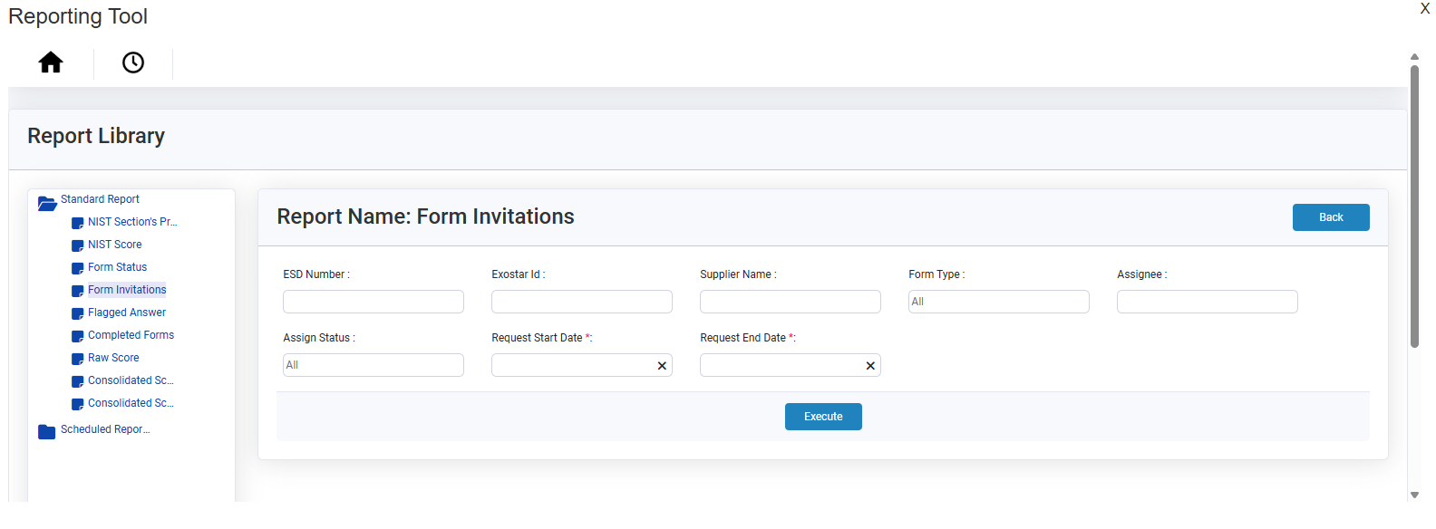
- Complete required fields and select execute

Manage System Emails
Functional Administrators and Technical Administrators can manage emails sent from SM system, by updating and modifying content at any time. Every email sent from SM has a template, and those templates are targeted for role-specific audiences (Buyer Admin, Supplier Admin, Buyer User).

Upon initial display of the Email Template page, all the current email’s recipient information (To, CC, Subject Line, and Email Body Text) displays as default content. Administrators can edit this information as needed. All variables/fields in the email body (i.e. the values/parameters that can change per the email's context) are shown within brackets such as "[Variable Name]".
To modify email templates:
- From the left-hand navigation on the Dashboard, click Email Template under the Administration section.

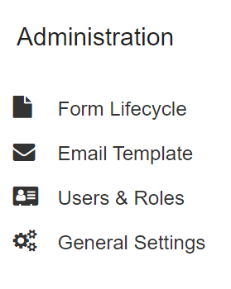
- Navigate to the desired Target section. Click the Edit icon, located on the right side of the screen, for the desired email.
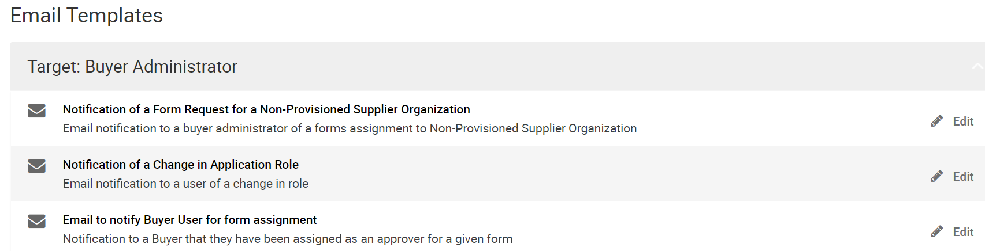

NOTE: The top portion of the template displays Email Template Name, Current Version Number, and Last Updated Date.

- Drag and drop desired fields from the options provided along the left side of the screen, into the body of the HTML editor. Click Save to complete the update.
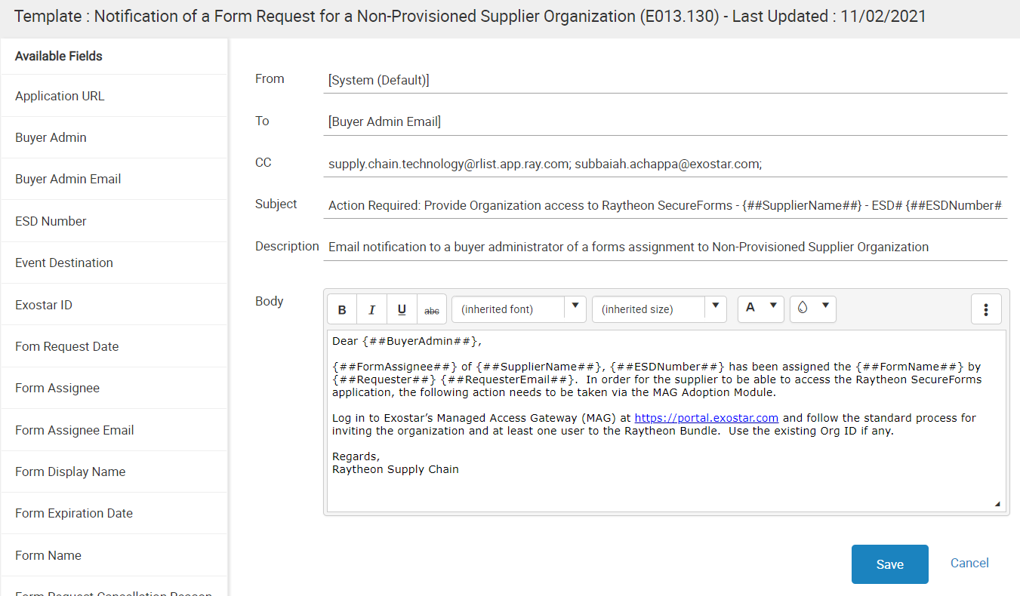

NOTE: Every time an Administrator edits and saves an email template, the template is incremented to the next version.

User Management
Administrators can manage all users in SM. This role can modify roles of any users, across all organization records in SM, along with the ability to deactivate accounts. Functional Administrators can also set role definitions.

Modify User Role and Status
To modify a user’s record:
- Select Users & Roles from the left-hand navigation tree, under Administration.
- The system defaults to the Manage Users tab. To search for an organization, enter the Organization Name in the text box. All users for that organization display in list view. Click the tool icon next to the desired user.
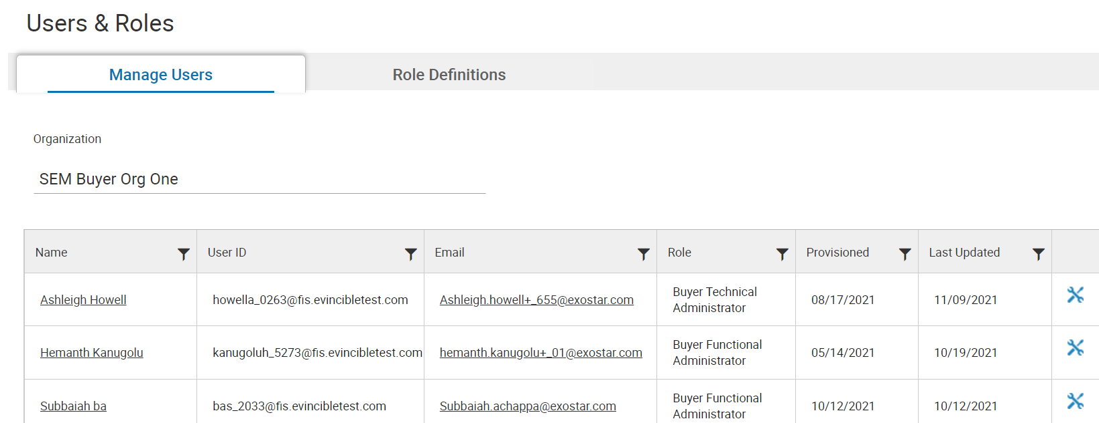

- The Role Management pop-up displays. From this screen, update the user’s roles or status. Click Update.
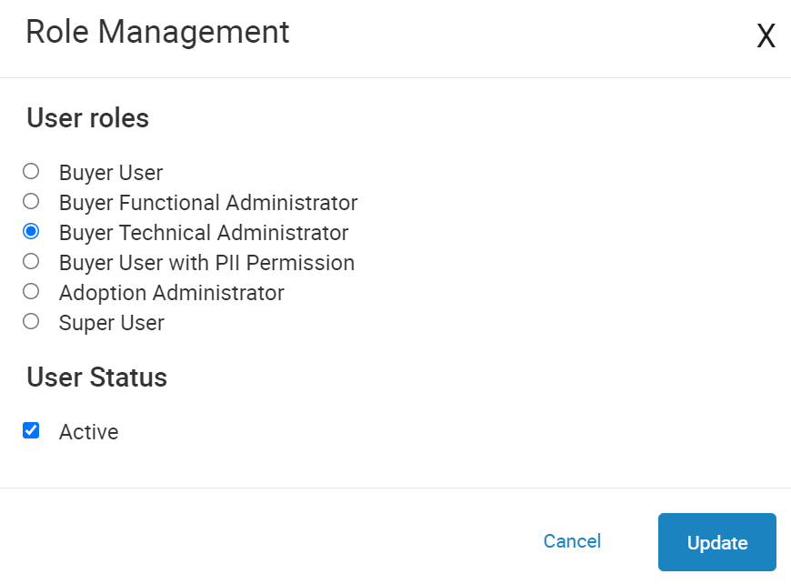

NOTE: If a user is deactivated in SM, they are not deactivated in MAG. To remove a user from MAG, contact the organization’s MAG Organization or SM Application Administrator. If users are no longer with the company, their accounts should be removed from MAG, which removes them from SM.

Set Role Definitions
Functional Administrators and Technical Administrators can modify existing role definitions, as well as create new role definitions. This essentially allows the administrator to modify role permissions.

Modify Existing Role Definitions
To modify existing role definitions:
- Select Users and Roles from the left-hand navigation menu.
- Navigate to the Role Definitions tab. Select the tool icon next to the desired role.
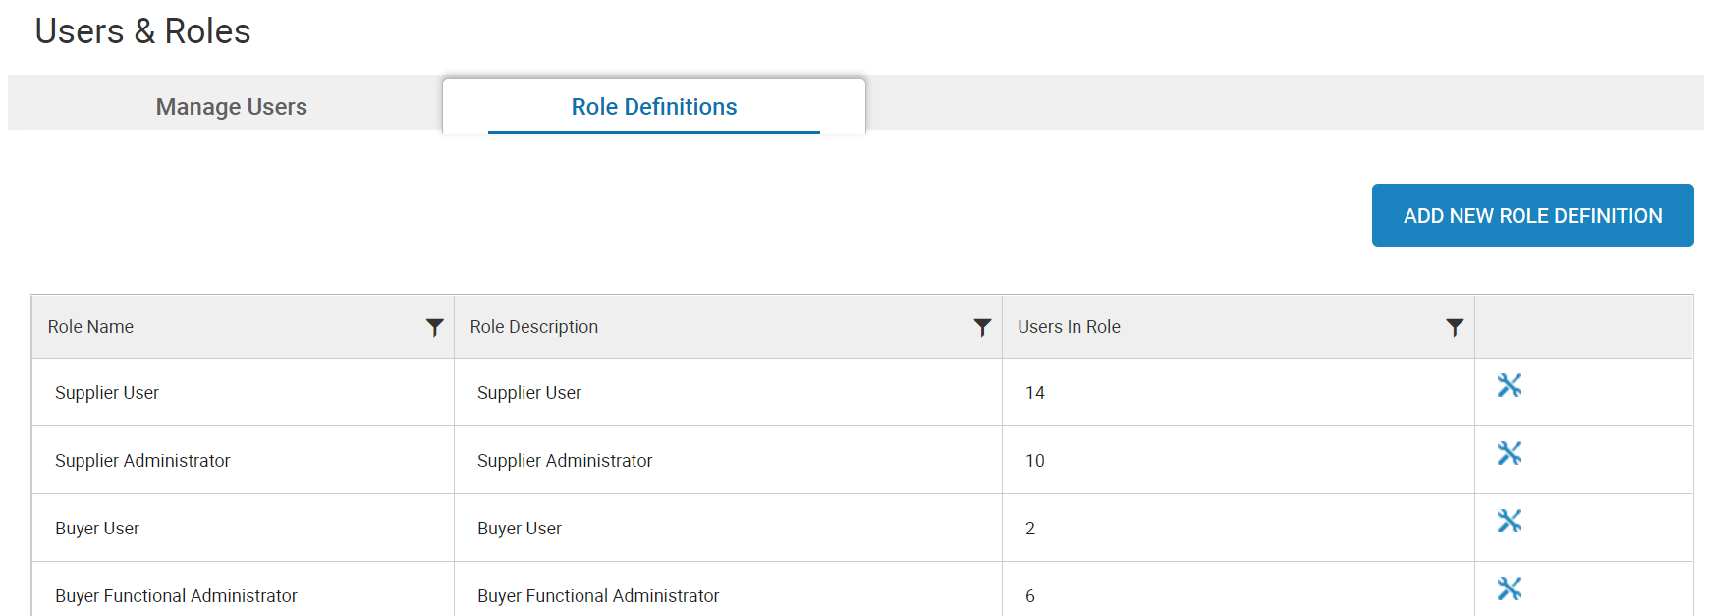

- Select or deselect Permissions as desired. Edit the Audience to change the role description, if desired. Click the Update button.
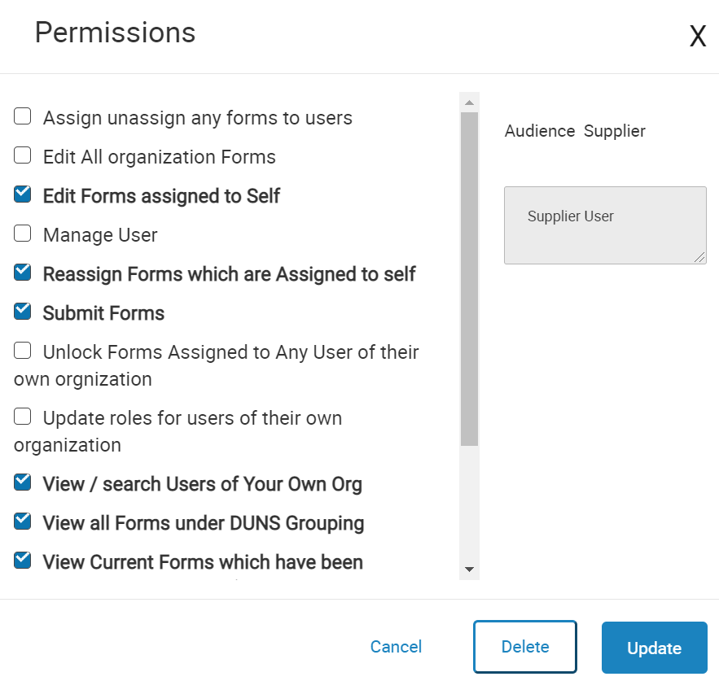
NOTE: If you wish to delete the role, simply navigate to the Permissions prompt, and select the Delete button.

Create New Role Definitions
To create a new role definition:
- Select Users and Roles from the left-hand navigation menu.
- Navigate to the Role Definitions tab. Select the ADD NEW ROLE DEFINITION button.

- Complete the Role Name field. Select from the Audience drop-down. Provide a Description and select Permissions. Click Add.
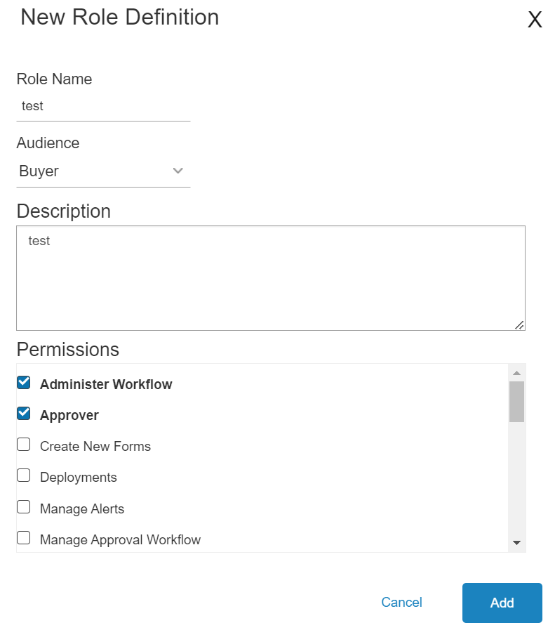

General Settings
General Settings is available from the left-hand menu and displays the following options:
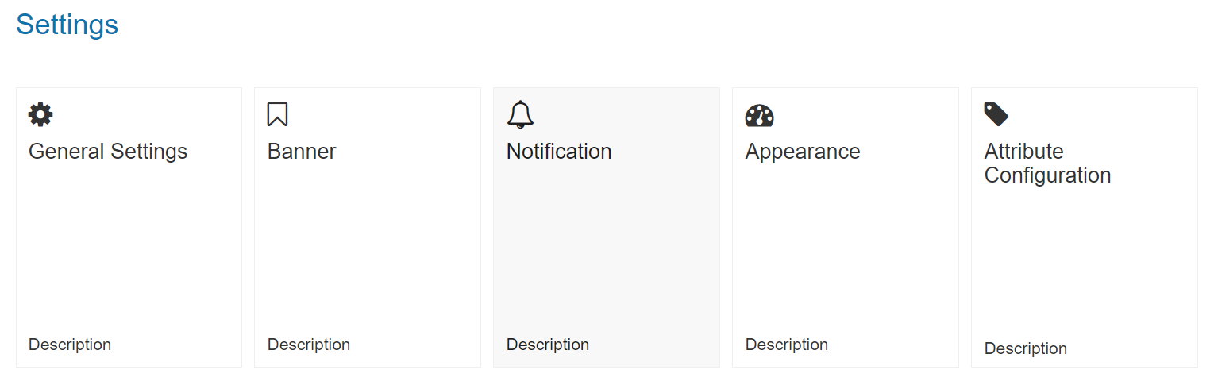

General Settings
The General Settings selection provides the following editable features as well as their current values:
- Email From Address: This selection allows you to update the Email From Address.
- Default Application Name: This selection allows you to update the application name that displays in the top header.
- Contact Us Email: This selection allows you to update the Contact Us email address that displays in the top header.
- MyExostar: This selection allows you to update the myExostar link that displays in the top header.
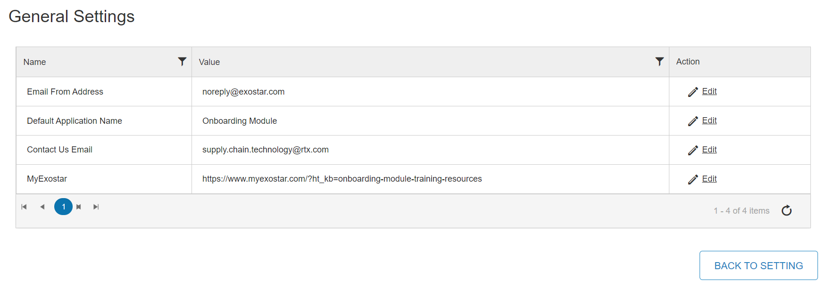

To edit any of the options:
- Select the Edit icon in the Action column.

- Make desired changes. Click the Update button.
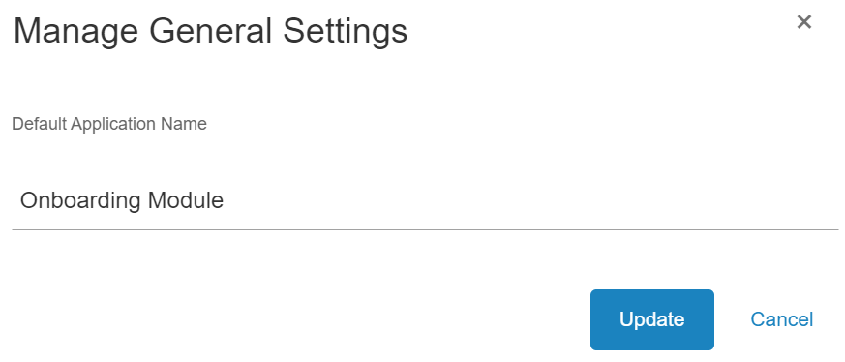

Banner
Depending on system permissions, Administrators can modify banner messages. There are two types of banners:
- Site: Displays announcements on the Supplier View.
- Report: Displays announcements in reporting.

Modify Existing Banner
To modify existing banner messages:
- From the left-hand navigation, select the General Settings option under Administration.
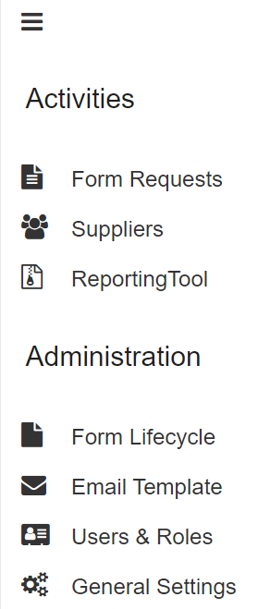

- Select Banner.

- Locate the desired banner message and click the Edit icon.
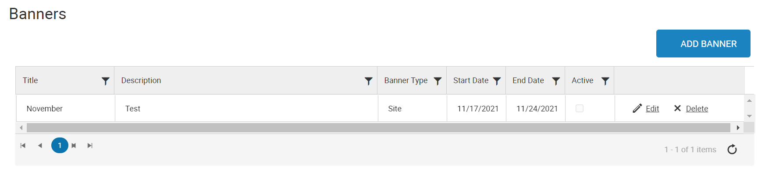

NOTE: Select the Delete option to remove the banner completely.
- Make all desired changes. Click Save.
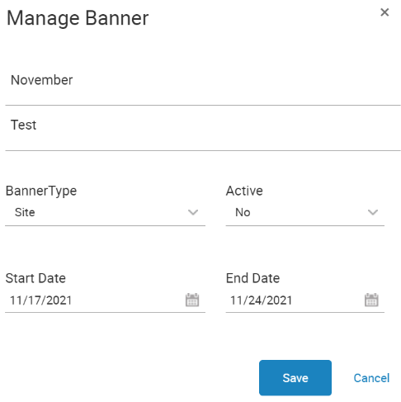

Add New Banner
To create a new banner message:
- From the left-hand navigation, select the Banner option under Administration. Click the Add Banner button.

- The Manage Banner screen displays. Add the Title, Description, Start Date and End Date, Banner Type, as well as Active drop-down. Click Save.
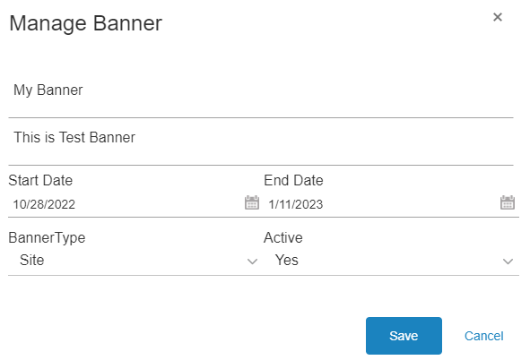

Notification
The Notifications section of the application is available from the General Settings page via the left-hand navigation menu. This allows you to set interval types, values, and reminder counts on some events. Notifications are used to send out email reminders, using a selected email templates (created in notifications) on specific configured internals on a given event

To navigate to and manage notifications:
- Select General Settings from the left-hand navigation menu.

- Select Notification.

- Click Edit for the desired Event.
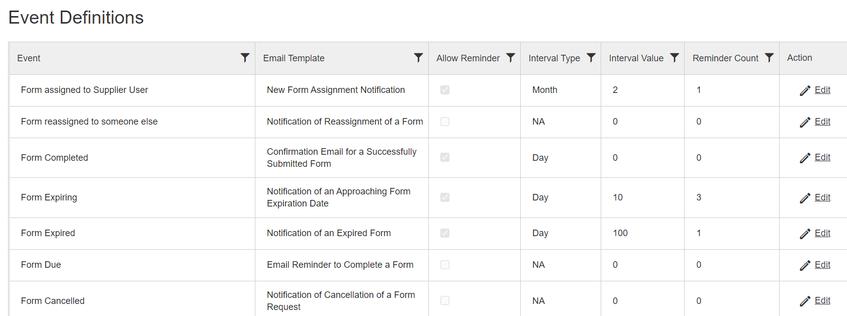

- Deselect or select the Allow Reminder checkbox.
- Select Day, Week, or Month from the Interval Type drop-down menu.
- Select the Interval Value (day, week, month) and Reminder Count (total number of reminder emails sent out based on interval type/value). Click Update.
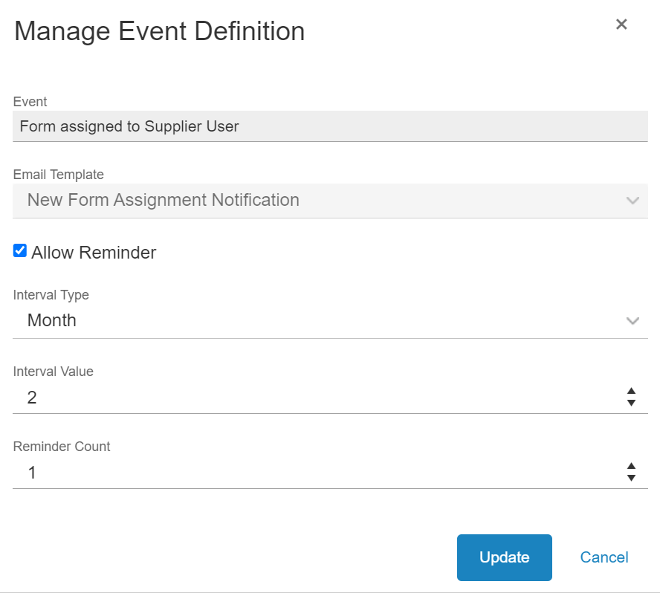

Appearance
The Appearance section is available from the General Settings page and allows end users to upload logo images, as well as customize links available from the dashboard.

Upload Logo
To upload a logo image:
- Select General Settings from the left-hand navigation.

- Select the Appearance option.

- On the Uploading Logo sub-tab, click Select files…and choose the desired file from your local drive. Click Save.
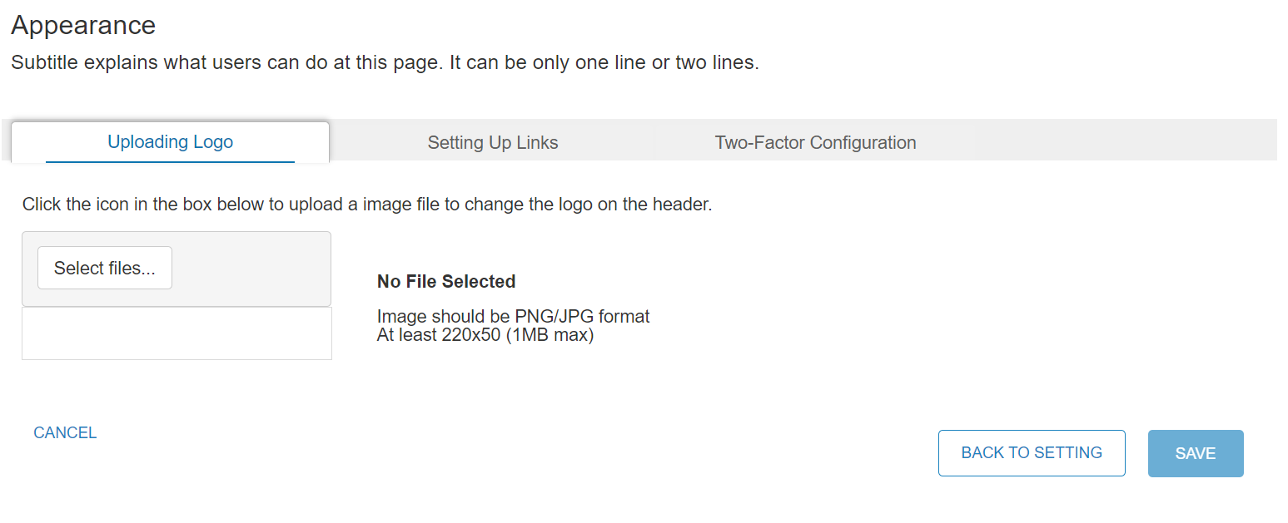

Customize Links
To customize the links displayed on the dashboard:
- Select General Settings from the left-hand navigation.

- Select the Appearance option.

- Open the Setting Up Links sub-tab. Click the Add Link button.
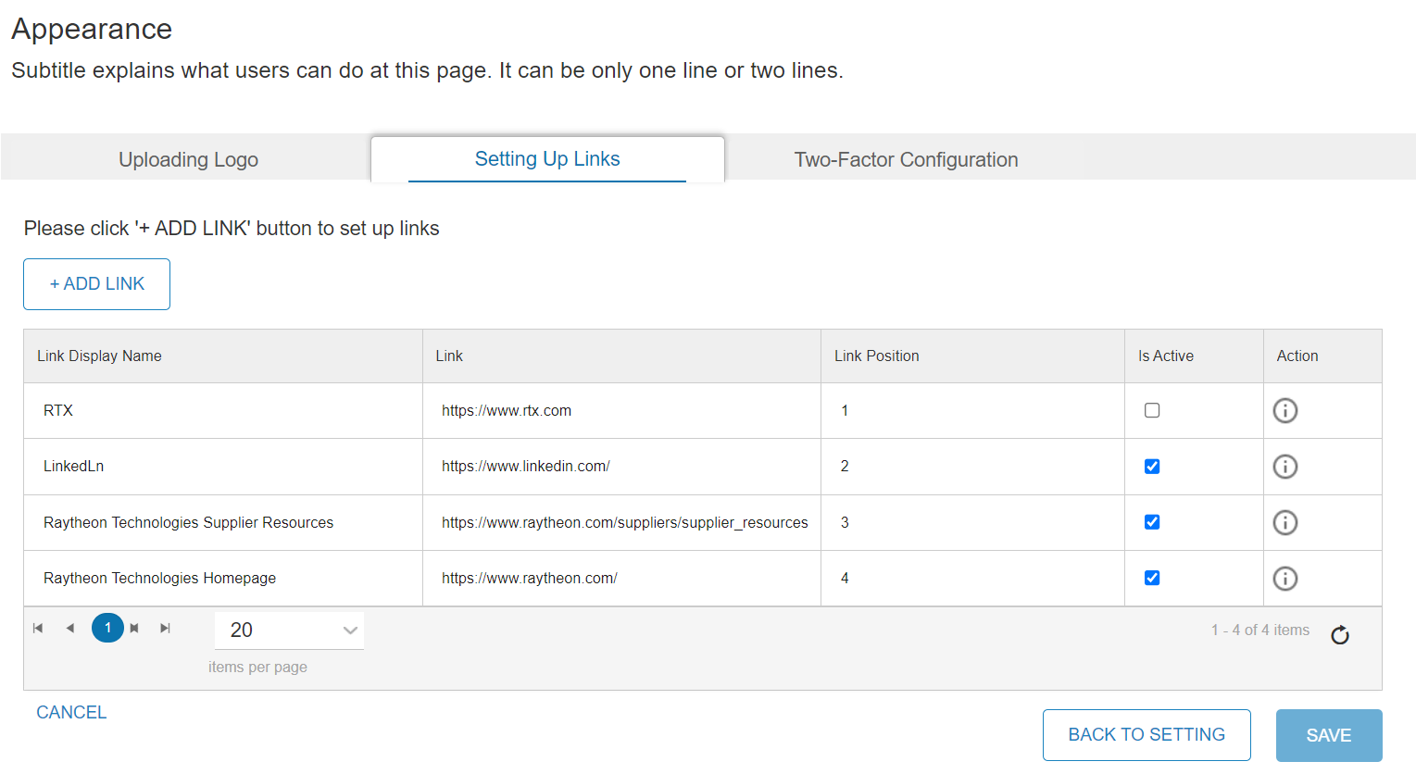

- Choose from the Select a Link Position drop-down.
NOTE: This determines the order in which the links display.

- Enter the Link Display Name and Link Address. Click Save.
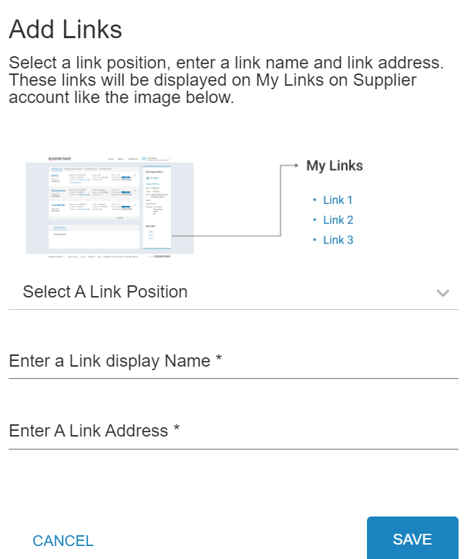

To manage existing links:
- Locate the desired link and select or deselect the Is Active checkbox.
- Select the Action option for the desired link to update name and address.
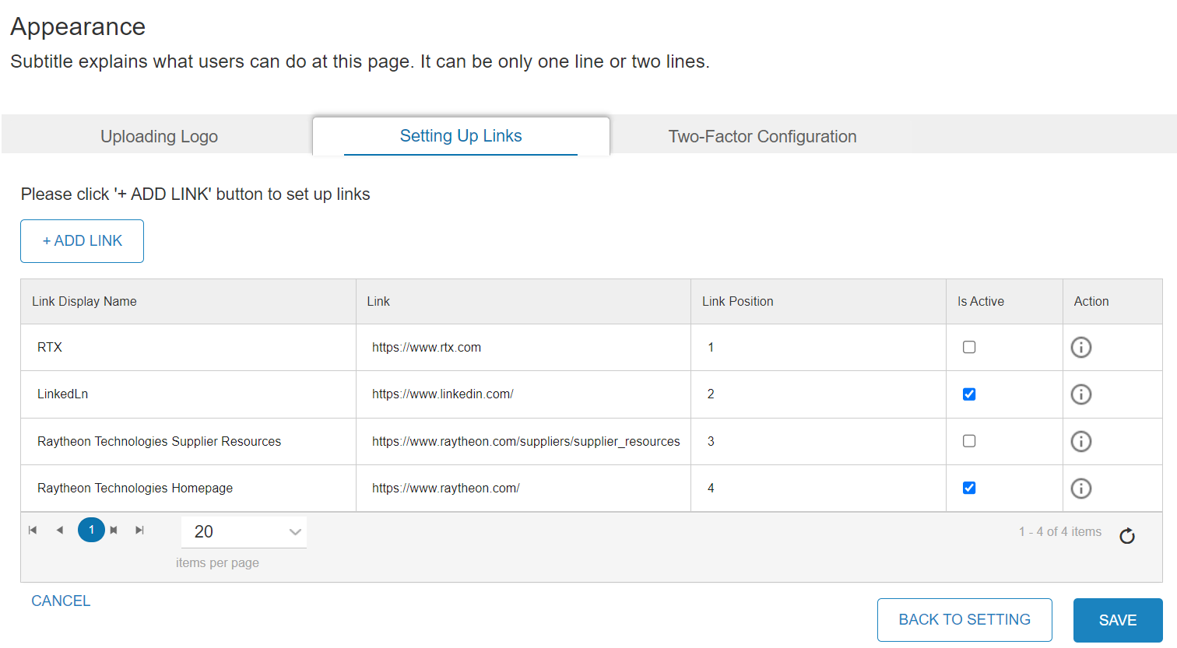

Two-Factor Configuration
This section allows you to configure required credentials to get into the Supplier Management. This feature is not currently in service. We will add additional content when it is turned on.
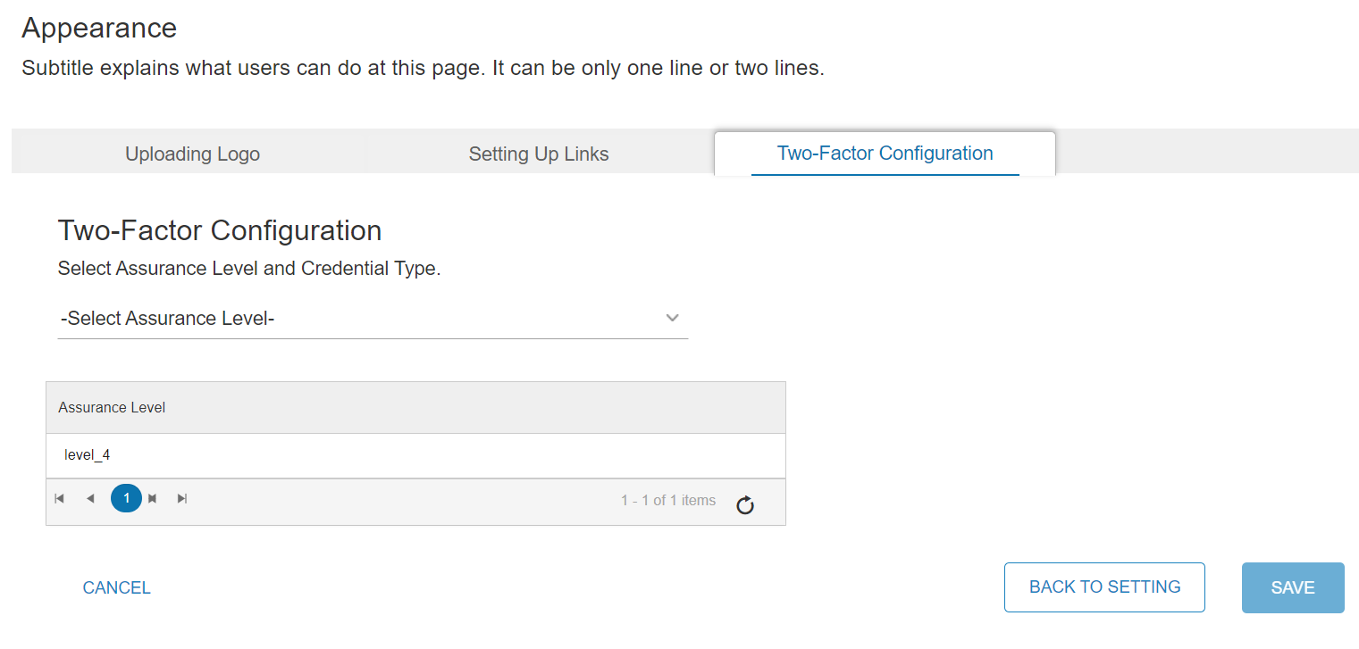

Attribute Configuration
Users with permission to manage attributes can create Supplier Attributes, or groups. These Attributes can be used during the New Form Request process, when sending a single form to multiple Suppliers. If you are updating an existing Category/Attribute, you can begin this process on the Associate Attributes tab.

To create an Attribute Configuration:
- Select General Settings from the left-hand navigation.

- Select the Attribute Configuration option.

- On the Setup Attributes tab, select an existing category to edit or delete, or select the +CREATE NEW CATEGORY button.
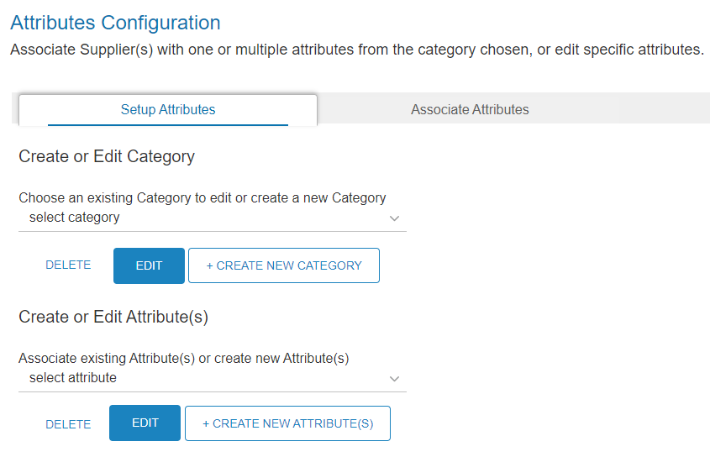

- Name the new category. Click Save.
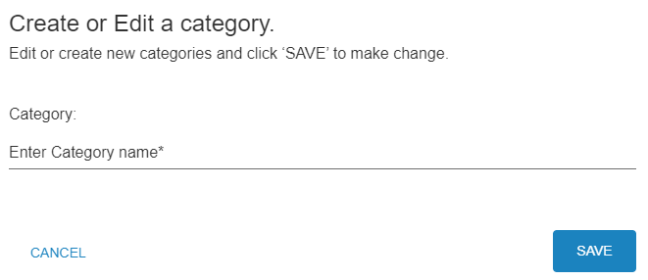

- A confirmation box displays. Click Okay.
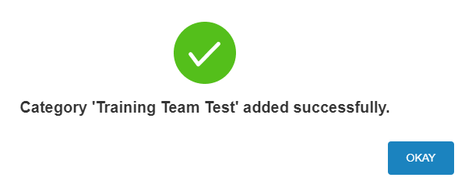
- Select an existing attribute to edit or delete or select the +CREATE NEW ATTRIBUTE(S) button.
NOTE: You cannot select an existing Attribute or create a new one if a Category is not selected.
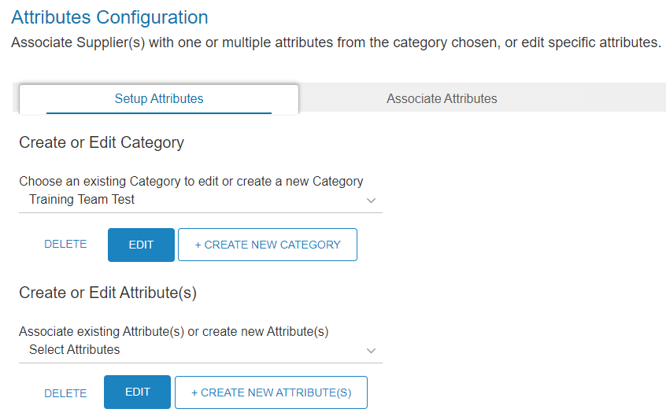

- Name the new Attribute. Click Save.
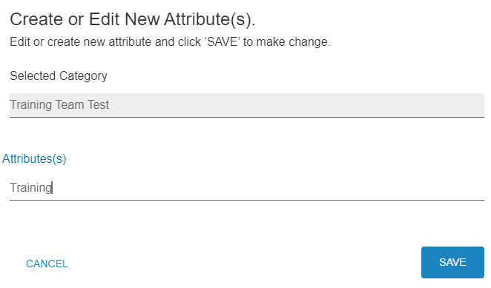

- On the confirmation screen, click Okay.
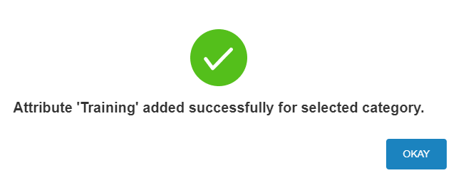

- To add Suppliers to the Attribute, navigate to the Associate Attributes tab. Select the Category. Select the Attribute.
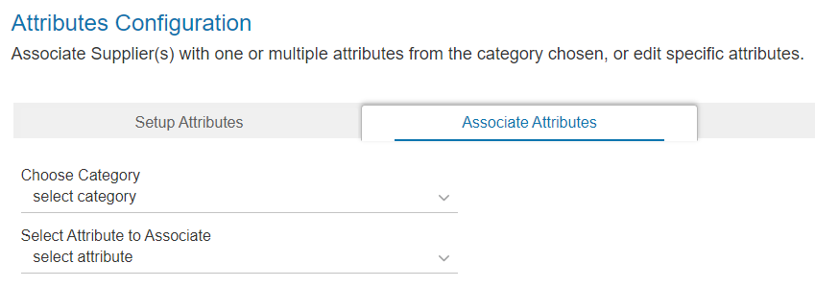

- Place checkmarks next to the desired Suppliers. Click Update Attribute.
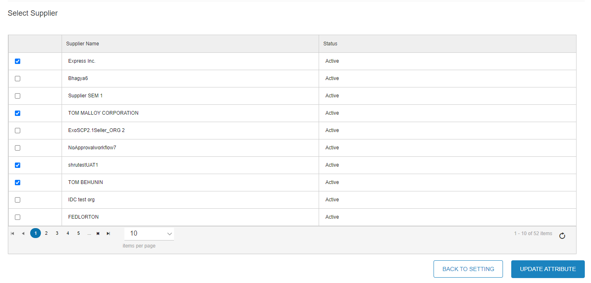
- Click Okay in the confirmation box.
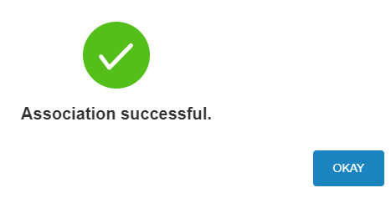

Suppliers
The Suppliers section of SM allows you to search for existing suppliers in MAG, as well as add new suppliers. Only existing MAG Suppliers, who are not provisioned to SM, can be invited.

IMPORTANT! To invite a Supplier to access SM, a Buyer must have the Adoption Administrator role for the SM application in MAG. Exostar must add this role to your user account. Please contact Exostar Customer Support to inquire about getting the Adoption Administrator role. Please see the Adoption Module Invitation section below for more information.

Supplier Search
Buyer users can search Exostar’s MAG and SMD database for suppliers. To complete a search:
- Select Suppliers from the left-hand navigation menu.
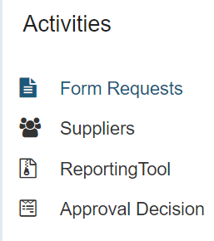
- On the Supplier List tab, enter the name of a supplier in the Enter Organization text area. Click the Search button to view the search results in the Supplier Search table.
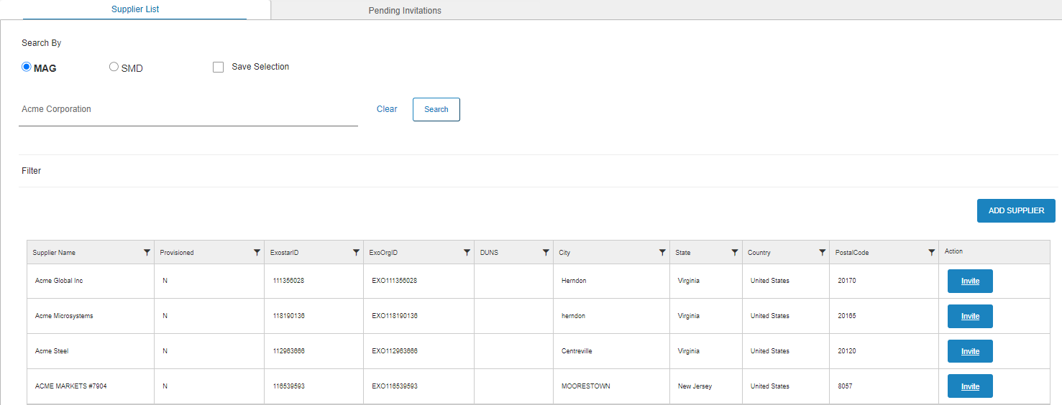

Invite
From the Supplier Search page, buyer organizations can invite existing MAG suppliers to the Supplier Management. To invite existing MAG suppliers:
- From the search results in the Supplier Search table, click the Invite button next to a non-provisioned supplier, where the Provisioned flag is N.
NOTE: If the Supplier is already provisioned to SM, and the Provisioned flag is Y, the Invite button will be displayed in white instead of blue. You must use the MAG Adoption Module for such an invitation. Also, invited suppliers have a clickable name to view their details. Please see the Adoption Module Invitation section below for more information.
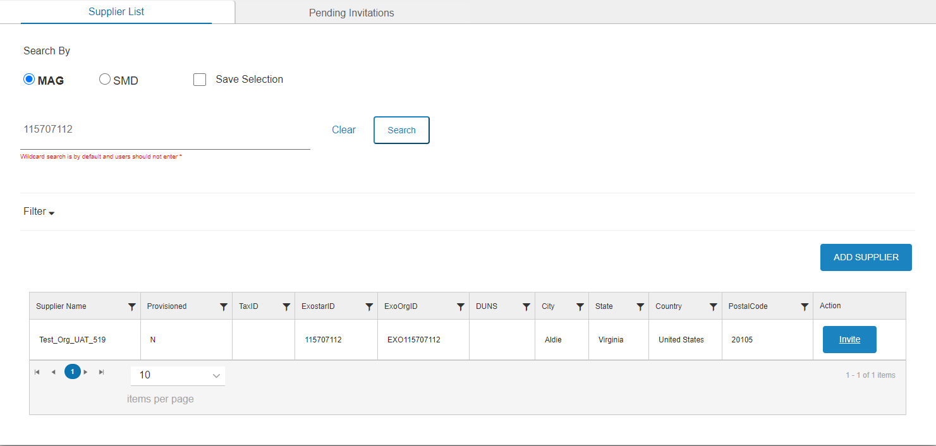

- Review the supplier organization information on the Organizational Details screen. Input the Supplier POC Email Address. Click the Next button.
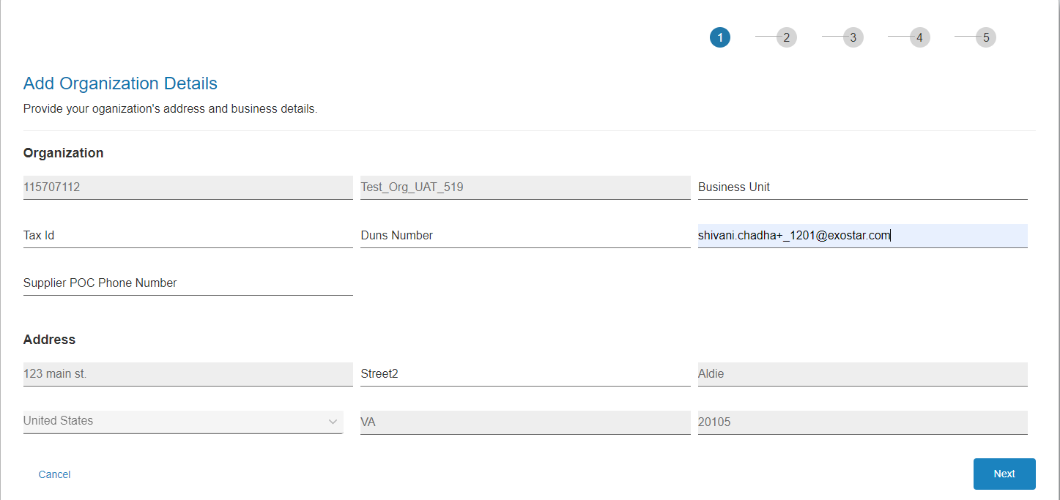

- On the User Details screen, check the existing user you want to invite, and you can also add a new user by clicking the Add New User button. Click Next.
NOTE: You cannot invite a user to a shell organization in MAG, which means there should be at least one user displayed on the User Details page.
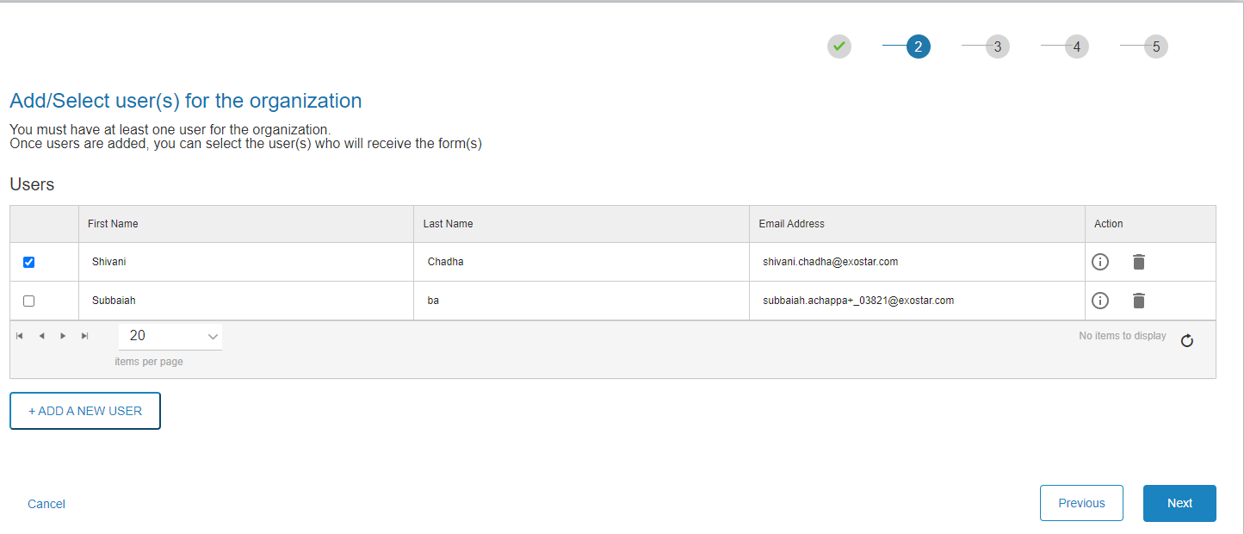

- If a new user is also invited, add information about the user in the Add New User prompt. Click the Add User button.
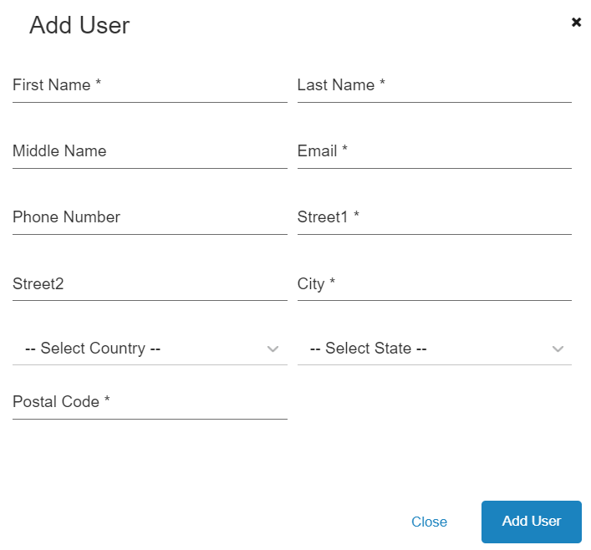

- Once all users have been added, place checkmarks next to the users you want to invite. Click Next.
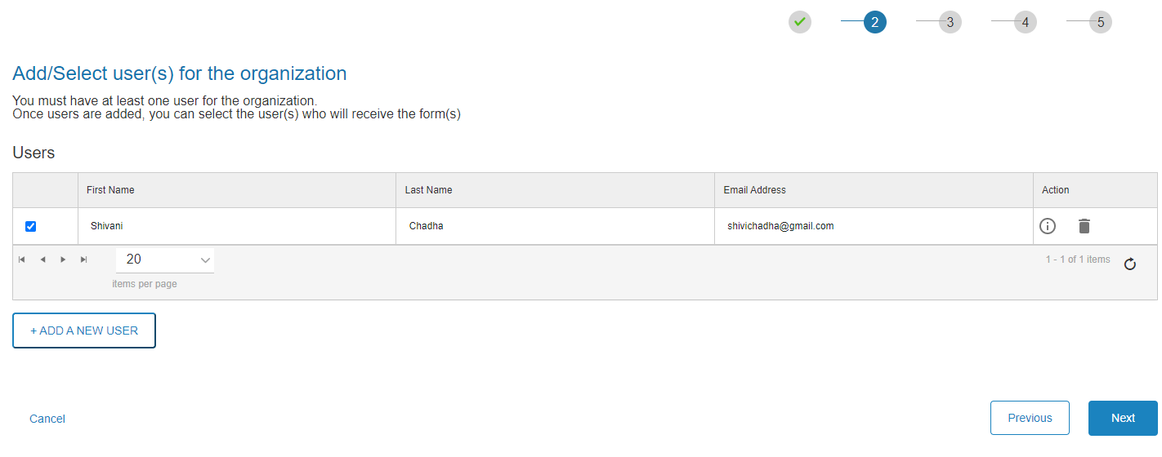

- Type in the Form Name in the field provided. Click Add.

- Select the user in the Assign a user... drop-down. Click Next.
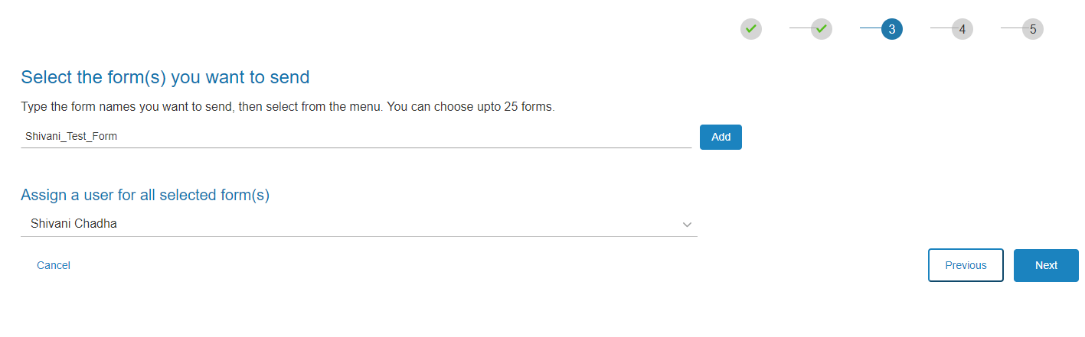
- Select the Yes to Enable Approval Workflow. Select No to NOT Enable Approval Workflow. Select Yes or No to determine the same set of Approvers, if you have added multiple forms. If enabled, assign a Buyer Approver. Click Next.
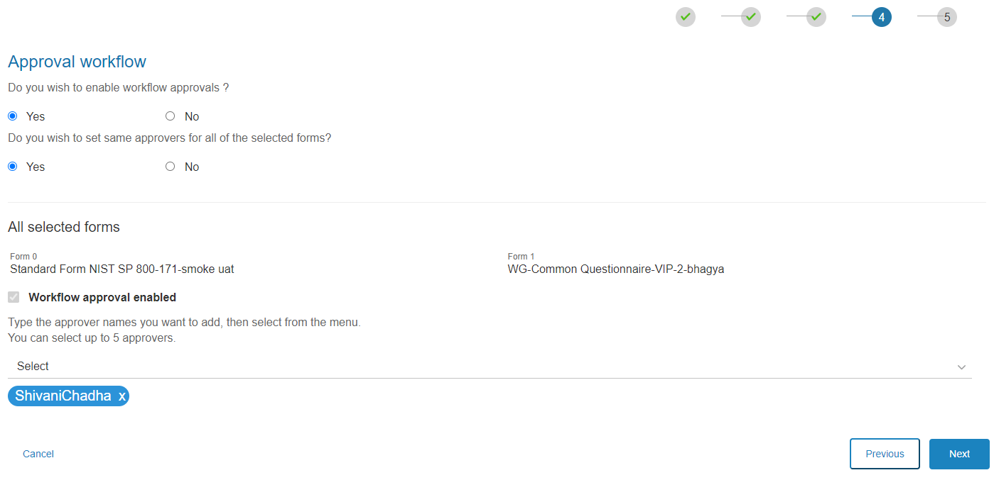

- Verify data input. Click Submit.
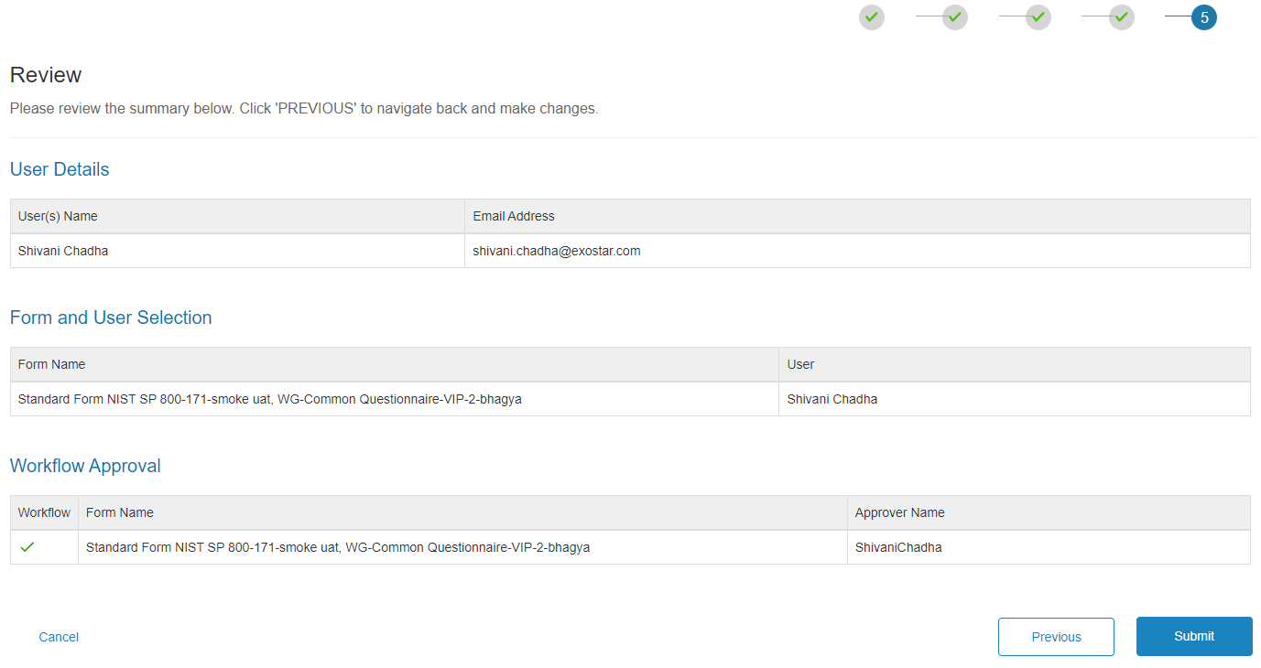

Add New Supplier
From the Supplier Search page, buyer organizations can invite existing MAG suppliers to the Supplier Management. To invite existing MAG suppliers:
- From the search results in the Supplier Search table, click the Invite button next to a non-provisioned supplier.
NOTE: If the Supplier is already provisioned to SM, the Invite button will be displayed in white instead of blue. You must use the MAG Adoption Module for such an invitation. Also, invited suppliers have a clickable name to view their details.

- Review the supplier organization information on the Organizational Details screen. Input the Supplier POC Email Address. Click the Next button.

- On the User Details screen, check the existing user you want to invite, and you can also add a new user by clicking the Add New User button. Click Next.
NOTE: You cannot invite a user to a shell organization in MAG, which means there should be at least one user displayed on the User Details page.

- If a new user is also invited, add information about the user in the Add New User prompt. Click the Add User button.

- Once all users have been added, place checkmarks next to the users you want to invite. Click Next.

- Type in the Form Name in the field provided. Click Add.

- Select the user in the Assign a user... drop-down. Click Next.
- Select the Yes to Enable Approval Workflow. Select No to NOT Enable Approval Workflow. Select Yes or No to determine the same set of Approvers, if you have added multiple forms. If enabled, assign a Buyer Approver. Click Next.

- Verify data input. Click Submit.

Adoption Module Invitation
This section outlines scenarios when SM cannot be used for invitations and Buyers must invite via the MAG Adoption Module.

IMPORTANT! To invite a Supplier to access SM, a Buyer must have the Adoption Administrator role for the SM application in MAG. Exostar must add this role to your user account. To verify you have this role, navigate to the My Account tab or view the Adoption tab. Please contact Exostar Customer Support to inquire about getting the Adoption Administrator role.
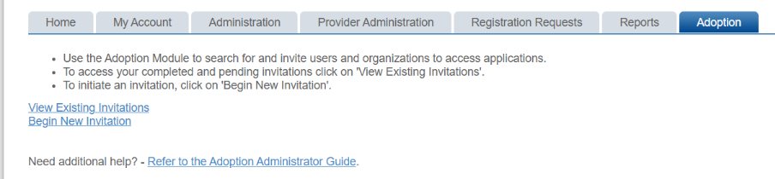

Scenario 1: Existing Org, Subscribed to SM, Add New User
For this scenario, when a search is performed, the Provisioned flag is Y and Invite button is white. This means the organization is already subscribed to SM.
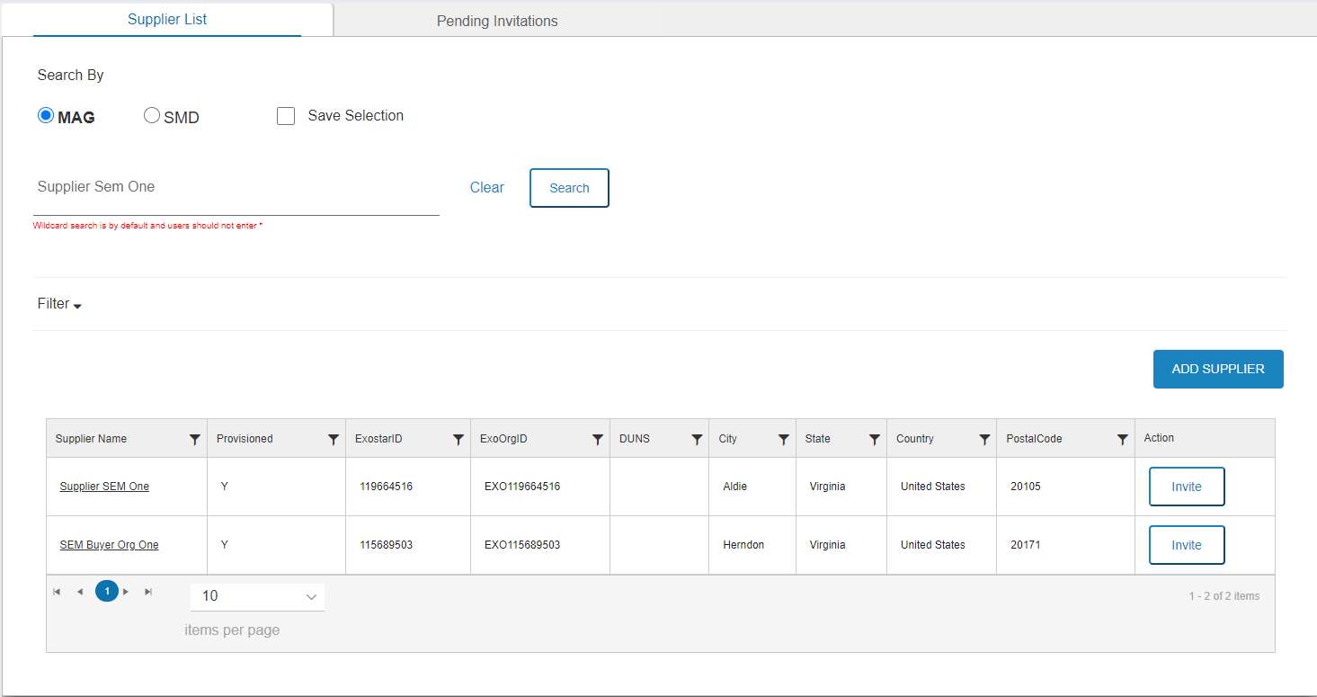
To invite a user to this organization, the Buyer must:
- Navigate to https://portal.exostar.com and complete the MAG login.
- Select the Adoption tab. Click the Begin New Invitation link.

- Click the Search Organizations button.
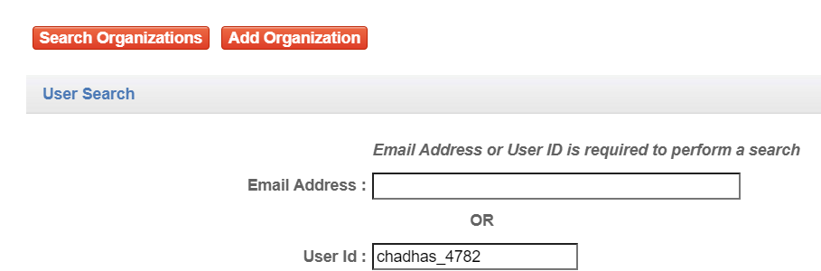

- Input the Organization Name or Exostar ID, and as many details as necessary to locate the desired organization. Click Search. Select the hyperlinked Org Name in the search results.
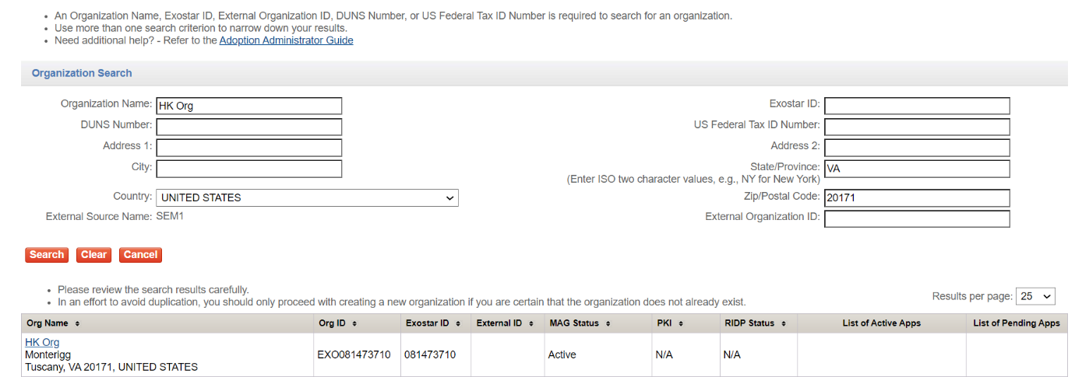

- The Organization Summary page displays. In the Actions section, select Invite New User.
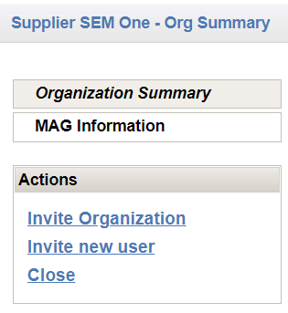

- Input all required fields for User Profile Information section.
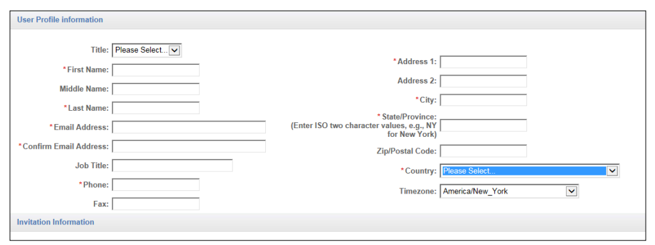

- In the Invitation Information section, place a checkmark for the Supplier Management application. Click Next.
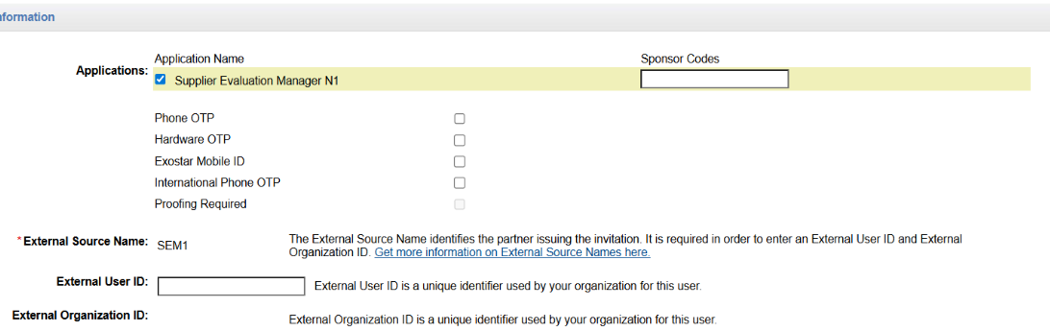

- Review the data input. Click Submit to complete adding the user.
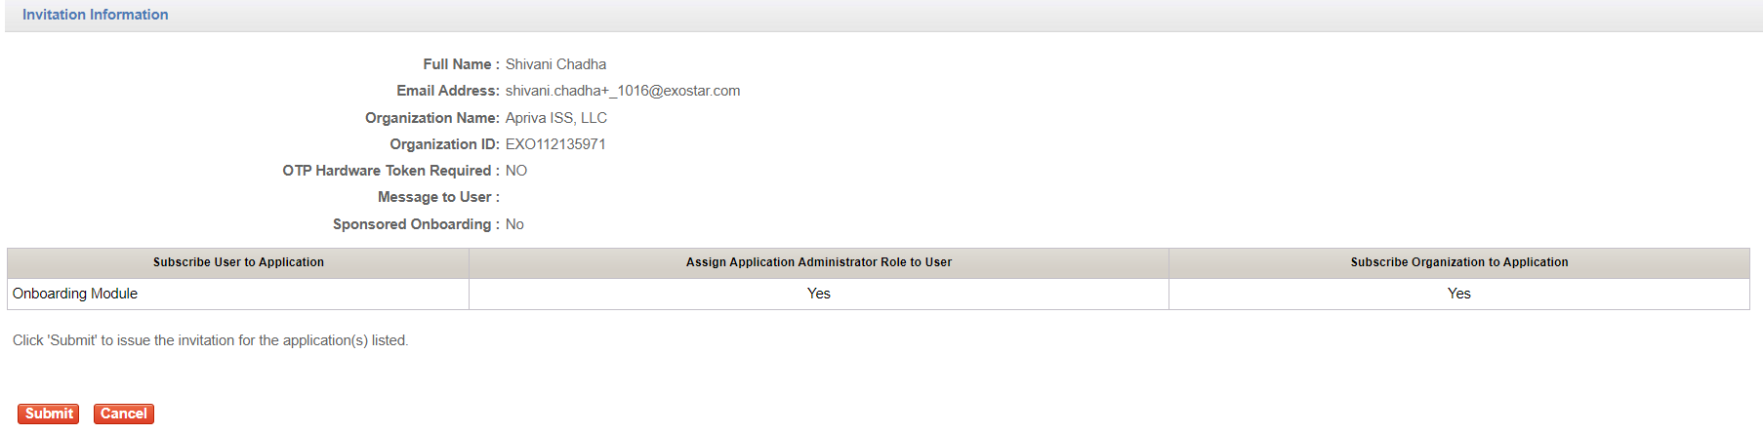

NOTE: If you invite an existing MAG user (same email address attached to an existing user account), MAG displays a duplicate account soft warning. A Buyer can still submit and proceed with the invitation.
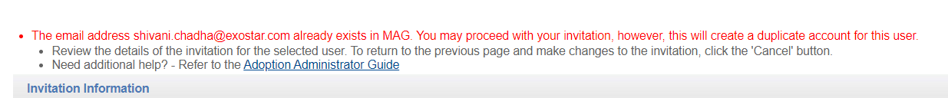
As the Adoption Administrator, you receive a notification once the user completes their invitation. The company’s Organization Administrator also receives a notification alerting them the user is subscribed to an application.

Scenario 2: Existing Org Subscribed to SM, Invite Existing User
This scenario works under the assumption that the organization exists in MAG and is currently subscribed to SM. The user exists in MAG as well but is not currently subscribed to SM. To complete this invitation scenario:
- Navigate to https://portal.exostar.com and complete the MAG login.
- Select the Adoption tab. Click the Begin New Invitation link.

- Input user’s Email Address or MAG User ID. Click Search.
- From the search results, select the desired hyperlinked Last Name.
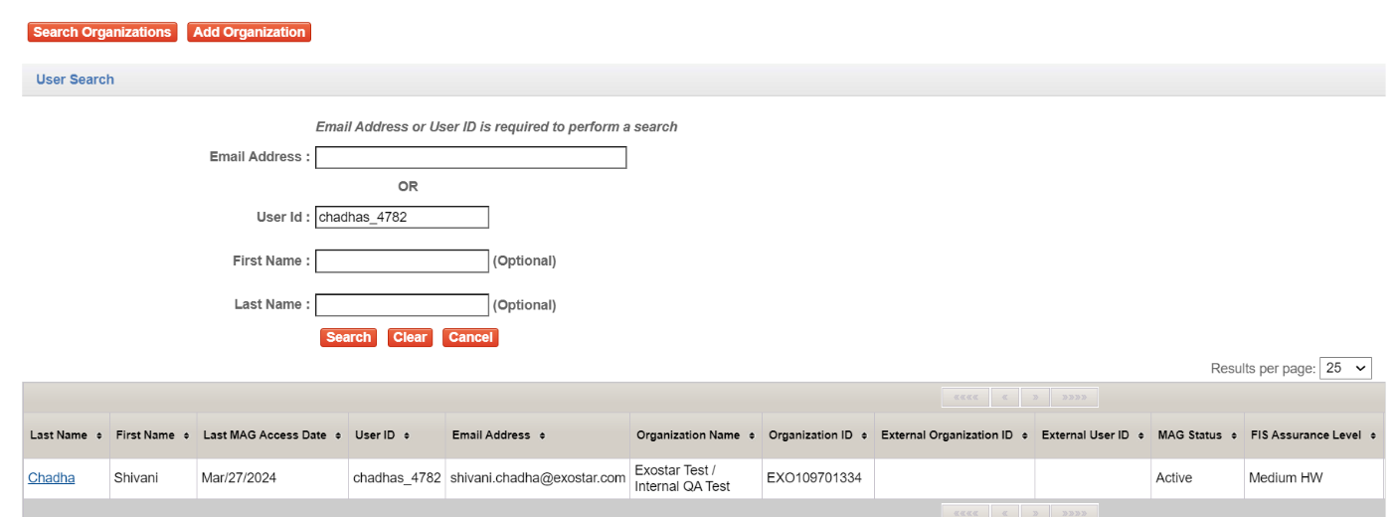

- Under Invitation Information, place a checkmark next to Supplier Management. Click Next.

- Click Save.
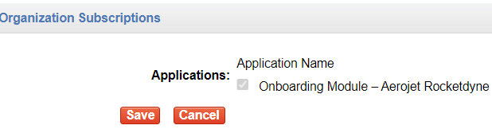

Scenario 3: Shell Orgs with NO Organization Administrator
This scenario occurs when you search for an organization in SM, you fill in the POC, and the user list page displays zero users listed in the organization. You cannot proceed in SM and must user the Adoption Module.
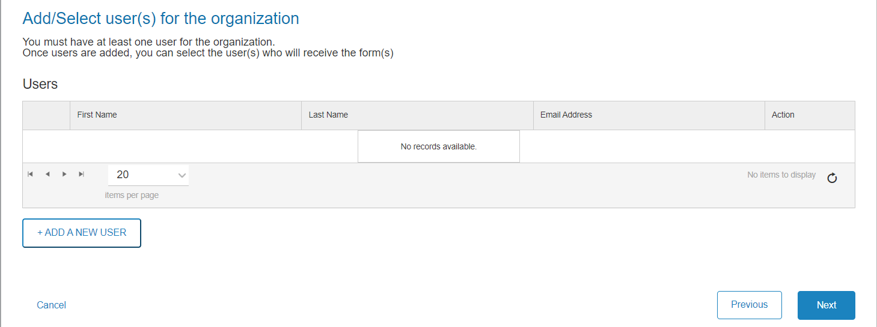
IMPORTANT! If a user IS listed, you can proceed in SM.

To proceed add a user to the shell account:
- Navigate to https://portal.exostar.com and complete the MAG login.
- Select the Adoption tab. Click the Begin New Invitation link.
- Click the Search Organizations button.

- Input the Organization Name or Exostar ID (remove EXO), and as many details as necessary to locate the desired organization. Click Search. Select the hyperlinked Org Name in the search results.

- The Organization Summary page displays. In the Actions section, select Invite New User.

- Since this organization does not currently have a user, a message displays notifying you this user will be assigned the Organization Administrator role. If you wish to proceed, click the Invite User button.
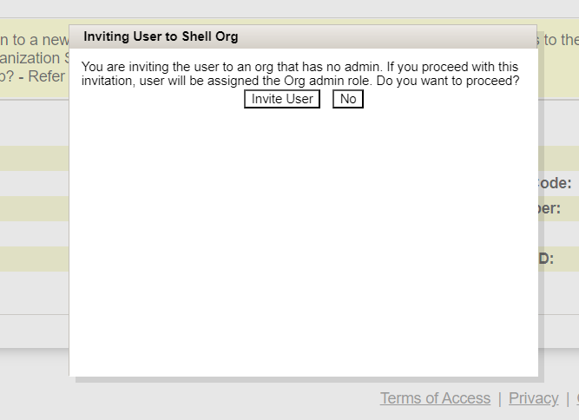
- Input all required fields for User Profile Information section.

- In the Invitation Information section, place a checkmark for the Supplier Management application. Click Next.

- Review the data input. Click Submit to complete adding the user.

NOTE: If you invite an existing MAG user (same email address attached to an existing user account), MAG displays a duplicate account soft warning. A Buyer can still submit and proceed with the invitation.
As the Adoption Administrator, you receive a notification once the user completes their invitation. The company’s Organization Administrator also receives a notification alerting them the user is subscribed to an application.

Track Invitations
As an Adoption Administrator, you can track invitations sent by you or other Adoption Administrators for the same application to which you are assigned. To track invitations:
- Navigate to https://portal.exostar.com and complete the MAG login.
- Select the Adoption tab. Click the View Existing Invitations link.
- Select the desired search criteria. Click Search.
- Select the hyperlinked Request ID to view the invitation.
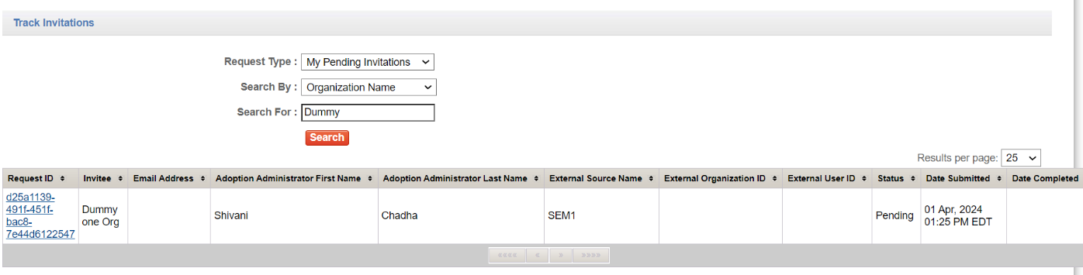

Invitation Status
Invited: An email is sent to the user to accept the invitation. Until they accept, and before the 30-day expiration, this status displays. This invitation type can be deleted.
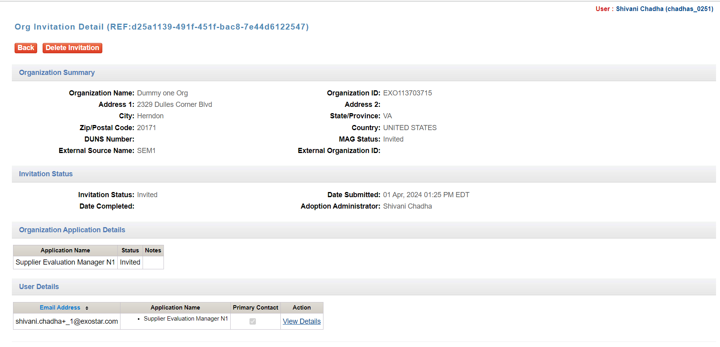

Expired: If the supplier does not accept the invitation in 30 days, the invitation expires and displays this status. You can delete and re-issue a new invitation in this case.

Supplier In Process: This status displays when the supplier acknowledges the invite. Please note, after this step, the invitation cannot be deleted.

Pending Exostar Approval: The organization is pending a DPL check. Please note, only a few organizations go through DPL checks.

Completed EPA Approval: The invitation is complete, and the user has been sent an Account Activation email.

