Trading Partner Manager (TPM)
LM Buyer Help Document

Version 3.0
Prepared by Exostar LLC.

July 1, 2020

Exostar Proprietary Information – Confidential

Contents
1.1 TPM Buyer Roles 3
1.2 Managed Access Gateway (MAG) Roles 3
1.3 TPM Profiles 4
4.1 Enter Core & Profile Information 9
4.2 Dun and Bradstreet Search Results Page 10
4.3 Resolve Duplicates Page 11
4.4 Enter Organization Information during Request New Org 12
4.5 Request/Invite Organization 12
4.5.1 Profile Type: Full (Regular) 13
4.5.2 Profile Type: Full (Expedited) 14
4.5.3 Profile Type: RFx or QA (with users) 17
4.5.4 Profile Type: Profile with no users 17
4.6 Contacts 18
4.7 Address Validation 20
5.1 My Open Requests 23
5.2 All Open Requests 26
View Request 26
Delete Request 26
5.3 Approval-Pending Requests 26
6.1 Profile Update 27
6.2 Upgrade Profile Type/Flag 27
6.3 FULL Profile 29
6.4 RFx or QA w/ Users Profile 30
6.5 NonPO/PCard/QA without Users Profile 30
6.6 Sample Add Profile Use Cases 30
7.1 Organization Debarment & Other D&B Alerts/Critical Events 35
7.2 Organization Mergers & Acquisitions per Dun & Bradstreet Load/Refresh 35
7.3 Denied Parties List 35
8.1 Profile Registration Report 36
8.2 Profile Expiration Report 38

1 | USER ROLES AND TPM PROFILES

The Trading Partner Manager (TPM), formerly CIC, supports a number of roles, each with varying levels of permissions and privileges. These roles include:

1.1 TPM Buyer Roles
Inquiry Only – This role allows the user to search and view all non-sensitive data for an organization.

Requester/ Buyer – This role includes the inquiry-only privileges plus the ability to request New Organizations/Trading Partner profiles, as well as modify certain organization data.

Site Administrator – This role allows the user to request New Organizations, search and view all sensitive and nonsensitive organization data as well as update certain organization data.

Corporate Administrator – In addition to the Site Administrator’ privileges, the Corporate Administrators can view all open requests.

Accounting Administrator – This role allows the user to request New Organizations, search and view all sensitive and non-sensitive organization data as well as update certain organization data specific to banking, payment & tax information.

Buyer Approver – This role is responsible for validating and approving/denying requests to expedite creation of an organization record.

1.2 Managed Access Gateway (MAG) Roles
The following roles are supported by Exostar and other designated third parties:

Exostar Portal Administrator (EPA) - This role is held by Exostar Membership Services team. The EPA authorizes & approves organization and user registrations. They can request New Organization administrators and perform One-Time-Password (OTP) resets as well as permanent password resets. They can also modify organization information.

Exostar Customer Support - Exostar Customer Support person who can view organization and user profile information as well as initiate password resets for users’ permanent password.

Service Provider Administrator (SP Administrator)– The SP Administrator is responsible for final approving the person employed by a SIG application owner (Service Provider), that is responsible for coming into SIG and updating organizations’ application subscription status.

The following roles are defined at the time of creating the MAG account for a supplier.

Organization Administrator – Organization Administrator (Org Admin) is the primary contact for the organization’s MAG account. The Org Admin is responsible for the overall administration of the organization’s MAG Account. This individual has the following privileges:


Approves a user to be added to MAG as an employee of their organization.

Able to search and view all sensitive and non-sensitive organization data.
Update certain organization data for their organization only.
Request subscription to additional MAG applications for the organization.
Overall administration of the organization’s MAG account and users.

After the initial account set-up, this role can be granted to multiple individuals by the existing Organization Administrator.

Company Contact - The individual identified as the Company Contact is the secondary contact for the organization.

Application Administrator – An application Administrator is designated for each application that an organization subscribes. The application administrator (app admin) is responsible for managing the access to the application within their organization by approving/denying a user’s application subscription. In approving the user’s request, the application administrator (on behalf of their organization) assumes financial responsibility for the user’s seat in that application.

User – A person with an active MAG account, whose employing organization is registered with MAG.

1.3 TPM Profiles

The following profile types are available to LM Buyers when inviting a supplier to complete the Invitation process.

 | Profile Type |  | Variation | Business Definition
 | Full |  | Regular | Complete, PO profile vendor (can be used for all activities). Allows an organization to do business with LM in all capacities. Highest level of profiles possible.
 |  |  | Expedited | Full profile, PO vendor that needs to be used in an emergency situation and as such is created by a slightly different process. Provisioned within 30 minutes.
 | RFx |  | - | Vendor that can be used for various RFx (i.e. RFQ, RFP, etc) activities.
 | QA |  | With users | These are quality only and inspection suppliers. They are OEM suppliers that are used on PO’s written to other third party distributors/vendors. These suppliers are able to login to LMP2P via Exostar MAG.
 |  |  | Without users | Same as above however these suppliers are not able to login to the Exostar MAG.
 | Non-PO |  | - | These are vendors for which there may be no PO activity, but to which payment still needs to be made (i.e. a special event payment).
 | PCard |  | - | Vendor with whom PCard purchases are made. These account types are created manually by LM users.
 | Unsolicited |  | - | This is a pseudo profile type. It is a supplier that already has an existing account within Exostar and most likely are doing business with another Exostar partner (e.g. Boeing, Raytheon, BAE, etc). Their information is searchable in TPM.
2 |  | NAVIGATION
Use the Previous, Next and Cancel buttons/links on each page to navigate between pages on the Organization profile. Clicking the Previous or Next buttons saves entries on the current page before navigating away.

Clicking Cancel at the bottom of the Org Summary pages discards any entries that have been made so far on the current page and returns the user to the main Org Summary page. No validation is performed.

The Cancel Request, Save, Resume Later, Submit Request and Send to LM Buyer buttons are located on the left global navigation pane so that the user is able to access them at any point in the request.

The Submit Request and Send to LM Buyer Mgr buttons become active when all required fields have been provided in all sections.

Clicking Cancel Request in the global navigation performs form validation and then prompts the user to confirm that they really want to cancel.

If Yes, the request is cancelled and the user is returned to the TPM Home page. If No, the user is returned to the page that they were on.

Clicking on another section of the Organization profile will save any information entered on the page and performs validation on the current page before displaying the next page. If there are any validation errors, the user will be required to fix these issues before advancing to the next page.

Clicking Save and Resume Later will take the user back to the page they were on before coming into the Organization Information page (This may not always be the TPM Home page). They can then access the request from their My Open Requests inbox.

IMPORTANT: Screenshots in this guide may not accurately reflect the most recent requirements and are shown only to provide the user with a visual image of what the screen will look like. Wherever possible, updated screenshots will be inserted.

3 | PERFORM ORGANIZATION SEARCH
To search for an organization that is registered in the TPM, enter a keyword (or part of a keyword) beside one or more of the search filter options and click Search to execute the search, Clear to clear all entries and re-enter, Close to cancel the search and close the screen. See notes on next page for information on search criteria.

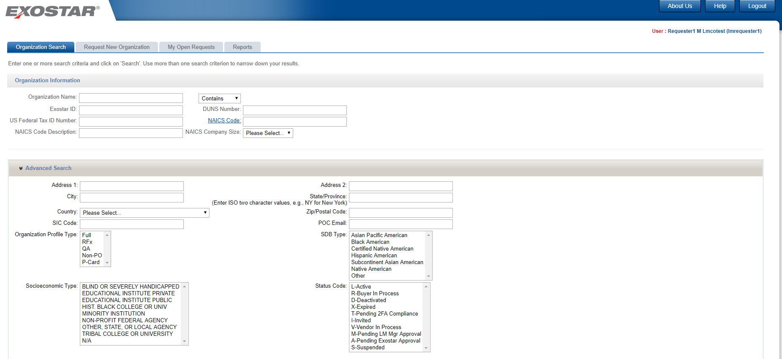

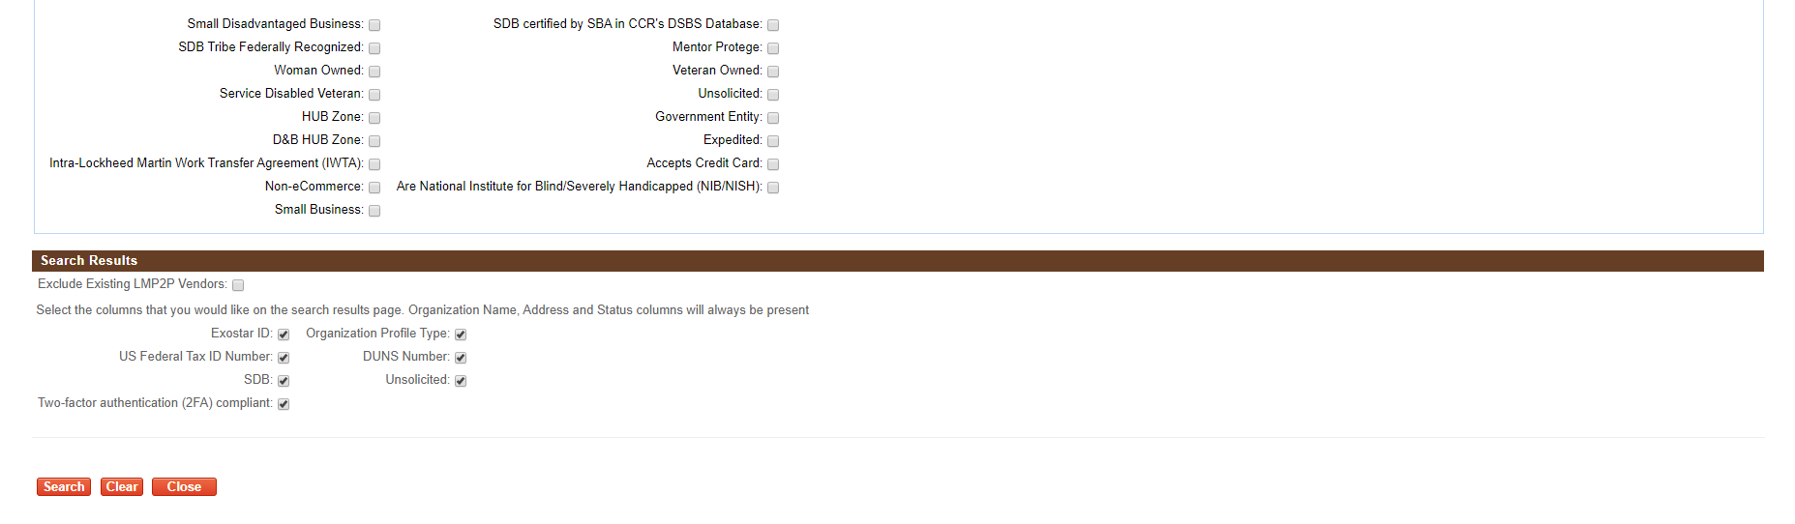
Screenshot 1: Organization Search Page

NOTES:
- The search logic for most of the fields is a 'CONTAINS'. For example, if you enter 'pol' in the Organization Name field, the system will return all organization records that contain the string 'pol' in the organization name.
- The search logic on the NAICS Code field is a 'STARTS-WITH'. As an example, a search for a NAICS code that starts with '123' would yield the results '123456', '123976', '123228', etc.
- When multiple entries are made, the system implements an 'AND' logic, i.e. if you enter 'pol' in the Organization Name field, and 'Virginia' in the State field, the system returns all organization records that contain the string 'pol' in the organization name AND are located in Virginia.
- The Search Results page can be customized to display certain fields by selecting from the available options however organization name and address will be returned by default upon every search.

Upon performing a search, the system will return all organizations that are registered in the TPM as well as all pending organization registration requests. Pending requests are any that have been submitted, but have not yet been approved by the EPA.
*Subject to the TPM Buyer role.

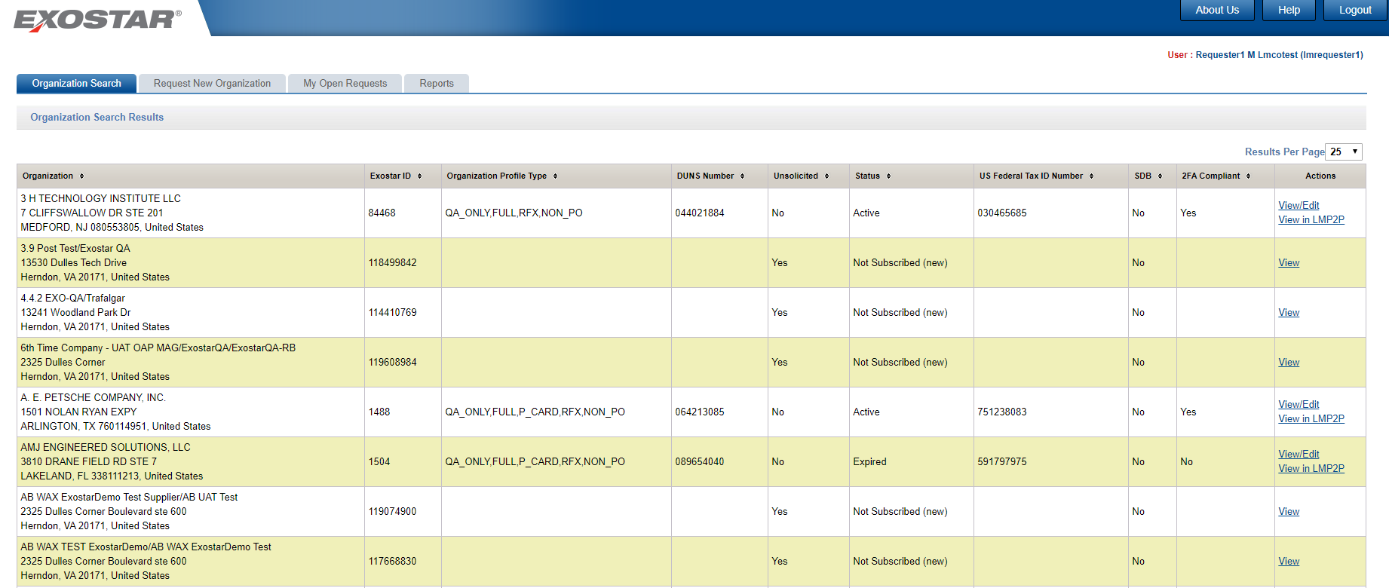
Screenshot 2: Organization Search Results Page

- With proper permissions, organization details may be viewed and/or edited by clicking the View/Edit link.
- The system displays a View link for each organization record that is not subscribed to LMP2P.
- Click on View/Edit link to display the organization information. (see screenshot below)
- Organizations already subscribed to LMP2P may be edited in TPM or viewed directly in LMP2P by selecting the View in LMP2P link.
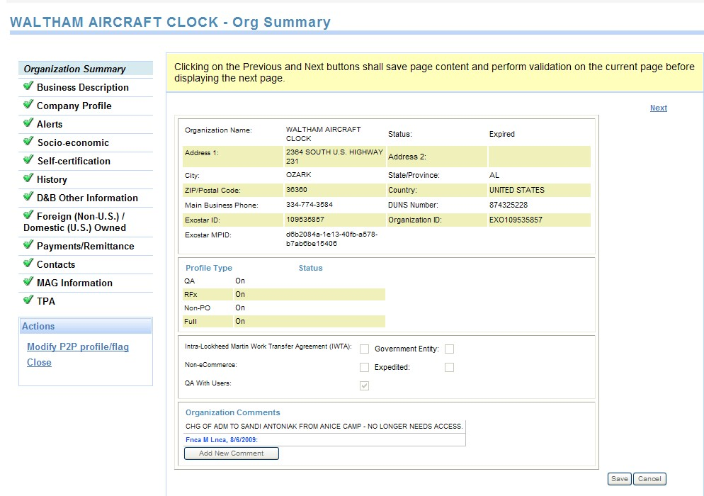

Screenshot 3: Organization Summary Page in TPM

To update:

- Click on any header on the Search Results page to sort the results by that field.
- The default return will be 25 results per page. To change, simply select from the options in the drop down list box.
- If the list of returned organizations exceeds 1 (one) page, use the arrow buttons to navigate back and forth.
- If the search yields more than 500 results, the system will prompt you to use additional filter options to narrow down your search.
- From the Search Results page, use the Revise Search button to return to the Organization Search page.

4 | REQUEST NEW ORGANIZATION
There are 2 (two) ways to initiate a request to a new organization to join LMP2P:
From the TPM Main Page, click the Request New Organization tab;

From the TPM Main Page, perform Organization Search -> From the Search Results page, click the View link for the desired organization -> From the Organization Summary page, click Request New Organization button.

4.1 Enter Core & Profile Information
The first step in creating a request is to enter some basic organization details and select the desired organization profile type(s) and flags.
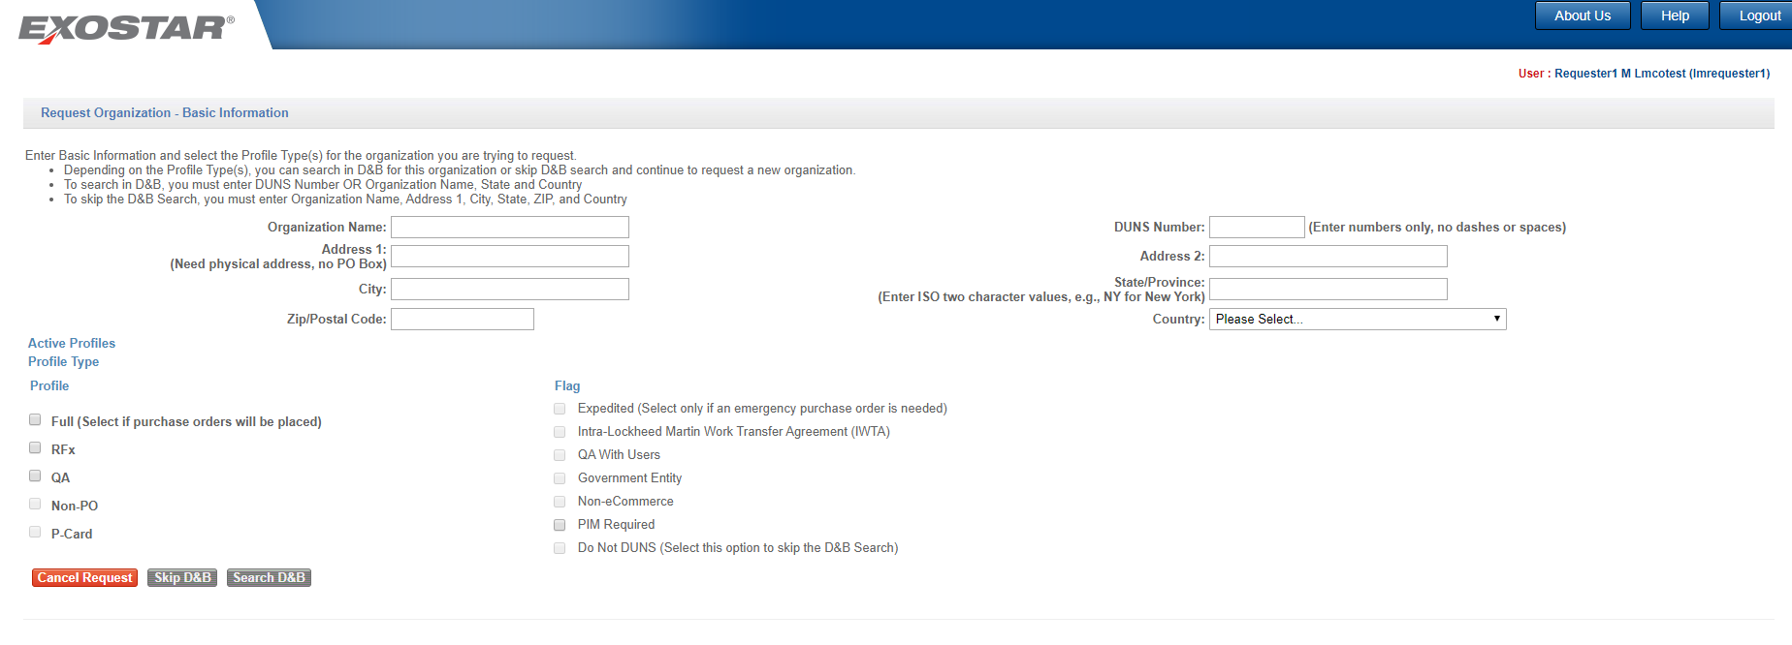

Screenshot 4: Request New Organization – Basic Information

IMPORTANT: The following rules govern the selection of flags:
- Upon page load all the flag checkboxes are disabled.
- Only the Corporate Admin will be able to mark a profile/organization as Do Not DUNS or Non-eCommerce.
- The system will require that at least 1 (one) profile must be selected on a request.
- If the Full profile is selected, the Expedited, IWTA, Non-eCommerce and Government Entity flags will be automatically enabled;
- If the Full profile is selected, the system will automatically check all of the other organization profile types EXCEPT P-Card. The system will also automatically select the QA with users and PIM Required flags, making them read-only.
- If the RFx profile is selected none of the flags will be enabled
- If the QA profile is selected, the QA with users flag will be enabled
- If the NonPO profile is selected, no additional flags will be enabled
- If the PCard profile is selected, no additional flags will be enabled.
- If the Non-eCommerce flag is checked, the system will display and require the Non-eCommerce Reason. If the IWTA, Government Entity or Non-eCommerce flag is checked, the user will not be able to select the Expedited flag, and vice versa.
- An organization can only be flagged as one of these at a time: IWTA, Government Entity or Non-eCommerce. Only the Corporate Admin or the Site Admin will be able to mark a profile/organization as Government Entity or IWTA.

NOTE: Selecting the Do Not DUNS option means that the organization will not be synchronously or asynchronously updated from D&B, neither will it be included in the monthly D&B batch update.
Upon selecting the appropriate profile type and flags, you can opt to do a D&B Search or Skip D&B in order to advance to the next step, depending on the combination of profile type(s) and flags that has been selected.

To use the Search D&B option, the user will be required to enter either the DUNS Number OR the Organization Name, State AND Country. The Search D&B button will be enabled only if this information is entered AND the Do Not DUNS flag is not checked.

The Skip D&B option is available to all organizations that are not Full Profile except those Full Profile organizations that are flagged as Do Not Duns.

NOTE: Synchronous D&B Search (and load) is mandatory for full, un-expedited profiles. Skip D&B option is allowed in all other cases (if core data is present). Setting the Do Not DUNS disables the Search D&B option making Skip D&B the only possible action.

- If the Search D&B button is selected, then the system will perform a free search for this organization in the D&B registry and display the Dun and Bradstreet Search Results page.
- If the Skip D&B option was selected, the system will display the Organization Summary page.

However, if any possible duplicates are found for the organization, the system will display the Resolve Duplicates page before going directly to the Organization Summary page.

Clicking Cancel Request from the Basic Information page will return the user to the TPM main page.

4.2 Dun and Bradstreet Search Results Page
The Dun and Bradstreet Search Results page displays all possible matching organizations found in the Dun and Bradstreet registry, up to a maximum of 20 records.

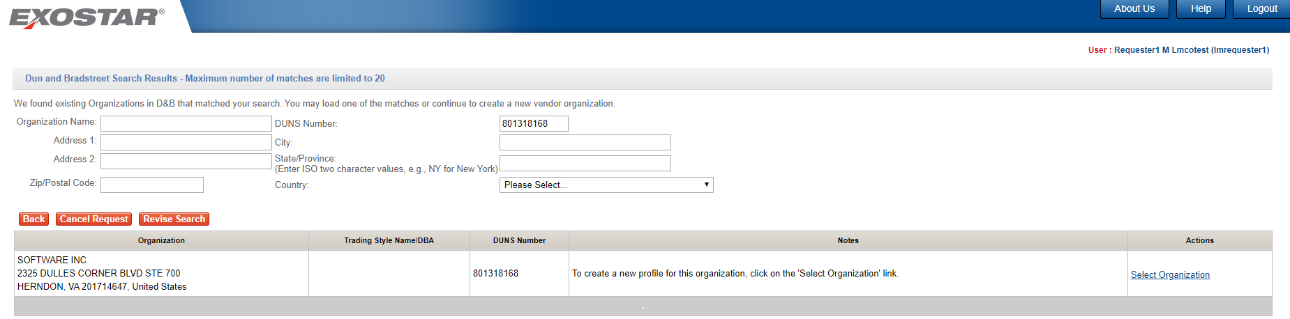

Screenshot 5: Dun and Bradstreet Search Results

- To ignore the Duns and Bradstreet search, click the Back button to go back to the previous page (the Basic Information page) and click on the Skip D&B button (if active) to be taken directly to the Organization Summary page.
- If any possible duplicates are found for the organization, the system will display the Resolve Duplicates page.

- If no matching address is found, the system will display an error message.

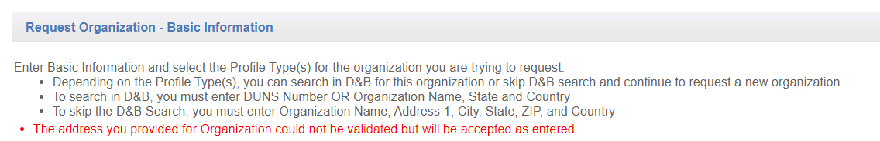

Screenshot 6: Organization Match Error Result page

To perform search again, modify search criteria at the top of the page and click the Revise Search option.

If no matches are found, e.g. if DUNS Number provided in the Basic Information page is invalid, a no match found message will be returned.
To cancel the request, select the Cancel Request button to return to the TPM main page. You will then be prompted to confirm the rejection or removal of the request.

Note: Organizations that are already in TPM or for which there is a pending request will not be available for selection.

4.3 Resolve Duplicates Page
Before advancing from the core information page, the system will automatically search the TPM to see if the organization already exists. If the system finds any, it will display the first 20 organizations that meet the threshold on the Resolve Duplicates page.

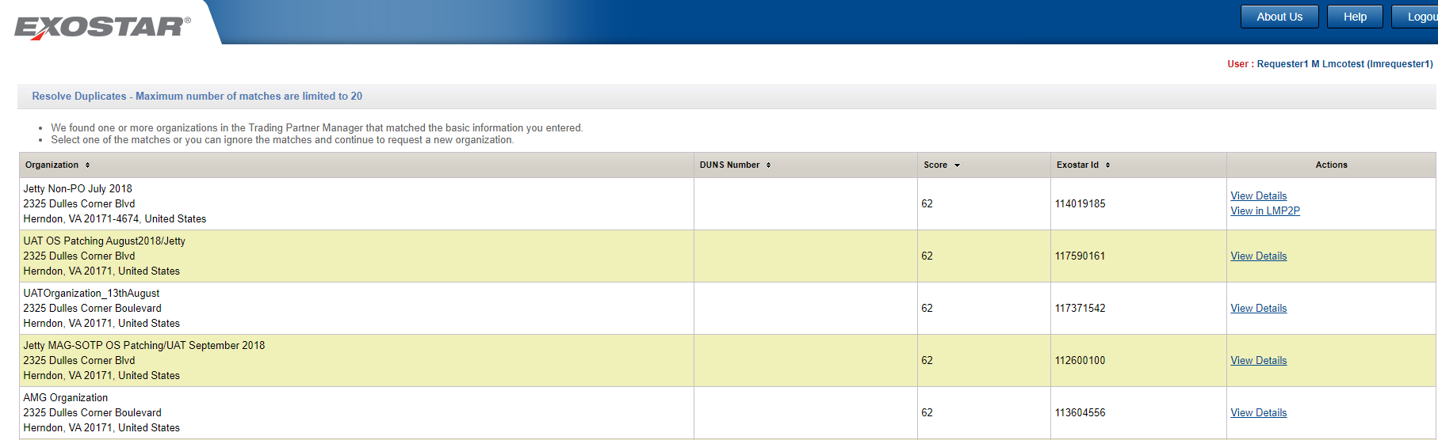

Screenshot 7: Resolve Duplicates Page

If no match is found in the TPM, the user will be taken directly to the Organization Summary page. The percentage match has a lower bound of 80%.

With proper permissions, organization details may be viewed by clicking the View Details link. Organizations already subscribed to LMP2P may be viewed directly in LMP2P by selecting the View in LMP2P link.

Click Cancel to cancel the process at this point or Ignore Duplicate Matches and Request New Organization to ignore the possible TPM matches. Use the Back button to go back to the previous page.
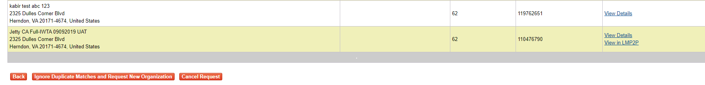Screenshot 8: Resolve Duplicates Page (bottom)

4.4 Enter Organization Information during Request New Org
The fields that will be displayed to you in the Organization Summary page during the Request New Org process depend on:

Your assigned role

The profile type(s) of the organization that is being created.

4.5 Request/Invite Organization
There are various types of profiles available within TPM.

Full (Regular)

Full (Expedited)
RFx or QA (with users)
Profile with no users (NonPO, PCard, QA (w/o users), Full (w/o users), RFx (w/o users)
Subsequent sections provide details on invitation process for each profile type.

4.5.1 Profile Type: Full (Regular)
From the Dun and Bradstreet Search Results page, if the organization’s profile type is Full AND a matching organization record is found in the D&B results list, click the Select Organization link, to perform a synchronous lookup of the organization's information against the Dun & Bradstreet registry. This will automatically load (for a fee) the organization's information packet, overwriting any information that may have been previously entered by you with that coming from Dun & Bradstreet. The system will display the Organization Summary page with this information already populated.

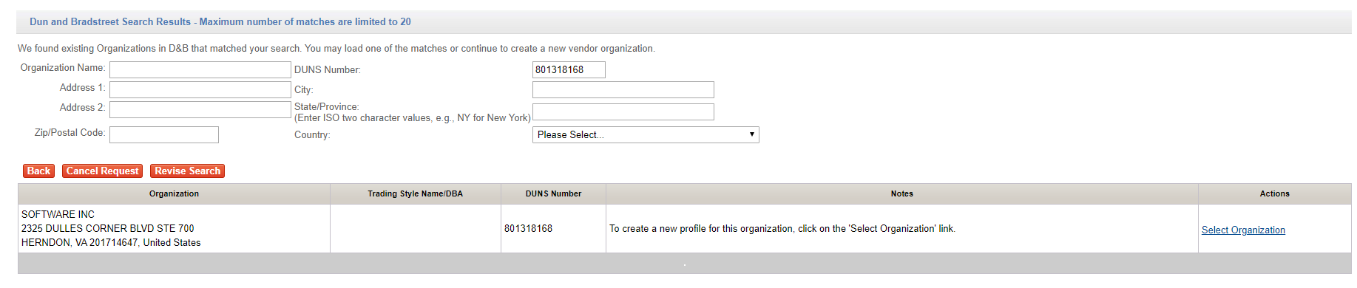
Screenshot 9: Organization Summary page

In all cases, whenever the Select Organization option is selected, if data coming from D&B fails the data validation checks (as specified in the tables in the SRS), the system will fail that record and display an error message to the user. The Supplier would need to be contacted out of band to update that record with D&B.

If the organization’s profile type is Full and you do not find a matching organization in the D&B Search results, you will NOT BE able to complete the Request New Organization process for this organization unless the Do not Dun flag is set. The Skip D&B button on the basic information page is not available.

NOTE: Only the CA role can set the Do Not DUNS flag on a Full Profile. This will enable the Skip D&B button.

If an organization’s packet is successfully loaded from D&B and you are on the Organization Summary page, OR if the organization is marked as Do Not DUNS and you have skipped the Dun and Bradstreet Search Results page to the Organization Summary page, you will be able to make any additional modifications to the organization’s record, and then click Invite to LMP2P to complete the initial creation of this organization’s profile and invite the supplier to participate in LMP2P.

Clicking Submit Request will display the following invitation page:

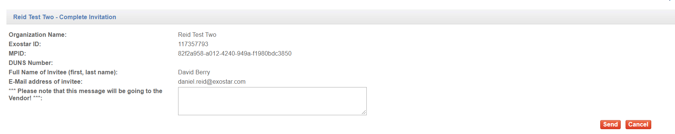
Screenshot 10: Invitation page

Clicking Send will:
- Create an organization account for this supplier in TPM with an LMP2P status of Invited and profile type status set to REQUESTED.
- Send an email notification to the Main Contact, providing instructions on how to register their organization for MAG and LMP2P application.
- A copy of this email will be sent to Exostar to ensure that if a supplier loses their copy of the email or never received it as a result of a typo or incorrect email, Exostar Customer Support is able to access and update the supplier’s organization account and re-send the email to the correct email address.
- If the invitation is for an organization that already exists in MAG, the email will be sent to the MAG Organization Administrators as well as to the TPM Main Contact.

NOTE: An automatic reminder email will be sent out to the contact person noted on the request if after 7 calendar days the organization has not completed its registration.

4.5.2 Profile Type: Full (Expedited)
For a Full, expedited organization, if a matching organization record is found in the D&B results list, clicking Select Organization, will work the same way as it does for the Full regular profile, e.g. the system will also perform a synchronous lookup of the organization's information against the Dun & Bradstreet registry and will automatically load (for a fee) the organization's information packet, overwriting any information that may have been previously entered by the user with that coming from Dun & Bradstreet. The system will display the Organization Summary page with this information already populated (similar to Full regular). If no matching organization record is found in the D&B results list, you will be able to go back to the basic information page and select the Skip D&B button to go straight to the Organization Summary page. No information will be loaded from D&B.

From the Organization Summary page, you will be able to click Send to Buyer Approver to send this expedited request to an LM Buyer Approver for approval.

Clicking Send to Buyer Approver will display an invitation page. You will be able to click Send to:
- Create this organization in the TPM with an LMP2P status of Pending LM Mgr Approval and profile type status set to REQUESTED.
- Send an email to the specified LM Buyer Approver, CC’ing user as a backup

Note: Although the expedite request will be emailed to one specific LM Buyer Approver, it could technically be approved by any LM Buyer Approver.

NOTE: An automatic reminder email will be sent out to the contact person noted on the request if after 7 calendar days the request has not been picked up from the queue.

Process Expedite Request – LM Buyer Approver
The LM Buyer Approver will be able to click on the link in the email to be federated into TPM to the request. They can also login to TPM, click on My Open Requests, and click the View Request link in one of the requests in the queue.

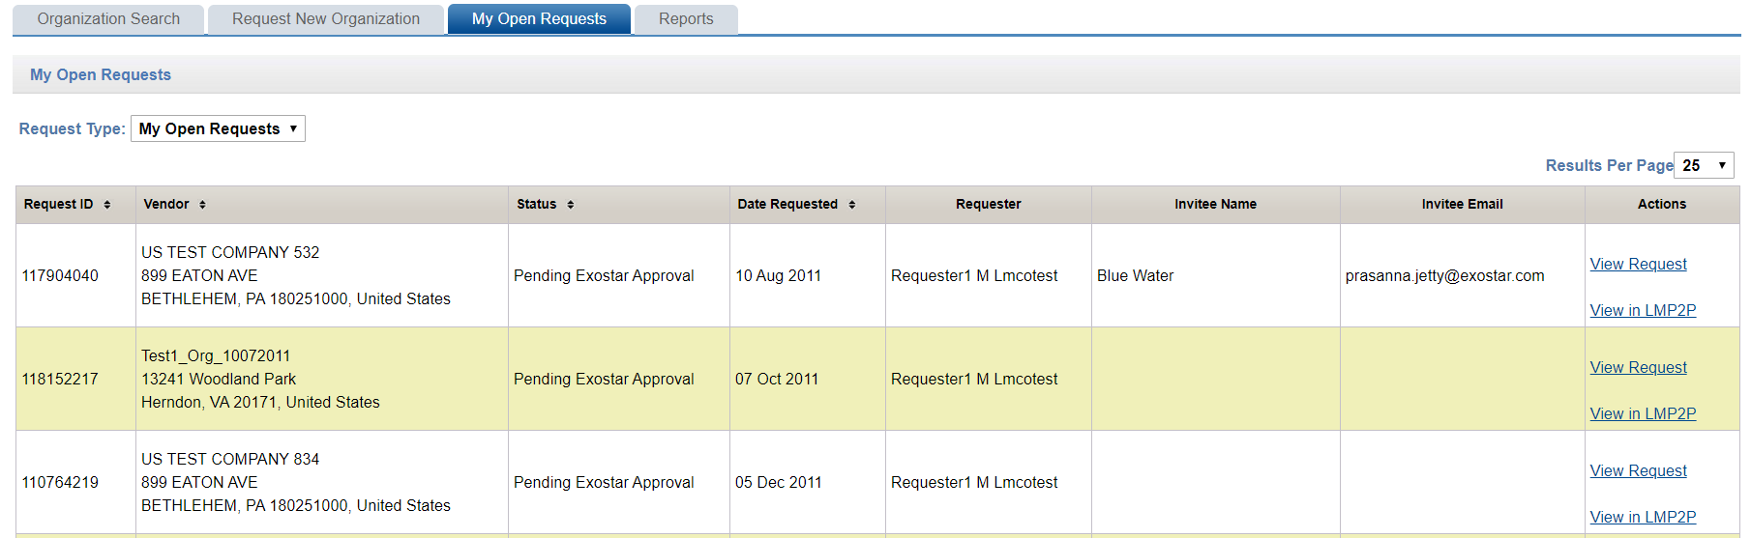
Screenshot 11: My Open Requests page

Click on any header on the My Open Requests page to sort the results by that field.

The default requests displayed will be 25 results per page. To change, simply select from the options in the drop down list box.

Should the list of returned organizations exceed 1 (one) page, use the arrow buttons to navigate back and forth or click on a page number to be taken to a specific page.

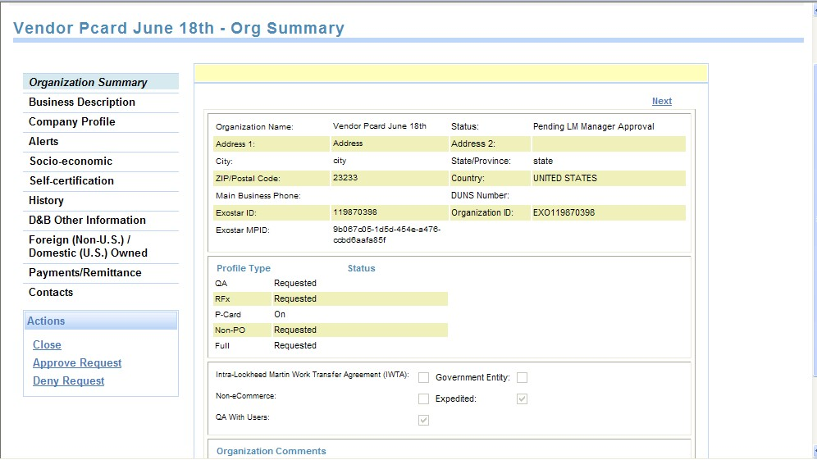

Screenshot 12: LM Buyer Approver Organization Summary Page

The LM Buyer Approver will be able to Approve or Deny an expedited request. If denying the request, they will be required to provide Deny comments. Click on Close to close the request without making changes.

When a request is denied by the LM Buyer Approver, the system sends a Request Denied email to the user who initiated the request. The status of the request will be set to Deactivated, and it will no longer be visible in the LM Buyer Approver’s My Open Request queue after 30 days.

If approving the request, the LM Buyer Approver will be required to provide Approval comments.

When a request is approved by the LM Buyer Approver:
- The system displays a confirmation message to the LM Buyer Approver and sends a Request Approved email to the user who initiated the request.
- The status of the request will be set to Invited, and it will no longer be visible in the LM Buyer Approver’s My Open Request queue.
- An email will be sent to organization’s company contact, providing instructions on how to register their organization for the LMP2P application.
- A copy of this email will be sent to an Exostar resource account so that if a supplier loses their copy of the email or never received it as a result of a typo or incorrect email, the EPA can access this account and send the email to the correct email address.
- If the invitation is for an organization that already exists in MAG, the email will be sent to the MAG Organization Administrators as well as to the TPM Main Contact (as opposed to the company contact as mentioned earlier).
NOTE: An automatic reminder email will be sent out if after 7 calendar days if the organization has not completed its registration.

If within 14 calendar days from the invitation the organization has completed its registration, the organization’s status will be set to Pending Exostar Admin and the registration request will be routed to the EPA for approval.

If after 14 calendar days from the invitation the organization has not completed its registration process (thereby converting this profile from Expedited to Full), the system will set the organization’s status to Expired.

Once an expired organization completes and submits their profile, the system will route the request to the EPA and will set the organization's status to Pending Exostar Admin.

4.5.3 Profile Type: RFx or QA (with users)
If the organization’s profile type is RFx or QA flagged as Provision QA with users AND NOT Full, AND a matching organization record is found in the D&B results list, when you select the organization and click Select Organization, the system will copy the DUNS number and other core information of the selected organization into the Organization Summary page.

Upon entering all required organization profile information, you will be able to click Submit Request. Doing this will prompt you to first specify the organization’s MAG officers (Organization Administrator, LMP2P Application Administrator, Company Contact) and then submit the request.

Upon submission:
- The system will kick off an asynchronous batch lookup of the organization's information against the Dun & Bradstreet registry. Based on current D&B processes, this could take up to 3 weeks or more to complete (not an Exostar system issue).
- The system will create this organization in the TPM with an LMP2P status of Pending Exostar Approval and profile type status set to REQUESTED. This will be propagated to Lockheed’s EMDM.
- Upon EPA approval of the request, the system will send out login instructions to the Organization Administrator.
- After the Exostar approval and Dun & Bradstreet updates have been received, TPM will send the organization’s information to Lockheed’s EMDM for update.

4.5.4 Profile Type: Profile with no users

i.e. NonPO, PCard, QA (w/out users), Full (w/out users), RFx (w/out users)

If the organization has a profile that does not have any users, e.g. is one of the following: NonPO, PCard, QA (without users), Full flagged as IWTA, NeC or Govt Entity, RFx flagged as IWTA, NeC or Govt Entity, AND a matching organization record is found in the D&B results list, when you select the organization and click the Select link, the system will copy the DUNS number and other core information of the selected organization into the Organization Summary page.

Upon entering all required organization profile information, you will be able to click Submit Request to kick off an asynchronous batch lookup of the organization's information against the Dun & Bradstreet registry. Based on current D&B processes, this could take up to 3 weeks or more to complete (not an Exostar system issue).

Note: If this is a Full flagged as IWTA, Govt Entity, or NeC, the batch lookups will remain synchronous.

The system will create this organization in the TPM with an LMP2P status of Active and profile type status set to ON. This will be propagated to Lockheed’s EMDM. No EPA approval process will be initiated.

When the D&B packet is eventually returned, information coming from the Dun & Bradstreet registry will overwrite existing organization information in the TPM. The TPM will send the organization’s information to Lockheed’s EMDM for update.

4.6 Contacts
Multiple contacts can be added to or deleted from an organization’s record. Click on Contacts to display the contact information screen.
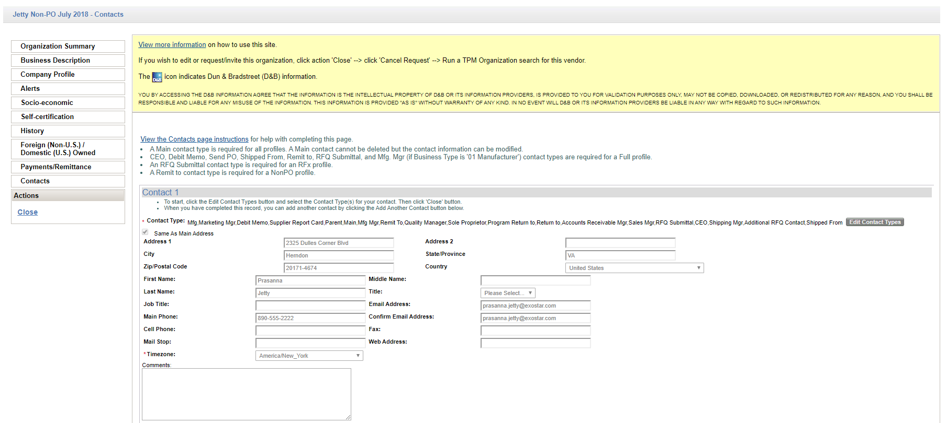
Screenshot 13: Contacts page

Clicking Edit Contact Type on the Contacts page will present 2 (two) pick lists: one with all the contact types and the other with the current selection of contact types. Use the arrow buttons to move contact types from one pick list to the other, adding or removing that contact type from the person. An organization can have any number of contacts for each contact type except Main and Remit To. An organization can only have 1 Main contact and 1 Remit To contact. An organization must have a Main contact.
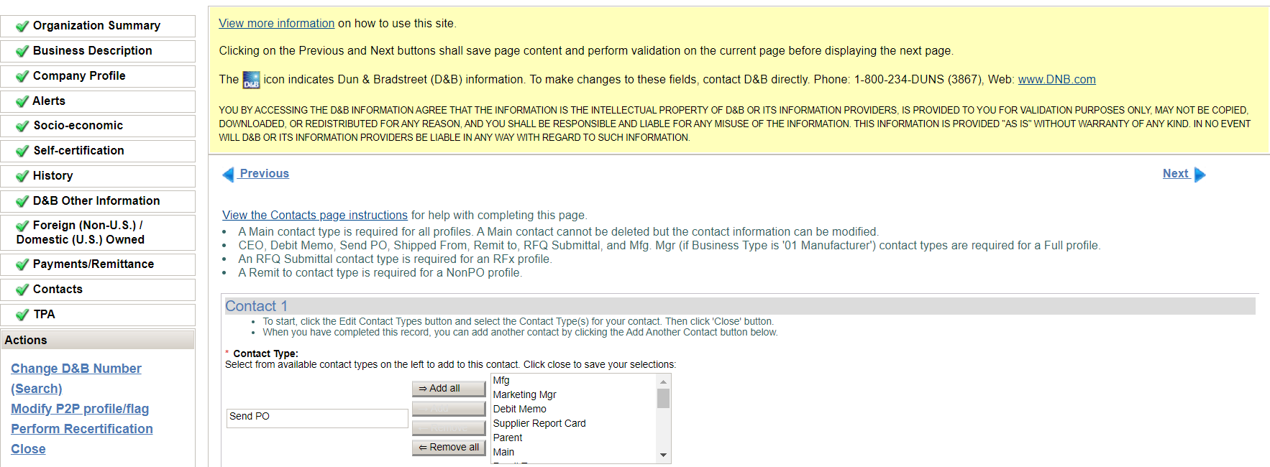

Screenshot 14: Edit Contact Type

When a MAIN contact is added to an organization’s profile, the system automatically sets the Same as Main flag, freezing all the Main Contact address attributes (Street 1, Street 2, City, State/Province, Postal Code & Country) so that they are in-editable. These address fields are automatically filled with values from the Organization address attributes so that both sets of addresses are a match. This rule is enforced even on Update actions, i.e. address fields are not updateable on the Main contact record.

A Remit To contact is required for a pure NonPO profile (in addition to a Main contact).
A Send PO contact is not allowed when creating a pure partial profile, e.g. a pure NonPO and/or QA (with or without users) and/or PCard and/or RFx only profiles. The user will not be able to specify a Send PO contact if the profile is just one of these or a combination of these partial profiles. This will apply during upgrades as well. If the profile is upgraded to a Full, then this contact type will be allowed.

The following contact types are required when creating a Full profile or when upgrading from a partial to a Full profile:

CEO,

Debit Memo,
Send PO,
Shipped From,
Remit to,
RFQ Submittal,

Mfg. Mgr (if Business Type is '01 - Manufacturer').

The RFQ Submittal contact type is required when creating an RFx profile or when upgrading to an RFx profile.

A Remit To or Send PO contact cannot be deleted from any profile. They can also not be added to the same contact record. They must be entered on 2 separate contact records even if they are the same contact person.

You will be able to link (or unlink) a TPM person to an existing MAG user account. When adding a new contact, you can search for an existing MAG user account. If a match is found, you can select that contact/user to link them.

Note: A TPM person may be linked to at most one MAG user account. Similarly, a MAG account may be linked to at most one TPM person. If a MAG user is linked to a TPM contact, that contact cannot be deleted.

When a TPM person is linked to a MAG user account, the contact person's attributes are pre-populated with MAG data.

4.7 Address Validation
The system is configured to validate only addresses from specified countries. Currently, address validation is limited to the US and Canada addresses.

The system can perform vendor address validation on the following vendor profile types: Full (Regular and Expedited), RFx, QA (with & without users), NonPO, PCard that are input by users into the TPM GUI.

The address validation service can only be performed on the Main Organization, Remit To contact and SendPO contact addresses. The following address elements are validated: Address1, Address2, City, State/Province, Zip/Postal Code & Country.

For the Main Organization's address, the validation can be performed in the Core Information page. Once you enter the address and click Skip D&B to advance to the next screen, the system will perform the validation. Clicking Search D&B will not invoke the address validation feature because D&B addresses cannot be overwritten.
If this address is later replaced by one from D&B, e.g. upon D&B load, it will not be validated at that time. Addresses coming from D&B will not be validated using this service.

Address validation is performed whenever these addresses are being added or updated (this applies to the SendPO and Remit To addresses as Org address is not editable during update), e.g. during the Request new org process and when adding or updating a contact.

If a contact's address is viewed but no changes are made to it, then no validation will be performed on it. This will be the case whether or not the address has been validated before.

The Address validation will be initiated when you enter/update an address and click Save, Next, Previous or if you try to navigate to another page using the left navigation menu.

When an address is being validated, the system will display the following text:
"Please wait while the information entered is processed. Address validation may be performed."

If you receive successful matches for an existing address, the system will replace the user-input data with the normalized address, and will display the address that corresponds to the information returned by the service. The text will be similar to the following:

For Organizations:
- US: "<Organization>: Address was successfully matched to the US Postal Service database and may have been updated. Please inspect before proceeding."
- Canada: "<Organization>: Address was successfully matched to the CA Postal Service database and may have been updated. Please inspect before proceeding." For Contacts:
- US: " Contact<#> (<Contact FN> <Contact LN>): Address was successfully matched to the US Postal Service database and may have been updated. Please inspect before proceeding."
- Canada: " Contact<#> (<Contact FN> <Contact LN>): Address was successfully matched to the CA Postal Service database and may have been updated. Please inspect before proceeding."

The normalized address will be updated in the vendor master record.

If no matches are returned for an address an error will be displayed. You will then be required to correct the address and resubmit before proceeding. The error will read something like the following:

For Organizations:
- "The address you provided for <Organization> could not be validated. Please correct the address before proceeding."
- “<Organization>: Could not locate the city, state, or zip in the US Postal Service database. Please validate City and State or ZIP and resubmit.”
- “<Organization>: Ambiguous address. There were two or more possible matches. Please correct the address and resubmit.”

For Contacts:
- "The address you provided for Contact<#> (<Contact FN><Contact LN>) could not be validated. Please correct the address before proceeding."
- “Contact<#> (<Contact FN> <Contact LN>): Could not locate the city, state, or zip in the US Postal Service database. Please validate City and State or ZIP and resubmit.”
- “Contact<#> (<Contact FN> <Contact LN>): Ambiguous address. There were two or more possible matches. Please correct the address and resubmit.”

If the address validation service is not available, the address will not be validated and will be accepted as-is. In such cases, the system will display some text similar to the following:

For Organizations:
- "The address you provided for <Organization> could not be validated but will be accepted as entered."

For Contacts:
- "The address you provided for Contact <#> (<Contact FN><Contact LN>) could not be validated but will be accepted as entered."

A separate message will be displayed for each address that is validated, e.g. if there are multiple addresses, a separate message will be displayed for each one, even if the addresses are the same for different contacts.

Address Validation Assumptions:
- Only the US and Canada addresses can be validated.
- No validation of vendor address data will be done in the US Bank batch interface
- No validation of vendor address data will be done in the D&B interface
- No validation will be done on existing addresses that are already in TPM.
- No validation of address data will be done for unsolicited profiles.
- Org address cannot be validated during ‘Add profile’ because the fields in the ‘Core Information’ page are in-editable. As such, the only time that unsolicited and existing TPM addresses will be validated is after they have been upgraded (i.e. via the ‘Add profile’ process), as part of Org record maintenance.
- If the address validation service is unavailable, no error messages will be displayed. The record will not be flagged.
- This address validation service will NOT be performed on the Mailstop field.

5 | OPEN REQUESTS
You will be able to click on the Open Requests link on the TPM main page (or from the LMP2P Buyer Portal) to get to a Request page. The Request page will offer the following 3 view options:
- My Open Requests
- All Open Requests
- Approval-Pending Requests

You will be able to select any one of the options to display the corresponding view at a time
Only an LM user with a Buyer role (i.e. Buyer, CA, SA, AA) will be able to see the My Open Requests option.

Only an LM user with a Corporate Administrator role will be able to see the All Open Requests option.

Only an LM user with a Buyer Manager role will be able to see the Approval-Pending Requests option.

The system will display the following items for each organization request in all three views:

Request ID: System-generated Id for this request

Vendor: Organization Name & Address
Status: Request status
Date Requested: Date when the request was sent by Requester
Requester: Name of the LM User creating the request
Invitee Name: Name of the Main Contact to whom the request is sent Invitee Email: Email of the Main Contact to whom the request is sent

The queues can be sorted by:
- Request ID
- Organization Name
- Status
- Date Requested (set to default sort)

The status categories are:
- Invited: Organization was sent a request to complete their profile. Awaiting their response.
- Buyer In Process: LM Buyer is still in the process of creating the request.
- Vendor In Process: Organization responded to the request but did not complete their information.
- Pending LM Manager Approval: Request has been routed to LM Buyer Manager for approval.
- Pending Exostar Approval: Organization completed request and is awaiting EPA approval.

5.1 My Open Requests
When an LM User requests a new organization, the status of that request will be set to Invited and will be visible to the LM User in their My Open Requests list.

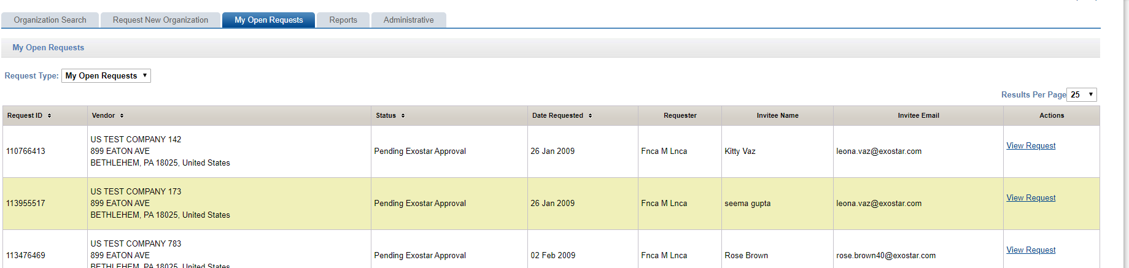

Screenshot 15: My Open Requests page

The LM user will have the ability to save a partially completed organization request. This will save the request with a status of Buyer In Process and will make it visible in their My Open Requests list.

The system will only display requests created by the LM User that is logged onto the current session.
The requests in the My Open Requests page can be sorted by the header.

When a request is automatically deactivated due to a time out, the system will send an email notification to the LM User that created the request.

If a request is rejected by the organization user, it is automatically deleted from the LM User’s My Open Requests queue (as well as from the All Open Requests queue) and an email notification is sent to the LM User that created that request.
The number of results that are displayed per page can be changed via a dropdown list box. Options will be 10, 25, 50 or 100. The default return will be 25 results. If the list of returned organizations exceeds 1 (one) page, click on Next to view additional results. To move to a specific page, click on the page number.

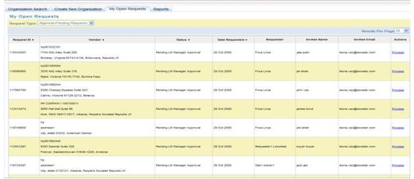

Screenshot 16: My Open Requests (Buyer Approver view)

Resume Request – You can resume requests that are in the process of being created but have saved temporarily. Resume working on a request by clicking Resume Request from the My Open Requests view to continue with the request.

View Request – You can view requests that are created and are still pending (Pending requests are any that have been submitted by an LM User, but have not yet been approved or denied by the EPA queue). You will be able to view the details of an open/pending organization request created by you by clicking the View Request link beside the request. Clicking View Requests displays the Organization Summary page for that organization in read-only mode.
Clicking Close on the request details page returns you to the My Open Requests page.

The LM User will be able to view the details of a request for an organization that is already subscribed to LMP2P by clicking the View in LMP2P link beside the request. Upon clicking this link, the user will be taken directly into LMP2P to view the organization's details.

Delete Request – You can delete a requested you created as long as the request is still in Invited status, e.g. has not been acted on by the organization user. Resume/View will be mutually exclusive, e.g. you will have the choice of one or the other. You will be able to delete a request that you created, if it has not been picked up by the organization. Clicking Delete beside a particular request will prompt for confirmation. Upon confirmation, the system will delete the request from your queue.

If a request remains in any one state for up to 90 days (configurable), the system will automatically deactivate that request, deleting it from your queue. This will be updated in the TPM and sent to EMDM.

Note: Auto-deletion of stale requests will not apply to those in Pending Exostar Approval status (RFC3263).

5.2 All Open Requests
The All Open Requests view will display all requests created by the current user, all requests created by other LM buyers, and all requests that are pending approval. Available actions will be: View, Delete. These will work the same way as in the My Open Requests view.

You will be able to sort the results by the headers on the All Open Requests page.

Change the number of results that are displayed per page via a drop down list box. Options will be 10, 25, 50 or 100. The default return will be 25 results.

If the list of returned organizations exceeds 1 (one) page, click on Next to view additional results. To move to a specific page, click on the page number.

View Request
An LM User with the role of Corporate Administrator will be able to view the All Open Requests option. They will also be able to view requests that have not yet been submitted by the buyer/requester, e.g. requests that have the status of Buyer In Process.

The Corporate Administrator will be able to filter the display of requests by Organization Name. To filter the requests displayed, enter an organization name or part of an organization name and click Search. This will modify the list of requests displayed per the search criteria entered.

Delete Request
An LM User with the role of Corporate Administrator will be able to delete requests from the All Open Requests view that are in any one of the following states:
- Pending LM Mgr Approval
- Invited
- Buyer In Process
- Expired

When a request is deleted by a Corporate Administrator, an email notification will be send to the LM User that created that request. If the request is deleted by its creator, no email notification will be sent.

5.3 Approval-Pending Requests
The Approval-Pending Requests view will display all requests that are pending approval. Available actions will be: Process. (See earlier description of this for more details).

6 | ORGANIZATION PROFILE MANAGEMENT

6.1 Profile Update
The LM User and Org Admin roles will be able to modify an LMP2P organization’s information in the Organization Summary pages. When an organization's information has been modified by an LM User or EPA or by a system (e.g. as a result of a D&B Refresh), the system will send an email notification to the Org Admin(s) with a list of the fields that have been modified.

Upon saving the changes made, all organization profile updates will be sent to EMDM.

6.2 Upgrade Profile Type/Flag
This use case assumes that an organization is an LMP2P organization, and therefore already has at least 1 (one) Organization Profile Type. Updating an organization’s profile type will always be initiated by an LM User.

An LM User (with role Buyer, AA, CA or SA) will have the ability to add additional profile types and flags (with the right permissions) to an organization that already exists in LMP2P. To initiate this process, the LM User will click the Modify P2P Profile/Flag on the Organization Summary page. This will display the Basic Information screen. They will be able to add profile and/or clear any of the non-user flags and then submit the request.

Note: The organization's core information will be in-editable.
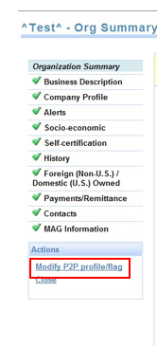

Screenshot 17: Modify P2P Profile/Flag

Only a CA will be able to clear the Non-eCommerce, IWTA and Government Entity flags from an organization's profile.

Note: While the SA can set the IWTA and Government Entity flags (and NOT the Non-eCommerce flag), they cannot clear/un-flag it.

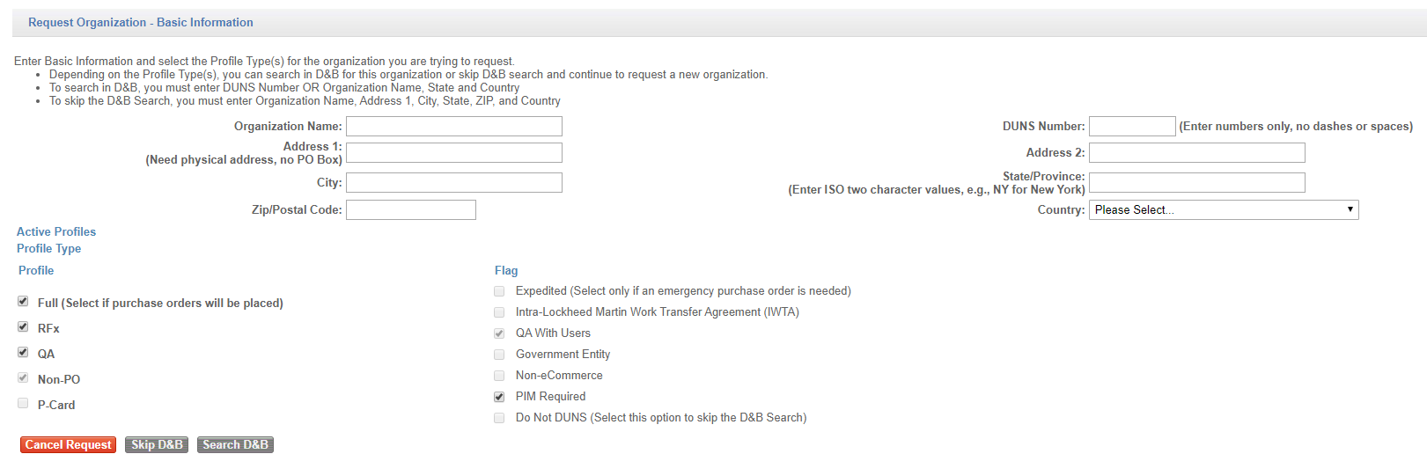
Screenshot 18: Basic Information page

If an organization already has user-enabled profiles, i.e. if it is already setup as having users, it cannot be changed back to not having users. This means that the Non-eCommerce, IWTA and Government Entity flags cannot be changed from not being set to being set. The only way that this can happen is if an org request is made to clear any one of these flags, and the request is deleted by the LM CA, or rejected by the Org Admin or EPA.

If the organization was previously a Full profile and either one of the Non-eCommerce, IWTA or Government Entity flag was set, and now the request was to clear the flag, this will initiate an invitation being sent to the organization's Main Contact, as if this was a new request.

Note: The LM User experience would be very similar to the Request New Org process, except that since all of the profile information would already have been provided, both the LM User and the Organization Admin would be able to get through the process much quicker.

If the organization was previously an RFx or QA w/ users profile and either one of the Non-eCommerce, IWTA or Government Entity flags was set, and now the request was to clear the flag, this will initiate the process where the LM User specifies the MAG officers and submits the request to the EPA.

When an organization is going from being LM-managed (e.g. Full, Non-eCommerce = true) to vendor-managed (e.g. Full, Non-ecommerce = false), if the LM user had previously provided values in the self-certification fields, the Org Admin will not be required to do so again. They will however be forced through each screen as during the regular Organization Registration process, and so will have a chance to view/confirm the entries on that screen.

The Expedited, QA w/ users and Do Not DUNS flags will only be allowed to be set to True during create or upgrade requests.

Once set, the Expedited, QA w/ users and Do Not DUNS flags cannot be reset. Functionality to be able to reset the Do Not DUNS flag will be implemented in a future TPM release.

The Expedited flag interferes with the Non-eCommerce, IWTA and Government Entity flags such that if set, these flags cannot be changed. As such, if the Expedited flag is set, it would need to be cleared before an LM User can clear any of the Non-eCommerce, IWTA or Government Entity flags. The process for clearing the Expedited flag is manual. The request to do this will need to be made outside of the system, by an LM CA or SA to Exostar.
Once an organization with users (i.e. Full, not flagged as IWTA/Non-eCommerce/ Govt Entity, RFx & QA with users) is created (during the Request New Org process), the system will automatically disable the QA with users flag so that it cannot be clicked on during the Add Profile process.

The LM user will be able to Skip the D&B search during Modify P2P profile/flag much like they would during the initial creation of an organization, taking them directly to the Organization Summary pages

If the LM User chooses the Search D&B option, the system will display the D&B Search results page, from which the LM User will be able to select the organization and proceed to the Organization Summary pages. The same rules for synchronous and asynchronous loading will apply here as they do during the Request New Org process.

6.3 FULL Profile
Once the LM User submits the request, if the Full profile is being added and the organization is new to MAG (for instance, if it did not previously have any users), the system will display the Invitation page with the following fields:
Organization Name
- Exostar ID
- MPID
- DUNS Number
- Full Name of Invitee
- Email Address of Invitee
- Additional Instructions/Comments

All fields will be read-only mode, except the Additional Instructions/Comments. The Full Name and Email Address fields will be automatically pre-filled with the Main Contact information. Submitting this request will send an email notification to the POC (same as during Request New Org).

If the organization is already registered in MAG, the system will display the Invitation page same as above, however upon submission of the request, the invitation will automatically be sent to all Org Admins for that organization, in addition to the POC.

If the LM User is adding a Full profile to an organization that is already registered in MAG, the process is completed once the invitation is accepted by the Organization Administrator.

6.4 RFx or QA w/ Users Profile
If an LM User is adding an RFx or QA with users profile to an organization that is NOT registered in MAG, then once the LM User puts in a request to that organization in TPM, the system will kick off the EPA approval workflow similar to the way that it does for the Request New Org process.

If an LM User is adding an RFx or QA with users profile to an organization that is already registered in MAG, then once the LM User puts in a request to that organization, the process will be completed, .e.g. no workflows (such as the EPA workflow) will be kicked off. However, if the organization did not already have an LMP2P App Admin (e.g. if this is an SCP org for instance), then when the LM User submits the request, the system will display the Invitation Confirmation page to the LM User with the option to add instructions.

Note: This is different from the way that it works during the Request New Org process.

Upon submission of the request, the invitation will automatically be sent to all Org Admins for that organization.

If adding a QA with users profile to an RFx org, the system will automatically gray out the QA with users flag, making it read-only such that the LM User is not able to select it. If an RFx profile is being added to a QA with users organization (or vice versa), the LM User will not be required to specify any Org Admin, Company Contact, or LMP2P App Admin.

6.5 NonPO/PCard/QA without Users Profile
Adding a NonPO, PCard or QA without users profile to an organization will work the same way as it does during the Request New Organization process.

An LM User will not be able to add a QA with users profile to a QA organization.

An Add Profile request cannot be made while a previous request is active, i.e. an LM User will not be able to add a profile to an organization if a request is open for that organization.

6.6 Sample Add Profile Use Cases
The following section identifies some of the basic Add Profile use cases that will be available in the TPM, and what the system behavior will be for each:

Use Case #1:
Use Case Name: Add Full profile to NonPO/PCard/QA without users profile
Pre-Conditions: Organization already exists in MAG (e.g. for SCP)
Post-Conditions: Organization has the Full profile type

Step – User | User action | System response
1 – LM User | Perform org search | Display search results
2 – LM User | Click View/Edit beside an org | Display Org Summary pages
3 – LM User | Click Add LMP2P profile | Display Basic Information page
4 – LM User | Select Full (system auto checks all unchecked profiles except PCard if unchecked), Click Skip D&B | Display Org Summary pages
5 – LM User | Provide all required info for Full profile; LM User is NOT prompted to  specify LMP2P App Admin. Click  Invite | Display Invitation page with option for additional comments only
6 – LM User | Submit invitation | Invitations will go to all Org Admins for that Org.
7 – Org Admin | Click link in email | Display Org Summary pages
8 – Org Admin | Fill in all attributes, specify LMP2P App admin -> Accept LM TPA -> Submit request | Update org record in TPM to reflect new profile and attributes.
Alternative Path
4 – LM User | Select Full (system auto checks all unchecked profiles except PCard if unchecked), Click Search D&B | Display D&B Search Results page
5 – LM User | Select an org (synch) | Display Org Summary pages
Use Case 1: Add Full profile to NonPO/PCard/QA without users profile

NOTE: If Org is new to MAG, they will be prompted to accept the Exostar Master Service Agreement (MSA). If Org has previously agreed to agreements for SCP, FP, RSP and/or RRGSP, they would not need to do so again and no amendments will be necessary.

Use Case #2:
Use Case Name: Add Full profile to NonPO/PCard/QA without users profile
Pre-Conditions: Organization is NOT in MAG
Post-Conditions: Organization has the Full profile type

Step – User | User action | System response
1 – LM User | Perform org search | Display search results
2 – LM User | Click View/Edit beside an org | Display Org Summary pages
3 – LM User | Click Add LMP2P profile | Display Basic Information page
4 – LM User | Select Full (system auto checks all unchecked profiles except PCard if unchecked), Click Skip D&B | Display Org Summary pages
5 – LM User | Provide all required info for Full profile; LM User is NOT prompted to  specify LMP2P App Admin. Click  Invite | Display Invitation page with POC info  pre-filled and option for additional comments
6 – LM User | Submit invitation | Invitations will go to POC
7 – Org Admin | Click link in email | Display Org Summary pages
8 – Org Admin | Fill in all attributes, specify Org Admin,  Company Contact & LMP2P App admin  -> Accept Exostar MSA -> Accept LM  TPA -> Submit request | Route workflow to EPA
9 – EPA | Approve request | Update org record in TPM to reflect new profile and attributes; Send MAG credentials to Admins
Alternative Path
4 – LM User | Select Full (system auto checks all unchecked profiles except PCard if unchecked), Click Search D&B | Display D&B Search Results page
5 – LM User | Select an org (synch) | Display Org Summary pages
Use Case 2: Add Full profile to NonPO/PCard/QA without users profile

Use Case #3:
Use Case Name: Add Full profile to RFx or QA with users profile
Pre-Conditions: By default, Organization already exists in MAG
Post-Conditions: Organization has the Full profile type

Step – User | User action | System response
1 – LM User | Perform org search | Display search results
2 – LM User | Click View/Edit beside an org | Display Org Summary pages
3 – LM User | Click Add LMP2P profile | Display Basic Information page
4 – LM User | Select Full (system auto checks all unchecked profiles except PCard if unchecked), Click Skip D&B | Display Org Summary pages
5 – LM User | Provide all required info for Full profile; Click Invite | Display Invitation page with option for additional comments only
6 – LM User | Submit invitation | Invitations will go to all Org Admins for that Org.
7 – Org Admin | Click link in email | Display Org Summary pages
8 – Org Admin | Fill in all attributes -> Accept LM TPA -> Submit request | Update org record in TPM to reflect new profile and attributes.
Alternative Path
4 – LM User | Select Full (system auto checks all unchecked profiles except PCard if unchecked), Click Search D&B | Display D&B Search Results page
5 – LM User | Select an org (synch) | Display Org Summary pages

Use Case 3: Add Full profile to RFx or QA with users profile

NOTE: If Org is new to MAG, they will be prompted to accept the Exostar Master Service Agreement (MSA). If Org has previously agreed to agreements for SCP, FP, RSP and/or RRGSP, they would not need to do so again and no amendments will be necessary.

Use Case #4:

Use Case Name: Add RFx to NonPO/PCard/QA without users profile
Pre-Conditions: Organization already exists in MAG (e.g. for SCP)
Post-Conditions: Organization has the RFx profile type

Step – User | User action | System response
1 – LM User | Perform org search | Display search results
2 – LM User | Click View/Edit beside an org | Display Org Summary pages
3 – LM User | Click Add LMP2P profile | Display Basic Information page
4 – LM User | Select RFx, Click Skip D&B | Display Org Summary pages
5 – LM User | Provide all required info for RFx profile; LM User is NOT prompted to specify LMP2P App Admin. Click Invite | Display Invitation page with option for additional comments only
6 – LM User | Submit invitation | Invitations will go to all Org Admins for that Org.
7 – Org Admin | Click link in email | Display Org Summary pages
8 – Org Admin | Fill in all attributes -> Specify LMP2P  App Admin. No Acceptance of LM TPA > Submit request | Update org record in TPM to reflect new profile and attributes; Send MAG credentials to LMP2P App Admin (if new to MAG)
Alternative Path
4 – LM User | Select RFx, Click Search D&B | Display D&B Search Results page
5 – LM User | Select an org (asynch) | Display Org Summary pages
Use Case 4: Add RFx to NonPO/PCard/QA without users profile

Use Case #5:
Use Case Name: Add Full to NonPO/PCard/QA without users profile & flag as IWTA, NeC or Govt Entity
Pre-Conditions: Organization may or may not already exists in MAG (e.g. for SCP)
Post-Conditions: Organization has the Full profile type with flag IWTA, NeC or Govt Entity

Step – User | User action | System response
1 – LM User | Perform org search | Display search results
2 – LM User | Click View/Edit beside an org | Display Org Summary pages
3 – LM User | Click Add LMP2P profile | Display Basic Information page
4 – LM User | Select Full, Select IWTA, NeC or Govt Entity, Click Skip D&B | Display Org Summary pages
5 – LM User | Provide all required info for Full profile -> Click Submit Request | Update org record in TPM to reflect new profile and attributes.
Alternative Path
4 – LM User | Select Full, Select IWTA, NeC or Govt Entity, Click Search D&B | Display D&B Search Results page
5 – LM User | Select an org (synch) | Display Org Summary pages
Use Case 5: Add Full to NonPO/PCard/QA without users profile & flag as IWTA, NeC or Govt Entity

Use Case #6:
Use Case Name: Add RFx to QA with users profile
Pre-Conditions: By default, Organization already exists in MAG
Post-Conditions: Organization has the RFx profile type

Step – User | User action | System response
1 – LM User | Perform org search | Display search results
2 – LM User | Click View/Edit beside an org | Display Org Summary pages
3 – LM User | Click Add LMP2P profile | Display Basic Information page
4 – LM User | Select RFx, Click Skip D&B | Display Org Summary pages
5 – LMUser | Provide all required info for RFx profile -> Click Submit Request | Update org record in TPM to reflect new profile and attributes.
Alternative Path
4 – LM User | Select RFx, Click Search D&B | Display D&B Search Results page
5 – LM User | Select an org (asynch) | Display Org Summary pages
Use Case 6: Add RFx to QA with users profile

7 | ALERTS & NOTIFICATION

7.1 Organization Debarment & Other D&B Alerts/Critical Events
Exostar will receive the following critical event notifications from D&B and will set the corresponding flags in the vendor master and send updated organization record to EMDM:
- Debarment
- Out of Business
- High Risk
- Bankruptcy
- Paydex

NOTE: LM will be responsible for sending out all critical event notification emails to various Site Administrators for the impacted purchasing organizations. LM will also handle all blocking logic (procure block & payment block).

If upon D&B refresh any one of these fields is cleared, this update will be sent to EMDM.

The valid values for each of the alert codes will be as follows:

Debarment Code: D=Debarred, N / Blank=Not Debarred, F=Family Debarred. Default is blank.
Out Of Business ID: F=Business discontinuance with outstanding debt, Blank.
High Risk: H-R = High Risk (business which exhibits characteristics of a fraudulent business), B-D = Business Deterioration (business which exhibits significant signs of financial distress or operating difficulty, including businesses that may be on the verge of failure), Blank.
Bankruptcy: B=Open bankruptcy, N=Bankruptcy has been closed, dismissed, discharged, void, or never bankrupt. Paydex: A numerical score characterizing the payment experiences of a business, Blank.

Exostar will automatically send an email notification to a specified LM distribution list every time one of these alerts or notifications is received from D&B.

7.2 Organization Mergers & Acquisitions per Dun & Bradstreet Load/Refresh
Exostar is responsible for updating the organization information in case of Mergers & Acquisitions. This information will be reflected in the organization information.

7.3 Denied Parties List
Exostar will disable all organizations that are in the Denied Parties list. If the organization’s account is deactivated by Exostar, an update will be sent to EMDM.

If the organization is an LMP2P subscriber, the EPA will send an email alert of this event.

8 | REPORTS
The LM User will have the ability to generate the following types of reports from the LMP2P Buyer Portal:
- Profile Registration Report
- Profile Expiration Report
- D&B Refresh Report (Only a CA can generate this report).

Only LM Users with the following roles will have the ability to run the Profile Registration and Profile Expiration reports: LM Buyer, CA, SA and AA. The regular Viewer role (i.e. Inquiry only) will be not able to do so.
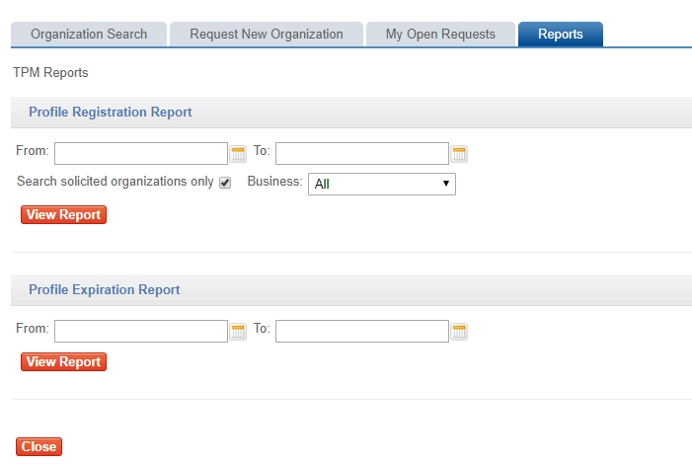
Screenshot 19: Reports Page

8.1 Profile Registration Report
The purpose of the Profile Registration Report is to provide the number of organizations that have registered or changed their profile in the Exostar Customer Information Center within the past calendar month.

An LM User (with the appropriate permissions/authorization) will have the ability to generate the Profile Registration report on an as-needed basis by clicking Reports from the LMP2P Buyer Portal. This will display a Reports page.
In the Profile Registration Report section of the Reports page, the LM User will be able to select various criteria from the following options against which the report will be run. Upon specifying the desired criteria and clicking View Report, the system will generate the report.

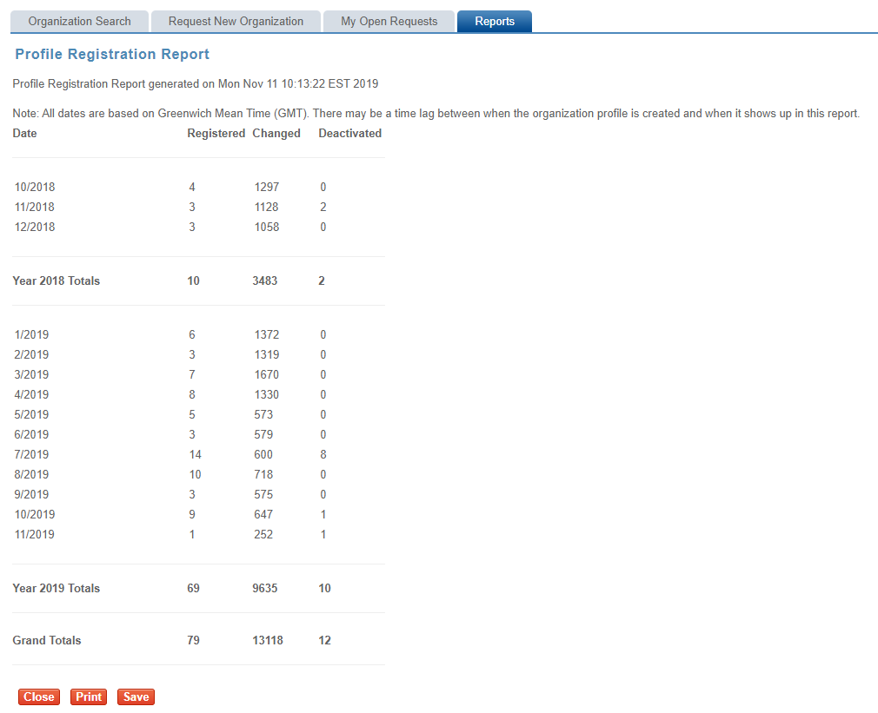

Screenshot 20: Profile Registration Sample Report

- The Profile Registration Report will display yearly totals at the end of each year, and will display grand totals at the bottom of the page.
Clicking Close will close out the report, returning the user to the Reports page.

Clicking Print will display the standard print command window from which the user can print a copy of the report.
Clicking Save will display the standard save command window where the user can specify the filename and location that it should be saved to. The LM User will have the ability to save the Profile Registration Report in .CSV format (viewable using Microsoft Excel).

8.2 Profile Expiration Report
The purpose of the Profile Expiration Report is to provide a list of organizations whose certification of their profile has expired or is about to expire, depending on the date range specified by the user.

An LM User (with the appropriate permissions/authorization) will have the ability to generate the Profile Expiration Report on an as-needed basis by clicking Reports from the LMP2P Buyer Portal. This will display a Reports page.

In the Profile Expiration Report section of the Reports page, the LM User will be able to select various criteria.

Upon specifying the desired criteria and clicking View Report, the system will generate the report.

If no From and To dates are specified, the system will display all expired organizations going back for 1 year, e.g. all organizations whose Expiration Dates fall within the last year.
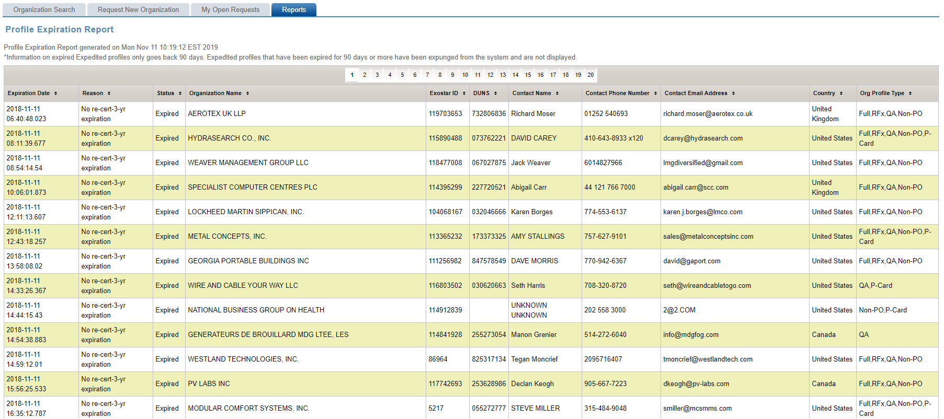

Screenshot 21: Profile Expiration Report

Clicking Close will close out the report, returning the user to the Reports page.

Clicking Print will display the standard print command window from which the user can print a copy of the report.
Clicking Save will generate report in the form of a Microsoft Excel spreadsheet. The LM User will also have the ability to save the Profile Expiration Report in .CSV format. The LM User will be able to use the standard save command window to specify a filename and location.

