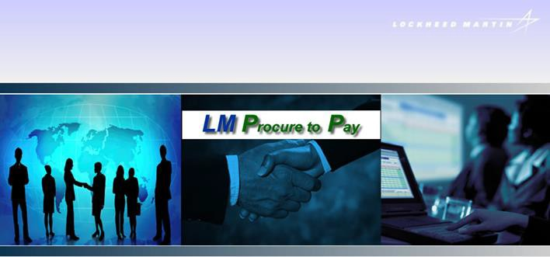



Last Updated 1/3/23

LM Procure to Pay Quick Reference Guide For Suppliers

Requesting Access to LM eInvoicing

Lockheed Martin Procure to Pay

Procedure

This quick reference guide displays the process for requesting access to the LM eInvoicing Application.

For users with an existing Exostar User ID
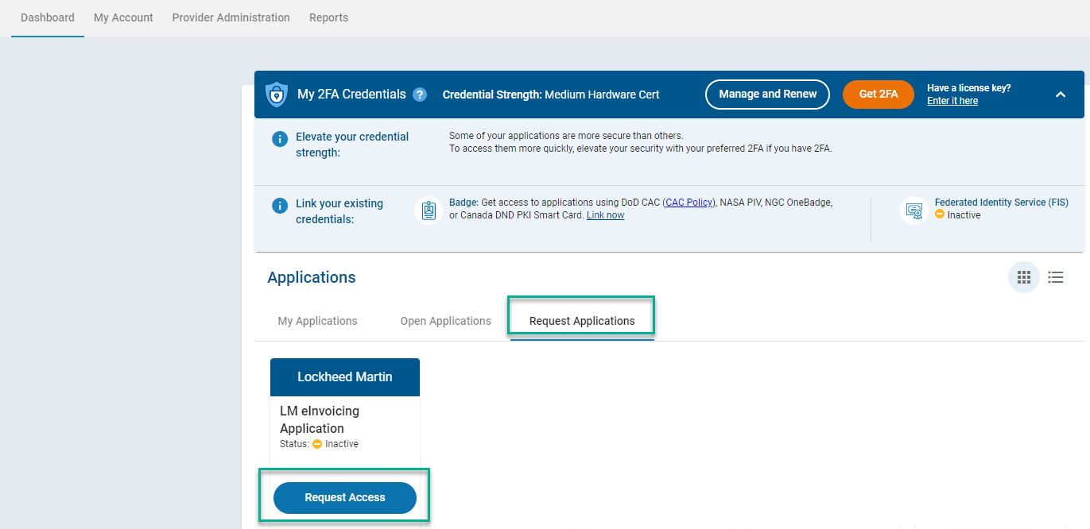

Step | Action
1. | Log into Exostar with your user id and password at https://portal.exostar.com.
2. | From the Dashboard, click on the “Request Applications” and then “Request Access” link next to the LM eInvoicing Application.
3. | Add note indicating the role you are requesting (Full Access or View Only Access)
4. | Click Submit

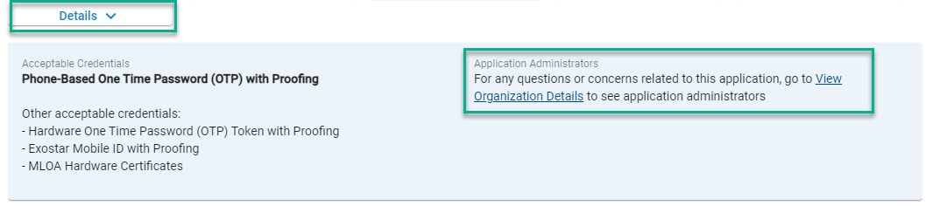

Step | Action
5. | The Application Administrator for your organization (will receive an email) will need to approve your access. To see who the Application Administrator is, click on the Details drop-down and View Organization Details link to view Application Administrators of the LM eInvoicing Application. This will show the individual(s) who can approve your access.
6. | Once your request is approved, your LM eInvoicing status changes from Pending Approval and now says Launch.

For new users that do not have an existing Exostar User ID:

To obtain a user account, you may either contact your company’s Organization Administrator, or go to https://portal.exostar.com/userRegistration and complete the online registration form.

You need to know the Exostar Organization ID of your company to start the registration process. You can get this information from any user or administrator(s) within your organization, or contact Exostar www.myexostar.com/contactSupport.aspx

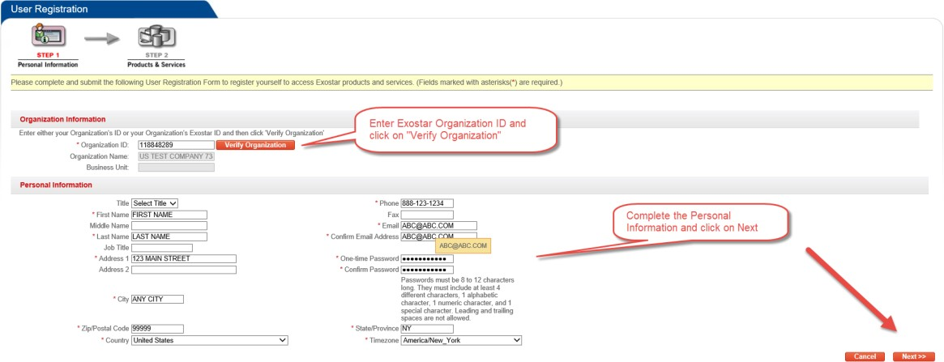

Step | Action
1. | Visit: https://portal.exostar.com/userRegistration
2. | Enter your Exostar Organization ID and click on Verify Organization
3. | Complete the Personal Information section and click on Next Fields marked with and asterisks are required
4. | Check the LM eInvoicing Application box
5. | Add note indicating the role you are requesting (Full Access or View Only Access)
6. | Click Next

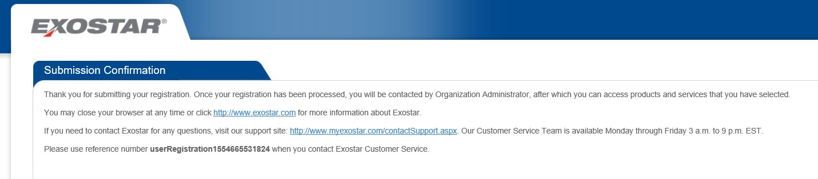

Step | Action
1. | You will receive a confirmation that your registration request was submitted.
2. | Once your request is approved, your LM eInvoicing status changes from  Pending Approval and now says Open Application.

