



Last Updated 8/12/2015
Last Reviewed 5/24/2022

LM Procure to Pay Quick Reference Guide For Suppliers

View Changed Schedule Agreements

Lockheed Martin Procure to Pay Revised August 2015

Procedure

This quick reference guide displays the procedure to view changed schedule agreements

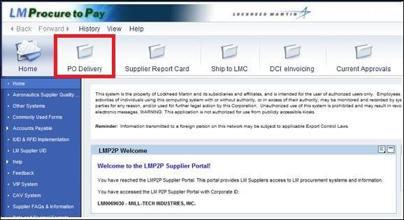

Step | Action
1. | 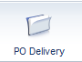  Click the PO Delivery tab.

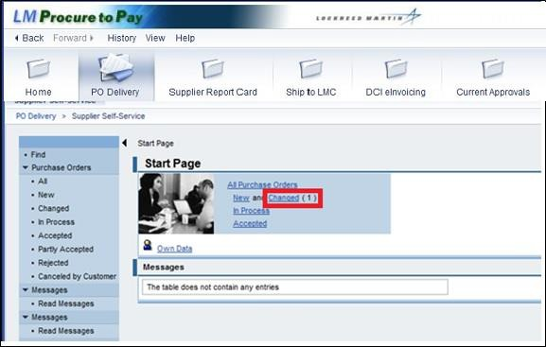

Step | Action
2. | Click the Changed link.

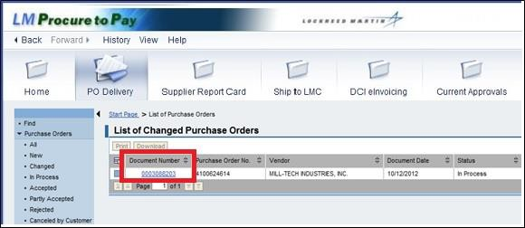

Step | Action
3. | The changed schedule agreements display with entries for document number, purchase order number, vendor, status and more. Please note: Although the links indicate “Purchase Orders”, these links will still be used to access your schedule agreements.
4. | 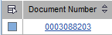  Click on the document number to select the schedule agreements.

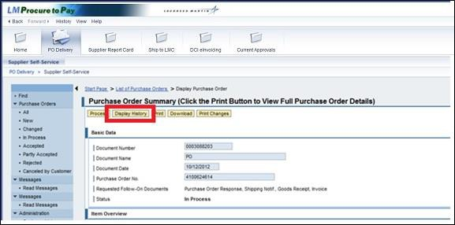

Step | Action
5. | To examine the changes made to the schedule agreements, click the Display History button.

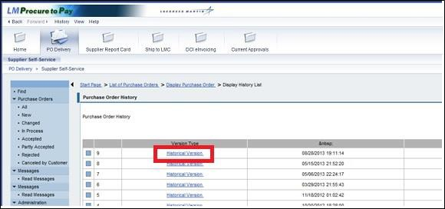

Step | Action
6. | Click the Historical Version link.

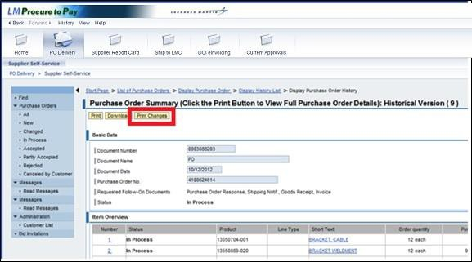

Step | Action
7. | Click the Print Changes button.

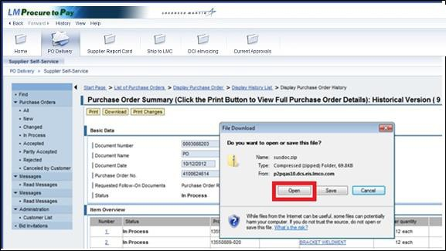

Step | Action
8. | Click the Open button.

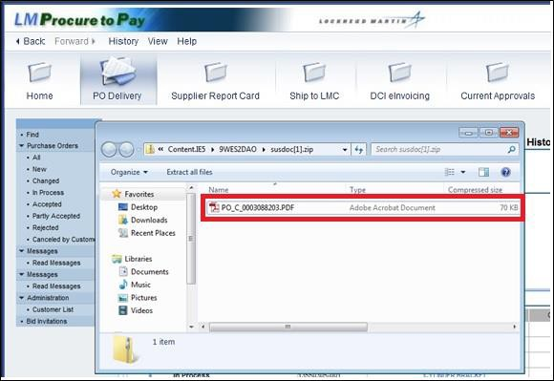

Step | Action
9. | Double-click the .pdf file to open.

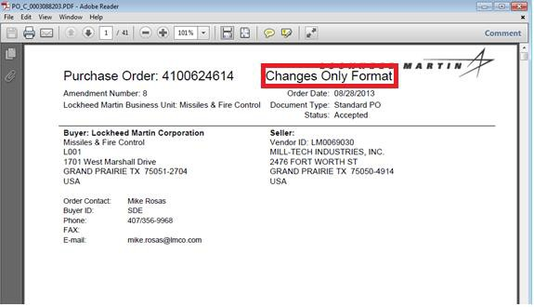

Step | Action
10. | This file displays the Changes Only Format for the schedule agreement.
11. | To return to the previous screen, click the Close button.

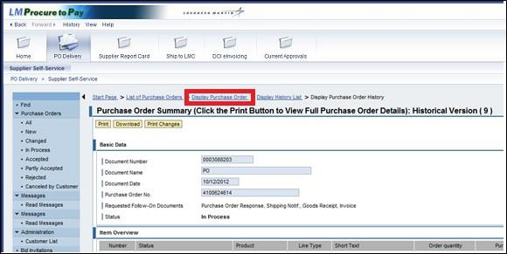

Step | Action
12. | To begin processing the changed schedule agreement, click the Display Purchase Order link to return to the Purchase Order Summary screen.

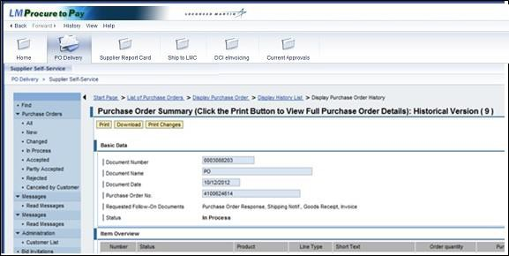

Step | Action
13. | You have successfully completed the procedure to view changed schedule agreements.

