



Last Updated 2/13/17
Last Reviewed 5/24/2022

LM Procure to Pay Quick Reference Guide For Suppliers

Print Schedule Agreement

Lockheed Martin Procure to Pay Revised February 2017

Procedure
This quick reference guide displays the procedure to print a schedule agreement.

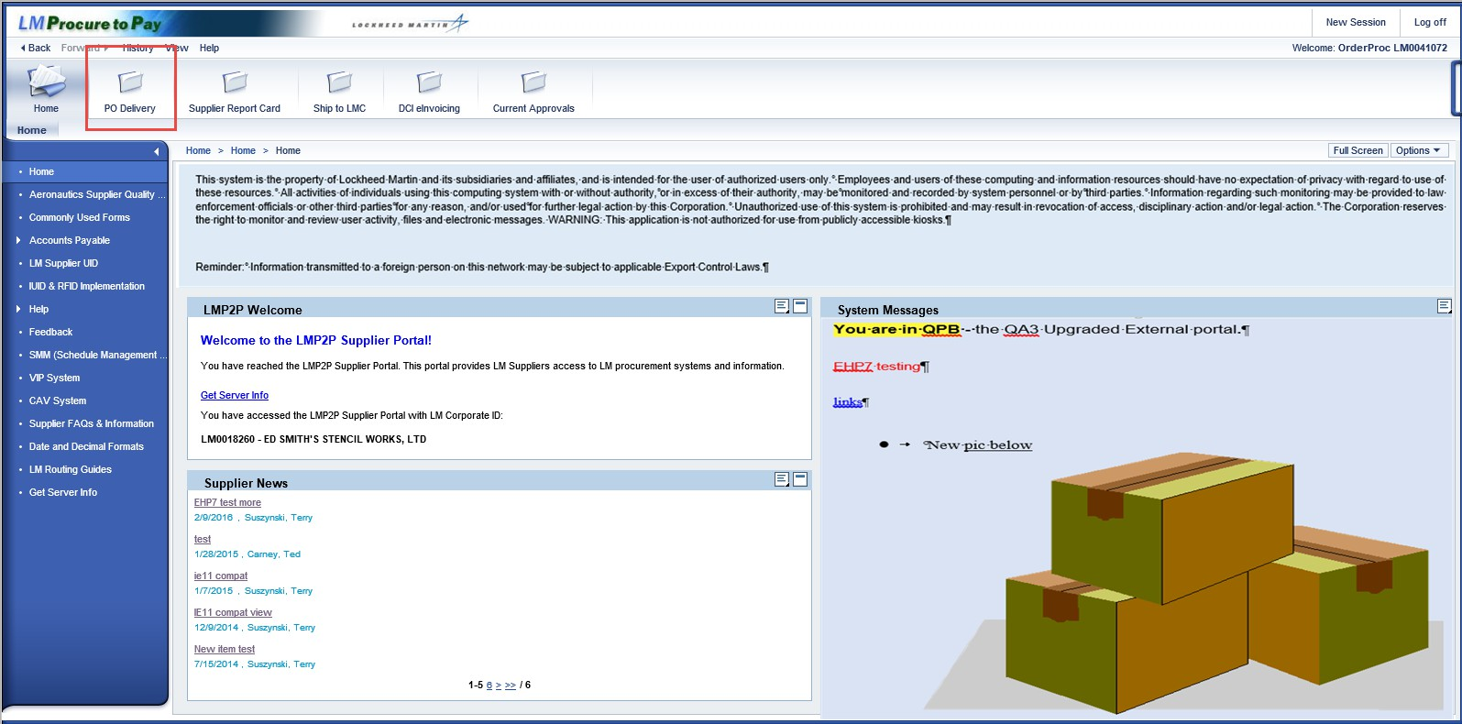

Step | Action
1. | 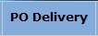  Click the PO Delivery tab.

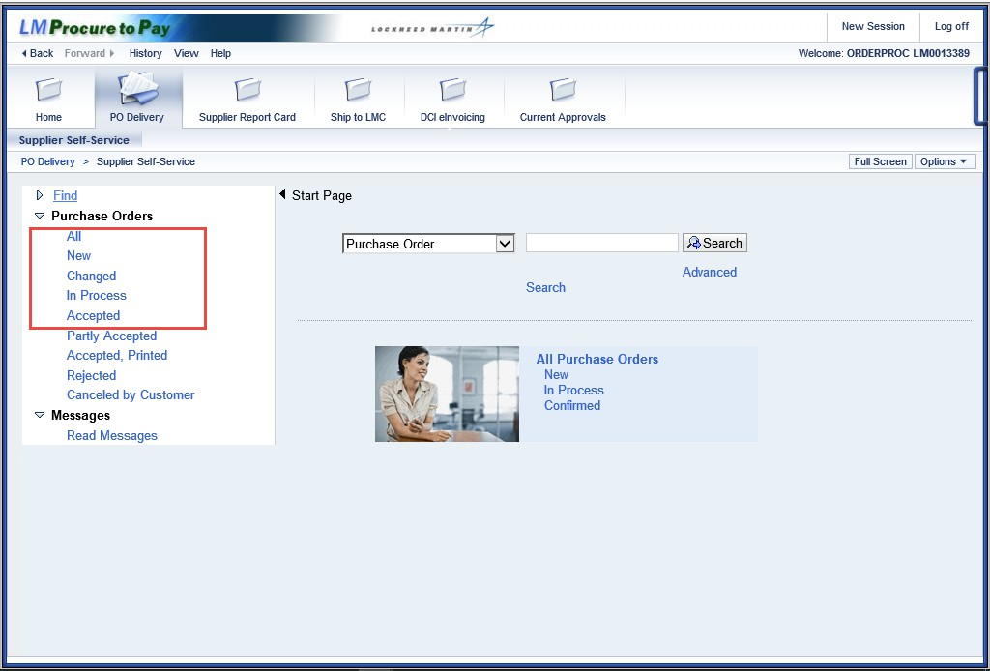

Step | Action
2. | Multiple options are available to view purchase orders or schedule agreements for the supplier. These include preset views for New, In process, Accepted, and Changed. All available predefined views are displayed in the menu tree under Purchase Orders
3. | Click the All Purchase Orders link on the menu tree.

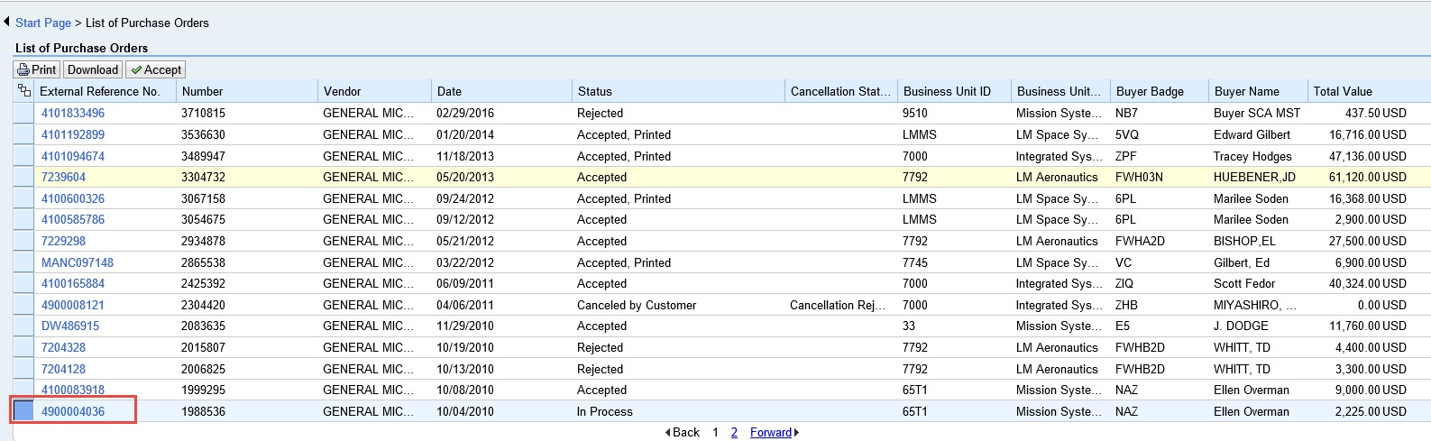

Step | Action
4. | To select a schedule agreement to print, click the button next to the line.

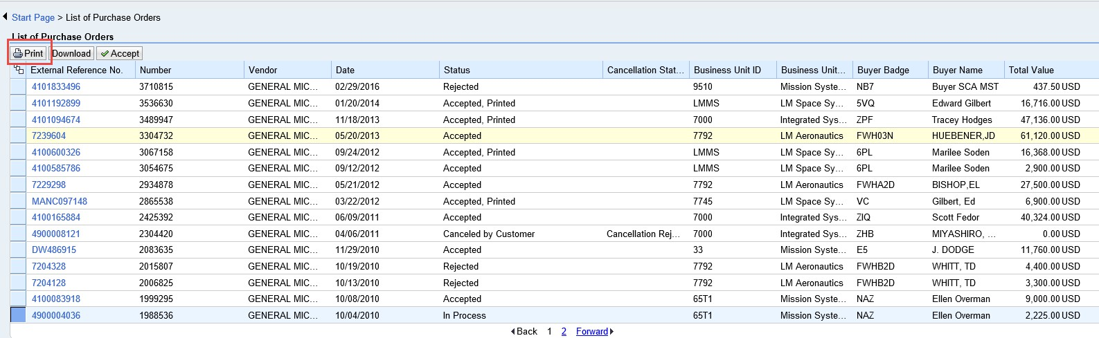

Step | Action
5. | Click the Print button.

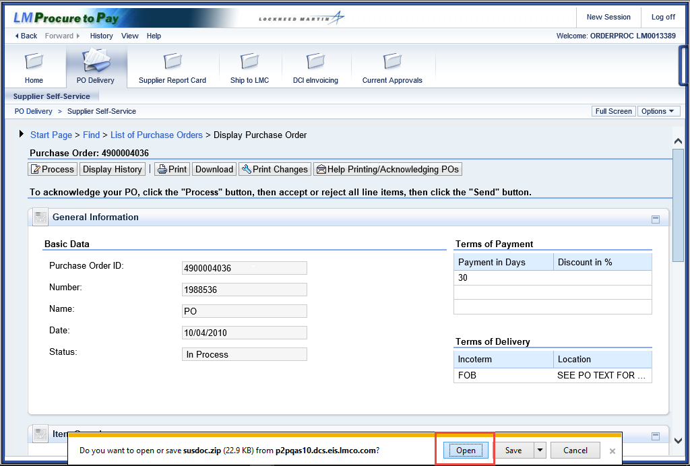

Step | Action
6. | Notice the file will be saved as a .zip file. Click the Open button.

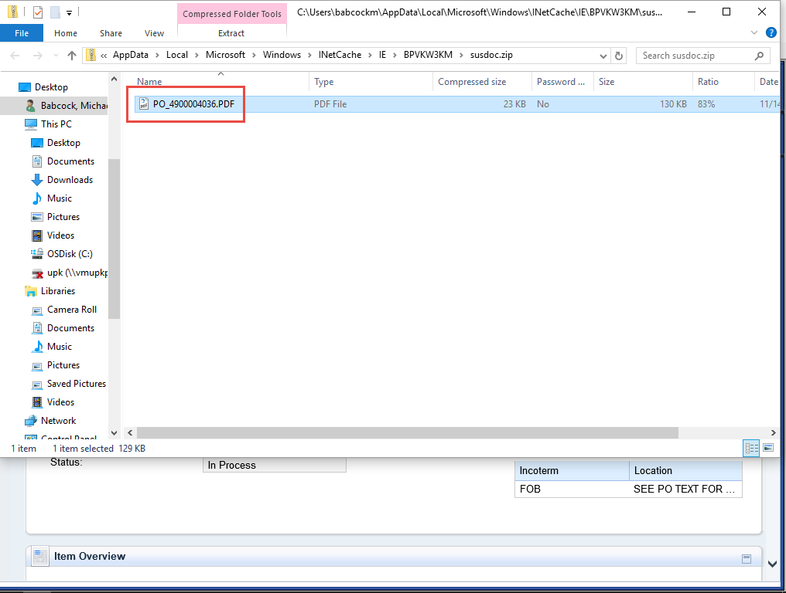

Step | Action
7. | Double click the .pdf document icon.  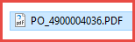

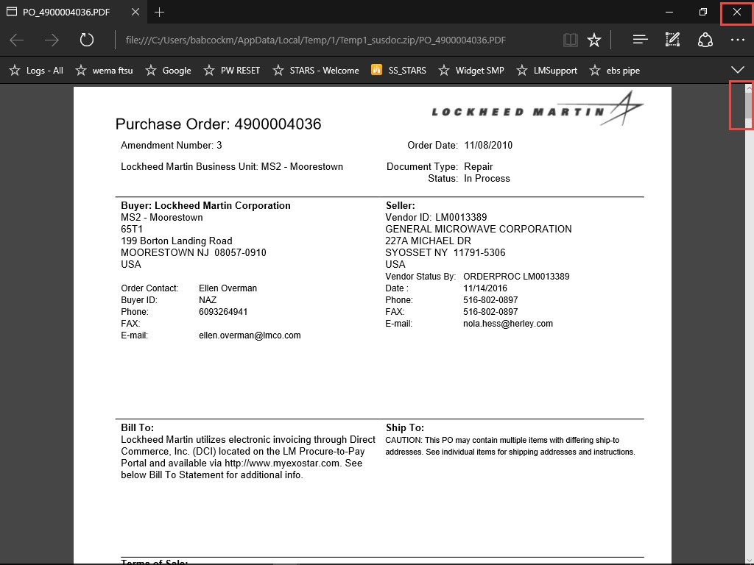

Step | Action
8. | The schedule agreement can now be viewed.
9. | Scroll down or tab to each of the pages to see all of the purchase order or schedule agreement information.

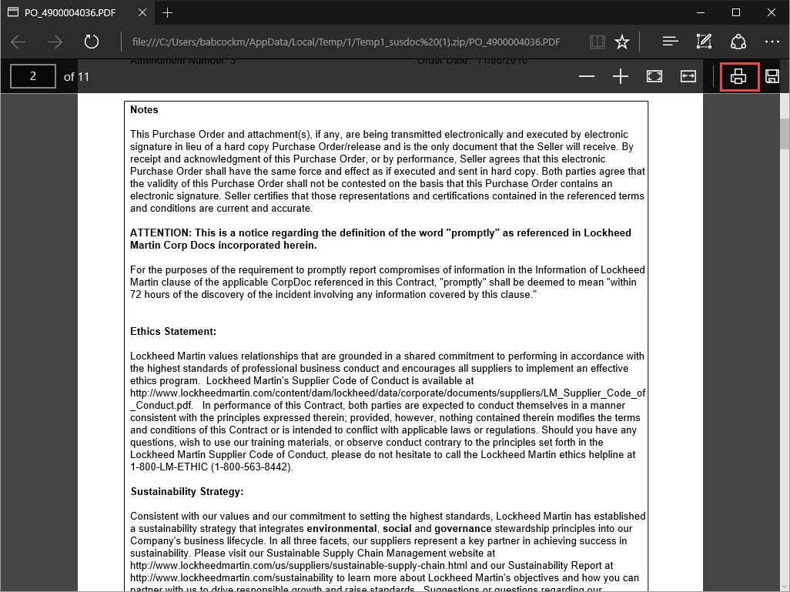

Step | Action
10. | The Notes section of the purchase order may contain special processes which you will need to supply additional information.
11. |   You may Print or Save the document as desired in this view. Click the Print button to print the schedule agreement.

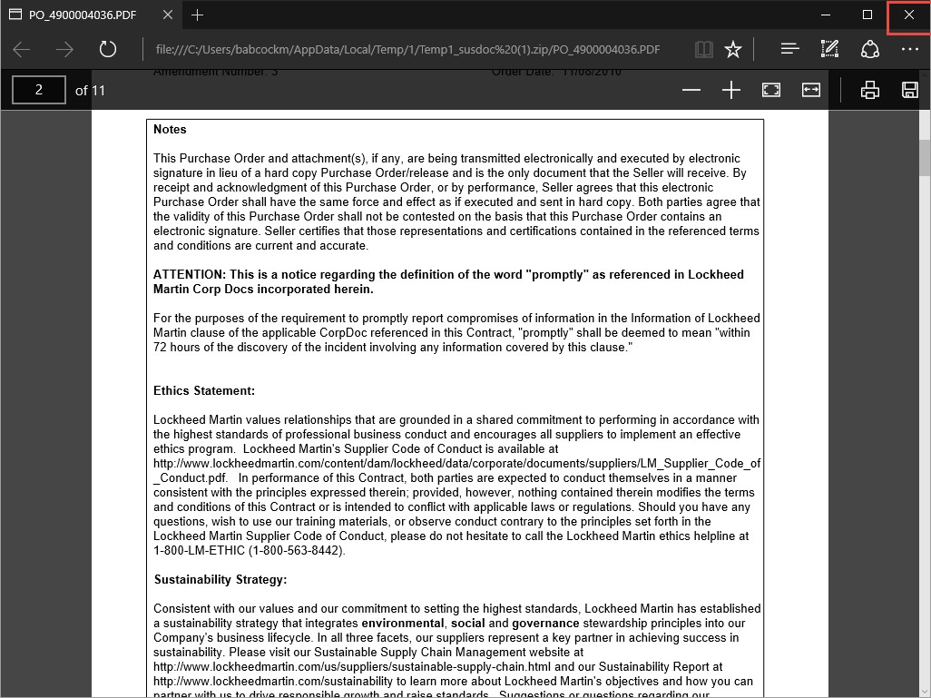

Step | Action
12. | Click the cancel button to close the schedule agreement print view.  

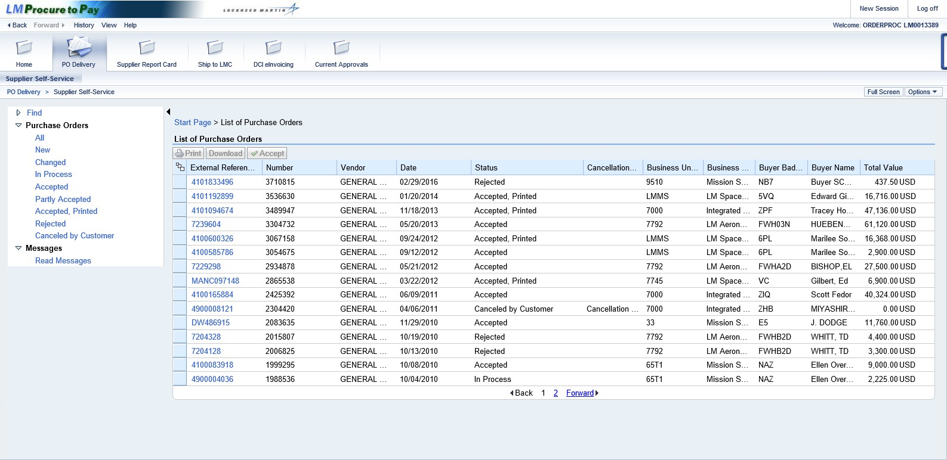

Step | Action
13. | You have successfully completed the procedure to print a schedule agreement.

