



Last Updated 2/13/2017
Last Reviewed 5/24/2022

LM Procure to Pay Quick Reference Guide For Suppliers

Display Schedule Agreement

Lockheed Martin Procure to Pay Revised February 2017

Procedure

This quick reference guide demonstrates the procedure to display a schedule agreement. The LMP2P display contains excerpts from the schedule agreement information. The full display of the schedule agreement is viewed in the print preview.

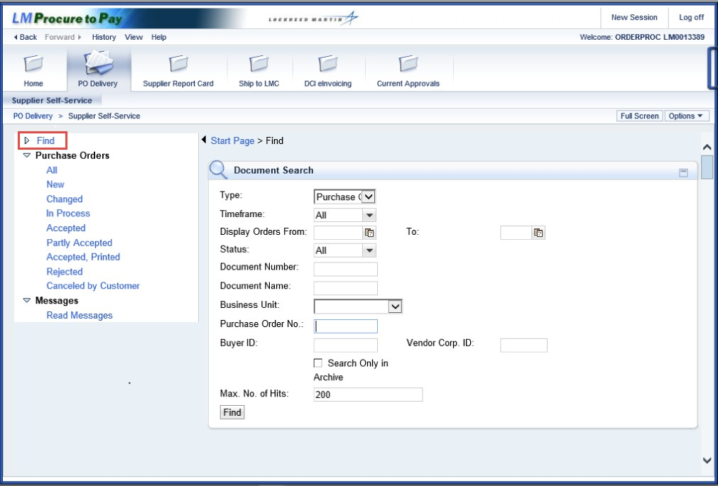

Step | Action
1. | Click the Find link.

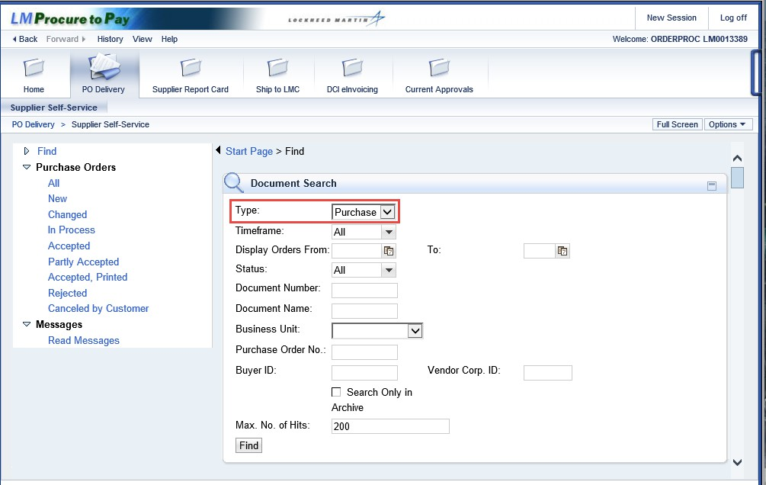

Step | Action
2. | Select the type of document you are searching for in the Type field.

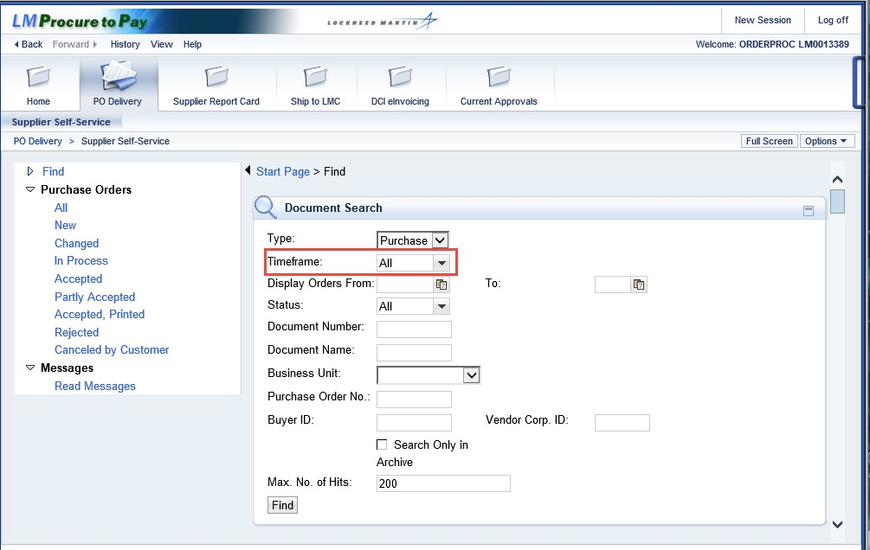

Step | Action
3. | In the Timeframe field it is recommended to leave the default of All.  Here is a scenario explaining why the Timeframe should left at All:  - The original Schedule Agreement XYZ1234 was created/approved on 01/01/2009  - The buyer lets the supplier know the Schedule Agreement was amended on 8/28/2012  - The supplier goes into PO Delivery to search for the Schedule Agreement and clicks on Find, enters Schedule Agreement XYZ1234 in the Purchase Order No. field, and clicks the Find button  - No search results will be returned  - Why are there no results?  - The Timeframe defaults to Last Month so PO Delivery is searching for any documents with a document date within the last 30 days  - Even though the amendment is aged less than 30 days, the document isn’t returned in the search results because the Document Date is from 2005  - By selecting All you will be able to find the Schedule Agrement you are searching for

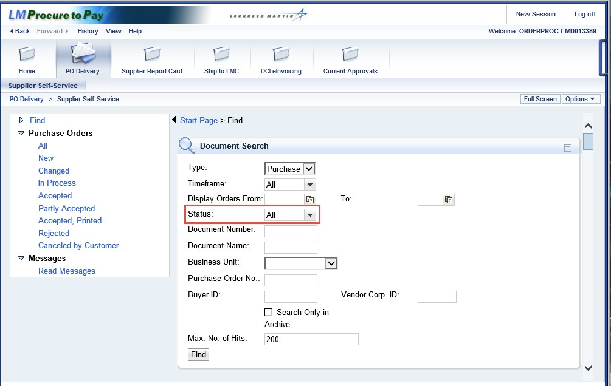

Step | Action
4. | In the Status field it is recommended to leave the default of All.  Here is a scenario explaining why the Status should left at All:  - The supplier enters Schedule Agreement XYZ1234 in the Purchase Order No. field and clicks the Find button  - The Schedule Agreement is returned in the search results with a document date of 01/01/2009, and shows a status of Accepted  - The supplier knows they haven’t accepted the latest amendment, so the supplier assumes the amendment isn’t in PO Delivery  - Why does the document return as accepted?  - Documents will only show up as New as long as the prior amendments or the original order have not been processed by the supplier  - If the supplier has acknowledged prior amendments or the original order, the new document won’t be listed as New, instead the system assumes the status is the same as the prior amendments or the original order

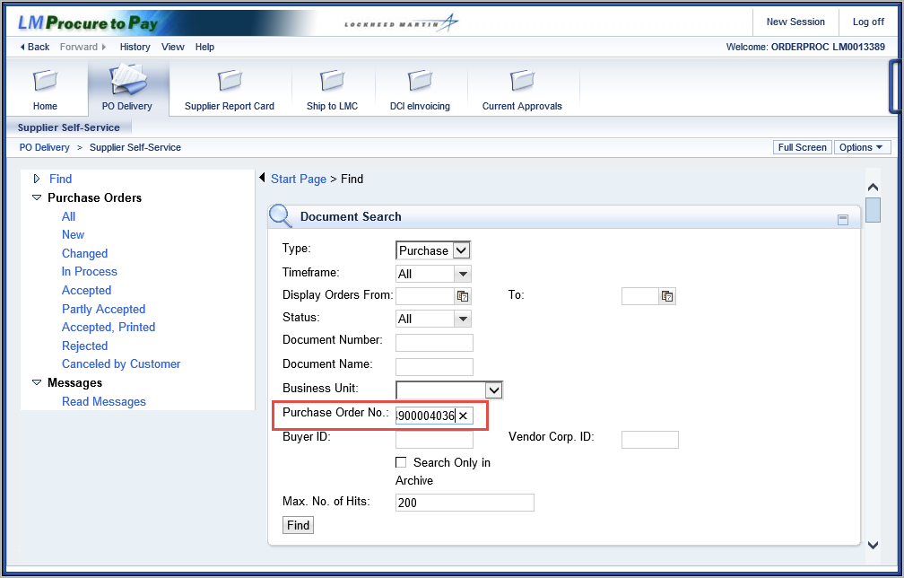

Step | Action
5. | Enter the schedule agreement number in the Purchase Order No field

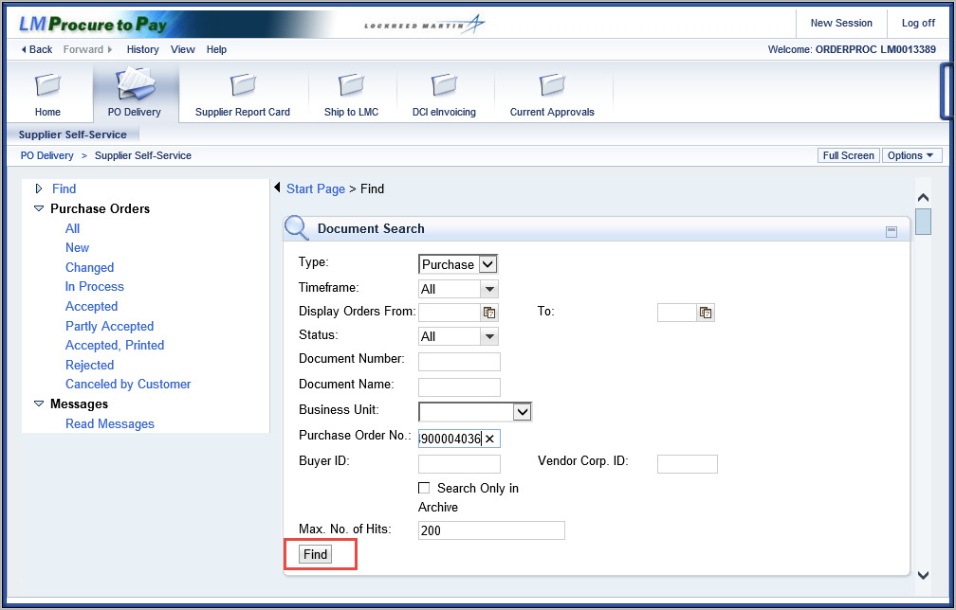

Step | Action
6. | Click the Find button.

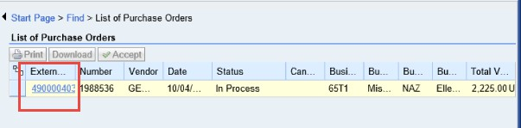

Step | Action
7. | Click on the External Document Number link to see purchase order details.  Note: The External Document number is not the same as the schedule agreement number.  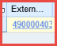

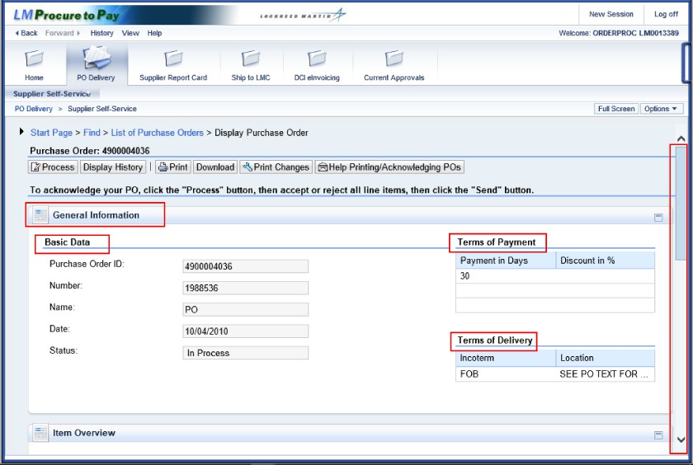

Step | Action
8. | The General Information content section contains data typically found in the Schedule Agreement header data: Basic Data, Terms of Payment, and Terms of Delivery.  Scroll down the schedule agreement.

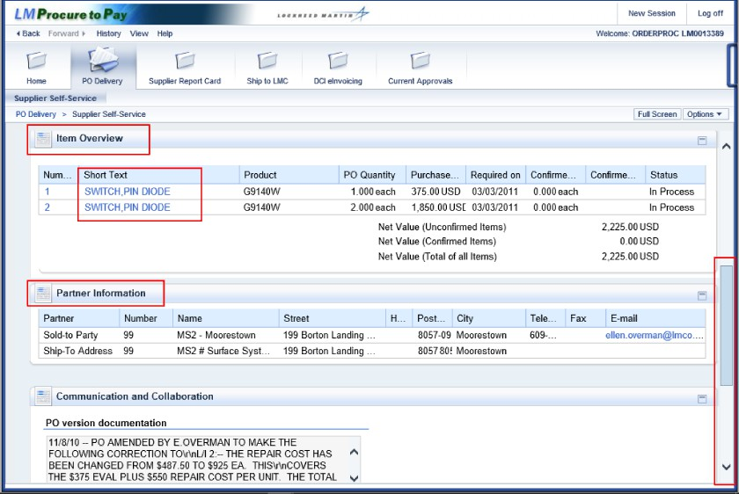

Step | Action
9. | The Item Overview section contains summary data related to the line item section of the purchase order or schedule agreement along with PO quantity and Purchase Price information. Click on the hyperlinks under Short Text to view additional line item details.  The Partner Information section displays the Sold-to Party and the Ship-to Address along with the respective Lockheed Martin company codes (number), address data, phone/fax and email.  Continue to scroll down.

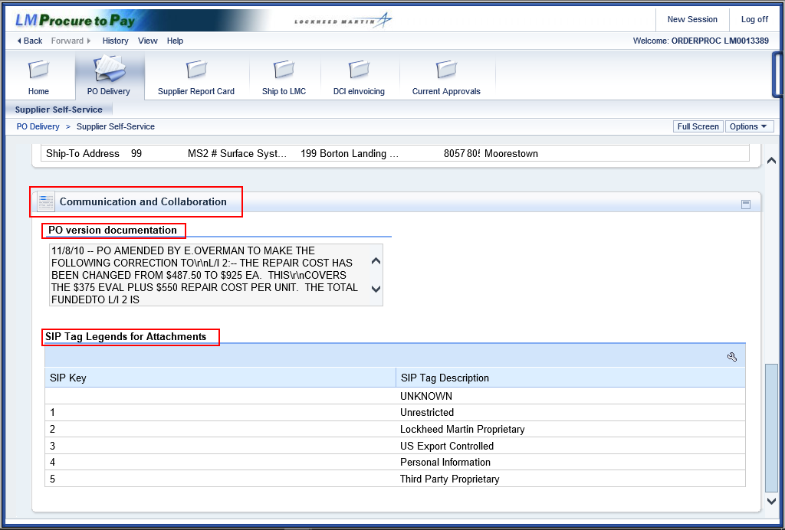

Step | Action
10. | The Communications and Collaboration section displays information related to messaging: PO Version documentation, Supplier Comments (when present), and the SIP tag Legend.  The Partner Information section displays the Lockheed Martin company code and the Lockheed Martin ship to address.  Use the scroll bar to return to the top of the schedule agreement.

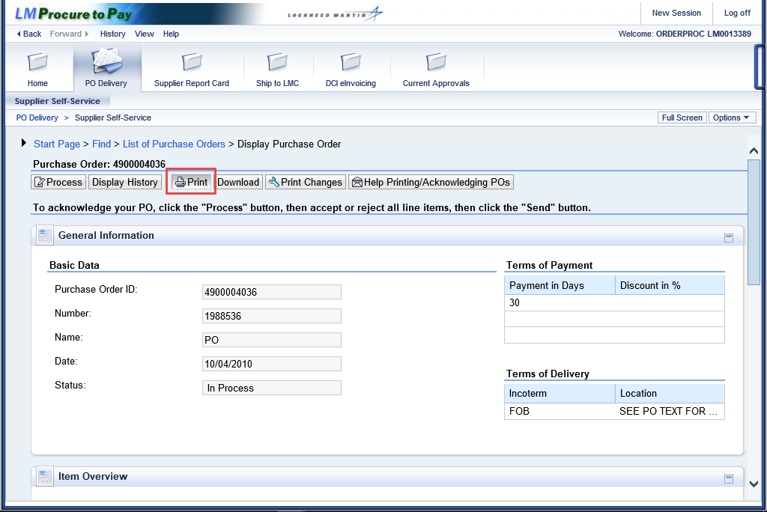

Step | Action
11. | At the top of the Schedule Agreement Summary screen is the Print button.  A full view of the schedule agreement including any custom data can be seen in a  .pdf format by clicking this button.  Click the Print button.  Note: In order to see the date associated with the latest document amendment in the PO Overlay Stack you must click on the Print button otherwise you will only see the original Schedule Agreement date.

Step | Action
12. | Scroll down or tab to each of the pages to see all of the purchase order information.  Print or save the document as desired.

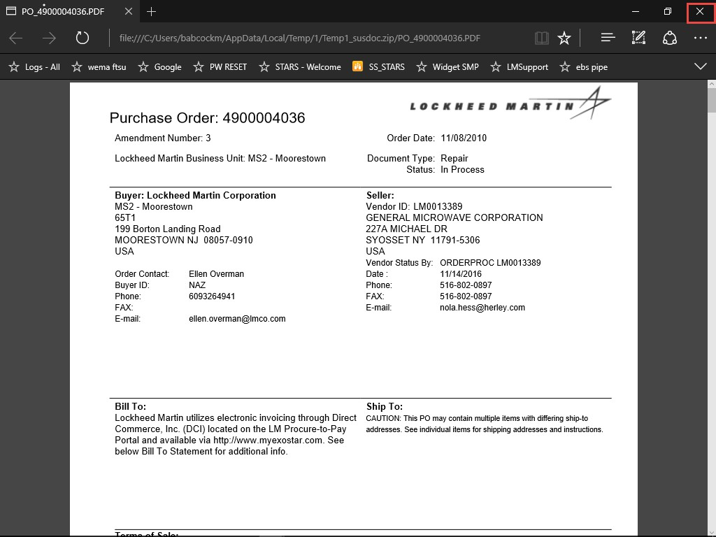

Step | Action
13. | Click the "Close" button to return.
14. | You have successfully completed procedure to display a schedule agreement.

