



Last Updated 2/13/2017
Last Reviewed 5/24/2022

LM Procure to Pay Quick Reference Guide For Suppliers

Schedule Agreement

Acceptance and Rejection

Lockheed Martin Procure to Pay Revised February 2017

Procedure

This quick reference guide displays the procedure to accept a schedule agreement.

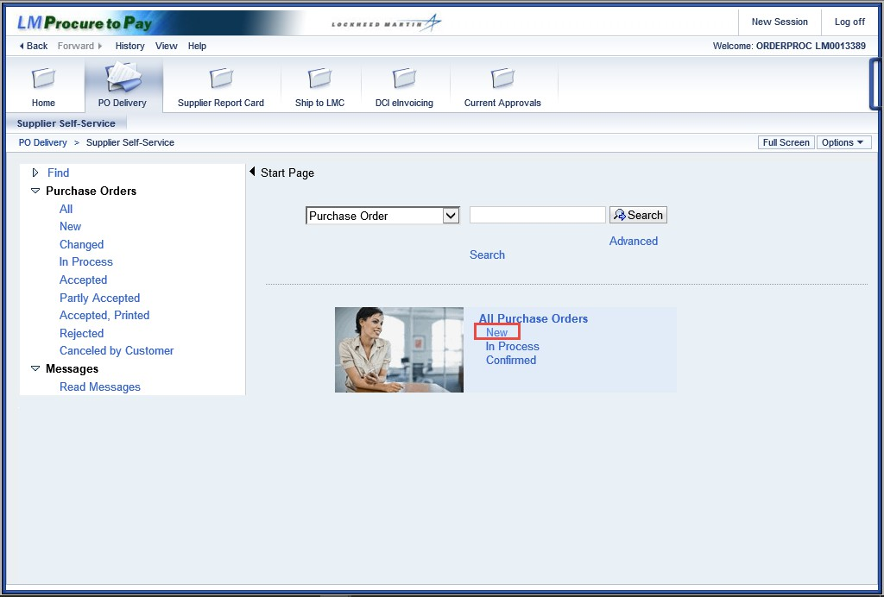

Step | Action
1. | Click the New link to see the new schedule agreements in your queue.

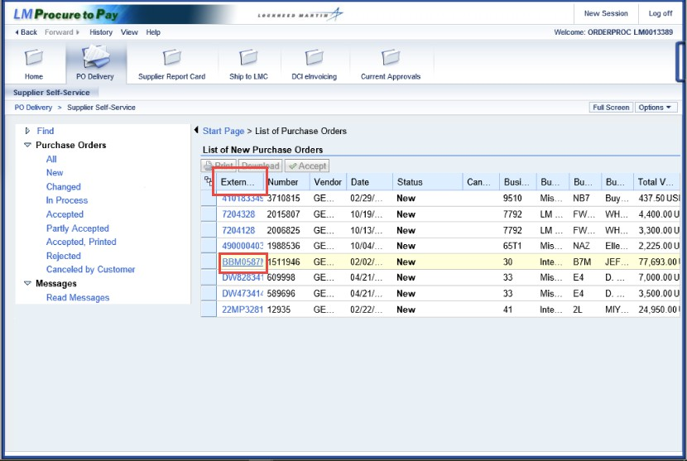

Step | Action
2. | The resulting page displays the document number, schedule agreement number, date, status, etc. for the new schedule agreements.  Schedule agreements not processed in three work days generate a reminder e-mail sent to the buyer and supplier point-of-contact.
3. | Although the External Document Number is the "hot-linked" field, the order is recognized by the schedule agreement number.  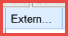

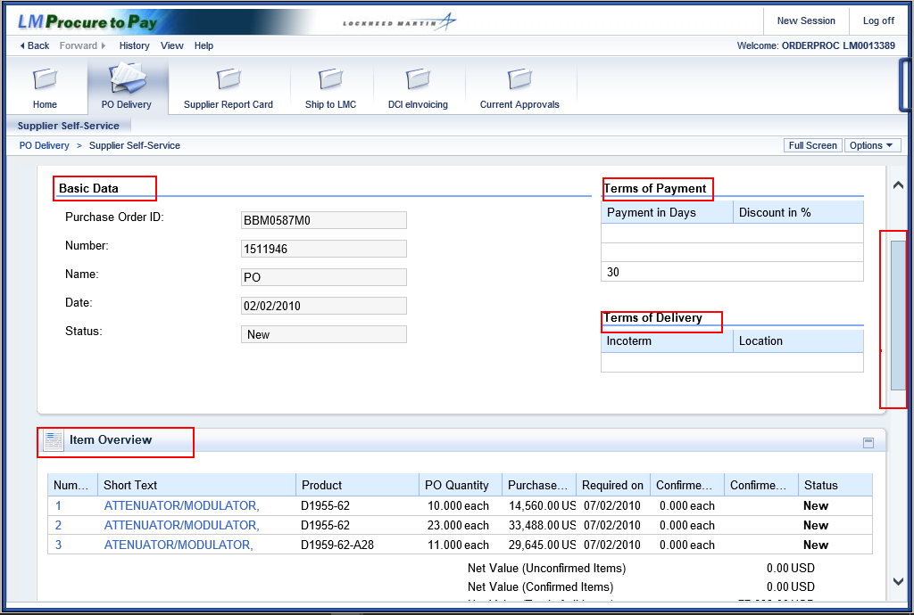

Step | Action
4. | This screen displays purchase order information by Content Sections. Shown here are the Content Area (Basic Data, Terms of Payment, and Terms of Delivery) and the Item Overview (line items of schedule agreement)  Further sections can be viewed by scrolling down. Click the scrollbar to continue.

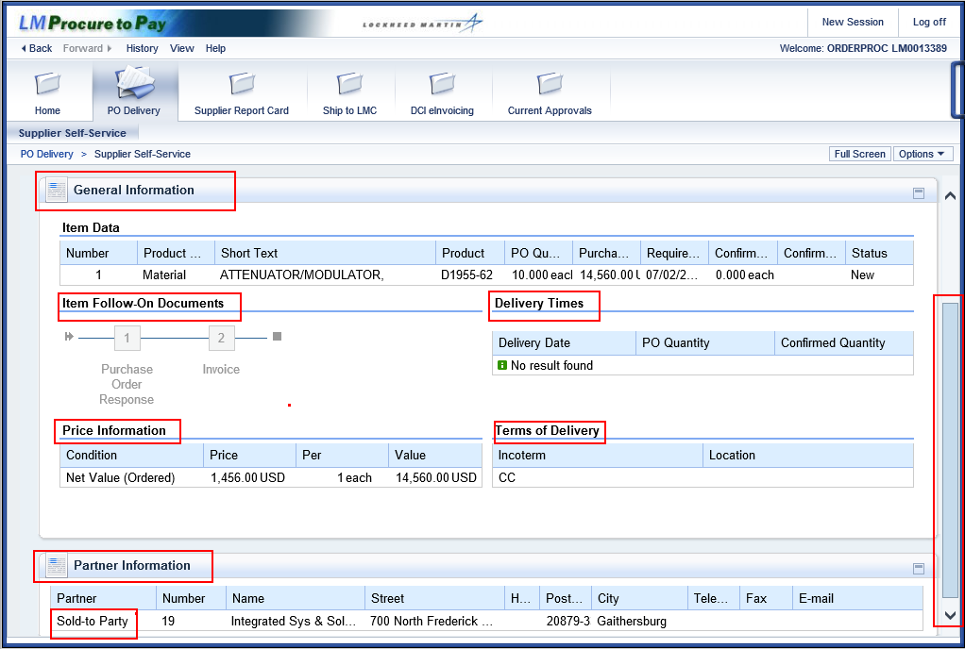

Step | Action
5. | Scrolling further down displays additional Content Sections including General Information (Item Data, Follow on Items, Delivery Times, and Price Information).  The Partner Information section reflects the business unit that LM is doing business with. The Partner Information contains details from the purchase order or schedule agreement pertaining to the partner. Sold-to Party includes the LM company code and address from the purchase order or schedule agreement. Ship- To Address is the delivery address from the purchase order or schedule agreement.

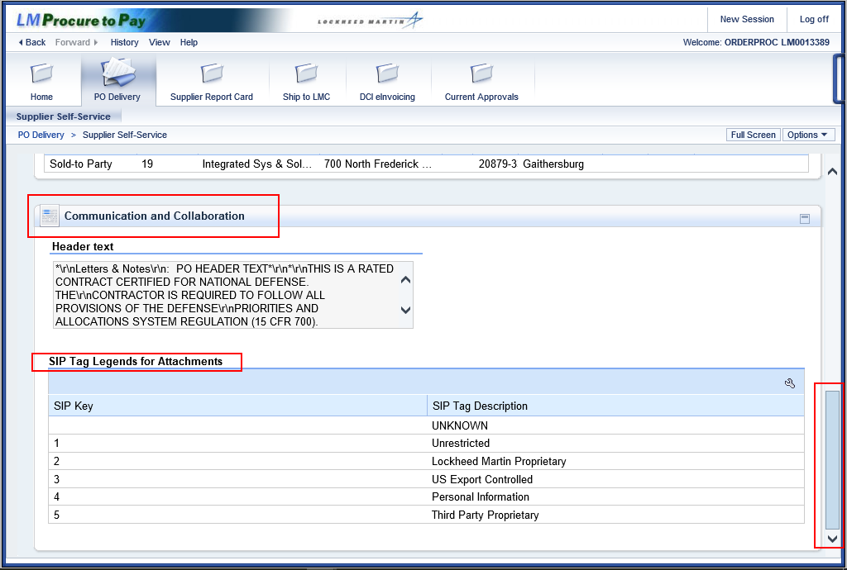

Step | Action
6. | By scrolling to the bottom or the purchase order you find the Communications and Collaborations section that displays header and message texts along with SIP keys and Descriptions.  Note - If the displayed purchase order or schedule agreement is acknowledged in Exostar (SCP) or LM eDocs, the historical information is available from the Display History link.  Scroll back to the top of the purchase order display.

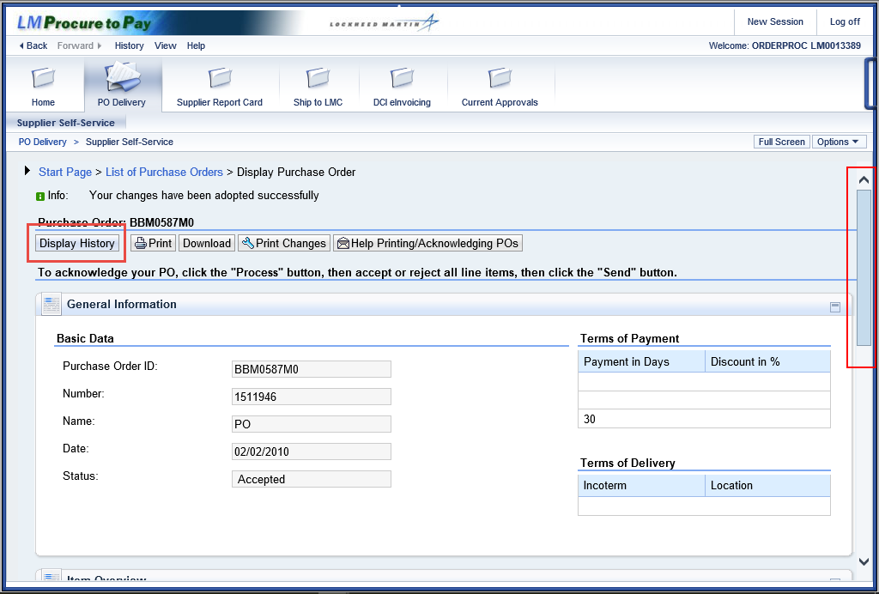

Step | Action
7. | Scroll to the top of the purchase order.  Click the Display History link. The following screens will allow you to open a generated .pdf file to view the purchase order details associated with the historical activity related to the PO.  Close those sub-screen by clicking the cancel button “X” on the upper right hand corner of each sub-screen.

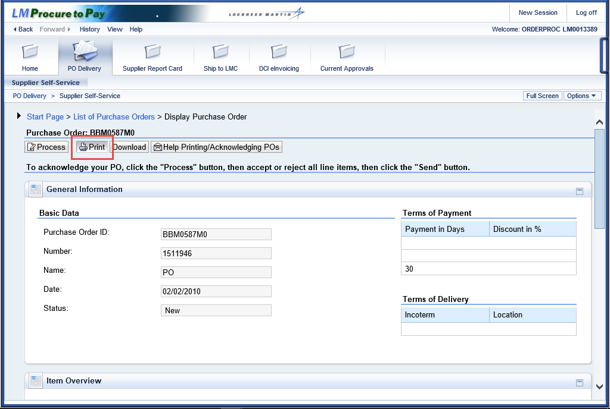

Step | Action
8. | To display the most complete view of the purchase order or schedule agreement, view the print version.  Click the Print button.  Use the Print button at the top of the page to view and save (in pdf format) or print the schedule agreement. This example is to View.  Step 1. Click the Print button.  Step 2. Click on the Open or Save Button.  Note - Don't use the Download button as this may provide a historical purchase order version.

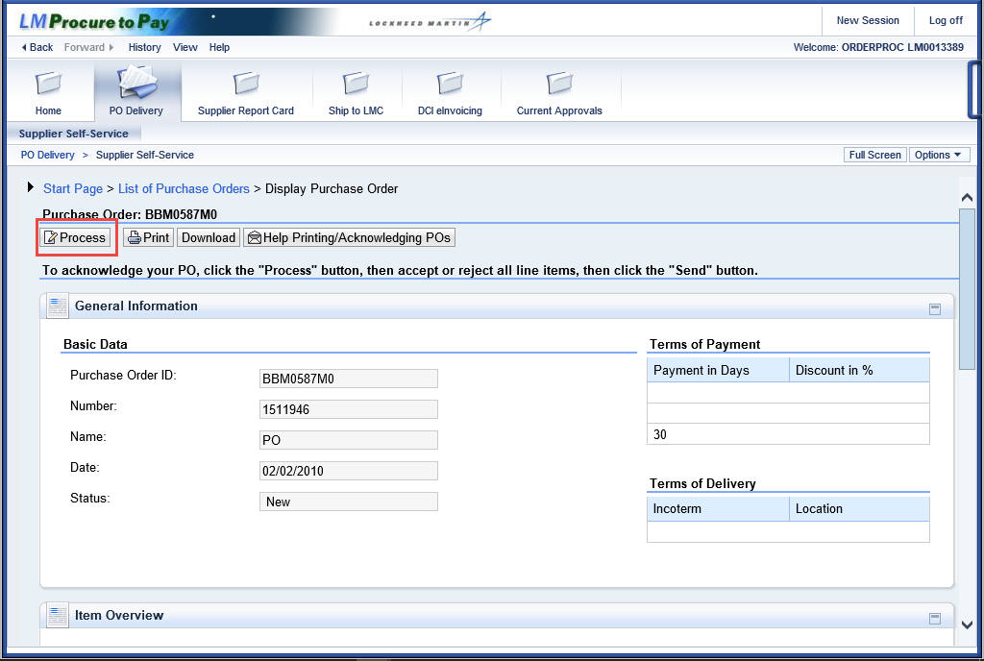

Step | Action
9. | To accept the schedule agreement, click the Process button.

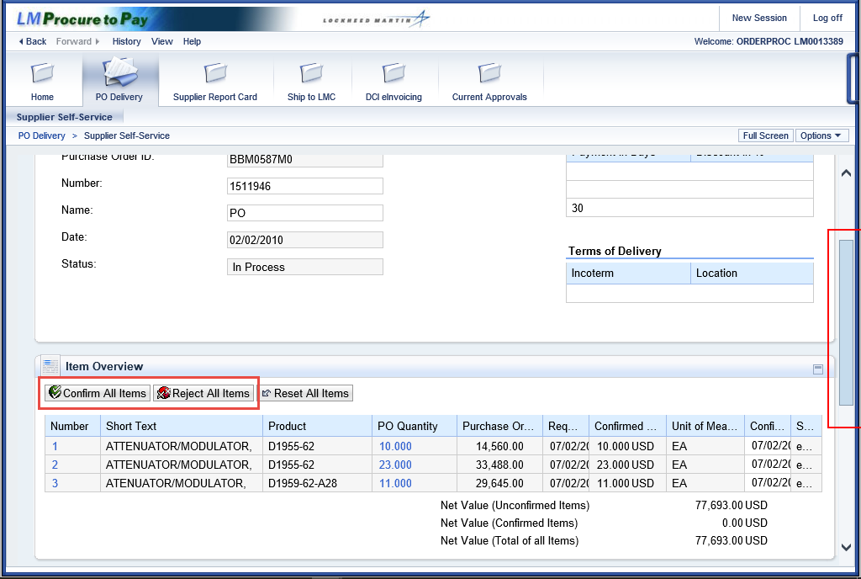

Step | Action
10. | Use the scroll bar to scroll down the page to the buttons for two options: Confirm All Items or Reject All Items.

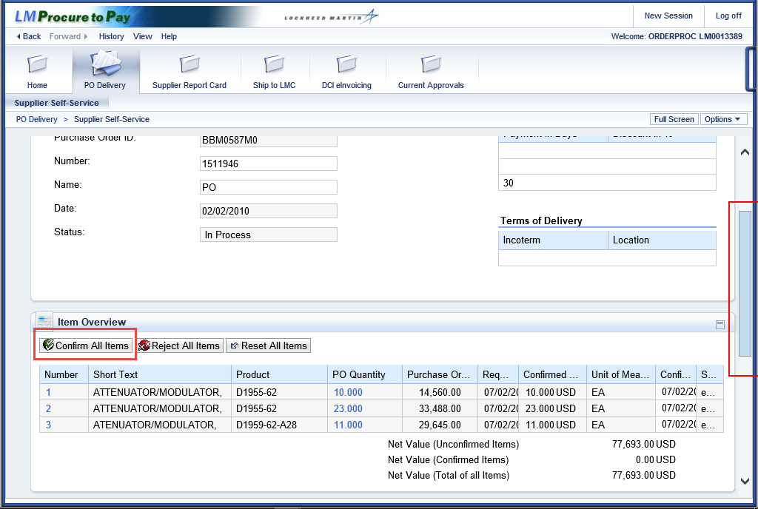

Step | Action
11. | Click the Confirm All Items button.  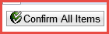

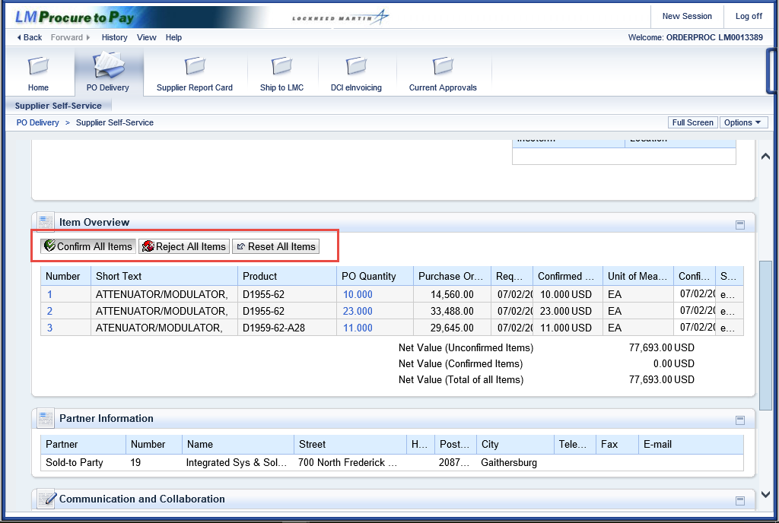

Step | Action
12. | Further Processing Comments:  Click Confirm All Items to accept the schedule agreement with ALL existing terms.  Click the Reset All Items button to cancel any of the previous actions.

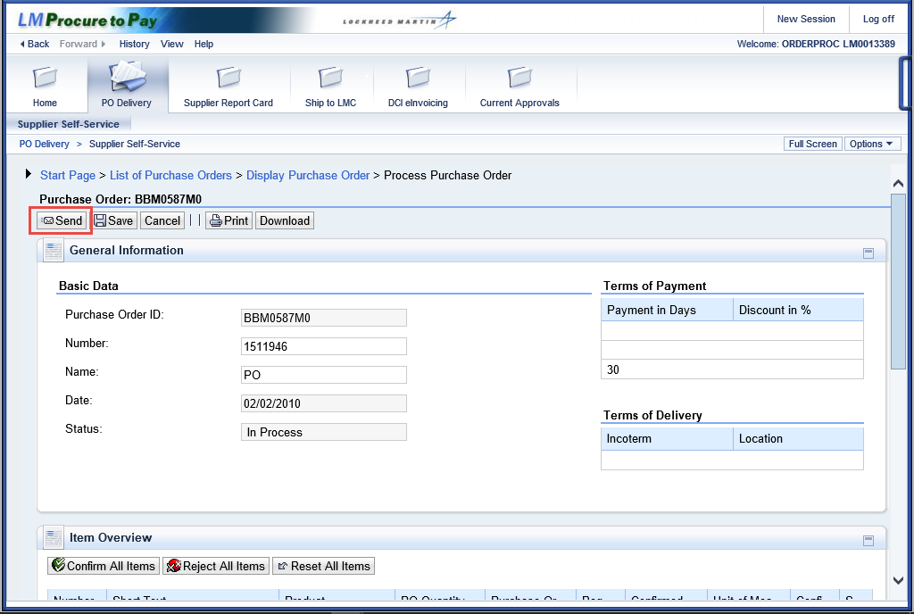

Step | Action
13. | Click the Send button. This will confirm the schedule agreement disposition.

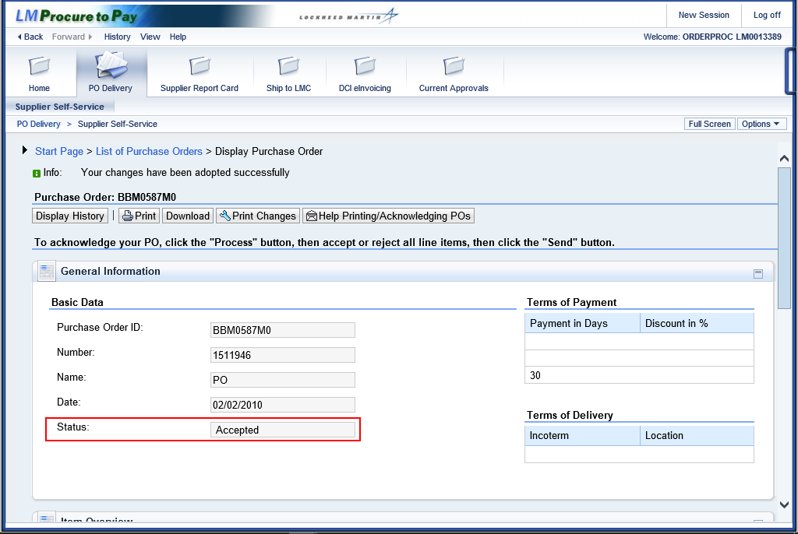

Step | Action
14. | The Status column (in the General Information section) for this item changes to  Accepted.  When the supplier agreement is accepted, an e-mail notification is sent to the applicable LMC buyer.

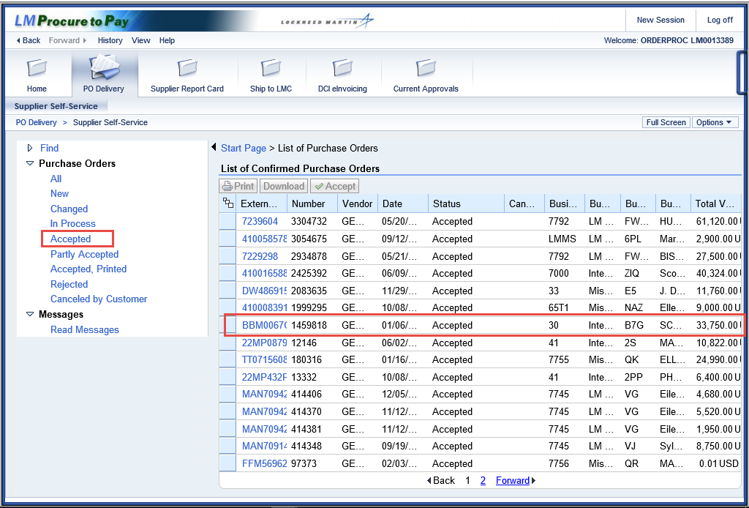

Step | Action
15. | Click the Accepted menu tree item.  The document now displays as Accepted.
16. | You have successfully completed the procedure to accept a schedule agreement.

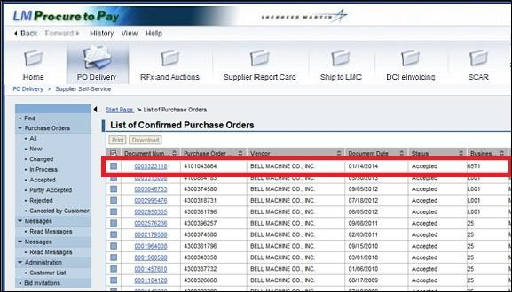

Step | Action
17. | The document now displays as Accepted.
18. | You have successfully completed the procedure to accept a schedule agreement.

Procedure
This section displays the procedure to reject a schedule agreement.

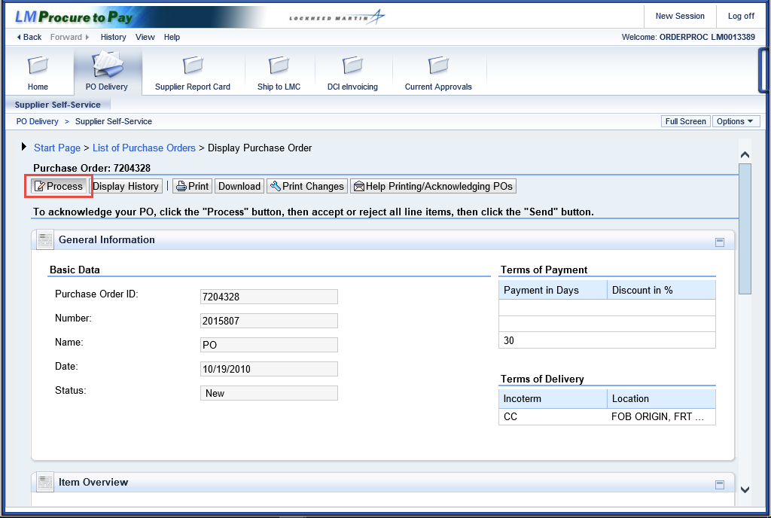

Step | Action
1. | To reject the schedule agreement, click the Process button.

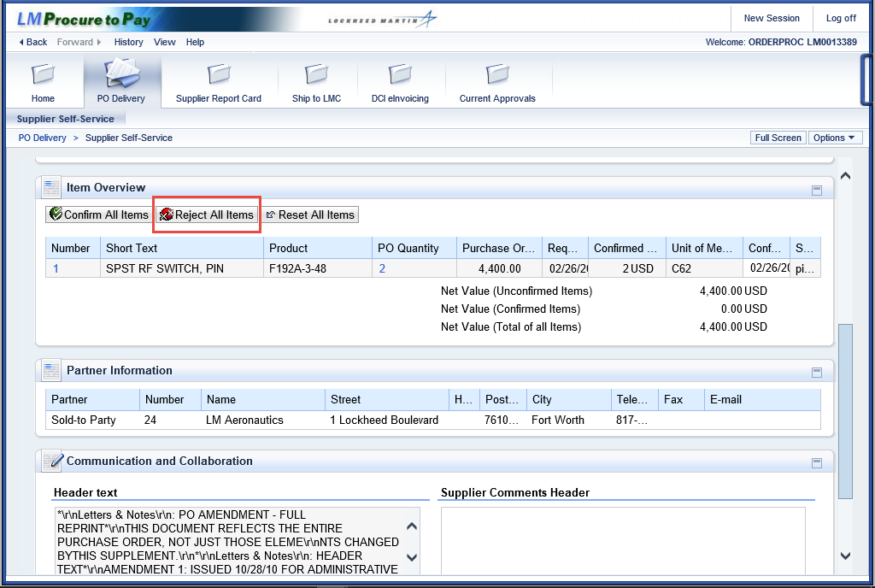

Step | Action
2. | Use the scroll bar to scroll down the page to the buttons for two options:  Accept All Items or Reject All Items.  For this example (and to reject this schedule agreement), click the Reject All Items button.

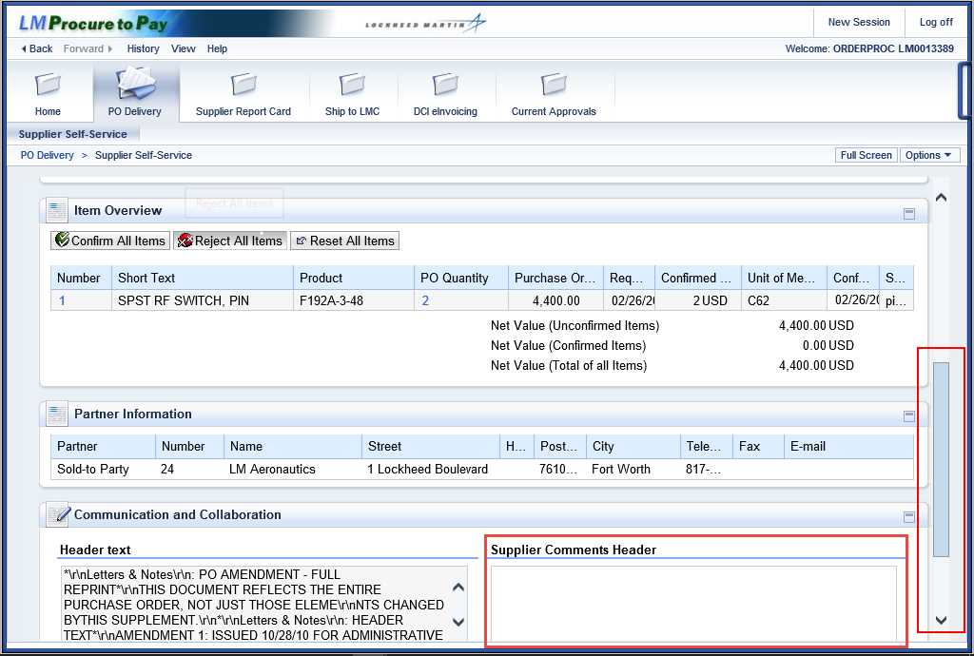

Step | Action
3. | In order to complete the process for rejecting a purchase order or schedule agreement, comments must be included that detail the reason for rejection.  Scroll down to the Supplier Comments Header section which now appears.

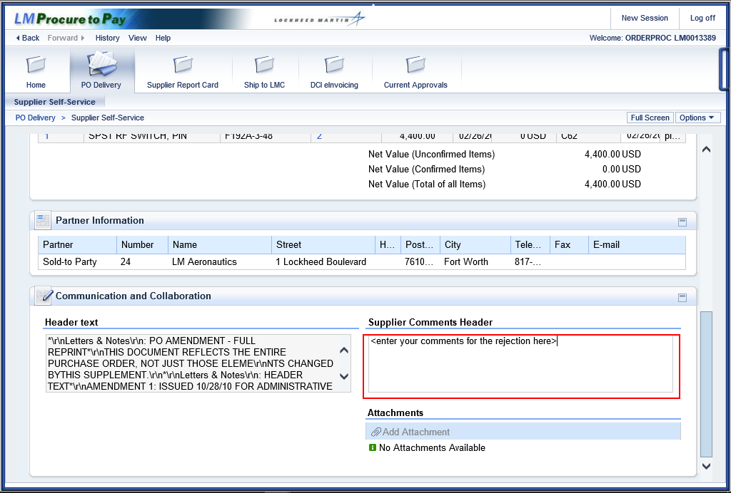

Step | Action
4. | Enter the desired message for rejection into the comments text area. For this example, type <enter your comments for the rejection here>.  Press Enter to continue.

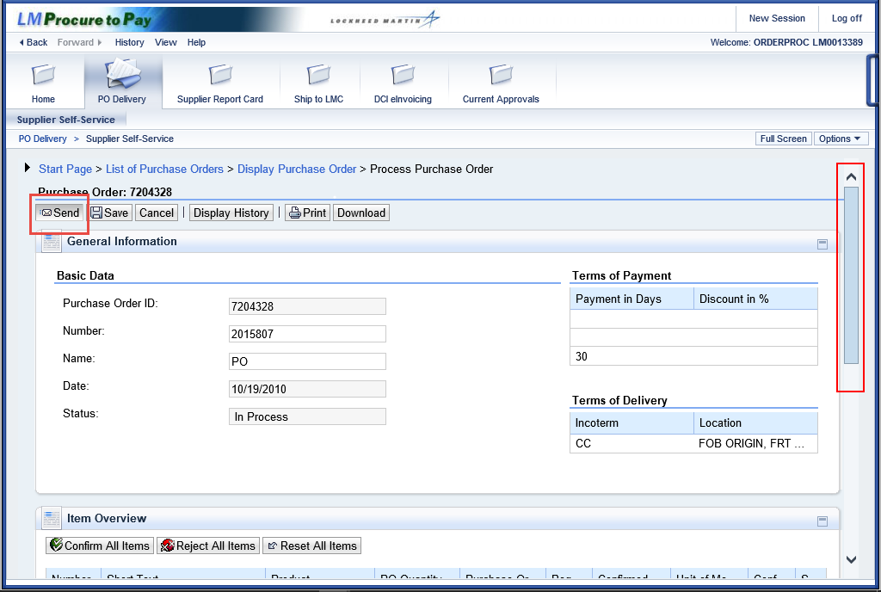

Step | Action
5. | Scroll back up to the Items Overview section.  To finalize the schedule agreement rejection click the Send button

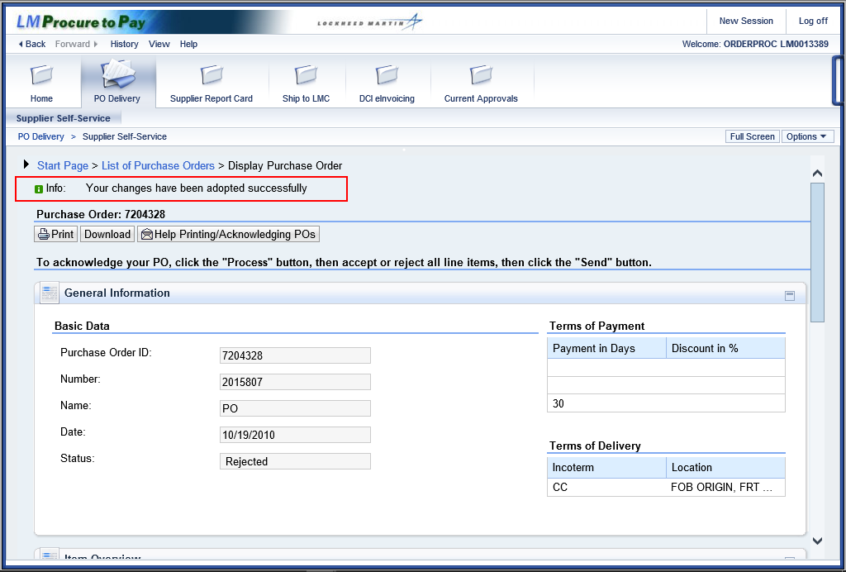

Step | Action
6. | The system message confirms the PO or schedule agreement is successfully rejected.  Info: Your changes have been adopted successfully  When a PO or schedule agreement is rejected an e-mail notification is sent to the applicable LMC buyer.

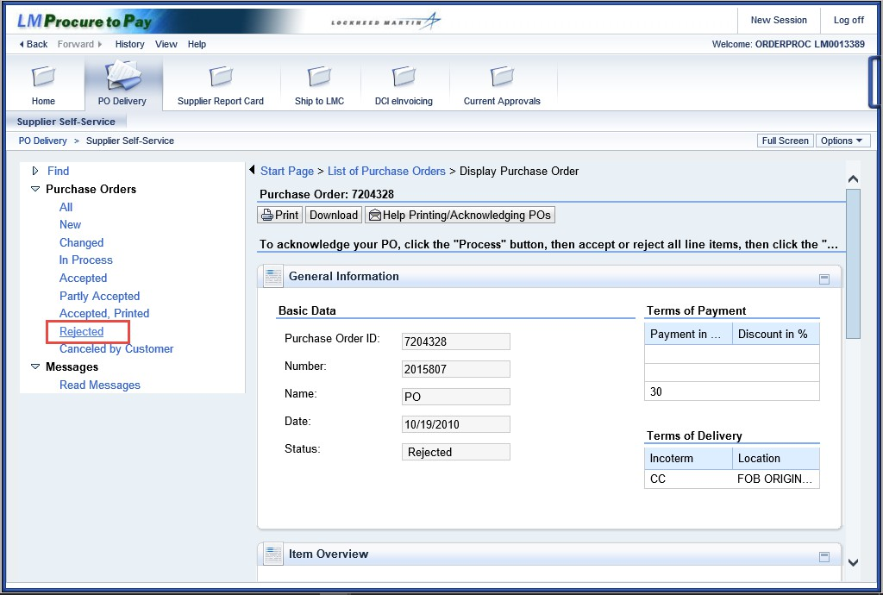

Step | Action
7. | Click the Rejected menu tree item.

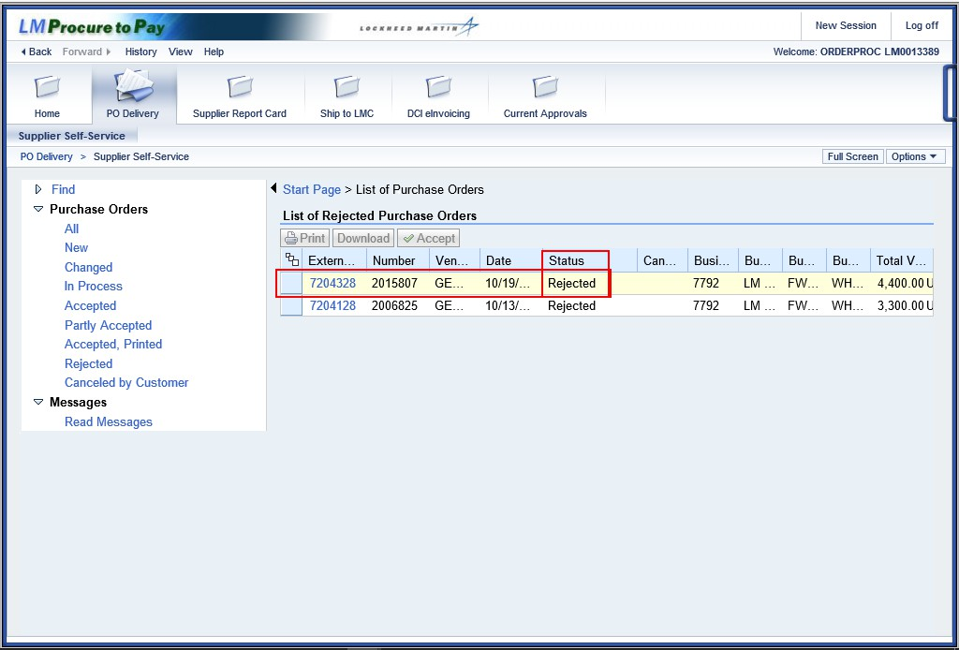

Step | Action
8. | The system message confirms the schedule agreement has been successfully rejected.  When a schedule agreement is rejected an e-mail notification is sent to the applicable Lockheed Martin buyer.
9. | You have now successfully completed the schedule agreement rejection scenario.

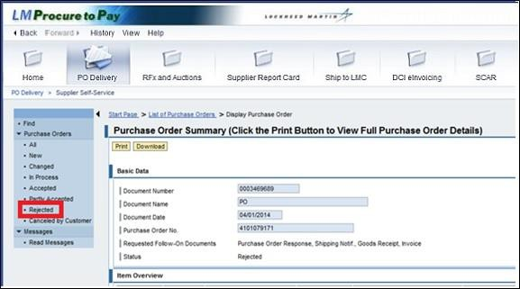

Step | Action
10. | Click the Rejected tree item.

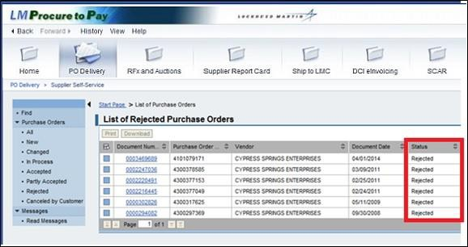

Step | Action
11. | The document status shows rejected.
12. | You have successfully completed the procedure to reject a schedule agreement.

