
Personalizing & Managing Views within SMM
Last Reviewed 5/24/2022

Contents
Introduction 2
Personalizing Views 3
Personalizing Column Views 5
Sorting Columns 7
Filtering Columns 10
Saving or Reverting Personalization Changes 13
Managing and Viewing Favorites 14
Saving a View to a Favorite 18

Personalizing & Managing Views within SMM, Introduction
This guide will explore the Supplier Management Module (SMM) Personalize and Favorite view functionality, where as a user you can personalize and save how you view your data within the Suppler Management Module  Note: By default, it is recommended that you display / view all fields, therefore, your default display is initially set up to show all available fields | 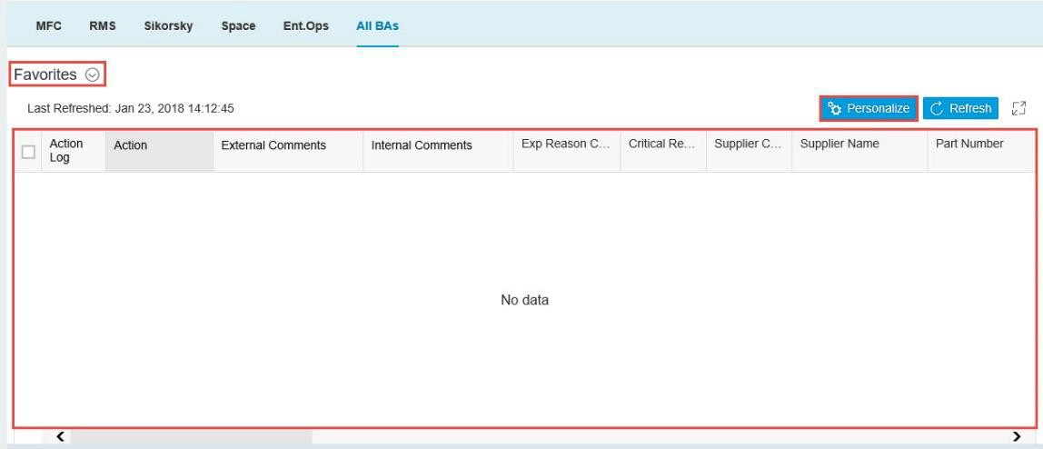

Personalizing & Managing Views within SMM, Personalizing Views
Your default view will display / view all available fields. However, you can personalize your current view and later save it as a favorite  - Click the Personalize button at the top of the data window to personalize how the PO data appears on your screen | 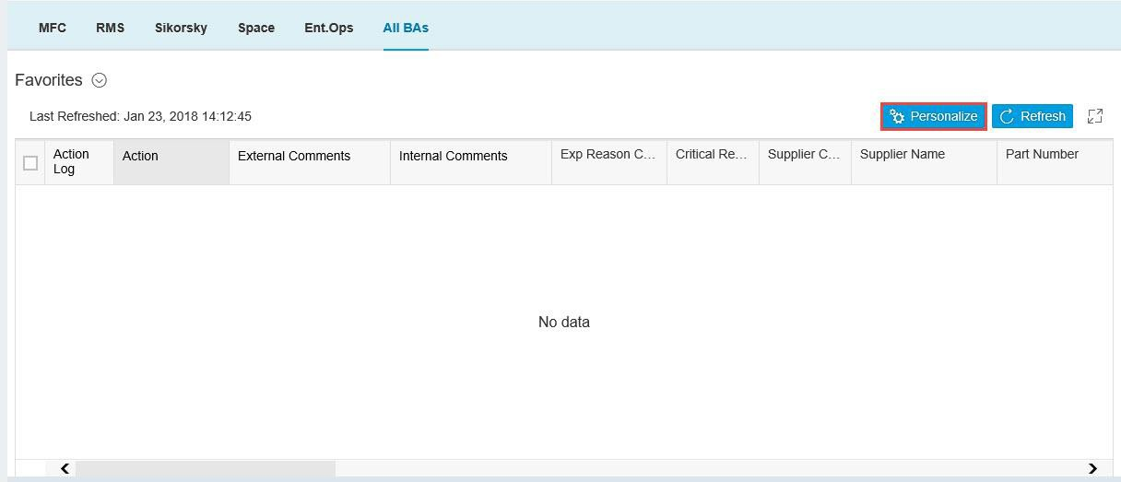

Personalizing & Managing Views within SMM, Personalizing Views continued
- From the View Settings screen, you can make changes to your view by selecting and changing from:  - Columns: Select or deselect columns to view  - Sort: Sort selected columns in ascending or descending order  - Filter: Filter selected columns by selected parameters | 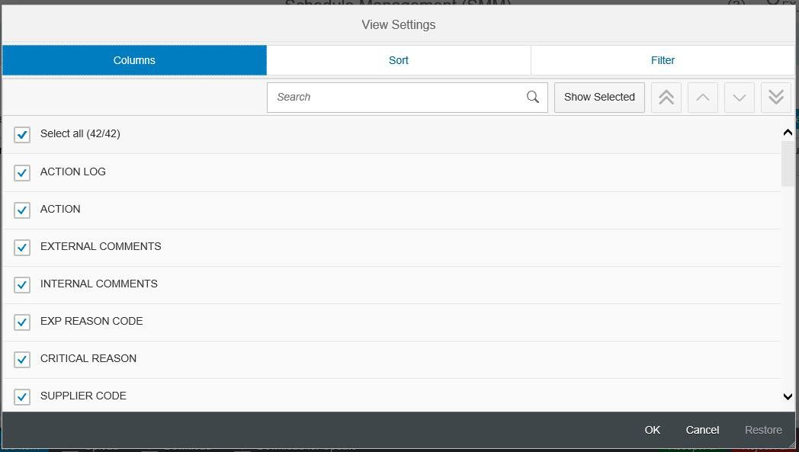

Personalizing & Managing Views within SMM, Personalizing Column Views
- From the Columns tab of the View Settings screen, click the Checkboxes to select or deselect columns to be displayed | 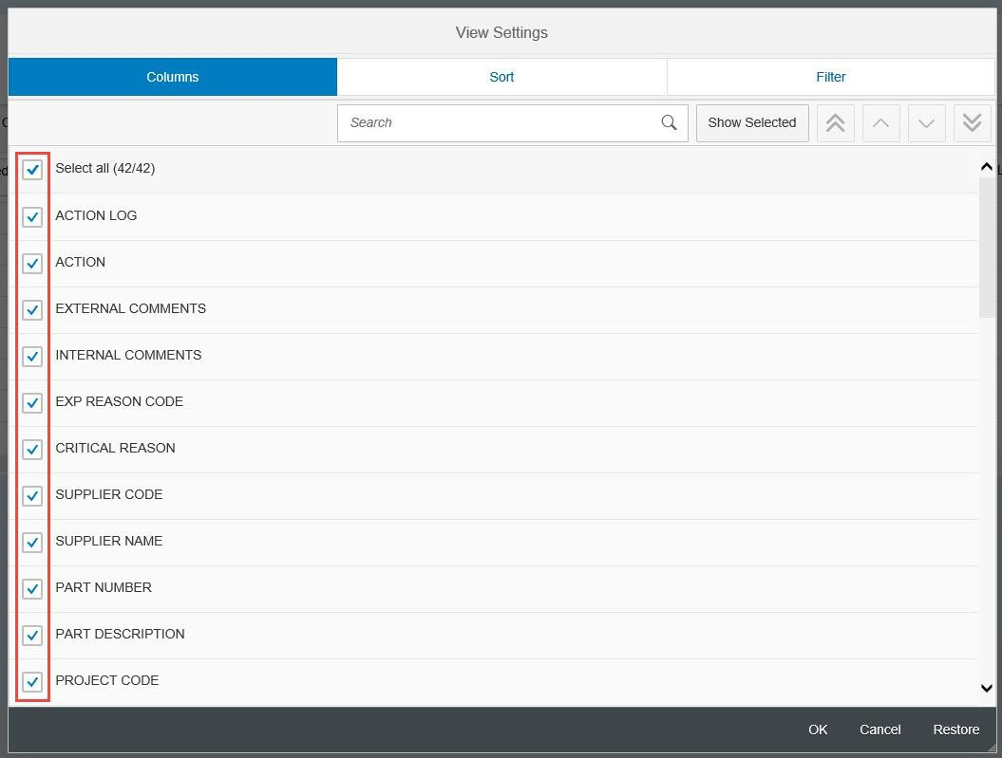
- Use the Search bar to search for a column to select/deselect

Personalizing & Managing Views within SMM, Personalizing Column Views continued
- Select Show All or Show Selected to view all available columns, or to view only those selected | 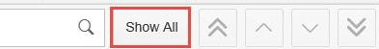  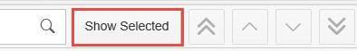
You can manage the order the columns appear in your view. Use the buttons on the panel to move selected columns:  - Move to Top: Moves the selected column to the top of the order  - Move Up: Moves the selected column to the top  - Move Down: Moves the selected column down  - Move to Bottom: Moves the selected column to the bottom of the order | 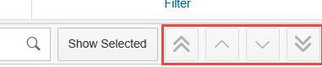

Personalizing & Managing Views within SMM, Sorting Columns
You can sort data in a column in ascending or descending order  - Click the Sort tab at the top of the View settings to sort column data | 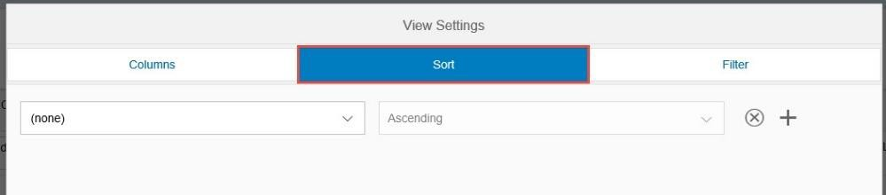

Personalizing & Managing Views within SMM, Sorting Columns continued
- Click the Sort drop-down menu to select a column to sort | 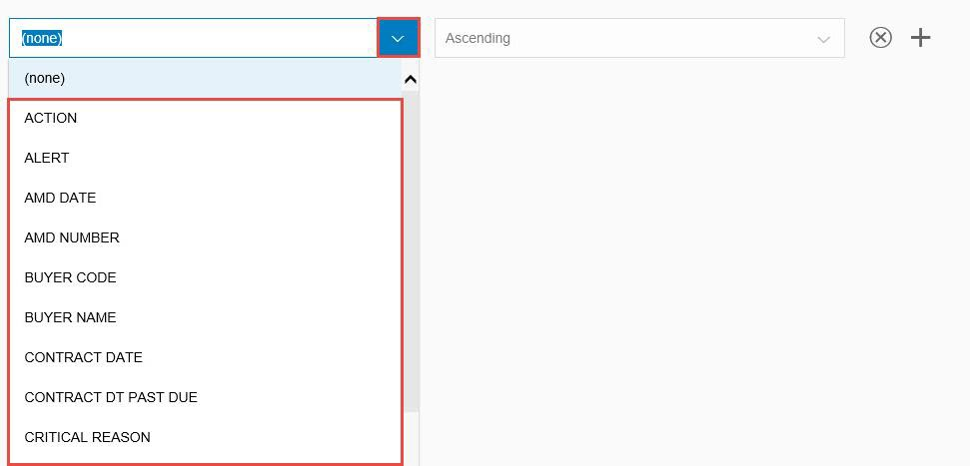
- Use the Ascending / Descending drop-down menu to sort column data in ascending or descending format | 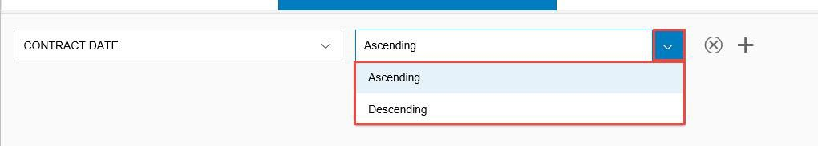

Personalizing & Managing Views within SMM, Sorting Columns continued
- Click the Remove Sort Creation (X) button to remove the sort parameter
- Click the Add Sort Creation (+) button to add additional the sort parameter lines

Personalizing & Managing Views within SMM, Filtering Columns
- Click the Filter tab at the top of the of the View Settings screen to begin filtering columns | 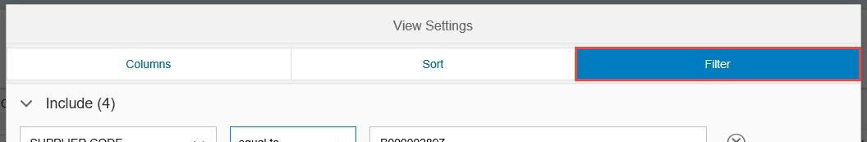
You can set filter parameters to Include or Exclude data in selected columns  Important Notes:  - You can filter columns to include data by these parameters:  - equal to  - between  - less than  - less than or equal to  - greater than  - greater than or equal to  You can filter columns to exclude data by the equal to  parameter | 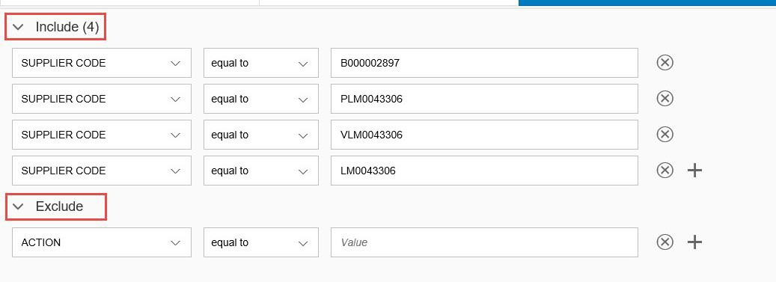

Personalizing & Managing Views within SMM, Filtering Columns continued
In this example, we will be setting a filter to exclude a Supplier Code  - Click the Column drop-down menu to select a column to filter | 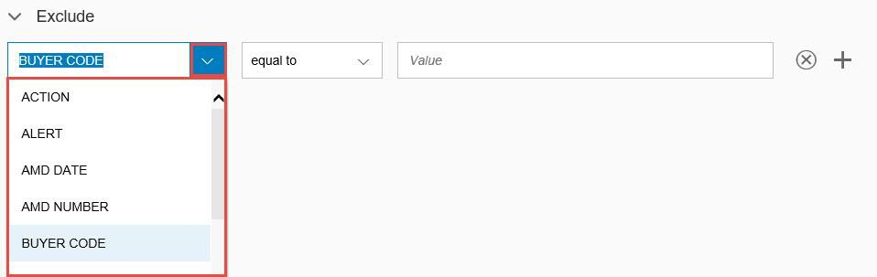

Personalizing & Managing Views within SMM, Filtering Columns continued
- Click the Filter parameter drop-down menu to select a filter parameter  Note: Because we are choosing to exclude data from this column, equal to is the defaulted selection | 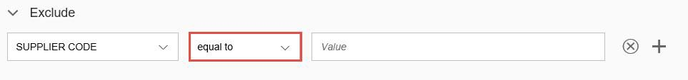
- Use the Value Box to enter a value to filter | 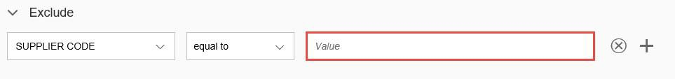

Personalizing & Managing Views within SMM, Saving or Reverting Personalization Changes
- In the bottom right corner of the View Settings screen, click OK or Cancel, to save or cancel your temporary view preferences and return to the SMM page  Note: Click Restore to revert any changes to default | 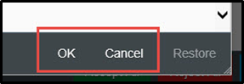

Navigating the Schedule Management Module (SMM), Managing and Viewing Favorites
You can save and manage your personalized views for later use  - Click the Favorites/Default drop-down arrow to open saved views  Note: By default, it is recommended that you display / view all fields, therefore, your default display is initially set up to show all available fields. Unless previously changed, “Default” is the name of the default view in the system | 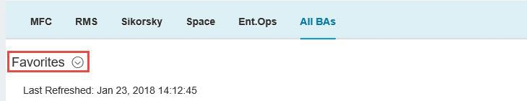

Navigating the Schedule Management Module (SMM), Managing and Viewing Favorites continued
- From the Variants drop-down screen, you can  - Manage: Select or manage previously saved favorites  - Save As: Save a current view as a favorite | 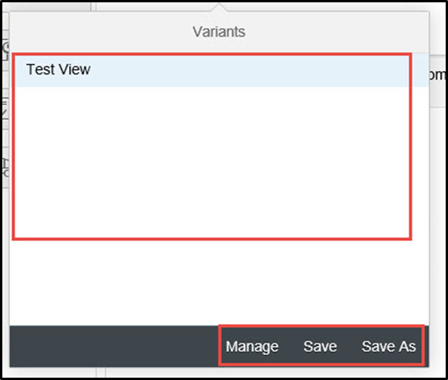
- Click the Manage button to view a list of all saved and defaulted views. | 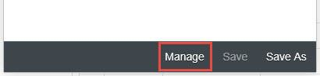

Navigating the Schedule Management Module (SMM), Managing and Viewing Favorites continued
You can select a view from you list of favorites to automatically default  - Click the Default radio button to select the view to default | 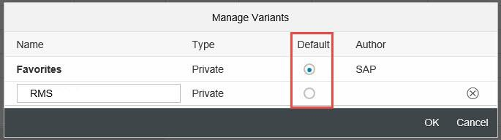
- Click the Delete (X) button next to a saved favorite to remove it from your list | 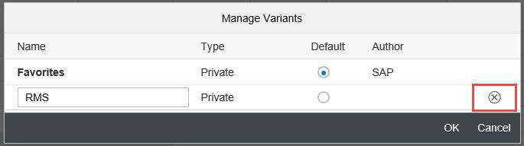

Navigating the Schedule Management Module (SMM), Managing and Viewing Favorites continued
Click OK or Cancel to save or cancel your changes | 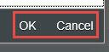

Navigating the Schedule Management Module (SMM), Saving a View to a Favorite
After personalizing your current view, you can save it as a favorite  - From the Variants drop-down screen, click Save As to save the current view as a favorite | 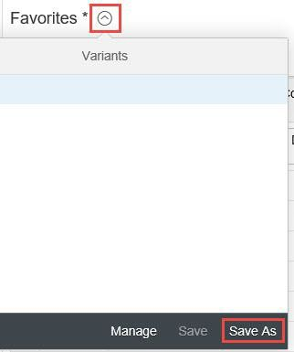

Navigating the Schedule Management Module (SMM), Saving a View to a Favorite continued
- Enter a name for your favorite in the Name box | 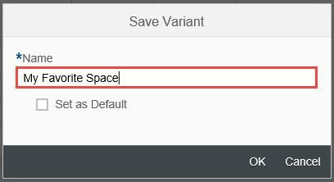
- Click OK to save the view as a favorite  Note: You can select the Set as Default checkbox to select this view as your default | 