
Schedule Management Module (SMM)
Last Reviewed 5/24/2022

Contents
SMM Introduction 2
Accessing Help/FAQ 4
Business Area Tabs 5
Viewing and Working with PO Data 6
Personalizing Data Views 8
Managing and Viewing Favorites 10

Navigating the Schedule Management Module (SMM), Introduction
The Schedule Management Module (SMM) is a secure, easy- to-use, web-based application enabling suppliers to provide periodic deliverable updates. Including the management of open purchase order (PO) lines and schedule agreement release lines with participating Lockheed Martin businesses:  SMM enables suppliers to provide open purchase order schedule updates via the Schedule Management Module  - To access the Schedule Management Module, Click the SMM button from the left panel of the Supply Chain Hub homepage | 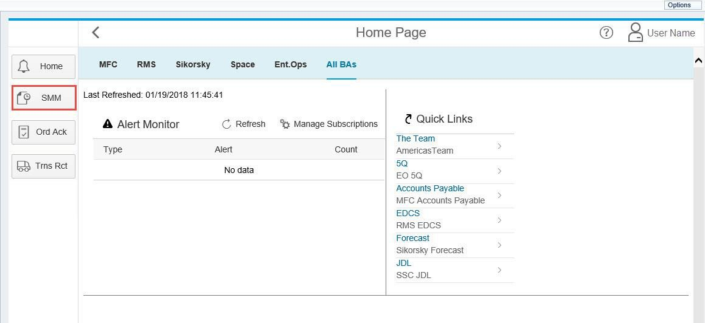

Navigating the Schedule Management Module (SMM), Continued
The Profile Name section contains your profile name and drives the content and data immediately viewable within the SMM.  Note: Depending on the permissions you have associated with your profile, the data and information within the SMM will default to show the most relevant PO data that pertains to the business areas you are supporting | 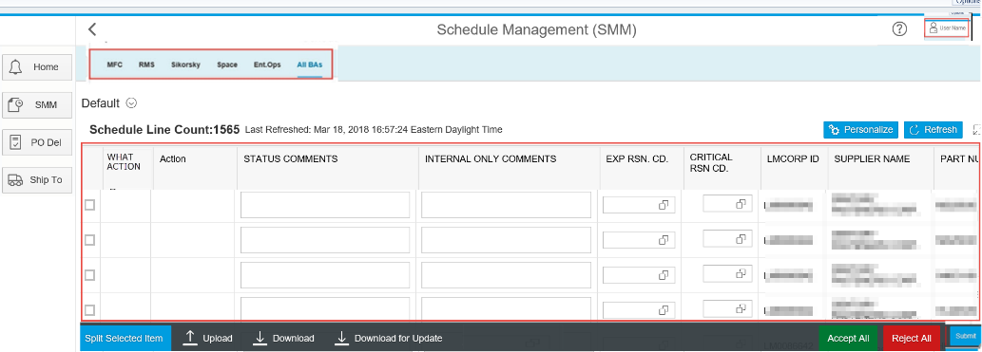

Navigating the Schedule Management Module (SMM), Help/FAQ
You can use the Help icon at the top right corner of the screen to access additional help resources  - Click the Help icon in the top right corner of the screen to access help links | 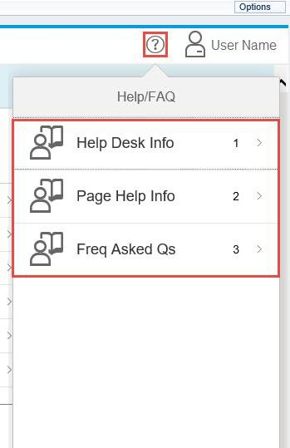

Navigating the Schedule Management Module (SMM), Business Area Tabs
The tabs at the top of the SMM page allow you to filter data by participating Business Area. This is a useful feature if you would like to filter PO information only pertaining to a business area you are supporting.
Note: The Business Area tab selection will default to ALL BAs

Navigating the Schedule Management Module (SMM), Viewing and Working with Data
The middle section of the SMM page provides you with direct PO data pertaining to the participating business area selected

Note: The data appearing in this section of the page will depend on the business area tab selected. In this example, all PO data for all business areas will appear because the user has remained in the default ALL BAs tab

Navigating the Schedule Management Module (SMM), Viewing and Working with Data continued
You can use the features at the bottom of the screen to download / upload PO data, split transactions, or accept / reject proposed changes to in the PO. Use the options at the bottom of the screen to:  Split data: Split a transaction by adjusting the open Schedule Quantity Promise date(s) for a line item. You can do this either on-line or by using the Download for update and uploading the file.  Upload: Upload a .CSV file  - File Type must be in correct .CSV format.  Download: Download the PO data in .CVS format  - This is used for information only and cannot be uploaded. If you wish to upload any new information, use the Download for Update feature  Download for Update: Download a .CVS file with a subset of data fields with column headings; this option can later be used to Upload changes  Accept All: Lockheed Martin internal feature Reject All: Lockheed Martin internal feature Submit: Submit PO change/update  See the Working with SMM Data Guide for more guidance on working with data in the Schedule Management Module | n

Navigating the Schedule Management Module (SMM), Personalizing Data Views
Personalizing views is another option you have when viewing PO data  - Click the Personalize button at the top of the data window to personalize how the PO data appears on your screen | 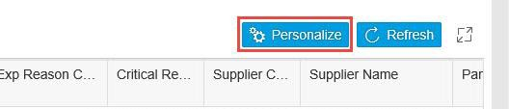
- From the View Settings screen, you can make changes to your view by selecting and changing from:  Columns: Select or deselect columns to view  Sort: Sort selected columns in ascending or descending order  Filter: Filter selected columns by selected parameters | 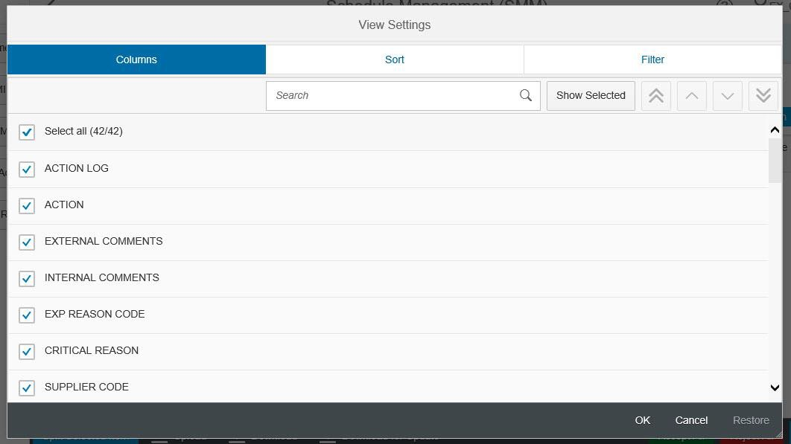

Navigating the Schedule Management Module (SMM), Personalizing Data Views continued
- Click OK or Cancel, to save or cancel your temporary view preferences and return to the SMM page  Note: Click Restore to revert any changes to default | 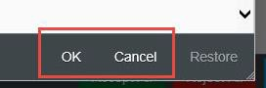

Navigating the Schedule Management Module (SMM), Managing and Viewing Favorites
You can save and manage your personalized views for later use  - Click the Favorites/Default drop-down arrow to open saved views  Note: By default, it is recommended that you display / view all fields, therefore, your default display is initially set up to show all available fields. Unless previously changed, “Default” is the  name of the default view in the system | 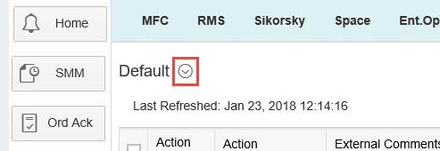

Navigating the Schedule Management Module (SMM), Managing and Viewing Favorites continued
- From the Variants drop-down screen, you can  - Manage: Select or manage previously saved favorites  - Save As: Save a current view as a favorite  See the Personalizing Views in SMM Guide for more guidance on personalizing views and managing favorites | 