
Contents

Suppliers Working with Schedule Management Module Data
Last Reviewed 5/24/2022

Suppliers Working with Schedule Management Module Data, Introduction 2
Suppliers Working with Schedule Management Module Data, Notable Fields 6
Suppliers Working with Schedule Management Module Data, Status and Internal Only Comment Fields 7
Suppliers Working with Schedule Management Module Data, Deliver To City Field 8
Suppliers Working with Schedule Management Module Data, Proposed Contract Date Field 9
Suppliers Working with Schedule Management Module Data, Required Update Fields 10
Suppliers Working with Schedule Management Module Data, Carrier Name and Tracking Information 11
Suppliers Working with Schedule Management Module Data, Utilizing Download for Update 12
Suppliers Working with Schedule Management Module Data, Pending Table 17

Suppliers Working with Schedule Management Module Data, Introduction
The new and improved Schedule Management Module (SMM) is a secure, easy-to-use, web-based application enabling expeditors, suppliers, program offices, and buyers to provide periodic deliverable updates. Including the management of open purchase order (PO) lines and schedule agreement release lines with participating Lockheed Martin businesses.  - The middle section of the SMM page provides you with direct data pertaining to the Lockheed Martin business area defaulted or selected  Note: The data and information within the SMM will default to show the most relevant PO data that pertains to the business areas you are supporting. In this example all data will be shown because the user is defaulted to show ALL BAs. | 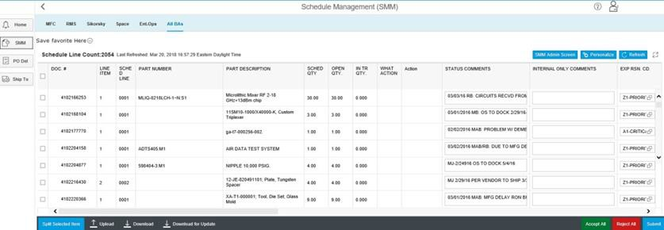

Suppliers Working with Schedule Management Module Data, Navigating Data, Continued
You can use the features at the bottom of the screen to download / upload PO data, split transactions, or accept / reject proposed changes to in the PO. Use the options at the bottom of the screen to:
Split data: Split an on-screen transaction by adjusting the open Schedule Quantity Promise date(s) for a line item.
Upload: Upload a .CSV file.
- File Type must be in correct .CSV format
Download: Download the PO data in .CVS format.
- This is used for information only and cannot be uploaded. If you wish to upload any new information, use the Download for Update feature
- This feature is useful for portable/printable versions used for your review
Download for Update: Download a .CVS file with a subset of data fields with column headings; this option can later be used to Upload changes made to the subsequent fields.
Accept All: Lockheed Martin Functionality.
Reject All: Lockheed Martin Functionality.

Suppliers Working with Schedule Management Module Data, Continued
Submit: Submit PO changes.

Suppliers Working with Schedule Management Module Data, Notable Fields
The data provided via the Supplier Schedule Module can be extremely useful in viewing and updating Purchase Orders in real time.

The next section of this guide will highlight some of the more notable fields commonly used and requested by users.
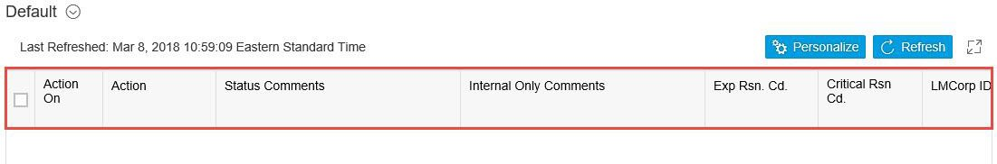

Suppliers Working with Schedule Management Module Data, Status and Internal Only Comment Fields
- Use the Status Comments field to share the status of the PO, Part number etc.  Note: The content in Status Comments are shared with all internal and external users. | 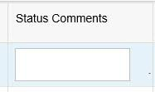
- You can use the Internal Only Comments field to store comments that you do not wish to share externally  Note: Internal Only Comments are only viewable internally. | 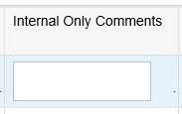

Suppliers Working with Schedule Management Module Data, Deliver To City Field
- Use the Deliver To City field to note the delivery city  - Not all deliveries are shipped to their order city. The Deliver To City field will display the requested delivery city directly within the Supplier Schedule Module  Note: The PO Line delivery should reflect the Deliver To City. | 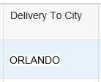

Suppliers Working with Schedule Management Module Data, Proposed Contract Date Field
- Use the Proposed Contract Date field to propose new supplier contract dates  Note:  Buyer or expeditor will have to accept it for it to be incorporated onto the PO. Once accepted by Lockheed Martin, a new amendment of that PO or Scheduling Agreement shall be sent to the supplier. | 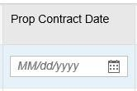

Suppliers Working with Schedule Management Module Data, Required Update Fields
- When updates are made, the supplier will be required to:  - Update Promise Dates that are less than today’s date  - Update Status Comments: You must have verbiage written in status comments  Note: The expeditor reason code (Exp Rsn. Cd.) is required but will automatically be populated with Updated by Supplier (US). | 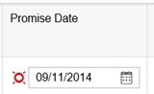  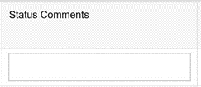  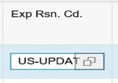

Suppliers Working with Schedule Management Module Data, Carrier Name and Tracking Information
- Carrier Name & Tracking information is automatically filled in SMM if the LM Ship-To Modules is used. It can also be manually updated within the SMM screen  - The Tracking Number field will provide you with a link to track shipments online once the field is populated | 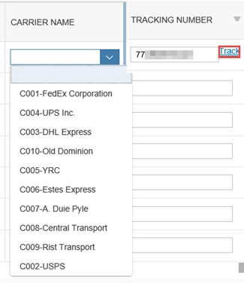

Suppliers Working with Schedule Management Module Data, Utilizing Download for Update
- Using Download for Update  - When Download for Update is selected it will download all the records and fields on the screen | 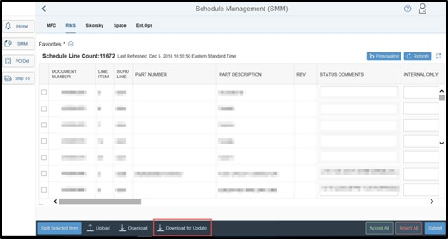
- You will be given the option to Open or Save. The file should be saved as a .csv comma
delimited file

Utilizing Download for Update, continued

- The file layout is the template needed for the upload. Do not delete or rearrange the columns. Do not change the column heading names.
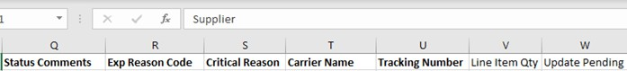
- The available fields to be changed are:
  - Prop Contract Date
  - Promise Date (must be prior to today’s date) *
  - Status Comments*
  - Exp Reason Code*
  - Critical Reason Code
  - Carrier Name
  - Tracking Number (* denotes a required field)
- Save File as a .csv (Comma Delimited)

- If you want to split a delivery:
  - Highlight the row
  - Copy and paste
  - Change the Open Qty field for the 1st schedule
  - Change the Open Qty field for the 2nd schedule

Utilizing Download for Update, continued
- Click Upload at the bottom of the screen
- Click Browse to select the file from the directory in which it is saved  - Click Upload | 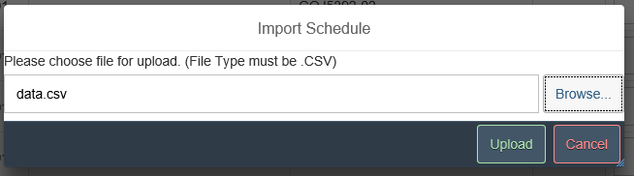

Utilizing Download for Update, continued
- Submitted Data Results will display both successful and failure records  - The results can be exported  - Failed records are placed in the Pending table for Lockheed Martin action to correct the issue that caused it to go into the Pending Table  - Users entries are shown on the screen  - Pending Table will try to reprocess the records every 15 min  Note: Lockheed Martin must correct the issues for Pending Table records to be updated. | 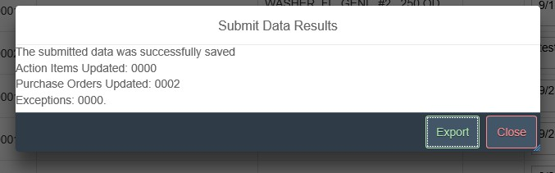  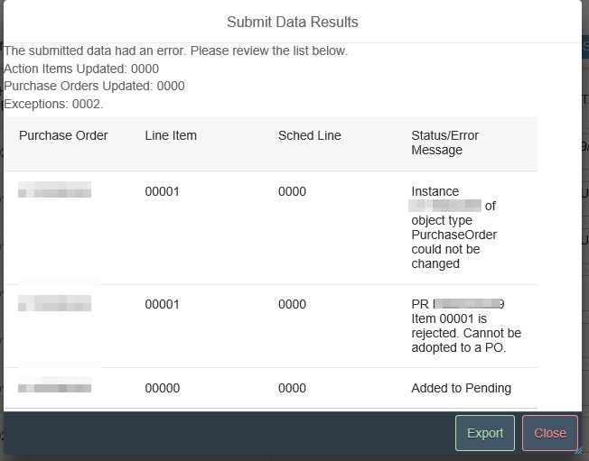

Utilizing Download for Update, continued
- The Refresh option in the upper right-hand corner will need to be clicked to see the updates applied on screen  Note: Updates are also applied when leaving/returning the screen. | 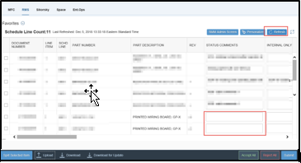  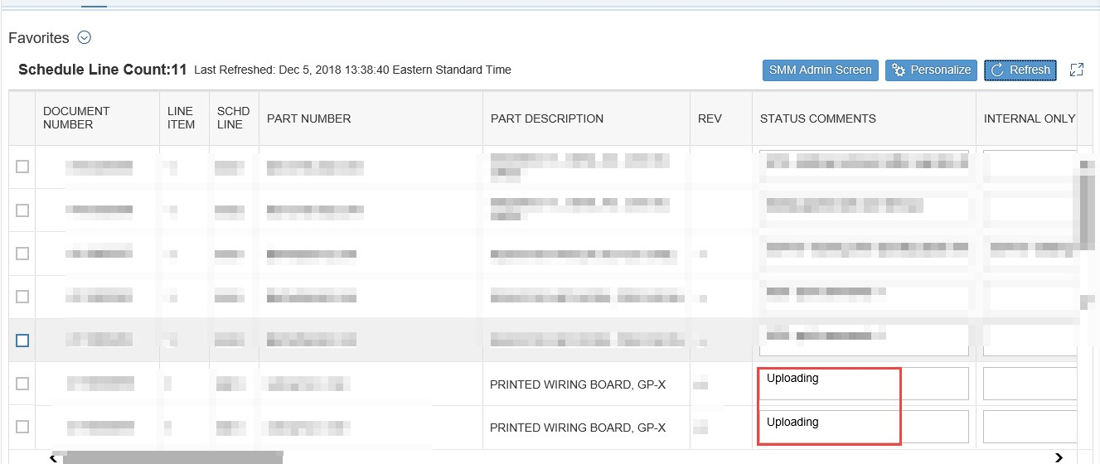

Suppliers Working with Schedule Management Module Data, Pending Table
- You can make entries to the PO schedule items even if the Lockheed Martin PO has error(s)  - If a record is deemed to have an error when you are attempting to make a change via SMM, the record will allow the change on the screen  - If a record is going to be placed in the Pending Table, you will be notified on the screen | 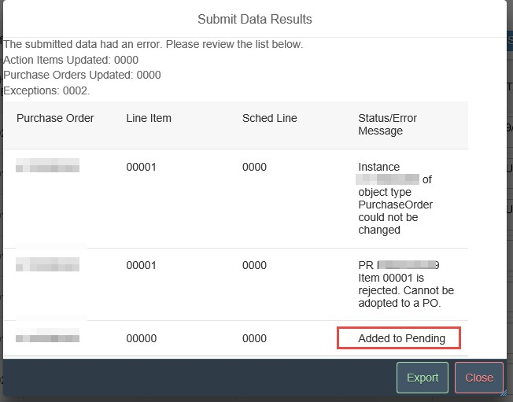
- Click Refresh to see the changes you made.  - The lines that are in the pending table will now be italicized and will allow you to update Internal Comments, Critical Reason code, Carrier, and Tracking information  - The remainder of the lines will no longer be available for update until the pending issue has been corrected by an LM representative  - The Update Pending column will also show 1-Pending Details as another way of identifying records are in the  Pending Table | 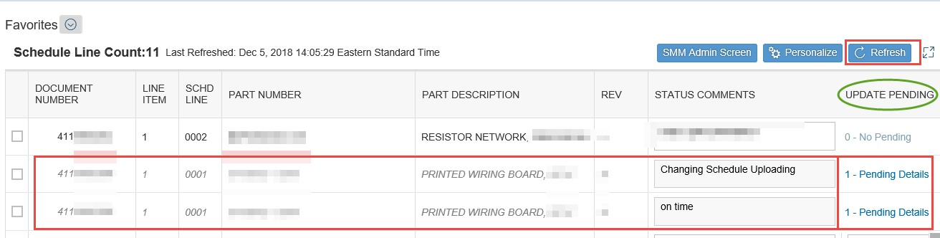

Suppliers Working with Schedule Management Module Data, Pending Table continued
- A Lockheed Martin representative reviews the entry(s) in the Pending Table and once issues have been resolved, the entries you have made will automatically be applied. The line will no longer be italicized, the Status Comments field will become ‘active’ again, and the Update Pending table column will display 0-No Pending Details | 