



Last Updated 6/19/2017
Last Reviewed 5/24/2022

LM Procure to Pay
Quick Reference Guide
Troubleshooting Guide for Bid Invitation Response

Confidential: Drafted by LMCO and shared by Exostar LLC at LMCO’s request Lockheed Martin Procure to Pay
June 2017

Troubleshooting Tips

This quick reference guide offers some common troubleshooting tips for issues that users may experience when trying to submit a bid invitation response.

Issue #1 – You can’t find the bid invitation number in your queue

- You may still have a search filter on from a previous bid response
- Click the Show Quick Criteria Maintenance button
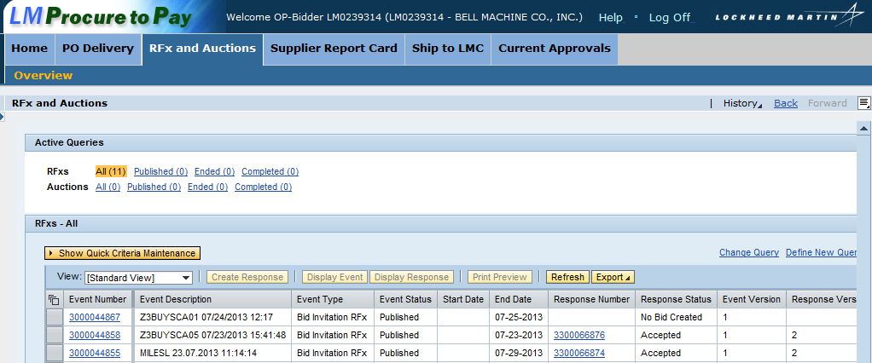
- If there are any entries in the fields, click the Clear button and try the search again
- Hint: You can collapse the criteria section by clicking Hide Quick Criteria Maintenance
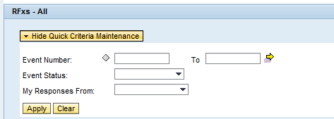

Issue #1 – You can’t find the bid invitation number in your queue (cont.)

- Check to make sure there is not a filter on your bid invitation list as well
- In the screenshot below, a filter has been applied to check Response Status
- Delete the filter by clicking the Delete Filter link in the upper right corner
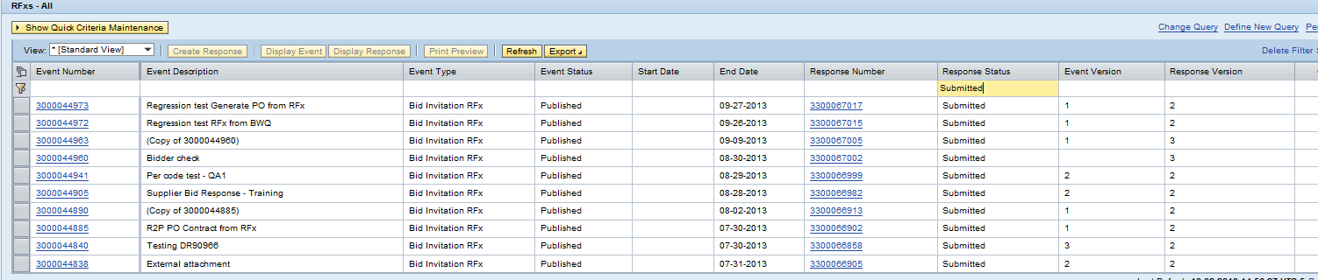

Issue #2 – You receive an error on the RFx stating “Delivery schedule is missing or inconsistent”
- You will need to update the delivery date and/or quantity for a particular line item
- From the Items tab, choose the appropriate line item and click the Details button
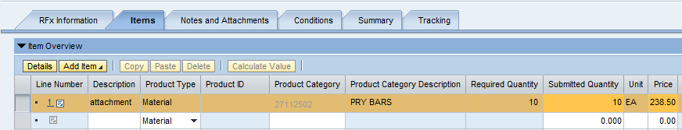
- Click the Table Extensions tab
- Click the Add button if nothing currently exists in the table
- Input the correct delivery date and/or delivery quantity (you may need to scroll to the right to view quantity)

Things to Consider
- Make sure the delivery date is not on a weekend
- Delivery date must be after the RFx end date
- Make sure a quantity has been entered
- The delivery date must be in this format: MM/DD/YYYY only
- The delivery date also has to match the date in the Item Data tab - same format. If you use the calendar, the format should be correct.

Issue #3 – You need to ‘No Bid’ the entire bid invitation or one line item in the bid invitation
- There are a few ways to let the Buyer know you will not be bidding

No Bid Entire Bid Invitation
- You can decline to bid by first opening the bid invitation in Display mode
- Select the bid invitation from the list and click the Display Event button
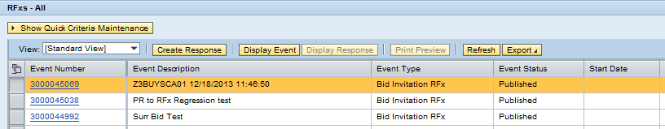
- Click the Do Not Participate button if you do not want to participate in the bid response
- This information can be viewed by the LM Buyer
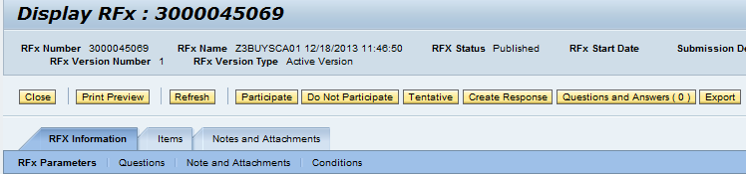
- Depending on the LM business area, the “Do Not Participate” Button may NOT be available. If it is not, then you may use option under the RFX Information tab > Questions that offers the option to enter a ‘No Bid’ response
- The question will be titled BID TYPE
- Enter ‘No Bid’ in the applicable text field
- And enter a date in the field “For How Long is Your Quote Valid?”
- Then hit Submit

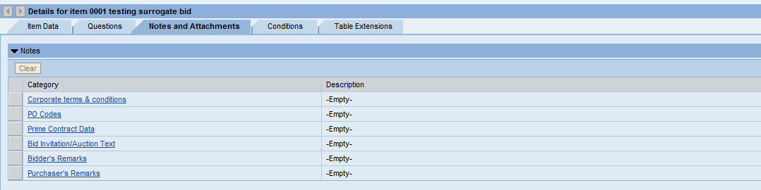
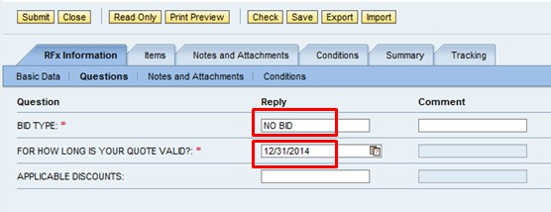

Issue #3 – You need to ‘No Bid’ the entire bid invitation or one line item in the bid invitation (cont.)

No Bid One Line of Bid Invitation
- At the line item level, go to the Notes and Attachments tab
- Click the Bidder’s Remarks category and enter ‘No Bid’ in the text box

Issue #4: You do not see the RFx and Auctions tab

- In order to bid on a bid invitation, you must have the role of Bidder in the LMP2P system
- If you do not see the RFx and Auctions tab at the top of your screen after logging in, you will need to request this role from your company’s Application Administrator
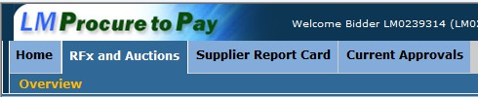

Issue #5 – You cannot access the P2P external portal due to browser incompatibility
- LMP2P is not currently compatible with Internet Explorer version 10
- If you use this version to access the site, you may experience issues such as:
  - A message that the screen is “loading” and may take a long time or never load
  - The screens appear jumbled with words on top of each other
  - Items on the screen may be greyed out
  - You may not see all your tabs across the top of the page
- To resolve this issue of browser incompatibility, please click on the ‘broken page” icon to the right of the URL to put your IE browser on compatibility mode. If the icon is present, this should work regardless of the version you are running in internet explorer. Then try to access the page again.

