



Last Updated 5/24/2022
Last Reviewed 5/24/2022

LM Procure to Pay
Quick Reference Guide
Supplier Bid Response Checklist

Lockheed Martin Procure to Pay April 2022

Bid Response Checklist

Review these important items prior to submitting your bid response and/or contacting your Lockheed Martin representative.

Remove any filters from the RFx list to ensure you can easily find the bid invitation.
- See screenshot below for an example of a filter
- Click the Delete Filter link to remove
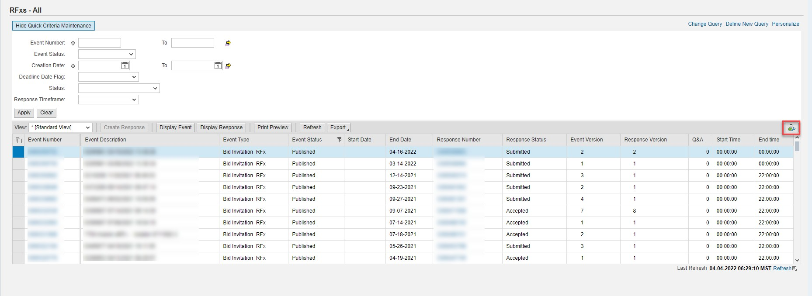
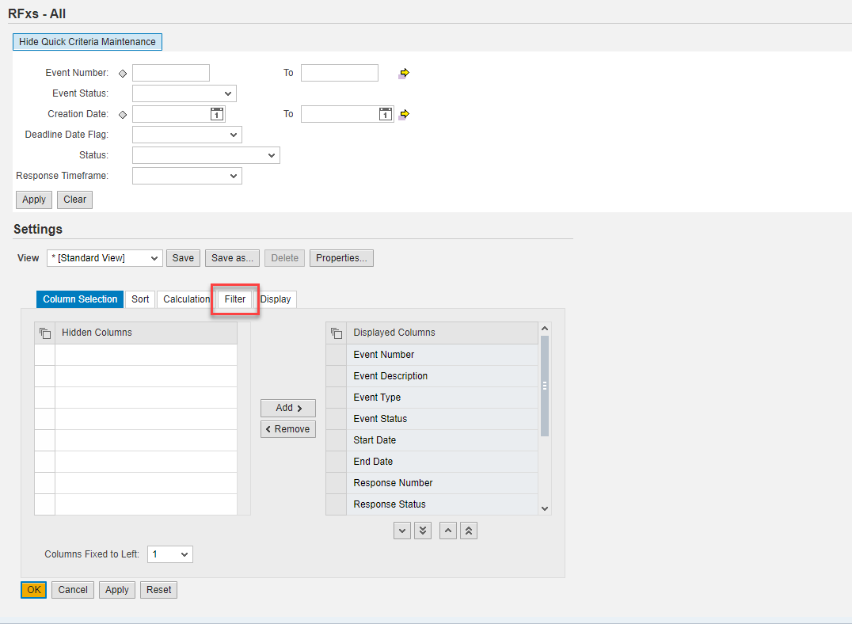

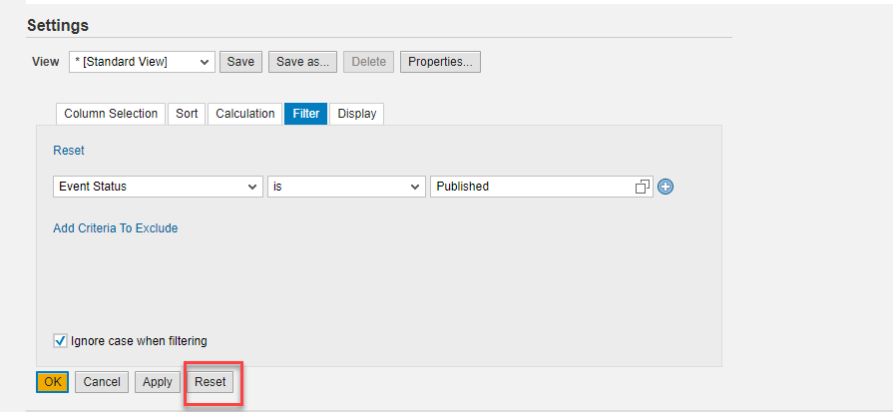

If you need to communicate that you will not be bidding on the bid response:

- Highlight the bid invitation and click Display Event from the main RFx list
- Click Do Not Participate
  - If the button is not available, follow the normal process to communicate a no bid per the Lockheed Martin business area
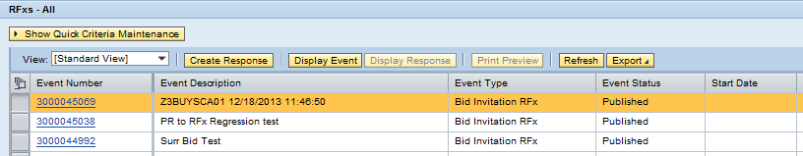
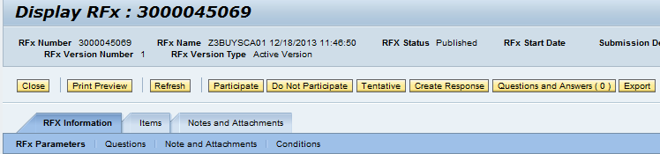

 Once inside the bid response, ensure you fill out the price for each line item you wish to bid on.
- Price column listed on Items tab
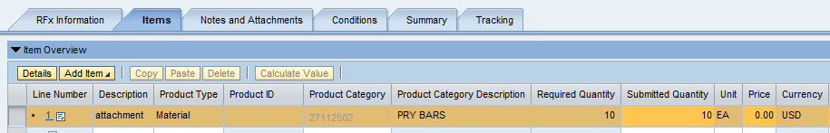
 You may receive an error stating “Delivery schedule is missing or inconsistent”. To fix this error you will need to complete or revise the delivery date on the Table Extensions tab.
- Choose applicable line item and select Details to be able to see Table Extensions
tab
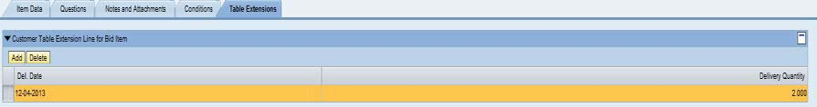
Fill out any required questions by going to the RFx Information tab and choosing the Questions sub tab.

- Scroll to the right to view the response area for the questions
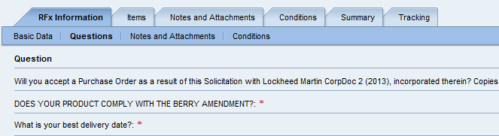

Review any notes sent by the Lockheed Martin buyer under the Notes and Attachments tab.
- Click the Add button to add any of your own comments
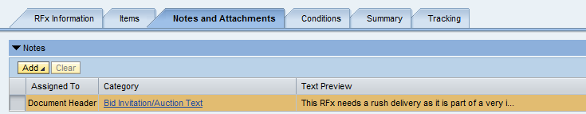
Add any necessary Conditions or Scale (Range) Pricing under the Conditions tab

- Select the line item, then click Add Condition for a list of conditions
- Use the Scales button to perform scale pricing
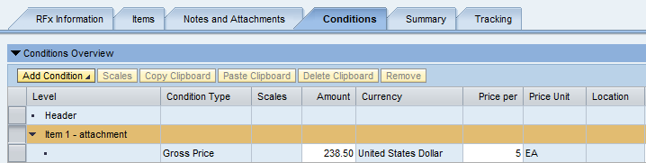
Prior to submitting the bid response, click Check to confirm all errors have been resolved.

- To submit the bid response, click Submit
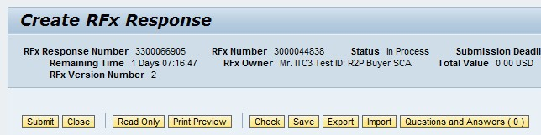

For more help with troubleshooting bid response issues, refer to the Troubleshooting Guide for Bid Invitation Response.

