



Last Updated 8/11/14
Last Reviewed 5/24/2022

LM Procure to Pay Quick Reference Guide For Suppliers

Auction Response

Lockheed Martin Procure to Pay Revised August 2014

Procedure

This quick reference guide displays the procedure when using the Live Auction Cockpit (LAC).

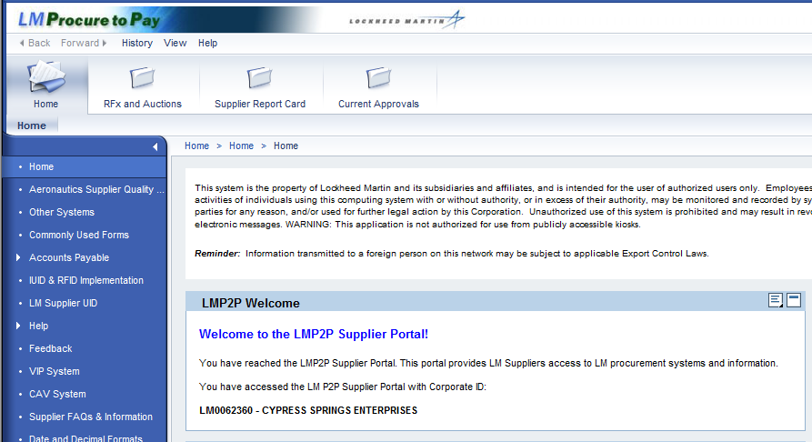

Step | Action
1. | Click the RFx and Auctions tab.  

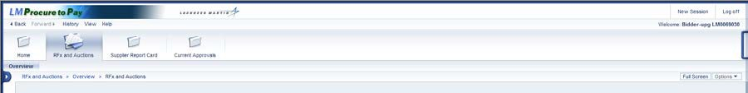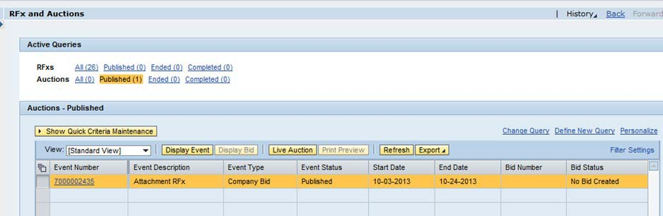

Step | Action
2. | Choose the Auctions section under Active Queries.  Select the auction that you wish to view from the resulting list by selecting the row. Click the Display Event button to view the event details.  To participate in the live auction, click the Live Auction button.

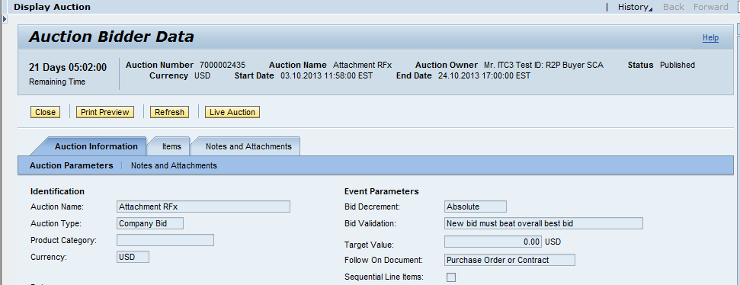

Step | Action
3. | This screen shows the basic data for the auction.  Click the Live Auction button to be taken into the Live Auction Cockpit.

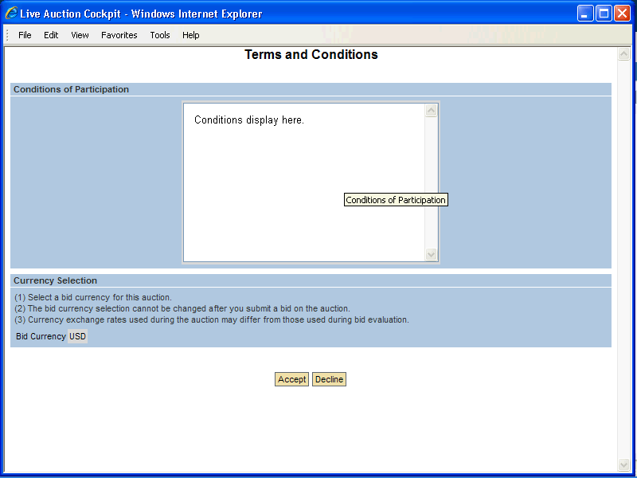

Step | Action
4. | Click the Accept button to accept the Conditions of Participation.

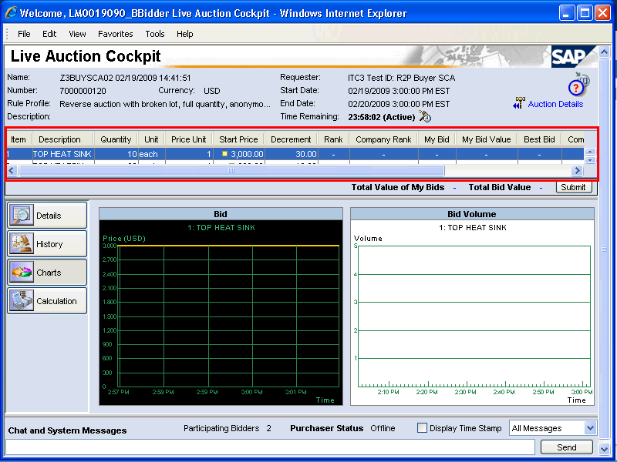

Step | Action
5. | This auction consists of two line items, scroll to reveal additional line items as necessary.

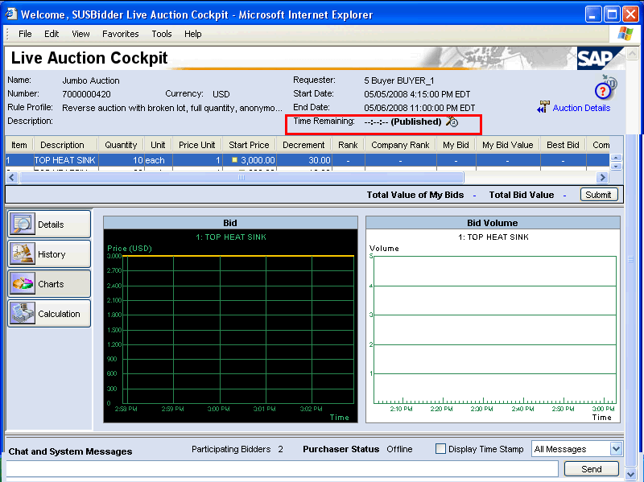

Step | Action
6. | Published in the Time Remaining area indicates the auction start time has not yet been reached.  Until the auction begins, the Minimum Bid Price field is unavailable for input

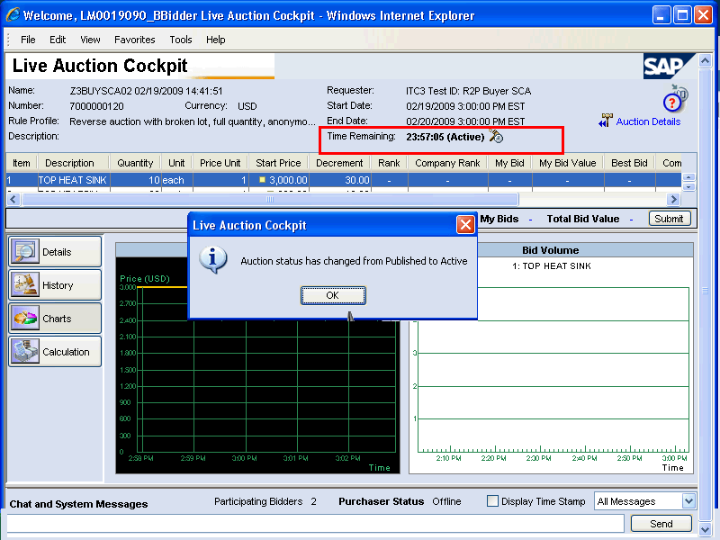

Step | Action
7. | This pop-up box appears as soon as the auction is opened for bidding (Active) Click the OK button.

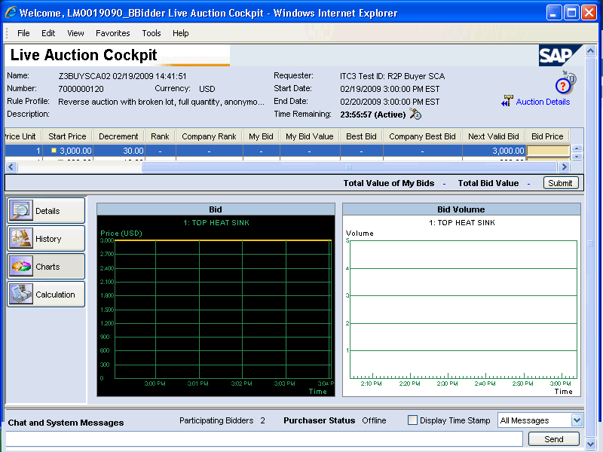

Step | Action
8. | 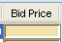  Enter the bid into the Bid Price field. The bid must be less than or equal to the value in the Next Valid Bid column.

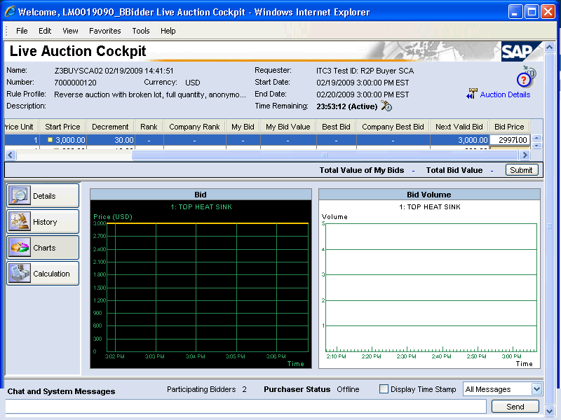

Step | Action
9. | Click the Submit button.

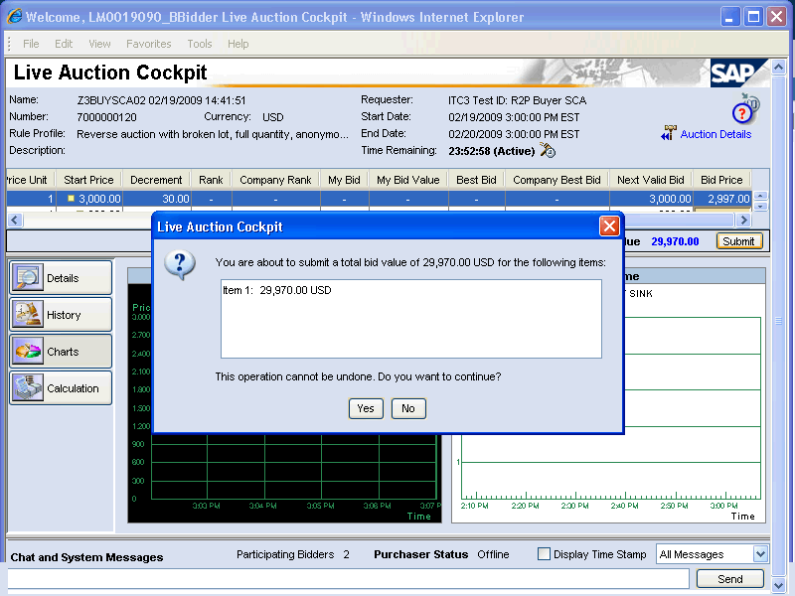

Step | Action
10. | Click the Yes button to confirm the bid.

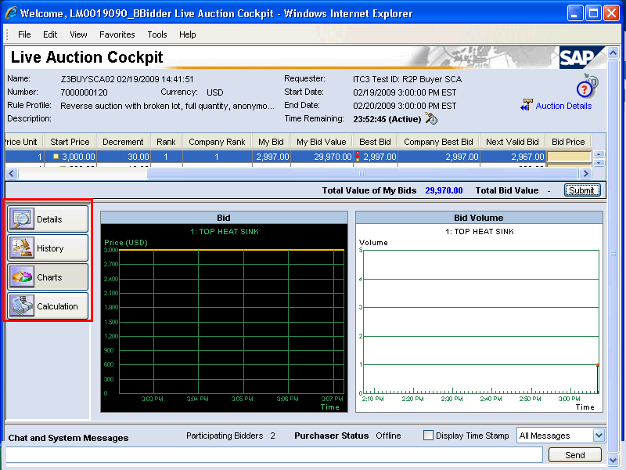

Step | Action
11. | Use these buttons to see the details of the line items, the history of the bids, charts of the bidding activity (current view), or calculations of your total bid values.

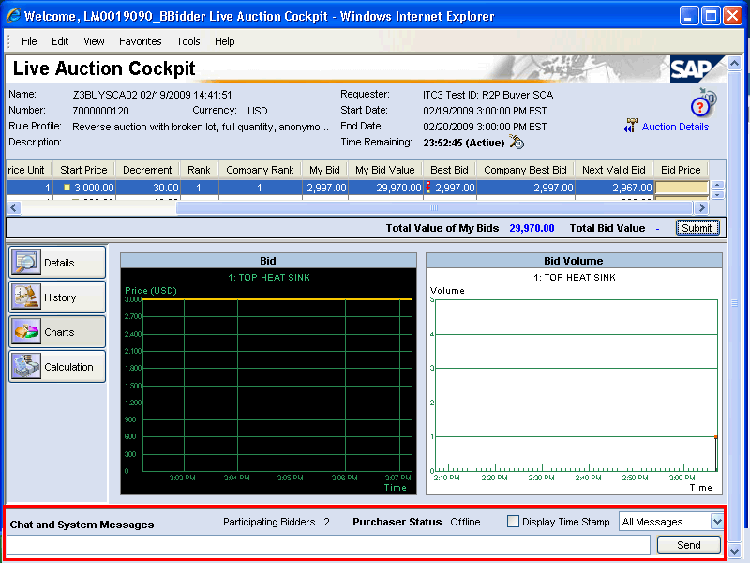

Step | Action
12. | Use this area to send messages to the host.

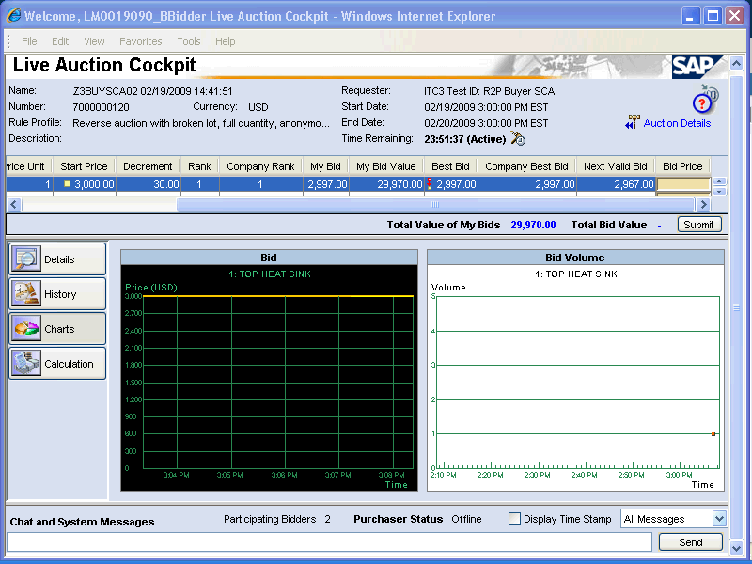

Step | Action
13. | Click the Send button.
14. | You have successfully completed the procedure when using the Live Auction Cockpit (LAC).

