
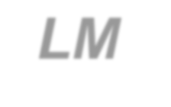


Last Updated 8/11/2014

LM Procure to Pay
Quick Reference Guide For External Source Quality
Field Engineers
Survey FQR Source Acceptance

Lockheed Martin Procure to Pay Revised August 2014

Procedure

This quick reference guide displays the procedure to process a Survey FQR.

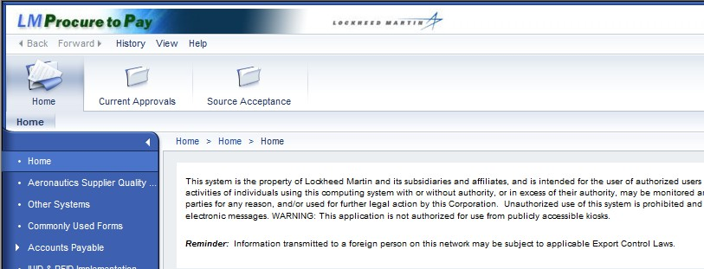

Step | Action
1. |   Click the Source Acceptance tab to process a Survey FQR.

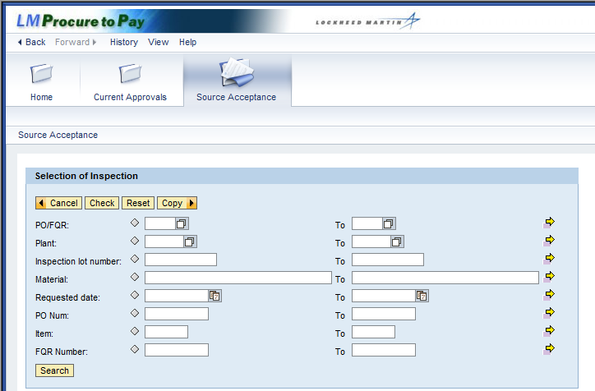

Step | Action
2. | The Source Acceptance screen displays search criteria that can be used to query inspection lots.  Click the PO/FQR matchcode button.

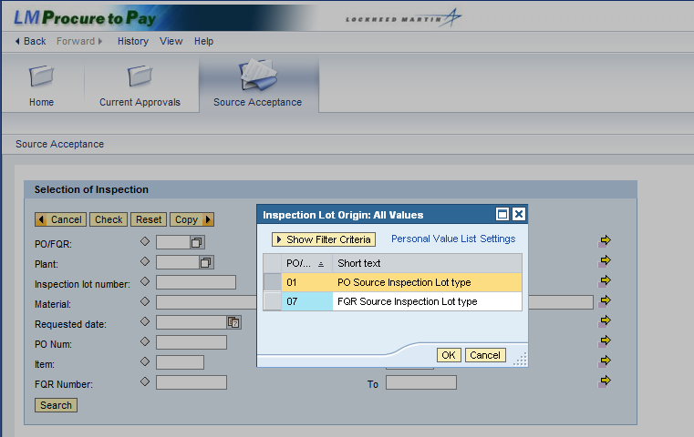

Step | Action
3. | Select the inspection lot origin by clicking the PO Source Inspection Lot type  selection box.
4. | Click the OK button to confirm your selection.

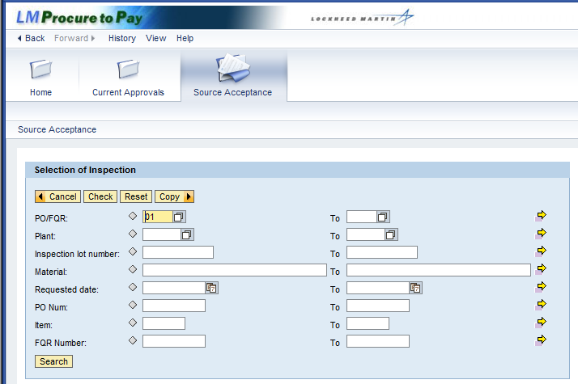

Step | Action
5. | Click the Plant matchcode button.

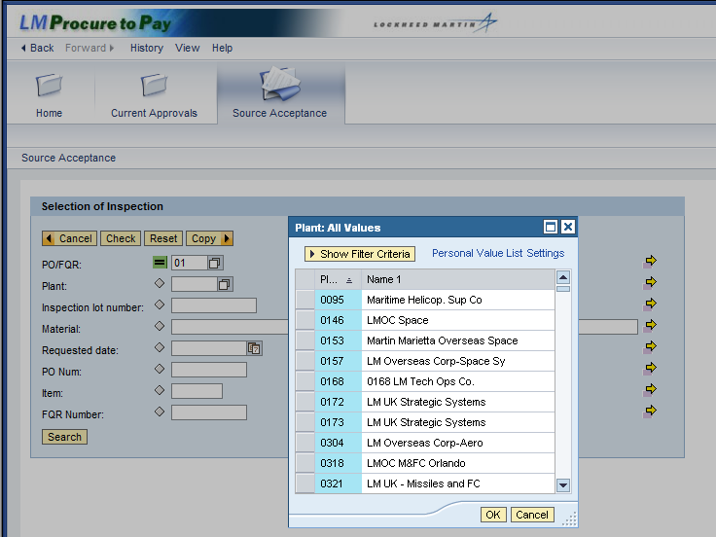

Step | Action
6. | In the Plant pop-up window you can select the plant where the source inspection will take place.

Step | Action
7. | You can also search using the inspection lot number and material. For the  Material field, enter a material (part) number and find all matching PO line items.  Note: Exact material matches require an asterisk (*) as the last character because each material has a plant identifier. For example, RG123345-3 is listed as RG123345-3:MO, and "MO" identifies the Moorestown plant.  Wildcard searches are used to query a range of materials. Enter an asterisk (*) for a range or a plus (+) for individual characters. For example, enter RNC55* to find materials beginning with RNC55 or enter RN+55 to find all materials beginning with "RN" that have any character in the 3rd position and "55" in the 4th and 5th position. For example, RNA551234.

Step | Action
8. | Additional criterion that further define the search include:  - Requested date: Enter a date range to narrow the list of inspection lots to a certain date. For example, enter a week's range to create your travel plans  - PO num: Enter a full PO number and find all PO line items with matching inspection lots. You can also enter a range of PO numbers  - Item: Enter a specific PO line item number, along the PO. If left blank, all items for a specific PO are displayed  - FQR Number: Enter a Field Quality Request (FQR) number, or a range of FQR numbers, to list those specific inspection lots

Step | Action
9. | To run the query for PO source inspections at any of your plant assignments, click the Search button.

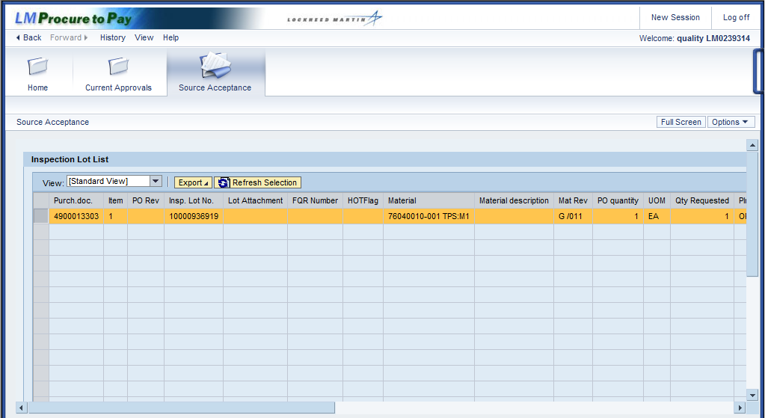

Step | Action
10. | The Inspection Lot List screen displays all PO inspection lots that are assigned to you.
11. | The Inspection Lot List screen displays information about the inspection lot. Column titles can be sorted and contain the following information:  - Purch. doc.: Purchase Order (PO) number  - Item: PO line item number  - PO Rev: Revision number of PO line item  - Insp. Lot No.: Inspection lot number, starts with a 1 (PO) or a 7 (FQR)  - FQR Number: Field Quality Request number  - HOTFlag: Contains an X if a priority inspection  - Material: For PO acceptance it is the material, for FQR it is an audit material number  - Material description: Name of the material  Click the horizontal scroll bar to display more columns of inspection lot information.

Step | Action
12. | (Continued) Columns describing the inspection lot include:  - Mat Rev: Revision of the material. For PO acceptance this is the document version of the material master  - PO quantity: Quantity ordered for the PO line item  - UOM: Unit of Measure (e.g., EA for each or GAL for gallon, etc.)  - Qty Requested: Quantity in the inspection lot. FQR quantity is 1 with inspection plan, and 0 without plan  - Plnt: Plant code. Contact site rep for list of plant names  - POrg: Purchasing Organization  - Supplier Vendor Name: Company name  - PostalCode: ZIP code of vendor's address  - PGr: The buyer's code in PO source acceptance. Contact site rep for list of buyer codes  - Inspector ID: Your profile ID in the system  Click the horizontal scroll bar to display more columns of inspection lot information.
13. | (Continued) Columns describing the inspection lot include:  Deliv. date: Date requested for visit to vendor's facility, which you can revise  QS: Quality Status, or current status code for inspection lot Quality Status Description: Current status of inspection lot Code: Program Code  Program Description: Name of the program  User Status: User status of inspection lot (PO acceptance only)  Click the horizontal scroll bar to display more columns of information.
14. | (Continued) Columns describing the inspection lot include:  - FQR Type: The type for surveys is SURV. Contact site rep for list of FQRs types  - FQR Draw Revision: Revision # of material/process, defined by procedures  - SCAR Number: The QNote number of the corrective action, if applicable  - FQR Comments: Additional instructions may be noted on the FQR  You have completed your review of the columns, so click the horizontal scroll bar to return to the initial view of the Inspection Lot List.

Step | Action
15. | Note: Several buttons are available at the top of this screen:  - Export: Export and/or print the Lot List in an Excel spreadsheet (.xls)  - Refresh Selection: Updates selected lot to reflect latest status changes

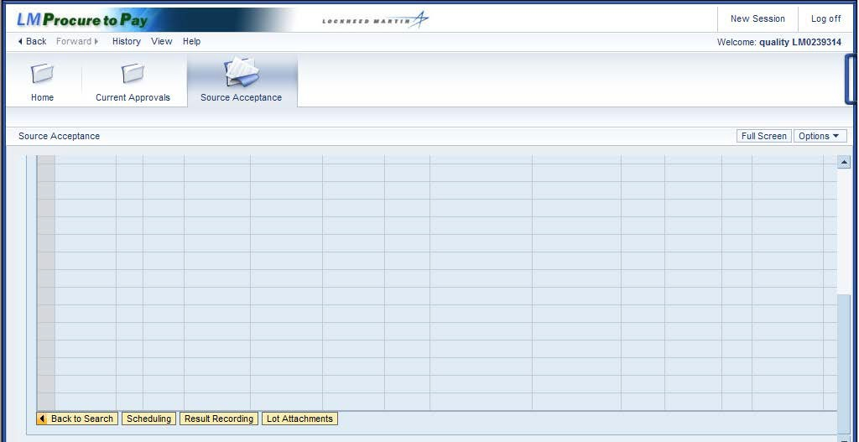

Step | Action
16. | Several buttons are also available at the bottom of the Inspection Lot List:  - Rows (up/down arrows): Used to advance by a single row, a whole page, or to the beginning/end of the list  - Back to Search: Returns to Selection of Inspection

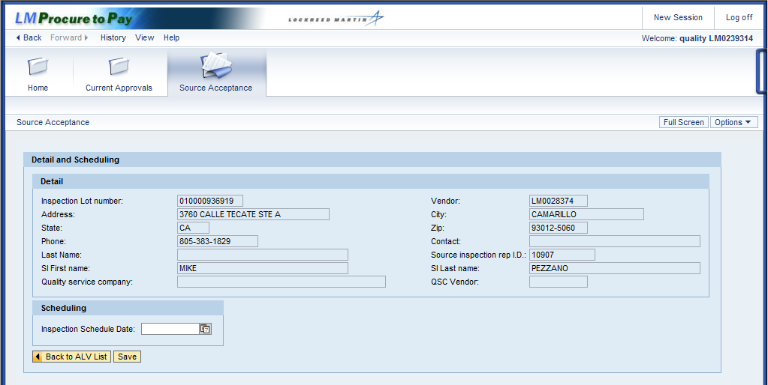

Step | Action
17. | Details about the source inspection are displayed in Detail and Scheduling.  The Detail section includes information about the inspection and the vendor. This is for your reference only, no information can be changed.  The Scheduling section allows you to modify the Inspection Schedule Date field, which is optional and is dictated by site procedures.

Step | Action
18. | Click the Inspection Schedule Date matchcode button to select your preferred inspection date.

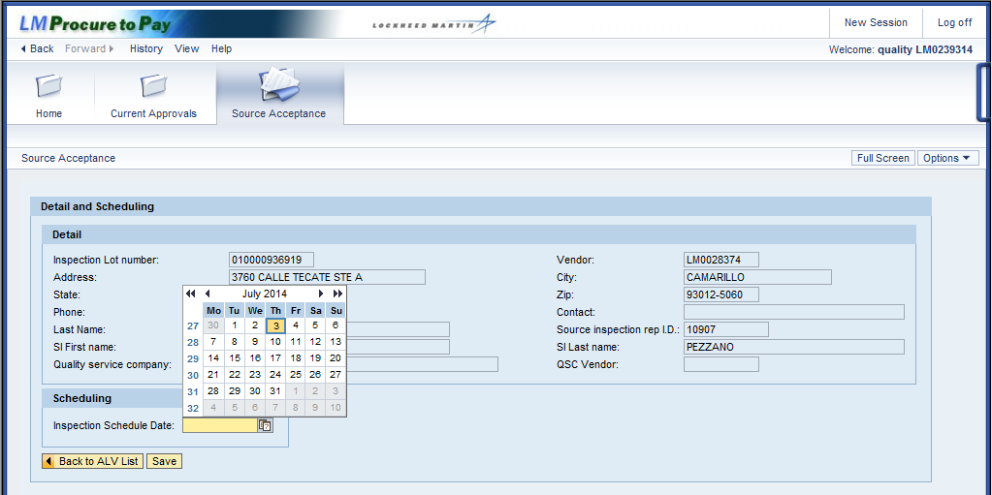

Step | Action
19. | Select the best date for the inspection.

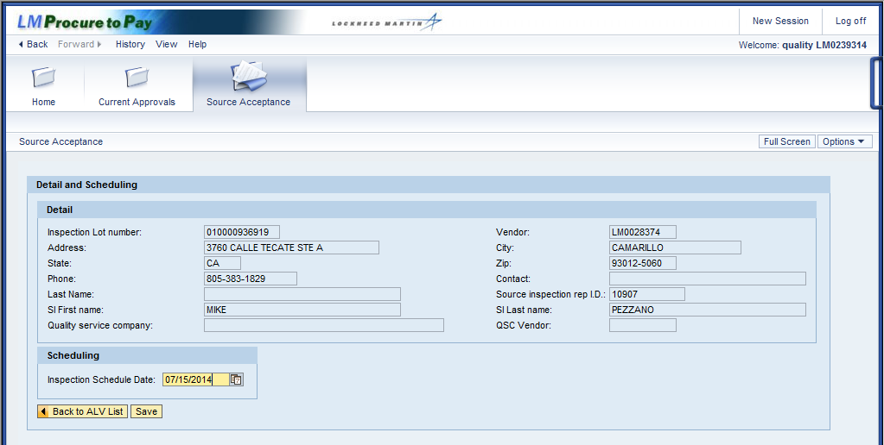

Step | Action
20. | Click the Save button.
21. | The date you selected date is now displayed as the inspection schedule date. Click the Back to ALV List button.
22. | You have returned to the Inspection Lot List.  Click the vertical scroll bar to return to the bottom of the screen.

Step | Action
23. | Click the Back to Search button to query another inspection lot.

Step | Action
24. | You have returned to Selection of Inspection.  This time you will complete a Survey FQR source inspection. Begin by clicking on the PO/FQR matchcode button.

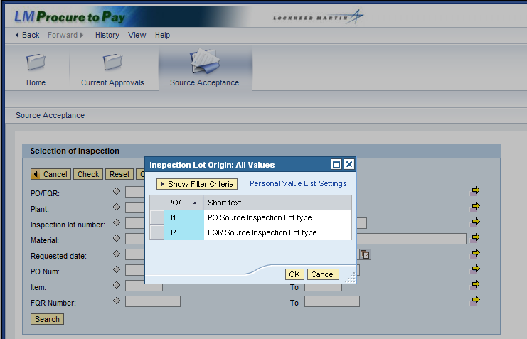

Step | Action
25. | Click the FQR Source Inspection Lot type selection box.
26. | Click the OK button.

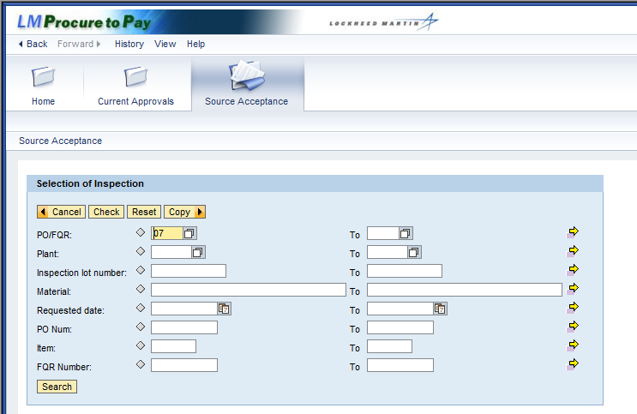

Step | Action
27. | Click the Search button to query all FQR source inspection lots you are assigned to complete.

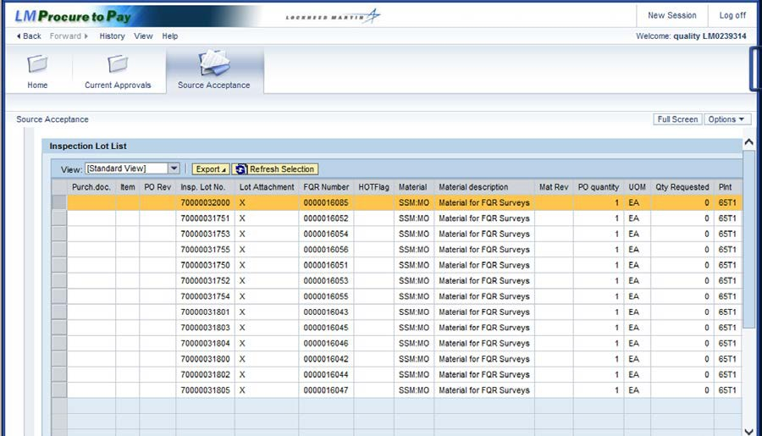

Step | Action
28. | The Inspection Lot List displays with the FQR lots assigned to you.
29. | Click the vertical scroll bar to display the buttons at the bottom of the screen.

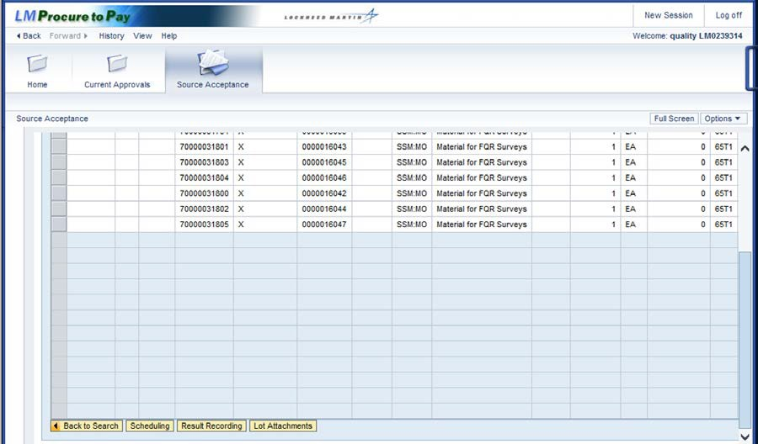

Step | Action
30. | Click the Result Recording button to enter the results of the inspection.

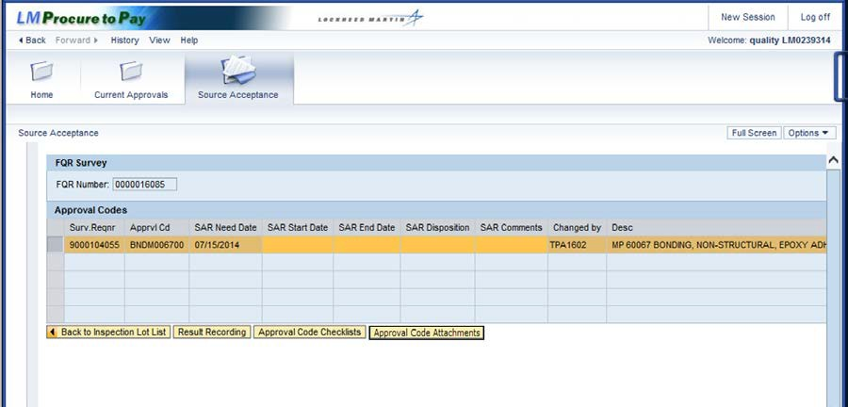

Step | Action
31. | Because the FQR type is SURV, the FQR Survey screen displays with the  Approval Codes table.  Only one approval code is shown and it has been selected by default. Click the Approval Codes Attachments button.

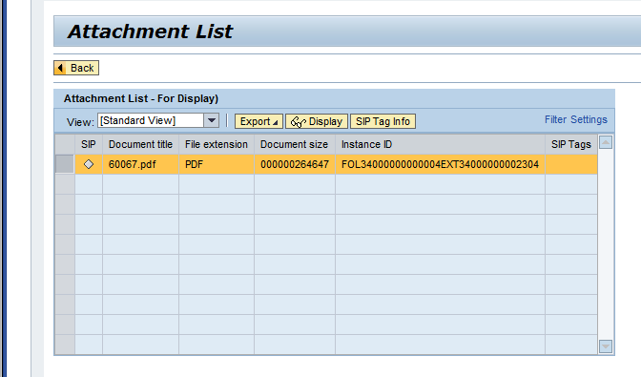

Step | Action
32. | The Attachment List screen displays a Microsoft Word document (.doc). Click the Display button to view this survey.

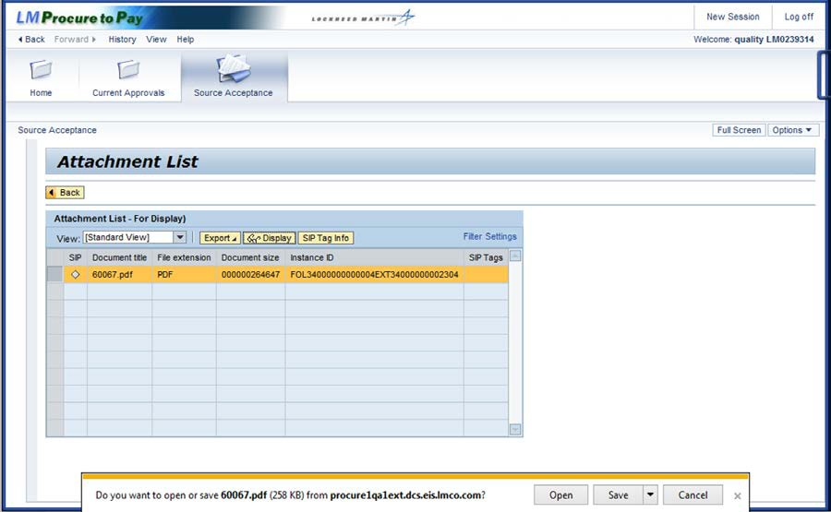

Step | Action
33. | Click the Open button to display the document in Microsoft Word.

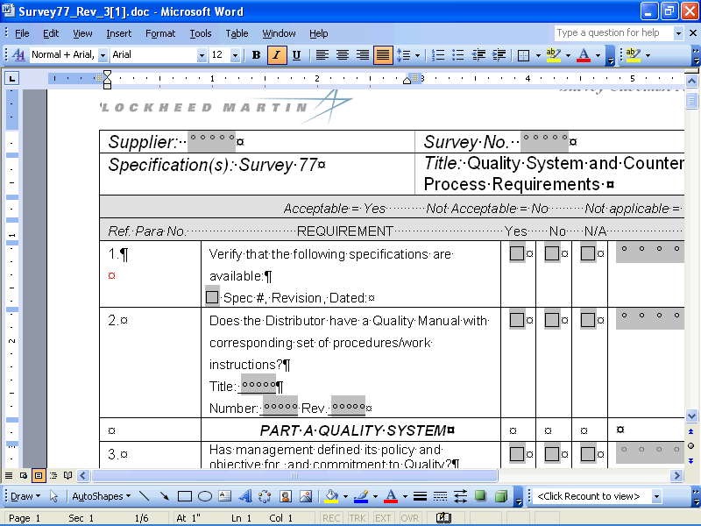

Step | Action
34. | The survey that needs to be completed for this inspection is displayed.  You can print this document to use during the survey, but remember to save the results electronically on your computer so they can be provided to your site rep.  Click the (Exit) button in the upper right corner of the screen to close the document and return to SAP.

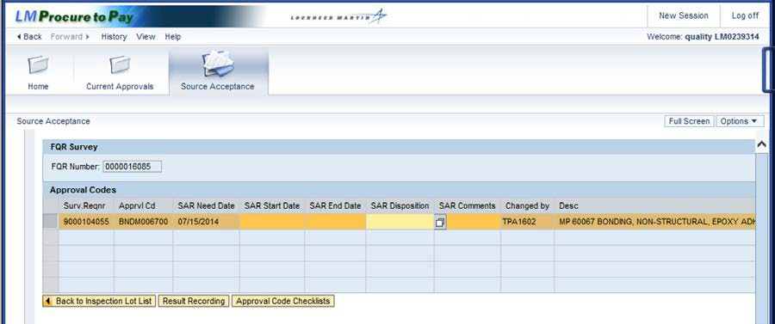

Step | Action
35. | 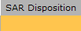  Click in the SAR Disposition field.
36. | Click the matchcode button.

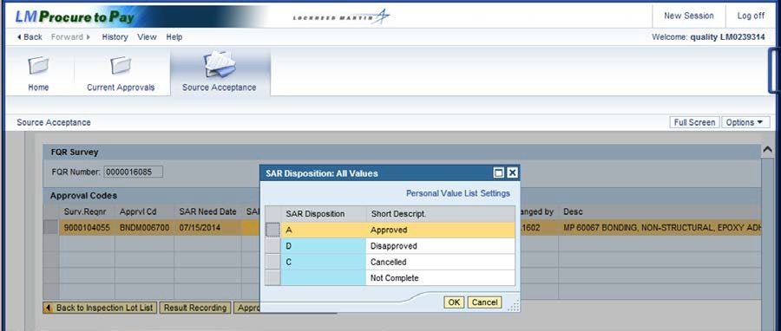

Step | Action
37. | Click the Approved menu item.
38. | Click the OK button.

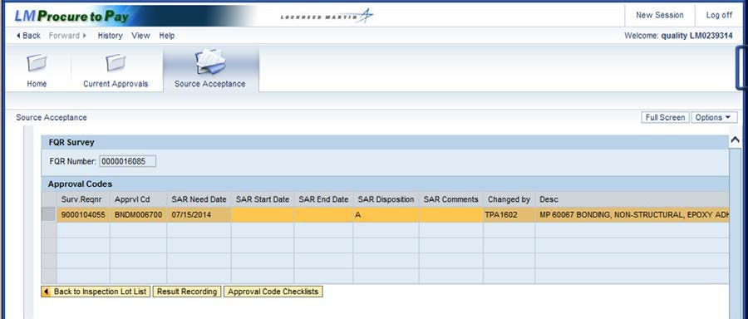

Step | Action
39. | Click the Result Recording button to enter your inspection results.

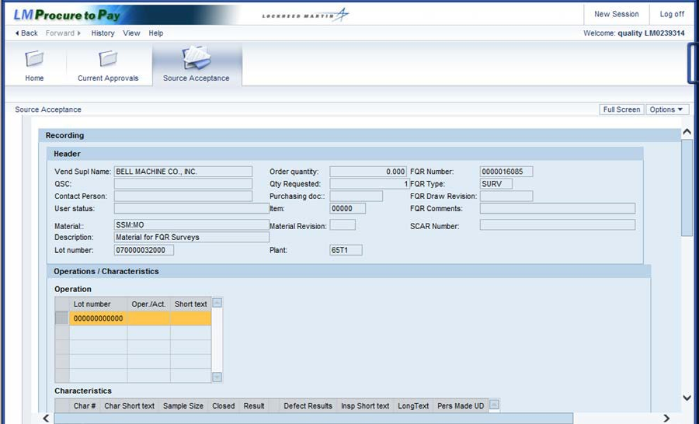

Step | Action
40. | The Source Acceptance Recording screen displays the Header and Operations  /Characteristics section.
41. | Header: Displays information from the Inspection Lot List, the vendor's contact person, and the Quality Service Company (QSC)  Operations: Displays an inspection plan that has at least 1 operation and 1 characteristic that must be completed. When the inspection plan has more than 1 operation and/or characteristic, you must complete all of them to complete the inspection  The single operation is default selected, so click the vertical scroll bar to display the characteristics.

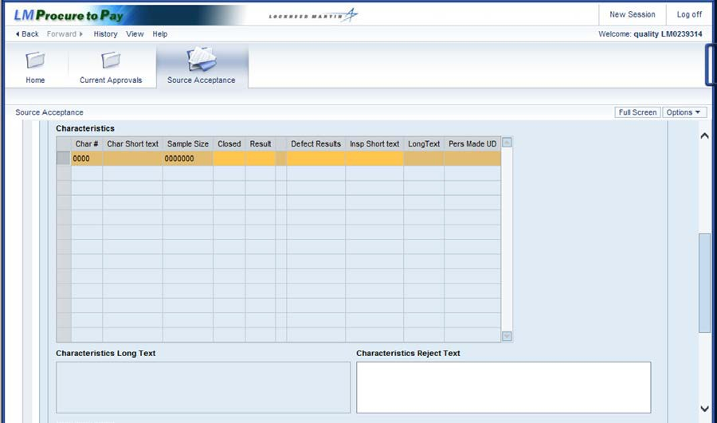

Step | Action
42. | The Characteristics table is empty.  No action is required when a survey is being performed using the external attachment.  Click the vertical scroll bar to display the buttons at the bottom of the screen.

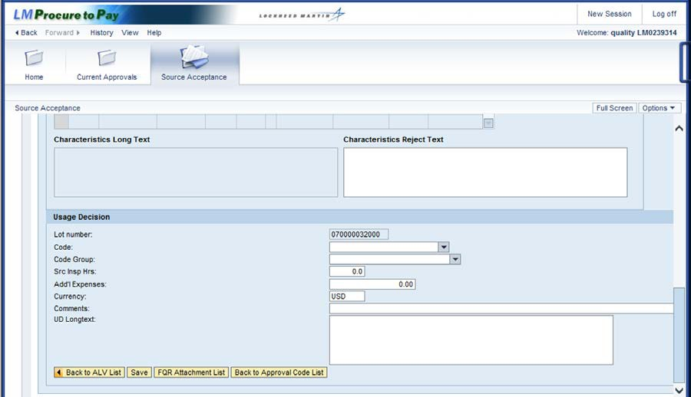

Step | Action
43. | The Usage Decision section is displayed, including:  - Lot number: The lot number you are currently inspecting  - Code: Every lot requires a usage decision, which is the final disposition of the entire lot  - Code Group: This field auto-completes once the code is selected  - Src Insp Hrs: 3rd party SI Reps should enter the time charged for processing this lot, as directed  - Add'l Expenses: 3rd party SI Reps should enter any additional expenses for processing lot, as directed  - Currency: Currency of expenses entered. The default is United States Dollars, or USD  - Comments: Enter as needed to explain and justify expenses  - UD Longtext: Enter as needed to provide further details about the usage decision

Step | Action
44. | Click the Code drop-down button to select the usage decision from a list.

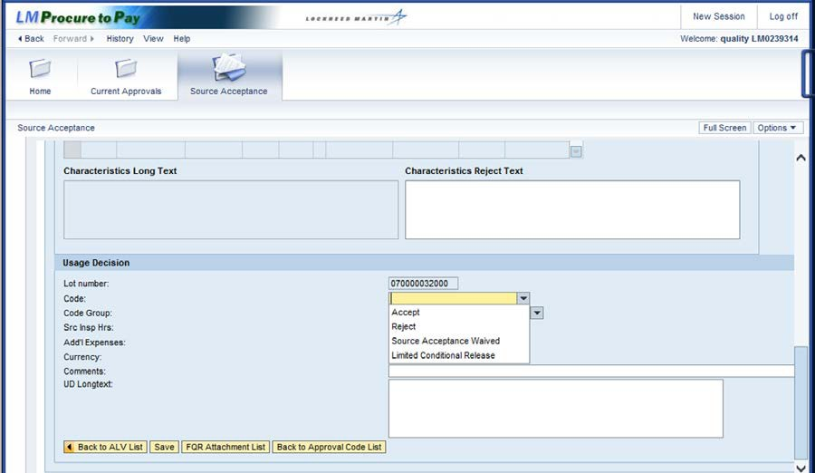

Step | Action
45. | There are four usage decision codes listed in the drop-down menu:  - Accept: Chosen if all characteristics are accepted, or as directed by your site. Lots with a rejection may be acceptable. For example, your site may direct you to accept the lot and set a hold flag upon Goods Receipt , which stops the lots to allow consideration by the Material Review Board (MRB)  - Reject: Chosen if you encounter any rejections while inspecting characteristics, or as directed by your site  - Source Acceptance Waived: Chosen only when directed by your site, it cancels the source acceptance  - Limited Conditional Release

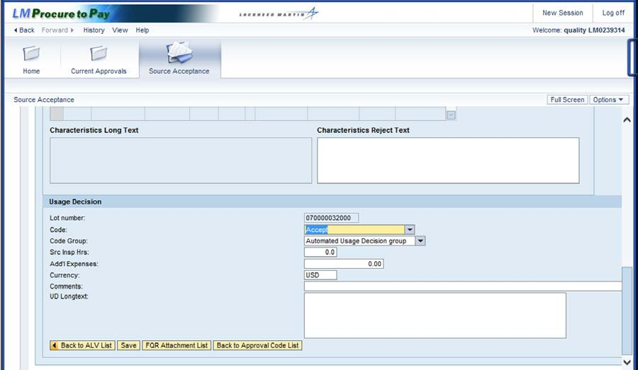

Step | Action
46. | There are several buttons available at the bottom of this screen:  - Back to ALV List: Return to the Inspection Lot List  - FQR Attachment List: No FQR attachments for survey inspections  - Back to Approval Code List: Return to the Approval Code List
47. | You have inspected all characteristics for Survey FQR source acceptance.  To complete this inspection lot with a usage decision of accept, click the Save  button to confirm if your entries have been correctly recorded.

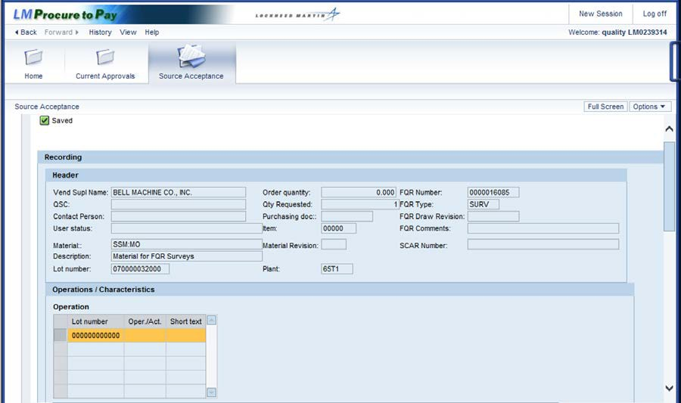

Step | Action
48. | The message at the top left of the screen indicates you have saved your inspection results, so you have completed the source inspection.
49. | You have successfully completed the procedure to process a Survey FQR.

