

LM Procure to Pay Quick Reference Guide For Suppliers

Ship to LMC

Lockheed Martin Procure to Pay July 2019

Contents
Ship to LMC Introduction 4
Ship to LMC Navigation 13
PO Quality Clauses 45
Request PO Review 58
Inspection Lot Attachments 69
Request FAI 80
Request Source Inspection 86
Authorized to Ship/Ship to Processing 96
Ship To LMC Header Screen 100
Special Processors 109
Serial Numbers 123
Shipping Input 144
Create Delivery/Barcode 151
Cancel LMC Action 156
LMC Action Reject 163

Ship to LMC Introduction
This guide demonstrates how to Ship to Lockheed Martin.

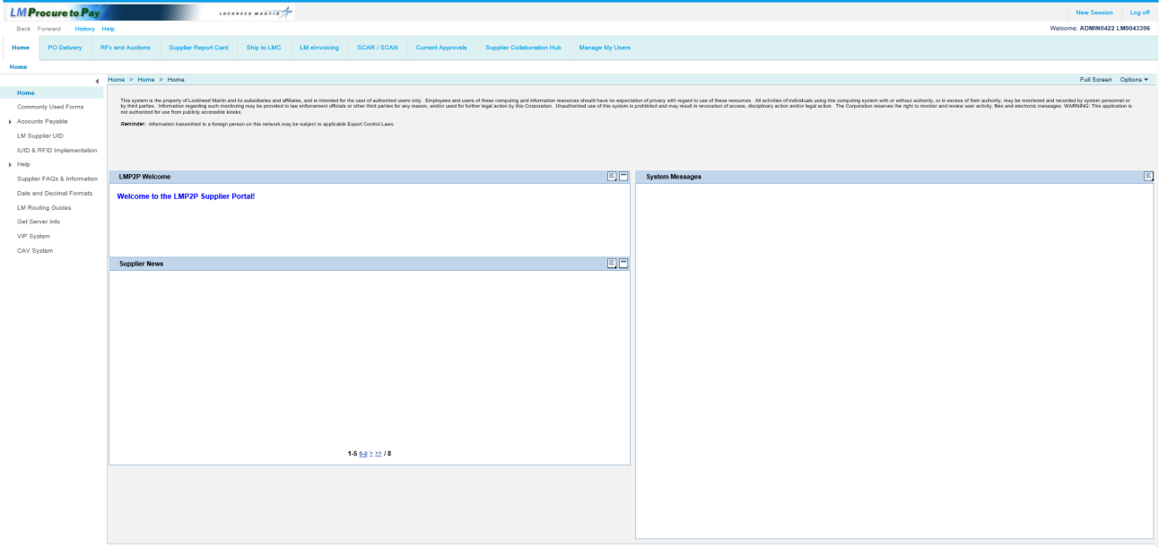

Step | Action
1. | Click the Ship to LMC folder.

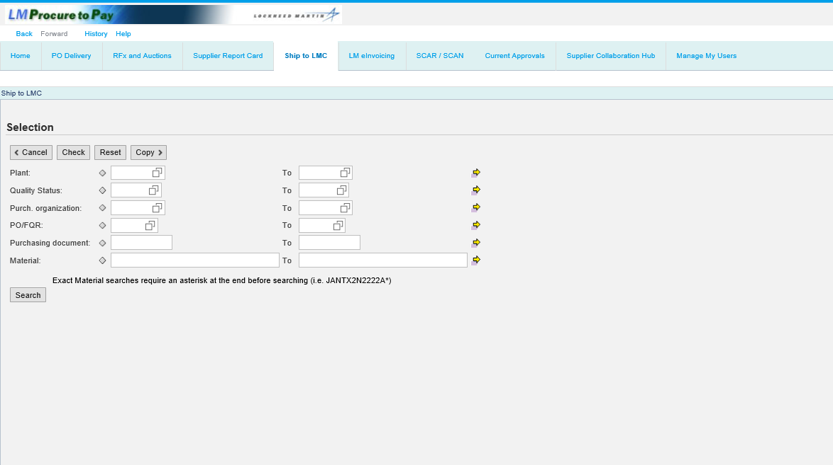

Step | Action
2. | In the Selection area, search for unshipped purchase order line items. By clicking Search without entering criteria, the system displays a complete list of all unshipped purchase order items including information regarding any survey or audit visits.

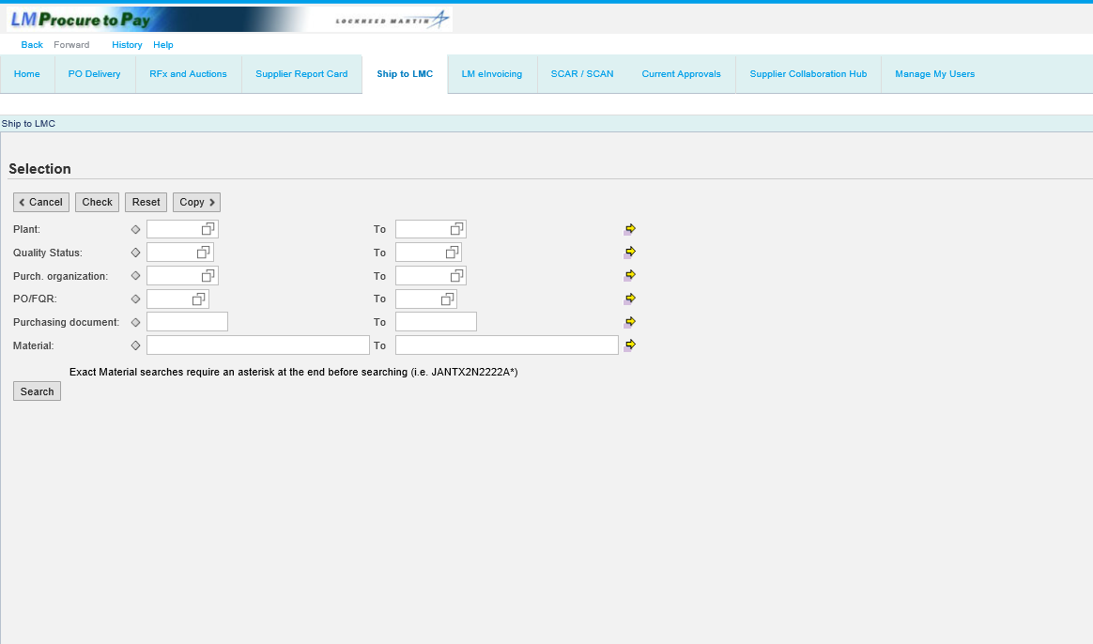

Step | Action
3. | Refine the search by entering a Plant ID in the Plant field.

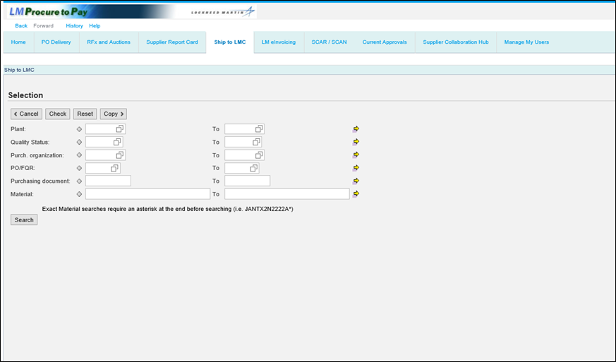

Step | Action
4. | Narrow the search by entering a Quality Status.  You can click the Quality Status matchcode button to pull up a list of various Quality Status codes.

Step | Action
5. | Narrow the search by entering the Lockheed Martin Purchasing Organization.  In this example, enter a valid value e.g. "LMP1" into the Purch. organization field.

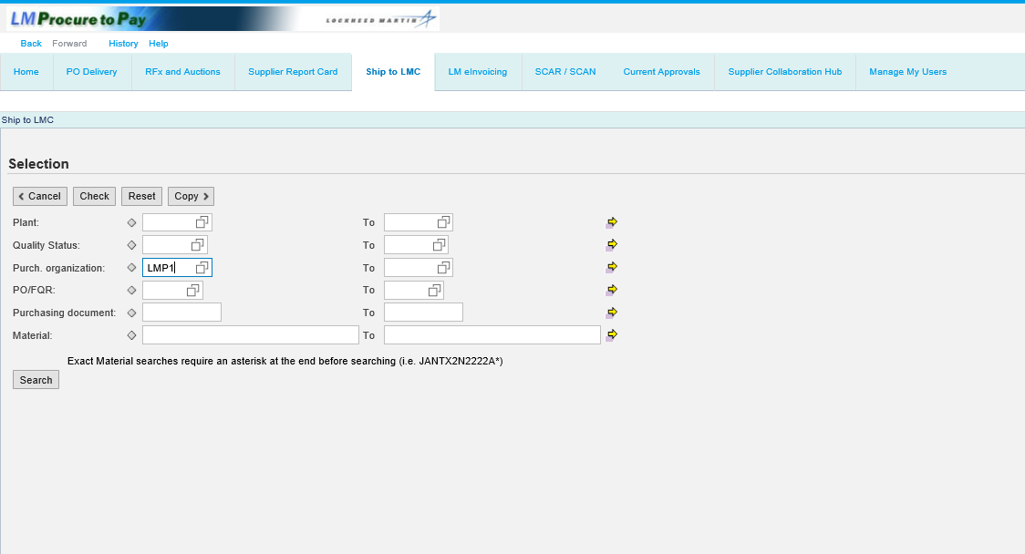

Step | Action
6. | PO/FQR field  The list can be filtered to display just those items for a certain type such as PO Line or Field Quality Request (FQR). FQR's are audits or surveys scheduled for your  facility. There are only two choices - PO or FQR.

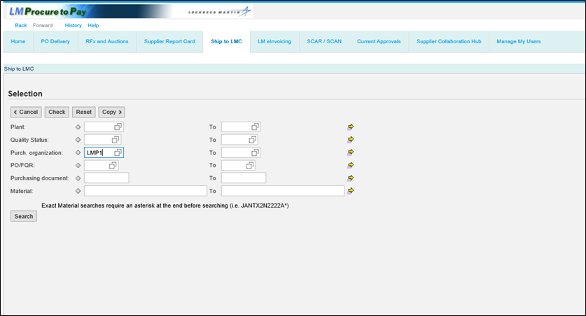

Step | Action
7. | Purchasing document field  Enter a Purchase Order number in the Purchasing document field to display all PO line items that match the entered purchase order number.

Step | Action
8. | Material field  Enter the complete material number (part number) in the Material field to display all PO line items that match the material number.  All exact material matches require an asterisk (*) as the last character. Lockheed Martin requires a plant identifier for each material number.

Step | Action
9. | Click the Search button.

Ship to LMC Navigation
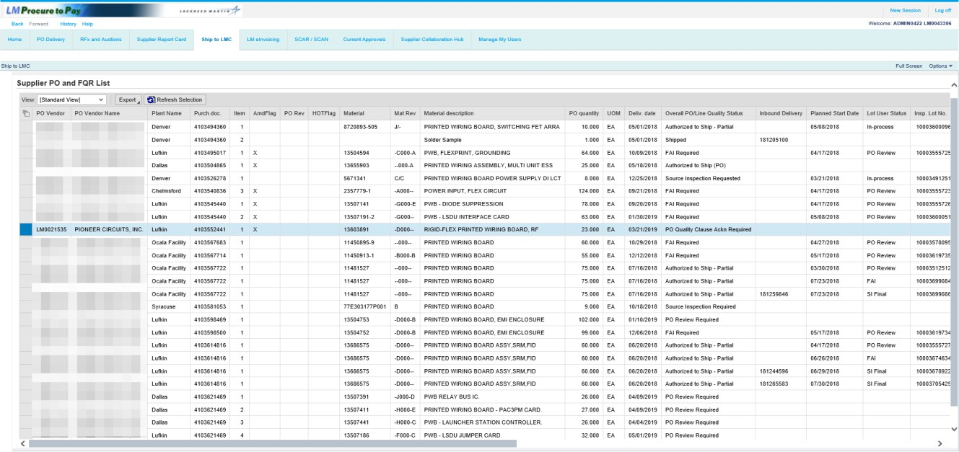

Step | Action
10. | A list of purchase order line items displays.  PO Vendor is the Lockheed Martin supplier number.

Step | Action
11. | Plant Name represents the Lockheed Martin facility placing the purchase order.

Step | Action
12. | Purch.doc. is the Lockheed Martin purchase order number.

Step | Action
13. | Item is the purchase order line item.

Step | Action
14. | Amd Flag is used to indicate if an amendment (Amdflag) to the PO is in process.

Step | Action
15. | PO Rev is the revision level of the purchase order line item.

Step | Action
16. | HOTFlag will display an X if the purchase order has been labeled as a priority by Lockheed Martin.

Step | Action
17. | Material is the material or part number on the purchase order line item.

Step | Action
18. | Mat Rev is the revision level of the material or the material's drawing.

Step | Action
19. | Material description is the name of the material or part.

Step | Action
20. | PO quantity is the total purchase order line item quantity.

Step | Action
21. | UOM is the unit of measure.

Step | Action
22. | Deliv. date is the date specified on the purchase order line item when the delivery is needed.

Step | Action
23. | Overall PO/Line Quality Status  - PO Quality Clause Ackn Required : PO line items with this status will require that all quality-related text keys/clauses be reviewed and acknowledged prior to either requesting on-site inspections or processing ship-to records  - Authorized to Ship (PO): PO line items with this status do not require source inspection and can be shipped to Lockheed Martin when possible  - Source Inspection Required: PO line items with this status require source inspection prior to being shipped to Lockheed Martin  - PO Review Required: PO line items with this status require a PO Review prior to being shipped to Lockheed Martin  - Authorized to Ship – AIM: PO line items with this status initially required source inspection but qualify for the Lockheed Martin Alternate Inspection Method  (AIM). Source Inspection is no longer required, and the PO line can be shipped to Lockheed Martin when possible  - Authorized to Ship – QVP: PO line items with this status initially required source inspection but qualify for the Lockheed Martin Qualified Vender Program  (QVP). Source Inspection is no longer required, and the PO line can be shipped to Lockheed Martin when possible

Step | Action
24. | Overall PO/Line Quality Status - continued  - Source Inspection Required: PO line items with this status have at least one inspection lot requested for source inspection  - Authorized to Ship – Waived: PO line items with this status initially required source inspection, however, source inspection has been waived by the source representative and the PO line can be shipped to Lockheed Martin when possible  - Source Inspection Assigned: PO line items with this status have a requested source inspection lot assigned to a source representative  - Source Inspection Scheduled: PO line items with this status have a requested source inspection lot assigned to a source representative who has entered a date for the actual source inspection visit

Step | Action
25. | Overall PO/Line Quality Status - continued  - Source Inspection Rejected: PO line items with this status have a requested source inspection lot for the full PO line quantity that was rejected by the source representative (partial lots that are rejected will not display in the queue)  - Authorized to Ship – Partial: PO line items with this status have a requested source inspection lot less than the PO line item quantity that was accepted by the source representative and the accepted quantity can be shipped to Lockheed Martin when possible  - FAI Required: PO line items with this status require a First Article Inspection (FAI) prior to being shipped to Lockheed Martin  - Source Inspection Unassigned: not used  - Source Insp Reqstd: Lot creation error. If displayed, call a Lockheed Martin representative  - Shipped: Indicates the full PO line quantity has been shipped to Lockheed Martin. These will roll-off after 30 days

Step | Action
26. | Inbound Delivery is the delivery number generated when you create the shipping document. This is used on the barcode and it is used to process receipts at Lockheed Martin.

Step | Action
27. | Planned Start Date is the date a source inspection will start (if applicable).

Step | Action
28. | Lot User Status is used if a PO Review FAI, or source inspection is requested. This column will can display various inspection types as encountered; PO Review FAI and if source inspection (final or in process).

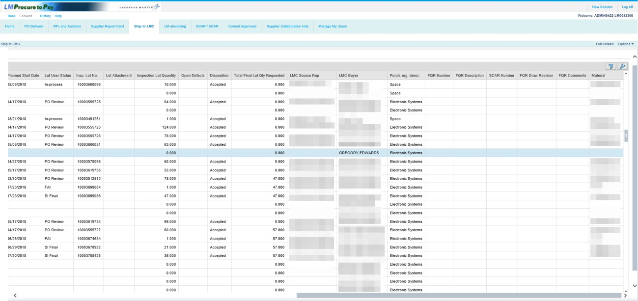

Step | Action
29. | Insp. Lot No. is the number assigned by the system to the inspection lot.

Step | Action
30. | Inspection Lot Quantity displays the quantity entered when the inspection lot was created.

Step | Action
31. | Open Defects  A "Y" flag displays if a vendor onsite activity has been rejected.

Step | Action
32. | Disposition is the inspection result and will display Accept, Accepted AIM or Accepted QVP, Reject, or Waived.

Step | Action
33. | Total Final Lot Qty Requested is the lot quantity for source inspection lots (Final Only).

Step | Action
34. | LMC Source Rep is the Lockheed Martin employee assigned to perform the PO Review FAI or Source Inspection requested.

Step | Action
35. | LMC Buyer is the Lockheed Martin employee responsible for placing the purchase order and is your primary point of contact for questions regarding this purchase order.

Step | Action
36. | Purch. org. descr. is the higher level Lockheed Martin Organization that represents multiple Lockheed Martin plants.

Step | Action
37. | FQR Number is the number assigned by the system to surveys or audits scheduled for your facility.

Step | Action
38. | FQR Description displays the type of non-PO line source inspection such as survey, corrective action verification, etc.

Step | Action
39. | SCAR Number is the number that is the subject of the corrective action validation.

Step | Action
40. | FQR Draw Revision displays the drawing revision of the special survey or audit material number.

Step | Action
41. | FQR Comments displays any comments entered by the user requesting the audit or survey.

PO Quality Clauses
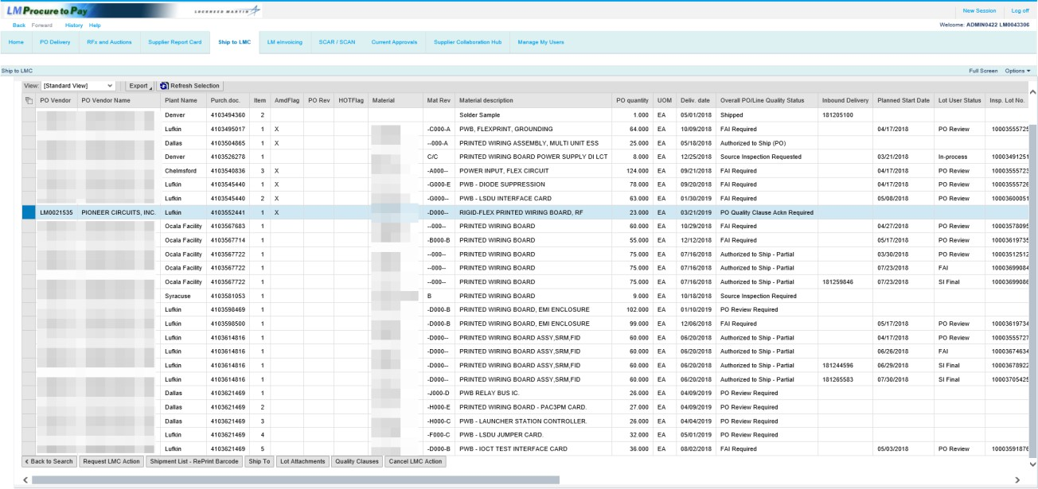

Step | Action
42. | If the Quality Status of the purchase order line item displays a message of PO Quality Clause Ackn Required, you are required to access the Quality Clauses button to review and acknowledge all quality-related text keys/clauses for the selected PO line item. This mandatory review is enforced prior to either requesting on-site inspections or processing ship-to records.

Step | Action
43. | This PO line item requires that all quality clauses be acknowledged before proceeding with any other required activities or actions.  Note: It is possible for PO line items that do not contain a PO Quality Clause Ackn Required status may still also require the acknowledgment of quality clauses. These types of PO line items will be seen when a Lockheed Martin business first activates this new functionality. All purchase orders created after activation will be set to PO Quality Clause Ackn Required.

Step | Action
44. | If the status of the line item is PO Quality Clause Ackn Required, any attempt to select Request LMC Action or Ship To will display a message of Not Authorized for SCHEDULING as Q status: PO Quality Clause Ackn Required.

Step | Action
45. | Click the Quality Clauses button.

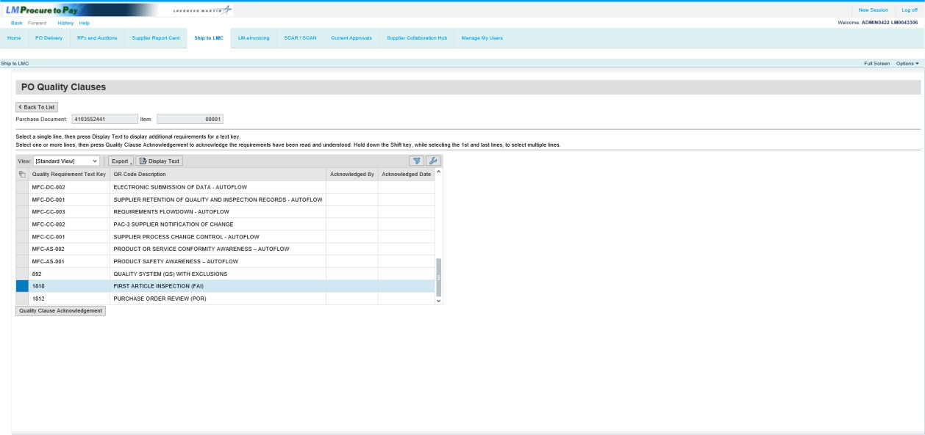

Step | Action
46. | For this PO line item, note the quality clauses that require review. Immediately displayed are the text key codes and descriptions.  To view the long text for the 1818 text key, first click the selection box to select it.

Step | Action
47. | Click the Display Text button to display the long text for the selected text key.

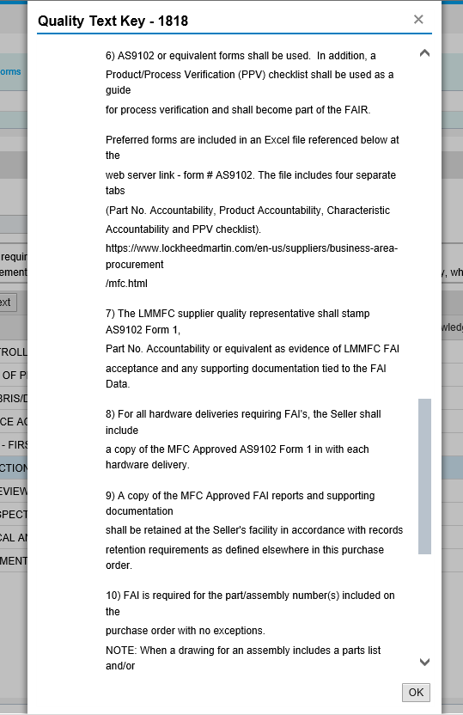

Step | Action
48. | Note the full long text of the text key selected.  Click the OK button to close the pop-up.

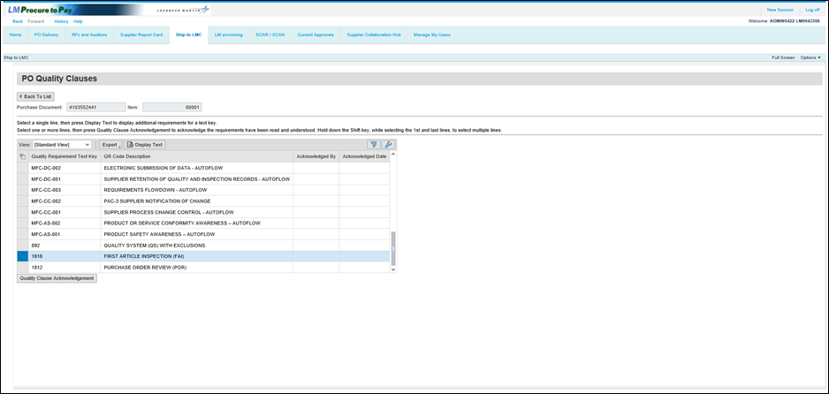

Step | Action
49. | To complete the acknowledgment for the text key, click the Quality Clause Acknowledgement button.

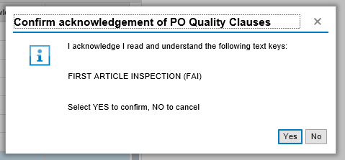

Step | Action
50. | To confirm acknowledgment of the text key, click the Yes button.

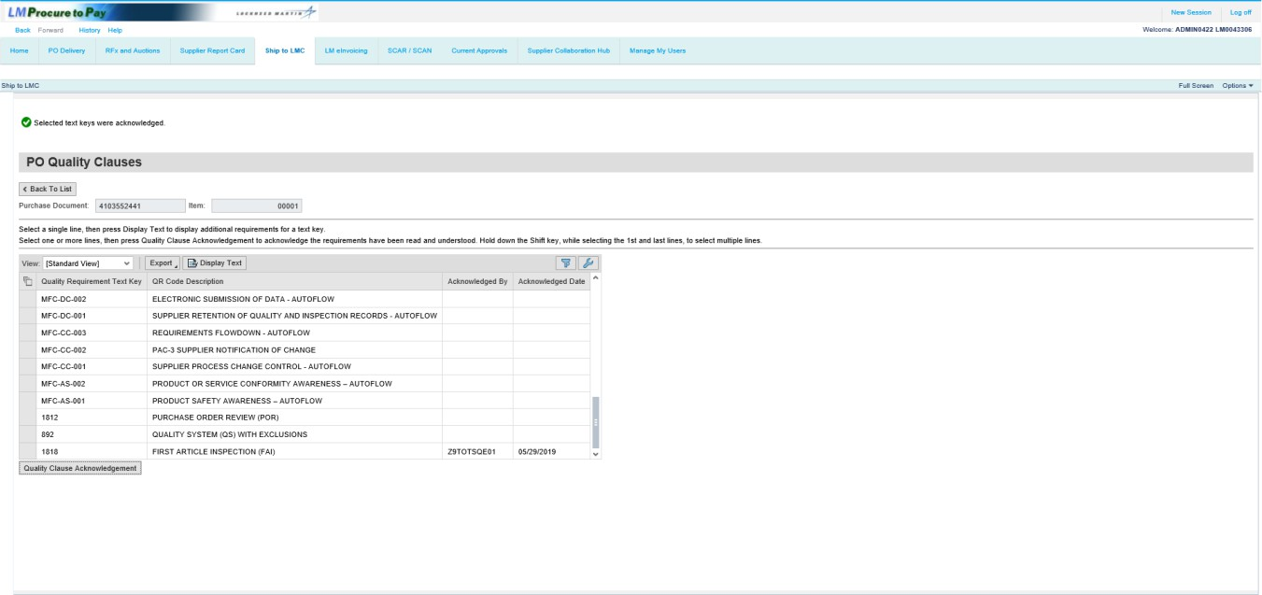

Step | Action
51. | Note the message displayed that the 1818 text key is acknowledged.  The selection now defaults to the first text key listed in the table. You can also acknowledge multiple text keys at once.  To select multiple text keys, press the [Ctrl] key on your keyboard and click the selection box for the additional text key.

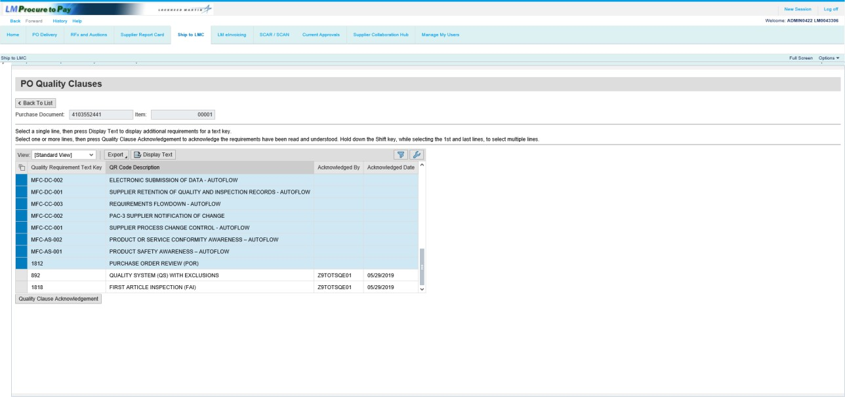

Step | Action
52. | Note that all the rest of the keys are selected. To acknowledge, click the Quality Clause Acknowledgement button.

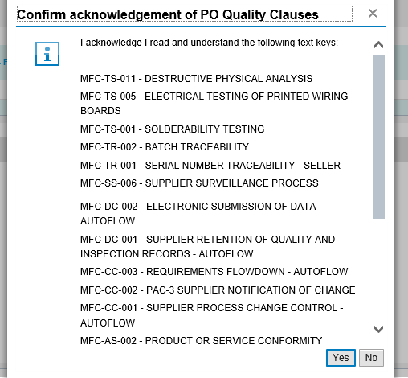

Step | Action
53. | To confirm acknowledgment of both text keys, click the Yes button.

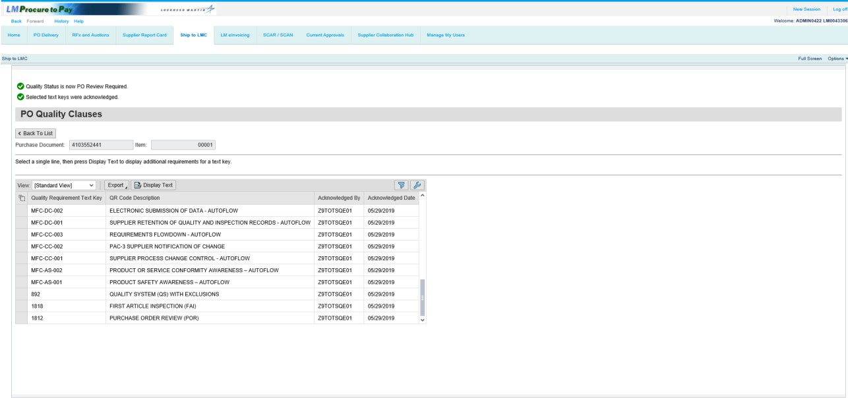

Step | Action
54. | Note the message displayed that the selected text keys are acknowledged. The Acknowledged By and Acknowledged Date columns also populate with the specific information.  Click the Back To List button.

Request PO Review
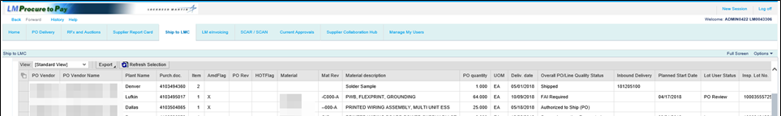

Step | Action
55. | Click the Refresh Selection button.

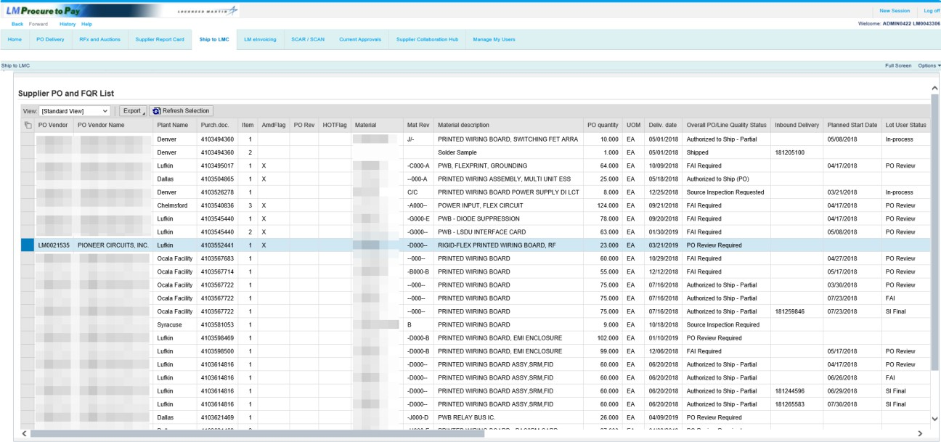

Step | Action
56. | Note the status has now changed to the next required action for the PO line item.

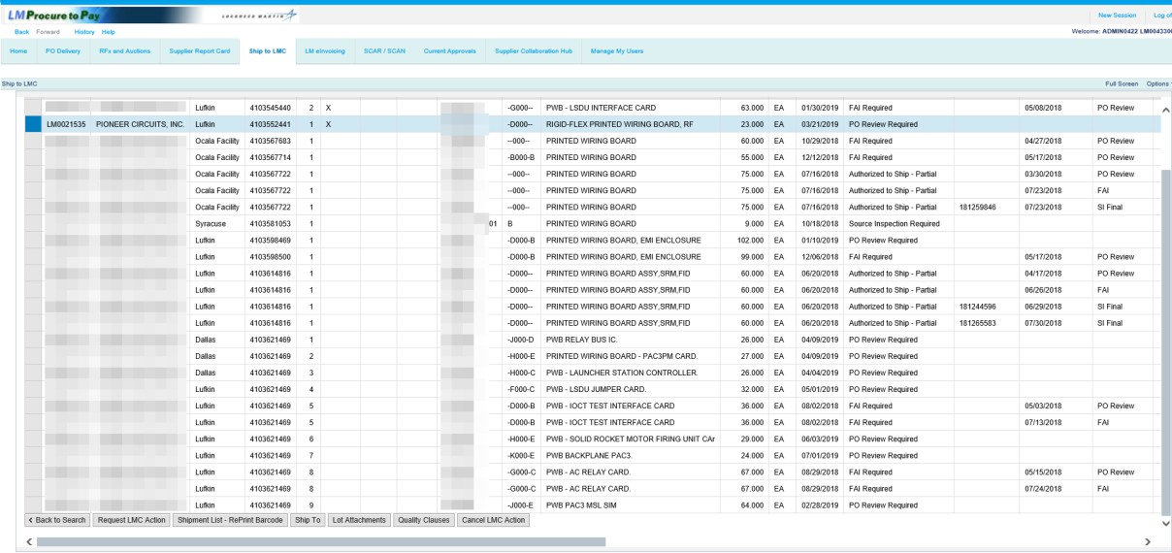

Step | Action
57. | If the Quality Status of the purchase order line item displays either PO Review Required, FAI Required, or Source Inspection Required, click the purchase order line item to select the line.  Overview of LMC Actions: Lockheed Martin now allows for up to three unique vendor onsite actions to be imposed on purchase order line items; PO Review, FAI, and/or Source Inspection. Note that all three requirements may be imposed together on a unique PO line item, in pairs, or applied uniquely. Further, the hierarchy order of processing these three unique vendor onsite actions is PO Review, FAI, Source Inspection should all three requirements apply on a PO line item or if applied in pairs.  Processing of LMC Actions: When processing a purchase order line item that contains all three requirements, a Quality Status will first be displayed as PO Review  Required. Upon Acceptable request & processing of a PO Review lot, the Quality Status will then be updated to reflect a FAI Required status. Upon Acceptable request & processing of an FAI lot, the Quality Status will then be updated to reflect a Source Inspection Required status. Upon Acceptable request & processing of a Source Inspection lot, the Quality Status will then be updated to either an Authorized to Ship - Partial status (if less than the total PO line item order quantity is represented) or an Authorized to Ship - Accepted (if the total PO line item order quantity is represented).  The purchase order used in this example includes a status of PO Review Required in the Overall PO/Line Quality Status field. To proceed, click the Request LMC Action button to schedule the Lockheed Martin Source Representative to visit your facility to perform the requested onsite action.

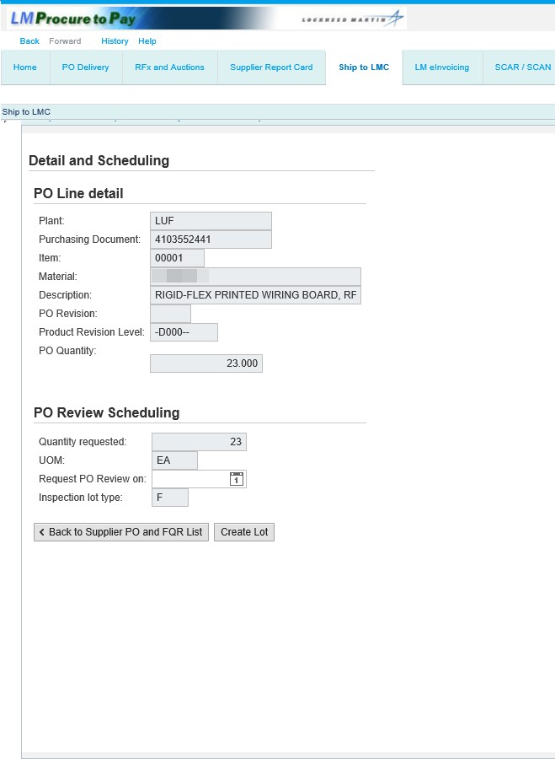

Step | Action
58. | The following slides provide a process walkthrough using a Purchase Order example in which PO Review, First Article Inspection, and Source Inspection have been imposed by Lockheed Martin.

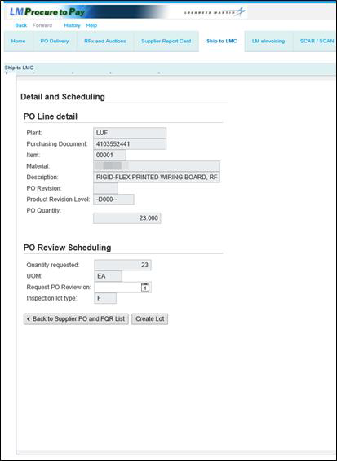

Step | Action
59. | Note: PO Review is a one-time LMC activity. Therefore, the entire quantity of the PO line item order will automatically default in the quantity requested field.  Enter the date the Lockheed Martin Source Representative will visit the facility to perform PO Review.  Click the Request PO Review on calendar button to select a date.

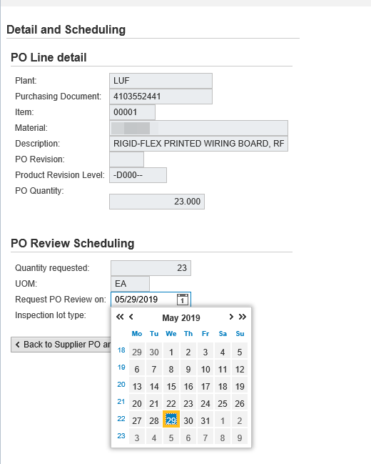

Step | Action
60. | Click the desired date.

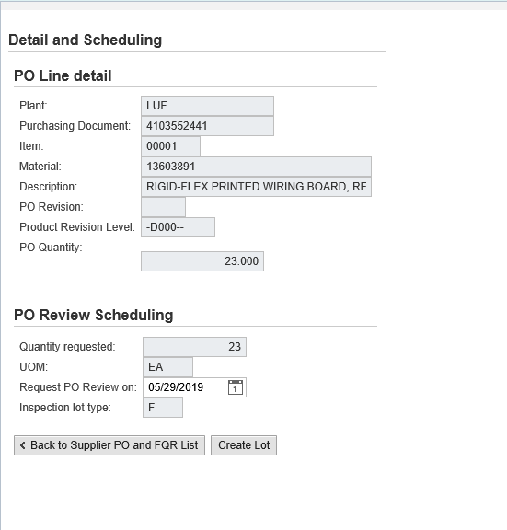

Step | Action
61. | The Inspection lot type defaults to F - Final Inspection when PO review is requested.

Step | Action
62. | Click the Create Lot button to create the inspection lot (see the upper portion of the screen for the lot number).

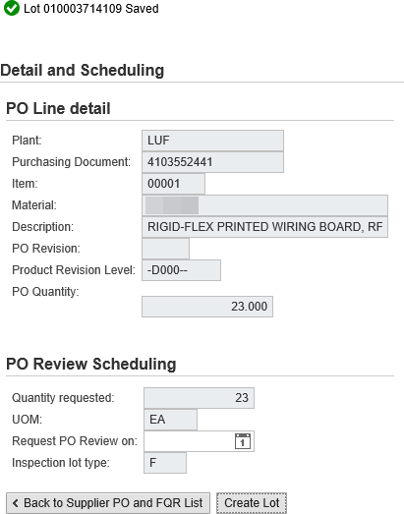

Step | Action
63. | A message appears that the lot is saved.  Click the Back to Supplier PO and FQR List button to return to the queue.

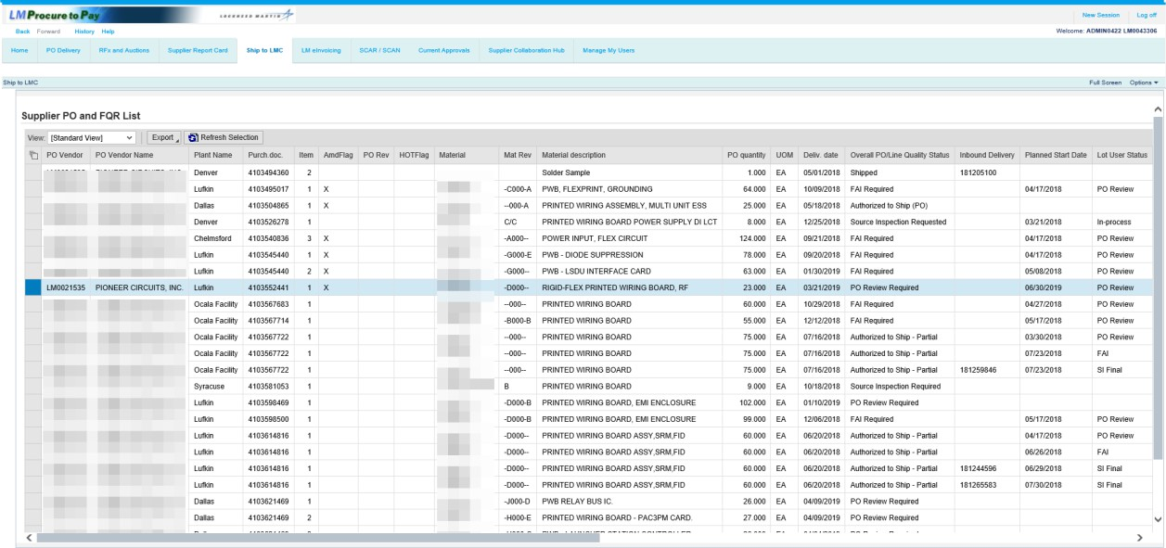

Step | Action
64. | Click the Refresh Selection button to view the submitted inspection lot data.

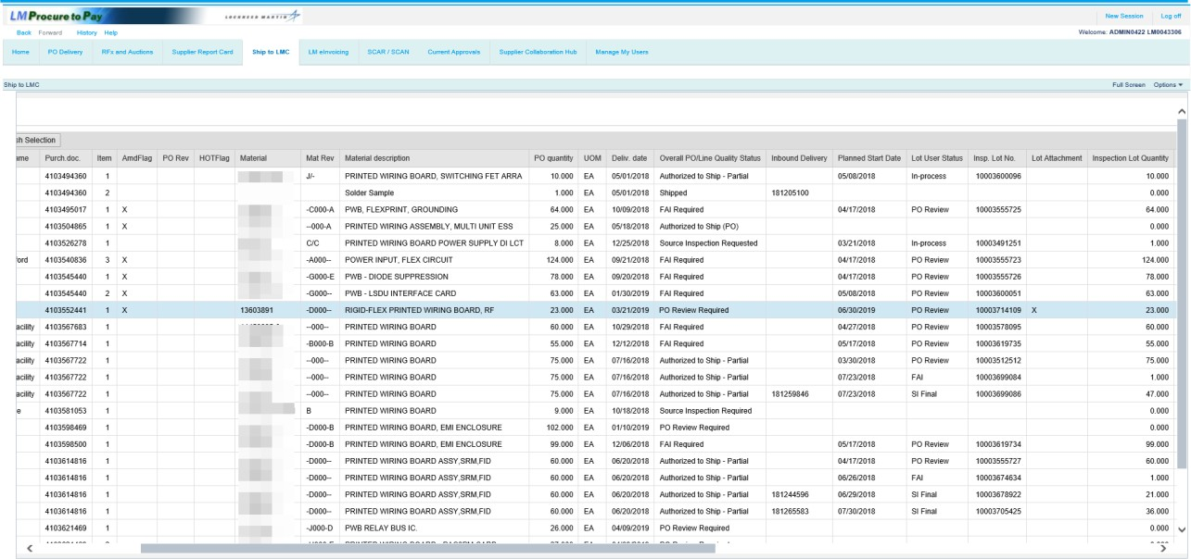

Step | Action
65. | Note the created inspection lot in the Insp. Lot No. field and the added scheduled date in the Planned Start Date field.

Inspection Lot Attachments
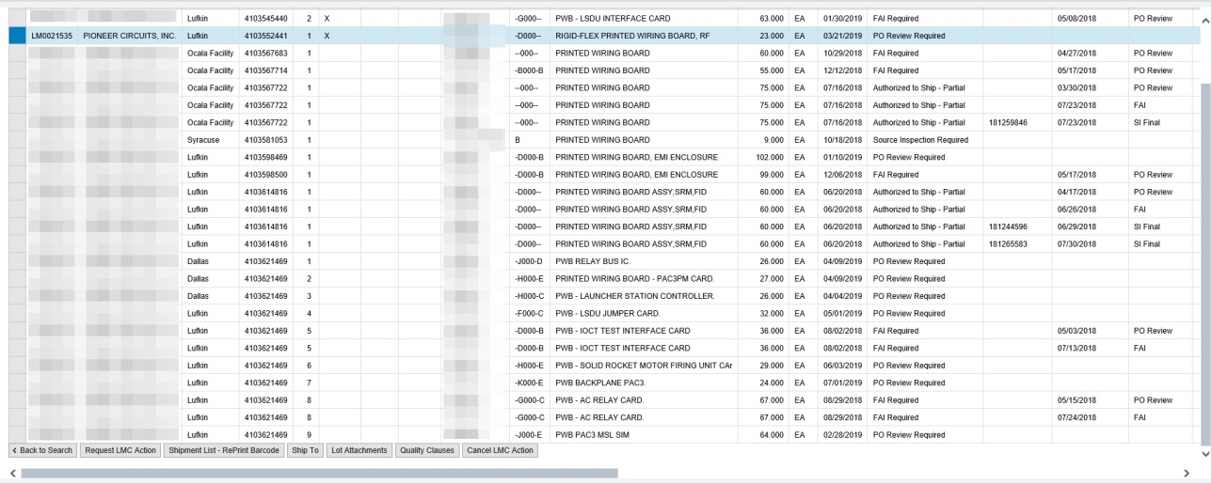

Step | Action
66. | Click the Lot Attachments button to attach documents or files that pertain to the LMC activity being performed or documentation requested by Lockheed Martin via Purchase Order flow down requirements.

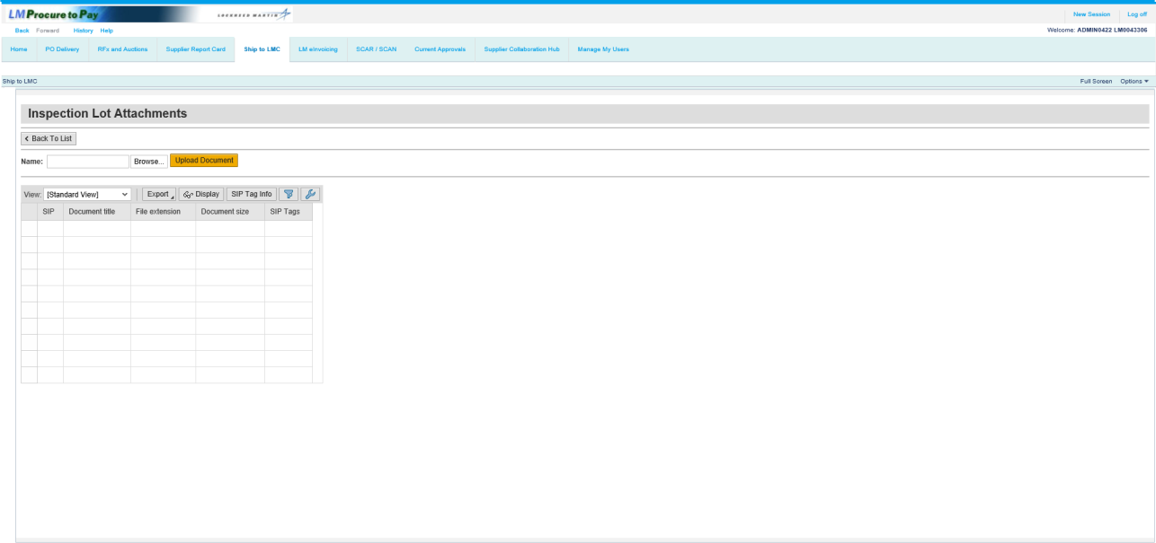

Step | Action
67. | Click the Browse... button to select a file to be uploaded.

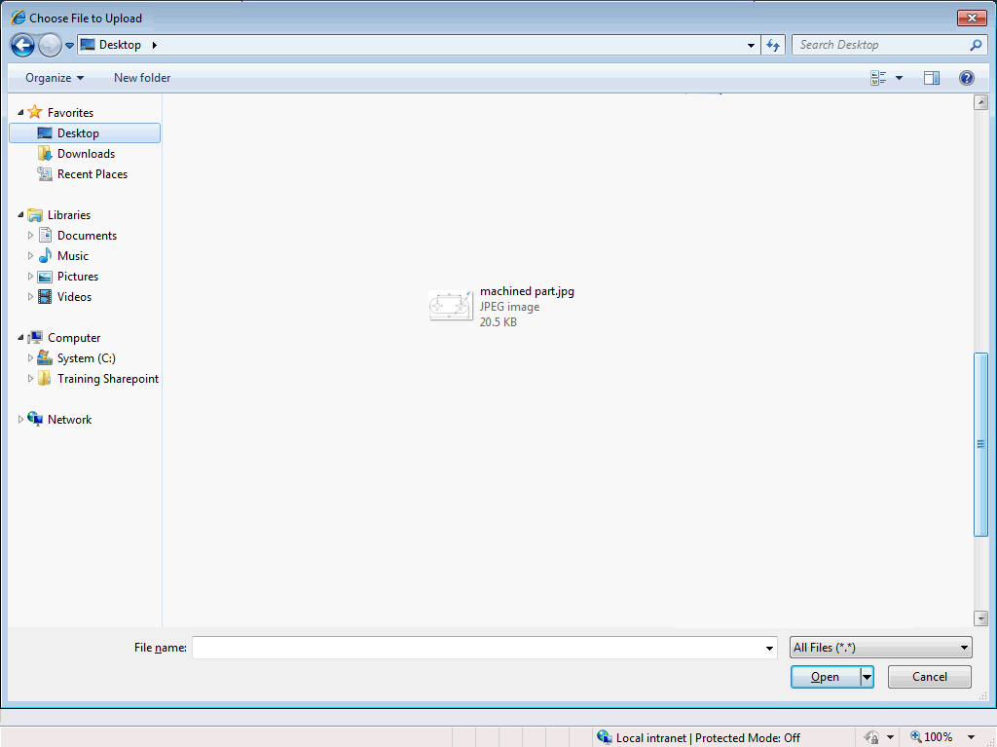

Step | Action
68. | Click the file to be uploaded.

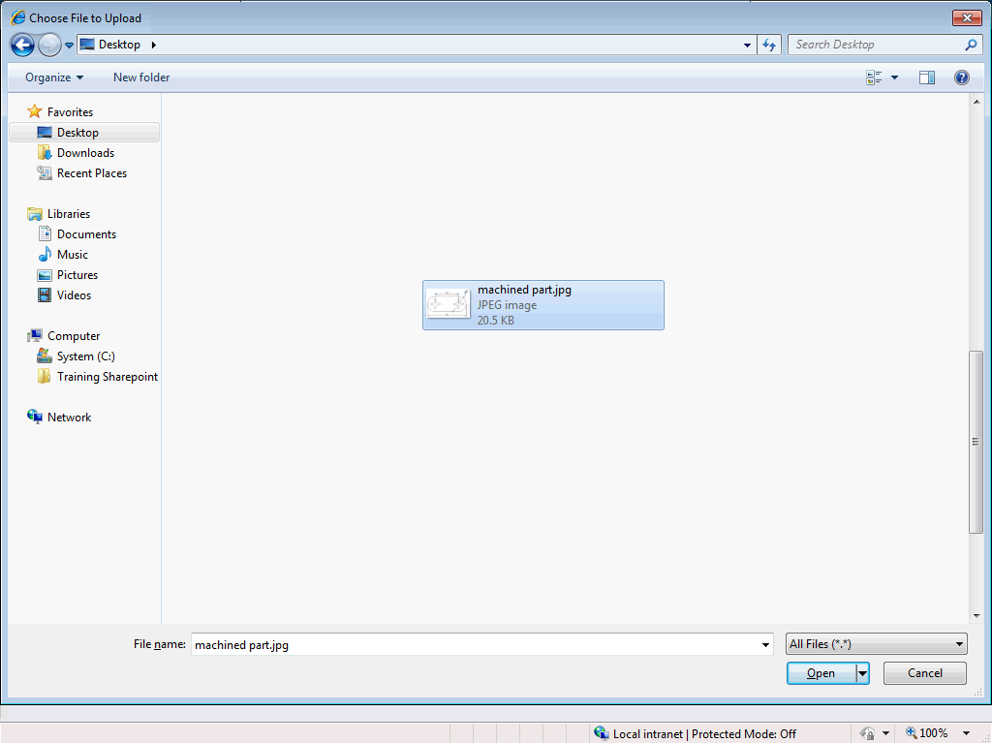

Step | Action
69. | Click the Open button to select the file.

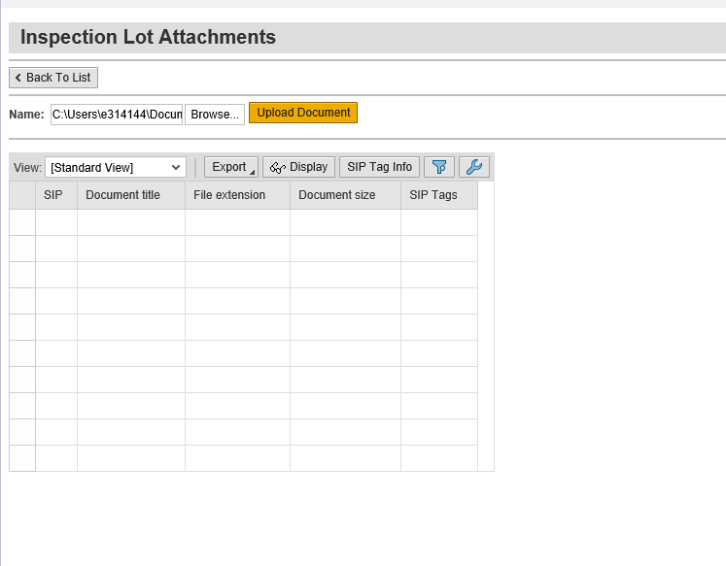

Step | Action
70. | Click the Upload Document button to associate the file to the created inspection lot.  You must apply the correct sensitive information protection (SIP) tag when attaching a document.  Note: You can click the SIP Tag Info button to view specific definitions for each SIP Tag. For instructions on how to properly upload secure attachments, access the Uploading and Displaying Secure Attachments reference guide on the Exostar P2P Support Guides page.  Caution: Once you upload a file, it can not be deleted.

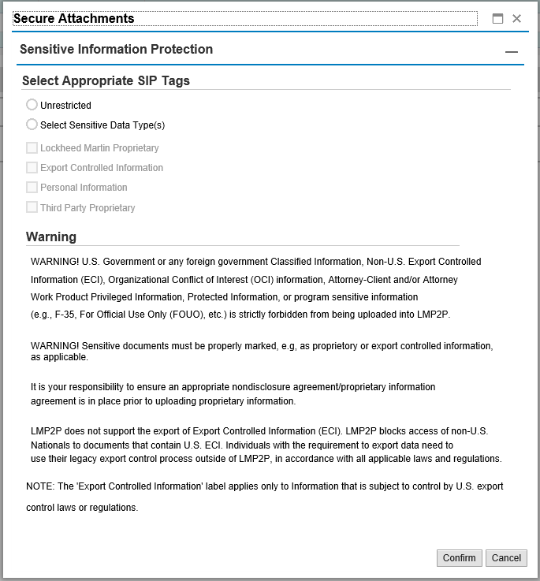

Step | Action
71. | Select the appropriate SIP Tag for the attached document. In this example, the document we've attached contains no sensitive information and it's marked as "Unrestricted".

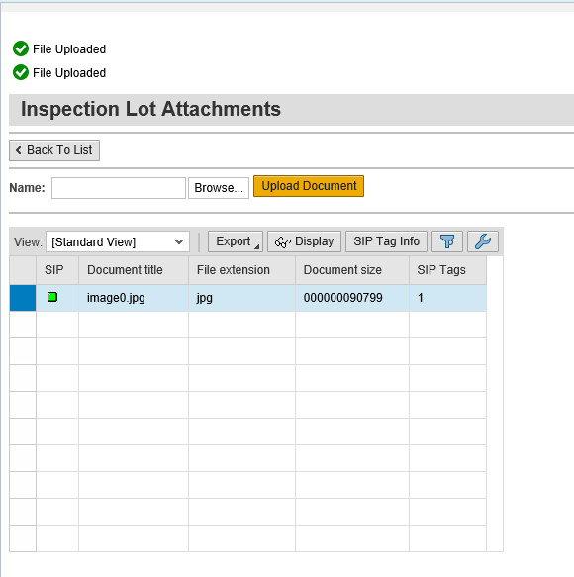

Step | Action
72. | Note the file name and properties are now associated with the inspection lot.  Note: To add additional files, repeat the upload document process.

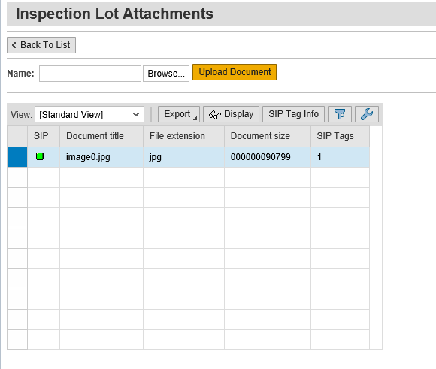

Step | Action
73. | To view the uploaded file, click the Display button.

Step | Action
74. | Click the Open button.

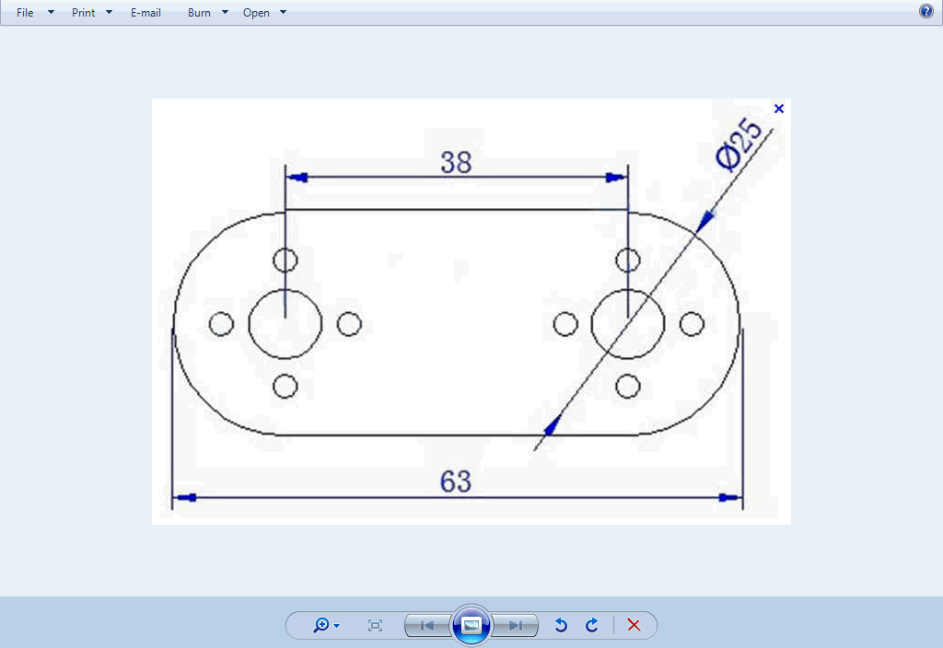

Step | Action
75. | The attached file displays. Click the Close button to return the Inspection Lot Attachments screen.

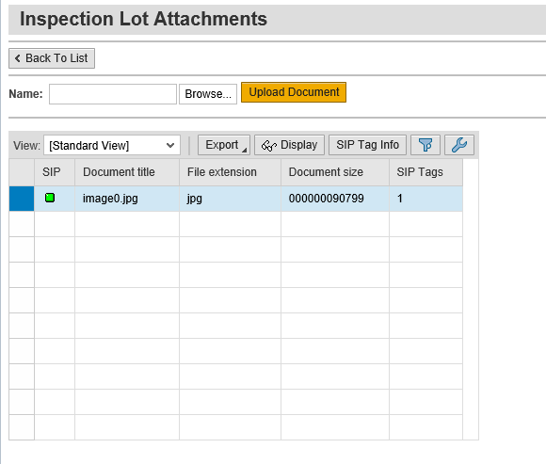

Step | Action
76. | Click the Back To List button to return to the Supplier PO and FQR List.

Request FAI
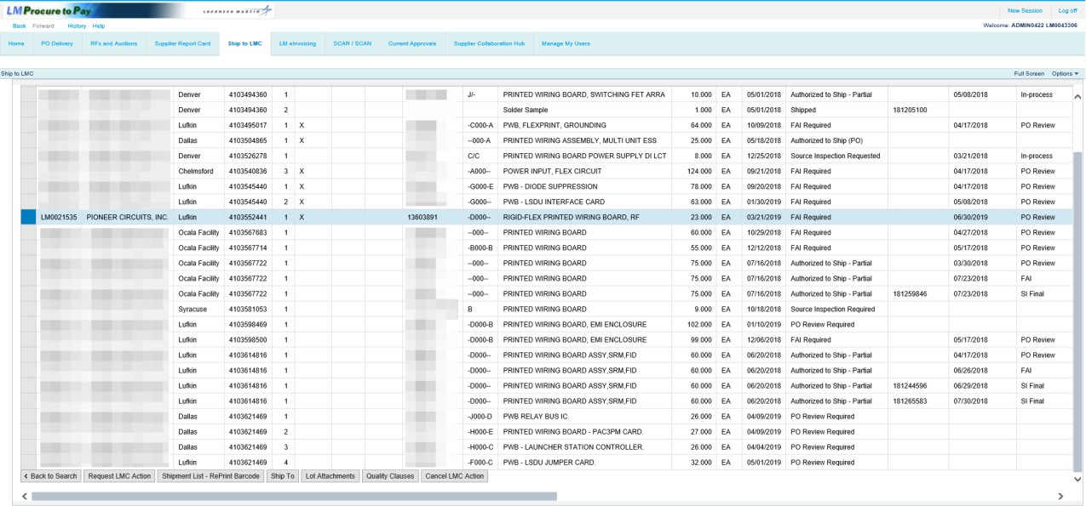

Step | Action
77. | After the PO Review activity has been completed and Accepted, the Overall PO/Line Status field will display the next activity to be requested. As in this example, the PO Review activity now shows as Accepted and FAI is now required to be requested. If the PO review activity had been Rejected, you will be required to re-request PO review after the required corrective actions are complete.  Note: Since FAI is still an outstanding activity on this Purchase Order, any attempt to perform Ship To processing at this point will be prevented and a message of Not Authorized for SHIP TO as Q status : FAI Required will be displayed.

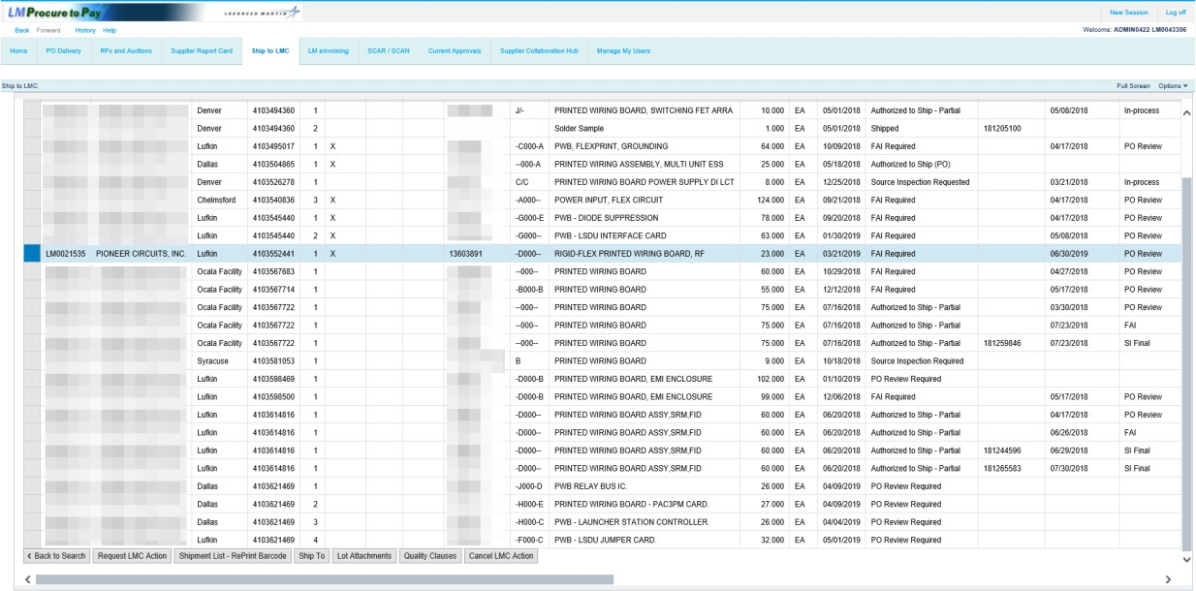

Step | Action
78. | To proceed, click the Request LMC Action button to schedule the Lockheed Martin Source Representative to visit your facility to perform the requested onsite action.

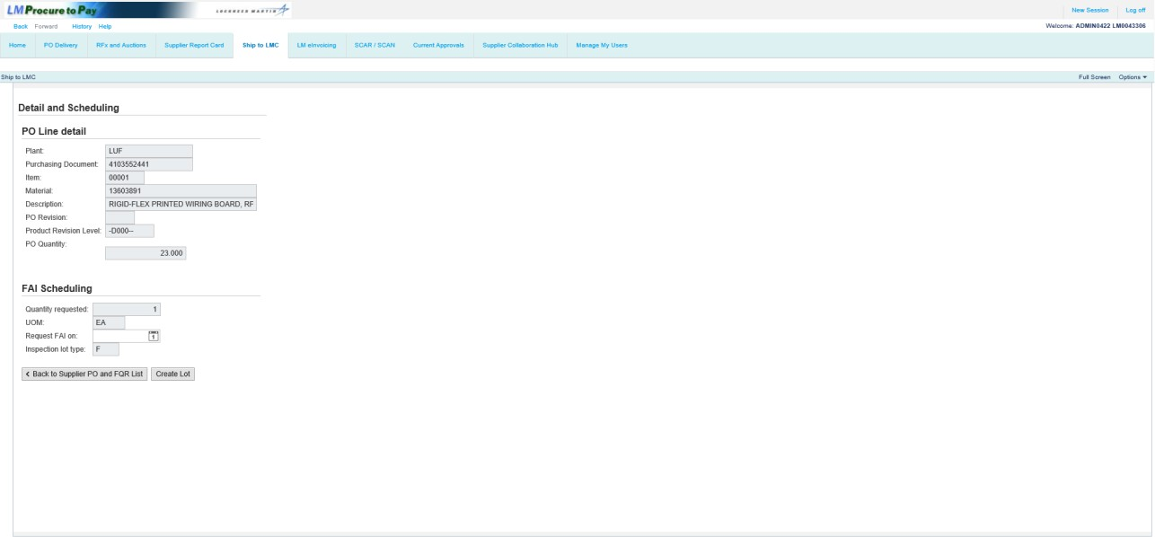

Step | Action
79. | Note: First Article Inspection is a one-time LMC activity. Note that a quantity of one will default in the Quantity requested field for the PO line item selected.  Enter the date the Lockheed Martin Source Representative will visit the facility to perform FAI.  Click the Request FAI on calendar button to select a date.

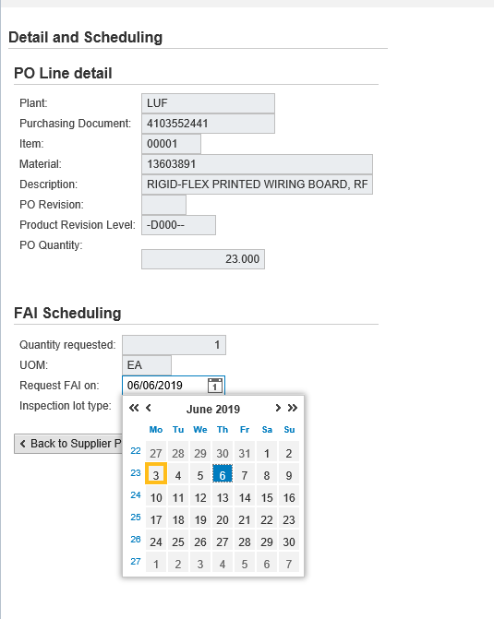

Step | Action
80. | Click the desired date.

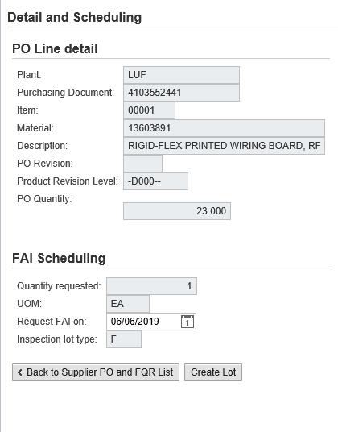

Step | Action
81. | Click the Create Lot button to create the inspection lot (see the upper portion of the screen for the lot number).

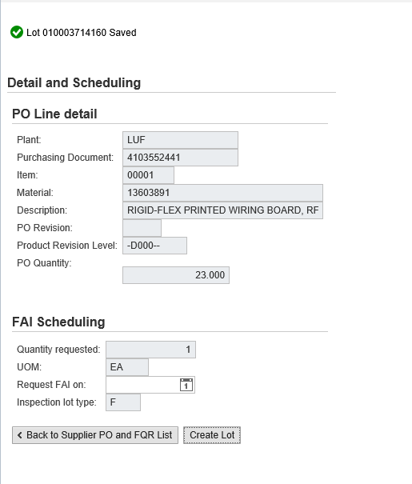

Step | Action
82. | A message appears that the lot is saved.  Click the Back to Supplier PO and FQR List button to return to the queue.

Request Source Inspection
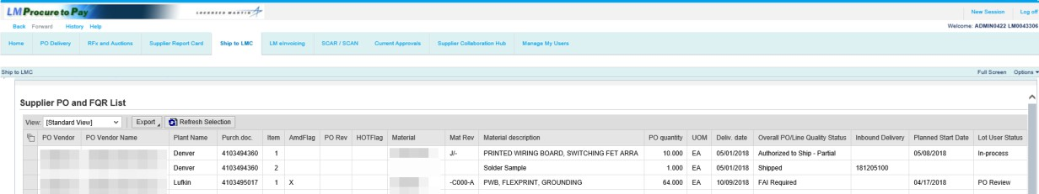

Step | Action
83. | Click the Refresh Selection button to view the submitted inspection lot data.

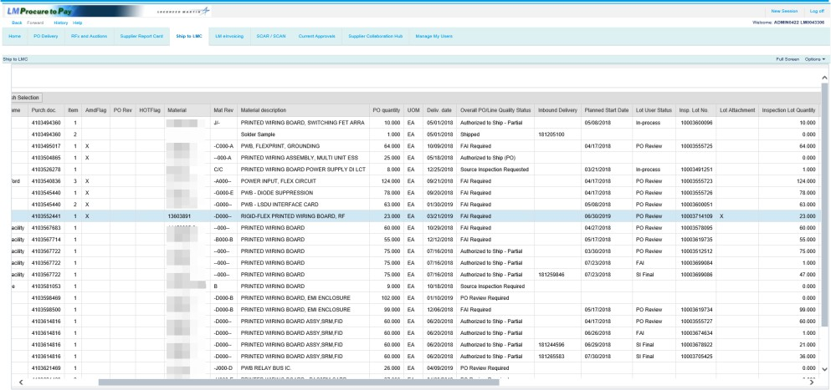

Step | Action
84. | Note the created inspection lot in the Insp. Lot No. field and the added scheduled date in the Planned Start Date field. for the line item with the quantity of 1 and the lot user status of FAI.  The previously performed PO review lot also displays as a separate activity line.  Note: If any required documentation is needed, use the Lot Attachments button to include the files for this inspection lot activity.

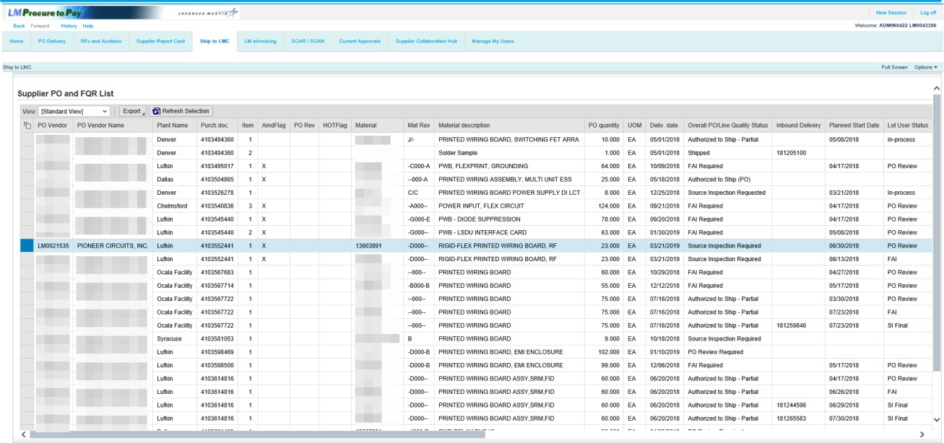

Step | Action
85. | After the FAI activity has been completed and Accepted, the Overall PO/Line Status field will display the next activity to be requested. As in this example, the FAI activity now shows as Accepted and Source Inspection is now required to be requested. If the FAI activity had been Rejected, you will be required to re-request FAI after the required corrective actions are complete.  Note: Since Source Inspection is still an outstanding activity on this Purchase Order, any attempt to perform Ship To processing at this point will be prevented and a message of Not Authorized for SHIP TO as Q status : Source Inspection Required will be displayed.

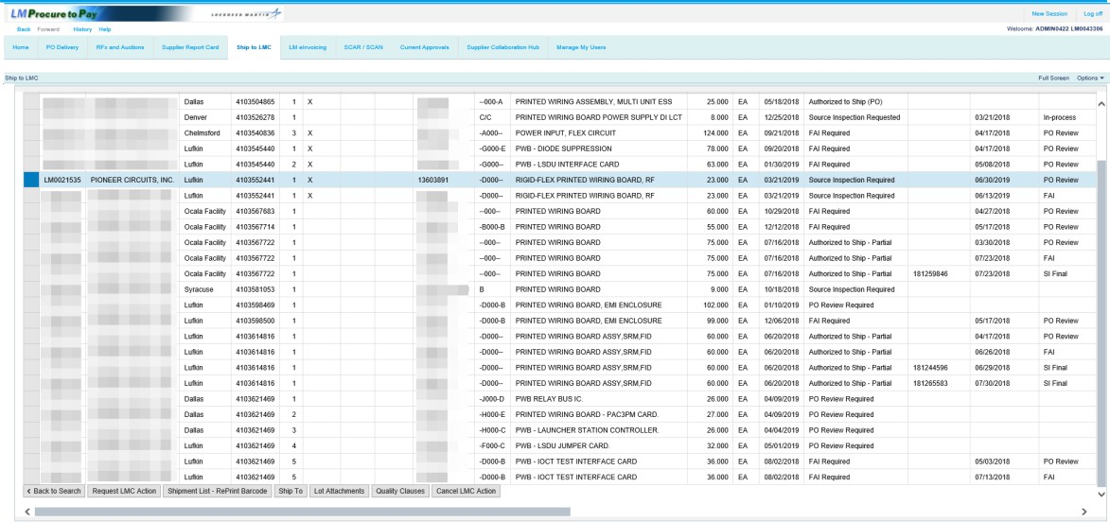

Step | Action
86. | Click the Request LMC Action button.

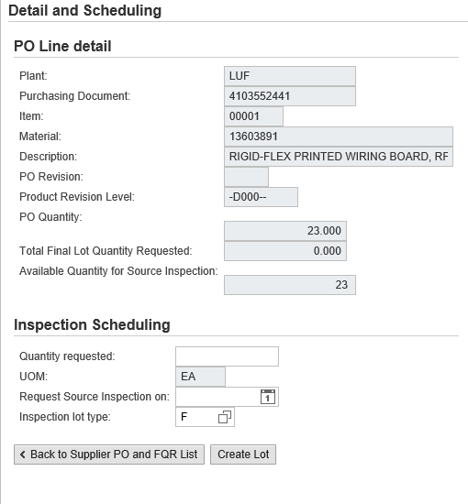

Step | Action
87. | Note: For Source Inspection requests, enter the quantity ready to be evaluated by a Lockheed Martin Source Representative. Either partial or full quantities may be requested.  Click in the Quantity requested field.

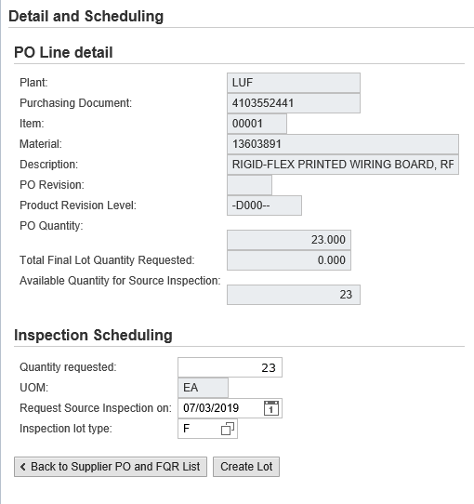

Step | Action
88. | In this example, Source Inspection is being requested for the full PO quantity.  Enter the quantity into the Quantity requested field.

Step | Action
89. | In this example, the Source Inspection is being requested on 07/03/2019. To request a different date, follow the process covered earlier in this help file.

Step | Action
90. | The default for Inspection lot type is F - Final Inspection and is the only acceptable lot type for shipment to Lockheed Martin.  Select In-Process lot type as directed by Lockheed Martin to perform inspections, such as a pre-cap visual.

Step | Action
91. | Click the Create Lot button to create the inspection lot (see the upper portion of the screen for the lot number). The system will determine if the source inspection can be skipped.  Note: After clicking Create Lot, a message appears at the top of the screen. If the lot number listed in the message contains a suffix of either Accepted QVP or Accepted AIM, Source Inspection is no longer required and you can process the immediate shipment for the material. If the lot number does not contain a suffix, Source Inspection is required and a Lockheed Martin Source Representative will be assigned.

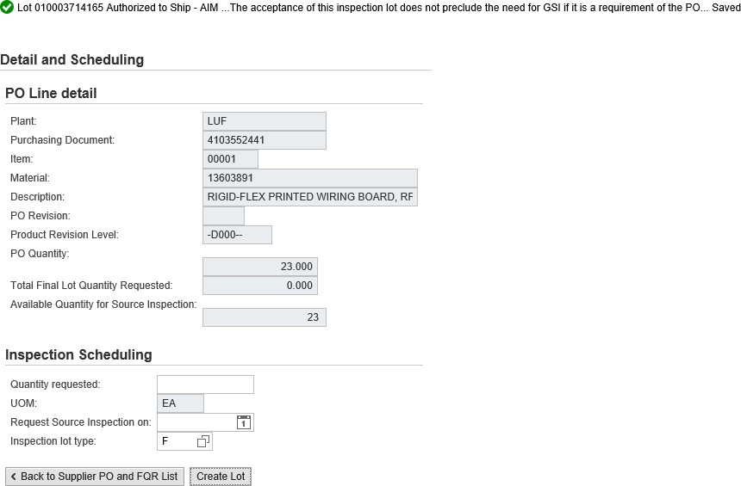

Step | Action
92. | In this example, a suffix of Accepted AIM was encountered for this lot and therefore Source Inspection is not required.  Click Back to Supplier PO and FQR List.

Authorized to Ship/Ship to Processing

Step | Action
93. | Click the Refresh Selection button.

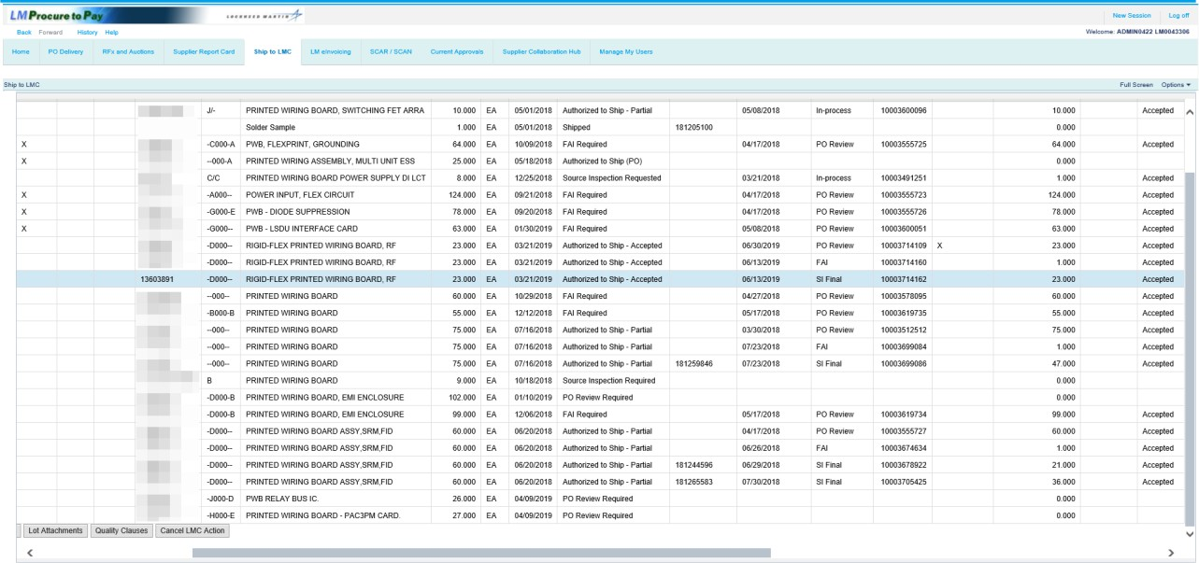

Step | Action
94. | If the Quality status displays Authorized to Ship or Accepted by AIM/QVP Process, click the line item and click the Ship To button.  Note: Only PO lines that display a lot user status of SI Final may be selected when ready to process Ship To records. An error message will display if PO lines with lot user statuses of PO Review or FAI are selected.

Step | Action
95. | Click the Ship To button.

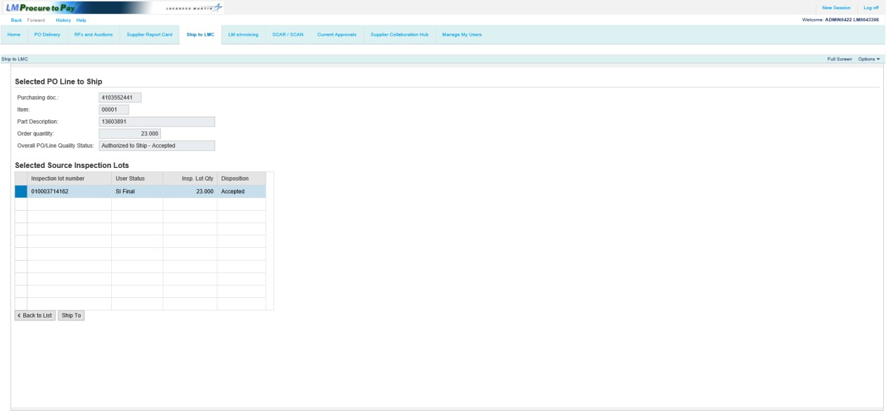

Step | Action
96. | Click the Ship To button.  Note: Use CTRL or Shift + click to select multiple lines (must be multiple inspection lots from the same purchase order line item).

Ship To LMC Header Screen
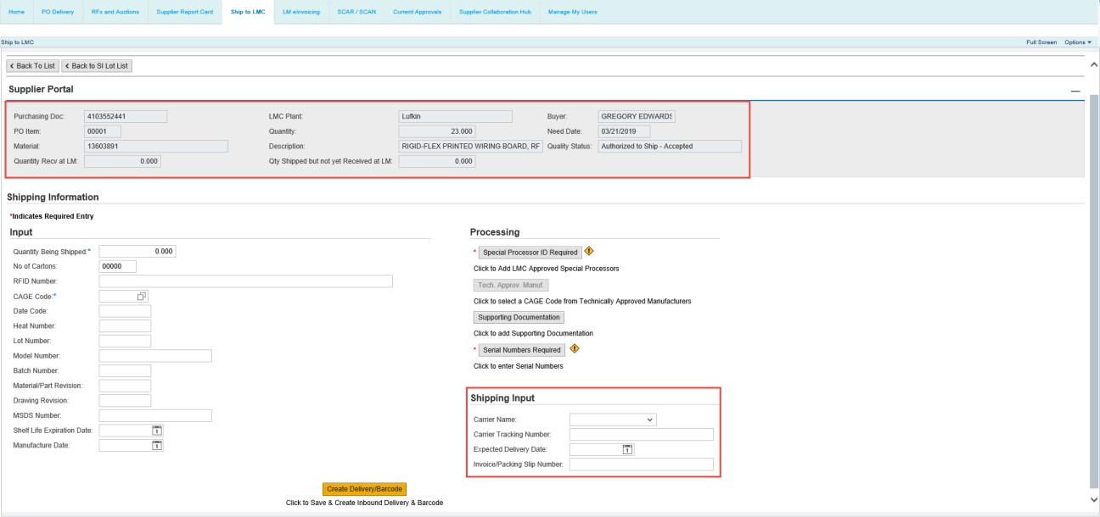

Step | Action
97. | There have been some enhancements to this Ship To header screen.  The Quantity Shipped but not yet Received at LM, Quantity Received at LM, PO Line Item Material Number and Batch Number fields have recently been added.  The Shipping Input section has been modified to include Carrier Name, Carrier Tracking Number, Expected Delivery Date and Invoice Packing Slip Number information.  The Purchasing Org field was removed and LMC Plant has replaced the Plant code  field, whereby the Lockheed Martin business name is provided.

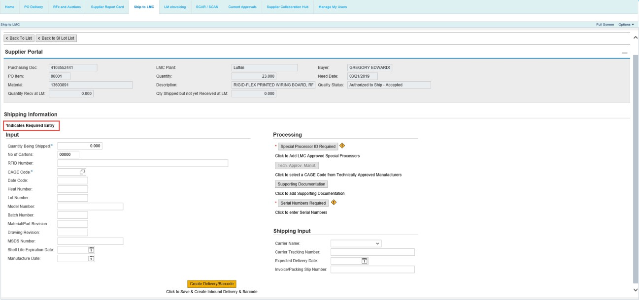

Step | Action
98. | The input message now reads *Indicates Required Entry and has an asterisk (*). Plant configured required text fields are identified with an asterisk (*).

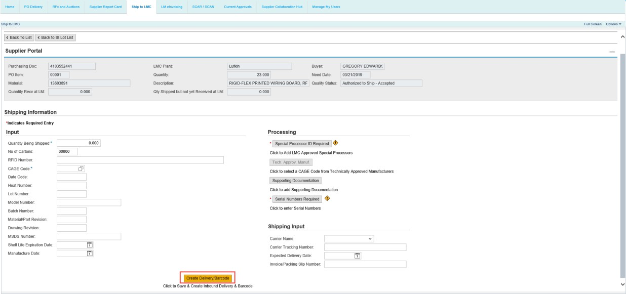

Step | Action
99. | The Create Delivery and Barcode buttons no longer display and have been replaced with a button called Create Delivery/Barcode exists. This new button combines the functions of the former Create Delivery and Barcode buttons and has been relocated to the bottom center of the screen.

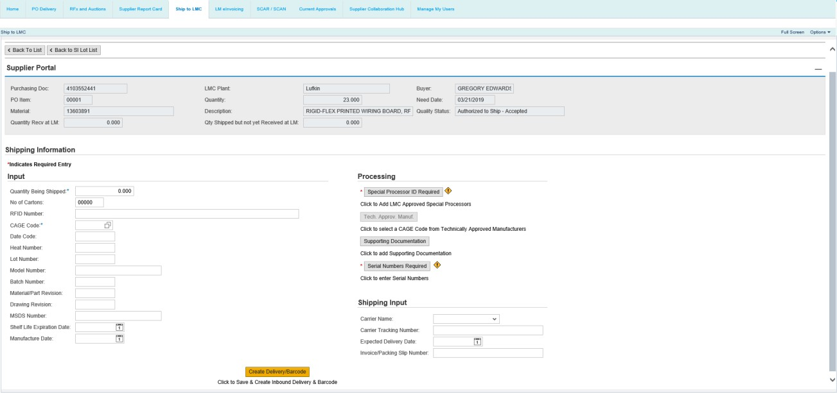

Step | Action
100. | Click in the Quantity Being Shipped field.

Step | Action
101. | Enter a quantity to ship in the Quantity Being Shipped field.

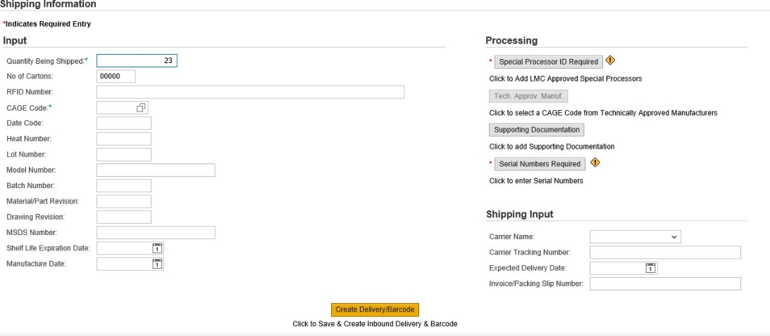

Step | Action
102. | Click in the No of Cartons field.

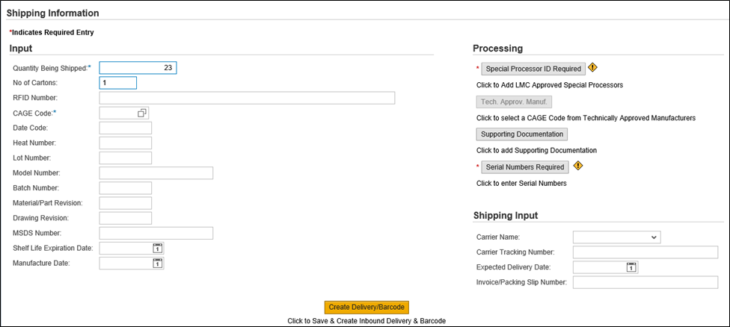

Step | Action
103. | Enter the number of cartons in the shipment in the No of Cartons field.

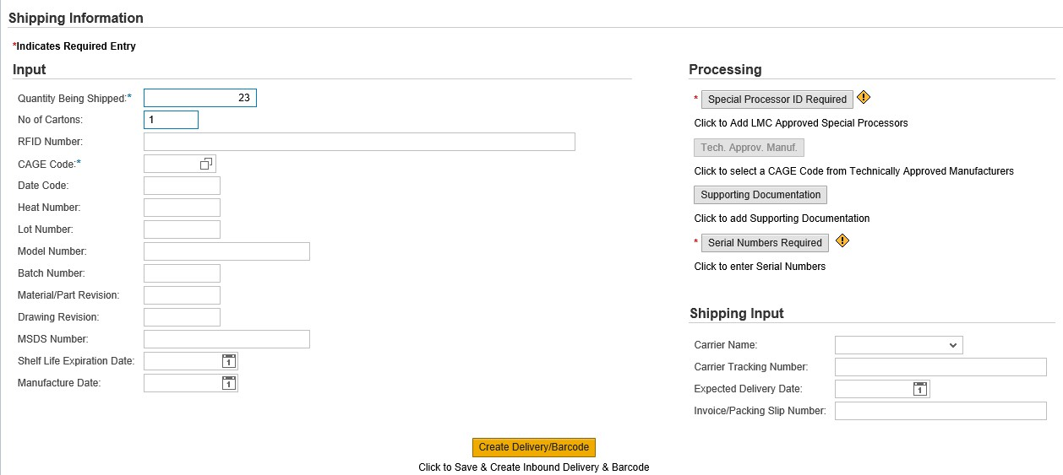

Step | Action
104. | If required by the purchase order, enter the RFID number.

Step | Action
105. | Some Lockheed Martin sites will require a CAGE (Commercial and Government Entity) code. If a CAGE code is required, you will receive an error and must enter a CAGE code before finalizing the shipment.  Note: Please ensure that the CAGE code recorded represents the manufacturer of the product being shipped to Lockheed Martin.

Special Processors

Step | Action
106. | Click the Special Processor ID Required button.

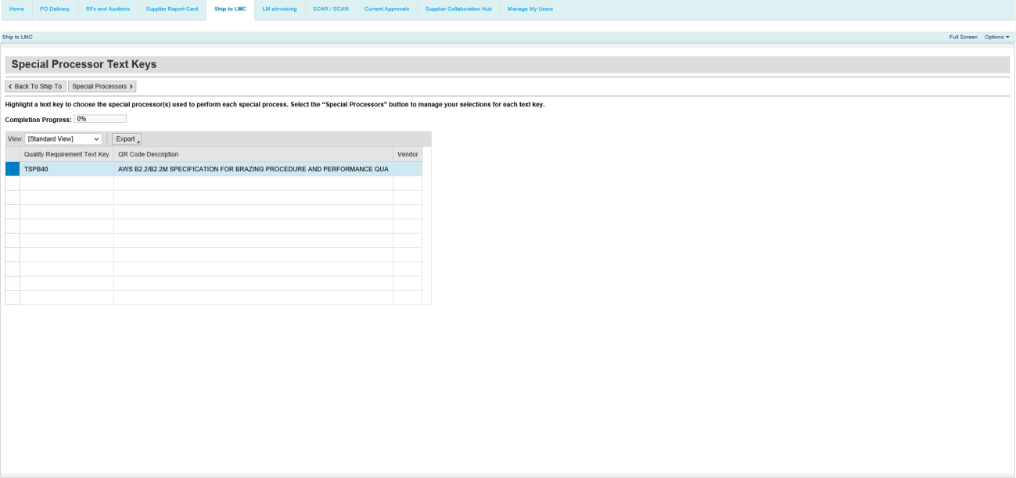

Step | Action
107. | Special Processor text keys display with descriptions and may be selected in any  order. As special processors are chosen, a completion progress bar will track the percent complete.  You can navigate back to the previous screens even if a text key was not selected. If text keys were chosen you navigate to another screen, the selection(s) and progress bar status are retained.  Once all the text keys have at least one processor, special processor text key screen will show the 100% completion. The Special Processor button on the Ship To screen will appear with a green check to show the step as completed.

Step | Action
108. | Click the Special Processors button.

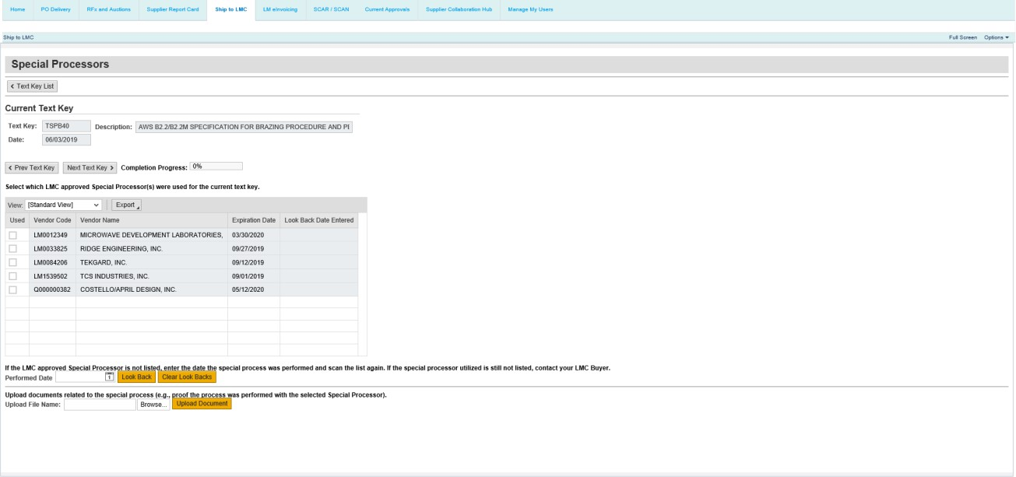

Step | Action
109. | As special processors are chosen, a completion progress bar will track the percent complete.  While this example includes one unique special process text key, there can be numerous special process text key requirements for any given PO line item. In those cases and after each special process text key requirement has been satisfied, the progress bar percentage will calculate completion based on the remaining text key requirements  You can navigate back to the previous screens even if a text key is not selected. If text keys are chosen and you navigate to another screen, the selection(s) and progress bar are retained.

Step | Action
110. | To perform a look back search, click the date button in the Performed Date field.

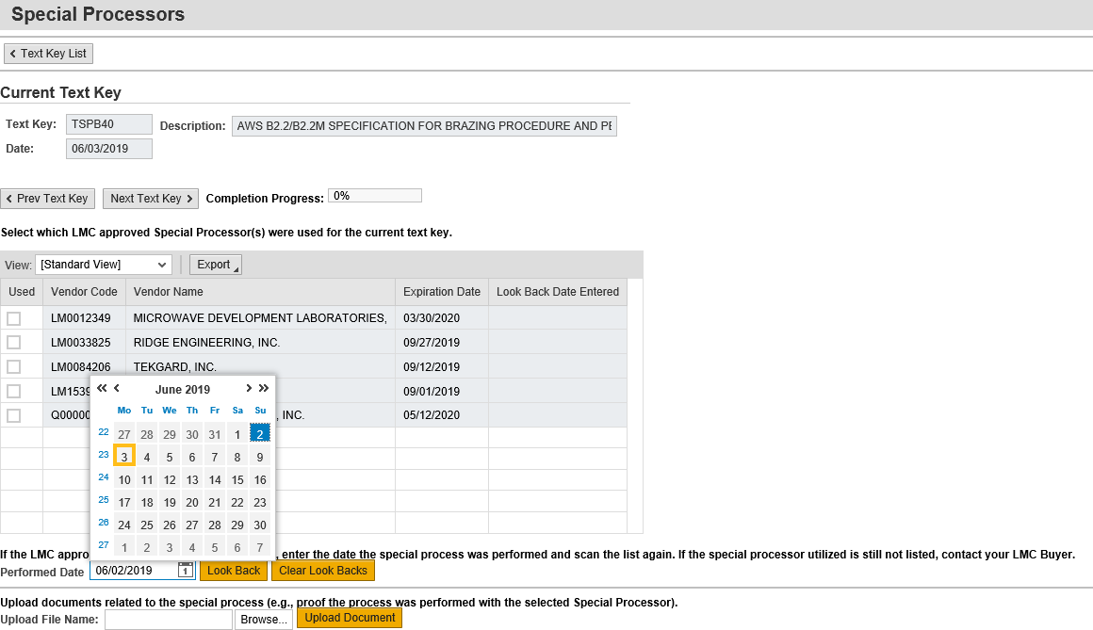

Step | Action
111. | Choose a look back date using the calendar.

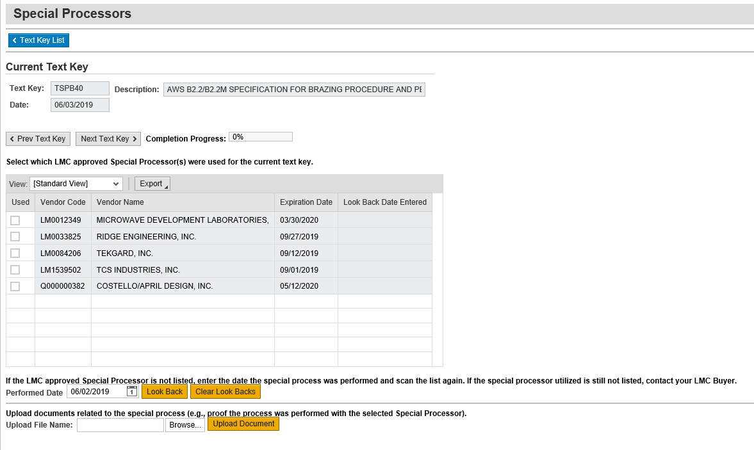

Step | Action
112. | Click the Look Back button.

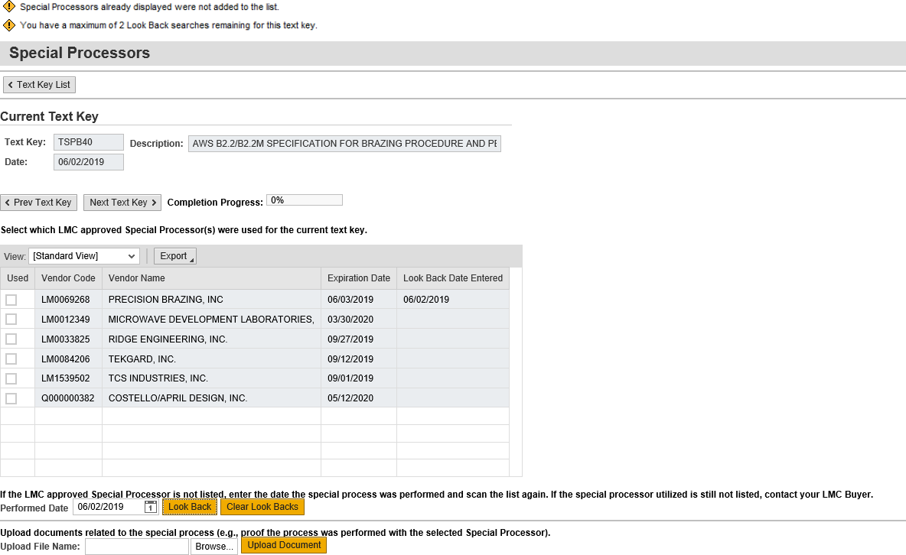

Step | Action
113. | Note the message that you have two look back searches remaining for this text key. You can only perform a look back three times for each special processor record. After the third attempt, the Ship To record is locked for the PO line item record and the PO quality status code is set to P17, Locked - call LMC.

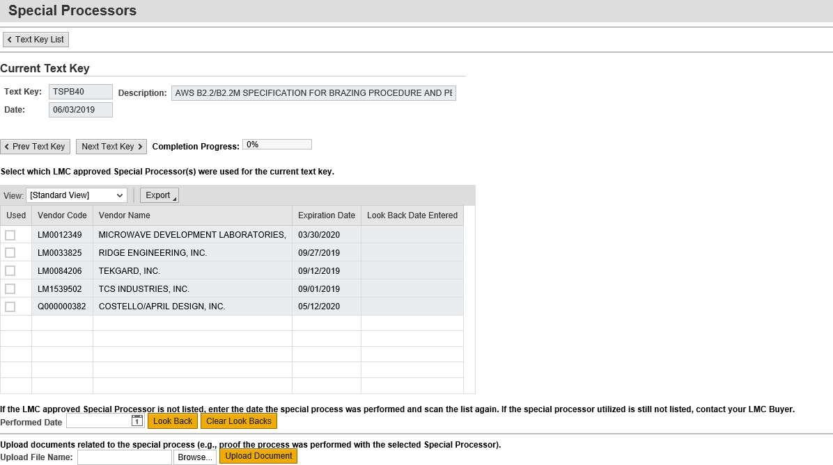

Step | Action
114. | Click a checkbox to select it as the special processor.

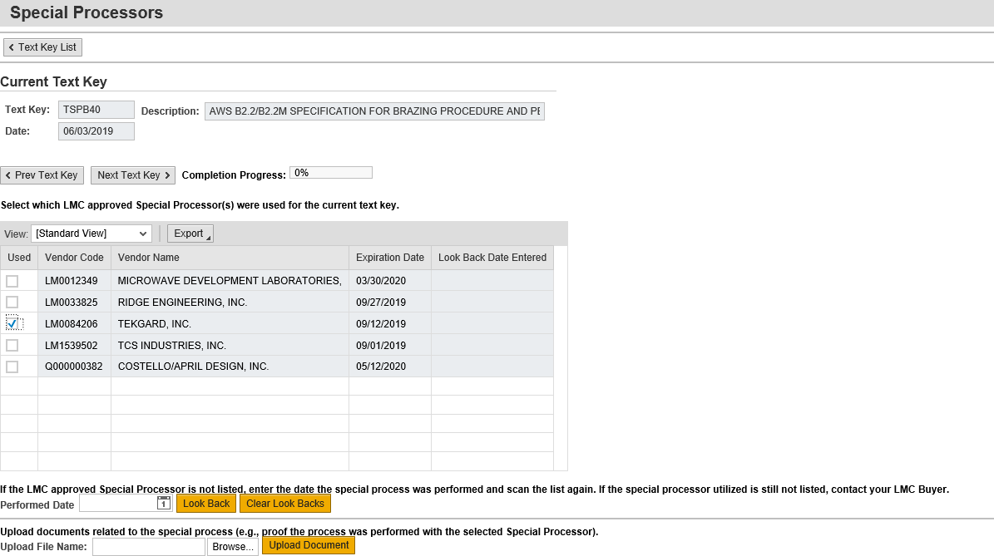

Step | Action
115. | Click the Next Text Key button.

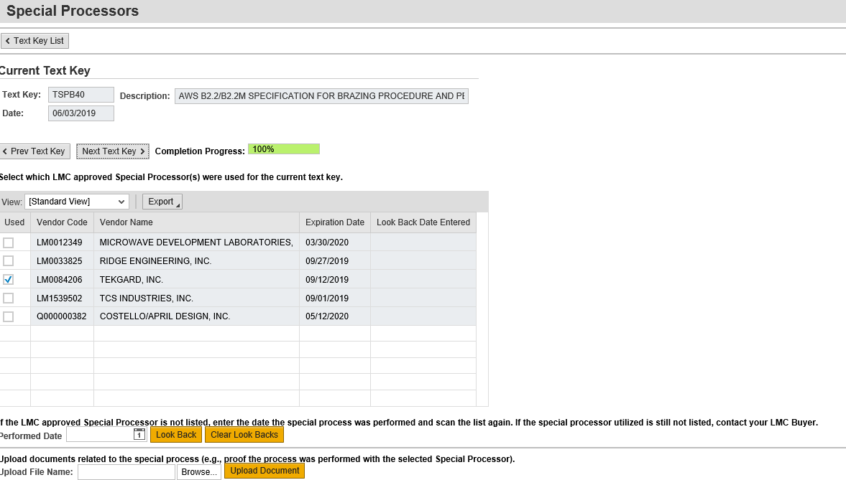

Step | Action
116. | There is only one text key in this example. Note the Completion Progress shows 100% completion.

Step | Action
117. | Click the Text Key List button.

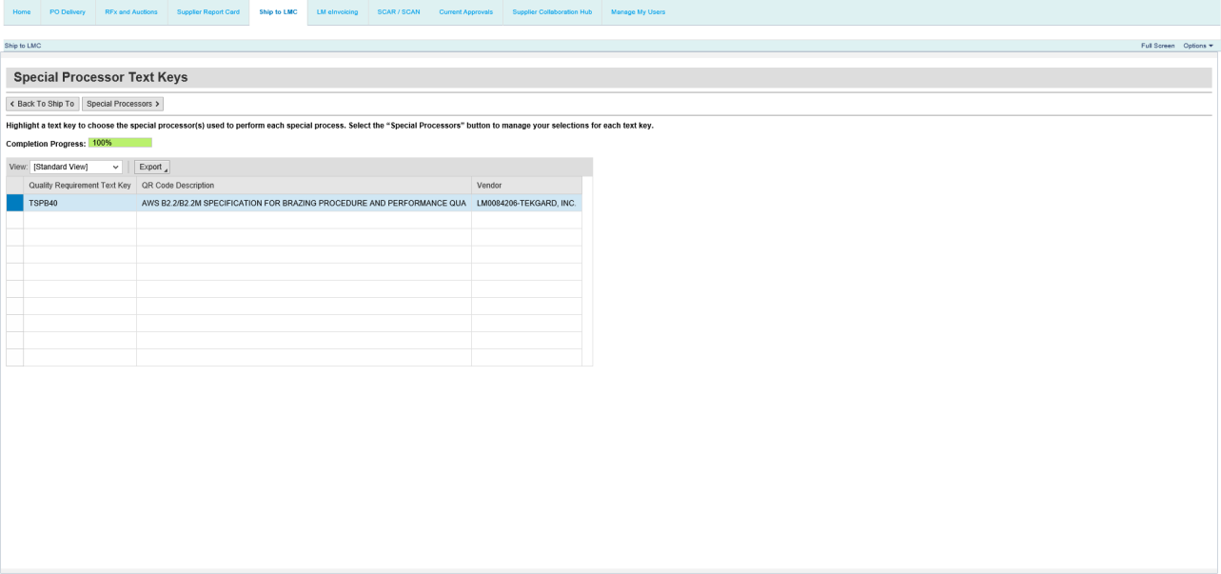

Step | Action
118. | Click the Back To Ship To button to return to the Ship To processing screen.

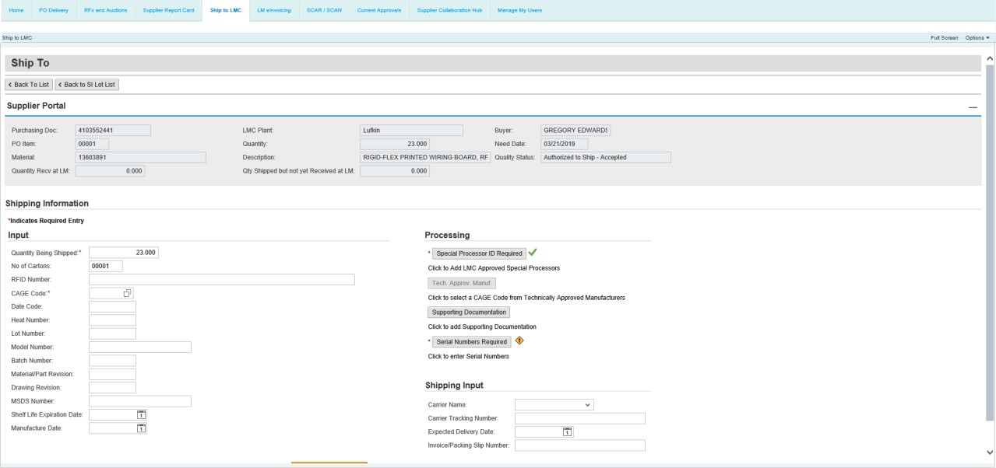

Step | Action
119. | Note the Special Processor ID Required button now displays a green completion checkmark.  If required by the purchase order line item, a document upload may be required.

Serial Numbers

Step | Action
120. | If required by the purchase order line item, enter the serial numbers of the items being shipped.  Click the Serial Numbers button. The serial number input field is mandatory if a yellow sign appears next to the button. Serial numbers may also be mandatory if required by Lockheed Martin purchase order text.

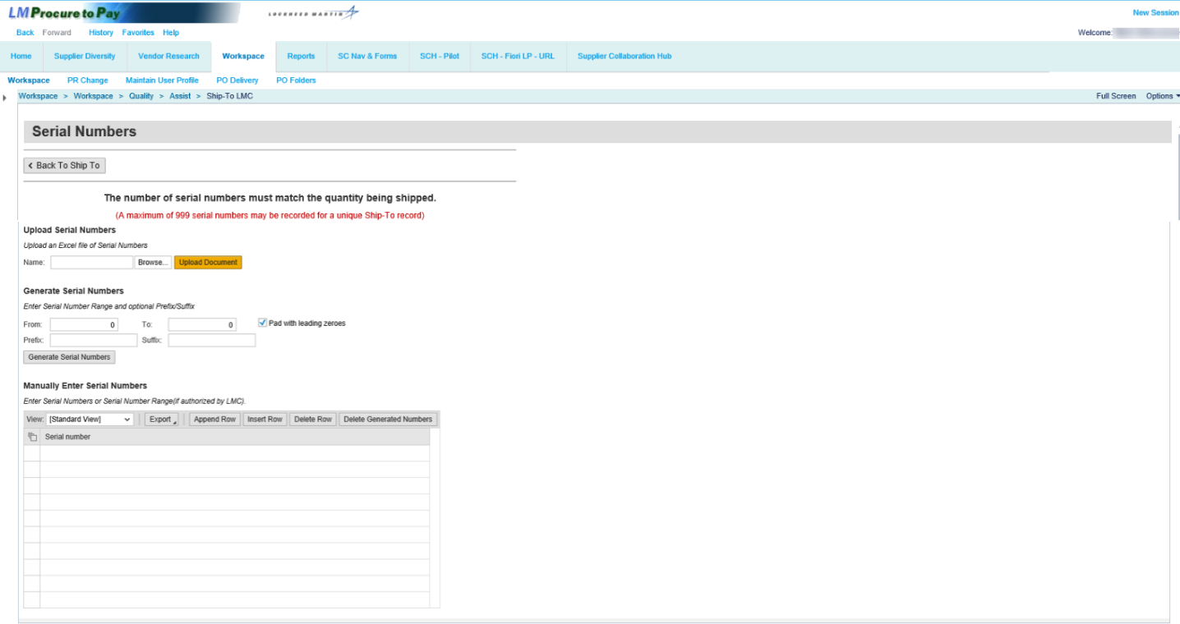

Step | Action
121. | In general, the number of serial numbers recorded must exactly match the number value recorded within the Ship To Quantity Being Shipped field or an error will be displayed. Also, a maximum length of 30 characters cannot be exceeded for any serial number recorded.  Note: A maximum of 999 serial numbers can be recorded for a unique Ship-To record. For serialized quantities beyond 999, additional ship to records must be created to support the balance of serial numbers.

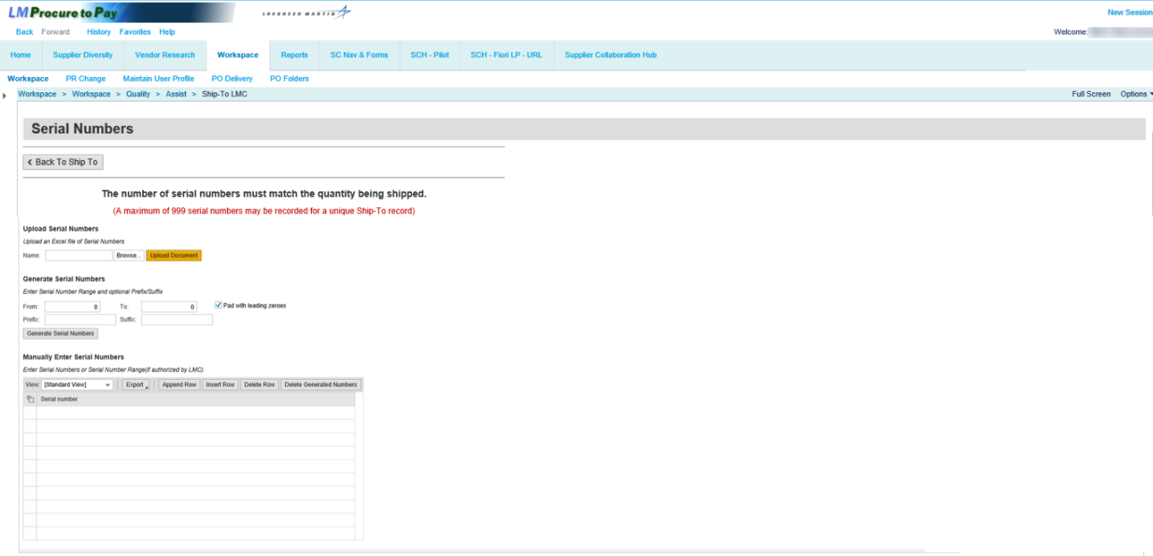

Step | Action
122. | Listed under the Upload Serial Numbers section, serial numbers may now be uploaded via MS Excel.  When using this method, a single column of the MS Excel file shall be used to record all serial numbers. If duplicate serial numbers are found within the file or the total number of unique serial numbers uploaded exceeds the inbound delivery (IBD) quantity being shipped, an error will be displayed to the user to manage file corrections.

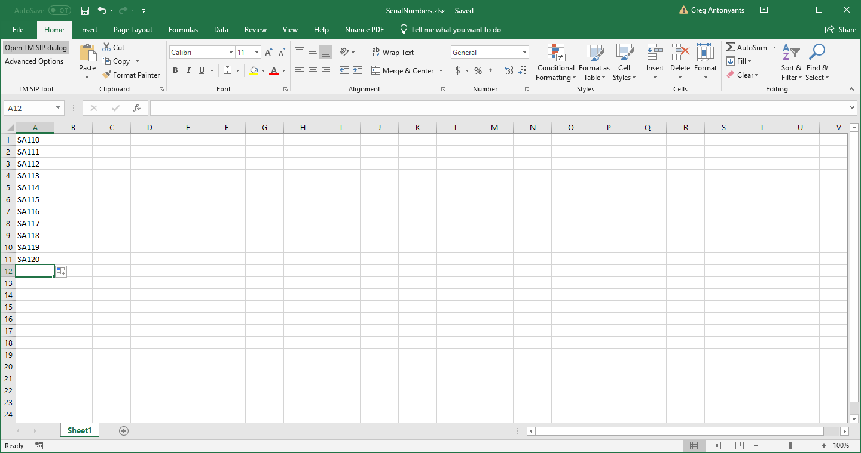

Step | Action
123. | This is an example of a Microsoft Excel spreadsheet with a single column including 11 different serial numbers.

Step | Action
124. | Click the Browse button to find the file you want to upload on your desktop.

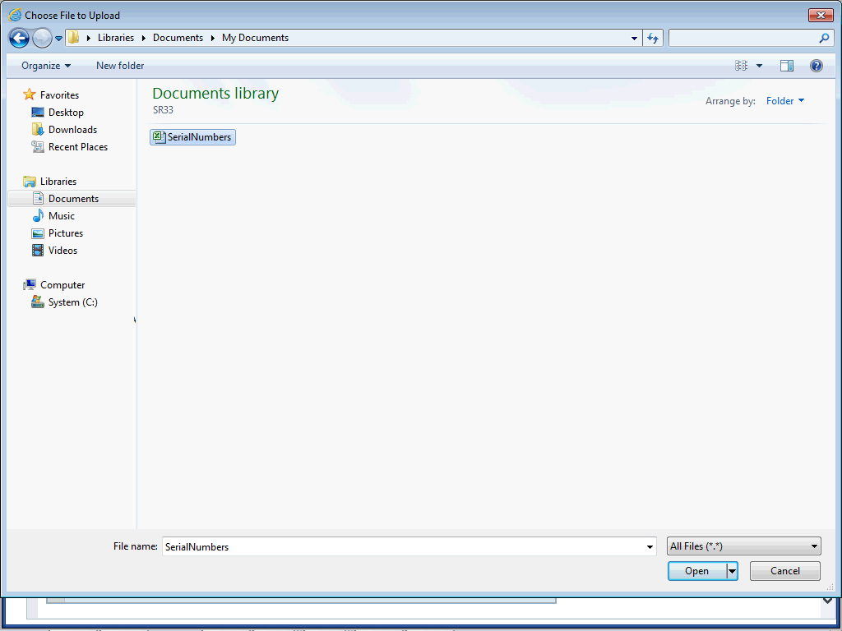

Step | Action
125. | Select the file to upload.

Step | Action
126. | Click the Open button.

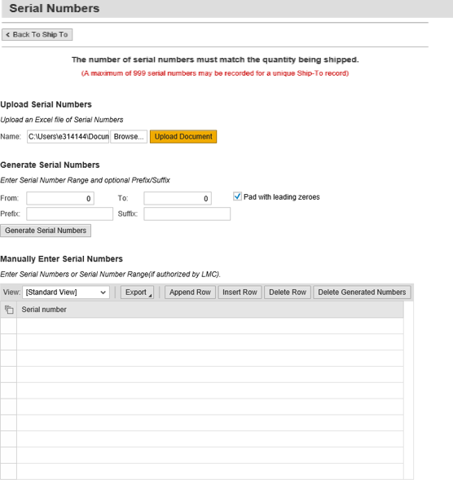

Step | Action
127. | Click the Upload Document button.

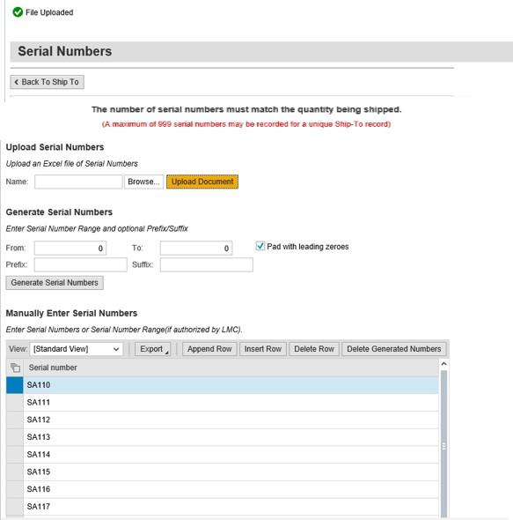

Step | Action
128. | Note the File Uploaded message at the top of the screen and the serial numbers that have been uploaded in the Serial Number table.

Step | Action
129. | You can manually delete the uploaded serial numbers row by row by clicking the Delete Row button. You can also delete all uploaded serial numbers at once by utilizing the Select All button that is demonstrated in the next step.

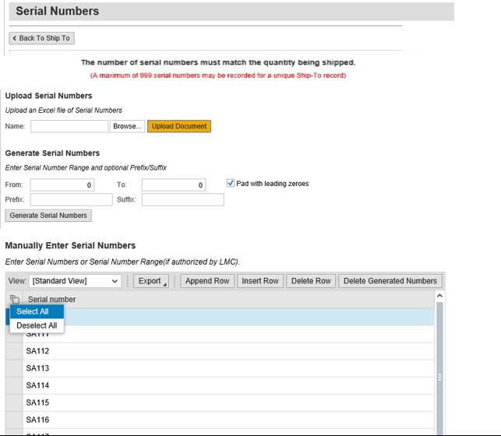

Step | Action
130. | Click the icon next to Serial Number and click Select All.

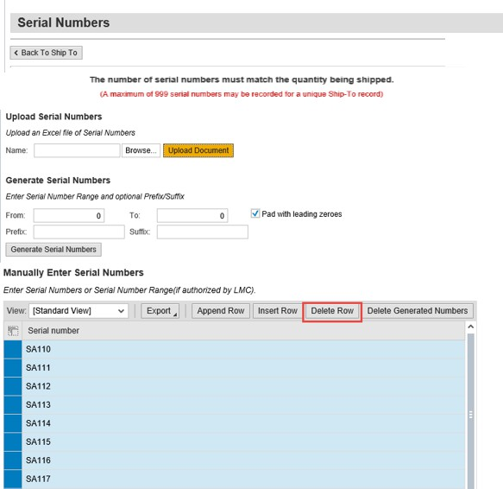

Step | Action
131. | All of the serial numbers in the table are selected. Click Delete Row to delete all of the upload serial numbers.

Step | Action
132. | Note that all of the serial numbers have been deleted from the table.

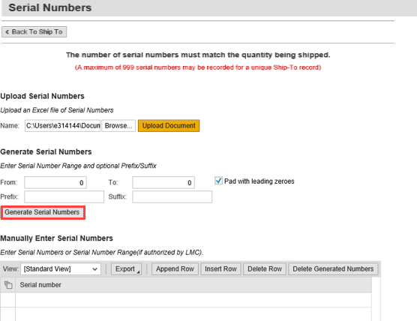

Step | Action
133. | Listed under the Generate Serial Numbers section, a range of serial number values can be input and the full list (or series) of serial numbers will then be automatically created after selecting the Generate Serial Numbers button.  Serial number prefixes and/or suffixes can also be specified as part of the serial number range values as can the ability to pad input serial numbers with leading zeroes.  In this example, we’ve typed 100 in the From field and 110 in the To field. We’ve also entered a prefix of SA in the Prefix field. You also have the option to enter a suffix in the Suffix field.  Click the Generate Serial Numbers button, which will add the serial number range of  SA100 – SA110.

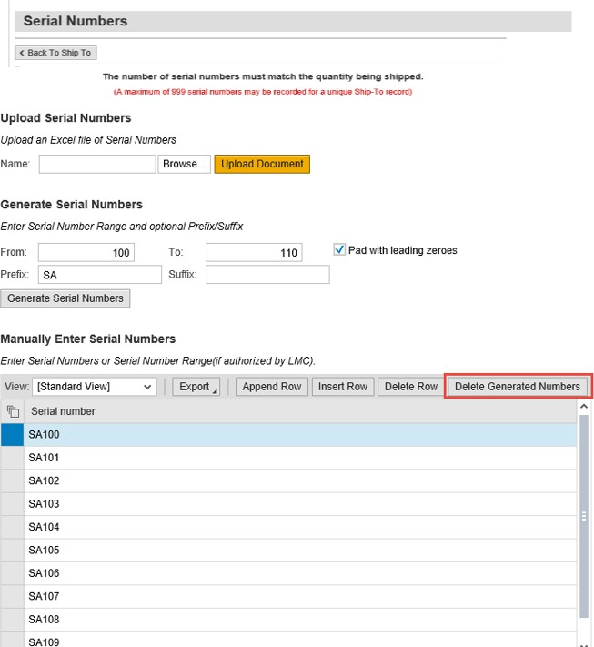

Step | Action
134. | Note the serial numbers have been added in the table.  Listed under the Manually Enter Serial Numbers section, a new capability (Delete Generated Numbers button) has been added to manage the deletion of auto-generated serial numbers should range record input mistakes occur. Existing capabilities for manually inserting or deleting serial number record rows also remains available.  Click Delete Generated Numbers to delete the auto-generated serial numbers.  Note: Remember the Delete Generated Numbers button does NOT delete file uploaded serial numbers.

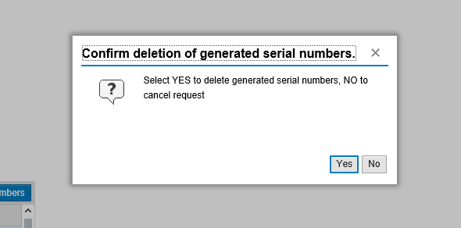

Step | Action
135. | A pop-up message appears. Click Yes to confirm the deletion of the generated numbers.

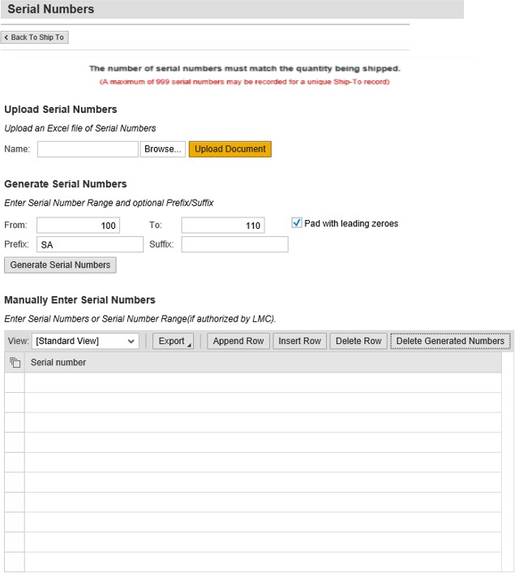

Step | Action
136. | Note the auto-generated serial numbers are deleted.

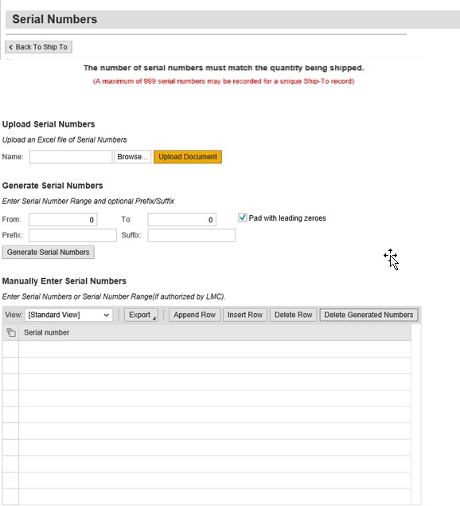

Step | Action
137. | You can also manually add serial numbers by clicking in an available row in the Serial Number table. Manually enter a serial number into a highlighted row.

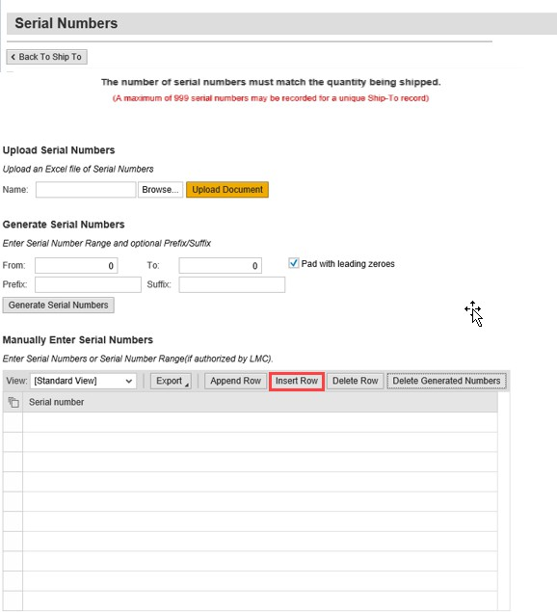

Step | Action
138. | A serial number has been manually added to the table. Click Insert Row to manually add another serial number.

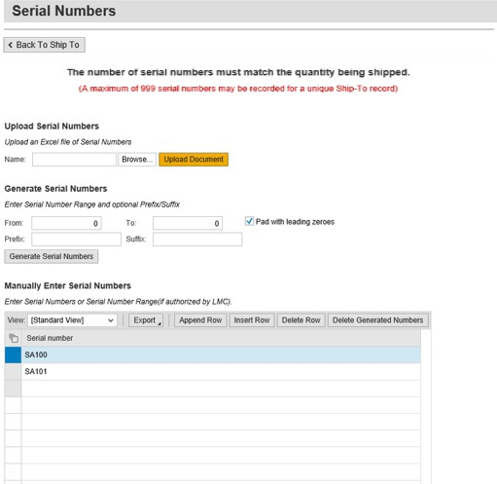

Step | Action
139. | Continue clicking the Insert Row button and manually adding more serial numbers to each available row of the table, if needed.

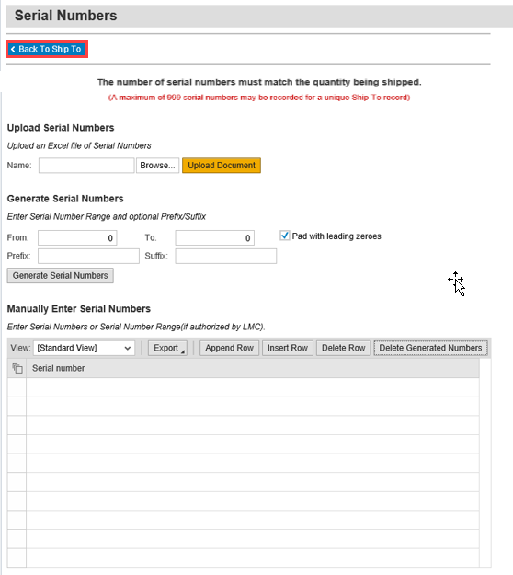

Step | Action
140. | Click the Back To Ship To button. Note the Serial Numbers Required button will display a green completion checkmark if the serial number field was marked as mandatory.

Shipping Input
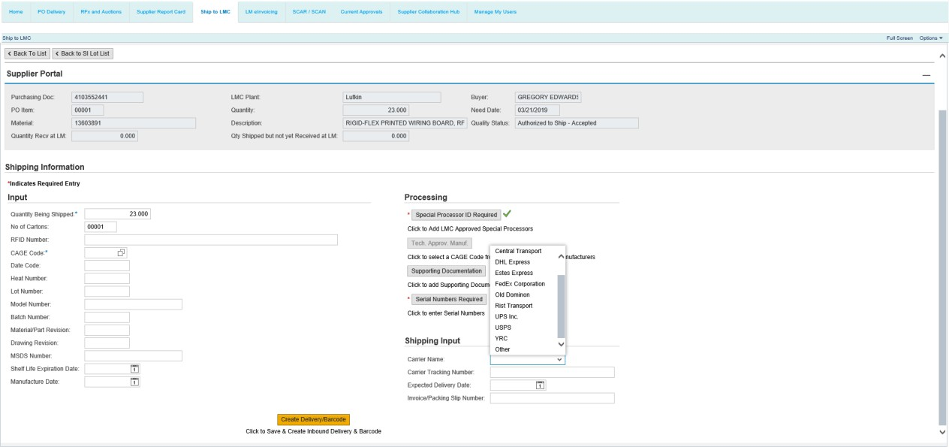

Step | Action
141. | Click the Carrier Name drop-down button to select a from a list of commonly used carriers.

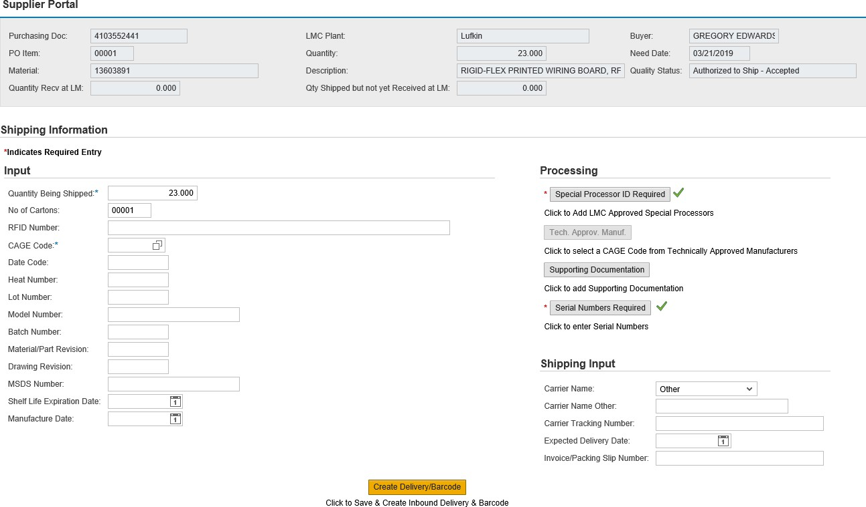

Step | Action
142. | If “Other” is selected from the Carrier Name drop-down, a new input field will populate where the carrier name can be manually recorded.

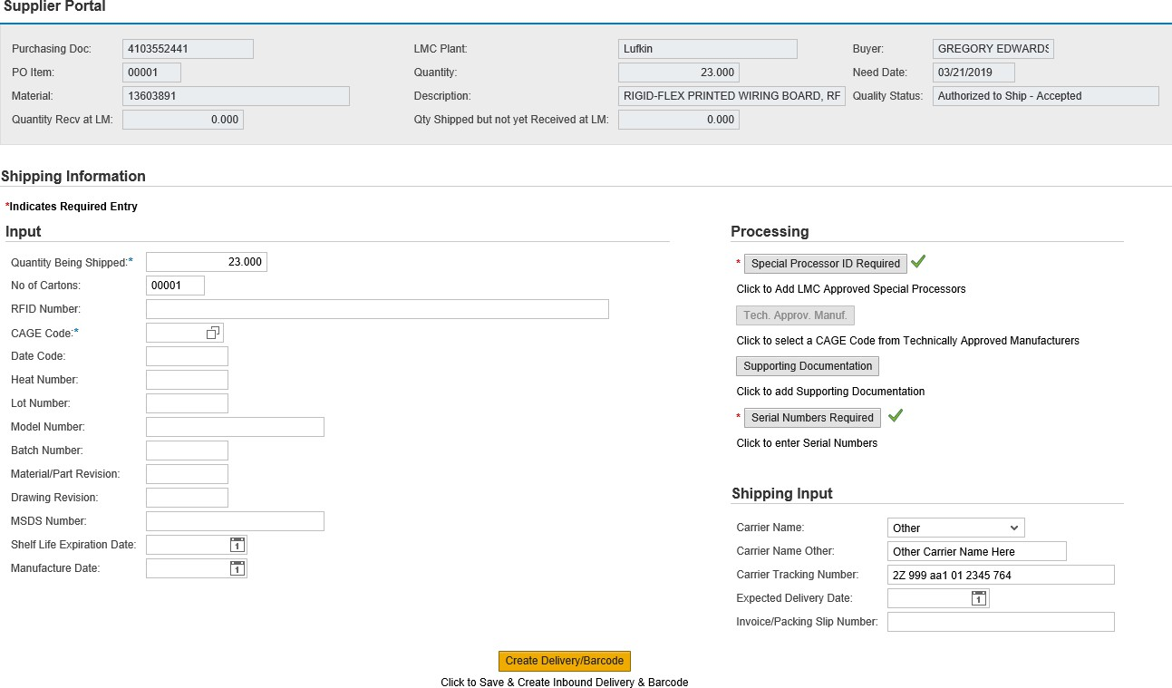

Step | Action
143. | Click the Carrier Tracking Number field to enter a tracking number.

Step | Action
144. | Click the Expected Delivery Date field to enter the expected delivery date of shipment arrival at a Lockheed Martin facility (or other purchase order identified location)

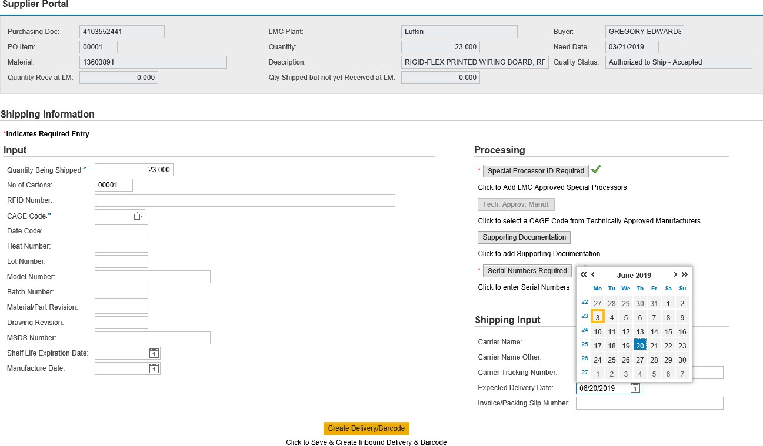

Step | Action
145. | Click to select a date.

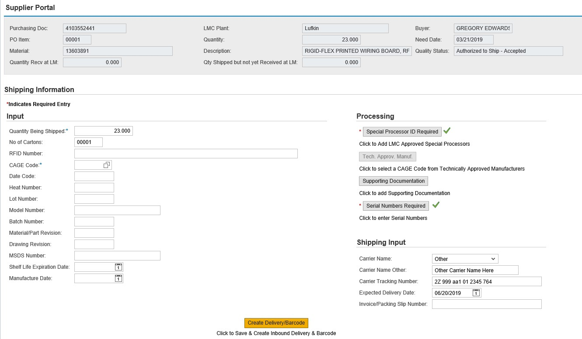

Step | Action
146. | Click the Invoice/Packing Slip Number field.

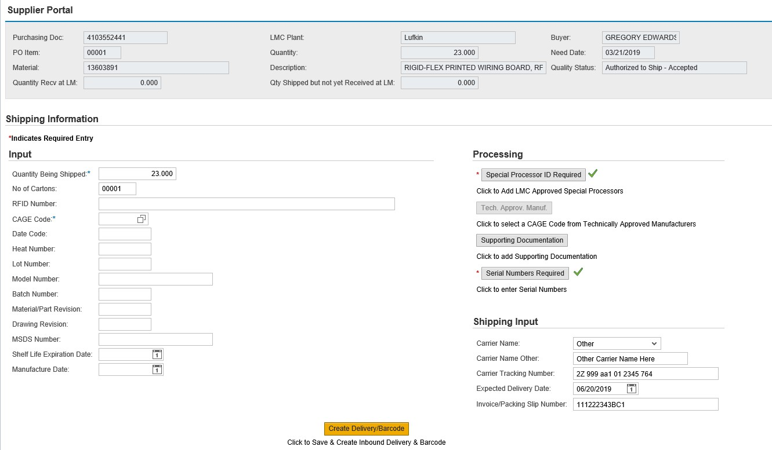

Step | Action
147. | Enter an invoice or packing slip number in the designated field.

Create Delivery/Barcode

Step | Action
148. | Click the Create Delivery/Barcode button to save, create the inbound delivery, create the inbound delivery number, and generate a barcode label.  If you click this button multiple times, a confirmation warning will display.

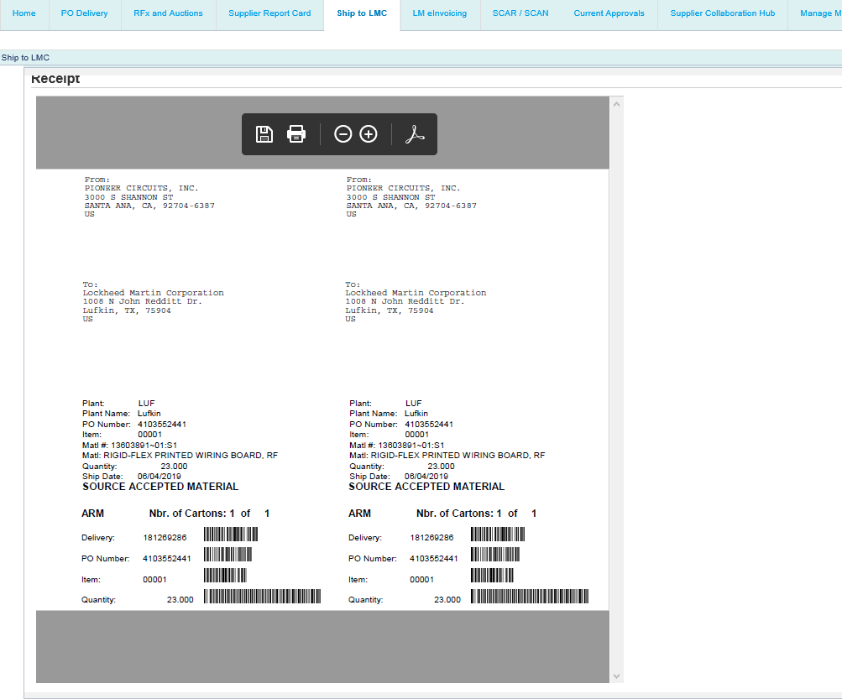

Step | Action
149. | The barcode will display.  Based upon the Ship To No of Cartons specified, an equal number of barcode labels will now be output – eg. an input of 3 cartons will result in 3 barcode labels to be output when the PDF file is saved and/or printed. In addition, the number of cartons will also be marked on each barcode label to better support material shipping identification & awareness – eg. an output for 3 barcode labels will be marked as Carton 1 of 3, Carton 2 of 3, and Carton 3 of 3.  If the No of Cartons value is left blank or a value of 1 is recorded, the system will output one barcode label marked as Carton 1 of 1.

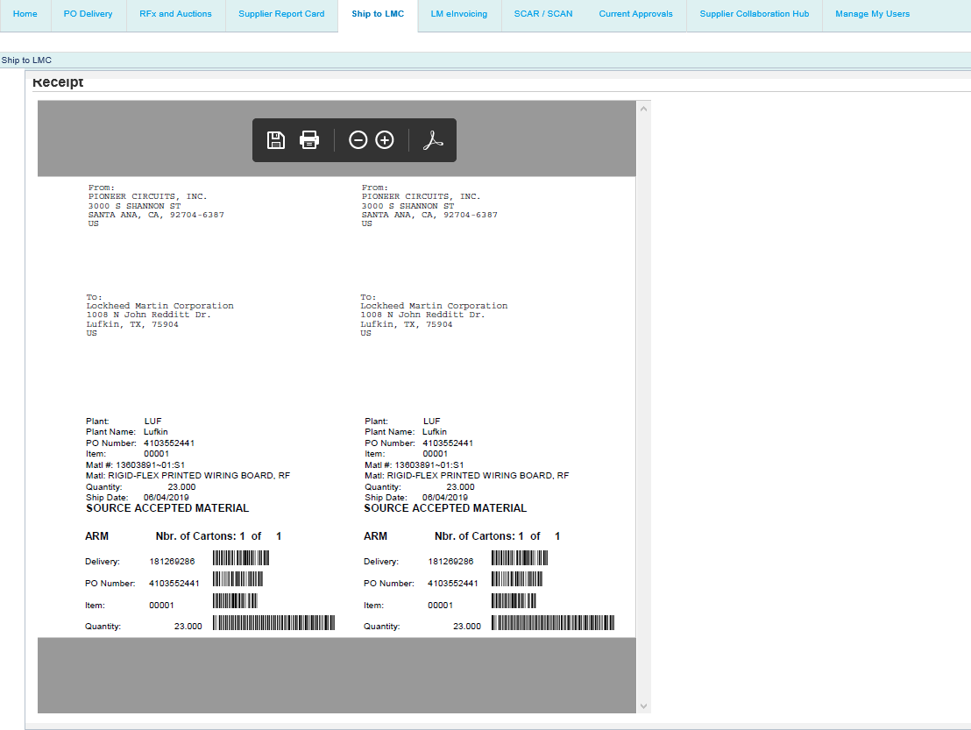

Step | Action
150. | If an inbound delivery record (IBD) shipment is processed against a PO line item where a Field activity had been performed, 1 of 3 canned statements will appear on the barcode label for Lockheed Martin receiving and inspection awareness:  - If PO Review was the last Field activity performed, PO Review Accepted Material will be printed on the barcode label(s)  - If First Article Inspection was the last Field activity performed, FAI Accepted Material  will be printed on the barcode label(s)  - If Source Inspection was the last Field activity performed, Source Accepted Material  will be printed on the barcode label(s)

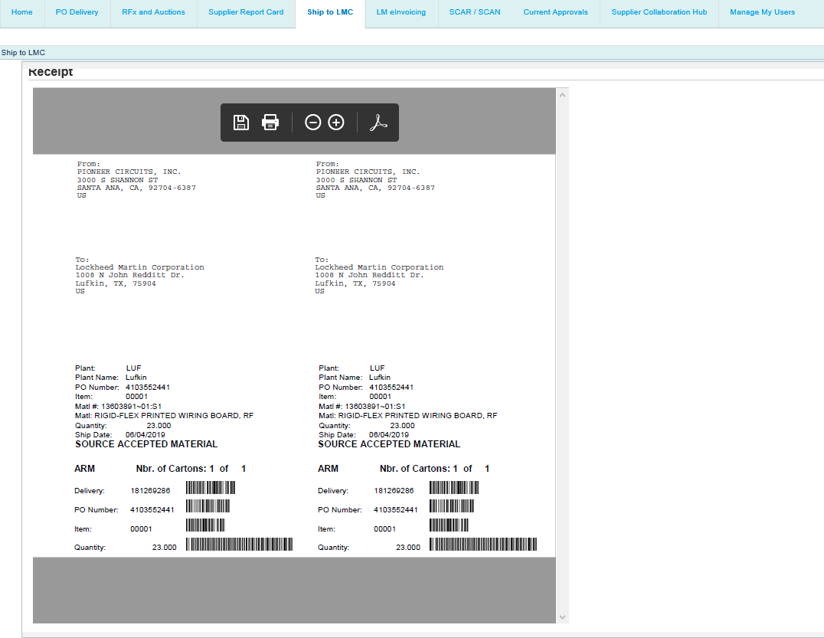

Step | Action
151. | Click the Back button to return to the Ship To Processing screen.

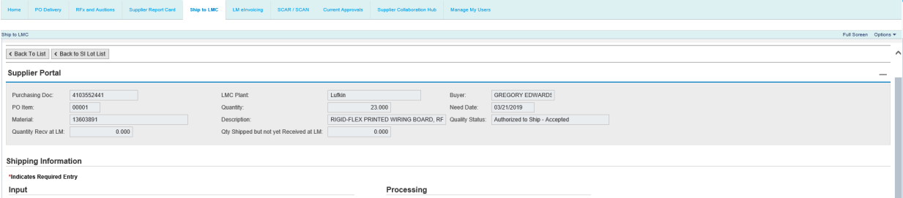

Step | Action
152. | Click the Back To List button to return to the Supplier PO and FQR List.

Cancel LMC Action
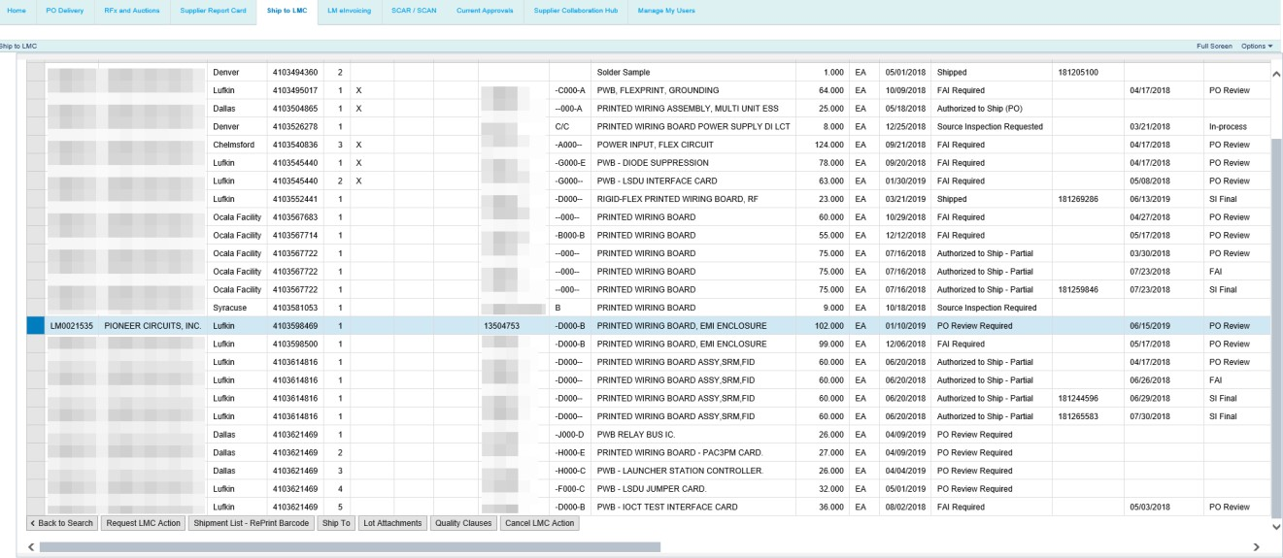

Step | Action
153. | Click the Refresh Selection link.

Step | Action
154. | New capability available to Cancel PO Review, FAI, and/or Source Inspection requests.  Overview of Cancel LMC Action Feature: Lockheed Martin now allows our vendor users the ability to Cancel PO Review, FAI, and/or Source Inspection requests. For example, in cases where an incorrect quantity was requested or a request was submitted against an incorrect PO line item. Any of these records may be cancelled up to the point of initial appraisal by Lockheed Martin Field personnel. Once a PO Review, FAI or Source Inspection record has been partially or fully appraised and/or shipped, the system will prevent their cancellation. However, records that have processed as either AIM or QVP Dock-to-Stock may also be cancelled.  The following example provides the instructions for Cancelling a PO Review requested activity that was created inadvertently. To proceed, click the Request LMC Action button to schedule the Lockheed Martin Source Representative to visit your facility to perform the requested onsite action.

Step | Action
155. | Click the selection box for the line item of the purchase order which you want to perform a cancellation action for.

Step | Action
156. | Click the Cancel LMC Action button to begin the cancellation process for the selected PO line item.

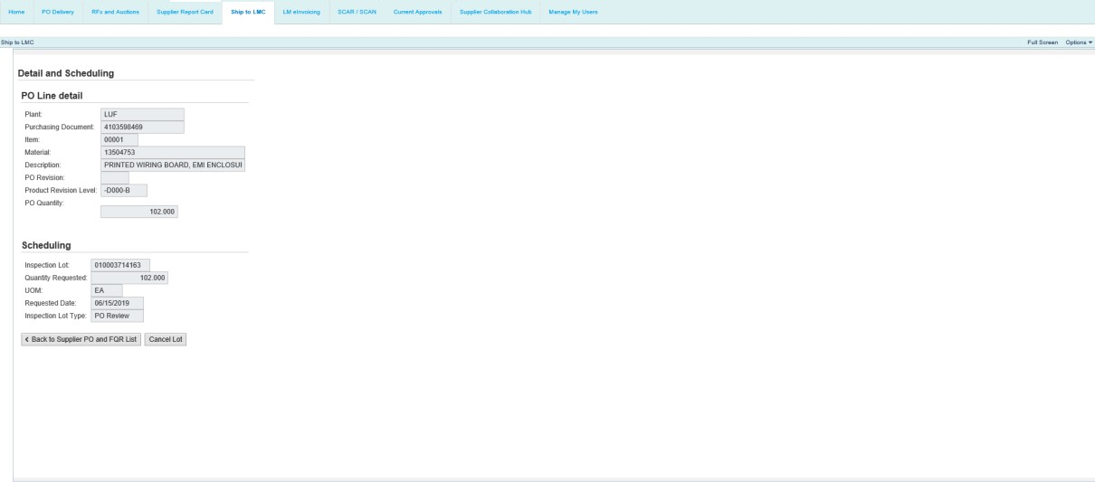

Step | Action
157. | Click the Cancel Lot button.

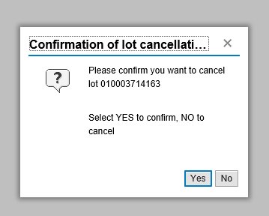

Step | Action
158. | Click the Yes button to confirm the cancellation.

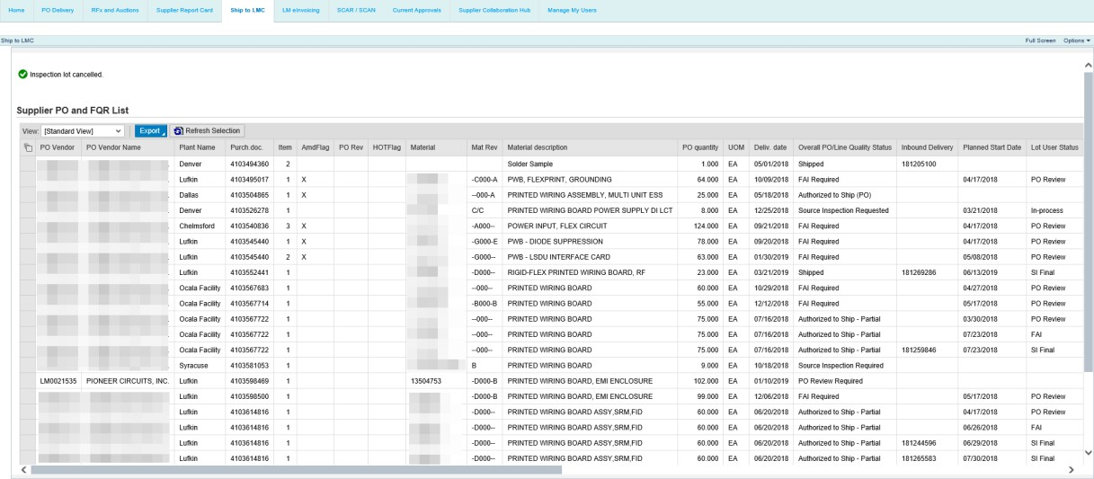

Step | Action
159. | Note the message at the top that the inspection lot is cancelled.  After the inspection lot is cancelled, you may submit a new request as needed.

LMC Action Reject
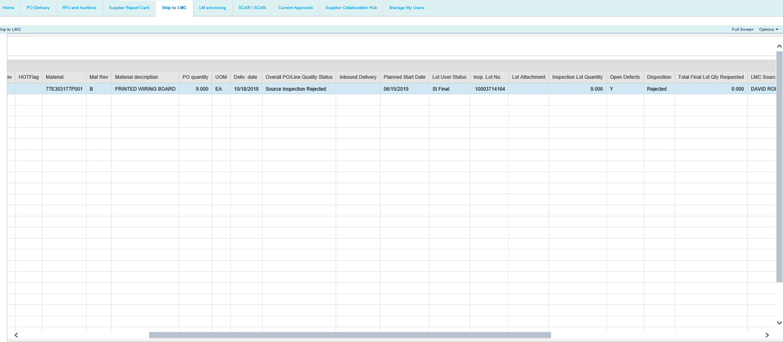

Step | Action
160. | New capability available that prevents additional LMC Actions from being requested on Rejected PO Review, FAI, and/or Source Inspection requests.  Lockheed Martin businesses now have the option to activate a new feature called “LMC Action Reject”. Upon activation, a "Y" flag will appear in the "Open Defects" display column if a PO Review, FAI, or Final Source Inspection lot is Rejected by Lockheed Martin Field personnel. Until the open defect has been resolved and formally closed by Lockheed Martin quality engineering personnel (the “Y” flag longer displays), Ship-To requests for PO Review, FAI, or Final Source Inspection against the given PO line item will be prevented.  However, In-Process source inspection lots can still be requested and any Final source inspection lots created before the Reject occurred may still be processed and shipped if accepted by Field personnel.  The following example depicts a PO line item where a PO Review was requested, inspected, and Rejected by Lockheed Martin Field personnel and an attempt to request a new PO Review is submitted.

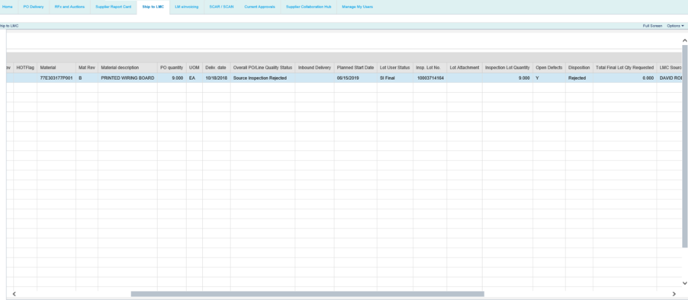

Step | Action
161. | Note that "Y" appears in the Open Defects column and Rejected appears in the  Disposition column.  In this example, we'll attempt to submit a new LMC Action for PO Review on the rejected line item.

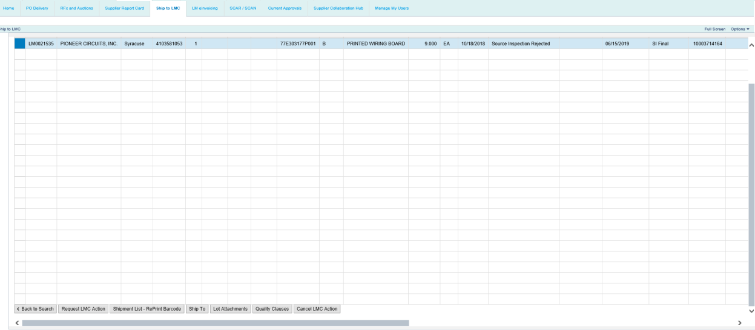

Step | Action
162. | Click the Request LMC Action button.

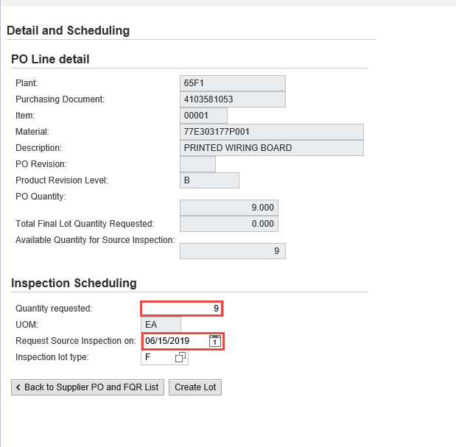

Step | Action
163. | Enter the desired quantity and date.

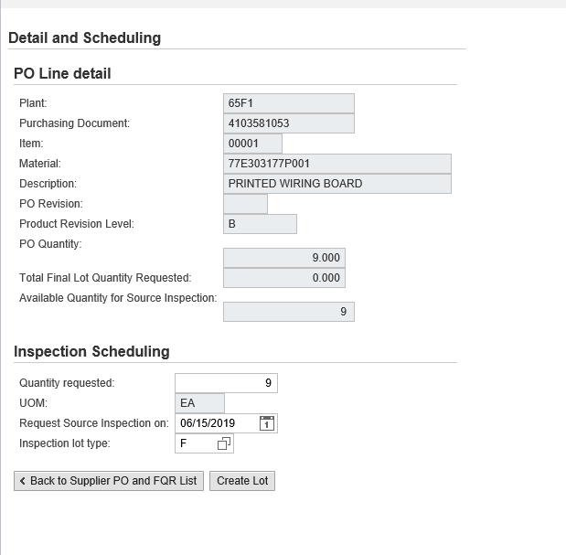

Step | Action
164. | Click the Create Lot button.

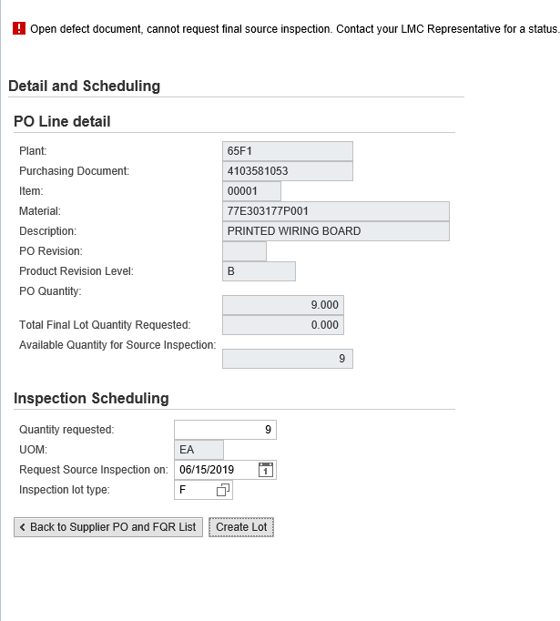

Step | Action
165. | Note the error message that appears at the top of the screen. This is a result of the open defect on the line item. No further requests can be submitted until the open defect has been formally closed by a Lockheed Martin Quality Engineer.  Click the Back to Supplier PO and FQR List button.

Step | Action
166. | You have completed the Ship to LMC guide.

