Contents (Green Pins Indicate Recent Content Updates)
Quality and Delivery Supplier Scorecard Introduction 2
Supplier Scorecard Rating Scale 3
Supplier Scorecard Procedure 4
Accessing Supplier Scorecard 5
Header Information 6
Top Buttons 7
Rating Scale & 6-month Averages 8
Current Month Rating & Rolling Averages 9
Changing Views 10
Filtering 11
Quality and Delivery Attribute Tables 12
Change Variable 14
Quality Rating: Introduction 17
Quality Rating Formula 18
Quality Rating Average Formula 19
Quality Rating Scale 20
Nonconformance Formula 21
Volume Factor Range Table 22
Location Weight Factors 23
Overdue Corrective Action Responsiveness 24
Critical Production Impact 25
Delivery Rating Introduction 26
Delivery Rating Logic Examples 28
Frequently Asked Questions 29

Quality and Delivery Supplier Scorecard Introduction
What is Supplier Scorecard?
- Supplier Scorecard is Lockheed Martin's enterprise supplier performance evaluation methodology. Aligning Lockheed Martin and suppliers under a standard supplier evaluation methodology with simplified, concise calculations
- Supplier Scorecard consolidates supplier Quality and Delivery ratings and displays them through a simplified and unified Scorecard view
- Supplier Scorecard replaces past supplier evaluation iterations such as "Supplier Report Card"
When will Supplier Scorecard be deployed and who will use it?
- Supplier Scorecard was deployed June 29, 2020
- Supplier Scorecard is a supplier evaluation methodology used across all Lockheed Martin business areas
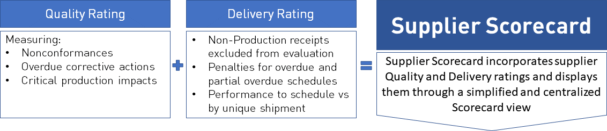

(Additional Quality and Delivery rating detail and derived calculations can be found in this guide)

Supplier Scorecard Rating Scale

 | Excellent | Approved | Conditional | Unsatisfactory
Quality | 100% | 95% - 99.99% | 90% - 94.99% | <90%
Delivery | 100% - 98% | 95% - 97.99% | 90% - 94.99% | <90%

(The table above outlines the quality and delivery thresholds that apply)

NOTE: Supplier Scorecard delivery ratings are not calculated for suppliers identified as Inspection Suppliers on purchase order line items. If a supplier is at times used as a PO supplier (the supplier the order is placed with) and an Inspection Supplier (manufacturer), delivery rating will only assess receipts for those purchase orders where the supplier is identified as a PO supplier. Should a supplier be found as an Inspection Supplier only on all purchase orders associated with them, delivery rating is not assessed.

Supplier Scorecard Procedure
Lockheed Martin regularly generates Scorecard updates. These updates depict delivery and quality activity for suppliers and are based on current month, and month ending reporting periods.
- Nightly Update: Lockheed Martin updates the current month Scorecard rating nightly.
- Monthly Updates: Lockheed Martin preforms monthly updates to monthly closing activity for rolling 6-month and 12-month views. You must have at least one month of data to populate a single month score.

The regularly updated information on Scorecard can be displayed in various formats and views to help your company focus on areas needing improvement, as well as the general quality of your products purchased by Lockheed Martin. Examples of how you can view Scorecard data will be shown later in this guide.
NOTE: Lockheed Martin Buyer and Quality email contact information is referenced directly within Scorecard. If you have questions about delivery or quality, please email the appropriate Lockheed Martin buyer or quality engineer.supp

Accessing Supplier Scorecard
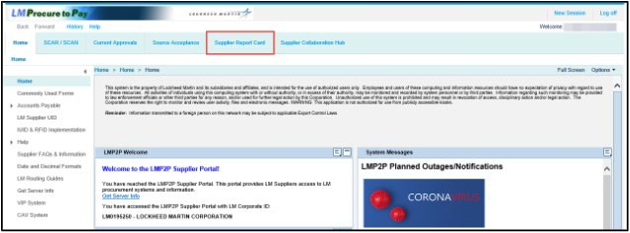
This section of the guide will explain how to access Supplier Scorecard as a Lockheed Martin supplier. The LMP2P Supplier Portal can be accessed via Exostar’s MAG Dashboard. Click here for LMP2P portal information.
- From the LMP2P Supplier Portal, click the Supplier Scorecard tab

Lockheed Martin Internal Users Only:
Please follow steps outlined in the internal version of this guide. The internal Supplier Scorecard guide can be found on the LMP2P Help-Page.

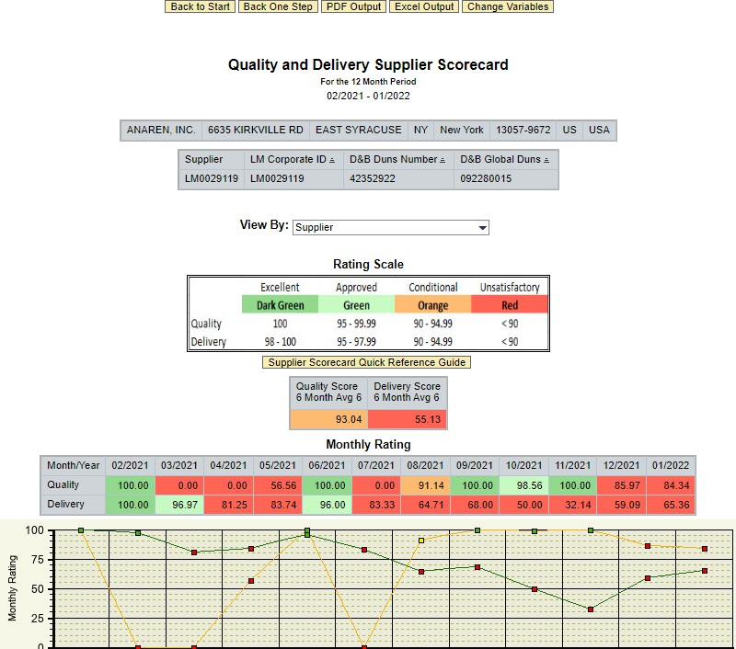
Navigating the Supplier Scorecard: Header Information

- The Supplier Scorecard default view will display along with header information about your company

Navigating the Supplier Scorecard: Top Buttons
- There are five buttons across the top of the Scorecard  - Back to Start: Will render the initial-access default display to the current month  - Back One Step: Will adjust the report view back tothe previous query step  - PDF Output: Will output the current data displayedto PDF  - Excel Output: Will output the current datadisplayed to Excel  - Change Variables: The Variable Entry pop-up appears, allowing you to input a new Report Date re- executing the query and revising the Scorecard output display. See the Change Variable section formore information | 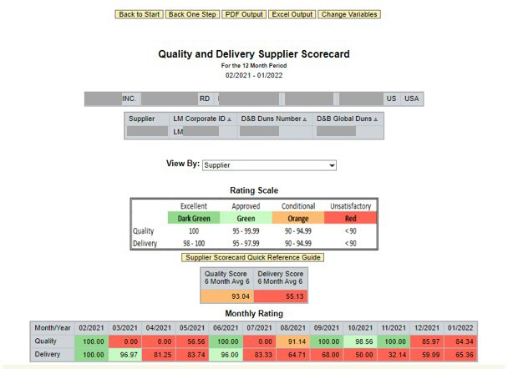

Navigating the Supplier Scorecard: Rating Scale & 6-month Averages
- The Supplier Scorecard Rating Scale is shown just underneath the header information and view change drop-down
- The Quality and Delivery 6-month averages are shown just underneath the Rating Scale table
  - This score is derived from a 6-month, month ending average
  - Suppliers must have at least 1-month of historical data in order to populate the 6 and 12-month rolling average graphs

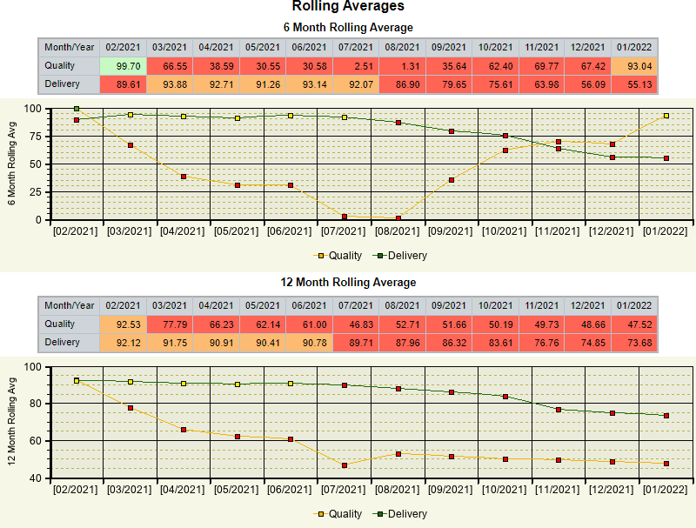

Navigating the Supplier Scorecard: Current Month Rating & Rolling Averages
- The Monthly Rating area will display current month Quality and Delivery score table and linear trend chart for each reporting month  - If you do not have reporting data for one of the months in the Monthly Rating, it will show as a blank cell in the table. Corresponding linear graph impacts will also be rendered accordingly  - Data for the current and prior month will be updated nightly | 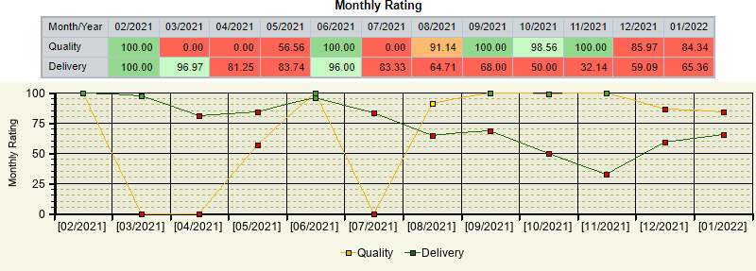
- The 6-month and 12-month Quality and Delivery score averages are displayed in the Rolling Averages area
NOTE: You must have at least 1-month of historical data in order to populate the 6 and 12-month rolling average graphs

Navigating the Supplier Scorecard: Changing Views
- You can change how the Scorecard data appears on your screen. To change from the default Supplier view, click the View By drop- down menu near the top of the Scorecard page
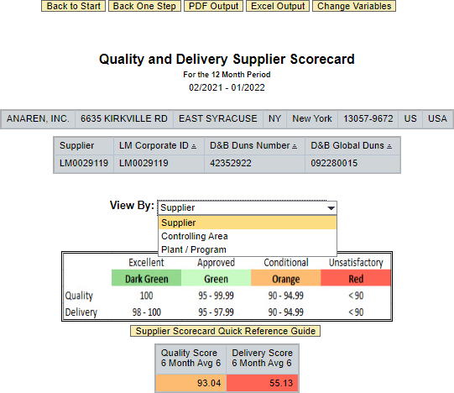
  - Supplier View: Default view displaying average Quality and Delivery ratings for supplier
  - Controlling Area: Displaying average Quality and Delivery ratings through filtered Lockheed Martin controlling areas (i.e. business areas)
  - Plant / Program: Displaying average Quality and Delivery ratings through filtered Lockheed Martin plants and program areas

Navigating the Supplier Scorecard: Filtering

In this example, the Plant / Program view is selected.
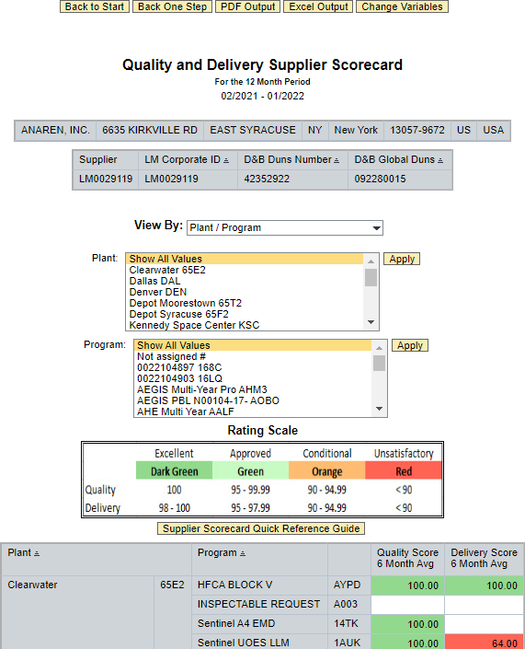
- You can press Control key + mouse left-click to select, deselect or select more than one item from the filter lists

- Click the Apply button to the right of the filter options to apply your selections.
NOTE: Show All Values is automatically selected at default. You should deselect it if filtering with other values.

Supplier Scorecard: Supplier Quality Rating: Quality and Delivery Attribute Tables
Scrolling further down the Supplier Scorecard will display the raw Quality and Delivery attributes and information.
Calculations and formulas are shown later in this guide:
- Quality Rating Attributes
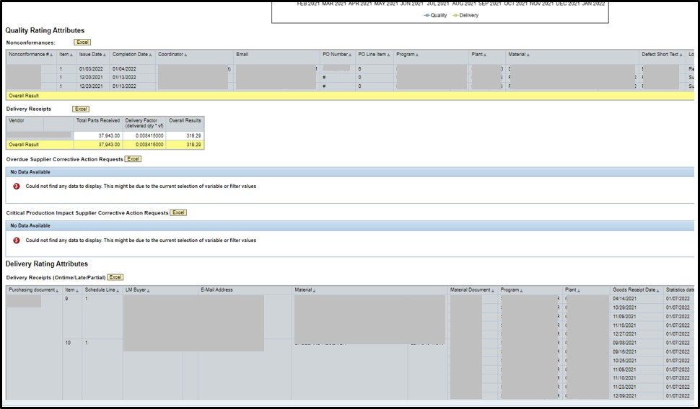
  - Nonconformances
  - Overdue Supplier Corrective Action Requests
  - Critical Production Impact Corrective Action Requests
- Delivery Rating Attributes
  - Delivery Receipts (Ontime/Late/Partial)
  - Late Delivery Receipts (Not Yet Received by Lockheed Martin)
Scorecard uses the information in these tables to calculate scorecard averages and ratings.

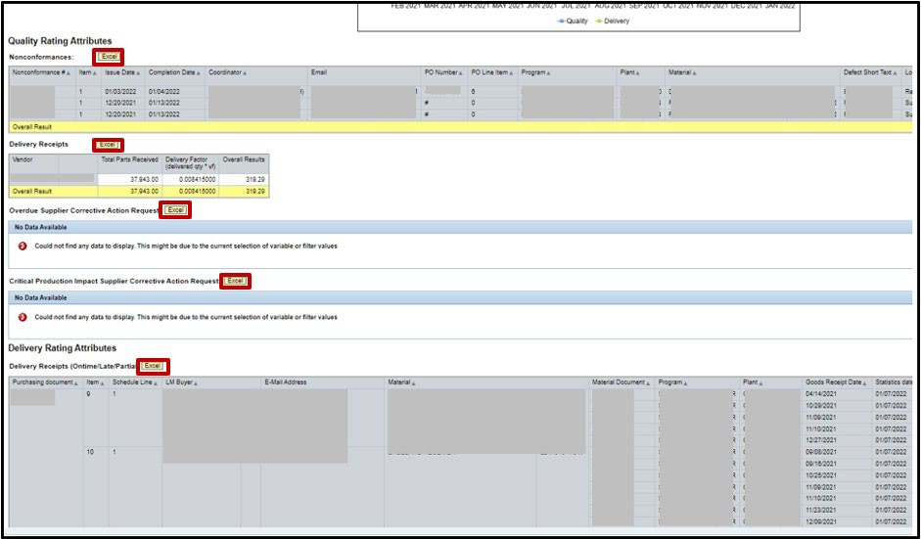
Supplier Scorecard: Supplier Quality Rating: Quality and Delivery Attribute Tables, continued
All data segments found in the Quality and Delivery attributes tables can be exported to Excel.
- You can click the Excel buttons next to the
data sets to export the data on your local machine

Supplier Scorecard: Change Variable

At default, Scorecard visually queries and displays the current months data. You can use the Change Variable feature to adjust date parameters and query for previous months of Scorecard attribute data.
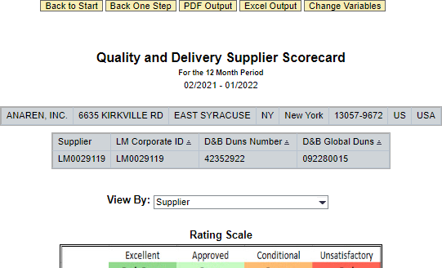
This may be valuable to suppliers who would like to see populated Supplier Scorecard data outside of the current or default reporting period.

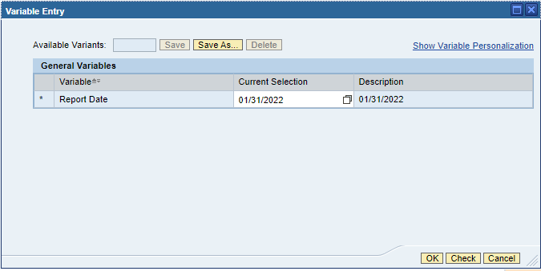
- Click the Change Variables button

- Click the White Box icon near the Report Date field

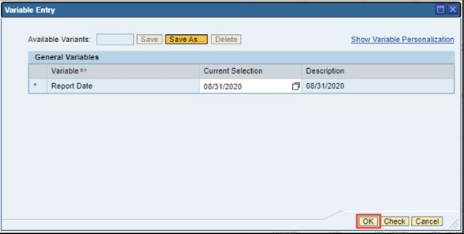
Supplier Scorecard: Change Variable, continued
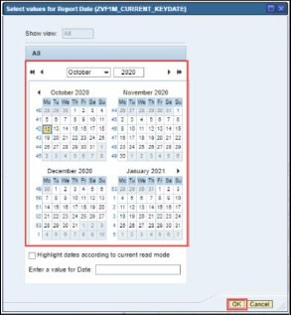
- Use the date wizard to select a new Report Date, then click the OK button
IMPORTANT NOTE:
If you wish to see a previous months reporting data, please enter the last calendar date of the month prior to it.
For example, if you wish to see the month of September 2020, you would enter August 31st , 2020 (8/31/2020).
- Click OK

Supplier Scorecard: Change Variable, continued
The Supplier Scorecard will re-execute the query based on the entered Report Date. Visual charts and data attributes will reflect this change.

NOTE: You can refresh the session, or manually adjust again to change scorecard back to the default (current) reporting period.

Quality Rating: Introduction
This section of the guide explains the Quality Rating formula used by the Lockheed Martin.
- This rating formula is used for all Lockheed Martin business units and for all suppliers that provide production/inspectable material

Quality Rating Formula
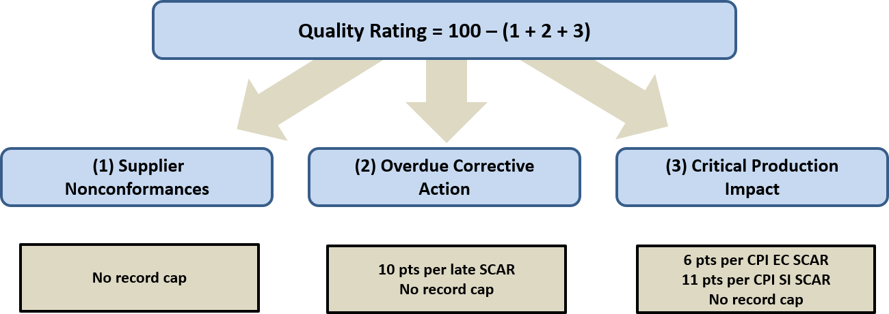

The Supplier Quality Score equals the most recent 6-month average of all monthly raw scores.
NOTE: “No record cap” indicates that there is not a limit on the number of points that can be decremented from the score.

Quality Rating Average Formula

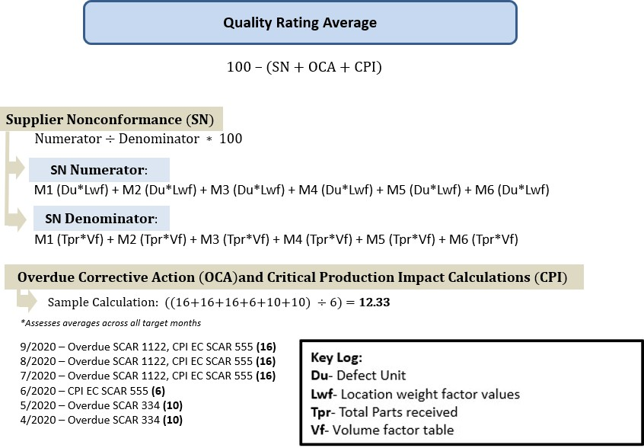

Quality Rating Formula: Quality Rating Scale

 | Excellent | Approved | Conditional | Unsatisfactory
Quality | 100 | 95-99.99 | 90-94.99 | <90

To receive a rating of excellent, a score of 100% must be maintained.

Nonconformance Formula
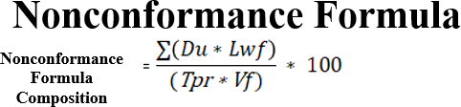

Classified as Supplier Responsible Defects, this calculation considers the current month of Supplier Responsible defects. It calculates impact based on the location weight factor applied on nonconformance records and only considers closed/completed Supplier Responsible Defects. Based on the total pieces received in the past 12 months, this calculation also normalizes the collective pieces received from all goods receipts through use of the volume factor calculation.
- 100 maximum points can be deducted from a vendor’s quality rating
- The “Du” (Defective Units) in the formula is equal to the number of nonconformance record supplier responsible pieces
- The “Lwf” in the formula is equal to the nonconformance record(s) location weight factor values
- The “Tpr” (Total Parts Received) in the formula is equal to the total number of goods receipt record pieces received
  - Only “inspectable” receipts will be assessed in Tpr (PR line items associated with ZQUAL records)
- The “Vf” in the formula is equal to the range value included in the volume factor table
- All supplier responsible nonconformance records, including those identified as Customer Escapes, are candidates for this calculation
- If a nonconformance record maintains multiple defect record items, the system will utilize the most severe location weight factor for the calculation
- The system leverages use of the nonconformance record completion date (disposition date) to determine whether a nonconformance record is calculated for the current month

Nonconformance Formula: Volume Factor Range Table

Volume Factor
Qty Range (Between) |  | Multiply Pieces Received Qty by:
1 | 9 | 1.000
10 | 99 | 0.800
100 | 999 | 0.400
1000 | 9999 | 0.400
10000 | 99999 | 0.400
100000 | 999999 | 0.100
1000000 | 999999999 | 0.050

Used within the denominator calculation of the Nonconformance Formula, the above shown Volume Factor range table has been incorporated in the rating formula to help normalize the ratio of goods receipt quantities used within this calculation.

Nonconformance Formula: Location Weight Factors

Location Weight Factor (Wf)
Defect Location | Wf
Supplier Discovered Defect | 0.5
Documentation Defect | 0.5
Source Acceptance Defect | 4
Receiving Defect | 4
Receiving Inspection Defect | 4
First Article Acceptance Defect | 4
Audit/Survey Finding | 4
Manufacturing Floor Defect | 6
Testing Discovered | 8
Customer Escape | 10
Mfg Floor Defect After Install – Delivery | 6

The nonconformance record weight factors apply a lower impact when defect record findings are found early in the supply chain process (i.e. Supplier Discovered Defect) versus a higher impact when defect record findings are found late in the process or even post-delivery (i.e. Customer Escapes).

Overdue Corrective Action Responsiveness
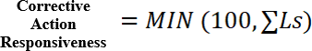

Classified as Corrective Action Responsiveness, this calculation considers the past 12 months of supplier responsible corrective action requests (SCARs) and assesses all location weight factors except those identified as Customer Escapes. It only considers overdue SCARs where the Required End Date has been exceeded and SCARs that are overdue and have been closed as Supplier did not Respond.
- 10 points will be deducted from a vendor’s quality rating for each record found in this calculation with a 100 point no-cap maximum
  - The system shall restore 10 points per record when a late SCAR has been closed or the Required End date has been extended
- The “Ls” in the formula is equal to the total number of late SCARs
- If an issued SCAR exceeds the Required End date (considered overdue), a 10-point penalty will be issued
- If a supplier response is not received for an issued SCAR, a 10-point penalty will be issued
- Customer Escape SCARs are excluded from this formula

Critical Production Impact
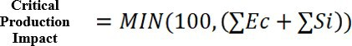

Classified as Critical Production Impact, this calculation considers SCAR which maintain either an Escalating Concern or Severe Impact classification. 6 points will be deducted for each SCAR classified as Escalating Concern and 11 points will be deducted for each SCAR classified as Severe Impact. Closed SCARs maintaining either classification will be excluded from penalty.
- 100 max points can be deducted from a vendor’s quality rating for this calculation with no per record cap

- The “Ec” in the formula is equal to 6 points per SCAR classified as Escalating Concern

- The “Si” in the formula is equal to 11 points per SCAR classified as Severe Impact

- Location weight factors are not considered for this calculation
All issued SCARs, regardless of age or status (less those marked as closed), are evaluated for penalty impact. SCARs closed as SCAR Closed No Response are included in the rating

Delivery Rating Introduction
Scope and Impact:
- The delivery rating period of performance is a monthly assessment
  - Promotes a quicker rating recovery as compared to the legacy/heritage 12 month assessment
  - Monthly delivery rating “boundaries” determine when goods receipt shipment quantities will be assessed
    - PO line item schedule dates determine the month in which goods receipt shipment quantities (or lack thereof) are assessed
    - Goods receipt shipment quantities posted earlier than the PO line item schedule month they’re due in will Not be assessed until explicit day of the PO line item schedule date has been realized
    - PO line item schedules which maintain late-month dates – specifically where the 7-day grace period extends into the following month – will invoke retroactive, prior-month rating updates (positive or negative) if goods receipt shipment quantities are posted after the PO line item schedule date/month boundary has been exceeded
  - The Supplier Scorecard renders the monthly rating linear graph to represent the monthly trend assessment and also limits the display of good receipt shipment records to those which fall within the monthly boundary
- Goods receipt quantities posted against Production orders, (those which maintain quality flow downs) are assessed against PO vendors
- A 7-day receipt-to-schedule date grace period is provided
- Overdue and partially overdue PO item schedule quantities are assessed against PO vendors after the 7-day grace period has been exceeded
- A PO line item schedule represents a single “Lot” opportunity (referred to as the “Possible Factor”)

Delivery Rating Introduction, continued
Delivery Rating Assessment:
- Goods receipt quantities are spread across available PO item schedule quantities where an On Time or Late determination is made;
  - On Time Lot Count: Credit is given when goods receipt quantities are determined to be On Time for the PO item schedule(s) they’re assessed against. If goods receipt quantities comprise only a portion of the PO item schedule quantity, then partial credit is given
  - Total Lot Count: The Total Lot Count value is increased by the aforementioned goods receipt-to-PO line item schedule quantity in order to account for the “Possible Factor”. However, On Time Lot Count credit will NOT be given (value remains at zero) when goods receipt quantities are determined to be Late for the PO item schedule(s) quantities they’re assessed against
  - Overdue Quantities: On Time Lot Count credit will NOT be given (value remains at zero) where the unaccounted balance of PO line item schedule quantities is determined to be Late. In such cases, the Total Lot Count is increased by 1 Lot for each fully overdue PO item schedule in order to account for “possible points”
Note: On Time and Total Lot Count values will be expressed as either whole numbers or as decimals
- The ratio of Lots On Time to Total Lots received then determines a vendor’s delivery rating raw score (i.e. 1.3 Lots On Time / 5 Total Lot Count = 26%)

Delivery Rating Formula: Delivery Rating Logic Examples
Example 1

PO line item contains 1 schedule for 100 pieces with 1 receipt posted On Time;

- Receipt #1 posted for 25 pieces (On Time) – On Time Count: .25 / Total Lot Count .25
Sum Total for PO line item – On Time Count: .25 / Total Lot Count .25 / Delivery rating: 100%
Example 2

PO line item contains 1 schedule for 100 pieces with 1 receipt On Time and 1 receipt Late;

- Receipt #1 posted for 15 pieces (On Time) – On Time Count .15 / Total Lot Count .15
- Receipt #2 posted for 85 pieces (Late) – On Time Count: 0 / Total Lot Count .85
Sum Total for PO line item – On Time Count: .15 / Total Lot Count 1 / Delivery rating: 15%
Example 3

PO line item contains 1 schedule for 100 pieces with 1 receipt On Time, 1 receipt Late, and the balance of PO line item schedule quantities have exceeded the 7-day grace period and are considered Late;
- Receipt #1 for 36 pieces (On Time) – On Time Count: .36 / Total Lot Count .36
- Receipt #2 for 19 pieces (Late) – On Time Count: 0 / Total Lot Count .19
- Balance of PO line item schedule pieces (Late) – On Time Count: 0 / Total Lot Count .45
Sum Total for PO line item – On Time Count: .36 / Total Lot Count 1 / Delivery rating: 36%

Frequently Asked Questions

I cannot access my EXOSTAR account. What do I do?
Contact the EXOSTAR help line at 703-793-7800 or https://my.exostar.com/display/TE/Support

What are the two ratings shown at the start of the Scorecard?
6-month averages of both the Quality and Delivery rating are shown just underneath the Rating Scale table.

How is the Quality Rating calculated?
Please reference the Quality Rating section of this guide

How is the Delivery Rating calculated?
Please reference the Delivery Rating section of this guide

How do I obtain LM assistance for problem solving or process improvement?
Contact the Buyer Listed on the purchase order. The Buyer will coordinate any required internal LM resource needs.

