



Last Updated 11/06/18

LM Procure to Pay Quick Reference Guide For Suppliers

SCAR/SCAN

Lockheed Martin Procure to Pay Revised November 2018

Procedure

The Lockheed Martin Supplier Corrective Action Request (SCAR)/Supplier Correction Action Notice (SCAN) module provides a means for Lockheed Martin Supplier Quality personnel to send SCAR's and SCAN’s electronically to your LM Procure to Pay Portal.

Your Portal Administrators and Quality Management will have access to this queue. SCAR's and SCAN’s can be issued for specific material or an overall process issue.

While SCAR’s often require a response, SCAN’s are established to provide awareness to supply base users when product defects are found at Lockheed Martin facilities.
This quick reference guide displays the procedure on how to complete a SCAR, view a SCAN and walks you through their various features.

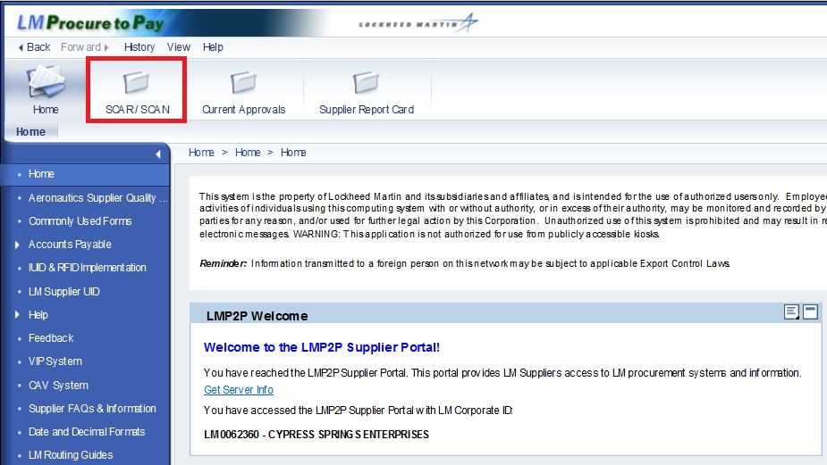

Step | Action
1. | Click the SCAR/SCAN tab.

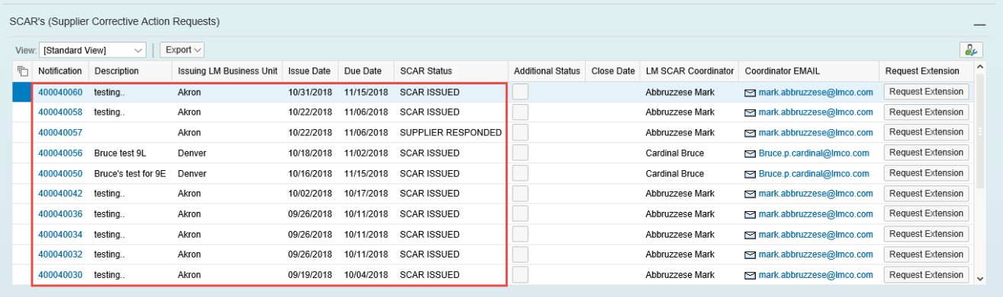

Step | Action
2. | Notification is the SCAR reference number and this is a link to the details of the SCAR.
3. | Description is the short header description of the issue.
4. | Issuing LM Business Unit is the Lockheed Martin business responsible for issuing the SCAR.
5. | Issue Date is the date the SCAR was sent to you.
6. | Due Date is the date you will need to respond on or before. If you need more time you can request an extension.
7. | SCAR Status displays the current status of the SCAR. SCAR ISSUED indicates the SCAR is new.
8. | Click the scroll bar.

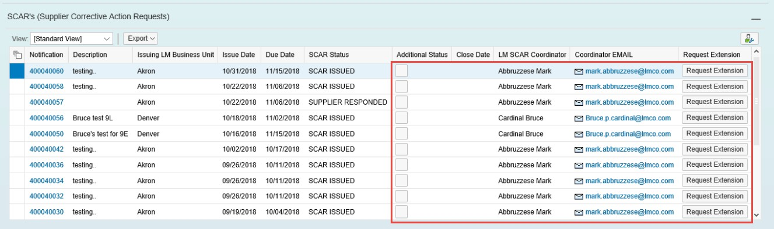

Step | Action
9. | Additional Status displays the extension request status.
10. | Close Date is the date the SCAR was closed by Lockheed Martin.

Step | Action
11. | LM SCAR Coordinator is the name of the person at Lockheed Martin who issued the SCAR.
12. | Coordinator EMAIL is the email address for the LM SCAR Coordinator.
13. | You will be able to click the Request Extension button to request an extension.
14. | Click the scroll bar.

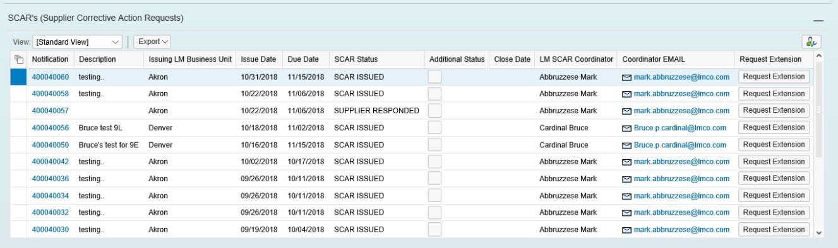

Step | Action
15. | 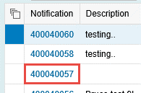  Click the Notification link to view the SCAR details.

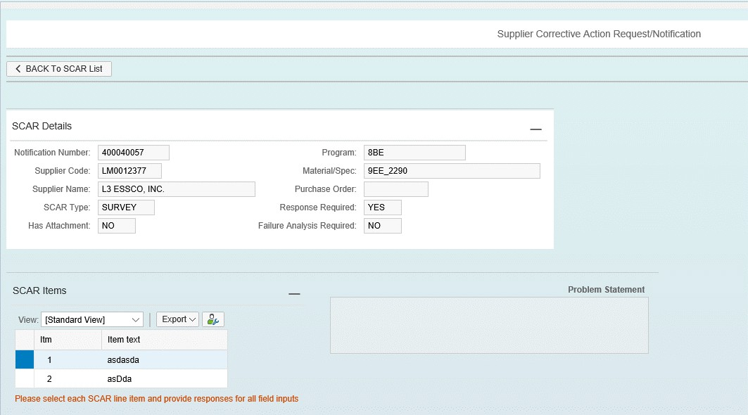

Step | Action
16. | The Supplier Code is your Lockheed Martin assigned code.
17. | The SCAR type can be Material, Process, or Survey.
18. | The Program represents the Lockheed Martin program if applicable.
19. | Material/Spec is the material number or specification depending on the SCAR type.
20. | Purchase Order is the Lockheed Martin purchase order number if applicable.
21. | Response Required indicates if the SCAR is for informational purposes or if a formal corrective action response is needed.
22. | Failure Analysis indicates if the SCAR requires you to attach your failure analysis (you can upload an attachment).

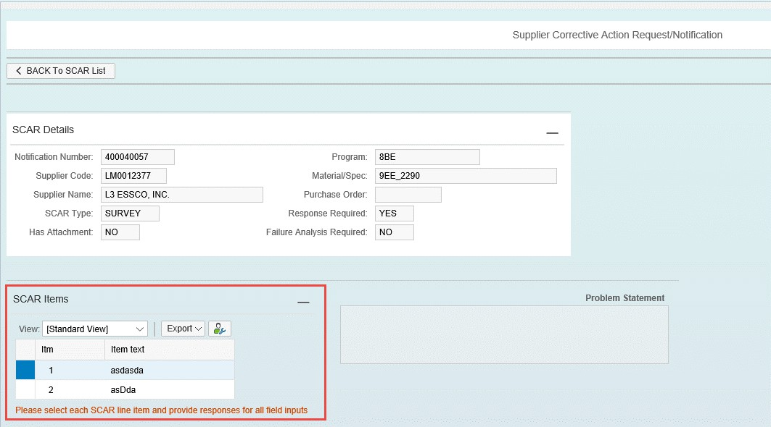

Step | Action
23. | SCAR Items: The SCAR may contain one item or multiple items You can select the item to display the problem statement for that item.  Note: If two Scar Items are displayed, please select each SCAR line item and provide responses for all input fields.

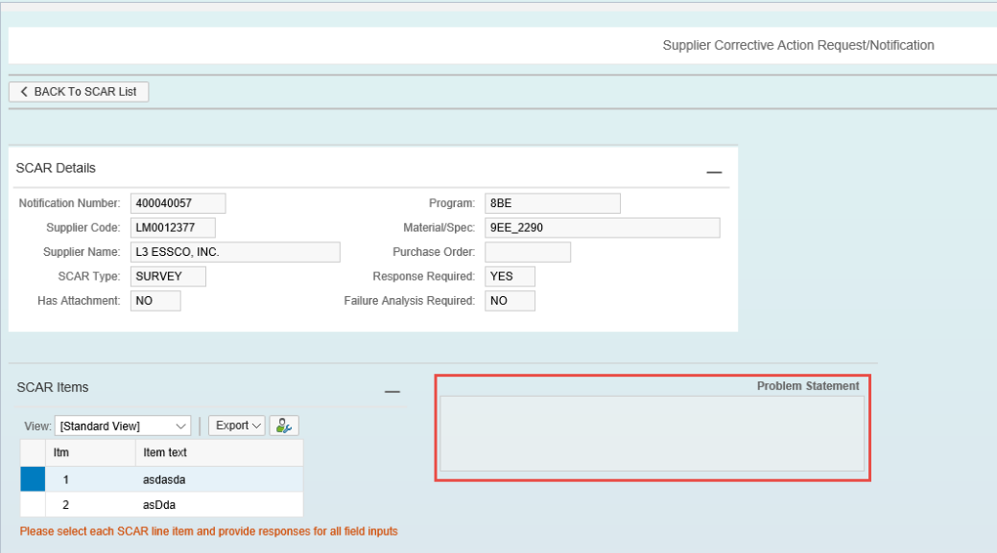

Step | Action
24. | Problem Statement is the detailed description of the problem needing corrective action. Each item will have its own problem statement.
25. | Click the Vertical scrollbar to scroll down.

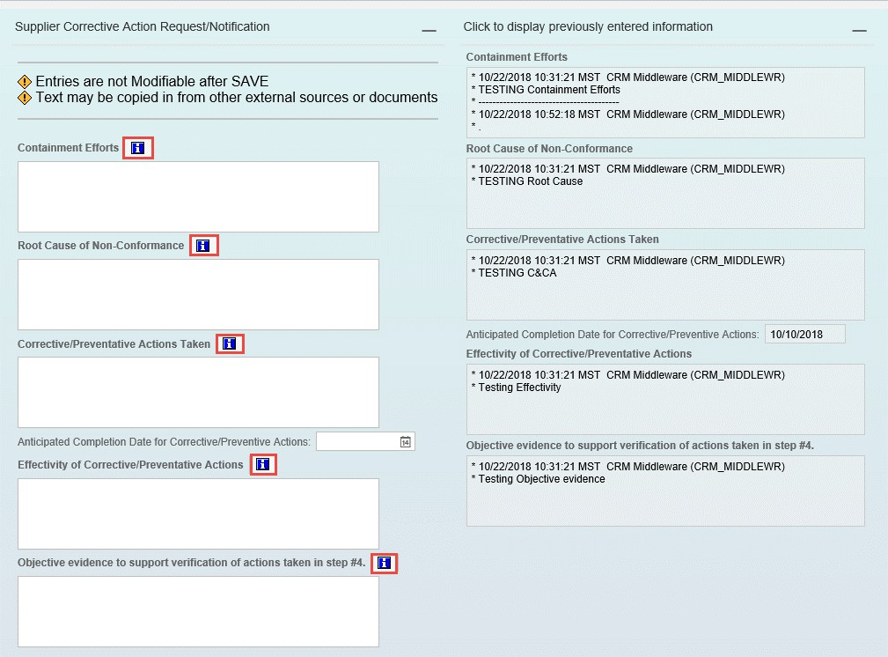

Step | Action
26. | You can click the Info icon to display a word document with more information on what is expected in each section.

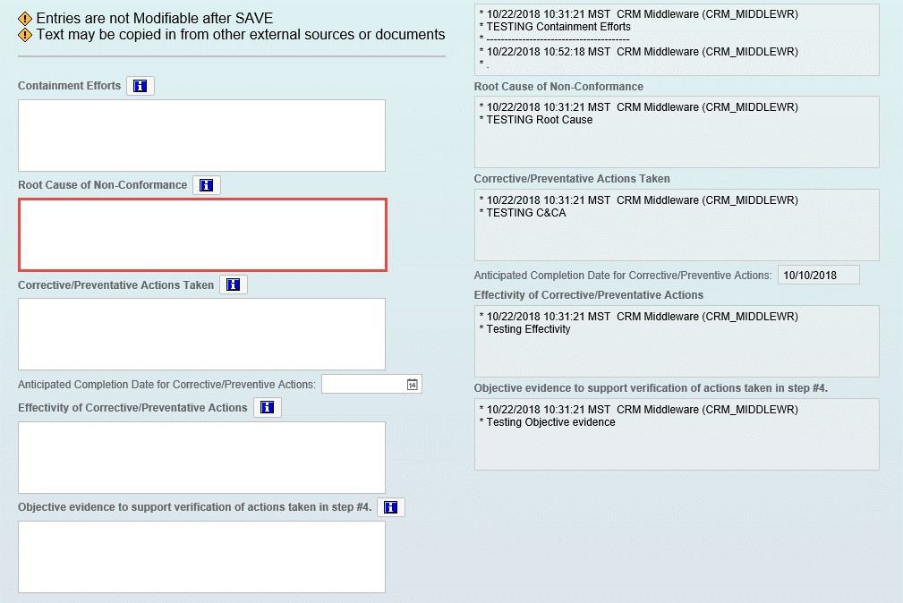

Step | Action
27. | Root Cause of Non-Conformance is where you enter the identification and verification of the existing or potential problem. The true root cause of the non- conformance, i.e. the reason that caused the defect and if eliminated would preclude another occurrence. Should include sub-tier supplier and/or raw material findings if necessary.

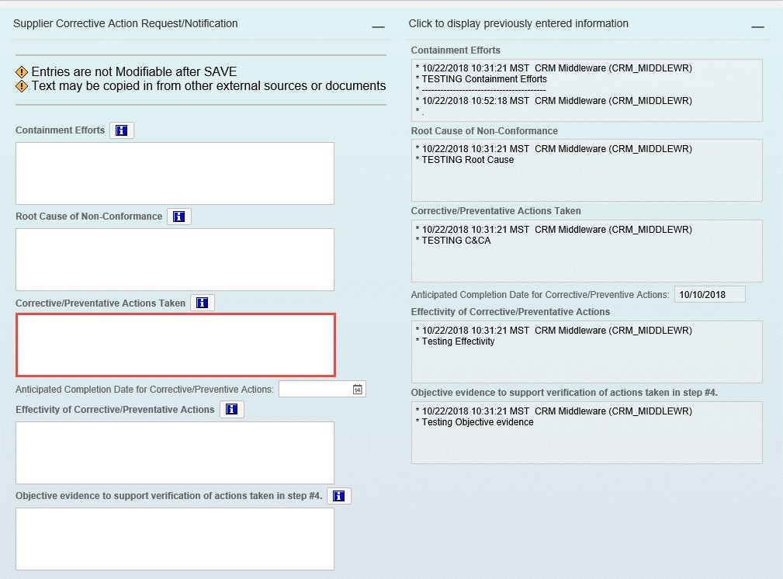

Step | Action
28. | Corrective/Preventative Actions Taken is where you enter the action taken to eliminate the cause of a detected and potential non-conformity or another undesirable situation. For example: what is being done immediately to bring the product back into conformance.
29. | Click the Vertical scrollbar to scroll down.

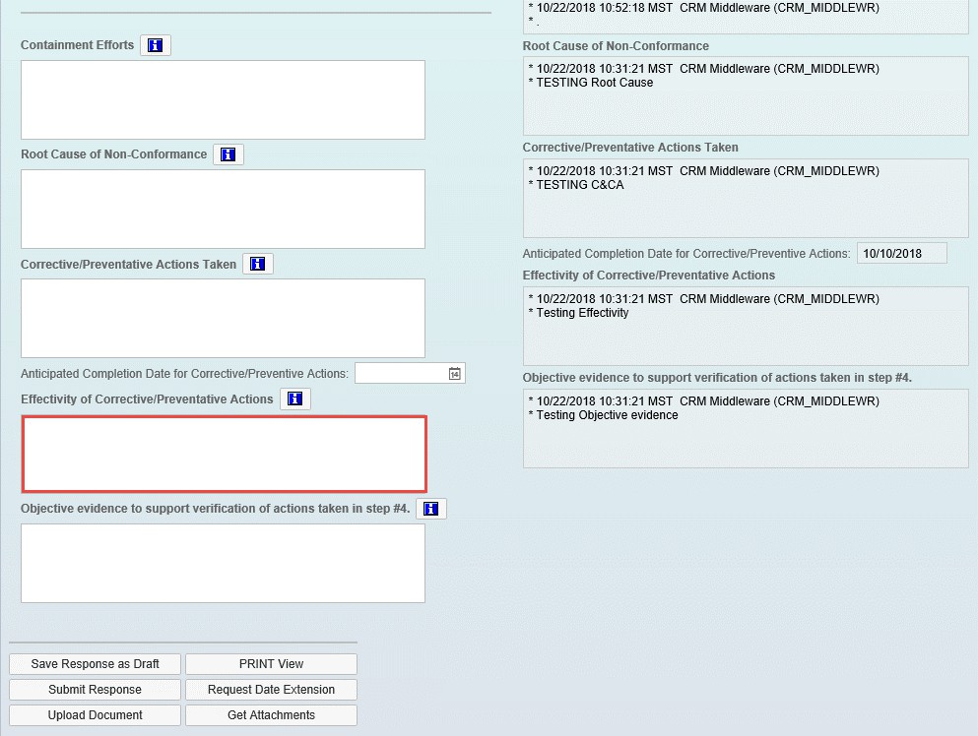

Step | Action
30. | Effectivity of Corrective/Preventative Actions is where you enter the effectiveness of the preventive action taken.

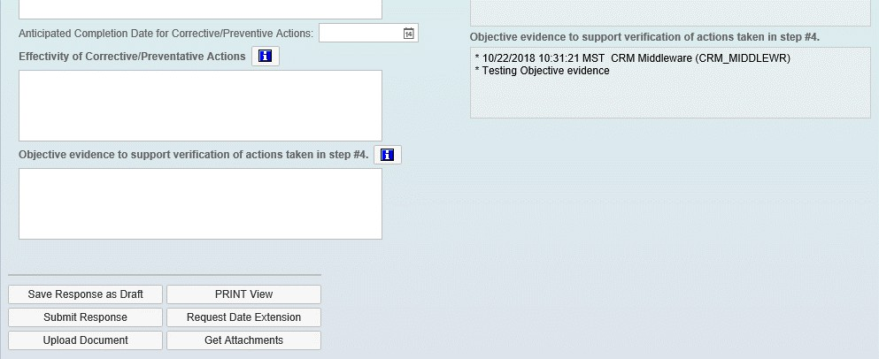

Step | Action
31. | Click | to save the response as Draft.
32. | Click | to Lockheed Martin which will also change the status.
33. | Click | to upload any supporting documents.
34. | Click | to preview a printed version of your response.
35. | Click to request an extension beyond the due date (this can also be done from the main list).
36. | Click or you. | to view any attachments uploaded by Lockheed Martin
37. | Click the scroll bar to scroll up.

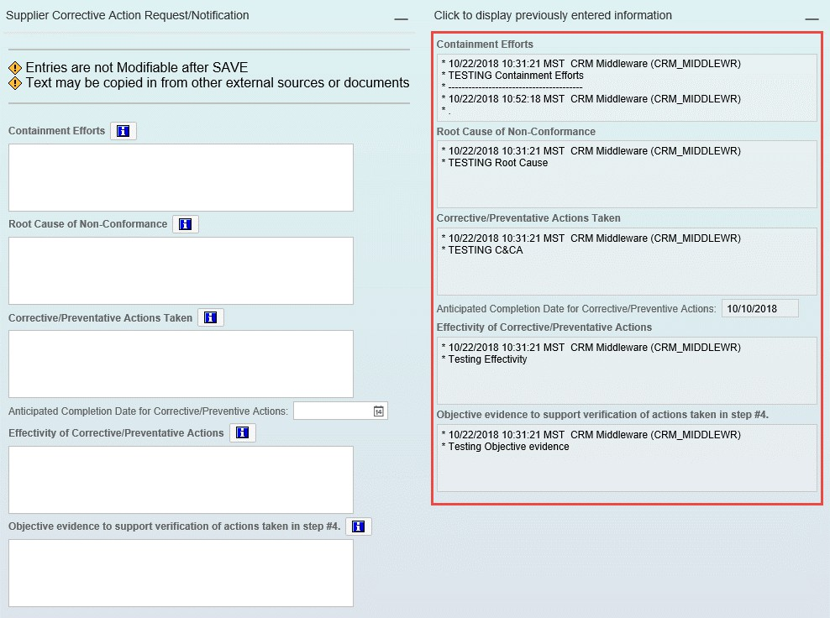

Step | Action
38. | Here you can view any comments which have been entered and saved.

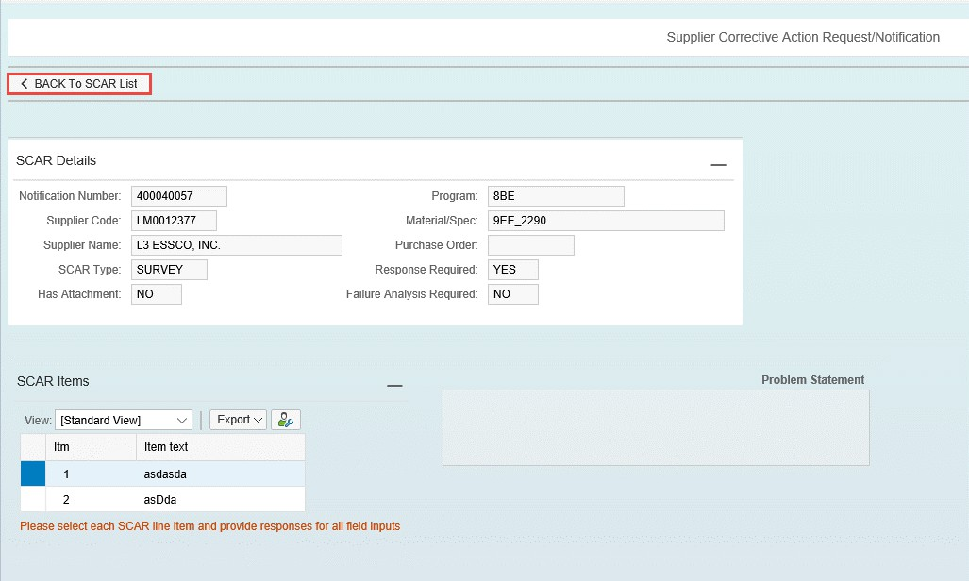

Step | Action
39. | Scroll to the top of the SCAR record. Click the Back to SCAR List button to return to the full SCAR listing.

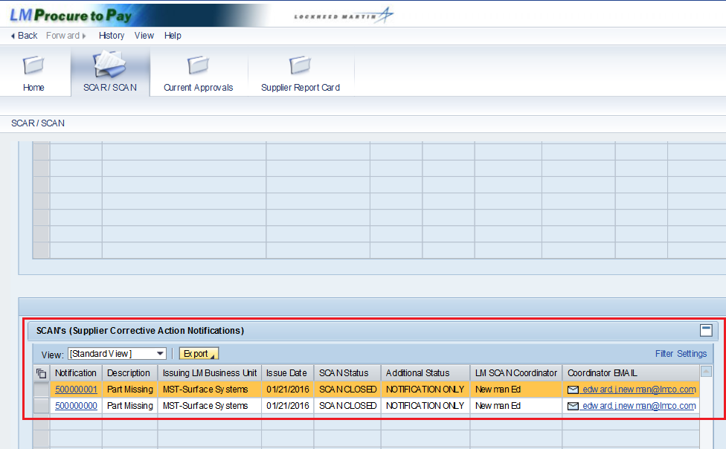

Step | Action
40. | Once on the main screen, scroll down to view the SCAN listing. SCAN stands for Supplier Corrective Action Notification. SCAN records will carry a 5000 series number vs. SCARs which carry a 4000 series number for unique identification.
41. | Notification is the SCAN reference number and this is a link to the details of the SCAN.
42. | Description is the short header description of the issue.
43. | Issuing LM Business Unit is the Lockheed Martin business responsible for issuing the SCAR.
44. | Issue Date is the date the SCAN notification is closed. There is no response required, so the issue date and close date are the same.
45. | SCAN Status displays the current status of the SCAN. SCAN CLOSED indicates the SCAN is closed.
46. | Additional Status shows that the SCAN is a notification only.
47. | LM SCAN Coordinator is the Lockheed Martin contact who issued the SCAN.
48. | Coordinator Email is the email address of the contact in the LM SCAN Coordinator field.

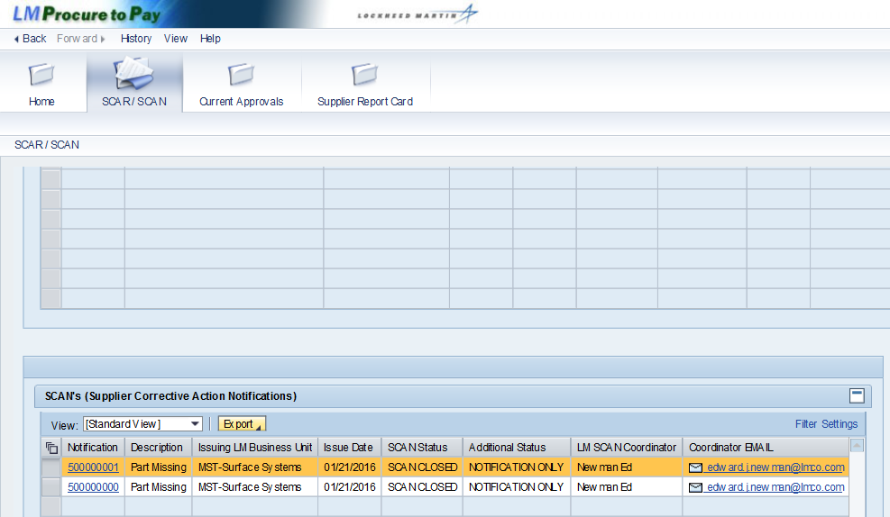

Step | Action
49. | Click the Notification link to view the SCAN details.  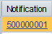

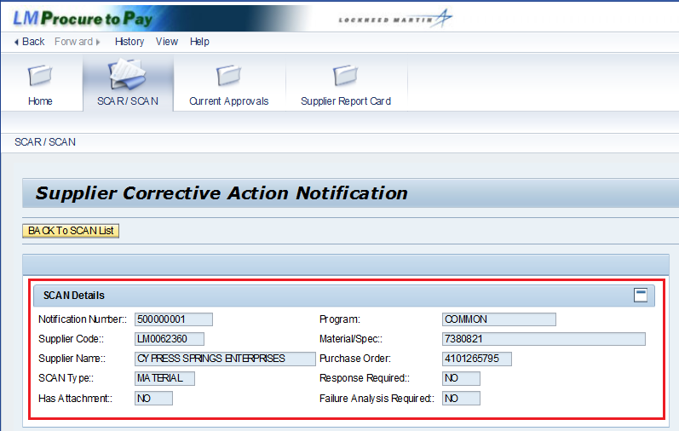

Step | Action
50. | The Supplier Code is your Lockheed Martin assigned code.
51. | The Program represents the Lockheed Martin program if applicable.
52. | Material/Spec is the material number or specification depending on the SCAN type.
53. | Purchase Order is the Lockheed Martin purchase order number if applicable.
54. | The SCAN type can be Material, Process, or Survey.
55. | Response Required indicates if the SCAN is for informational purposes or if a formal corrective action response is needed.
56. | Failure Analysis indicates if the SCAN requires you to attach your failure analysis (you can upload an attachment).

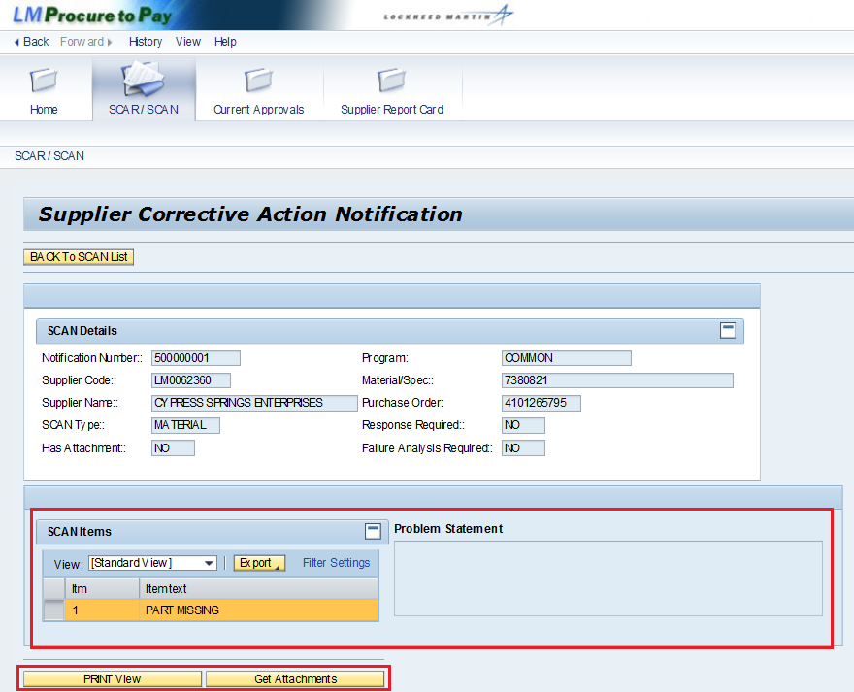

Step | Action
57. | SCAN Items: The SCAN may contain one item or multiple items. You can select the item to display the problem statement for that item.
58. | Problem Statement is the detailed description of the problem. Each item will have its own problem statement.
59. | PRINT View: Click this button to convert the SCAN to a Word document suitable for printing.
60. | Get Attachments: If the SCAN has attachments, they can be accessed from this button. Refer to the Has Attachment response in the SCAN Details section to see if the SCAN has any attachments.

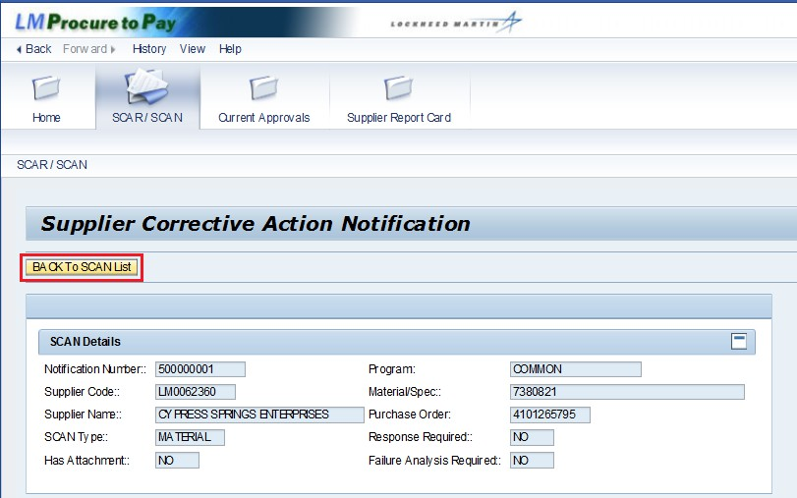

Step | Action
61. | Click the Back to SCAN List button to return to the SCAN listing.
62. | You have successfully completed the procedure on how to complete a SCAR and view a SCAN.

