
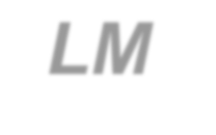


Last Updated 8/11/2014

LM Procure to Pay
Quick Reference Guide For External Source Quality
Field Engineers
Non-Survey FQR Source Acceptance

Lockheed Martin Procure to Pay Revised August 2014

Procedure

This quick reference guide displays the procedure to process a Non-Survey FQR Source Acceptance procedure.

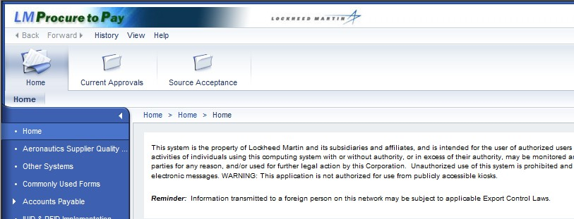

Step | Action
1. |   Click the Source Acceptance tab to process a PO source acceptance.

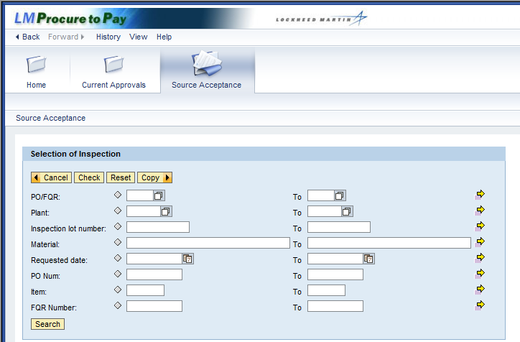

Step | Action
2. | The Source Acceptance screen displays a variety of search criteria that can be used to query inspection lots.  Click the PO/FQR matchcode button.

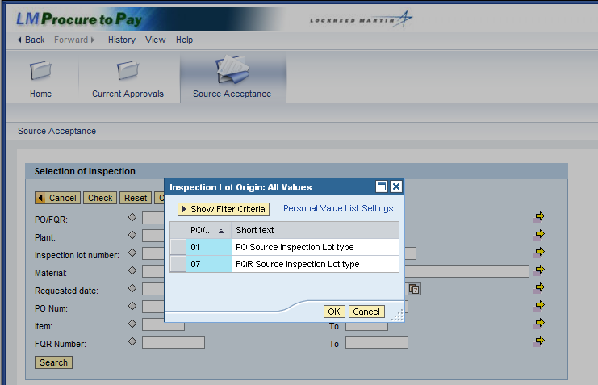

Step | Action
3. | Select the inspection lot origin by clicking the PO Source Inspection Lot type  selection box.

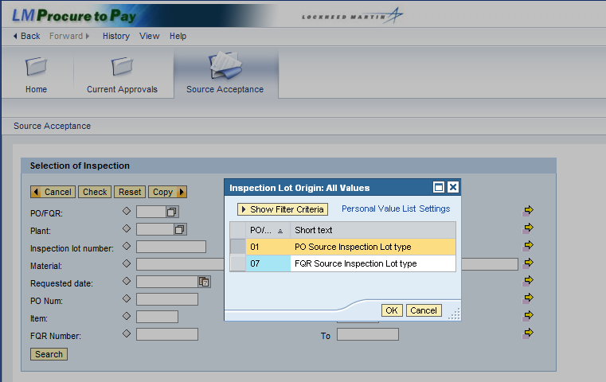

Step | Action
4. | Click the OK button to confirm your selection.

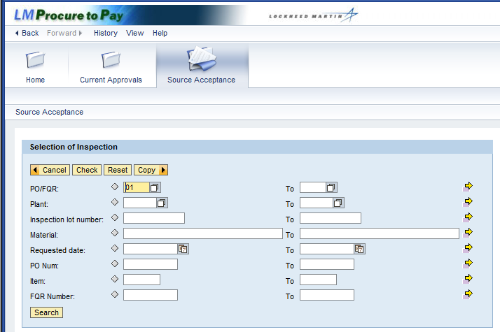

Step | Action
5. | Click the Plant matchcode button.

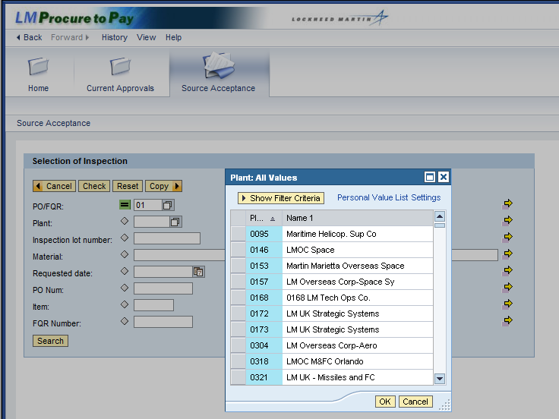

Step | Action
6. | In the Plant pop-up window you can select the plant where the source inspection will take place.
7. | You can also search using the inspection lot number and material. For the  Material field, enter a material (part) number and find all matching PO line items.  Note: Exact material matches require an asterisk (*) as the last character because each material has a plant identifier. For example, RG123345-3 is listed as RG123345-3:MO, and "MO" identify the Moorestown plant.  Wildcard searches are used to query a range of materials. Enter an asterisk (*) for a range or a plus (+) for individual characters. For example, enter RNC55* to find materials beginning with RNC55 or enter RN+55 to find all materials beginning with "RN" that have any character in the 3rd position and "55" in the 4th and 5th position. For example, RNA551234.

Step | Action
8. | Additional criterion that can be entered to further refine the search include:  - Requested date: Enter a date range to narrow the list of inspection lots to a specific date. For example, enter a week's range to create your travel plans  - PO num: Enter a full PO number and find all line items with matching inspection lots, or enter a range of PO numbers  - Item: Enter a specific PO line item number, along with the PO. If left blank, the line items for a specific PO are displayed  - FQR Number: Enter a specific Field Quality Request (FQR) number, or a range, to list specific inspection lots

Step | Action
9. | To run the query for PO source inspections at every plant you are assigned to, click the Search button.

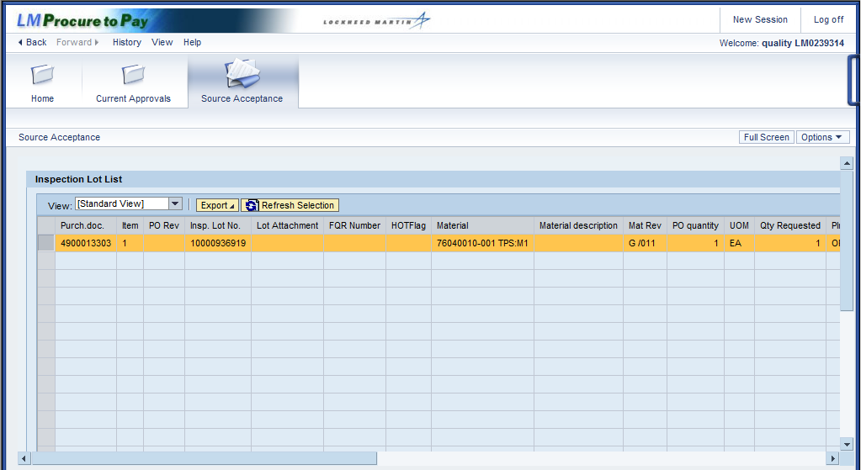

Step | Action
10. | The Inspection Lot List displays all PO inspection lots that are assigned to you.
11. | The Inspection Lot List screen displays information about each lot, and column titles can be sorted and contain the following information:  - Purch. doc.: Purchase Order (PO) number  - Item: PO line item number  - PO Rev: Revision number of PO line item  - Insp. Lot No.: Inspection lot number, starts with a 1 (PO) or a 7 (FQR)  - FQR Number: Field Quality Request number  - HOTFlag: Contains an X if a priority inspection  - Material: For PO acceptance it is the material, for FQR it is an audit material number  - Material description: Name of the material  Click the horizontal scroll bar to display more columns of inspection lot information.

Step | Action
12. | (Continued) Columns describing the inspection lot include:  - Mat Rev: Revision of the material. For PO acceptance this is the document version of the material master  - PO quantity: Quantity ordered for the PO line item  - UOM: Unit of Measure (e.g., EA for each or GAL for gallon, etc.)  - Qty Requested: Quantity in the inspection lot. FQR quantity is 1 with inspection plan, and 0 without plan  - Plnt: Plant code. Contact site rep for list of plant names  - POrg: Purchasing Organization  - Supplier Vendor Name: Company name  - PostalCode: ZIP code of vendor's address  - PGr: The buyer's code in PO source acceptance. Contact site rep for list of buyer codes  - Inspector ID: Your profile ID  Click the horizontal scroll bar to display more columns of inspection lot information.
13. | (Continued) Columns describing the inspection lot include:  Deliv. date: Date requested for visit to vendor's facility, which you can revise  QS: Quality Status, or current status code for inspection lot Quality Status Description: Current status of inspection lot Code: Program Code  Program Description: Name of the program  User Status: User status of inspection lot (i.e., in-process or final), for PO acceptance only  Click the horizontal scroll bar to display more columns of information.
14. | (Continued) Columns describing the inspection lot include:  - FQR Type: The type for surveys is SURV. Contact site rep for list of FQRs types  - FQR Draw Revision: Revision # of material/process, defined by procedures  - SCAR Number: The QNote number of the corrective action, if applicable  - FQR Comments: Additional instructions noted in the FQR  You have completed your review of the columns, so click the horizontal scroll bar to return to the initial view of the Inspection Lot List.

Step | Action
15. | Two buttons are available at the top of this screen:  - Export: Export and/or print the Lot List in an Excel spreadsheet (.xls)  - Refresh Selection: Updates selected lot to the latest status change

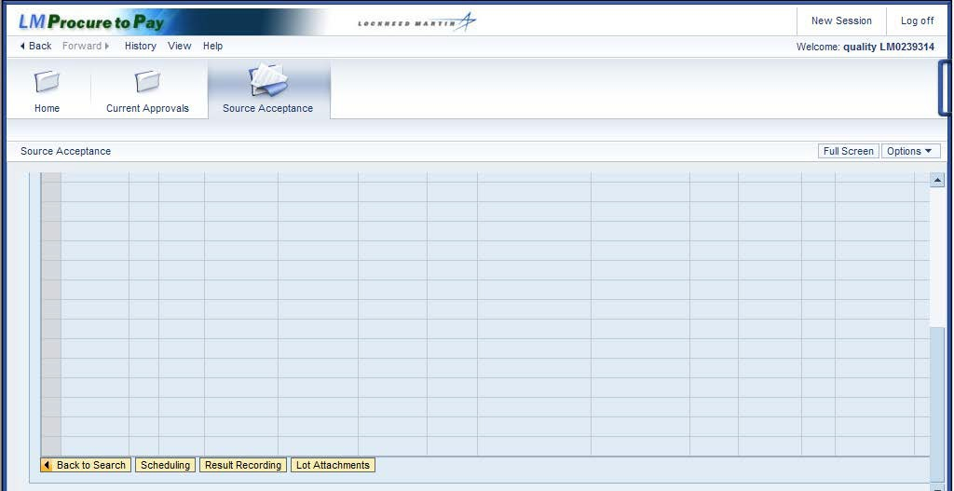

Step | Action
16. | Several buttons are at the bottom of the Inspection Lot List:  - Back to Search: Returns to Selection of Inspection  - Result Recording:  - Lot Attachments  Click the Scheduling button.

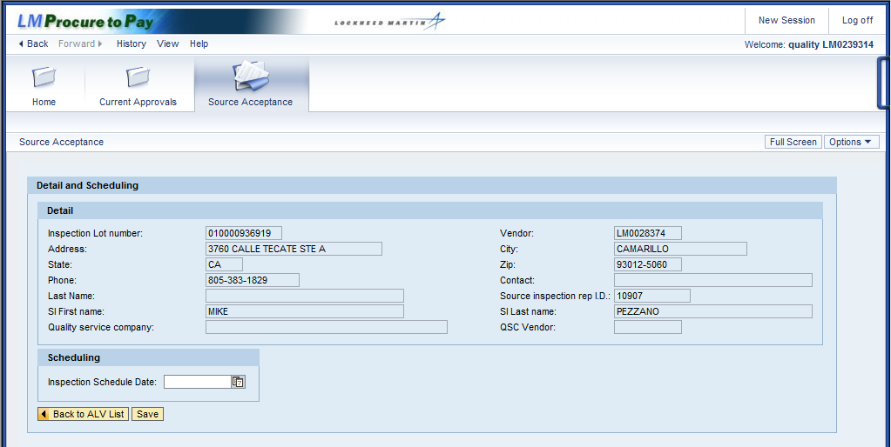

Step | Action
17. | Source inspection information is displayed in the Detail and Scheduling screen.  The Detail section includes information about the inspection and the vendor. This is for your reference only, no information can be changed.  The Scheduling section allows you to modify the Inspection Schedule Date field, which is optional and is dictated by site procedures.
18. | Click the Inspection Schedule Date matchcode button to enter a date that works with your schedule.

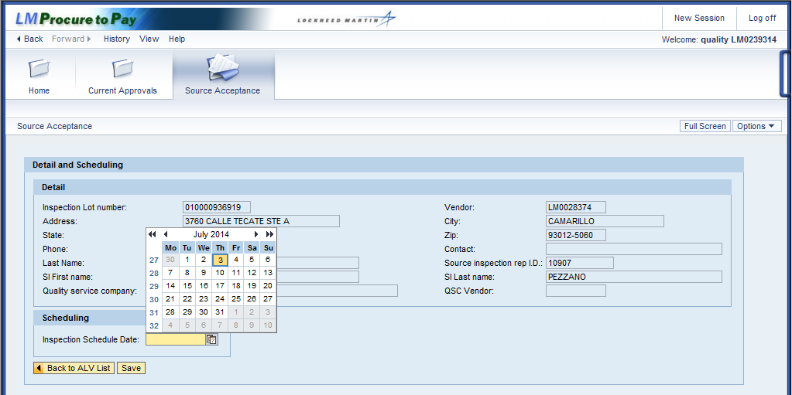

Step | Action
19. | Select the best date for the inspection.

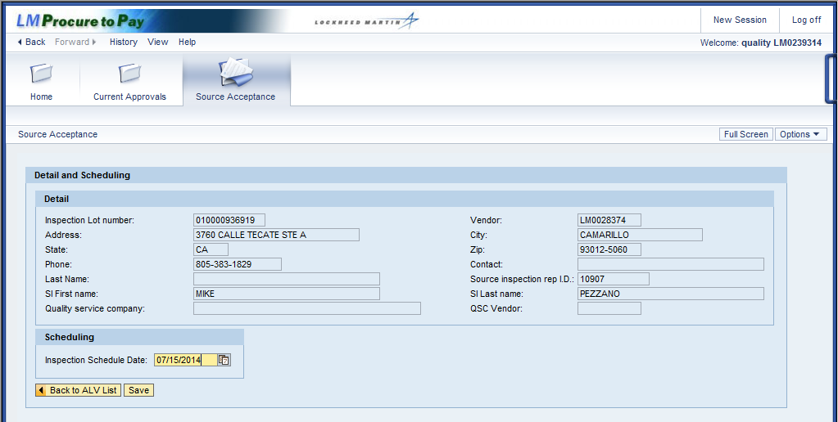

Step | Action
20. | Click the Save button.
21. | The date you selected date is now displayed as the inspection schedule date.  Click the Back to ALV List button.
22. | You have returned to the Inspection Lot List.  Click the vertical scroll bar to return to the bottom of the screen.

Step | Action
23. | Click the Back to Search button to query another inspection lot.

Step | Action
24. | You have returned to Selection of Inspection.  This time you will complete a Non-Survey FQR inspection lot. Begin by clicking on the PO/FQR matchcode button.

Step | Action
25. | Select the inspection lot origin by clicking the FQR Source Inspection Lot type  selection box.  Recall that these always begin with the number 7.

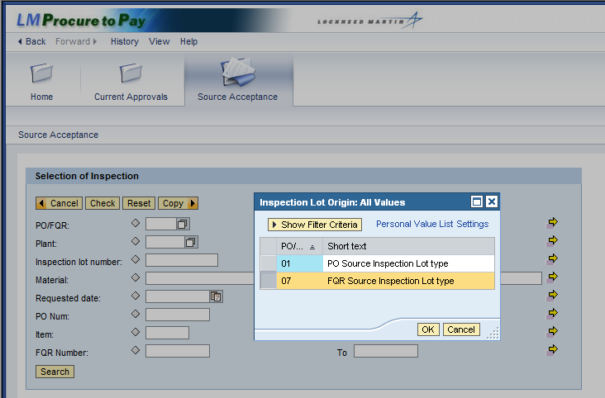

Step | Action
26. | Click the OK button.

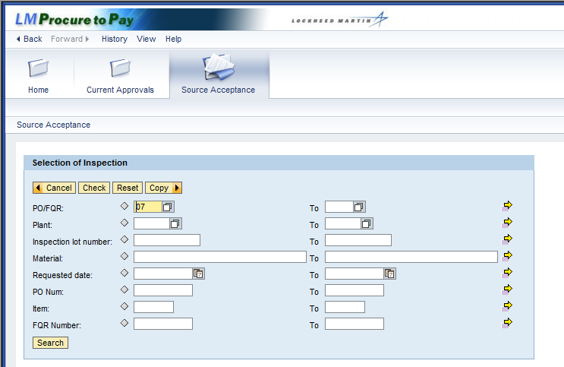

Step | Action
27. | Click the Search button to query all FQR source inspection lots that are assigned to you.
28. | The Inspection Lot List displays with the FQR lots assigned to you. The first inspection lot displayed in the table has been default selected.  Click the vertical scroll bar to display the buttons at the bottom of the screen.

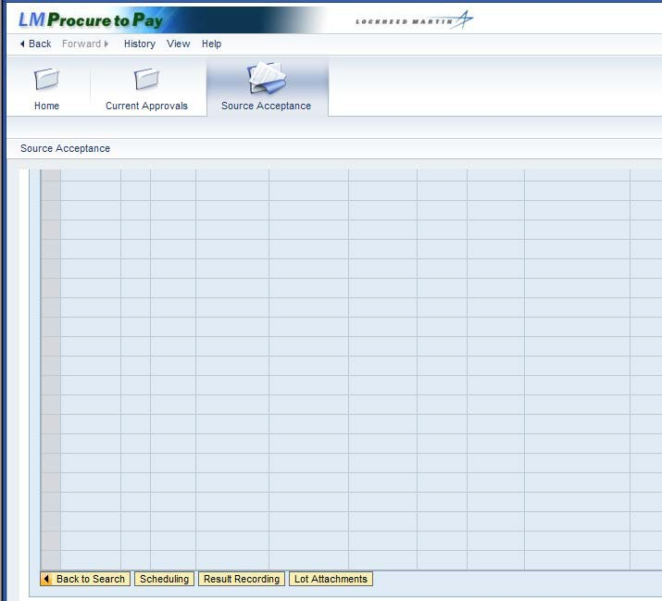

Step | Action
29. | Click the Result Recording button to enter the results of the inspection.

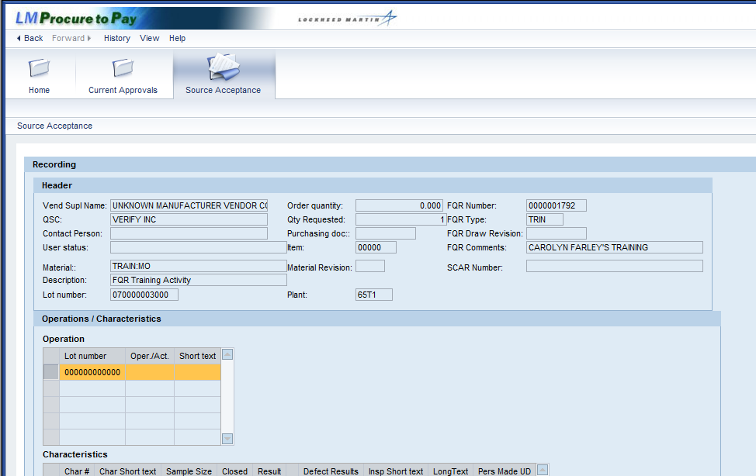

Step | Action
30. | The Source Acceptance Recording screen displays the Header and Operations  /Characteristics section.
31. | Header: Displays information from the Lot List, including the vendor's contact person and the Quality Service Company (QSC)  Operations: Contains an inspection plan, which has at least 1 operation and 1 characteristic that must be completed. When the inspection plan has more than 1 operation and/or characteristic, you must complete all of them to complete the inspection.

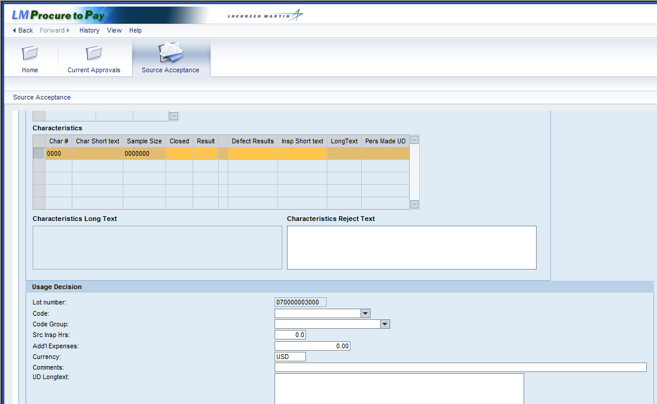

Step | Action
32. | The Characteristics Long Text field may be empty for this inspection type, so you will need to display the FQR attachment to see the inspection characteristics.  Click the vertical scroll bar to display the buttons at the bottom of the screen.

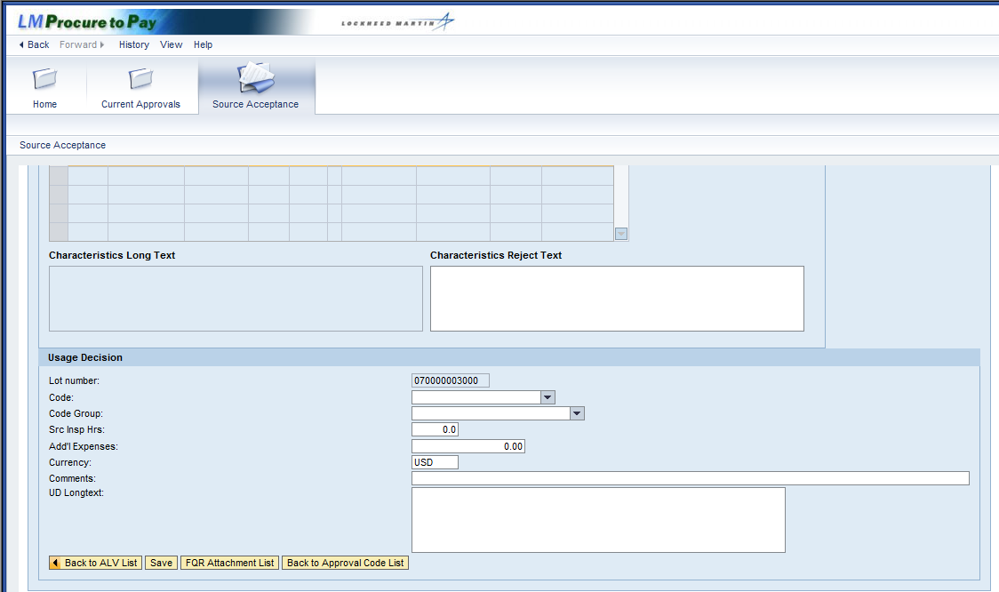

Step | Action
33. | There are several buttons at the bottom of the screen.  - Back to ALV List: Returns to the Inspection Lot List  - Back to Approval Code List: Not used for non-survey inspection lots  Click the FQR Attachment List button to view the inspection characteristics.

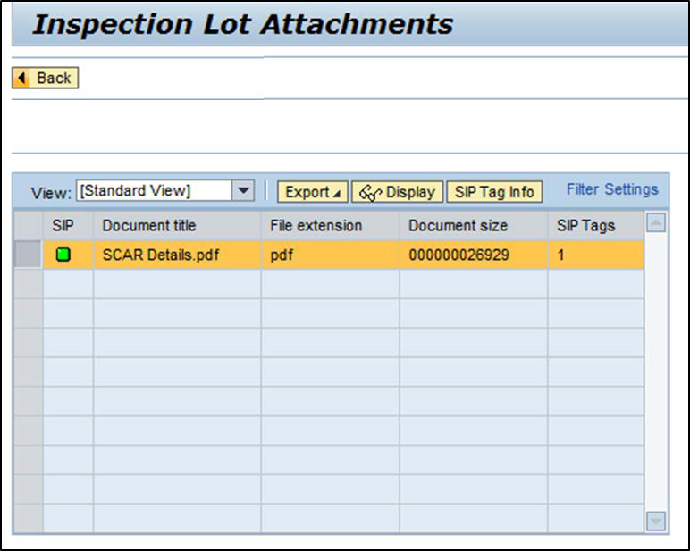

Step | Action
34. | The Attachment List displays.  Columns of information include the document title, file extension, document size, and the Sensitive Information Protection (SIP) tag. For more information on the SIP Tag, click the SIP Tag Info button.  The attachment entitled SCAR DETAILS is selected by default. Click the Display button to open the Adobe Acrobat (.pdf) file.

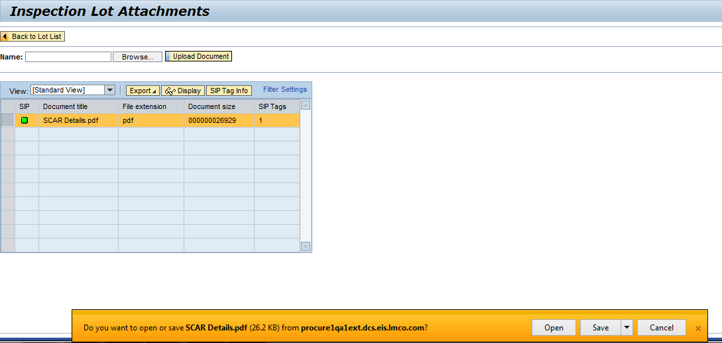

Step | Action
35. | Click the Open button to display the document in Adobe Acrobat.  Note: You can also save the file, but you are usually conducting the inspection when completing this step.

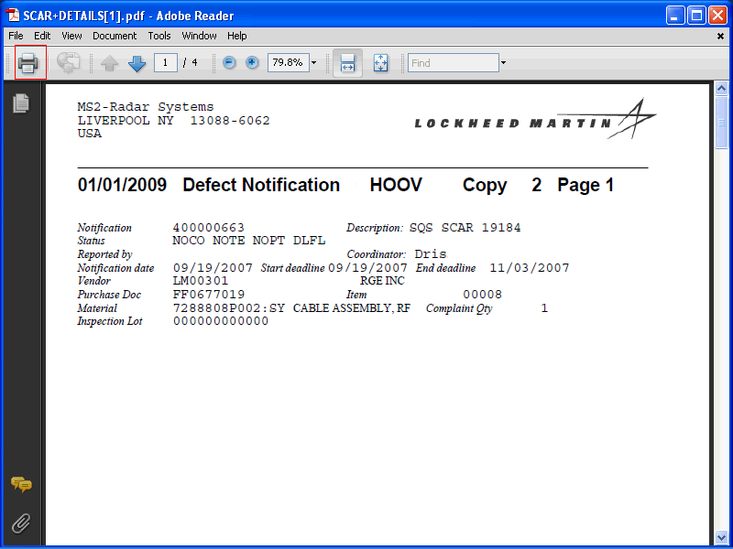

Step | Action
36. | The SCAR DETAILS document is displayed. The characteristics to complete this inspection are contained within this document.    You can print the document by clicking on the Printer button in the upper left corner of the screen.

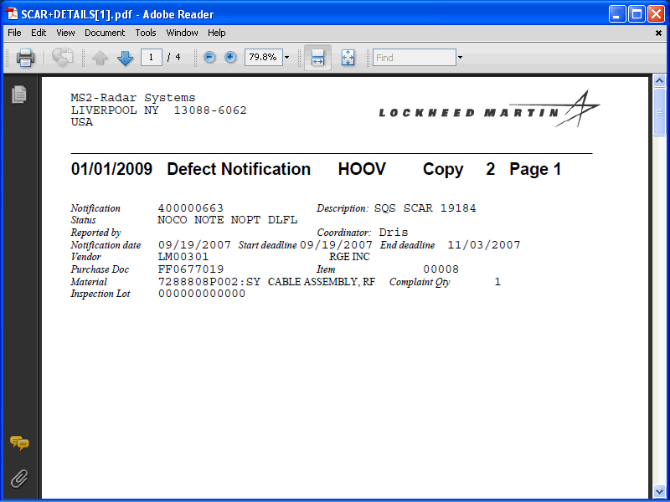

Step | Action
37. | Click the (Close) button in the upper right corner of the screen to exit this document.

Step | Action
38. | Click the Back button to return to the Recording screen.
39. | Click the vertical scroll bar to display the Characteristics table.

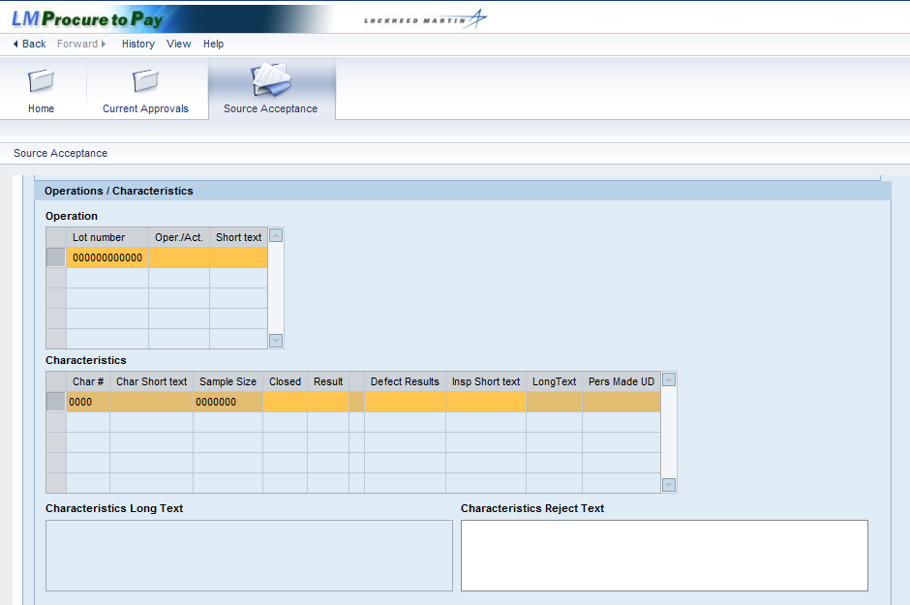

Step | Action
40. | 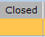  Click in the Closed field and enter the letter X to indicate you have completed this inspection.

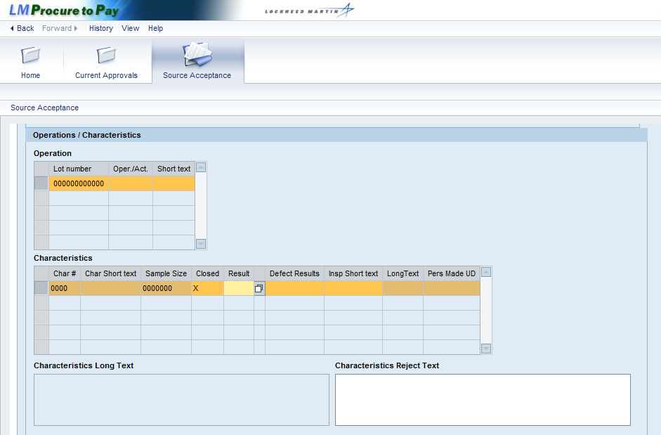

Step | Action
41. | 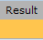  Click in the Result field.
42. | Click the Result matchcode button.

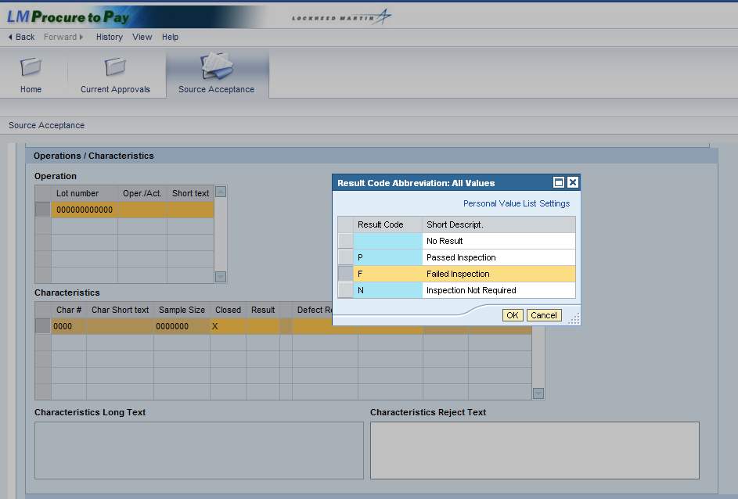

Step | Action
43. | Click the Failed Inspection selection.
44. | Click the OK button.

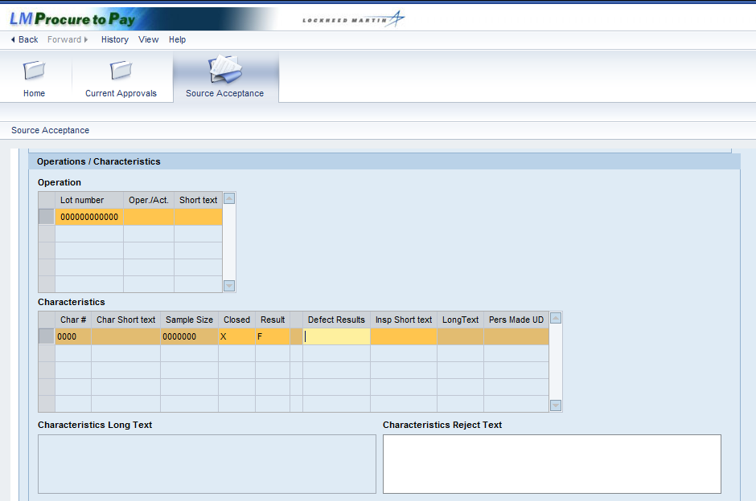

Step | Action
45. | 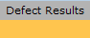  Click in the Defect Results field.
46. | 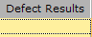  Enter the number of defects. This usually matches the sample size.

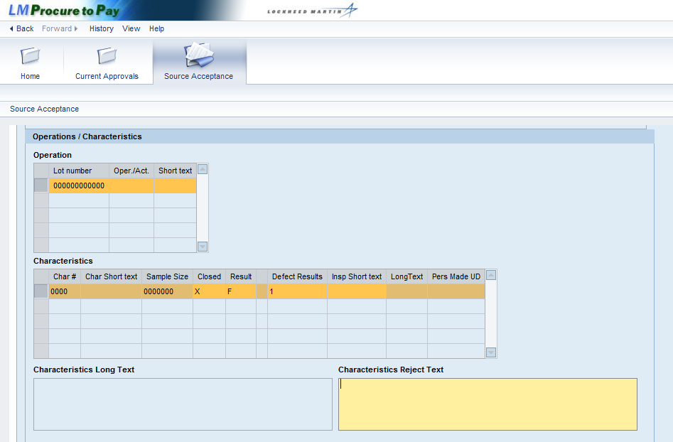

Step | Action
47. | Click in the Characteristics Reject Text field to describe the defect(s).
48. | Enter a Detailed description of the reason for the reject in this text field.
49. | Click the vertical scroll bar to record the usage decision.

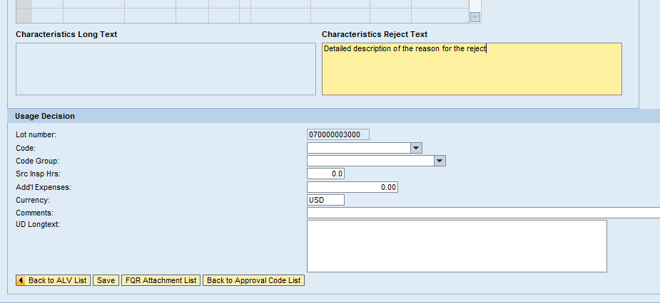

Step | Action
50. | The Usage Decision section is displayed. Information in this section includes:  - Lot number: The lot number you are currently inspecting  - Code: Every lot requires a usage decision, which is the final disposition of the entire lot  - Code Group: This field auto-completes once the code is selected  - Src Insp Hrs: 3rd party SI Reps should enter the time charged for processing this lot, as directed  - Add'l Expenses: 3rd party SI Reps should enter any additional expenses for processing lot, as directed  - Currency: Currency of expenses entered. The default is United States Dollars, or USD  - Comments: Enter as needed to explain and justify expenses  - UD Longtext: Enter as needed to provide further details about the usage decision

Step | Action
51. | Click the Code drop-down button to select the usage decision from a list.

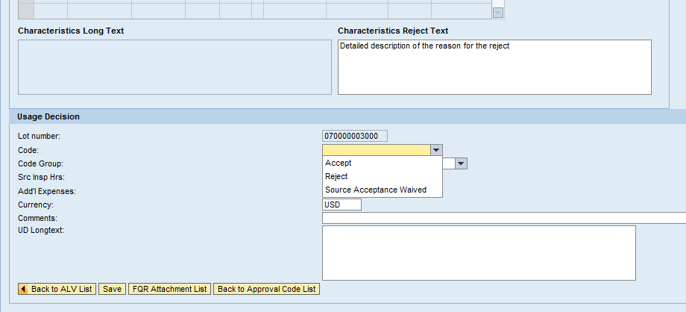

Step | Action
52. | There are three usage decision codes listed in the drop-down box:  - Accept: Chosen if all characteristics are accepted, or as directed by your site. Some lots with a rejection may be acceptable. For example, your site may direct you to accept the lot and set a hold flag upon Goods Receipt, which stops the lots for consideration by the Material Review Board (MRB)  - Reject: Chosen if you encounter any rejections while inspecting characteristics, or as directed by your site  - Source Acceptance Waived: Chosen only when directed by your site, it cancels the source acceptance
53. | Click the Reject menu item to select it as the usage code.

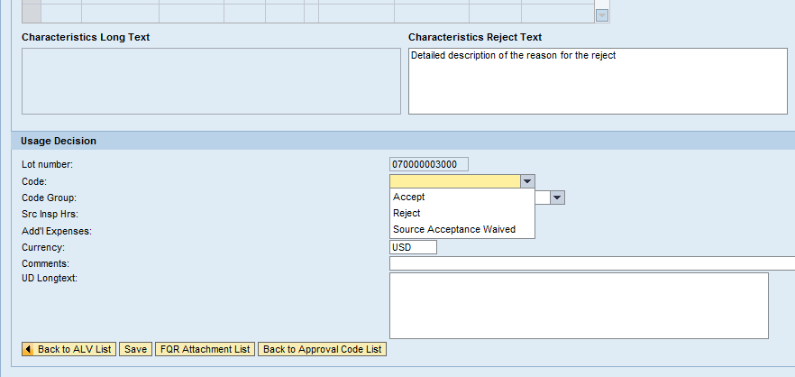

Step | Action
54. | There are several buttons options available at the bottom of this screen:  - Back to ALV List: Return to the Inspection Lot List  - FQR Attachment List: You have already viewed the attachment, but this button displays all FQR attachments  - Back to Approval Code List: If the lot is a survey FQR, this will return you to the Approval Code List
55. | You have inspected all characteristics for this Non-Survey FQR source acceptance simulation.  To complete this inspection lot with a usage decision of reject, click the Save  button to confirm your entry is complete.

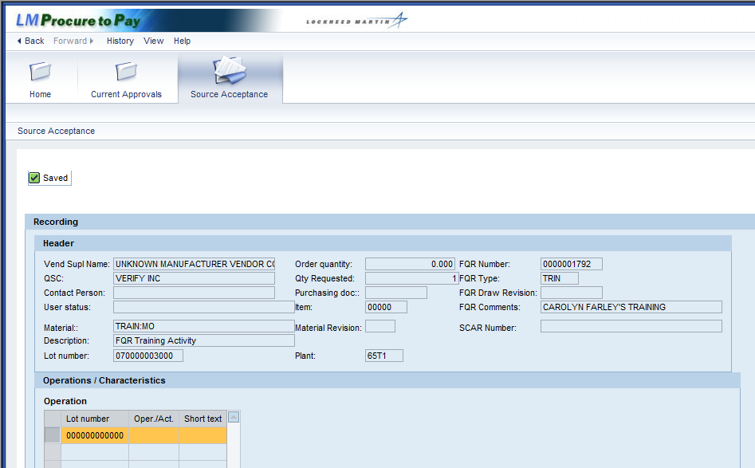

Step | Action
56. | You have completed the source inspection for the selected lot.  To return to the Inspection Lot List you would click the vertical scroll bar, and then click the Return to ALV button at the bottom of the screen.  Click the Home tab to exit this transaction.  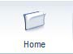
57. | You have successfully completed the procedure to process a Non-Survey FQR Source Acceptance procedure.

