Last Updated 06/29/2023
LM Procure to Pay
Quick Reference Guide For Suppliers
Current Approvals
Lockheed Martin Procure to Pay
Revised April 2019

LM Procure to Pay Current Approvals Quick Reference Guide
Procedure
This quick reference guide displays the procedure to view a Lockheed Martin Approved Special Processor. When selecting a Lockheed Martin approved special processor, use only those special processors with an Approved Disposition. This guide has been developed in order to provide the ability to search for and find approved special processors.
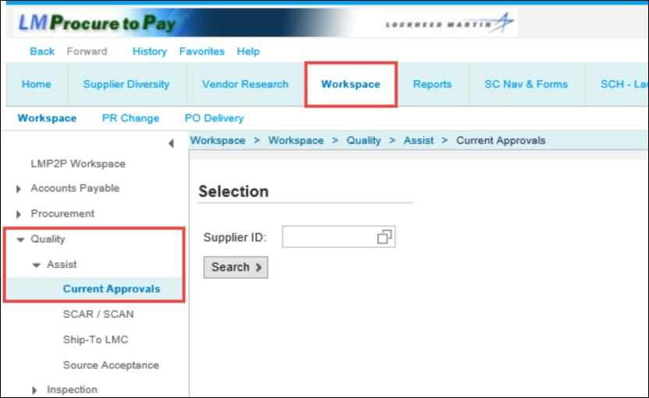
Step | Action
1. | To access the Current Approval screen, click Workspace tab > Quality > Assist > Current Approvals  Note: Enter a Supplier ID to continue.

LM Procure to Pay Current Approvals Quick Reference Guide
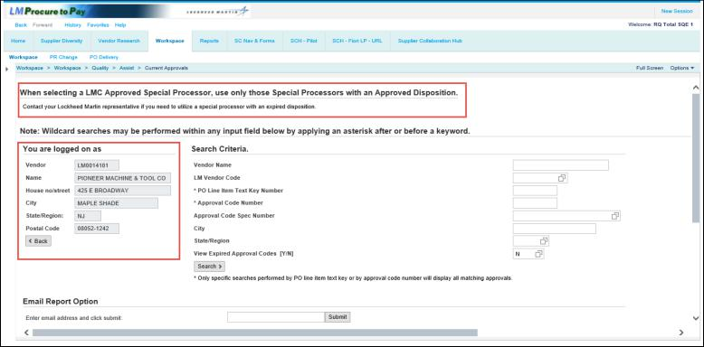
Step | Action
2. | The Current Approvals screen displays. Take note the statement at the top of the display which advises to use only those Special Processors with an Approved Disposition.  The other highlighted area of the screen displays your company information.

3. | If the purchase order has special process requirements, this area provides an easy way to search for Lockheed Martin approved special processors. The Search Criteria box contains several fields with which to perform a search.  - If a vendor is familiar with a Lockheed Martin vendor code, they can perform a direct query for it in the LM Vendor Code field  - A vendor can also input a Lockheed Martin PO line item approval code text key (for example TQ7E) and obtain a list of approved special processors associated with that approval code per use of the PO Line Item Text Key Number field  - If a vendor is familiar with an explicit Lockheed Martin approval code (for example SQZR900182 which is tied to text key TQ7E), they can perform a direct query for it in the Approval Code Number field  - Take note, there are also queries available by Approval Code Specification Number, by City and by State/Region  - An option to view both Active and Expired approvals is also available via a Y/N option in the View Expired Approval Codes field. Take note the default option is set to ‘N’ to ensure only approved special processors are utilized.  - Special process suppliers must have an approved QMS at the time special processes is performed in addition to special process certification.

LM Procure to Pay Current Approvals Quick Reference Guide
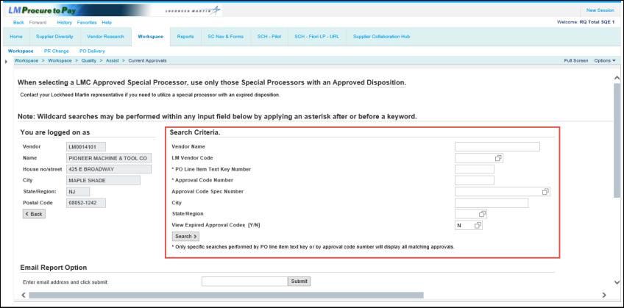
Step | Action

4

LM Procure to Pay Current Approvals Quick Reference Guide
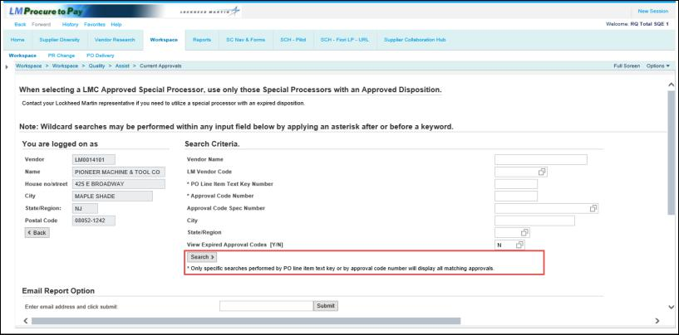
Step | Action
3b | Only specific searches Performed by PO line item text key or by approval code number will display all matching approvals.  Special Search Capability: Wildcard searches can be performed within any query field by applying an asterisk before or after a keyword. For example, typing *Technical* in the Vendor Name field will return all vendors with the word Technical in their name.

LM Procure to Pay Current Approvals Quick Reference Guide
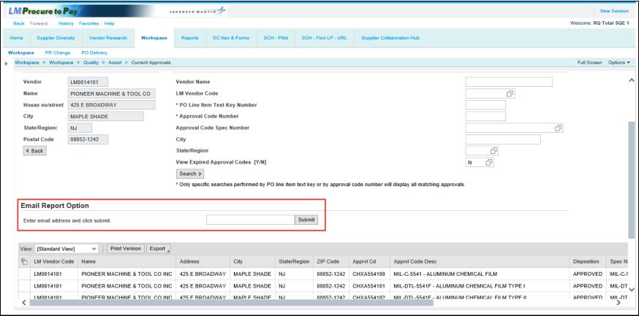
Step | Action
4. | A Current Approvals module improvement has now been introduced whereby a new email option is offered which allows users to have record export files emailed to them. By averting the potential for screen timeouts, this solution provides an improved method for requesting & receiving file exports from the Current Approval module. This method was designed to support both full and filtered outputs based on the Search Criteria values specified.  Note – Due to consistent screen timeouts encountered when Full record displays are attempted, users will now also be forced to specify at least one input value for “on screen” requests.

LM Procure to Pay Current Approvals Quick Reference Guide
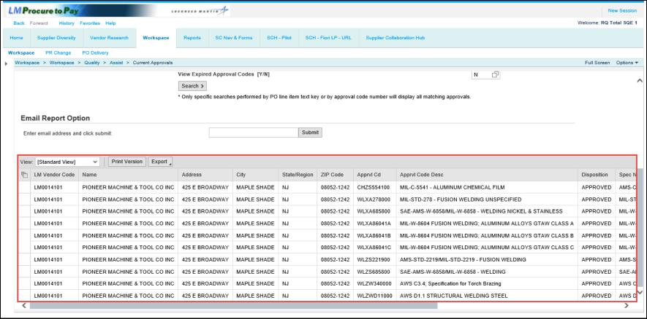
Step | Action
5. | The bottom of the screen displays the results of the query. The columns available include the Vendor code, name, address, Approval Code and description.  Scrolling to the right reveals more fields which are explained on the next screen.

LM Procure to Pay Current Approvals Quick Reference Guide
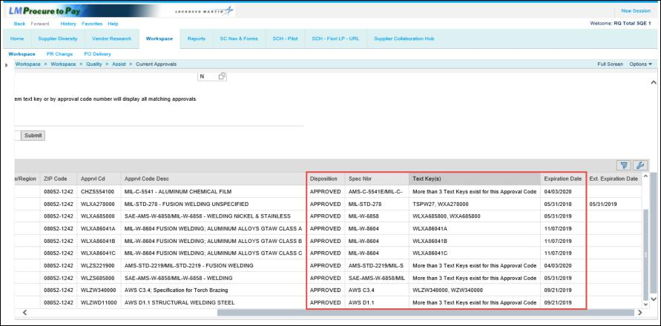
Step | Action
6. | Additional fields are the disposition of the special processor (either Approved or Expired), Spec Number, Text Key(s) and Expiration Date.  The Text Key field will display up to three text keys for any unique approval code (a single approval code may be associated with more than one Lockheed Martin text key). For approval codes which display more than three text keys, the field will state “More than 3 Text Keys exist for this Approval Code”.  To display additional query records, use the inner scroll bar highlighted in the screen shot above to view the additional data.

LM Procure to Pay Current Approvals Quick Reference Guide
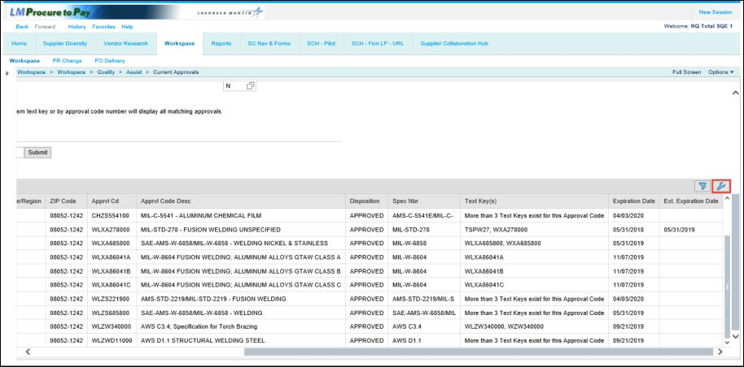
Step | Action
7. | You can find certain records within your output results through use of the Filtering option. To use this feature, click the Filter link located on the far right of the screen.

LM Procure to Pay Current Approvals Quick Reference Guide
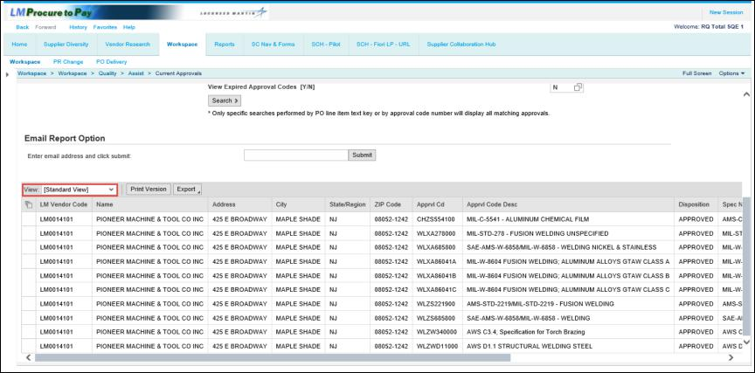
Step | Action
 | After creating a filter view, you can apply it from the View dropdown menu.
 | You have successfully completed the procedure to view a Lockheed Martin Approved Special Processor.

