Contents
SCH Quick Links Introduction 2
Viewing Quick Links 3

Supplier Collaboration Hub (SCH) Quick Links, Introduction
- This guide will explore the Supply Chain Hub (SCH) Quick Links functionality | 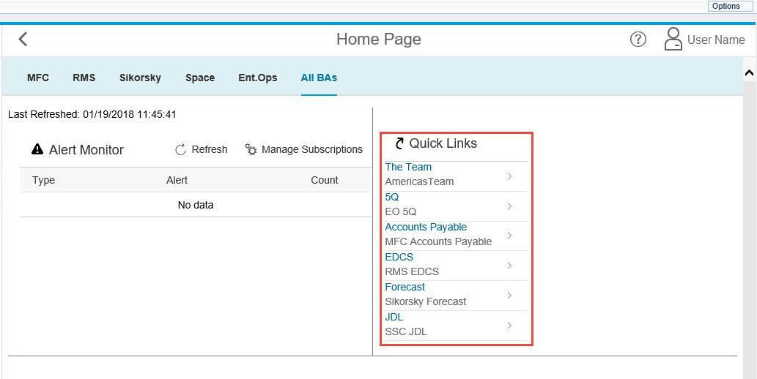

Viewing Supplier Collaboration Hub (SCH) Quick Links
- Quick links will be available under the All BA’s and will show you all of the quick links for all of the Business areas  - Select a single Business Area to only see the specific Quick Links for that business | 