Contents
Supplier Collaboration Hub Milestone Management, Introduction 2
Navigating to SCH Milestone Management 3
Navigating Milestone Management 4
Reviewing a Buyer Proposed Milestone 6
Reviewing a Buyer Proposed Milestone, Supplier Completion Date 9
Reviewing a Buyer Proposed Milestone, Supplier Proposal Date 10
Reviewing a Buyer Proposed Milestone, Special Instructions & Comments 11
Reviewing a Buyer Proposed Milestone, Attachments 13
Reviewing a Buyer Proposed Milestone, Saving or Submitting 16
Approved or Rejected Milestones 17

Supplier Collaboration Hub Milestone Management, Introduction
This quick reference guide explores the Supplier Collaboration Hub Milestone Management Module  The Milestone Management Module is a secure, easy-to-use, web-based application enabling buyers and suppliers to collaborate po item detailed planning for tasks with in a Milestone. Eliminating Word and Excel documents exchange via email buyers and suppliers can now collaborate within a tool to track detailed cost and delivery items tasks depending on Milestone type.  - From the top navigation panel of the LMP2P Portal, click Supplier Collaboration Hub to access the SCH Launchpad | 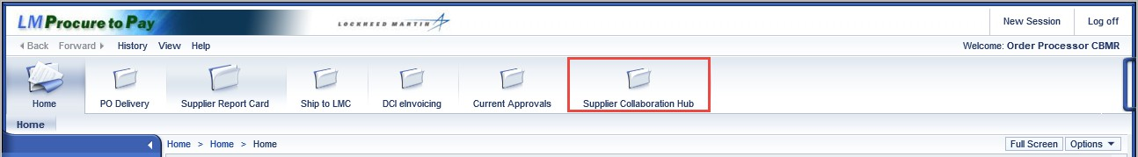

Navigating to SCH Milestone Management
- From the SCH launchpad, click the SCH Milestone Management tile to access the Milestone Module  Note: The number described in the SCH Milestone tile refers to the number of Open milestones in process. | 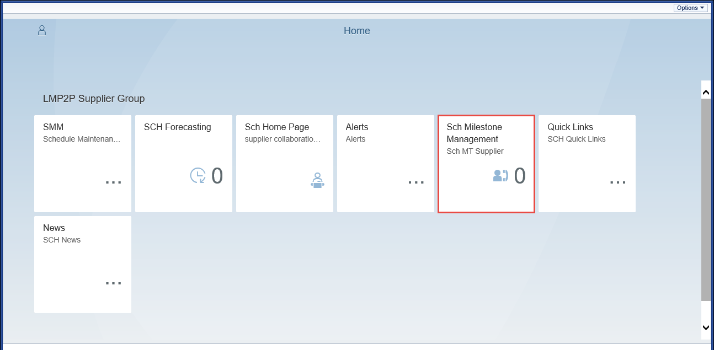

Navigating Milestone Management
The Milestone Module (Supplier View) will open. | 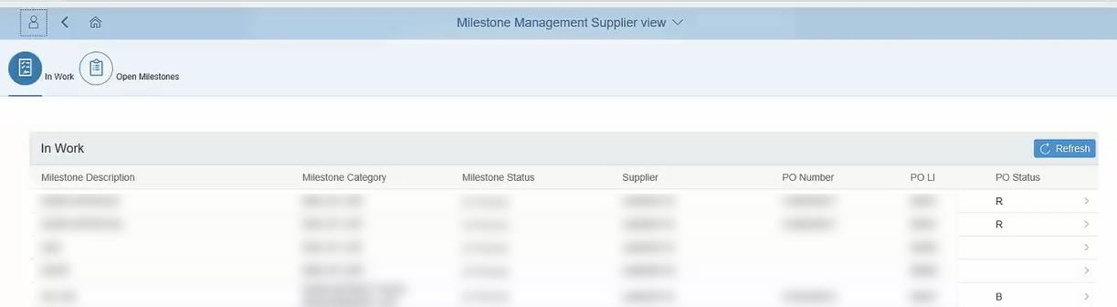

Navigating Milestone Management, continued
The top section of the screen will display the current page you are on.  - Work In: The default page when opening the Milestone Management Module (Supplier view). This page displays buyer proposed milestones yet to be reviewed  - Open Milestones: This page is used to view in process milestones that have gone though  supplier/buyer screening and approval | 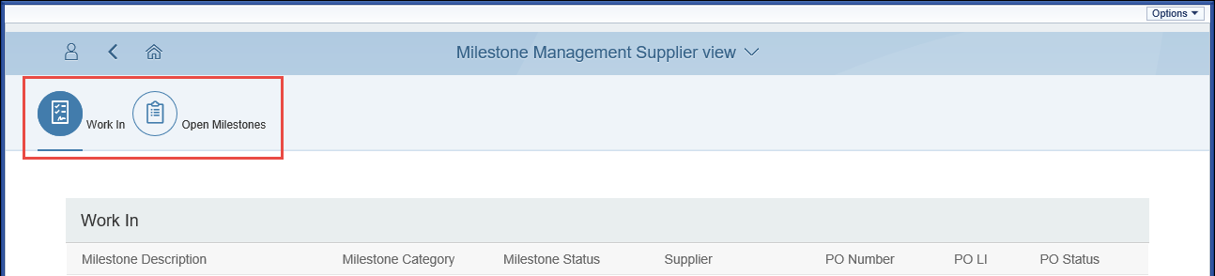

Reviewing a Buyer Proposed Milestone
- From the Work In page, click a Milestone line item to  open for review | 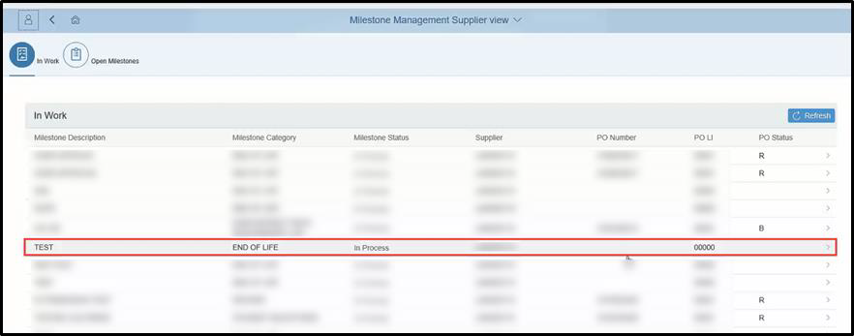

Reviewing a Buyer Proposed Milestone, continued
- Review the Milestone Details on the top section of the screen  Note: You can click the Back button to navigate back the to the Work In page | 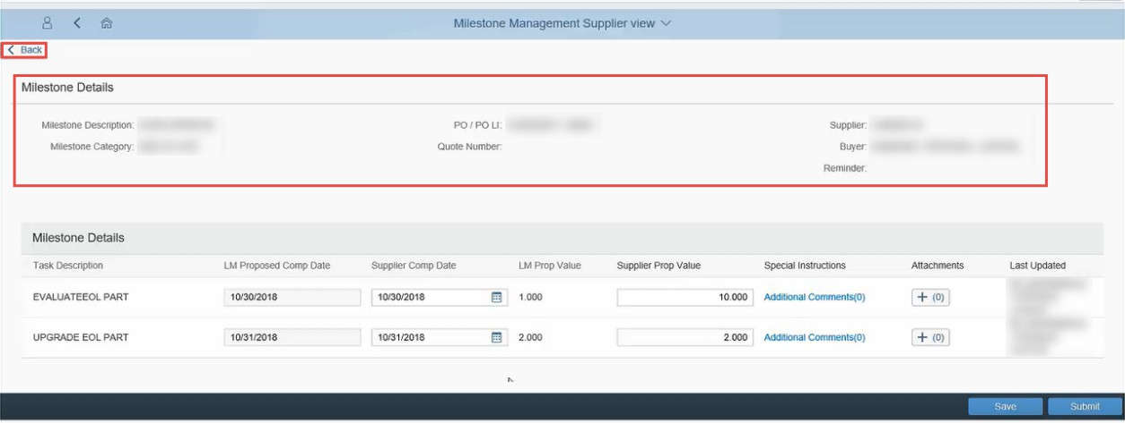

Reviewing a Buyer Proposed Milestone, continued
From the bottom section of the screen, you can view Task Descriptions, view or change Proposed Completion Dates (Buyer and Supplier), Proposed Values (Buyer and Supplier), Special Instructions/comments and add or view Attachments. | 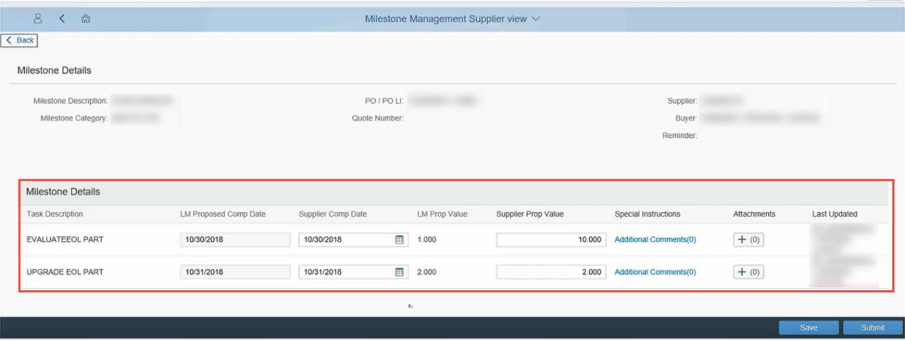

Reviewing a Buyer Proposed Milestone, Supplier Completion Date
You can use the Supplier Comp Date column and fields to alter supplier proposed dates for each of the milestone task items. | 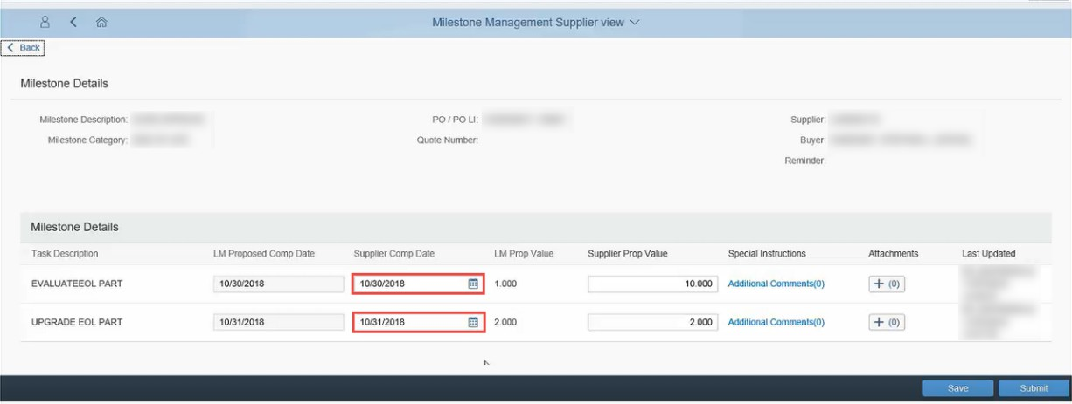

Reviewing a Buyer Proposed Milestone, Supplier Proposal Date
You can use the Supplier Prop Value column and fields to alter supplier proposed values for each of the milestone task items | 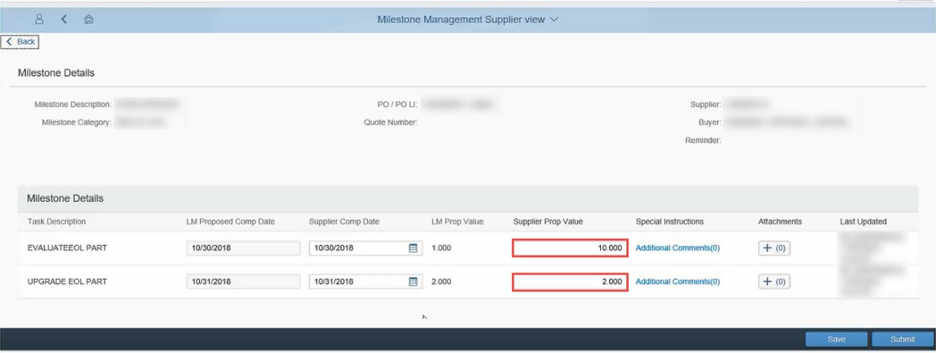

Reviewing a Buyer Proposed Milestone, Special Instructions & Comments
You can also add or view special instructions of comments for each of the task items.  - Click the Additional Comments link underneath the Special Instructions column  Note: Additional comments allow for buyer / supplier collaboration as comments are stored and tracked in a log. | 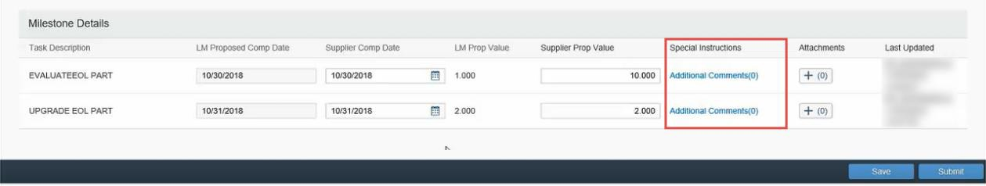
The Special Instructions pop-up will open.  - Enter your Special Instructions or comments, then click Submit to save | 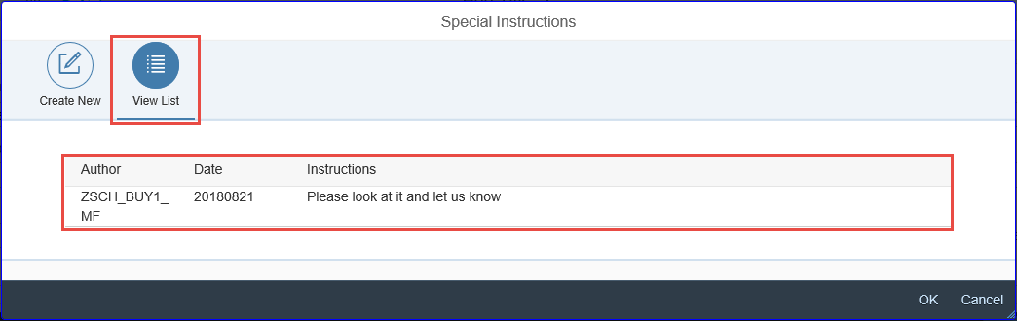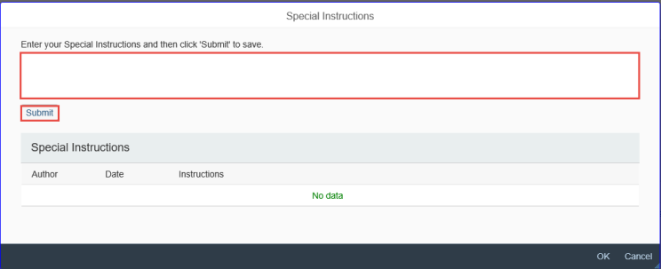

Reviewing a Buyer Proposed Milestone, Special Instructions & Comments continued
- Click OK or Cancel to navigate out of the Special Instructions pop-up | 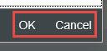

Reviewing a Buyer Proposed Milestone, Attachments
You can also add or view Attachments for each task item.  - Click the plus (+) icon underneath the Attachments  column | 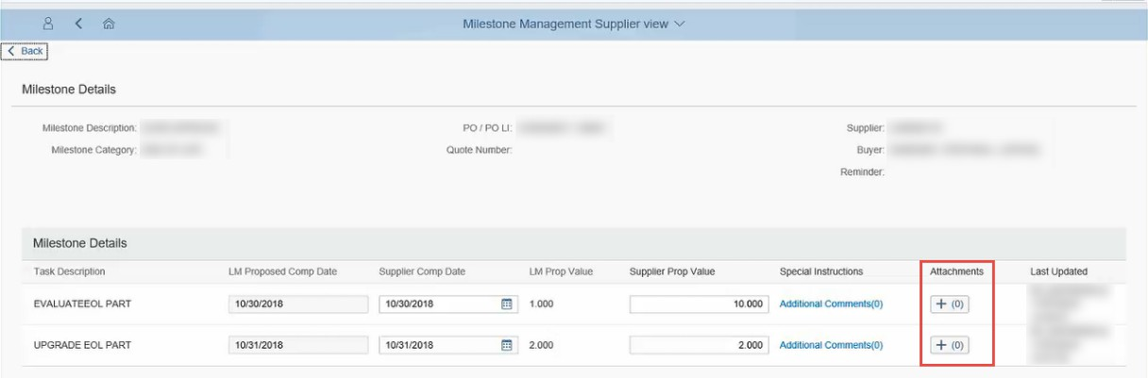
An attachments screen will open.  - Click any of the attachment items to open and view  Note: To remove an attachment from the list, Click the  (x) icon next to the attachment you wish to remove. | 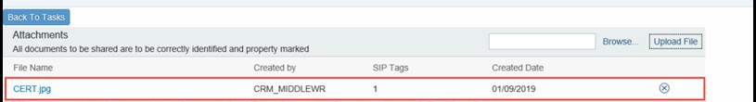

Reviewing a Buyer Proposed Milestone, Attachments continued
- To remove an attachment from the list, Click the (x) icon next to the attachment you wish to remove | 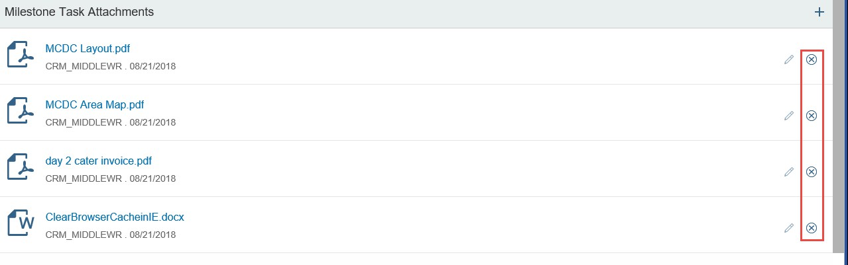
- To add an attachment to the list, click the Browse icon to browse your computer and select a file.
- Click Upload File to upload your selected file

Reviewing a Buyer Proposed Milestone, Attachments continued
- To navigate back to tasks, click the Back To Tasks button | 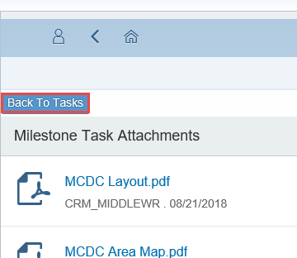

Reviewing a Buyer Proposed Milestone, Saving or Submitting
After reviewing the Milestone Details and reviewing the related tasks associated with the milestone, you can Save or Submit the milestone back to the buyer  - Save: Clicking Save will save a draft of this milestone. All milestones in draft status will appear back in the Supplier In Work Milestones list on the Work In page  - Submit: Clicking Submit will send the milestone (with your changes) to the buyer for acceptance  - Click Submit to submit the milestone back to the buyer | 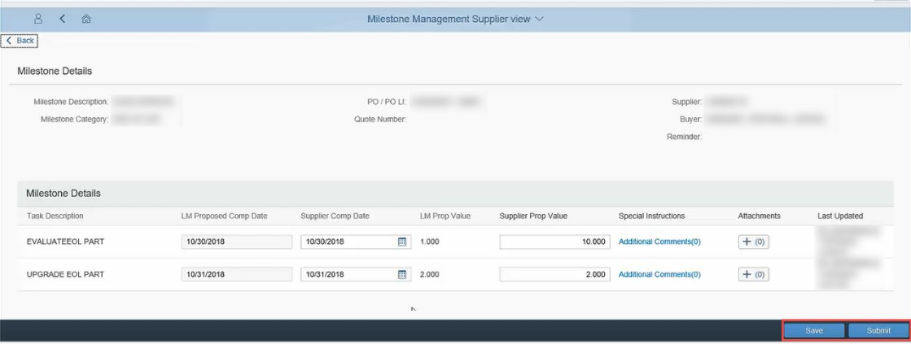

Approved or Rejected Milestones
The submitted milestone has been sent to the buyer for deposition. If the buyer approves the milestone changes, the milestone will appear in the Open Milestones page with status of Approved.  Note: A LM buyer may approve a Milestone on behalf of the supplier. | 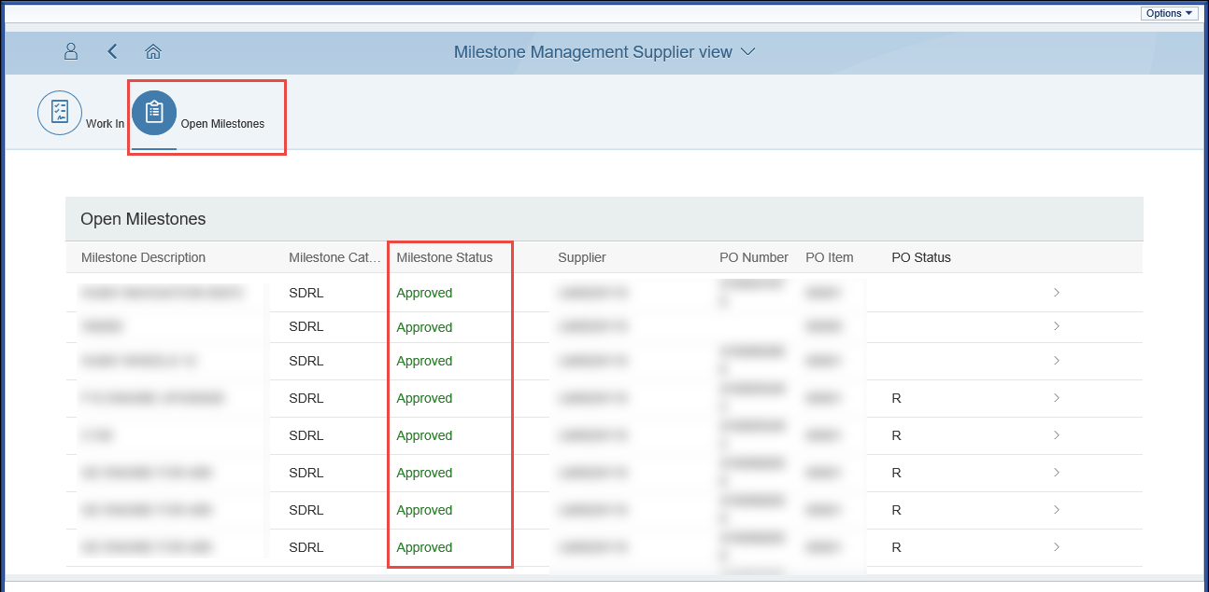
If the buyer has made additional changes for your review, the milestone will appear back in the Work In page milestone list.  Note: Follow the guidance shown above to review the milestone tasks and re-submit to buyer | 