Contents
Supplier Collaboration Hub Forecasting, Introduction 2
Navigating to SCH Forecasting 3
Business Area Tabs and Data 6
Viewing and Working with Data 7
Personalizing Data Views 10
Managing and Setting Personalized Views as Favorite 20
Downloading Data 23
Error: Too Many Rows 24

Supplier Collaboration Hub Forecasting, Introduction
This quick reference guide explores the Supplier Collaboration Hub Forecasting Module. The Forecasting Module is a secure, easy-to-use, web-based application enabling suppliers to plan and collaborate with Lockheed to reduce lead-times and support forecasting.  - From the top navigation panel of LMP2P Portal, click Supply Collaboration Hub to access the SCH Launchpad | 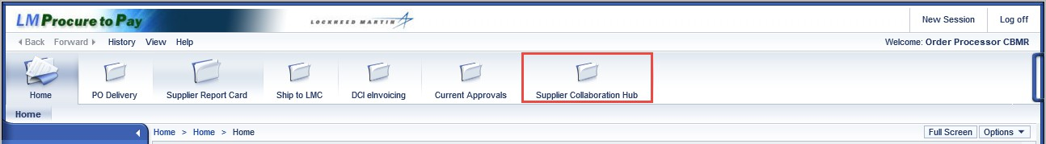

Navigating to SCH Forecasting
- From the SCH launchpad, click the SCH Forecasting  tile to access the Forecasting Module | 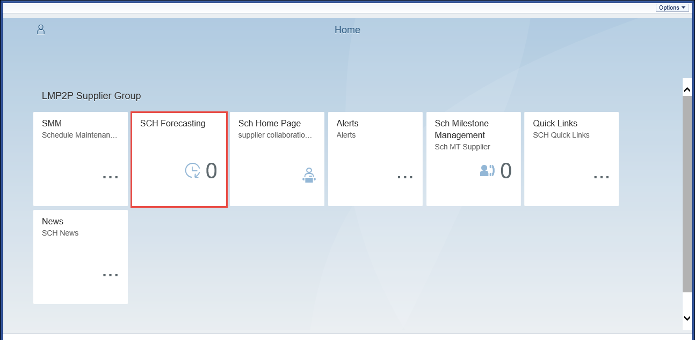

Accepting SCH Forecasting Disclaimer
- From SCH Forecasting tile you will be presented with a legal disclaimer outlining the usage of the Lockheed Martin Proprietary Information (LMPI) contained within the module.  - You will need to click ‘Yes” to agree to all conditions before you will see any forecast data.  Note: This disclaimer satisfies compliance requirements. Acknowledgments are captured, for audit requirements. | 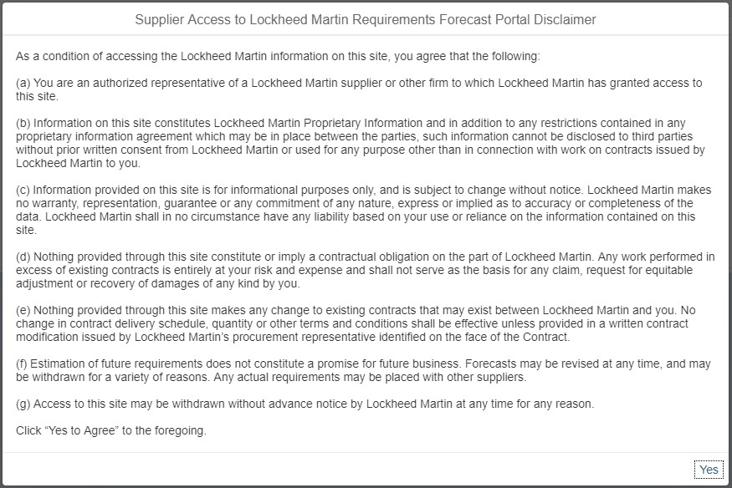

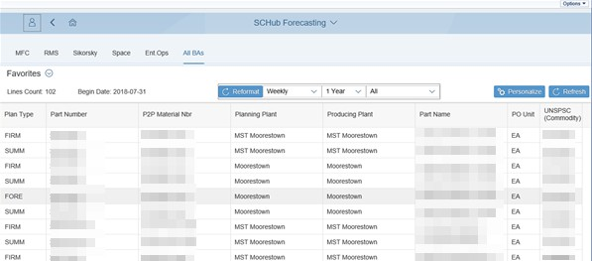
Navigating to SCH Forecasting, continued

The Forecasting Module page will open.

Business Area Tabs and Data
- The data and information within the Forecasting module will default to show the most relevant data for All BAs | 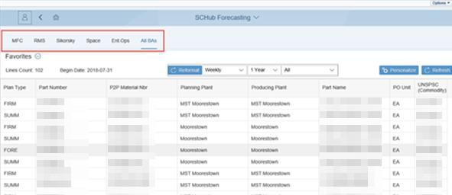

Viewing and Working with Data
The middle section of the page will display forecasting  data  Note: The data appearing in this section of the page will depend on the business area tab selected. In this example, data for the All BAs business area will appear because the user has elected to remain underneath the defaulted All BAs tab. | 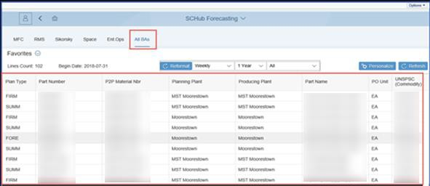

Viewing and Working with Data, continued
You can use the Reformat features found above the data section to reformat your forecasting data.  - Use the drop-down options to reformat data by:  - Sort Length: Reformat the data by selecting from weekly, monthly, quarterly or yearly data buckets  - Forecast Horizon: Set how far in the future you would like to see your forecasting data  - Plan Type: Use this drop-down to reformat data by Plan type | 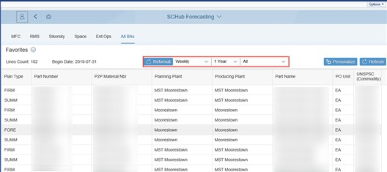
- Click the Reformat button to apply any selected reformatting changes | 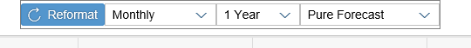

Viewing and Working with Data, continued
- You can use the Refresh button to refresh data to show the most up-to-date data available | 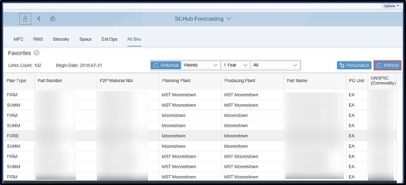

Personalizing Data Views
Personalizing views is another option to filter how you see forecasting data  - Click the Personalize button to personalize how the data appears on your screen | 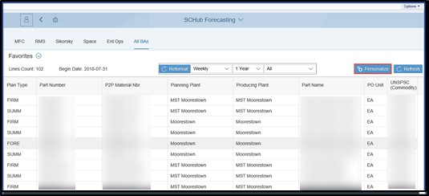

Personalizing Data Views, continued
- From the View Settings screen, you can make changes to your view by selecting and changing from:  - Columns: Select or deselect columns to view  - Sort: Sort selected columns in ascending or descending order  - Filter: Filter selected columns by selected parameters | 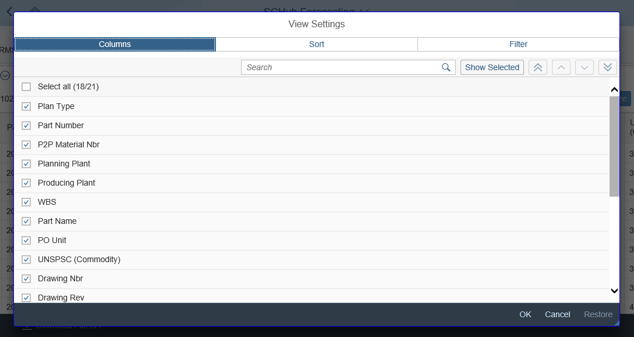

Personalizing Data Views, continued
- From the Columns tab of the View Settings screen, click the Checkboxes to select or deselect columns to be displayed | 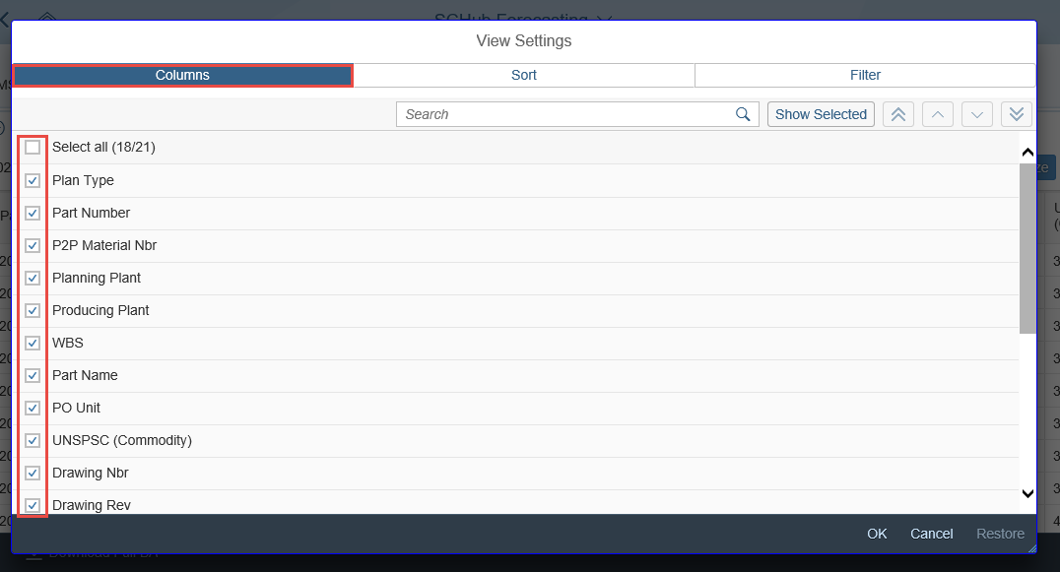
- You can also use the Search bar to search for a column to select/deselect | 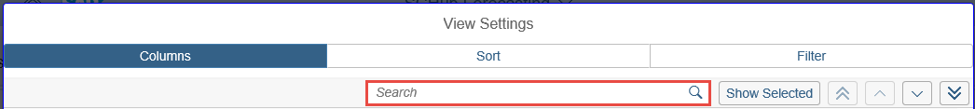

Personalizing Data Views, continued
- Select Show All or Show Selected to view all available columns, or to view only those selected
You can manage the order the columns appear in your view. Use the buttons on the panel to move selected columns:
- Move to Top: Moves the selected column to the top of the order
- Move Up: Moves the selected column to the top
- Move Down: Moves the selected column down
- Move to Bottom: Moves the selected column to the bottom of the order

Personalizing Data Views, continued
- Click the Sort drop-down menu to select a column to sort | 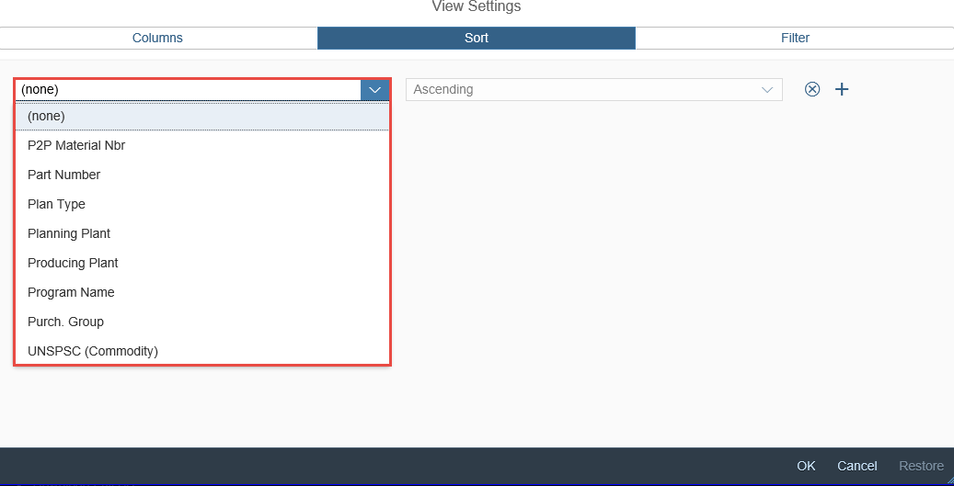
- Use the Ascending / Descending drop-down menu to sort column data in ascending or descending format | 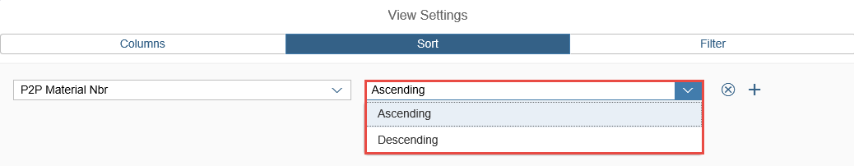

Personalizing Data Views, continued
- Click the Remove Sort Creation (X) button to remove the sort parameter
- Click the Add Sort Creation (+) button to add additional the sort parameter lines

Personalizing Data Views, continued
- Click the Filter tab at the top of the of the View Settings screen to begin filtering columns | 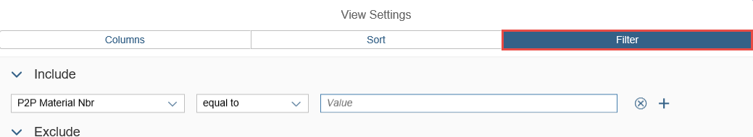
You can set filter parameters to Include or Exclude data in selected columns  Important Notes:  - You can filter columns to include data by these parameters:  - equal to  - between  - less than  - less than or equal to  - greater than  - greater than or equal to  - You can filter columns to exclude data using the equal to  parameter | 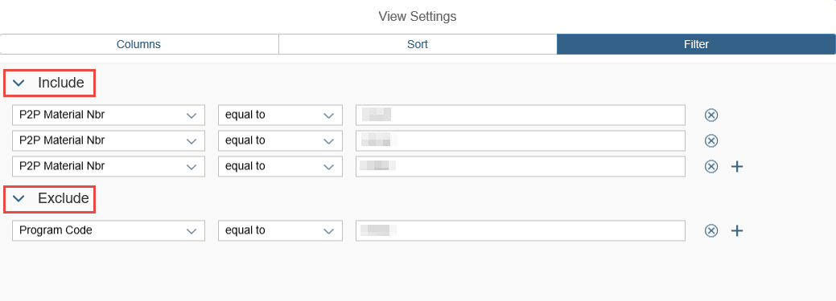

Personalizing Data Views, continued
In this example, we will be setting a filter to exclude a Program Code  - Click the Column drop-down menu to select a column to filter | 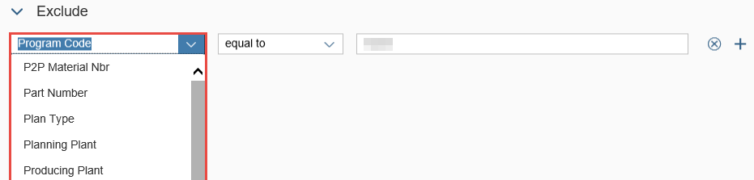

Personalizing Data Views, continued
- Click the Filter parameter drop-down menu to select a filter parameter  Note: Because we are choosing to exclude data from this column, equal to is the defaulted selection | 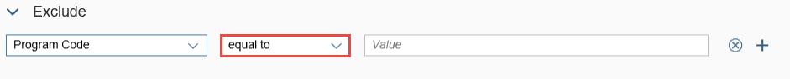
- Use the Value Box to enter a value to filter | 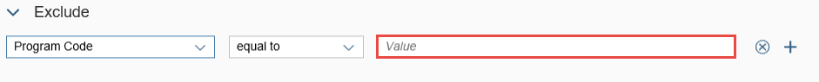

Saving or Reverting Personalization Changes
- In the bottom right corner of the View Settings screen, click OK or Cancel, to save or cancel your temporary view preferences and return to the SMM page  Note: Click Restore to revert any changes to default | 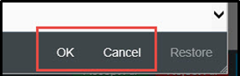

Managing and Setting Personalized Views as Favorite
After personalizing your current view, you can save it as a favorite  - From the Variants drop-down screen, click Save As to save the current view as a favorite | 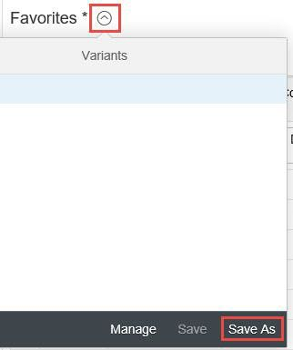
- Enter a name for your favorite in the Name box  - Click OK to save the view as a favorite  Note: You can select the Set as Default checkbox to select this view as your default | 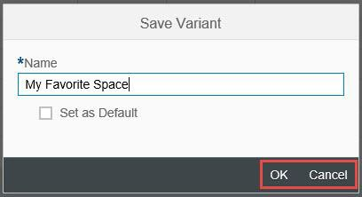

Managing and Setting Personalized Views as Favorite, continued
You can manage your saved personalized views  - Click the Favorites drop-down arrow to open saved views | 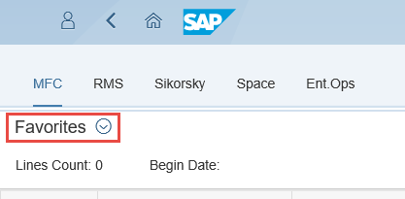
- From the Variants drop-down screen, you can:  - Manage: Select or manage previously saved favorites  - Save As: Save a current view as a favorite  - Click the Manage button to view a list of all saved and defaulted views. | 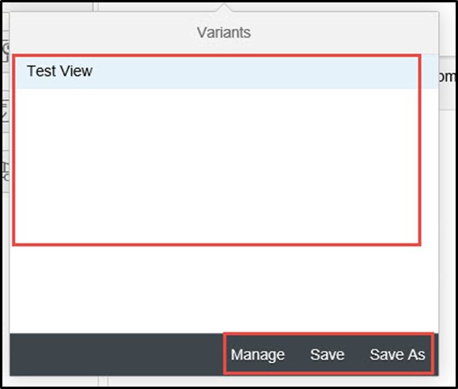

Managing and Setting Personalized Views as Favorite, continued
You can select a view from you list of favorites to automatically default  - Click the Default radio button to select the view to default | 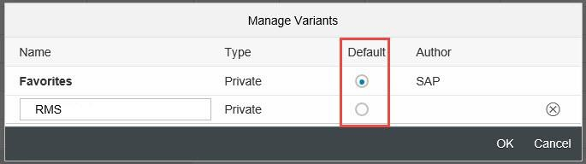
- Click the Delete (X) button next to a saved favorite to remove it from your list  - Click OK or Cancel to save or cancel your changes | 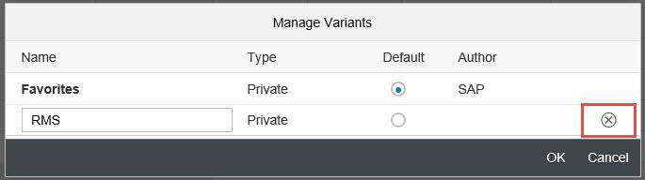  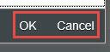

Downloading Data
You can use the download features at the bottom of the screen to download data in .CVS format. Use the options at the bottom of the screen to:  - Download: Download the data as it has been formatted or personalized on your screen | 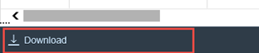

Error: Too Many Rows
You may encounter a “Too many rows” error when attempting to view Forecasting data. This error occurs if the total data line count exceeds the number of rows the Forecasting can display at one time.  - To resolve this error, use the Filter functionality to filter applicable data to an appropriate size | 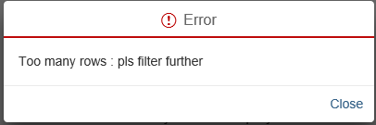
- In this example, we are filtering the Forecasting data to only include data applicable to Producing Plant 65M1 | 