

Last Updated 5/24/2022
Last Reviewed 5/24/2022

LM Procure to Pay Quick Reference Guide For Suppliers

Supplier Portal Overview

Lockheed Martin Procure to Pay Revised May 2022

Procedure

This quick reference guide displays the options available to you upon logging into the External Portal.

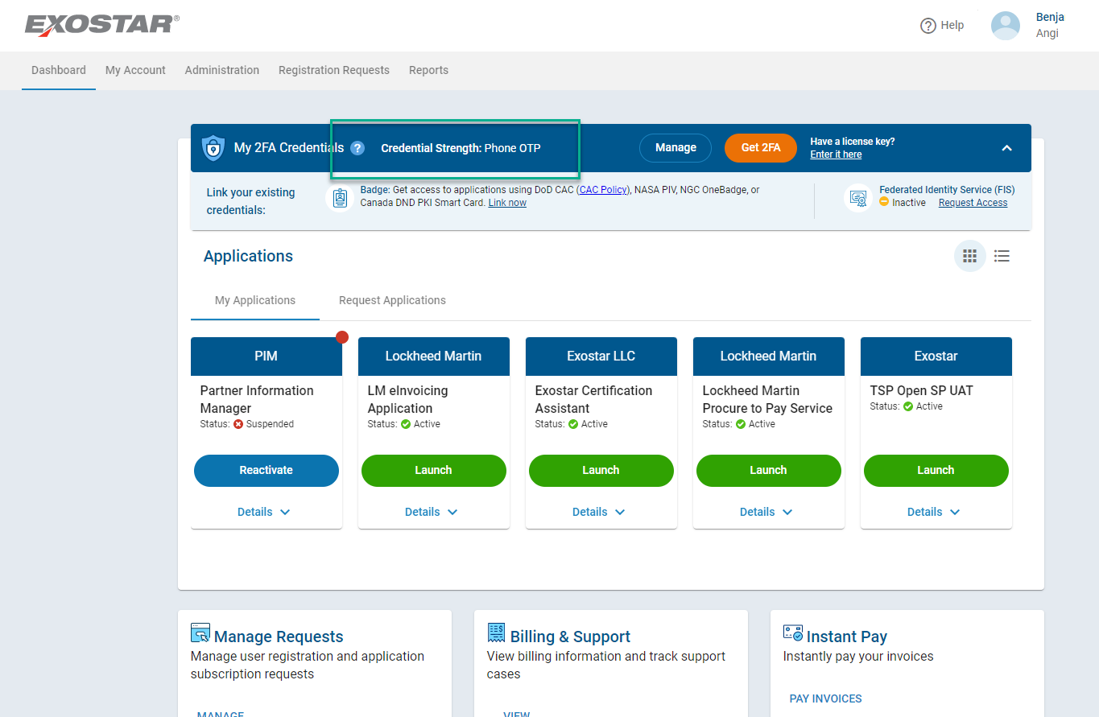

Step | Action
1. | After logging into Exostar with 2FA credentials, click the Lauch Application  button.

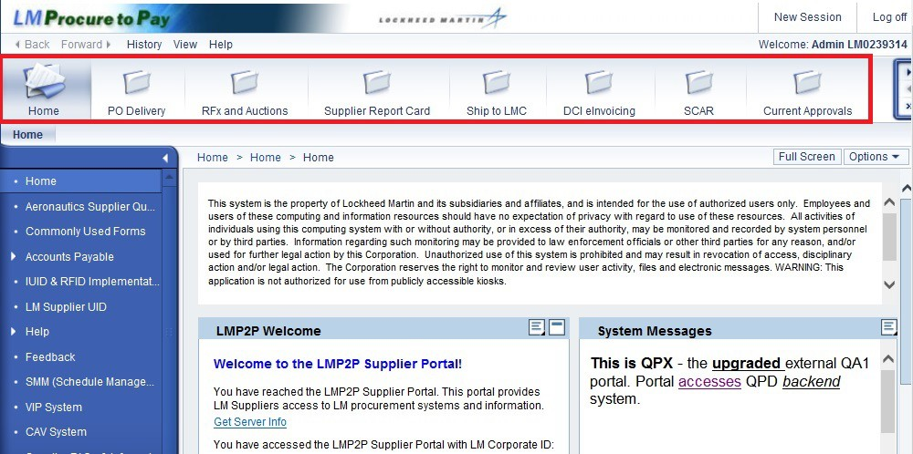

Step | Action
2. | You will be signed on to the LMP2P External Portal. From your LMP2P Portal, you will see several tabs across the top segregating the Portal into different functional activities. When logging into the External Portal you will be defaulted to the Home tab.  NOTE: These tabs may vary based upon your role.

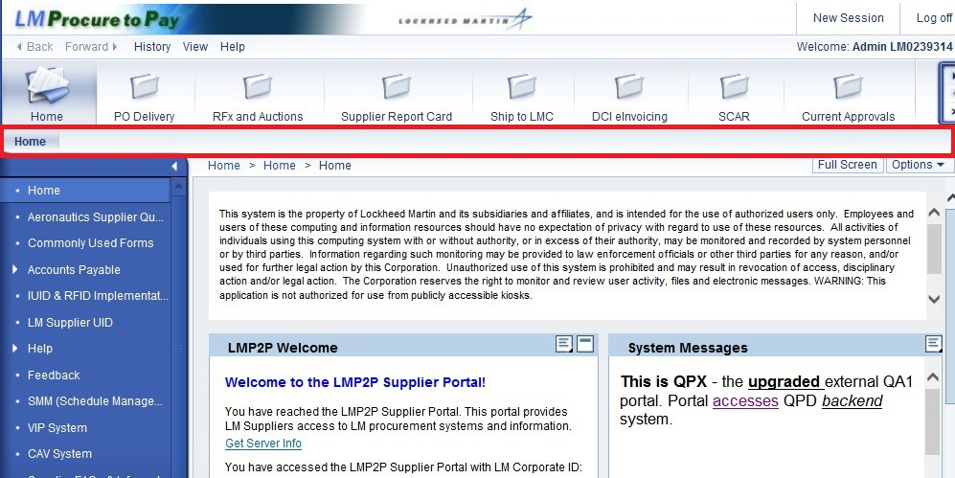

Step | Action
3. | The tabbed structure of the Navigation Toolbar provides two levels of navigation that are based on the selected entry. These sub-tabs provide more detailed options for each tab.

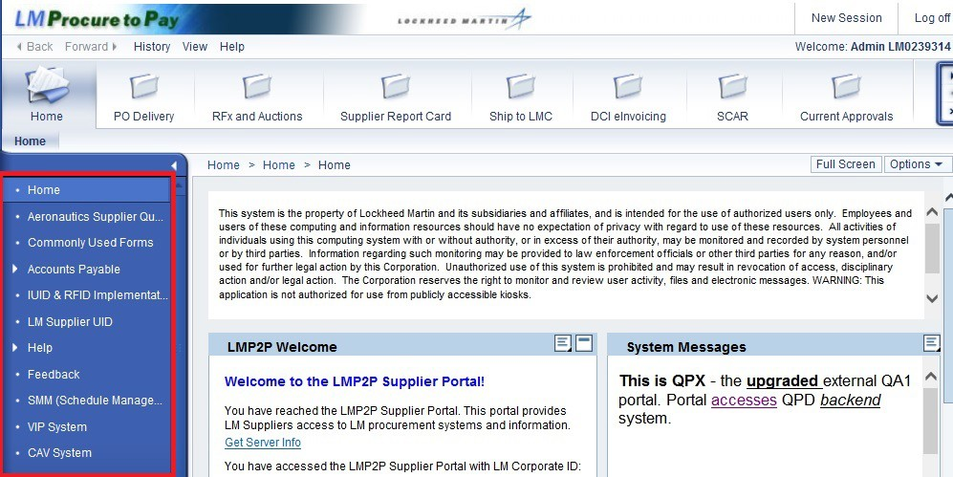

Step | Action
4. | The Detailed Navigation Menu enables users to access important systems out of LMP2P as well complete forms and feedback which are emailed to the Lockheed Martin administrators.

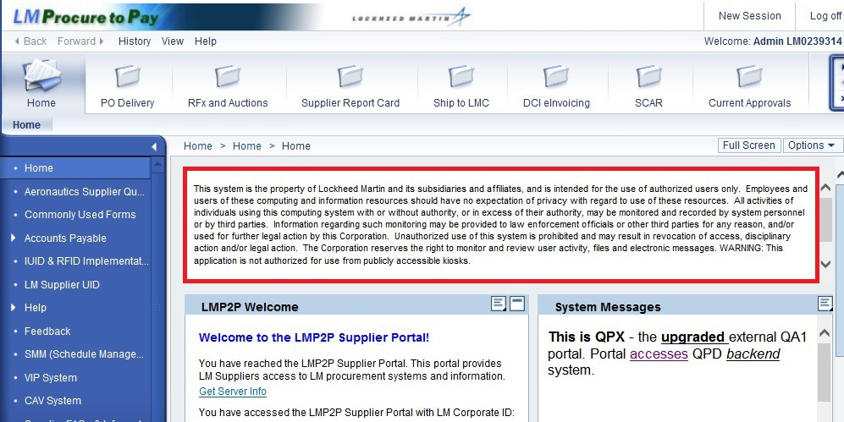

Step | Action
5. | The iView at the top shows the mandatory standard banner statement as required per Lockheed Martin policy.

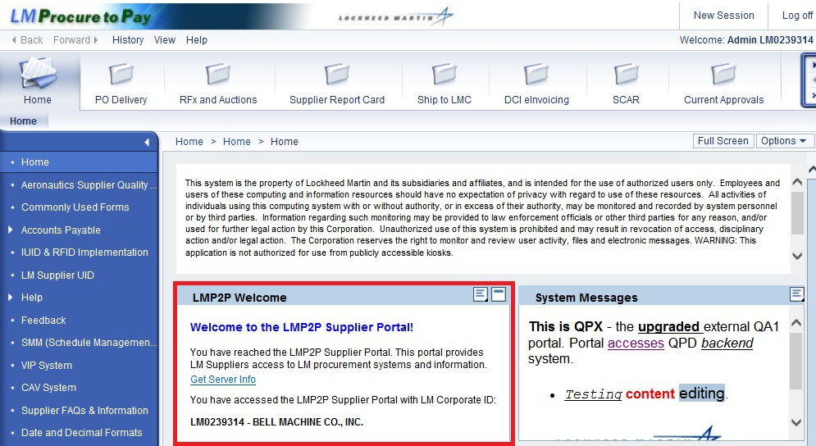

Step | Action
6. | The LM P2P Welcome iView welcomes you to the LMP2P Portal. You can view which LM Corporate ID you have used to log into the LMP2P portal.

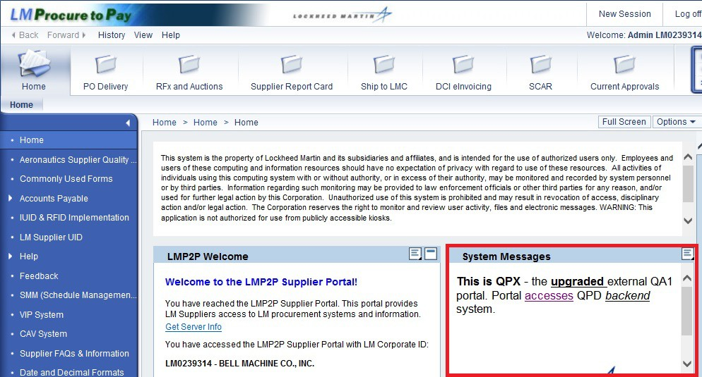

Step | Action
7. | The Systems Messages iView will show messages pertinent to the entire end user community, e.g. a message indicating a future system outage.

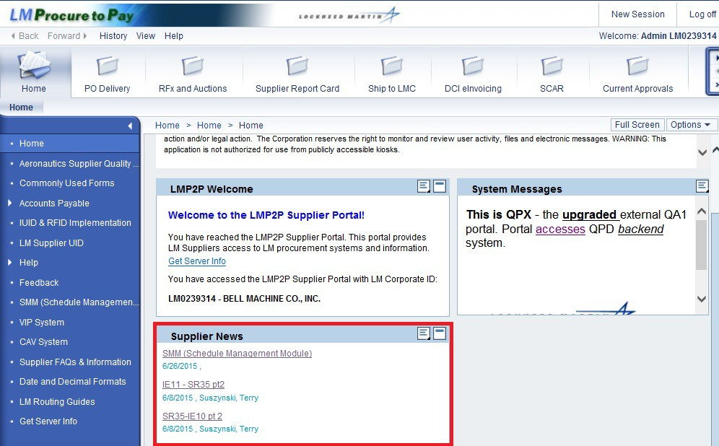

Step | Action
8. | The Supplier News iView will share content for information purposes only. For example, aesthetic alterations to the look and feel of the LMP2P Portal.

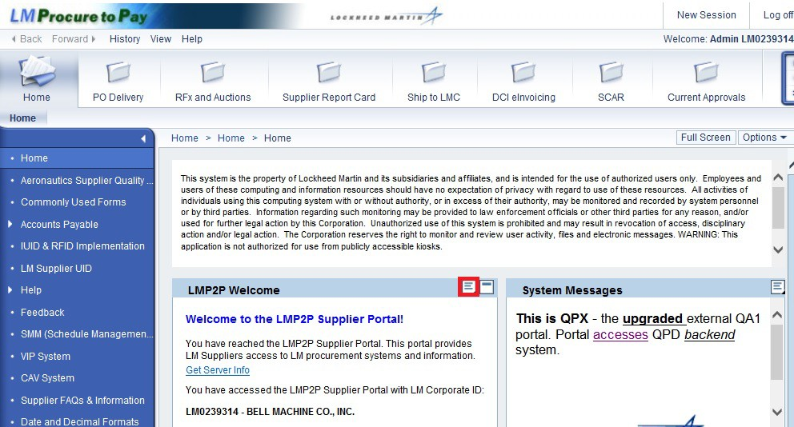

Step | Action
9. | Each iView has various menu properties associated with it. Click the Options button to view the available menu items.

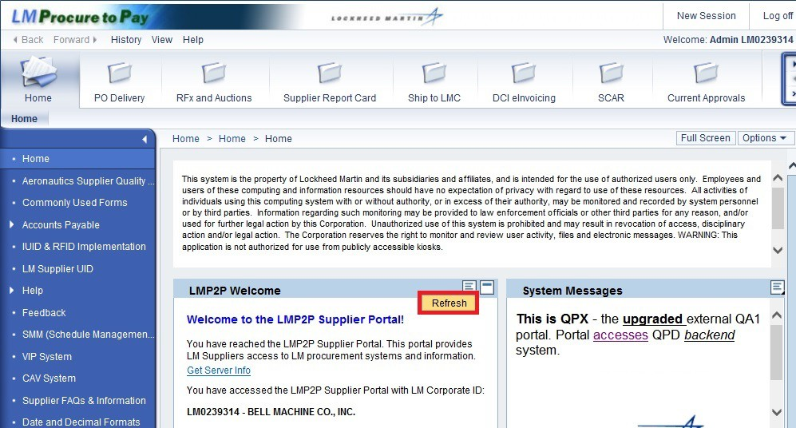

Step | Action
10. | There is one option available from this iView:  - Refresh - refreshes the iView content  NOTE: There is an Options button near the top right hand corner of the Home tab that we will cover later in this guide. This button offers additional options not available within the iViews.

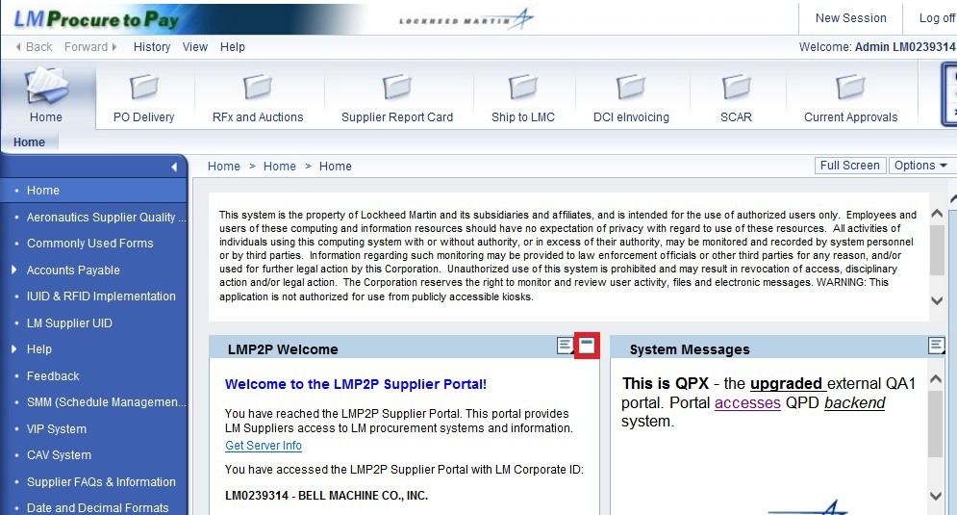

Step | Action
11. | Each iView also can be collapsed or expanded.  Click the Collapse tray button to minimize the LMP2P Welcome iView.

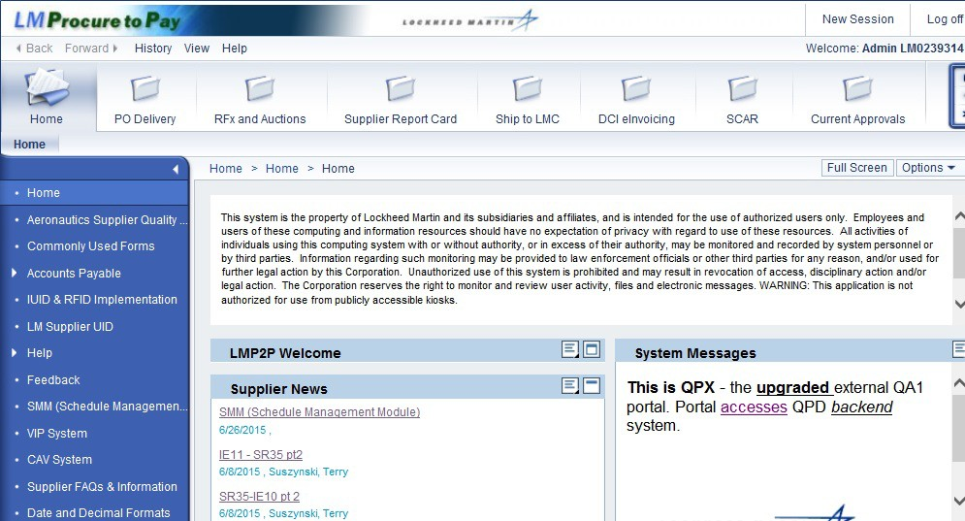

Step | Action
12. | NOTE: The iView is now collapsed. Your last selection for each iView, whether collapsed or expanded, is remembered when the browser window is closed and later reopened.  Click the Expand tray button to restore the Welcome to the P2P Portal iView to the expanded state.

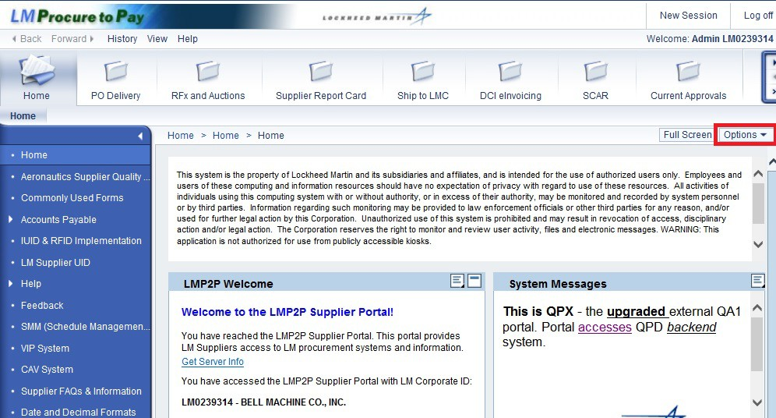

Step | Action
13. | Each page also has various menu properties associated with it.  Click the Options button to view the available menu items on this page.

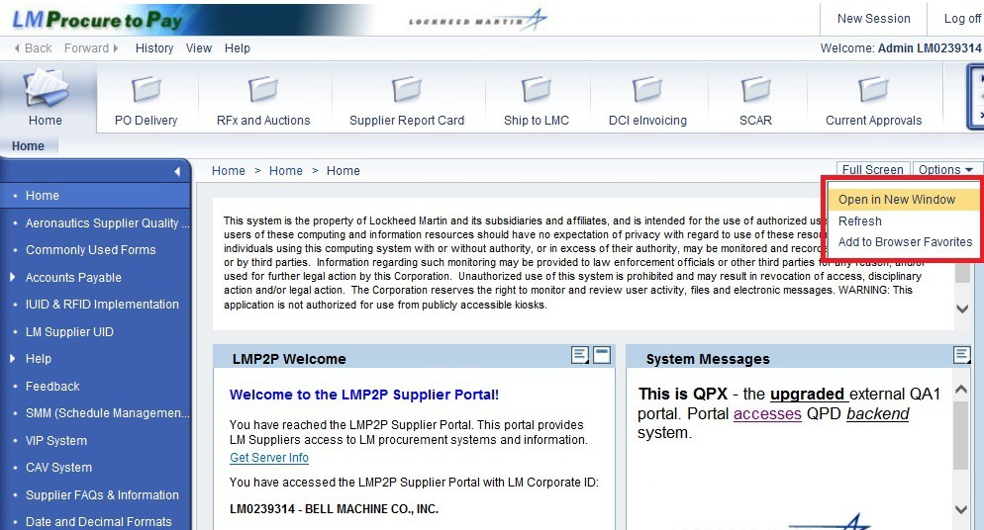

Step | Action
14. | There are three options available from this menu:  - Open in New Window - opens the page in a new browser window  - Refresh - refreshes the content on this page  - Add to Browser Favorites - bookmarks this page as a favorite

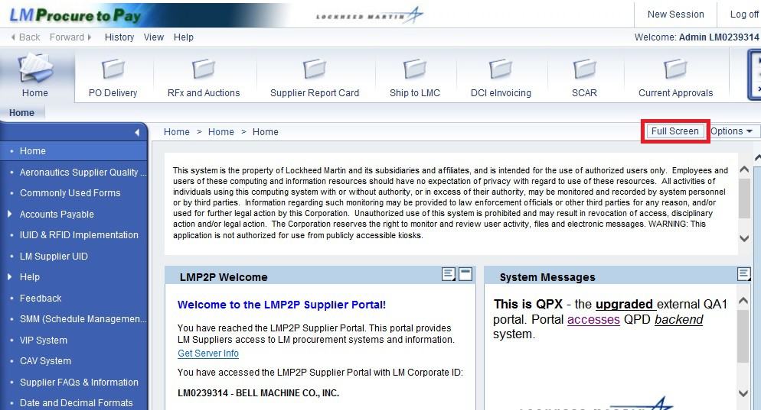

Step | Action
15. | The Full Screen button will open the LMP2P portal in full screen mode.

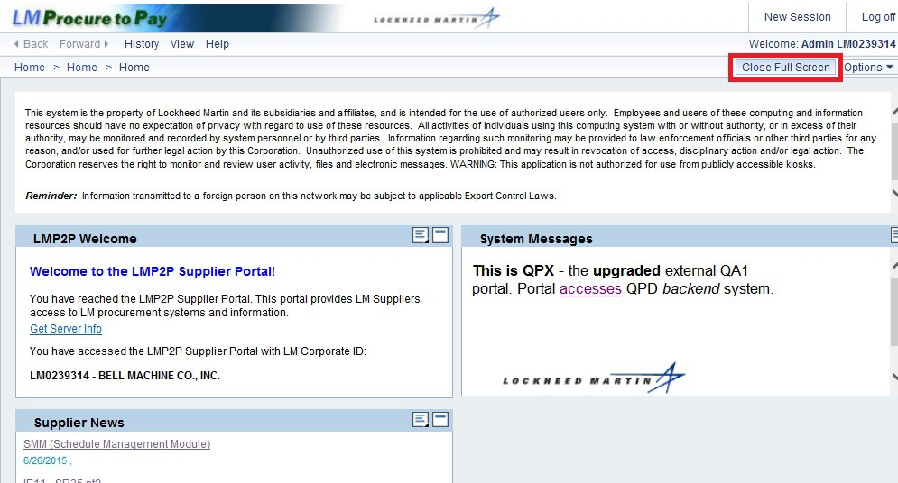

Step | Action
16. | Full Screen mode collapses navigation menus, allowing more focus on main screen content.  To exit Full Screen mode, click the Close Full Screen button..

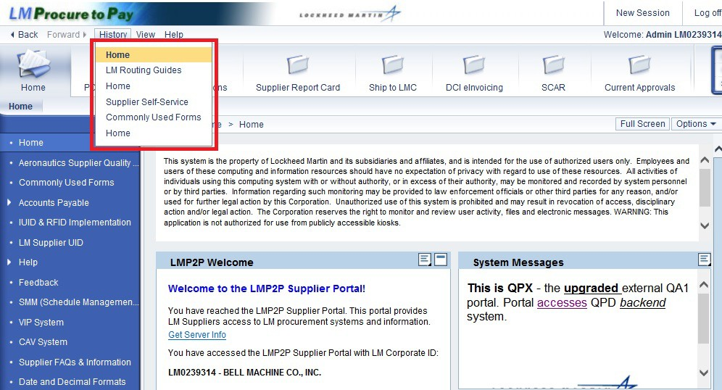

Step | Action
17. | Use the History link at the top of the screen to view a list of pages you have previously accessed. You can click on one of the page names to return to that page in the portal.

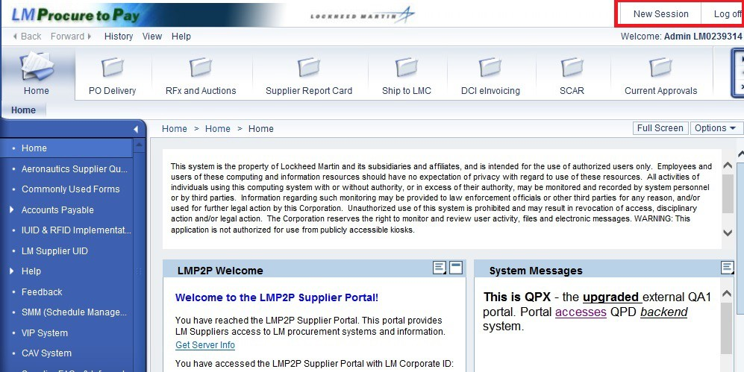

Step | Action
18. | Use the New Session button to open a new session of the LMP2P portal in a separate window.  Also, the Log off button is also in the upper right hand corner to log off the LMP2P portal.

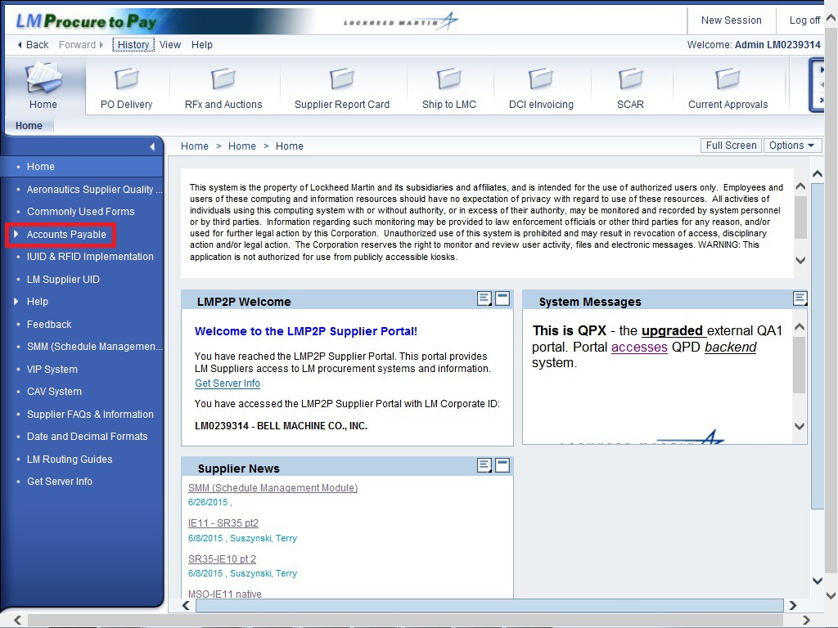

Step | Action
19. | In the Detailed Navigation Panel some links have folders available.  Click the Accounts Payable folder to expand the Detailed Navigation options in this domain.

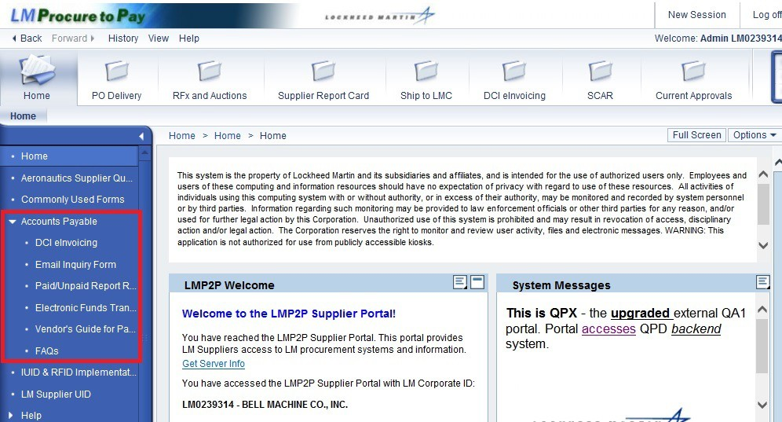

Step | Action
20. | Notice that the Account Payable folder has now been expanded to show more menu items.

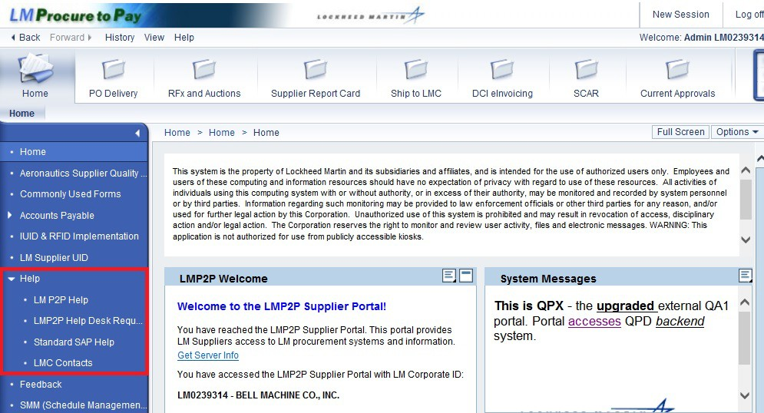

Step | Action
21. | Click the Help folder to expand Detailed Navigation options for Help.
22. | There are four help options to choose from:  - LM P2P Help  - LM eBusiness Help Desk  - Standard SAP Help  - LMC Contacts

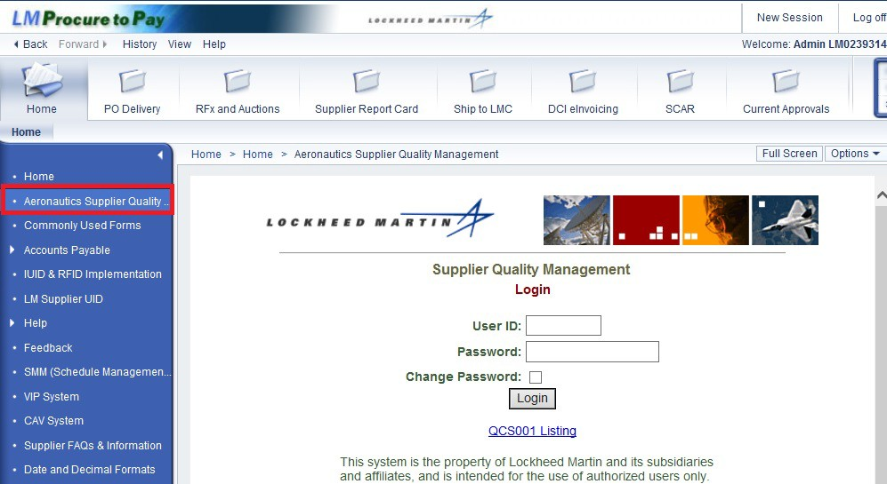

Step | Action
23. | The next several slides will describe the available menu options in the Detailed Navigation Panel.  The Aeronautics Supplier Quality Management legacy system is an electronic portal which provides Aero suppliers access to many types of document submittals, purchase order information, contact information, and access to Aero's listing of approved processors.

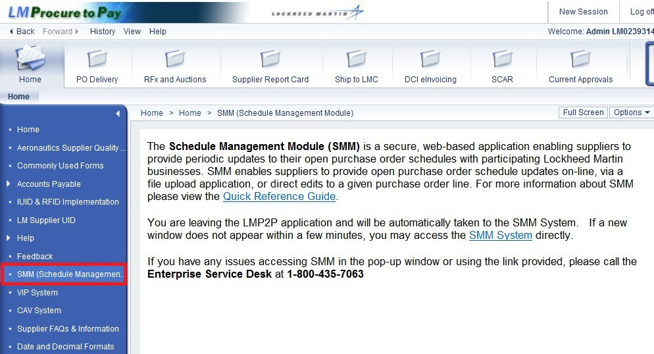

Step | Action
24. | To access the Schedule Management Module, click SMM (Schedule Management Module).

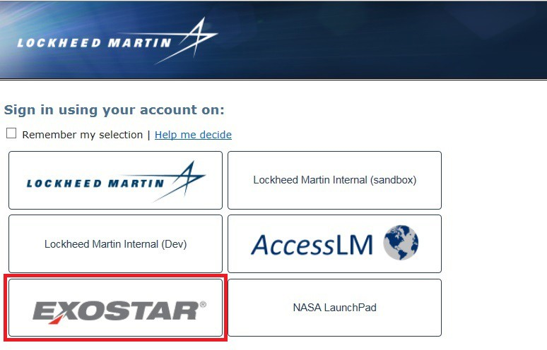

Step | Action
25. | Click the Exostar button to access SMM. You should only have to click this button the first time you access SMM.

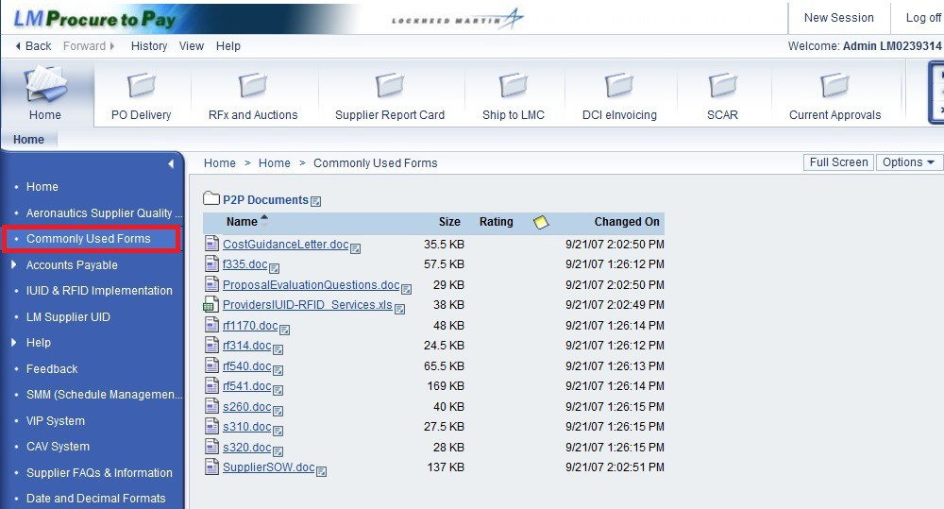

Step | Action
26. | Use the Commonly Used Forms link to access commonly used documents previously available on SupplierNet.

Step | Action
27. | Select Accounts Payable to create an invoice, view an invoice status, perform an email inquiry, access an ACH form, review FAQ’s, and request the paid/unpaid request form.

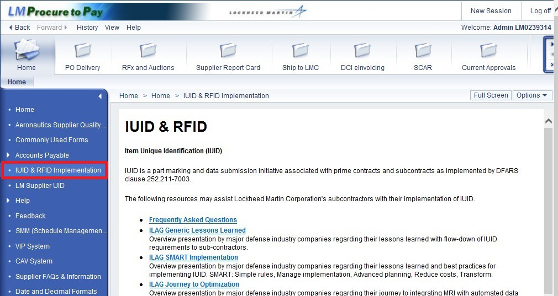

Step | Action
28. | Use the UID & RFID Implementation link to access information on Item Unique Identification (IUID) and Radio Frequency Identification (RFID) which was previously available on SupplierNet.

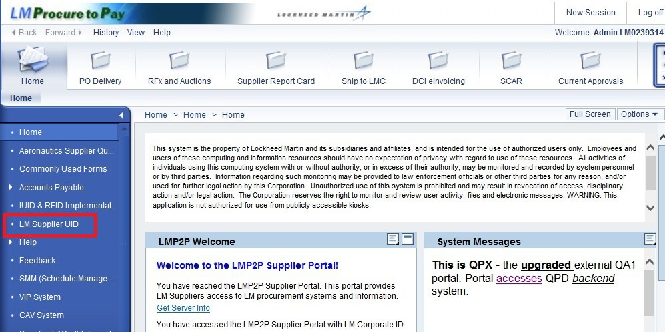

Step | Action
29. | Click the LM Supplier UID link to access the system to submit UID updates.

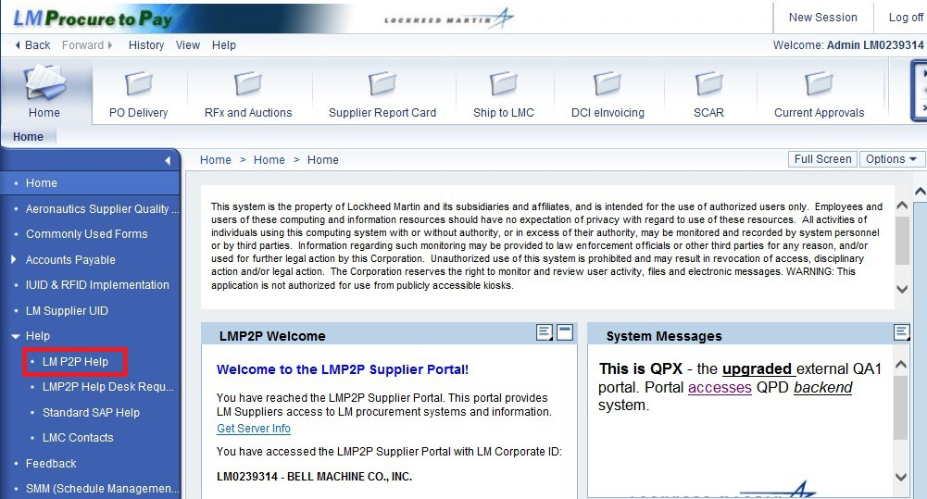

Step | Action
30. | The LMP2P Help link allows you to access helpful training materials or quick reference guides.

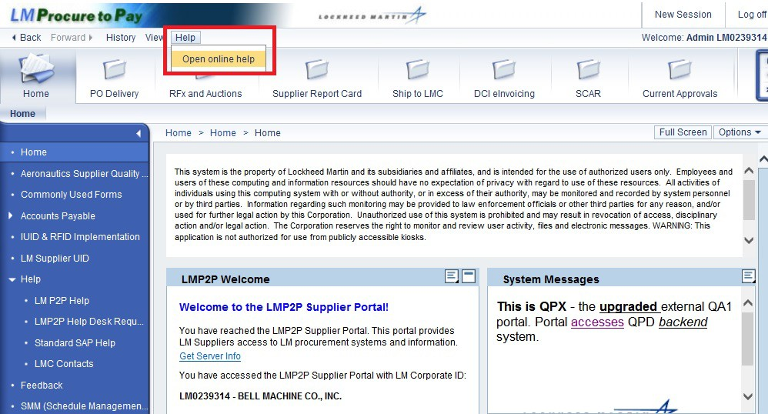

Step | Action
31. | The LMP2P Help can also be accessed from the Help tab at the top of the page. Click Open online help.

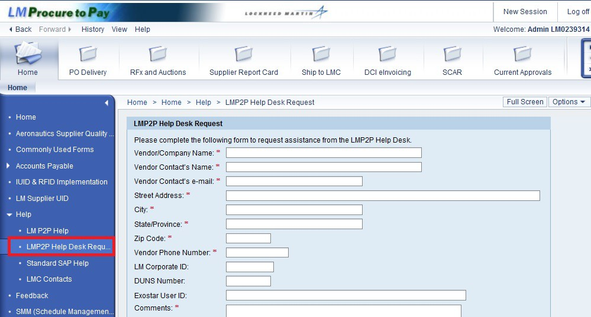

Step | Action
32. | Click the LMP2P Help Desk Request link to submit a question to the LMP2P Help Desk.

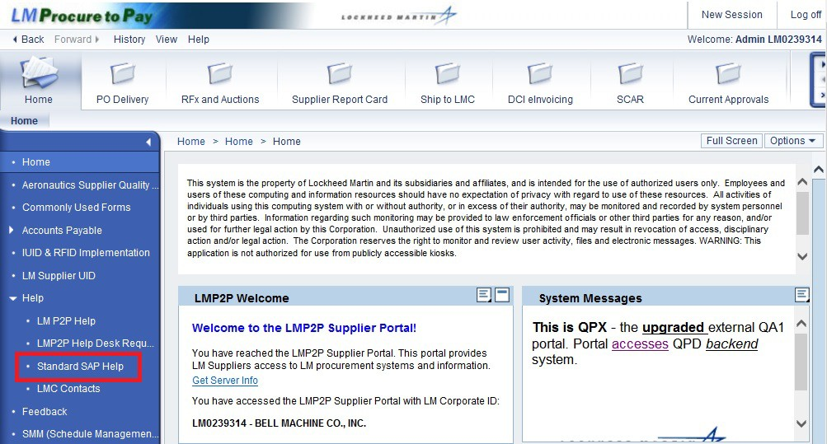

Step | Action
33. | Use the Standard SAP Help link to access helpful standard SAP help available on SAP’s website.

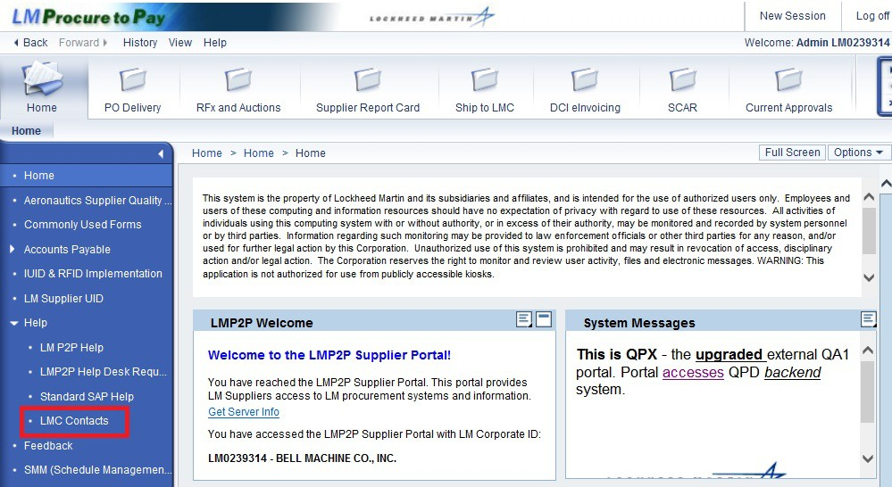

Step | Action
34. | Use the LMC Contacts link to access contact numbers when you need assistance.

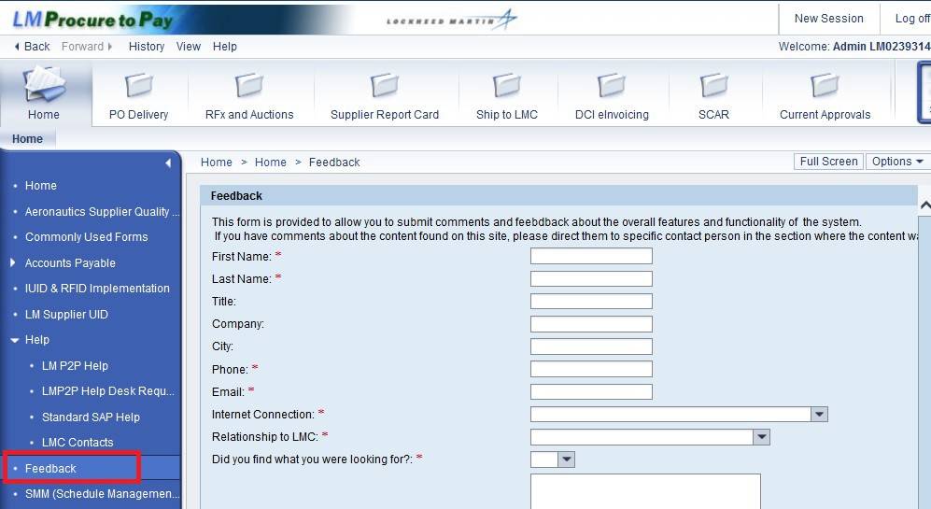

Step | Action
35. | Click the Feedback link to submit a question to provide Lockheed Martin feedback, an option previously available through SupplierNet.
36. | You have successfully completed reviewing the options available to you through the LM P2P Vendor Portal.

