

Last Updated 04/10/2020

LM Procure to Pay Quick Reference Guide For Suppliers

DPAS Rating

Lockheed Martin Procure to Pay Revised April 2020

Procedure

This quick reference guide documents how Suppliers can see a Purchase Order that contain a DPAS rating and Accept or Reject the Purchase Order.
The following screens include instructions illustrating:
- When and how the DPAS ratings will be flowed to the Supplier
- How to see the DPAS on the internal Purchase Order PDF
- How to track the Supplier responses to Purchase Order.

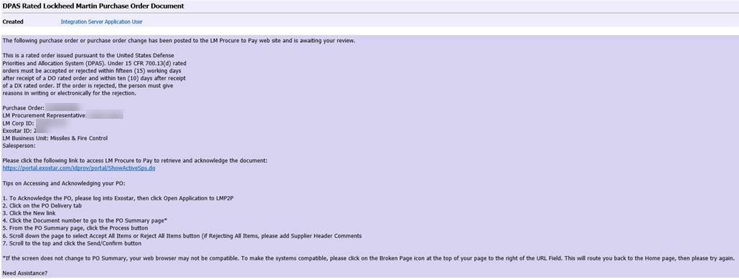

Step | Action
1. | Email by the Supplier when a Buyer releases a new or amended Purchase Order to the Supplier. If any of the Purchase Order items contain a valid DPAS rating, the subject matter of the email will read DPAS Rated Lockheed Martin Purchase Order Document. (as shown above)  If it does not contain a valid DPAS rating the Supplier will receive an email with the subject line Lockheed Martin Purchase Order Document Notification.

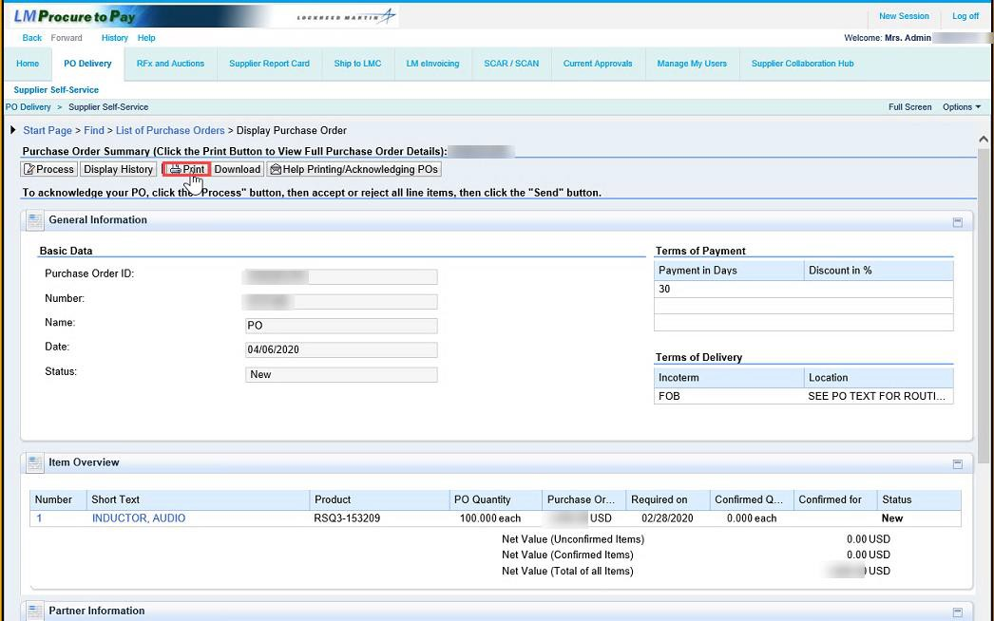

Step | Action
2. | Click the Print button to view the full Purchase Order details.

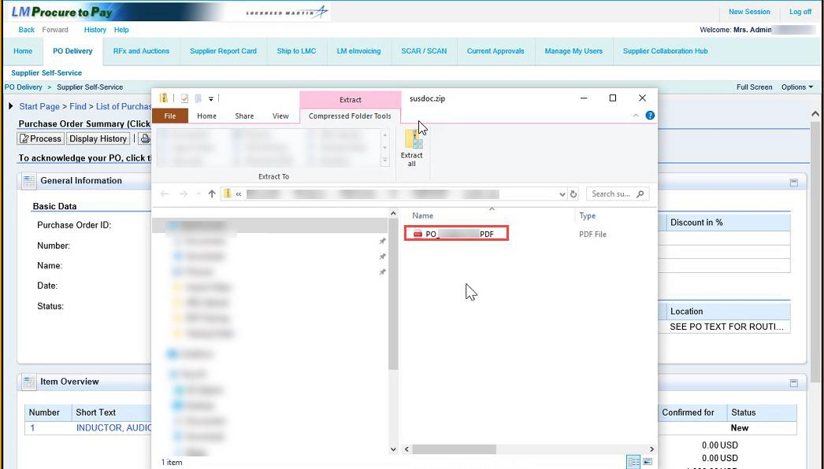

Step | Action
3. | Open PDF to view Purchase Order details

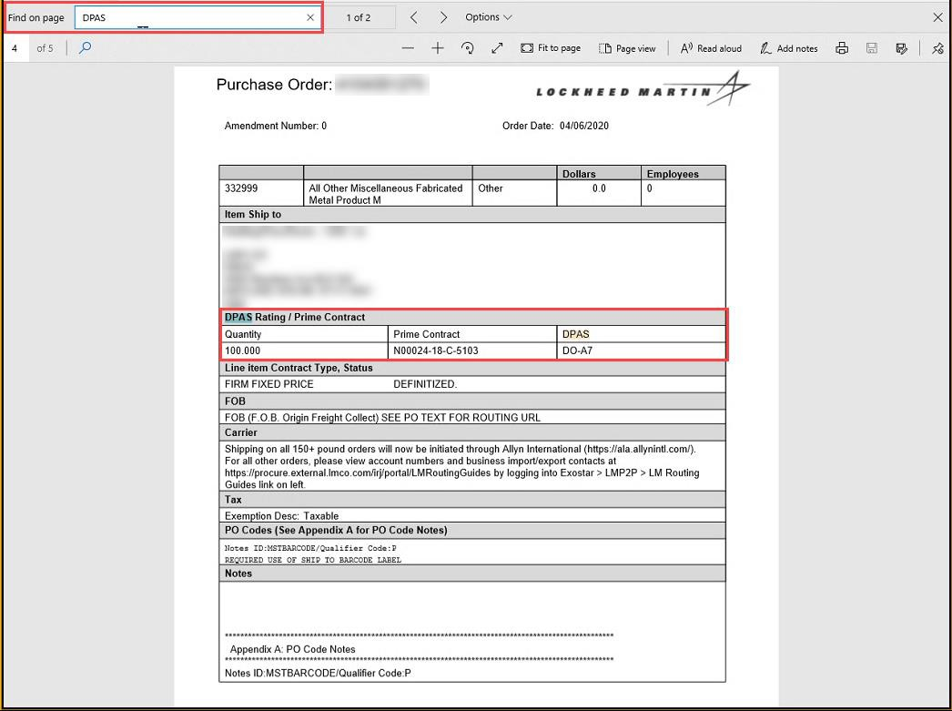

Step | Action
4. | From the PDF document Ctrl F and type in “DPAS” in the search field and navigate to DPAS rating. You can use the navigation arrows to quickly see how many lines have a DPAS rating and what the DPAS rating is.

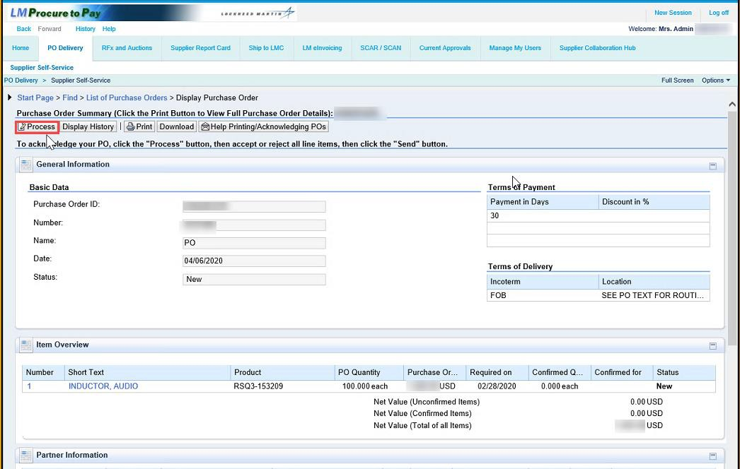

Step | Action
5. | Click Process to process Purchase Order

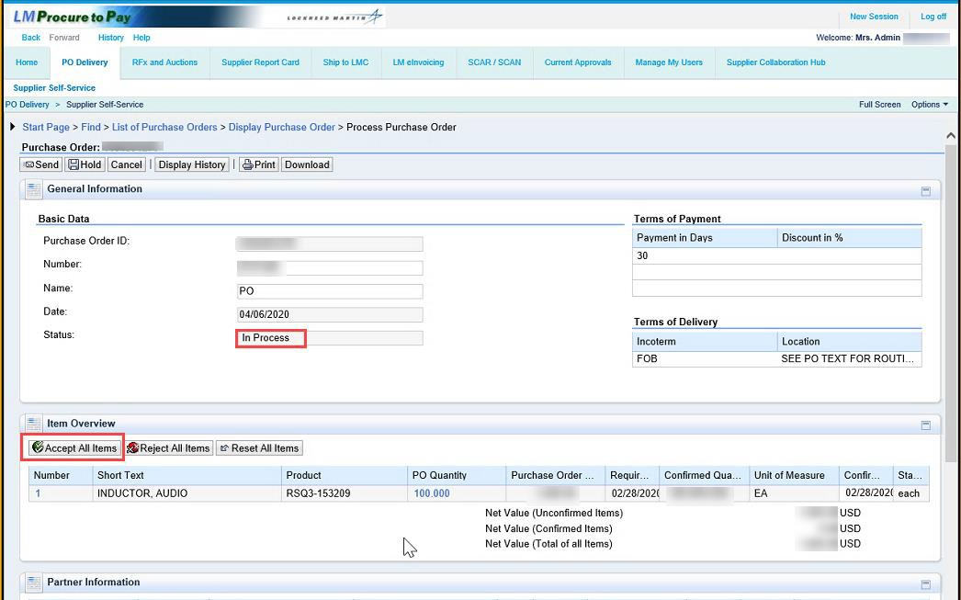

Step | Action
6. | Purchase Order Status: In Process.  Click Accept All Items or Reject All Items, in his example we are accepting all items.

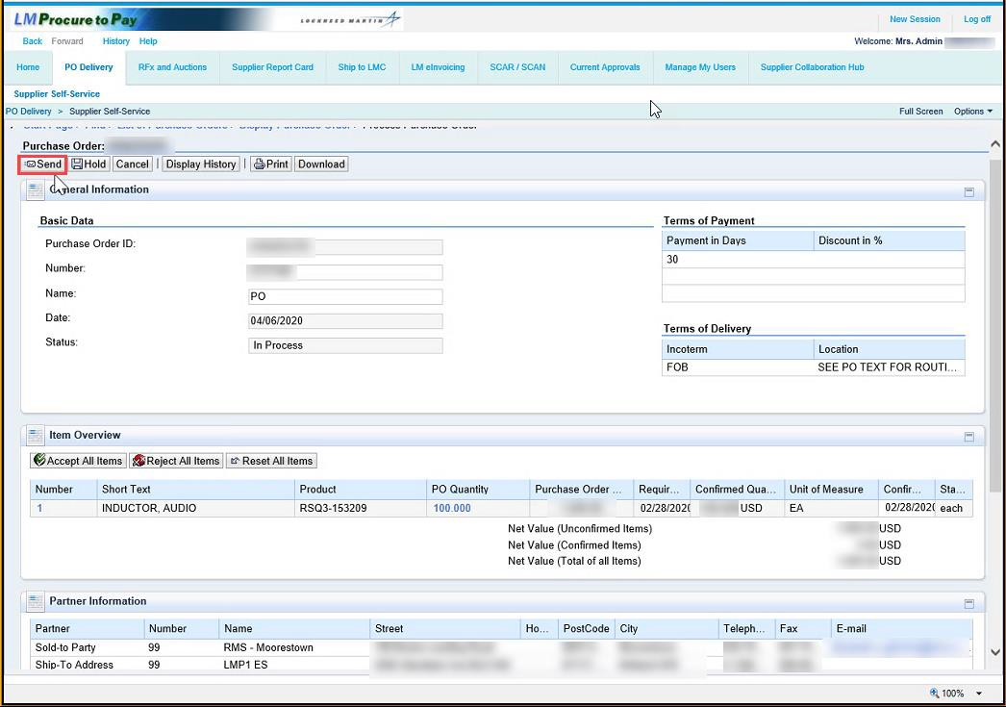

Step | Action
7. | Clicking Send to Accept or Reject the Purchase Order.

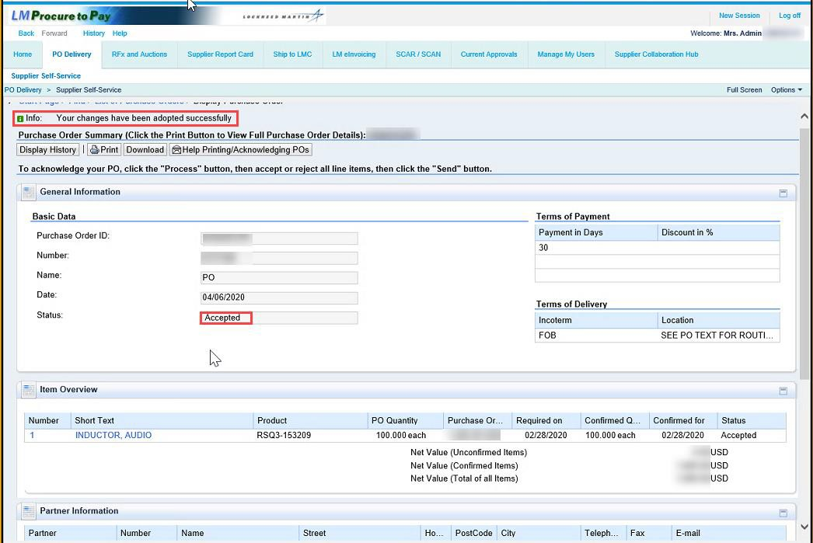

Step | Action
8. | Info note: Your changes have been adopted successfully.  In this example the Purchase Order Status: Accepted.

