



Last Updated 8/11/2015
Last Reviewed 5/24/2022

LM Procure to Pay Quick Reference Guide For Suppliers

For Order Processors: Where is My Purchase Order?

Lockheed Martin Procure to Pay Revised August 2015

Introduction:
Purchase Orders can normally be found under the PO Delivery tab. If you are still having problems, the two most common reasons why are:
- You cannot see a PO Delivery tab within LMP2P
- You can see a PO Delivery tab however you cannot find the POs you need

You cannot see a PO Delivery tab within LMP2P
If you cannot see a PO Delivery tab as shown in this screen shot, please follow these next steps:

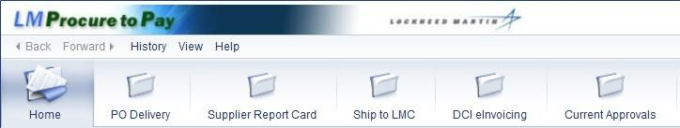

Role | PO  Delivery | Bid Invitations | Supplier Report  Card | Ship to LMC | SCAR | Current Approvals | Source Acceptance | Manage My Users
Application Admin* |  |  |  |  |  |  |  | X
Order Processor | X |  | X | X |  | X
Source Representative |  |  |  |  |  |  | X
Supplier Quality |  |  | X |  | X | X
Supplier Bidder |  | X | X |  |  | X
Schedule Maintenance ** |  |  | X |  |  | X

Note: Application Admin and Order Processors also have access to the DCI eInvoicing tab.

Step | Action
1. | Contact your Application Administrator to manage your access.  Note: The grid above shows which roles can access which of the eight tabs. To find your Application Administrator follow steps 2 through 5
2. | Log into Exostar
3. | 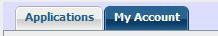  Click the My Account tab

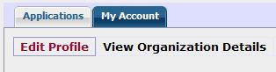

Step | Action
4. | Click on
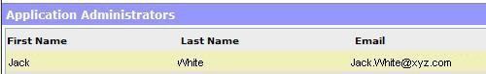

Step | Action
5. | Scroll to the bottom of the page and you will find your Application Administrator

- You can see a PO Delivery tab, however you cannot find the purchase orders you are looking for:

Step | Action
1. | Contact the application admin for the Corp. ID on the purchase orders you need.  Note:  Most likely your login ID is not setup to see purchase orders for the Corporate ID on the purchase orders you are expecting to find.  In this case you need to contact the application admin for the Corp. ID on the POs you need. The application admin will set you up with a login ID in order to access the POs for that Corp. ID.  To determine what Corp. ID you need access to you will need to know a Purchase Order number of the PO you are trying to find.
2. | Once you have the purchase order number, contact the LMP2P Help Desk at 863-647- 0558.  Note: From the Purchase Order number the LMP2P Help Desk can help determine who the application admin is you need to contact for access.

