



Last Updated 5/24/2022
Last Reviewed 5/24/2022

LM Procure to Pay Quick Reference Guide for Suppliers

For Application Admins: How to Help my Order

Processors See Their Purchase Order

Lockheed Martin Procure to Pay

Introduction:
The most common reasons why users cannot find or access their purchase orders are:
- The Order Processor cannot see the PO Delivery tab within LMP2P
- The Order Processor can see the PO Delivery tab within LMP2P but cannot find the purchase orders they need (go to page 8)

The Order Processor cannot see the PO Delivery tab within LMP2P:
If your Order Processor cannot see the PO Delivery tab (shown below), you will need to manage their access by following these steps.
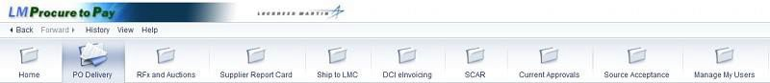
Note: The grid below shows which roles can access which of the nine tabs.

Role | PO  Delivery | Bid Invitations | Supplier  Report Card | Ship to LMC | SCAR | Current Approvals | Source Acceptance | Manage My Users
Application Admin* |  |  |  |  |  |  |  | X
Order Processor | X |  | X | X |  | X
Source Representative |  |  |  |  |  |  | X
Supplier Quality |  |  | X |  | X | X
Supplier Bidder |  | X | X |  |  | X
Schedule Maintenance ** |  |  | X |  |  | X

Note: Application Admins and Order Processors can also access the LM eInvoicing tab.

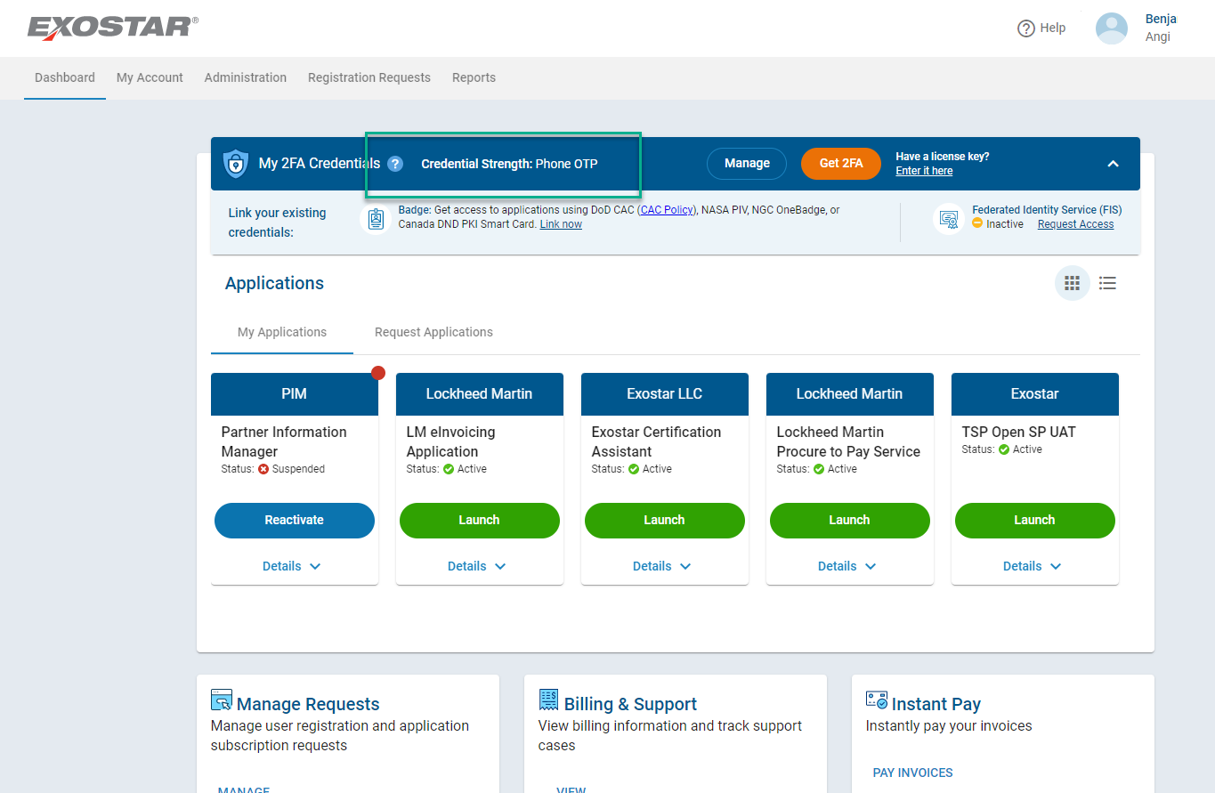

Step | Action
1. | To modify a user’s role log into Exostar with 2FA, click the Launch Application  button.

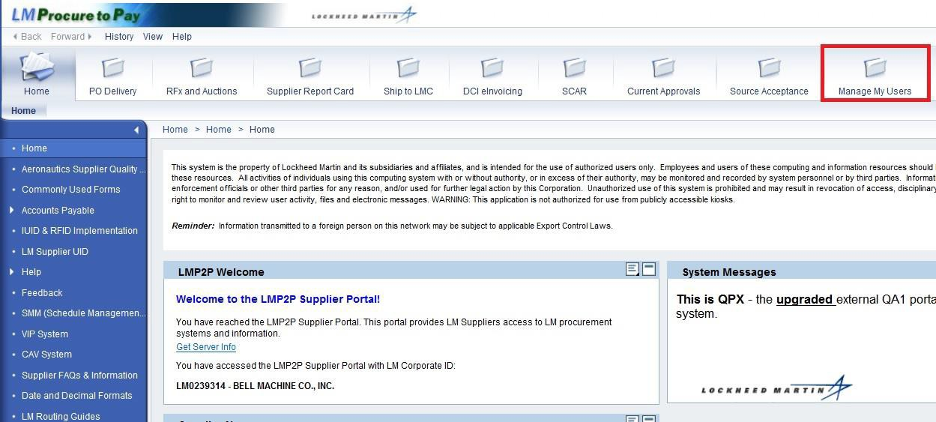

Step | Action
2. | You will be signed on to the LMP2P External Portal.  Click the Manage My Users tab to modify the role(s) of one of your users.

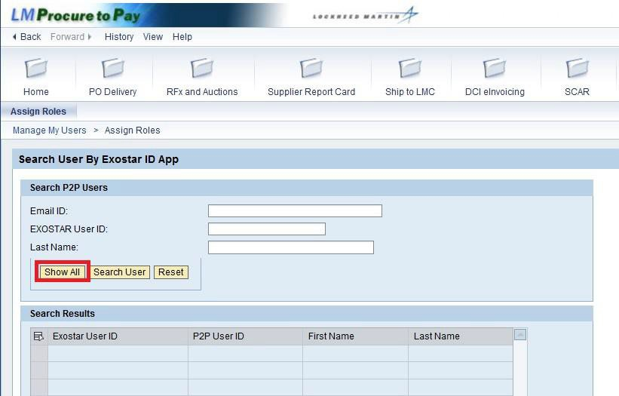

Step | Action
3. | There are multiple ways you can find one of your users. If you know the user's ID, you could enter it here and select Search User.  Click Show All to list all of the users you are responsible for.

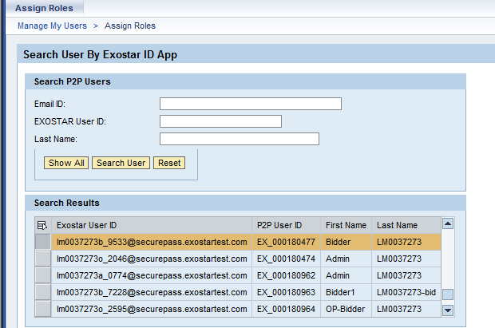

Step | Action
4. | Identify the user whose role(s) you choose to modify.  Click the Entry button next to the user id to change his/her role.
5. | Click the scroll bar to scroll to the bottom of the screen to modify the selected user's role.

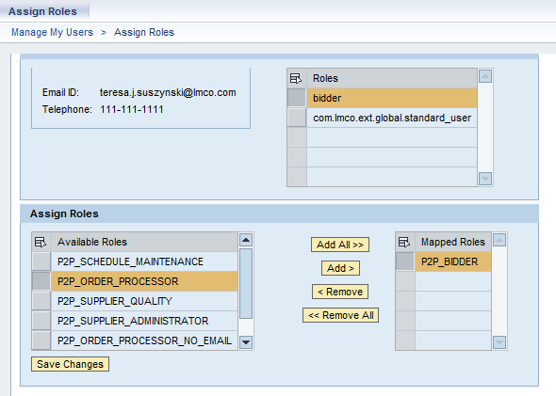

Step | Action
6. | Roles to the left under Available Roles are potential user roles, and those to the right (Mapped Roles) reflect the user's current roles. You can also add or delete all roles for your users.
7. | Select the role you want added to the user.
8. | Click the Add button to add the role to the user's profile.
9. | Click the Save Changes button.  You have successfully completed the procedure the Supplier Administrators use to manage access privileges for your users within the LMP2P External Portal.

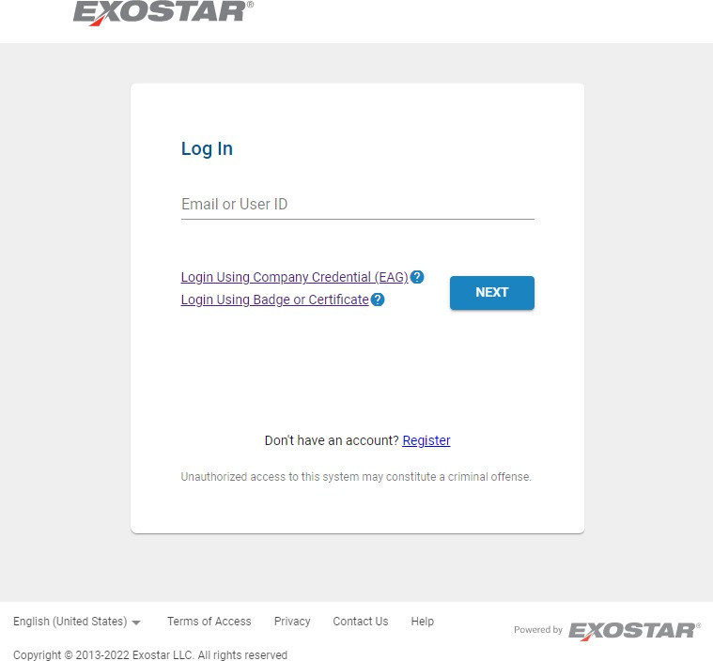

- The Order Processor can see the PO Delivery tab within LMP2P but cannot find the purchase orders they need:
If your Order Processor can see the PO Delivery tab but does not see the purchase orders they need, follow steps 1 through 23 below.

Step | Action
1. | In order to login to Exostar it is necessary to submit a user name and password. Enter your user ID into the User ID: field.
2. | Enter your password into the Password: field.
3. | Click the Login button.

Step | Action
4. | Upon entering Exostar, Organization Administrators will be presented with four tabs. The availability of this functionality will differ based upon your user privileges.  - The Applications Tab indicates the systems you are able to access. In this case, the only other available system is the LMP2P Supplier Portal.  - The My Account Tab is where you go to change your contact information and organizational information within Exostar.  - Administration is where you go to set new user's initial LMP2P External Portal roles.  - The Registration Requests tab is where you can assign user roles within applications you administer. (Modifications to user roles are made within LMP2P.)
5. | Click the Administration tab to add a new user.
6. | Click the Search button to ensure that the user does not already exist.
7. | If the user does not already exist, click the Add New User link to request an additional user.

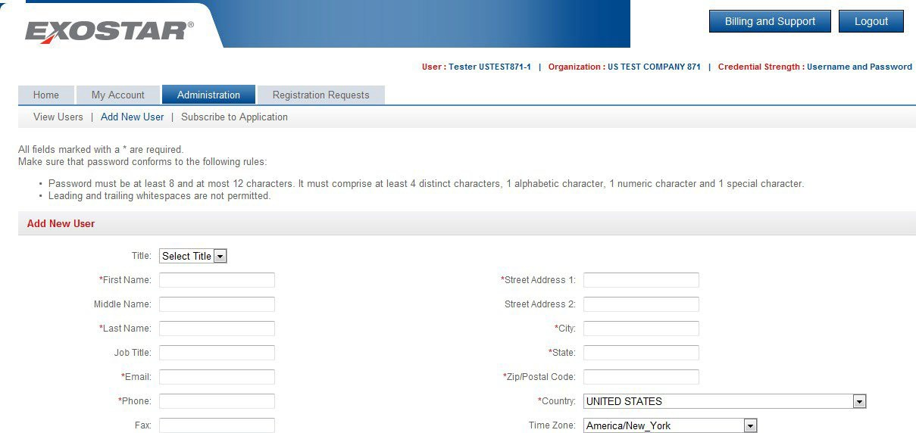

Step | Action
8. | Fields marked with a red asterisks are required and will be completed.
9. | Scroll to the bottom of the screen to continue.

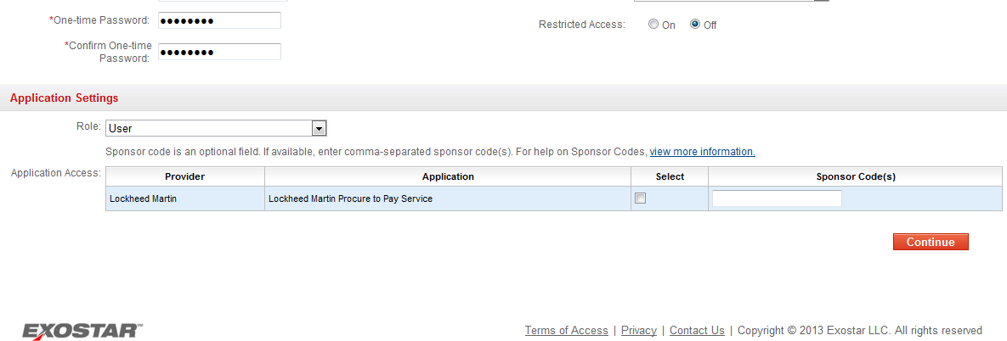

Step | Action
10. | The new user will be prompted to enter a one-time password when setting up their Exostar account.
11. | There are multiple roles within Exostar. A user can be an Application Admin and/or an Organization Admin. Presently, you are set up as both roles as evidenced by the current task of adding a new user to your Organization within the LMP2P Application.  Select "User" from the Role: dropdown menu.
12. | Click the Lockheed Martin Procure to Pay Service check box to add the new user to LMP2P.
13. | Click the Continue button.

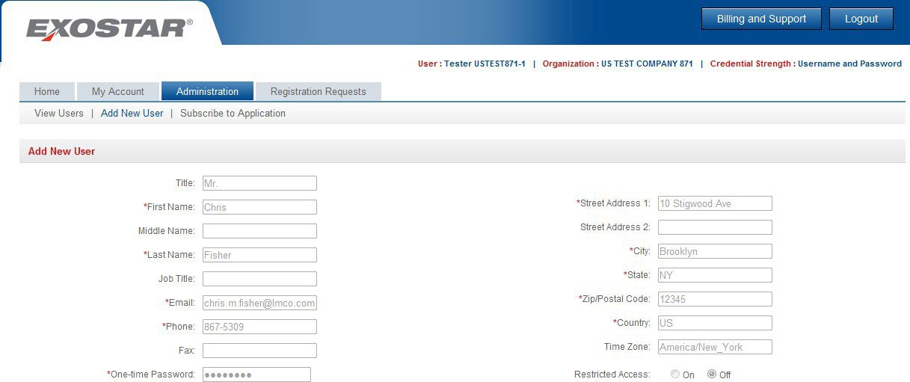

Step | Action
14. | Scroll to the bottom of the screen after confirming the information entered.

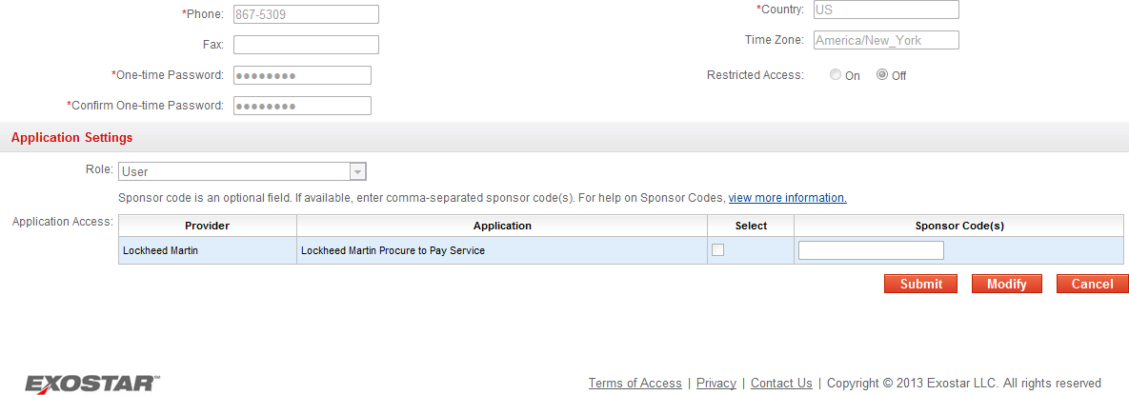

Step | Action
15. | Confirm the information entered and click the Submit button.

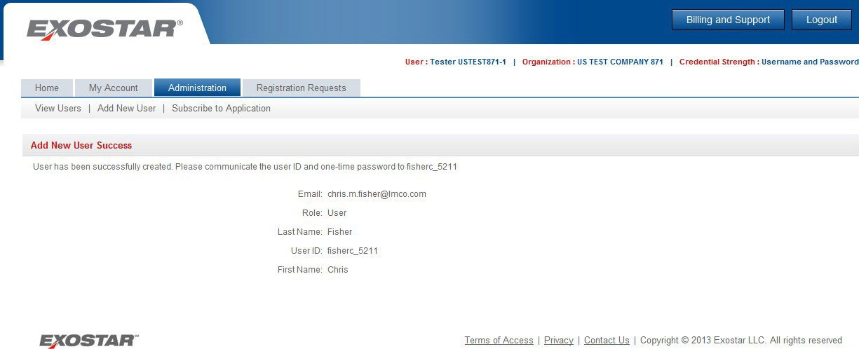

Step | Action
16. | Click the Registration Requests tab to provide the new user with their initial LMP2P External Portal role(s).

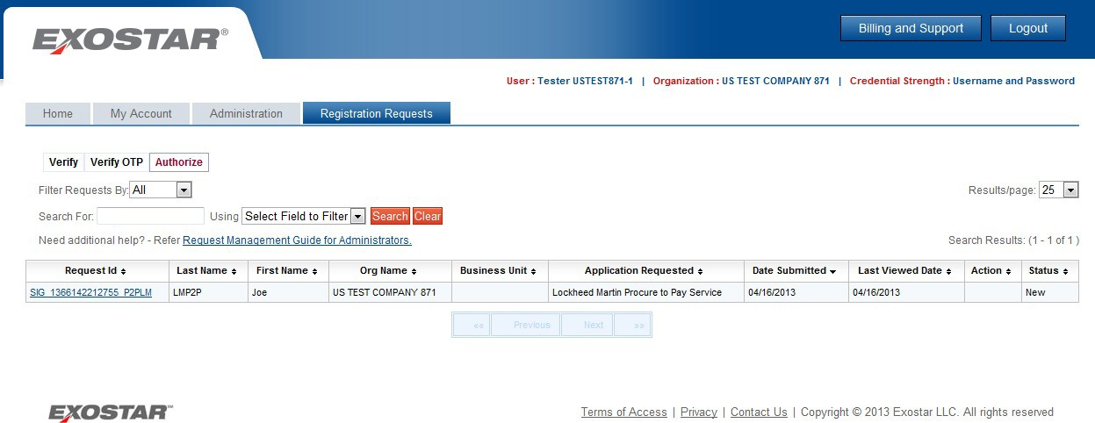

Step | Action
17. | Click the Request Id link to provide the new user with their initial LMP2P External Portal role(s).

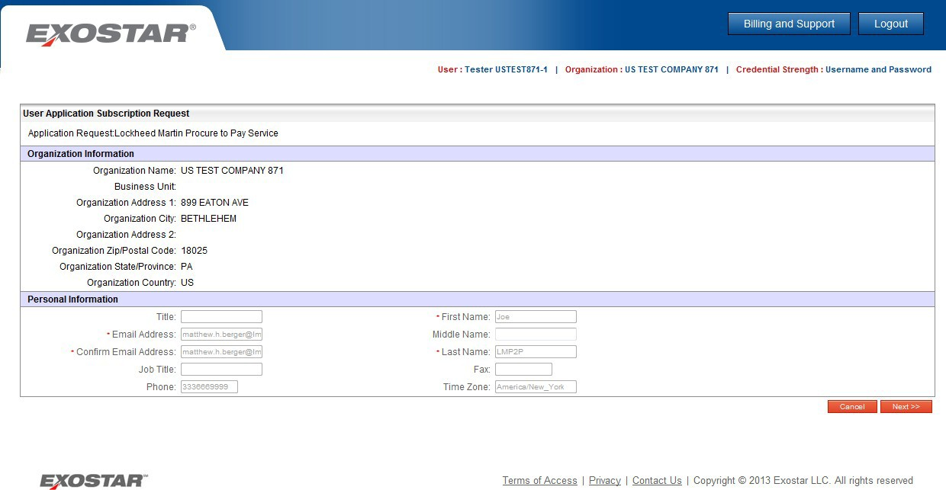

Step | Action
18. | Click the Next >> button.

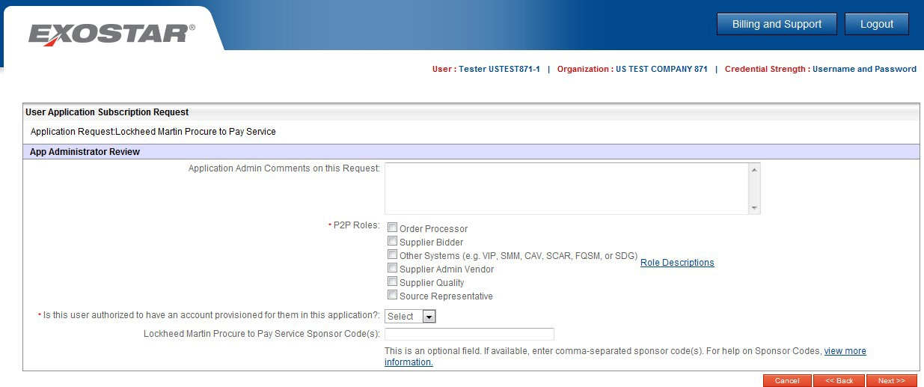

Step | Action
19. | You are able to provide the user with up to five roles within LMP2P. Select the role(s) you are assigning to the new user.
20. | Select "Approve" from the drop down menu.
21. | Click the Next >> button.
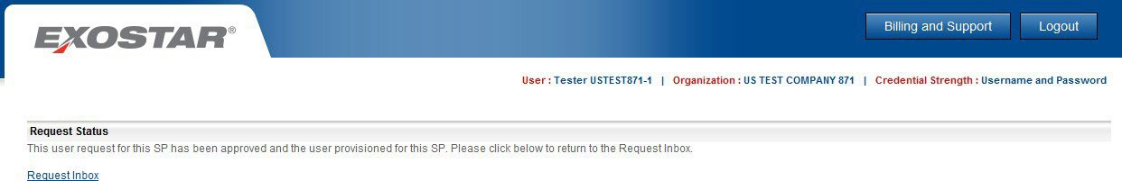

Step | Action
22. | Click the Request Inbox link to continue.

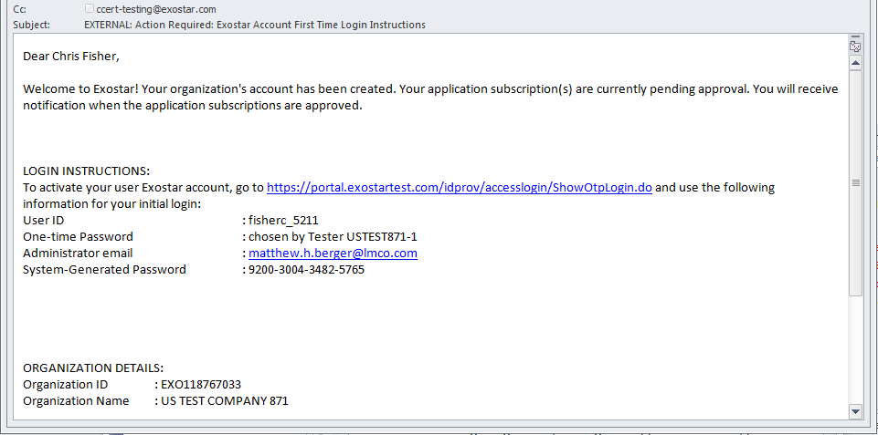

Step | Action
23. | Once the Exostar request is complete, an email will be sent to the newly created account holder with their initial credentials. To access Exostar for the first time, the new user will follow the instructions found within this email, an exercise not covered within this training material.

