

Last Updated 04/14/2020
Last Reviewed 5/24/2022

LM Procure to Pay Quick Reference Guide For Suppliers

Mass Acceptance of Purchase Orders

Lockheed Martin Procure to Pay Revised April 2020

Procedure

This quick reference guide documents how Suppliers can Accept or Reject the Purchase Order.
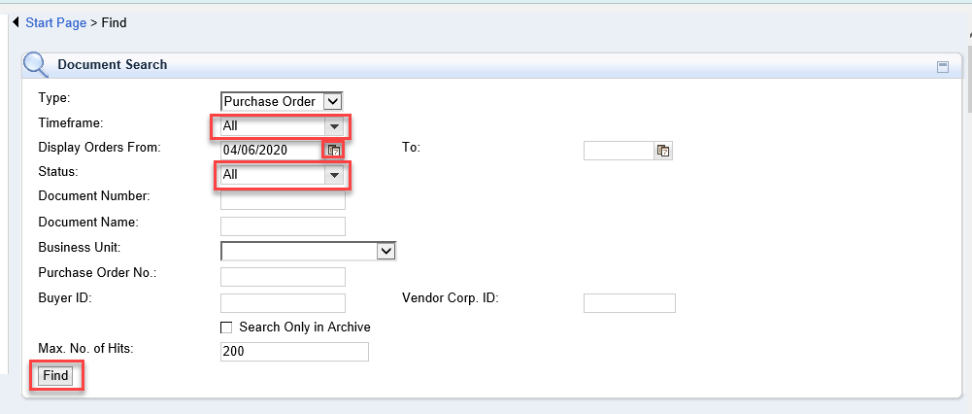

Step | Action
1. | To complete a mass acceptance of Purchase Orders within PO Delivery, access the Find section. Select the all timeframe, enter a date or date range to pull the data, Status select all or New. Click Find.

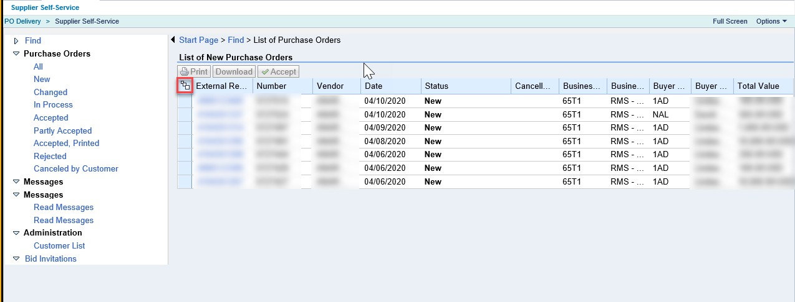

Step | Action
2. | On the list of POs returned, click the select all button on the upper left hand corner of the screen

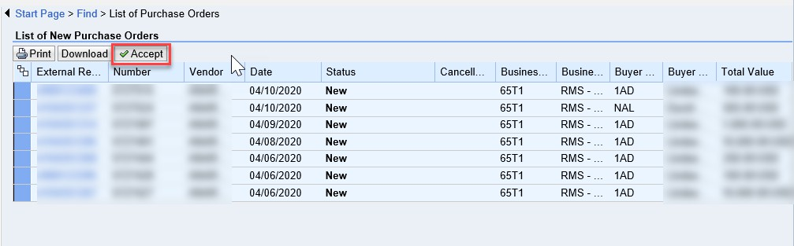

Step | Action
3. | This will select all the POs listed. Now the Print, Download and Accept buttons are available. Click the Accept button to process the PO acceptance in mass

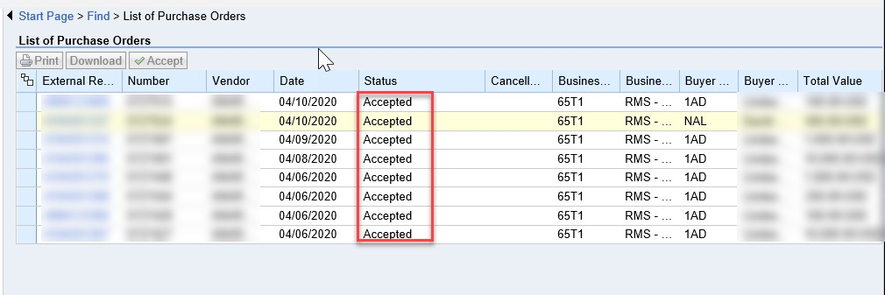

Step | Action
4. | Note if you searched by Status = New, you may need to reset the filter to All to see the update. The status should now show as Accepted  Note: Using this process to accept the PO will mean that you are accepting the PO without accessing and reviewing the details of the PO/s

Step | Action
5. | Click Process to process Purchase Order
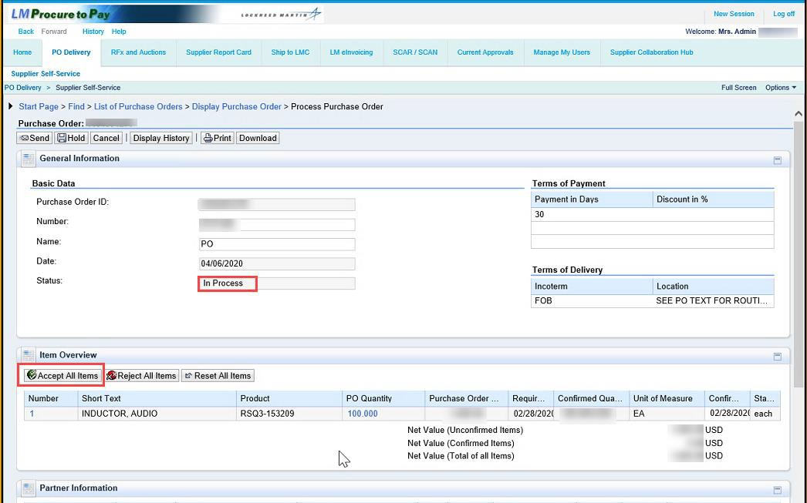

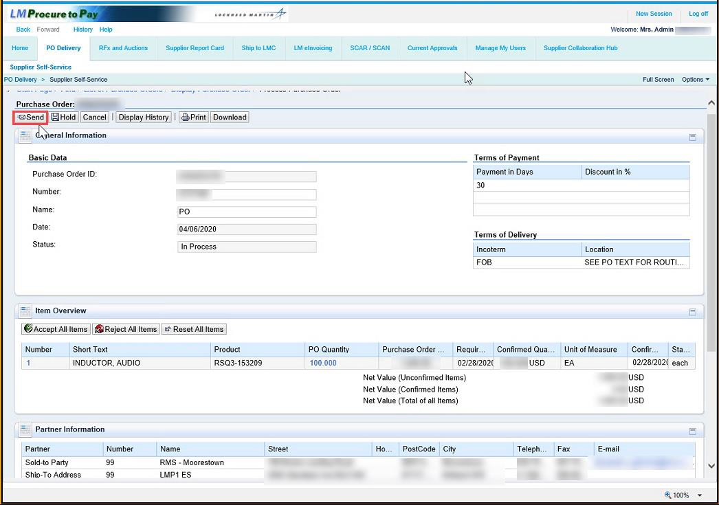

Step | Action
6. | Clicking Send to Accept or Reject the Purchase Order.

