
Purchase Order Delivery System Quick Reference Guide

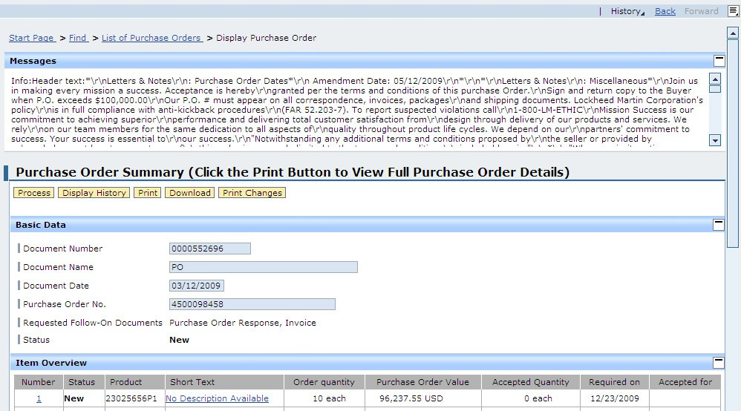
- Lockheed Martin has the following VERY IMPORTANT information for you to remember when viewing, accepting, or rejecting Purchase Orders in the new LM Procure to Pay PO Delivery system.

Click “Print” button to see all details of Purchase Order. This Summary Screen does not include all PO information.
- The PO Summary Screen does not show all purchase order information. In order to make sure you have all the correct information regarding the purchase order, please be sure to click the “Print” button as depicted on the right.
- Examples of this are: the prices shown on the screen for each line item do NOT include any “Special Charges”. You must view the PDF in order to see the true line item total.

