



Last Updated 3/23/2014
Last Reviewed 5/24/20202

LM Procure to Pay Quick Reference Guide For Suppliers

Uploading & Displaying Secure Attachments

Lockheed Martin Procure to Pay Revised March 2014

Table of Contents
Secure Attachments Overview 3
Sensitive Information Protection (SIP) Tag Information 4
Displaying Secure Attachments – PO Delivery 5
Uploading Secure Attachments – RFx/Auctions 12
Displaying Secure Attachments – RFx/Auctions 21
Uploading Secure Attachments – Ship To LMC 26
Displaying Secure Attachments – Ship To LMC 33
Uploading Secure Attachments – SCAR 39
Displaying Secure Attachments – SCAR 48

Secure Attachments Overview

This quick reference guide displays the procedure to upload and display secure attachments in LMP2P.

You are able to upload and display attachments marked as “sensitive” based on your permissions within LMP2P. Attachments may be tagged as:
- Unrestricted
- Lockheed Martin Proprietary
- US Export Controlled Information
- Personal Information
- Third Party Proprietary Information
The system will prompt users to select the sensitivity for each attachment. When displaying attachments, you may be prompted to acknowledge criteria based on how the attachment is tagged.

In order to upload or display attachments that include sensitive information, you must have completed the LMP2P 2-Factor Authentication. You will not be able to upload or display these attachments until you complete the registration for 2-Factor Authentication.

Sensitive Information Protection (SIP) Tag Information

When accessing attachments in LMP2P, specific numbers will display the SIP Tag information. The coding for SIP Tags in LMP2P is:
- 1 – Unrestricted
- 2 – Lockheed Martin Proprietary
- 3 – US Export Controlled
- 4 – Personal Information
- 5 – Third Party Proprietary
You are able to upload and display attachments marked as “sensitive” based on your permissions within LMP2P. Attachments may be tagged as:
- Unrestricted
- Lockheed Martin Proprietary
- US Export Controlled Information
- Personal Information
- Third Party Proprietary Information
The system will prompt users to select the sensitivity for each attachment. When displaying attachments, you may be prompted to acknowledge criteria based on how the attachment is tagged.

Displaying Secure Attachments – PO Delivery
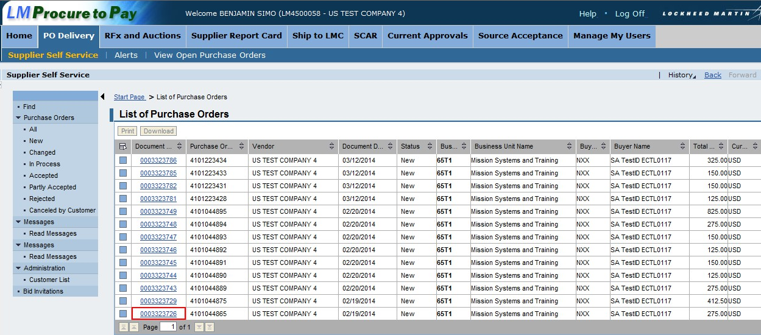

Follow these steps to display secure attachments in PO Delivery.

Step | Action
1. | Access the list of purchase orders by clicking the PO Delivery tab
2. | Click a hyperlink to access the Purchase Order Summary

Displaying Secure Attachments – PO Delivery
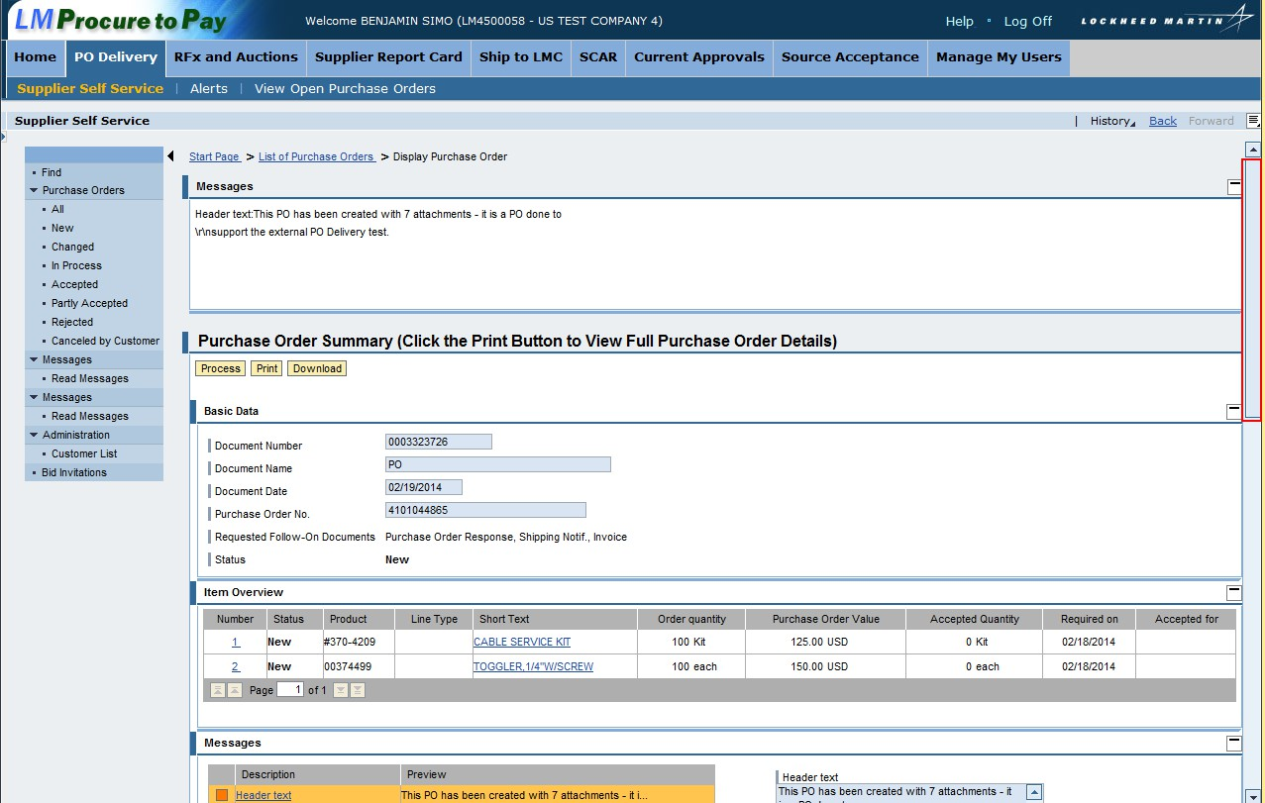

Step | Action
3. | Scroll down to view the attachment list for this purchase order

Displaying Secure Attachments – PO Delivery
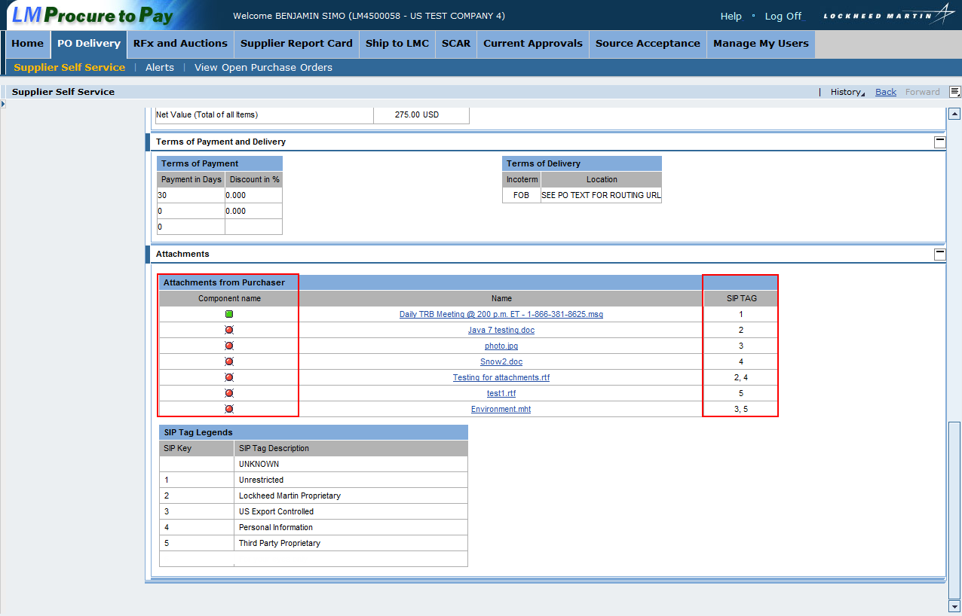

Step | Action
4. | The Attachments section displays at the bottom of the screen
5. | The SIP Key column shows color coding for each attachment. Green means the attachment was tagged as “unrestricted”. Red means the attachment was tagged as sensitive information. If the color coding is blank, it means the attachment was loaded in the system prior to 3/31/14
6. | Note the SIP tag information appears in the SIP TAG column. The numbers signify how the attachment was tagged when uploaded
7. | The SIP Tag Legends table shows each SIP Key number and a description for each

Displaying Secure Attachments – PO Delivery
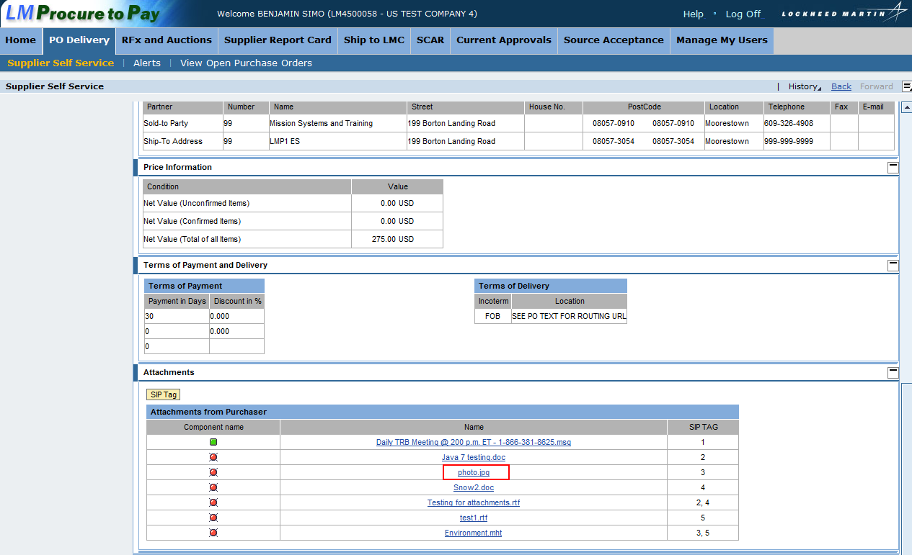

Step | Action
8. | Click a hyperlink within the attachments list to display the attachment

Displaying Secure Attachments – PO Delivery
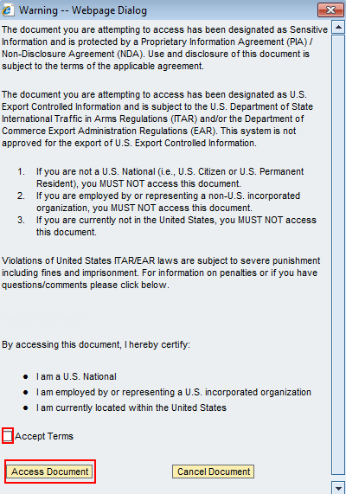

Step | Action
9. | This pop-up screen appears because the attachment was tagged as US Export Controlled. There are specific requirements required to view an US Export Controlled attachment.
10. | To access the attachment, read the warning and if you meet the requirements to access US Export Controlled information, click the Accept Terms checkbox
11. | Click Access Document. Note: You will not be able to access the attachment if the Accept Terms checkbox is not checked.

Displaying Secure Attachments – PO Delivery
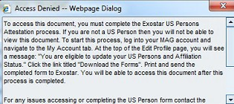
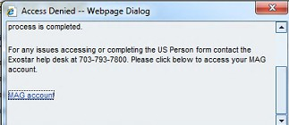

Step | Action
12. | If your credentials or status do not allow you to view attachments tagged as US Export Controlled, this is the message that will appear

Displaying Secure Attachments – PO Delivery
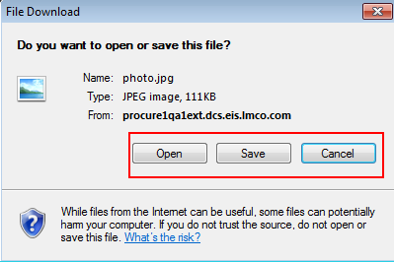

Step | Action
13. | If your credentials allow you to view US Export Controlled information, you can open or save the attachment.

Uploading Secure Attachments – RFx/Auctions
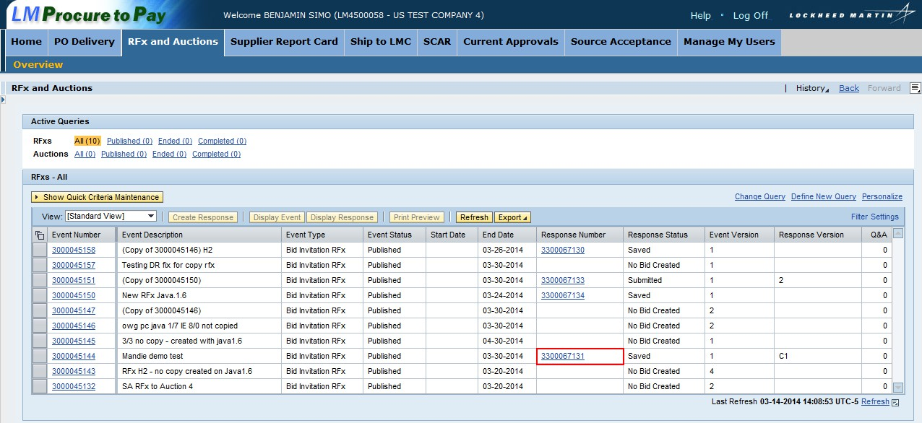

Follow these steps to upload a secure attachment for an RFx or Auction.

Step | Action
1. | Access the RFx and Auctions screen by clicking the RFx and Auctions tab
2. | In this example, we’ll access a response. Click the hyperlink for a specific response in the Response Number column

Uploading Secure Attachments – RFx/Auctions
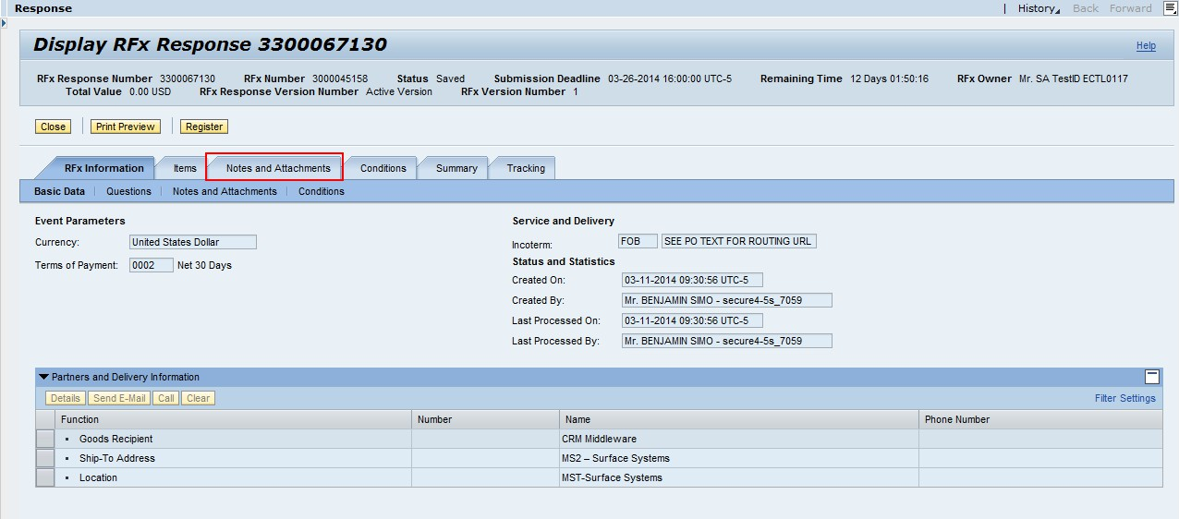

Step | Action
3. | The response appears
4. | Click the Notes and Attachments tab to view all of the attachments for the response

Uploading Secure Attachments – RFx/Auctions
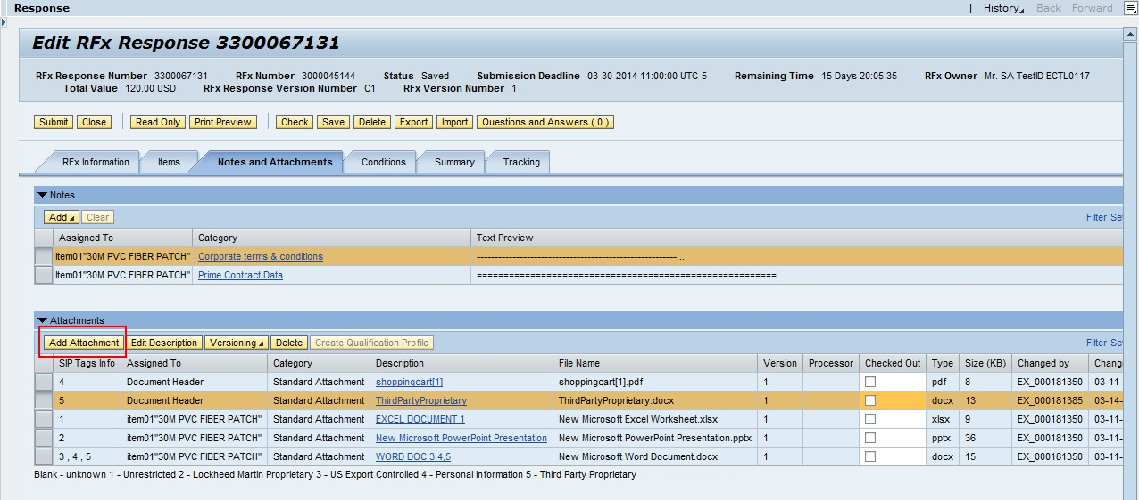

Step | Action
5. | The Attachments list appears
6. | Click Add Attachment to upload an attachment

Uploading Secure Attachments – RFx/Auctions
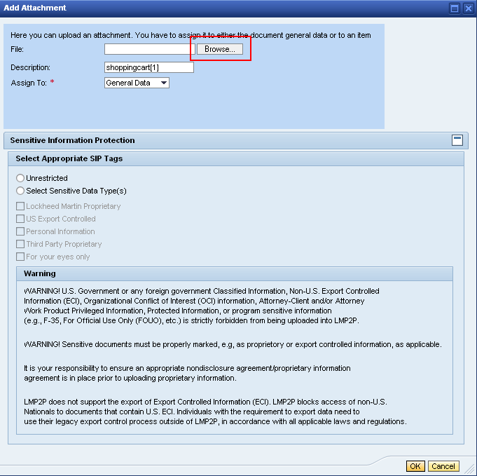

Step | Action
7. | You can either select the appropriate SIP Tag or browse to find the file you are uploading. In this example, click Browse… to locate your upload

Uploading Secure Attachments – RFx/Auctions
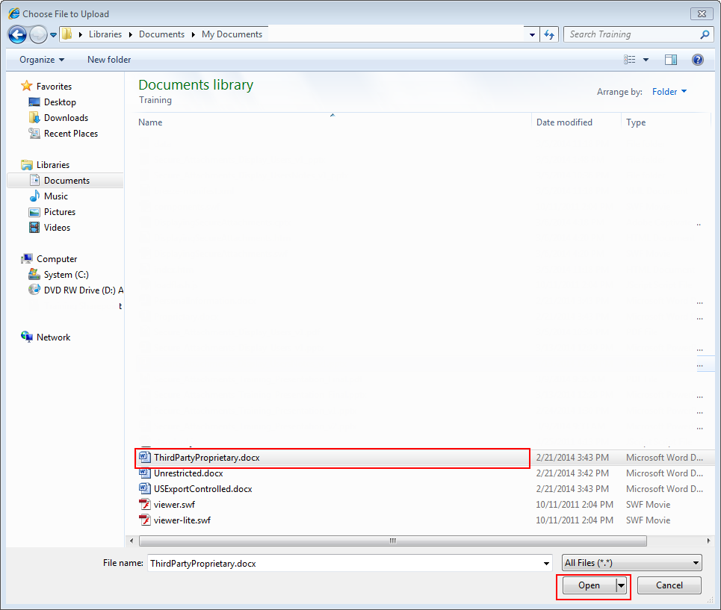

Step | Action
8. | Select the document you are attaching from your computer
9. | Click Open

Uploading Secure Attachments – RFx/Auctions
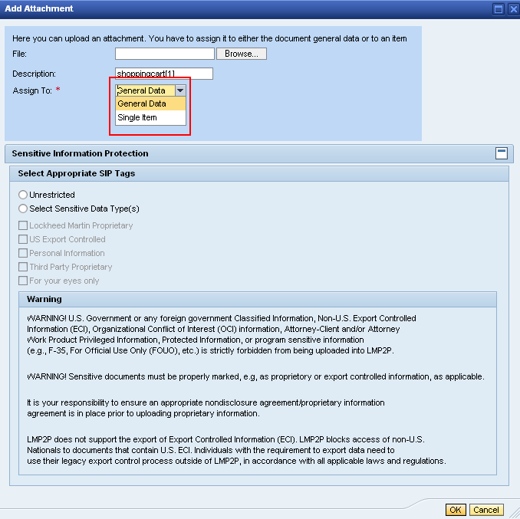

Step | Action
10. | You can assign the attachment to a single line item or the entire response. In this example, we’ll apply it to the entire response by leaving the Assign To: field set to General Data

Uploading Secure Attachments – RFx/Auctions
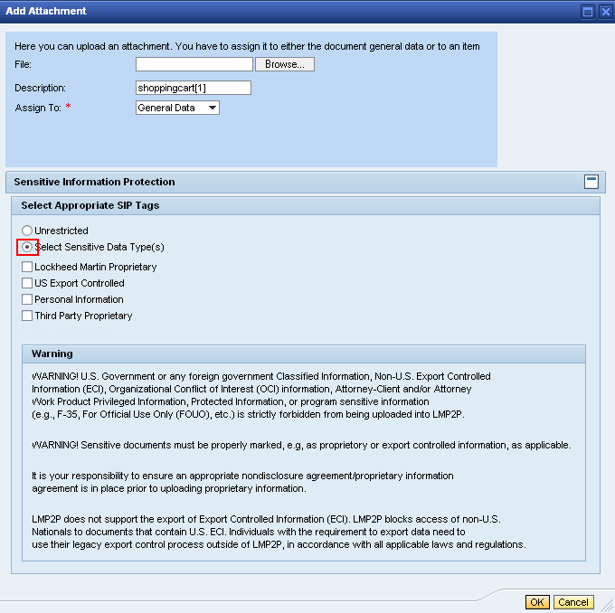

Step | Action
11. | Click the Select Sensitive Data Type(s) radio button to select the appropriate SIP tag. Note: If the attachment does not contain sensitive information, click the Unrestricted radio button

Uploading Secure Attachments – RFx/Auctions
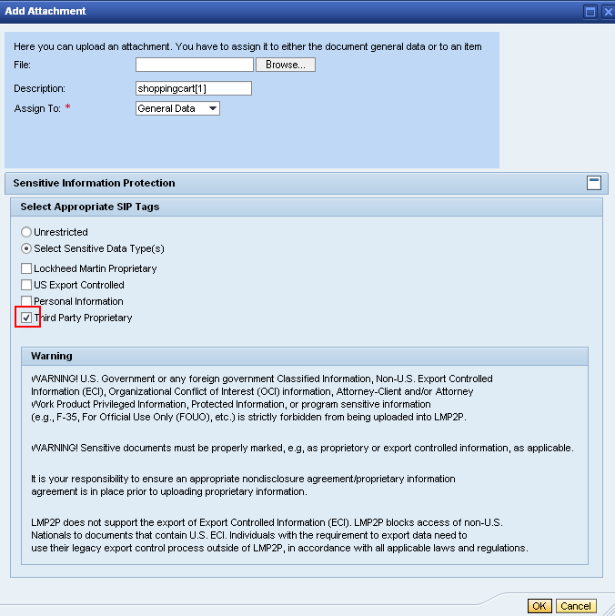

Step | Action
12. | In this example, click Third Party Proprietary
13. | Click OK

Uploading Secure Attachments – RFx/Auctions
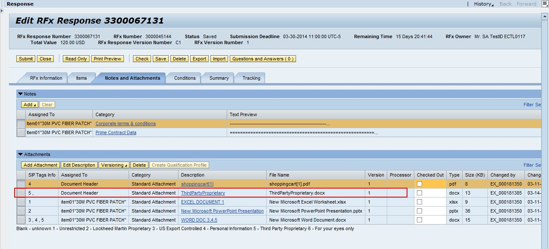

Step | Action
14. | Note that the uploaded attachment appears in the Attachments list

Displaying Secure Attachments – RFx/Auctions

Follow these steps to display a secure attachment for an RFx or Auction.

Step | Action
1. | Access the RFx and Auctions screen by clicking the RFx and Auctions tab
2. | In this example, we’ll access a response. Click the hyperlink for a specific response in the Response Number column

Displaying Secure Attachments – RFx/Auctions

Step | Action
3. | The response appears
4. | Click the Notes and Attachments tab to view all of the attachments for the response

Displaying Secure Attachments – RFx/Auctions
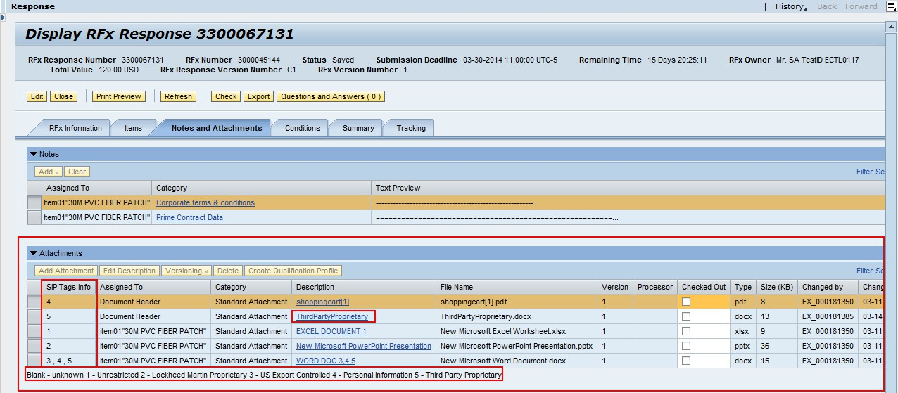

Step | Action
5. | The Attachments lists shows all of the attachments for this response
6. | The SIP Tag Info column includes the number that correlates with how the attachment was tagged
7. | You can view see what each SIP number corresponds to by looking at the key below the attachments list
8. | In this example, we’re going to access an attachment that was tagged as Third Party Proprietary information
9. | Click a hyperlink under the Description column to display an attachment

Displaying Secure Attachments – RFx/Auctions
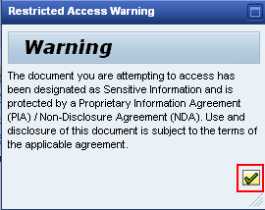

Step | Action
10. | This is the pop-up that appears for the document tagged as Third Party Proprietary
11. | Click the Green check to acknowledge the warning

Displaying Secure Attachments – RFx/Auctions
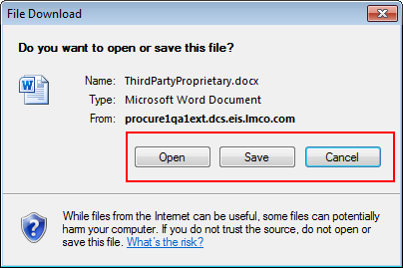

Step | Action
12. | You can open or save the attachment

Uploading Secure Attachments – Ship To LMC
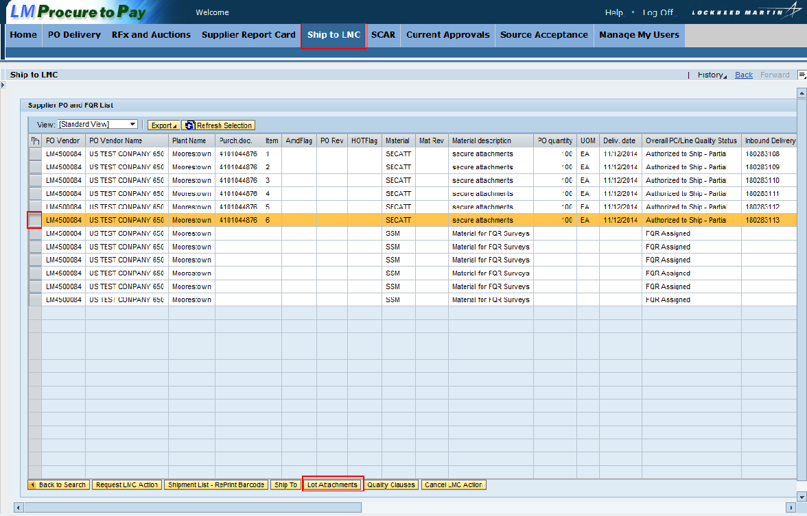

Follow these steps to upload secure attachments within Ship To LMC

Step | Action
1. | Access Ship to LMC
2. | Click the selection box to select a line item
3. | Click Lot Attachments

Uploading Secure Attachments – Ship To LMC
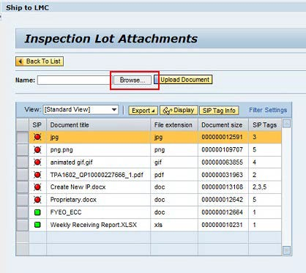

Step | Action
4. | The Inspection Lot Attachments screen appears
5. | Click Browse… to select an attachment to upload

Uploading Secure Attachments – Ship To LMC
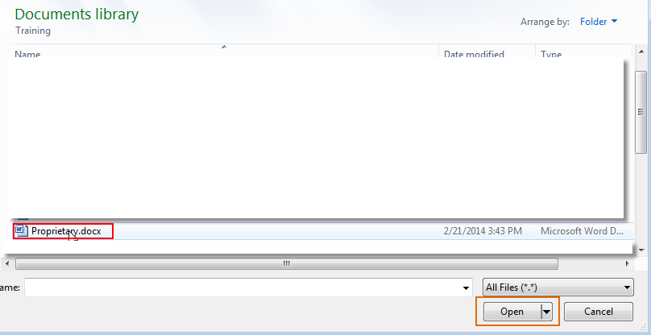

Step | Action
6. | Select the document you are attaching from your computer
7. | Click Open

Uploading Secure Attachments – Ship To LMC
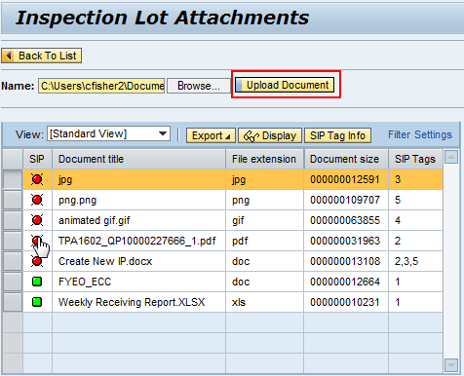

Step | Action
8. | The attachment has been added. Click Upload Document

Uploading Secure Attachments – Ship To LMC
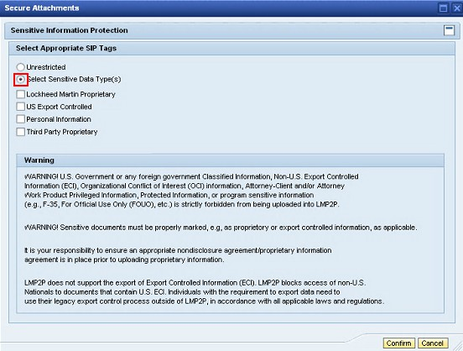

Step | Action
9. | Click the Select Sensitive Data Type(s) radio button to select the appropriate SIP tag. Note: If the attachment does not contain sensitive information, click the Unrestricted radio button

Uploading Secure Attachments – Ship To LMC
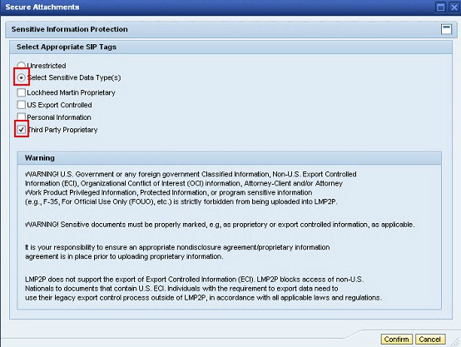

Step | Action
10. | In this example, click Third Party Proprietary
11. | Click Confirm

Uploading Secure Attachments – Ship To LMC
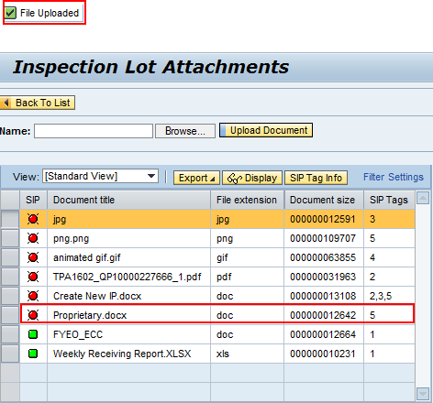

Step | Action
12. | Note the message that the attachment is uploaded
13. | The attachment appears in the attachment list

Displaying Secure Attachments – Ship To LMC
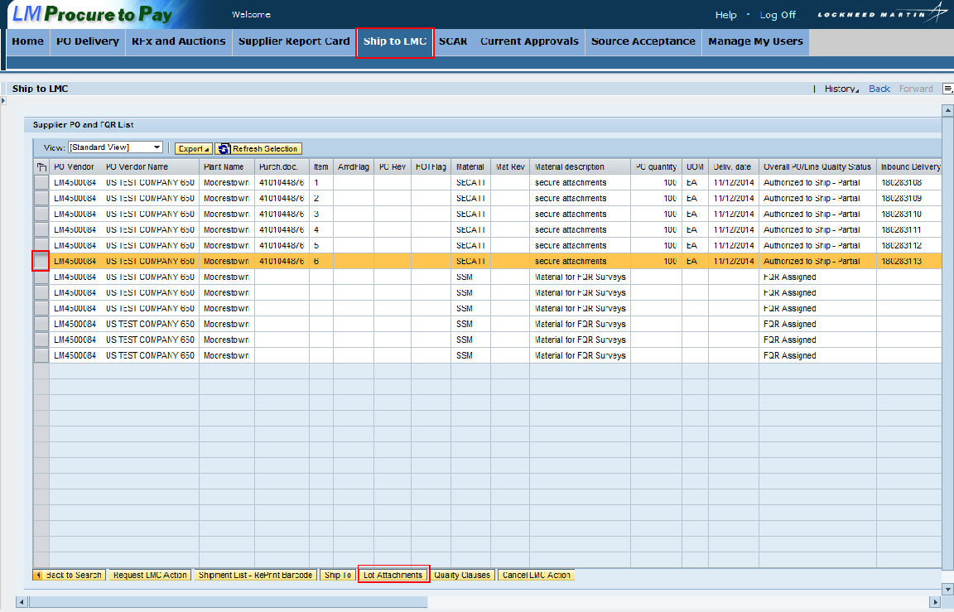

Step | Action
1. | Access Ship To LMC
2. | Click the selection box to select a line item
3. | Click Lot Attachments

Displaying Secure Attachments – Ship To LMC
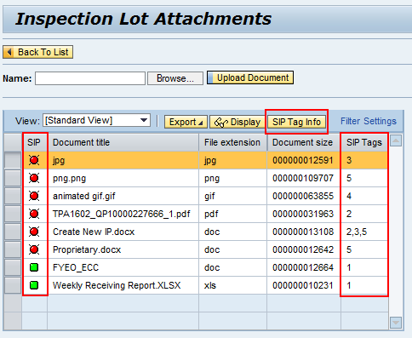

Step | Action
4. | The attachment list displays
5. | The SIP column shows color coding for each attachment. Green means the attachment was tag as “unrestricted”. Red means the attachment was tagged as sensitive information. If the color coding is blank, it means the attachment was loaded in the system prior to 3/31/14
6. | Note the SIP tag information appears in the SIP Tags column. The numbers signify how the attachment was tagged when uploaded
7. | To view the SIP Tag information, click SIP Tag Info

Displaying Secure Attachments – Ship To LMC
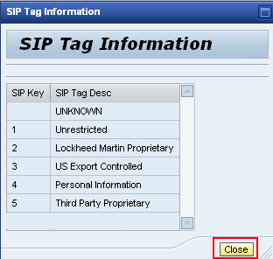

Step | Action
8. | The SIP Tag Information screen appears
9. | This screen provides a key with the SIP Key numbers and SIP Tag descriptions
10. | Click Close to return to the attachment list

Displaying Secure Attachments – Ship To LMC
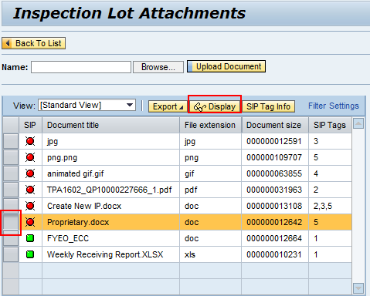

Step | Action
11. | The attachment list appears
12. | To select an attachment to display, click the selection box for the attachment
13. | Click Display

Displaying Secure Attachments – Ship To LMC
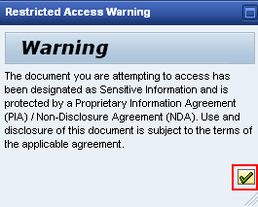

Step | Action
14. | This is the pop-up that appears for the document tagged as Third Party Proprietary
15. | Click the Green check to acknowledge the warning

Displaying Secure Attachments – Ship To LMC
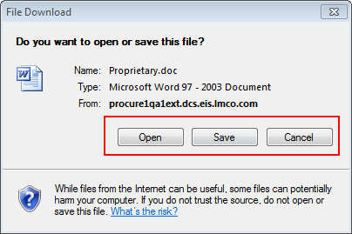

Step | Action
16. | You have the option to open or save the document

Uploading Secure Attachments – SCAR
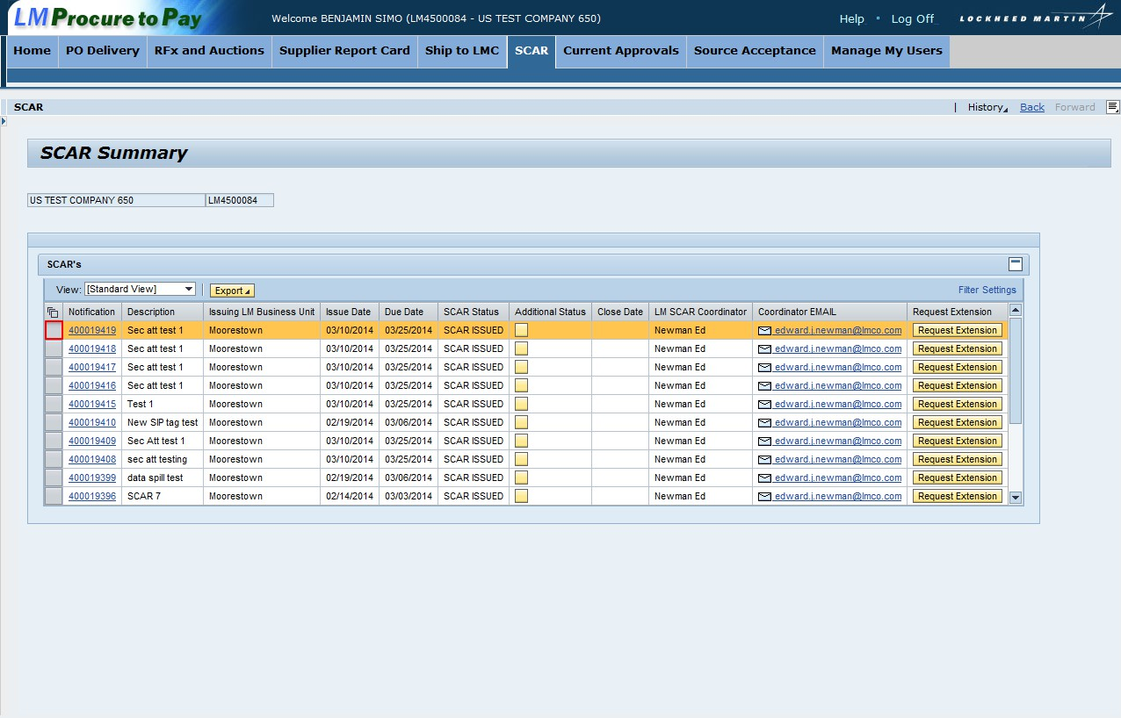

Step | Action
1. | Access SCAR by clicking the SCAR tab
2. | Click a selection box to select a specific SCAR

Uploading Secure Attachments – SCAR
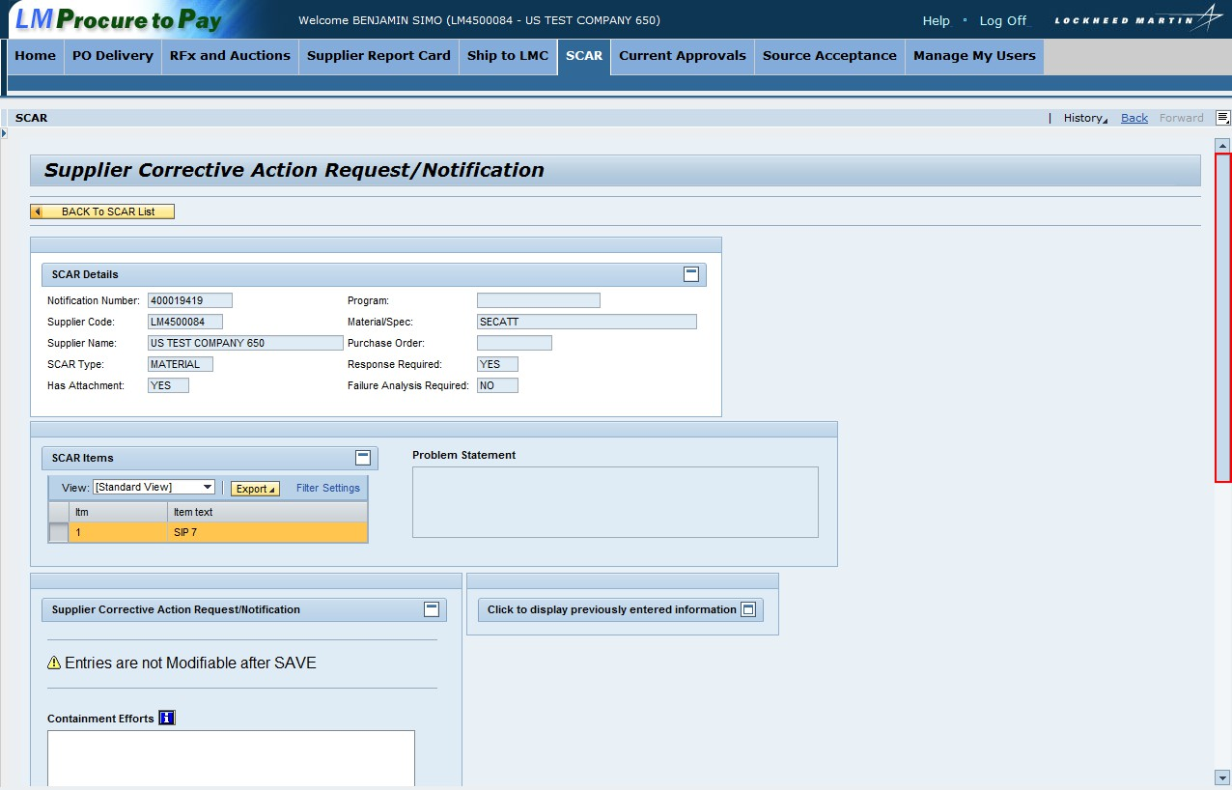

Step | Action
3. | The Supplier Correct Action Request/Notification screen appears
4. | Scroll down on the page to view the button used to upload an attachment

Uploading Secure Attachments – SCAR
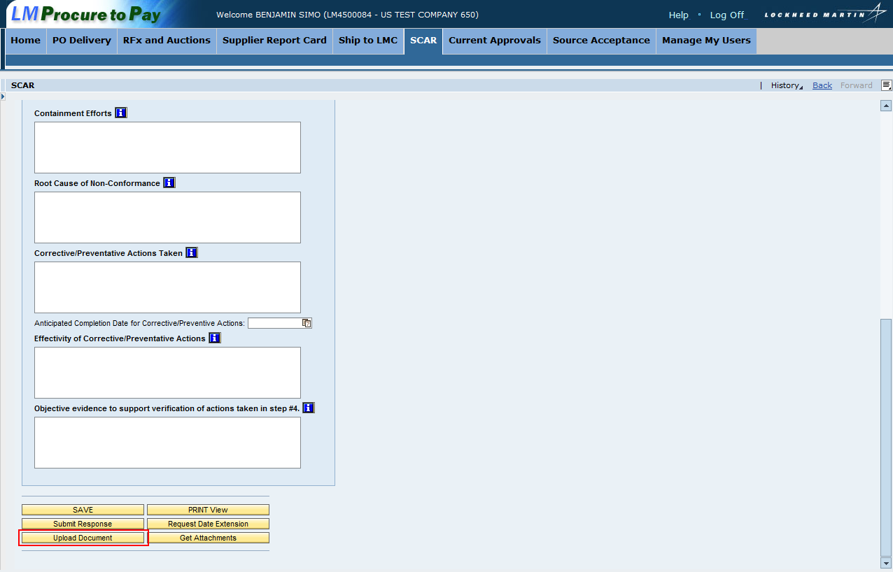

Step | Action
5. | Click Upload Document to add an attachment

Uploading Secure Attachments – SCAR
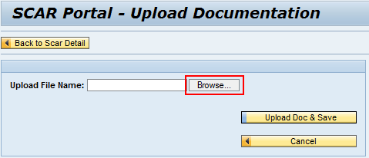

Step | Action
6. | The SCAR Portal – Upload Documentation screen appears
7. | Click Browse… to select the attachment

Uploading Secure Attachments – SCAR
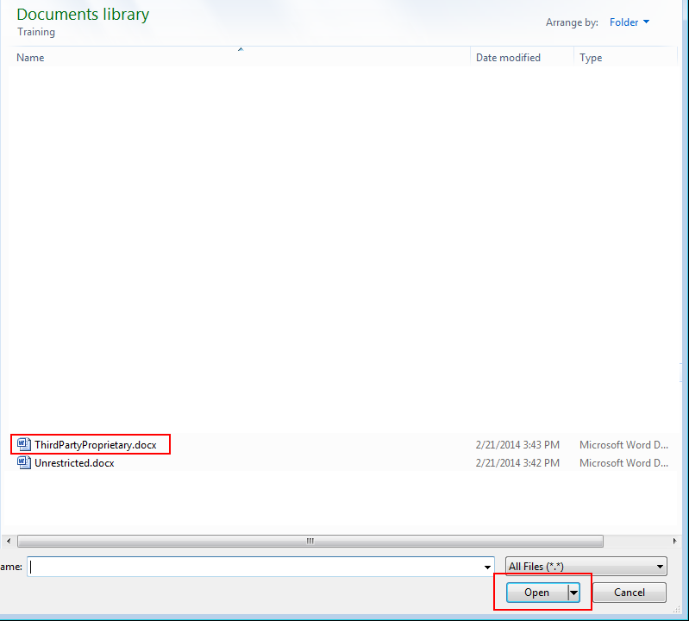

Step | Action
8. | Select the document you are attaching from your computer
9. | Click Open

Uploading Secure Attachments – SCAR
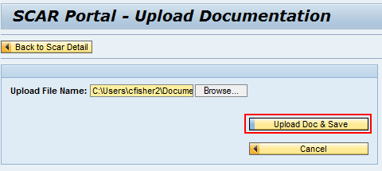

Step | Action
10. | The document is added to the Upload File Name: field
11. | Click Upload Doc & Save

Uploading Secure Attachments – SCAR
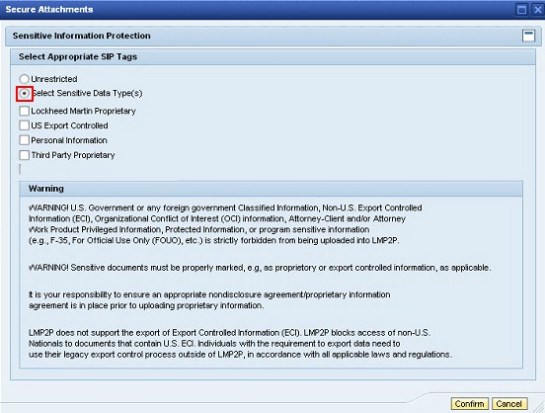

Step | Action
12. | Click the Select Sensitive Data Type(s) radio button to select the appropriate SIP tag. Note: If the attachment does not contain sensitive information, click the Unrestricted radio button

Uploading Secure Attachments – SCAR

Step | Action
13. | Click the Select Sensitive Data Type(s) radio button to select the appropriate SIP tag. Note: If the attachment does not contain sensitive information, click the Unrestricted radio button
14. | Click Confirm

Uploading Secure Attachments – SCAR
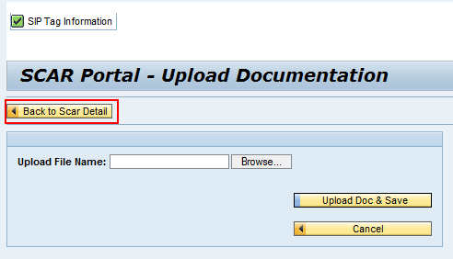

Step | Action
15. | A message appears that states SIP Tag Information
16. | Click Back to Scar Detail

Displaying Secure Attachments – SCAR

Follow these steps to display secure attachments within Ship To LMC

Step | Action
1. | Access SCAR by clicking the SCAR tab
2. | Click a hyperlink to access a SCAR

Displaying Secure Attachments – SCAR

Step | Action
3. | The Supplier Correct Action Request/Notification screen appears
4. | Scroll down on the page to view the button used to display an attachment

Displaying Secure Attachments – SCAR
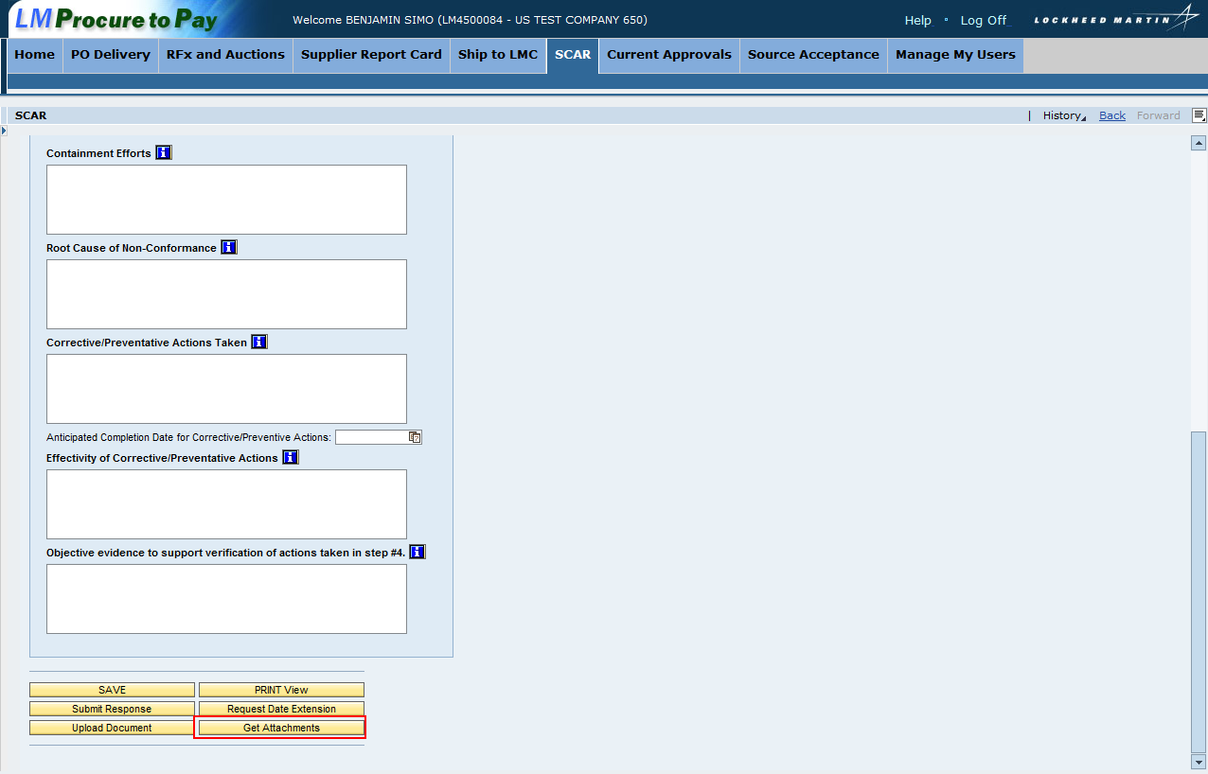

Step | Action
5. | The Supplier Correct Action Request/Notification screen appears
6. | Scroll down on the page to view the button used to display an attachment
7. | Click Get Attachments

Displaying Secure Attachments – SCAR
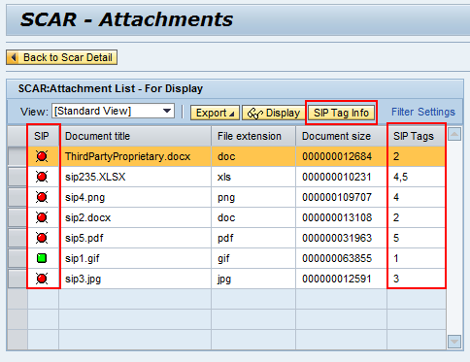

Step | Action
8. | The attachment list displays
9. | The SIP column shows color coding for each attachment. Green means the attachment was tag as “unrestricted”. Red means the attachment was tagged as sensitive information. If the color coding is blank, it means the attachment was loaded in the system prior to 3/31/14
10. | Note the SIP tag information appears in the SIP Tags column. The numbers signify how the attachment was tagged when uploaded
11. | To view the SIP Tag information, click SIP Tag Info

Displaying Secure Attachments – SCAR

Step | Action
12. | The SIP Tag Information screen appears
13. | This screen provides a key with the SIP Key numbers and SIP Tag descriptions
14. | Click Close to return to the attachment list

Displaying Secure Attachments – SCAR
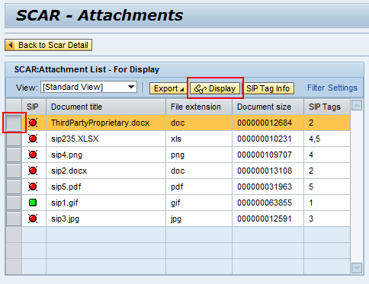

Step | Action
15. | The attachment list appears
16. | To select an attachment to display, click the selection box for the attachment
17. | Click Display

Displaying Secure Attachments – SCAR
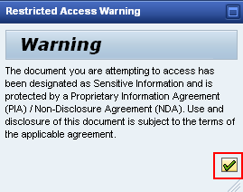

Step | Action
18. | This is the pop-up that appears for the document tagged as Third Party Proprietary
19. | Click the Green check to acknowledge the warning

Displaying Secure Attachments – SCAR
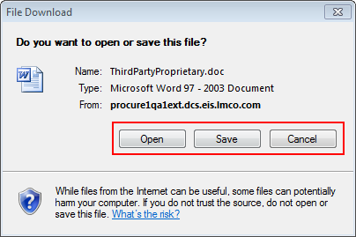

Step | Action
20. | You have the option to open or save the document

